Power

Power Allocation by Subsystems

Electronics Enclosure

FCWS Engineering Computer and video recorder
The power of the FCWS engineering and video recording computers comes from the +24V bus bar.

SCWS Engineering Computer and video recorder
The power of the SCWS engineering computers comes from the +12V bus bar.

Sensors
The 12V bus bar provides power to sensors including accelerometers, cameras, RS232 converters, Lidars and radars. The power supply of Lidars is controlled by a speed-controlled relay. Whenever the bus speed measured is below 3m/s and the creeping detector detects the bus is not moving, a lidar control signal is set inactive to turn off the power to the Lidars. When the bus speed measured is greater than 3m/s or the creeping detector detects the bus is moving, the lidar control signal is active and the Lidar power is resumed. (This relay may be removed if the sensor manufacturer improves the design to make the sensor eye-safe.)

PATH / CMU | Sensors | Power supplies
PATH | Lidars | 12V DC from the third relay
PATH | Radars | 12V DC from the bus bar
PATH | RS232 Converters | 12V DC from the bus bar
PATH | Cameras | 10V DC from a regulator off the 12V bus bar
PATH | Video combiner | 12V AC from transformers
PATH | Video timestamper | 12V DC from the bus bar
PATH | Accelerometer | 12V DC from the bus bar
PATH | Creeping detector | 12V DC from the bus bar
PATH | Windshield wiper sensor | 12V DC from the bus bar
PATH | Rate Gyro | 12V DC from the bus bar
PATH | Sensitivity | 5V DC from a voltage converter
PATH | Voltage converters and Transformers | 12V DC from the bus bar
CMU | RS232 Converters | Driven by Interface
CMU | Cameras | 12V DC from a regulator off the 12V bus bar
CMU | Video combiner | 12V DC
CMU | Accelerometer | 12V DC from the bus bar in computer case
CMU | Curb Detector | 12V DC from a regulator off the 12V bus bar
Table 1 Sensor power supplies

DVI
The power for DVI comes from a voltage converter that converts 12V DC to 5V DC. The converter is located in the Driver Interface Control Box next to the driver.

Power Conditioning
There are bypass capacitors next to DC power converters and regulators.

Grounding Scheme
The bus ground bar is the ground for the whole ICWS. Both FCWS and SCWS have their own sub-system ground. All components of each system are grounded on its own sub-system ground. The sub-system grounds are then connected to the bus ground bar.
Figure 1 Grounding scheme

4.4 Maximum Power
PATH | Object Sensors | 85Watts(3 Lidars and 2 Radars)
PATH | Host-bus sensors | 3Watts
PATH | Cameras | 8Watts
PATH | Engineering Computer | 40Watts
PATH | Video combiner | 6Watts
PATH | Video Recorder | 40 Watts
PATH | Miscellaneous | 8Watts
Total PATH |  | 190Watts

CMU | Laser scanners (2) | 56 Watts
CMU | Cameras | 5 Watts
CMU | Curb Detector | 3 Watts
CMU | SCWS Computers | 60 Watts
CMU | Video combiner | 6 Watts
CMU | Video Recorder | 30 Watts
CMU | Accelerometer | 2 Watts
CMU | Miscellaneous | 8 Watts
Total CMU |  | 170 Watts

ICWS  Total Power |  | 360 Watts
Table 2 Power allotment by subsystem

5. FCWS Engineering Computer
The engineering data that sensors send out is recorded and processed by a PC104 computer system. The engineering computer has a digital I/O card, an Analog/Digital I/O card, a CAN card which reads J data bus, and a Serial Port card. One parallel port and two serial ports are reserved for communication with SCWS.
Serial ports:
The following serial port on the engineering computer is used for synchronization between the FCWS engineering computer and the video recorder:
Port 1: Engineering - Video Computer Communications (115200 Baud)
The following serial ports of the Serial Port card are reserved for FCWS:
Port 3: (RS-232) P-RADAR (19200 baud)
Port 4: (RS-232) D-RADAR (19200 baud)
Port 5: (RS-232) F-LIDAR (19200 baud)
Port 6: (RS-232) P-LIDAR (19200 baud)
Port 7: (RS-232) D-LIDAR (19200 baud)
Port 8: (RS-232) video timestamper (9600 baud)
Port 9: (RS-232) GPS (4800 baud)
Port 10: (RS-232) Rate Gyro (9600 baud)
The following serial port on the engineering computer is used for communication between SCWS and FCWS:
Port 2: Data communications between the FCWS and the SCWS (115200 Baud)

FCWS Digital signals

Digital Inputs from subject vehicle sensors

# | Definition | Range | Description
1 | Power off  Indicator | 0-5V | Normally 0, set = 1 when bus is turned off (about 1 minutes of power remain)
Table 3 the Input from subject vehicle sensors

FCWS digital output

# | Definition | Range | Description
1 | Status light | 0-5V | Set active when the system is working
2 | Lidar control signal | 0-5V | Set active when the bus moves
Table 4 Miscellaneous I/O signals

FCWS Analog Signals
The following analog signals are inputs to the FCWS engineering computer.
# | Definition | Range
1 | Windshield wiper signal  (high=on low=off) | -10 to 10V
2 | Brake pressure | -10 to 10V
3 | Left turn signal  (high=on low=off) | -10 to 10V
4 | Right turn signal  (high=on low=off) | -10 to 10V
5 | Creeping detector | -10 to 10V
6 | Sensitivity | 0 to 5V
7 | Back up lights  (high=on low=off) | -10 to 10V
8 | Doors open/close | -10 to 10V
Table 5 Analog signals

FCWS Sensor interface, parameters and format
Figure 2 Interface between host-bus sensors and the engineering computer
Figure 3 Interface between obstacle sensors and the engineering computer

SCWS Engineering Computers
The data that the left and right side sensors send out is recorded and processed with two PC104 industrial computers. In addition to the processor card for each side, there is a quad serial port card in each engineering computer. Two serial ports are reserved for communication and synchronization with the FCWS.
The I/O ports for the left and right SCWS Engineering Computers are assigned as follows:
Left Side SCWS Engineering Computer
CPU Board Serial port 1: FCWS - SCWS Talk Interface
CPU Board Serial port 2: (RS-232) Spare
Serial Board Port 1: (RS-232) Spare
Serial Board Port 2: (RS-232)
Serial Board Port 3: (RS-422) Left Laser Scanner (500 K Baud)
Serial Board Port 4: (RS-422) Spare
Video Input 1: Right side camera looking forward for curb estimator

Right Side SCWS Engineering Computer
CPU Board Serial port 1: Crossbow IMU
CPU Board Serial port 2: (RS-232) J1708 Converter (19200 baud)
Serial Board Port 1: (RS-232) Spare
Serial Board Port 2: (RS-232) Spare
Serial Board Port 3: (RS-422) Odometry Counter/Timer Module (9600 baud)
Serial Board Port 4: (RS-422) Right Laser Scanner (500 KBaud)
Video Input 1: Curb tracker camera output

SCWS Sensor interface, parameters and format

Figure 4 Interface between obstacle sensors and the engineering computer

SCWS Bus coordinate reference frame and translation
s_{b} = the (scalar) speed of the bus
= direction of the bus velocity (=0 for t=0)
= the yaw-rate of the bus
x_{o},y_{o} = the position of the object relative to the midpoint of the rear axle
s_{o} = the speed of the object relative to the world
θ_{o} = the direction of the object velocity
= the yaw rate of the object
xy_{c} = the position of the curb with respect to the bus
w = the width of the bus
l = the length of the bus

Figure 15 - Bus Coordinate System

yx_{o}
θ_{o}
s_{o}
xy_{c}
xy_{o}
s_{b}
θ_{b}
w
At t = 0 seconds, the origin of the coordinate system is the midpoint of the rear axle

SCWS Host Bus Interfaces
Figure 5 Interface between host-bus electronic busses and the engineering computer

DINEXTM Data (PAT Bus only)
The following data is collected through the DINEXTM Interface. The DINEXTM system needs to be reprogrammed to allow these signals to appear on the interface. A converter is added to the DINEXTM bus to convert the interface to RS232.
- Day run
- Night run
- Hazard Lights On / Off
- Front Door open
- Rear door open
- Left turn
- Right turn
- Stop Requested On / Off
- Zero speed – may be available at later date
- Reverse – may be available at later date
- Foot brake – may be available at later date

In addition – we get a power down signal from the DINEXTM system via a junction in the radio box behind the driver. This signal is a retasked digital I/O line.

J1939 / J1708 Data
The following data is collected through the J1708 Interface via an RS-232 converter.. The interface is operated in listen only mode and does not put any commands onto the J1939 / J1708 bus.
- Throttle position % travel
- Accelerator % travel
- Speed
- Brake Pressure
- RPM (engine)

SCWS IMU
A 3 – axis accelerometer and yaw gyro is installed for use in the bus trajectory prediction algorithms. This IMU has an RS232 Interface which is located in the same compartment as the SCWS engineering computers.

Video Recorder

FCWS Video Recorder Hardware
Video streams from the cameras are recorded in a standard format (MPEG-2) by a QNX-6 based PC104 video recording system PATH developed.

Cameras of FCWS
The cameras of the FCWS capture the front road scene, the left and right front corner road scene, and the passenger compartment of the bus. The video streams from the four cameras are combined into one video stream by a quad image combiner to extend the hard drive storage capacity. The video-in port of video recording computer is connected to the video-out port of the quad combiner by a75$Ω$ video cable.
Figure 6 Video computer-FCWS camera interface

Synchronization
The video files recorded and the sensor files recorded need to be synchronized to describe the same scenario. The video recorder reads commands from the engineering computer and records the MPEG video clips to a removable hard drive. The commands from the engineering computer are “start recording (with a time stamp),” and “stop recording”. Every time the video recorder gets a “start recording” command it closes the old video file, opens up a new file (named by the time stamp) and starts recording.

SCWS Video Recorder Hardware

Cameras of SCWS
The cameras of the SCWS are located on the mid right side of the bus looking forward (also used to track curb position in front of the bus), the right front looking rearward, the left front of the bus looking rearward and the left rear of the bus looking forward. The video streams from the four cameras are combined into one video stream by a quad image combiner to extend the hard drive storage capacity. The video-in port of video recording computer is connected to the video-out port of the quad combiner by a 75$Ω$ video cable.
Figure 7 Video computer-SCWS camera interface

Synchronization
The video files recorded, the sensor data files recorded and the intermediate computer data recorded are synchronized using a master time stamp for each data file.

Human-machine interface, parameters and format

Warning Levels
The ICWS uses a two level warning approach with an additional indicators defined below:
Alert: there is a detected threat that has the potential to become more dangerous. The warning is displayed in the visual channel only.
Imminent (Warn): there is a detected threat that has a high potential to make contact with the bus, and that evasive action is required. The warning is currently displayed in the visual channel. The DVI also contains a highly salient secondary channel (currently specified as audio) to allow testing with sound cues as well.
Contact indication: the system is to notify the driver when it believes a side collision has occurred.
Under bus indication: The SCWS looks for the disappearance of pedestrian sized objects in front of the wheel wells and generates a warning when detected.

Hardware Architecture
The human-machine interface is composed of the DVI and its control circuit, dimmer and sensitivity control. Other control inputs, e.g. DVI modality selection, may be added in.

Figure 8 Human-machine interface

Driver Interface Control Box
The controls include brightness, volume, and sensitivity knobs and a Contact Override button. The sensitivity control allows for three settings. These three settings change the threshold at which warnings are triggered. This allows the drivers to adjust the system to their preferred settings. The contact override switch is a pushbutton to prevent permanent suppression of the contact warning. Green LED’s for the left, front and right warning systems indicate the system is running correctly.
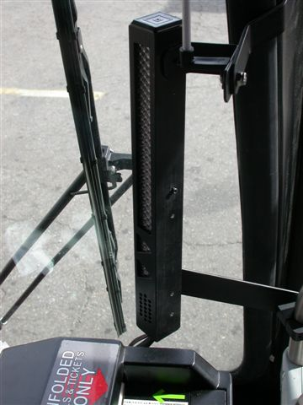
Also present at the bottom of each LED assembly is a speaker for playing the Imminent, Contact, and Under bus warnings. The perception of the sound is centered on the driver’s body through physical placement and is positioned such that audio bleed into the passenger area is minimized.

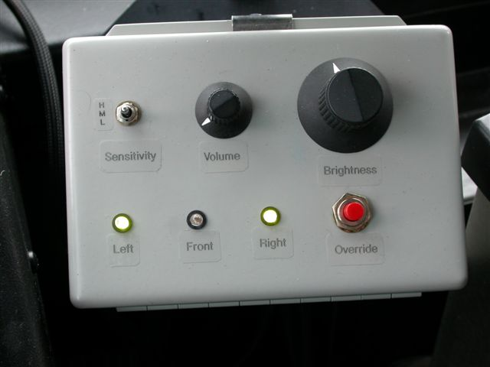

Figure 9 Driver control box and right DVI

8.4 Driver Vehicle Interface
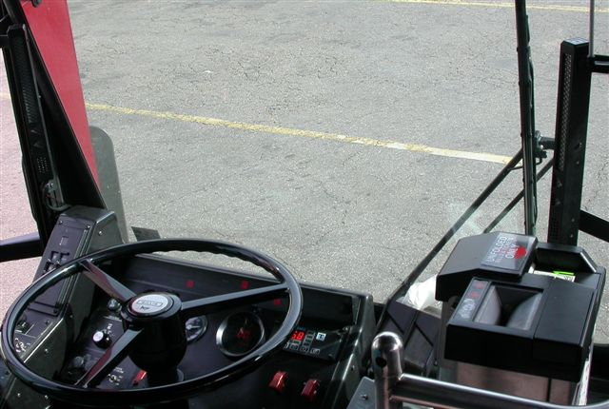
DVI
Figure 10 Driver machine interface

8.5 Forward Component
Bars (see Figures below) illuminate sequentially from top to bottom to indicate an approaching threat. Depending on how imminent the threat is some combination of the first segment and the first four segments will sequentially illuminate amber. The greater the number of segments illuminated the higher the threat. To indicate an imminent warning the segments will change color to red and as the threat becomes more time critical it will grow to the full length of the display.
When the left display is lit the object is forward to the left of the bus. When the right display is lit the object is forward to the right of the display. When the object is directly in front of the bus both displays will be lit.
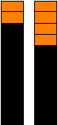
FCWS Alert Mode
Pictorially, forward alert on right side:

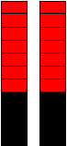
FCWS Imminent Mode
Pictorially, Forward imminent with no lateral bias:

Side component
In the event that the side component detects an alert level threat it will trigger an Alert Side warning. The triangular shaped LED for the appropriate side and front/rear position illuminates.
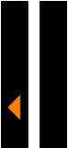
SCWS Alert Mode
Pictorially, left side front alert:

In the event that the side component detects an imminent threat it will trigger an Imminent Side warning. The triangular LED for the appropriate side position illuminates red at highest brightness level. The Imminent warning sound plays.


SCWS Imminent Mode
Pictorially, right side rear imminent:

In the event that the side component detects a collision event it will trigger a Contact warning. Both triangles for the appropriate side illuminate yellow at highest brightness level and blink at 2 Hz and the Contact warning sound plays. The transit operator is then expected to check their mirrors and decide on an appropriate course of action. Should the driver determine that the warning is a false alarm, pressing the Contact/Under Bus Override button will turn off the alarm and suppress contact detection for 10 seconds. As previously mentioned, the button must be fully released before being activated again.
Under Bus warnings are the same as Contact warnings except the triangles are red and the Under Bus warning sound plays. Under Bus warnings only occur at speed less than 5 mph. The transit operator is then expected to check their mirrors and, if necessary, stop and exit the bus for closer inspection. Should the transit operator determine that the warning is a false alarm, pressing the Contact/Under Bus Override button will turn off the alarm and suppress contact detection for 10 seconds. As previously mentioned, the button must be fully released before being activated again.

Timing
No warning yields to warnings immediately. For each side, independently, the order of priority is as follows: Under Bus, Contact, Imminent, Alert, none. A 10% probability of contact (POC) hysteresis with a bias to higher POC is used for level decreases from Imminent or Alert to prevent border oscillations.
All sounds trigger once [within the first 2 seconds of a visual warning, TBD]. A 5% POC hysteresis with a bias to higher POC drop will immediately cut off any ongoing sound warning. Targets that oscillate between Alert and Imminent (e.g., a vehicle pacing the bus in a neighboring lane) do not trigger repeat sounds within 10 seconds of the previous sound [To be reviewed by Transit Agency Advisory Board].
Digital DVI outputs are refreshed every 75ms.

Displaying current sensitivity setting
Besides control labeling, the operator can determine the sensitivity setting three different ways: ignition, change of setting via operator controls, or demonstration. LED feedback using the bottom 6 of 7 LEDs in the FCWS bars will display sensitivity setting.

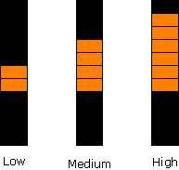
Sensitivity Display
Pictorially, both left and right bars show one of the following:

Ignition: upon ignition, sensitivity is displayed until the bus wheels begin to move. The imminent warning sounds loop 3 times.

Change of setting: upon change of setting, sensitivity is displayed for: [1 second + (9 seconds OR wheels move)] OR [sensitivity control changed].

Demonstration: if the wheels are not moving and no stimulus has been issued in the last 30 seconds, the operator can enter demonstration mode by pressing and holding the override button for 1 second. Sensitivity will be displayed and the warning sounds looped until the override button is pressed or the bus wheels move. Operators can enter this mode to receive feedback while changing LED brightness and volume.

Future modifications to this specification
Additional driver input has the potential to modify the design presented here. The continued involvement of the drivers in the design process is essential to the eventual acceptance of the deployed prototypes. Specifically, as the PATH FCWS system is further developed we are investigating giving the operator the option of either visual or auditory alerts or imminent warnings.

FCWS / SCWS Interface

FCWS / SCWS Computer Hardware Interface
A serial port serves as the link of the between the FCWS and SCWS systems.
Figure 11 - Interface between the FCWS and SCWS engineering computers

9.2 FCWS / SCWS Computer interface Data Format / Protocol

9.2.1 Header (Bidirectional)
Each message will consist of a header, data and checksum values. The header will consist of a four integer sequence of 0x99, 0x44, 0x22, 0x66 followed by the message ID and the message length.

Timestamp
A time stamp is added in each message having the format of hour/minute/second/millisecond.

Warning messages (Bidirectional)
The warnings that are generated by each of the CWS systems are passed to the other system for use in post processing. The formats for each direction are shown below:
(1) FCWS warning message format
Figure 12 FCWS Warning message format
(Section 1 (active low) is the top LED; section 7 is the bottom LED)

(2) SCWS warning message format

Bit | Description
 | Right/Left | Front/Rear | Sensitivity | Title
0 | Right | Front | Low | Alert
1 | Right | Front | Low | Imminent
2 | Right | Front | Medium | Alert
3 | Right | Front | Medium | Imminent
4 | Right | Front | High | Alert
5 | Right | Front | High | Imminent
6 | Right | Rear | Low | Alert
7 | Right | Rear | Low | Imminent
8 | Right | Rear | Medium | Alert
9 | Right | Rear | Medium | Imminent
10 | Right | Rear | High | Alert
11 | Right | Rear | High | Imminent
12 | Left | Front | Low | Alert
13 | Left | Front | Low | Imminent
14 | Left | Front | Medium | Alert
15 | Left | Front | Medium | Imminent
16 | Left | Front | High | Alert
17 | Left | Front | High | Imminent
18 | Left | Rear | Low | Alert
19 | Left | Rear | Low | Imminent
20 | Left | Rear | Medium | Alert
21 | Left | Rear | Medium | Imminent
22 | Left | Rear | High | Alert
23 | Left | Rear | High | Imminent
24 | Right |  |  | Contact
25 | Left |  |  | Contact
26 | Right |  |  | Under Bus
27 | Left |  |  | Under Bus
28-31 |  |  |  | Spare
Table 6 SCWS warning message format

Objects (Bidirectional)
Objects crossing the boundaries between the Frontal and Side CWS coverage areas are communicated to the other CWS ahead of time to aid in tracking, classification and for early warning. The coordinate systems for the FCWS generated data are defined in Error: Reference source not found. The coordinate systems for the SCWS generated data are defined in Error: Reference source not found. The parameters for these objects are:
Left object location – Location (x_{o},y_{o} for SCWS and x, z for FCWS) of the object relative to each CWS as defined in the above figures. The units are in centimeters. All ones in this integer will indicate no object present.
Left object heading – Heading (θ_{o}) of the object relative to each CWS at the current time. The units are in tenths of degrees
Left object speed – Speed (s_{o}) of the object relative to each CWS. The units are in cm / sec.
Right object location– as shown above
Right object heading – as shown above
Right object speed – as shown above
Frontal object location– as shown above
Frontal object heading – as shown above
Frontal object speed – as shown above

Curb information (CMU to PATH)
(1) Curb Location in front of the bus
The position of the curb in front of the bus is determined by CMU using a video camera on the right side of the bus in order to determine sidewalk boundaries. The position is passed using five (x, y) points to approximate the curb position. The units are in centimeters and relative to the mid point of the rear axle.
(2) Current Curb Location
The current position of the curb is measured by CMU with the use of the laser striper in the front bumper. The units are in centimeters and relative to the mid point of the rear axle.

Sound variables
(1) Sound Index (PATH to CMU)
The sound index is an index of four possible wav files that should be played through the Driver Vehicle Interface. This is a value from 0 to 3. Sound will not be a part of the initial evaluation, but this value is used as a placeholder to allow the possibility of generating audio warnings to the Driver.
(2) Sound Bearing (PATH to CMU)
The sound bearing acts as a balance control for the left and right DVI speakers. The value is between 0 and 180 degrees.

Host-bus information: Status

(1) Front Door Open / Closed
On the PAT Bus, this signal is read from the DINEXTM unit by CMU and passed to PATH. On the SamTrans Bus, PATH will read this signal via a switch on the door and pass it to CMU.

(2) Rear Door Open / Closed
On the PAT Bus, this signal is read from the DINEXTM unit by CMU and passed to PATH. On the SamTrans Bus, PATH will read this signal via a switch on the door and pass it to CMU.

(3) Right Turn Signal
On the PAT Bus, this signal is read from the DINEXTM unit by CMU and passed to PATH. On the SamTrans Bus, PATH will read this signal via a switch on the turn signal and pass it to CMU.

(4) Left Turn Signal
On the PAT Bus, this signal is read from the DINEXTM unit by CMU and passed to PATH. On the SamTrans Bus, PATH will read this signal via a switch on the signal and pass it to CMU.

(5) Hazard Lights
Hazard lights is a special case of the left and right turn signals in that it reflects the fact that both the left and the right turn signals are on at the same time.

(6) Power On (Bidirectional)
On the PAT Bus, the FCWS will monitor the ignition switch and the SCWS will monitor the DINEXTM output indicating the batteries charging condition. On the SamTrans Bus, the FCWS and the SCWS will both monitor the ignition switch. This message is broadcast to each computer as a redundant message to initiate system shutdown in case of hardware malfunction.

(7) Override Button (CMU to PATH)
The status of the override button on the Driver Interface Control Box is read by the SCWS and passed to the FCWS.

Checksum
The last byte of each message packet is the checksum which is a two’s complement of the sum of all of the prior bytes in the packet, including the header. The two’s complement is used so that if all of the bytes of the message packet are summed up including the checksum, the result will equal zero for a valid message.
Figure 13 FCWS to SCWS message (from PATH to CMU)
Figure 14 SCWS to FCWS message (from PATH to CMU)

9.3 FCWS-SCWS Synchronization
The FCWS and SCWS are synchronized by using the timestamps of communication messages between them.

