REPORT DOCUMENTATION PAGE |  |  |  | Form Approved  OMB No. 0704-0188
Public reporting burden for this collection of information is estimated to average 1 hour per response, including the time for reviewing instructions, searching existing data sources, gathering and maintaining the data needed, and completing and reviewing the collection of information. Send comments regarding this burden estimate or any other aspect of this collection of information, including suggestions for reducing this burden, to Washington Headquarters Services, Directorate for Information Operations and Reports, 1215 Jefferson Davis Highway, Suite 1204, Arlington, VA 22202-4302, and to the Office of Management and Budget, Paperwork Reduction Project (0704-0188), Washington, DC 20503.
1. AGENCY USE ONLY (Leave blank) |  | 2. REPORT DATE  December 2004 |  | 3. REPORT TYPE AND DATES COVERED  Final Research Report  April 2002 – March 2004
4. TITLE AND SUBTITLE  Transit Bus Collision Warning System: Integrated Transit Collision Warning Systems Interface Control Document |  |  |  |  | 5. FUNDING NUMBERS  Federal ID # 250969449000
6. AUTHOR(S)
University of California PATH, Carnegie Mellon University Robotics Institute
7. PERFORMING ORGANIZATION NAME(S) AND ADDRESS(ES)  University of California PATH Carnegie Mellon University Robotics Institute  5000 Forbes Ave  Pittsburgh, PA 15213 |  |  |  |  | 8. PERFORMING ORGANIZATION REPORT NUMBER
9. SPONSORING/MONITORING AGENCY NAME(S) AND ADDRESS(ES)  U.S. Department of Transportation, Federal Transit Administration  400 Seventh Street, S. W.  Washington, D. C. 20590 |  |  |  |  | 10. SPONSORING/MONITORING  AGENCY REPORT NUMBER  FHWA-JPO-04-097  FTA-
11. SUPPLEMENTARY NOTES

12a. DISTRIBUTION/AVAILABILITY STATEMENT -- Available from the National Technical Information Service/NTIS, Springfield, Virginia, 22161. Phone 703.605.6000, Fax 703.605.6900, Email [orders@ntis.fedworld.gov] |  |  |  |  | 12b. DISTRIBUTION CODE
13. ABSTRACT (Maximum 200 words)

The Integrated collision warning system (ICWS) is to predict imminent potential crashes, or collisions with objects and warn the transit operator. The goal of the ICWS program is to integrate the advanced frontal and side collision warning systems into a integrated collision warning system with a Driver Vehicle Interface (DVI) that can effectively display warnings from both frontal and side collision warning system, signaling the driver in a manner that is effective in avoiding potential accidents. Under this program, a functional transit ICWS was developed. This Interface Control Document (ICD) was to define the architecture of the Integrated Collision Warning System (ICWS) and the physical, electrical and electronic interface among different components. This is the final document for the installation of the Integrated Collision Warning System on a transit bus.

14. SUBJECT TERMS  ICWS, Collision Warning, Transit bus safety |  |  |  |  |  | 15. NUMBER OF PAGES
 |  |  |  |  |  | 16. PRICE CODE
17. SECURITY CLASSIFICATION  OF REPORT  Unclassified | 18. SECURITY CLASSIFICATION  OF THIS PAGE  Unclassified |  | 19. SECURITY CLASSIFICATION  OF ABSTRACT  Unclassified |  |  | 20. LIMITATION OF ABSTRACT

NSN 7540-01-280-5500 Standard Form 298 (Rev. 2-89)
Prescribed by ANSI Std. 239-18298-102

Transit Bus Collision Warning Systems:
Integrated Collision Warning System
Interface Control Document

December 2004

Prepared by:

Carnegie Mellon University  Robotics Institute  5000 Forbes Ave  Pittsburgh, PA 15213 | University of California at Berkeley  PATH Program  1357 South 46th Street  Richmond, CA 94804

Prepared for:

U.S. Department of Transportation
Federal Transit Administration
Washington, DC 20590

Report Number:
FHWA-JPO-04-097
Disclaimer Notice

NOTICE

This document is disseminated under the sponsorship of the U.S. Department of Transportation in the interest of information exchange. The United States Government assumes no liability for its contents or use thereof.

The United States Government does not endorse products of manufacturers. Trade or manufacturers’ names appear herein solely because they are considered essential to the objective of this report.

Integrated Collision Warning System
Interface Control Document

1. Introduction 4
2. System Architecture 5
3. Mechanical 7
3.1. Computer enclosure layouts 7
3.1.1. Electronics power conditioning and power supplies 7
3.1.2. Sensor power conditioning and power supplies 8
3.1.3. Power up and shutdown circuitry 8
3.2. Sensor mounting 9
3.2.1. FCWS object sensors 9
3.2.2. FCWS cameras 11
3.2.3. FCWS Host-bus sensors 11
3.2.4. SCWS Sensor Layout 12
3.2.5. SCWS object sensors 12
3.2.6. SCWS cameras 13
3.2.7. SCWS Host-bus sensors 14
3.3. Driver Vehicle Interface 14
3.4. Sensors Field of View 15
3.5. Cable routing 16
4. Power 17
4.1. Power Allocation by Subsystems 17
4.1.1. Electronics Enclosure 17
4.1.2. Sensors 17
4.1.3. DVI 18
4.2. Power Conditioning 18
4.3. Grounding Scheme 18
4.4. Maximum Power 19
5. FCWS Engineering Computer 20
5.1. FCWS Digital signals 21
5.1.1. Digital Inputs from subject vehicle sensors 21
5.1.2. FCWS digital output 21
5.2. FCWS Analog Signals 21
5.3. FCWS Sensor interface, parameters and format 22
6. SCWS Engineering Computers 22
6.1. SCWS Sensor interface, parameters and format 24
6.2. SCWS Bus coordinate reference frame and translation 24
6.3. SCWS Host Bus Interfaces 25
6.3.1. DINEXTM Data (PAT Bus only) 25
6.3.2. J1939 / J1708 Data 26
6.3.3. SCWS IMU 26
7. Video Recorder 27
7.1. FCWS Video Recorder Hardware 27
7.1.1. Cameras of FCWS 27
7.1.2. Synchronization 27
7.2. SCWS Video Recorder Hardware 28
7.2.1. Cameras of SCWS 28
7.2.2. Synchronization 28
8. Human-machine interface, parameters and format 29
8.1. Warning Levels 29
8.2. Hardware Architecture 29
8.3. Driver Interface Control Box 30
8.4. Driver Vehicle Interface 31
8.5. Forward Component 31
8.6. Side component 32
8.7. Timing 33
8.8. Displaying current sensitivity setting 33
8.9. Future modifications to this specification 34
9. FCWS / SCWS Interface 35
9.1. FCWS / SCWS Computer Hardware Interface 35
9.2. FCWS / SCWS Computer interface Data Format / Protocol 35
9.2.1. Header (Bidirectional) 35
9.2.2. Timestamp 35
9.2.3. Warning messages (Bidirectional) 35
9.2.4. Objects (Bidirectional) 36
9.2.5. Curb information (CMU to PATH) 37
9.2.6. Sound variables 37
9.2.7. Host-bus information: Status 38
9.2.8. Checksum 39
9.3. FCWS-SCWS Synchronization 40

Acknowledgements
This report presents the results of a research effort undertaken by the Carnegie Mellon University Robotics Institute and the University of California at Berkeley PATH Program under funding provided by the Federal Transit Administration under Federal ID # 250969449000. The direction of Brian Cronin is gratefully acknowledged.

Special thanks are also due to the state transportation agencies for providing additional funding and contractual assistance. Specifically, the California Department of Transportation (CalTrans) and the Pennsylvania Department of Transportation (PennDOT) were instrumental in the progress of this work.

Also this work would not have been possible without the cooperation of the local transit agencies. Specifically, the Port Authority of Allegheny County (PAT) and the San Mateo County Transit District (Samtrans).

Introduction
This document was created for the integrated collision warning system developed under the joint research program sponsored by a partnership of California and Pennsylvania teams under the Department of Transportation Federal Transit Administration Intelligent Vehicle Initiative program. The purpose of this Interface Control Document (ICD) was to define the architecture of the Integrated Collision Warning System (ICWS) and the physical, electrical and electronic interface among different components.
This is the final document for the installation of the Integrated Collision Warning System on a transit bus.

System Architecture
shows the architecture of the Integrated Collision Warning System (ICWS). The Frontal Collision Warning System (FCWS) and the Side Collision Warning System (SCWS) are integrated at the higher level. Each system has its own power adapters, host-bus sensors, obstacle sensors, video cameras, video combiners, video recorders and engineering computers. The three engineering computers, which are executing the warning algorithms, are integrated together through a FCWS-SCWS talk link. Messages are exchanged through this link. The integrated DVI will display the warnings from both the FCWS and the SCWS. The two systems are synchronized offline through the use of time tagged data.
This document describes the interface between the FCWS and the SCWS, and the interface between the collision warning systems and the host bus.
Figure 1 - System Architecture
For convenience, the following abbreviations are used in the description of FCWS-related items.

F- | Frontal-looking or frontal
D- | Driver-side-looking or driver-side
P- | Passenger-side-looking or passenger-side
I- | Interior-looking
LIDAR | Laser scanning radar
RADAR | Micro-wave radar
CAM | Camera

For example, F-CAM represents “frontal-looking camera”, and D-RADAR means “driver-side micro-wave radar”.

Mechanical

Computer enclosure layouts
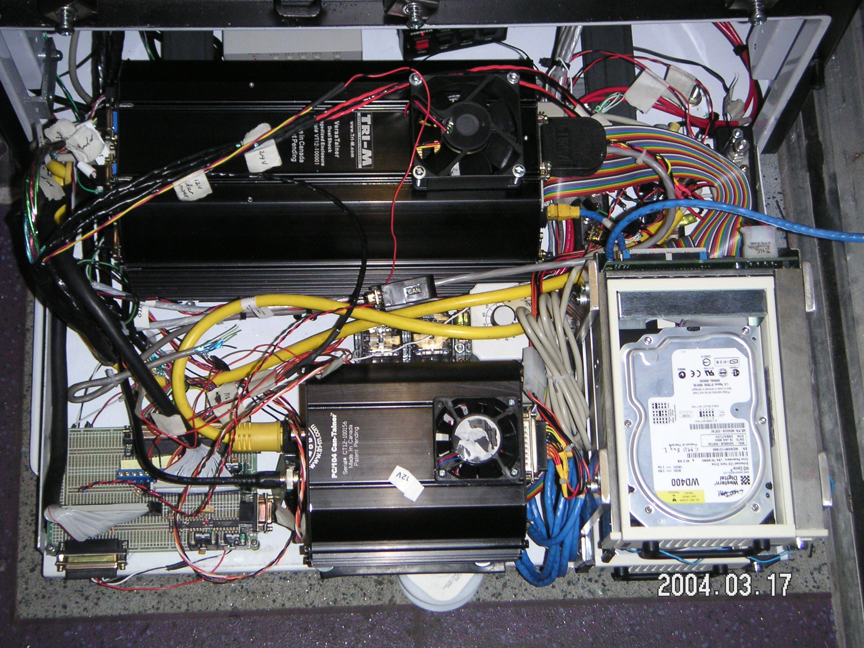
Figure 2 shows the layout of the FCWS computer enclosure of the integrated system on SamTrans bus 601. There are two PC104 computers (one is the FCWS engineering computer, the other is the FCWS video recorder), electronics circuits including power adapters, bus power bars, cable connectors and other circuit boards.
Figure 2 – Frontal portion of the computer enclosure on the bus (top view)

Figure 3 shows the layout of the SCWS computer enclosure.
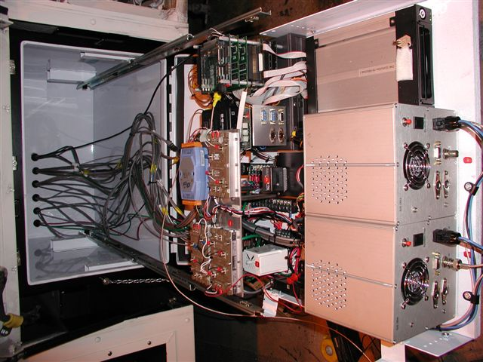
Figure 3 – Side portion of the computer enclosure on the bus (top view)

Electronics power conditioning and power supplies
The master power supplies come from the bus batteries. They are connected to the 12V/ 24V bus bars by two relays. Power supplies (the 12V/24V bus bars) are located in the computer enclosure. Bypass capacitors are put on the bus bars to reduce the crosstalk among various electronics powers.

Sensor power conditioning and power supplies
All sensor power supplies, except for the driver control input power supply, which is in the driver box, are from the 12V bus bars, or provided by power adapters (transformers and converters) inside the computer enclosure. Bypass capacitors are put at the output of the power adapters to reduce the power noise.

Power up and shutdown circuitry

FCWS Power up and shutdown circuitry
Two relays control the master power supplies: one is the master relay; the other is a time-delay relay. After ignition is on/off, the master relay turns the switch on/off. The switch will trigger the time-delay relay counter. Once the counter reaches a preset value, the time-delay relay will turn on/off the 12V and 24V bus bars. The purpose of the time-delay is to avoid noise-triggered false on/off of power supplies, and give some additional time to the computers to save files before exiting the program after the ignition is off. The master relay on/off signal is sent to the engineering computers to indicate the ignition operation.

SCWS Power up and shutdown Circuitry
Power up time delays and shutdown circuitry is located inside the computer enclosure.
Power up on the PAT Bus is determined by using a signal that the DINEXTM outputs to control power to the electronics. This DINEXTM signal is output when the ignition is turned on and the batteries are being charged. The power down signal is controlled by a time delay relay which is activated when the ignition is turn off.
Power up / down on the SamTrans Bus is determined by using the ignition on / off switch through time delay relays.

Sensor mounting

FCWS object sensors
Figure 4 shows the layout of FCWS object sensors and video cameras as well as the SCWS Curb Detector on the front face of SamTrans bus 601. The positions of each sensor/camera are measured in a FCWS reference frame. The frame is originated on the ground under the center point of the frontal bumper with positive directions of x-, y- and z- axes pointing to driver-side, upward, forward respectively.

Figure 4 Layout of FCWS sensors, cameras, HMI and SCWS curb detector
The numbers that are given in the following tables are the sensor positions of the FCWS on the SamTrans bus 601 and PAT bus 1560.
Sensor/Parameter |  |  | Host bus/Value
Description | Parameter | Bus 601
F-LIDAR | X (lateral, mm) | 768
F-LIDAR | Y(vertical to ground, mm) | 445
F-LIDAR | Z(longitudinal to frontal face of the bumper, mm) | -25
F-LIDAR | Angle (°) | 0
D-LIDAR | X (lateral, mm) | 1150
D-LIDAR | Y(vertical to ground, mm) | 435
D-LIDAR | Z(longitudinal to frontal face of the bumper, mm) | -38
D-LIDAR | Angle (° to the left) | 20
P-LIDAR | X (lateral, mm) | -1180
P-LIDAR | Y(vertical to ground, mm) | 445
P-LIDAR | Z(longitudinal to frontal face of the bumper, mm) | -76
P-LIDAR | Angle (° to the right) | 20
D-RADAR | X (lateral, mm) | 965
D-RADAR | Y(vertical to ground, mm) | 445
D-RADAR | Z(longitudinal to frontal face of the bumper, mm) | -51
D-RADAR | Angle (°) | 0
P-RADAR | X (lateral, mm) | -965
P-RADAR | Y(vertical to ground, mm) | 440
P-RADAR | Z(longitudinal to frontal face of the bumper, mm) | -51
P-RADAR | Angle (°) | 0
Description | Parameter | PAT bus
F- LIDAR | X (lateral, mm) | 820
F- LIDAR | Y(vertical to ground, mm) | 483
F- LIDAR | Z(longitudinal to frontal face of the bumper, mm) | -16
F- LIDAR | Angle (°) | 0
D-RADAR | X (lateral, mm) | 975
D-RADAR | Y(vertical to ground, mm) | 483
D-RADAR | Z(longitudinal to frontal face of the bumper, mm) | -48
D-RADAR | Angle (°) | 0
P-RADAR | X (lateral, mm) | -950
P-RADAR | Y(vertical to ground, mm) | 483
P-RADAR | Z(longitudinal to frontal face of the bumper, mm) | -48
P-RADAR | Angle (°) | 0
Table 1 - Location and orientation of obstacle detection sensors
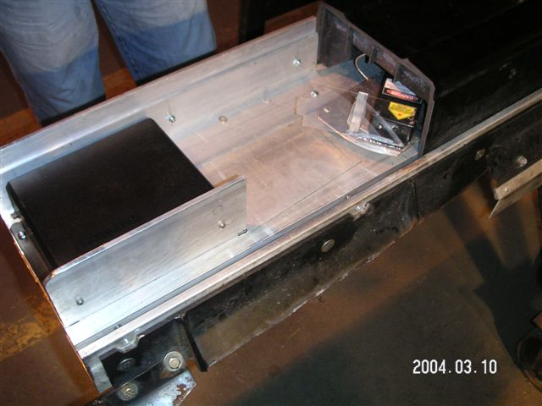
The right side of the front bumper below shows the current location of the FCWS radar and SCWS curb sensors.

FCWS cameras

Camera  (Bus 601) | X(m) | Y(m) | Z(m)
P-CAM | -0.60 | 2.59 | 0.27
F-CAM | 0.93 | 2.69 | -0.13
D-CAM | 0.95 | 2.69 | -0.26
Table 2 Camera locations on BUS 601

3.2.3 FCWS Host-bus sensors
As to the integrated system on SamTrans bus 601, serial converters for Lidars are mounted in a waterproof enclosure on the rear surface of the front bumper. Serial converters for radars are inside the computer enclosure. Vehicle speed is measured by listening to the vehicle’s SAE J1939 (J1708 on PAT bus) data bus and also by tapping off of an analog speed signal directly from the transmission. This speed signal from the transmission is filtered and conditioned by an electronic circuit. The rate gyro is mounted in a waterproof enclosure on the underside of the bus floor near the rear axle. Brake pressure is measured using a pressure transducer mounted on a spare port of the air brake system under the floor of the driving area. A proximity sensor is mounted near a universal joint on the drive shaft. This transducer is used to determine if the bus is moving at speeds lower than 2-3 miles per hour. Turn signal activation and backing light status is recorded by tapping off the existing turn signal circuit and backing lights. Windshield wiper activation is determined with a proximity sensor mounted on the windshield wiper mechanism. The GPS antenna is mounted on the rear of roof near the exhaust for the HVAC, the GPS computer is mounted in a waterproof enclosure near the HVAC evaporator unit in the rear of the bus. The GPS and CDPD modem antenna are mounted on the rear of roof near the exhaust for the HVAC, the GPS and CDPD modem computers are mounted in a waterproof enclosure near the HVAC evaporator unit in the rear of the bus.

SCWS Sensor Layout
Figure 5 and Figure 6 show the layout of SCWS object sensors and video cameras on the right and left sides of the bus. Descriptions of each are included in the sections below.
Camera looking towards front
Camera looking towards rear
Scanner
Curb Tracker
Front of Bus
Figure 5 - Right Side Collision Warning System Sensor Layout
Front of Bus
Scanner
Camera looking towards front
Camera looking towards rear
Figure 6 - Right Side Collision Warning System Sensor Layout

SCWS object sensors
The SCWS object sensors consist of a SICK laser scanner mounted on the left and right sides of the transit bus and a curb detector mounted in the right side of the front bumper. The SICK laser scanners sit approximately 24 inches above the ground.
The Curb Detector is mounted in the front bumper as shown. Integrating the Frontal and Side CWS sensors in the front bumper required a layout that ensured the FCWS Lidars and SCWS Curb Detector would not interfere with each other mechanically as well as not occlude each other.
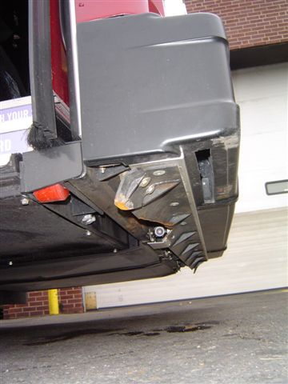
Figure 7 The underside of the front bumper is shown with the laser (blue arrow).and camera (red arrow) of the curb detector visible

SCWS cameras
Four video cameras are installed on the transit bus in positions shown in Figure 5 and Figure 6. The camera mount is shown in the photo below.
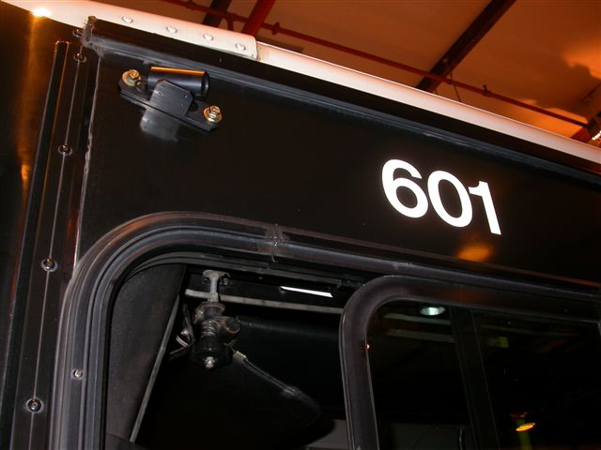
Camera
Figure 8 - Left Side Camera on SamTrans Bus 601

SCWS Host-bus sensors
The SCWS will tie into the existing electronic infrastructure of the bus through the J1939 / J1708 interface and the DINEXTM interface when available. In addition a yaw rate accelerometer is mounted within the electronics area. The SCWS also duplicates the interfaces to two of the sensors used for the FCWS. These are the odometry and creep sensors.

Driver Vehicle Interface
The main components of the DVI are two LED assemblies – one on the left-hand A-pillar and the other on the center pillar. Both assemblies are constructed identically, with 7 LED segments filling the top and 2 LED segments filling the bottom (see Figure 9)
All LEDs in the displays have the capability to be either amber or red (2-color on demand). The forward LEDs are 3 x 2 cm and the rear LEDs are 3 x 3 cm with a diamond mask. The total assembly dimension is 4 x 22 cm. The positioning of the side LEDs below the forward ones was done to match the spatial representation of the driver with respect to the threat. In this pattern, the driver “sits” between the bottom forward LED and the top side LED diamond. The LED’s have a maximum luminance intensity of 90/60 mcd and a viewing angle of 100 degrees. The display should be covered with a diffusion lens that has a privacy coating to reduce passenger observation.
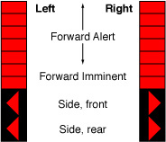
Figure 9 DVI

Sensors Field of View
The farthest detectable range for the FCWS in the same lane is 100m (330ft). The closest detectable range in the same lane is no greater than 3m (10ft). The maximum detectable side-looking angle from the front bus corners is 30 degrees on SamTrans bus 601 and 20 degrees on PAT bus. The detectable lateral position for the forward sensors is over 6m (20ft). The side looking sensors will closely track objects that are within 3m of the bus however, objects will be detected as far as 50 meters away. (This whole section is confusing. We should clearly distinguish between the actual field of view of the sensors and the areas of interest. We should also state how we come up with the areas of interest. In the SCWS it is just a good guess and subject to modification.
Figure 10 Integrated system spatial coverage on SamTrans 601 and PAT bus

3.5 Cable routing
Cables are run from the computer enclosures to various locations on the vehicle. Each cable passes through a water tight fitting through the wall of the enclosures. Each cable is jacketed with plastic split loom of the appropriate size to protect the cable. Most cables run along the frame rail, either to the front or rear of the bus. The cable is secured to the frame/bus via plastic cable ties. Each cable is then either routed to another enclosure or terminated with a connector.

