Transit Rail Advisory Committee for Safety (TRACS) Meeting
Wednesday, April 27-28, 2011
Four Points Sheraton,
1201 K Street NW
Washington, D.C. 20005

Table of Contents
Attendance 2
Proceedings 3
Welcome/Introductions 3
Working Group 10-01 Draft Letter Report 4
Committee General Comments 7
Comments on Recommendations 8
Working Group 10-02 Draft Letter Report 10
Committee Comments on Essential Functions and Attributes 12
Review of Recommendations 15
Committee Vote on WG-01 and WG-02 Proposed Letter Report Recommendations 17
Briefings 24
Brief, FTA’s Proposed Certification and Training Curriculum for Rail Transit, Ruth Lyons, FTA 24
Brief, Overview of FRA’s Close-Call Reporting System, Jordan Multer, Volpe 24
Brief, Rx/OTC Study, Jerry Powers, FTA 24
Public Comment 24

Attendance

TRACS Members

William Bates, Amtrak and United Transportation Union
Eric Cheng, Utah Department of Transportation
Richard W. Clark, California Public Utilities Commission
Diane Davidson (Acting Chair), Oakridge National Laboratory
James M. Dougherty, Washington Metropolitan Area Transit Authority
Bernadette Fowlkes-Bridges, Maryland Transit Administration
David Genova, Regional Transportation District
Georgetta Gregory, Metropolitan Atlanta Rapid Transit Authority
William P. Grizard (Team Lead Working Group 10-01), American Public Transportation Association
Leonard Hardy, Bay Area Rapid Transit
Henry Hartberg, Dallas Area Rapid Transit
Rich Inclima, Brotherhood of Maintenance of Way Employees Division
Jackie Jeter, Amalgamated Transit Union
Linda Kleinbaum, Metropolitan Transit Authority
Amy Kovalan, Chicago Transit Authority
Richard Krisak, Metropolitan Atlanta Transportation Rapid Transit Agency
Tamara Lesh, Tri-County Metropolitan Transportation District (Tri-Met)
Pamela McCombe, Greater Cleveland Regional Transit Authority
Alvin Pearson, Memphis Area Transit Authority
Ed Watt, Transit Workers Union of America
Other Working Group Members
Matthew Basset (Acting Team Lead Working Group 10-02), Tri-State Oversight Commission
John Goodworth, Regional Transit Authority
Vijay Khawani, California Public Utilities Commission
David Morgan, New Jersey Department of Transportation
Gerald Ruggiero, Jacobs Engineering Group
FTA Representatives
Henrika Buchanan-Smith, Associate Administrator, Office of Program Management
Ruth Lyons, Transit Safety and Security Training Specialist
Levern McElveen, Senior Safety and Security Specialist
Jerry Powers, Acting Director, Office of Safety and Security
Peter Rogoff, Admisitrator
Bruce Walker, Acting Designated Federal Officer
Volpe Support Staff
Jeffrey Bryan, Facilitator
Aaron Jette, Notetaker

Proceedings

Welcome/Introductions

Facility Safety Brief
The meeting began with a safety brief by Mr. Jerry Powers, Acting Director, Office of Safety and Security, Federal Transit Administration (FTA).

Henrika Buchanan-Smith, Associate Administrator, Office of Program Management, FTA
Ms. Henrika Buchanan-Smith provided welcoming remarks. Ms. Buchanan-Smith explained that, while there have been significant changes to FTA’s Office of Safety and Security staff in recent months, safety remains a top priority. The FTA is pleased that the President has proposed doubling the budget of FTA. While the current political climate will make passage of the President’s proposed budget difficult, she remains hopeful that FTA will see an increase in its budget. She noted that the Administration has proposed funding for a FTA safety program and continues to assert that the FTA should have enhanced oversight of rail safety.

Working Group Member Introductions
The participants in the working groups briefly introduced themselves.

Peter Rogoff, Administrator, FTA
Administrator Rogoff welcomed the TRACS group and thanked the members for their hard work to date. He described proposed legislative efforts to grant FTA more enhanced regulatory authority over safety; noting the Senate Banking Committee unanimously passed a transit safety bill, though it was stopped by a hold placed by a Senator opposed to additional regulations. The Administration has asserted that they will propose a transit safety bill again for consideration.
The Administrator discussed two new tasks for TRACS to take on upon completion of the initial tasks that were distributed at the September 2010 meeting.
- Non-punitive reporting systems
This is an issue receiving a lot of attention right now, due to several high profile incidents of fatigue in air traffic controllers. The Federal Aviation Administration (FAA) believes that an uptick in reported operational errors by air traffic controllers being reported by the press is actually the result of the success of its non-punitive reporting system. All the eyes and ears of transit agency employees need to be able to report safety issues and there should be a feedback loop that ensures that the problem is addressed. The Administrator requests TRACS advice on how to model a non-punitive reporting system for the transit industry.
- Over-the-counter and prescription medications
The use of over-the-counter and prescription medications by operators and others in transit agencies has been raised as a factor in safety accidents by the National Transit Safety Board (NTSB) a number of times. How can FTA facilitate the establishment of systems in regional transit agencies (RTAs) that embody best practices as far as monitoring the use of medications by operators and making sure that those who should not be operating vehicles are not?

Questions and Answers
There were several questions. The Administrator explained that FTA has been examining the results of NTSB accident investigations and has found that prescription drug use is often correlated with major accidents. He also noted that FTA wants to identify the most effective reporting system model and encourage its dissemination as widely as possible. In response to questions, the Administrator said it would be up to TRACS to determine how the prescription drug initiative was distinct from fitness for duty issues and whether different forms of drug testing would be effective.
The Administrator noted that he has recommended to the Secretary that the 11 members whose current, one-year term is soon to expire be reappointed. He also wants to add new members from academia that can work on a number of transit topics. He would like recommendations from current TRACS members as to potential nominees.

Bruce Walker, Acting Designated Federal Officer, FTA
Bruce Walker reviewed the agenda for the day. Mr. Walker noted that FTA is already beginning to develop new tasks for TRACS based on the preliminary results.

Diane Davidson, ActingTRACS Chair
Diane Davidson welcomed the members and stated that her goal is to achieve consensus on the reports that will be discussed during the meeting. She also noted that there will be an option to make minority recommendations if consensus cannot be achieved. There will be a vote on the recommendations at the conclusion of the proceedings.

Jeffrey Bryan, TRACS Facilitator
Jeffery Bryan reviewed the formal and informal ground rules to be observed by discussion participants. Informal ground rules include: you don’t need to agree, but everyone’s comments are valid; and don’t sit on your good stuff. He reiterated that there will be a formal up or down vote on the recommendations by the end of this meeting. TRACS members will have three options: 1) Approve the report with minor edits; 2) Request further editing of the document prior to approval; or 3) Develop a minority report.

Working Group 10-01 Draft Letter Report
William Grizard, Team Lead, presented the work of Working Group 10-01 (WG1). WG1’s task was to develop advice on the best safety management model, incorporating safety management system (SMS) and high reliability organization (HRO) principles. WG1 began in October 2010 by reviewing relevant safety management literature. They tried to understand the essence of SMS and HRO principles developed for different high risk industries and translate them into a transit environment. WG1 identified three major areas under which SMS and HRO principles could be organized (see figure below).
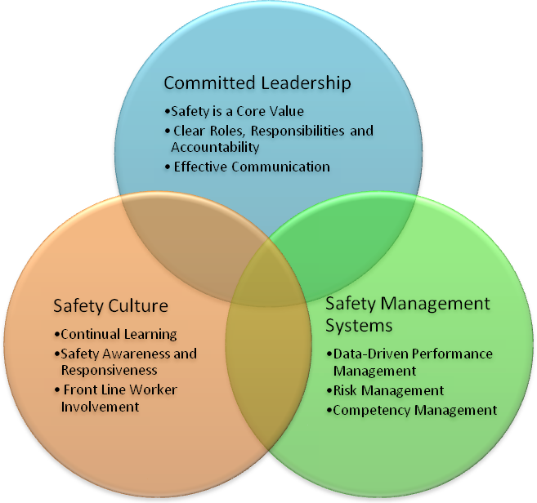
Figure 1. Components of High Safety Management Performance in Transit Agencies
WG1 developed a safety maturity model (see Figure 2 below) that is intended to explain how an organization can move along a path of improvement. They adapted this model from a number of different resources and it is similar to other maturity models. At the basic level, an organization must be responsive to incidents and meet regulatory requirements. WG1 integrated the principles of CFR 659 into the maturity model. The model then adds safety culture elements, leadership and management elements, and additional safety elements.

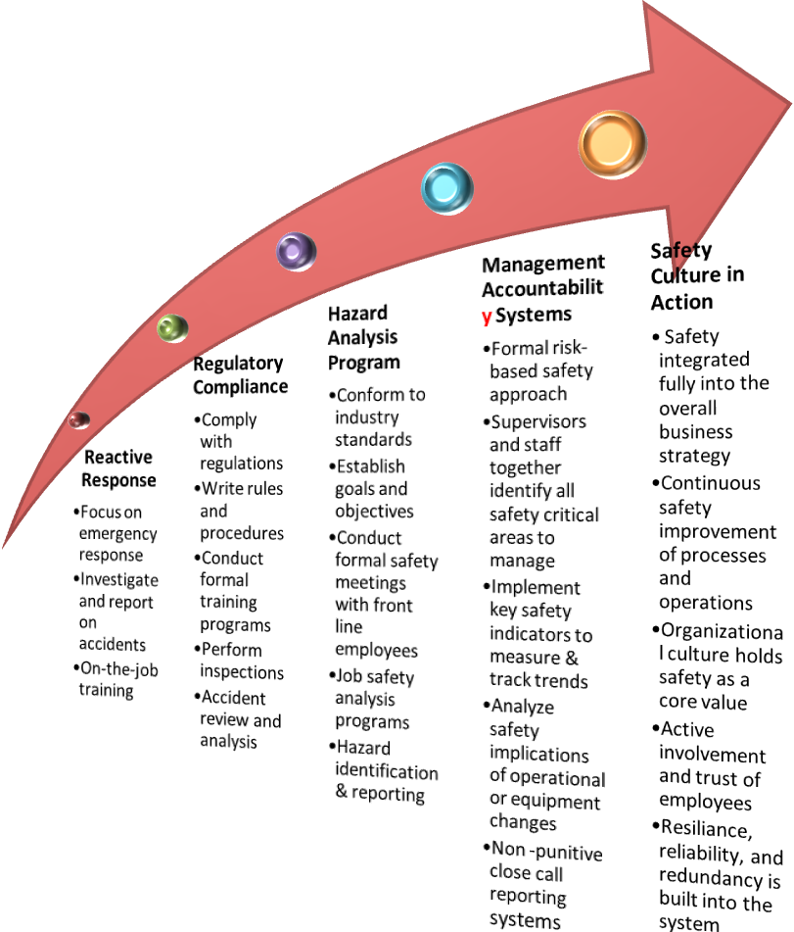
Figure 2. Safety Management Maturity Model
WG1 developed nine recommendations for FTA. It is important to understand, though, that the entire report is a recommendation to the industry. The following nine recommendations are actionable items that the administrator can take.
- Identify and disseminate guidance on leading indicators of safety.
- Conduct a confidential assessment to establish a national baseline of transit agencies’ safety climate.
- Develop safety culture maturity model.
- Create a guidance manual on safety practices and principles including those highlighted in this report.
- Support external executive leadership training and coaching on safety.
- Recognize good safety performance and the establishment of innovative practices by transit agencies.
- Pilot an anonymous close-call/near-miss non-punitive reporting system.
- Promote hazard identification and resolution for operations and maintenance.
- Evaluate implementation of these recommendations after 5 years and consider appropriate adjustments to 49CFR Part 659.

Committee General Comments
James Dougherty noted that at Washington Metropolitan Area Transit Authority (WMATA) safety is a primary focus not just a core value. Mr. Bryan clarified that WG1 understood a core value to be something that was integrated into everything an organization did and that the difference was likely one of terminology rather than substance.
Vijay Khawani, disagreed with the recommendation of a five year review. He asserted that the shortcomings of Part 659 are already known and that the working group should encourage FTA to start revising CFR Part 659 immediately. Mr. Grizard explained that the working group decided not to recommend changes to existing regulation. The recommendations are designed to make the existing regulations more effective. Mr. Walker remarked that it would be premature to make recommendations for revising CFR Part 659 given that there is the potential for legislation regarding FTA’s safety regulatory authority.
Richard Clark asked if there were particular references that the working group used. Mr. Grizard explained that while the references were not listed in the report, WG1 reviewed a number of documents. He suggested that the report could be revised to include a list of the key documents reviewed.
Henry Hartberg asked if the working group looked at the role of the State Safety Oversight (SSO). Mr. Grizard remarked that he was not sure if you could define a safety culture for a SSO and that is an issue better suited for Working Group 2.
Mr. Khawani noted that there is currently an effort underway by Department of City and Regional Planning at the University of North Carolina on safety culture. They are asking what is a safety culture and how can it be implemented.
Ed Watt commented that the phrase “these are the recommendations” belies the fact that the entire report is a recommendation to the transit industry. The sections on effective practices seem like good recommendations and the working group should ensure that it is clear that those practices should get passed on to the rail transit systems.

Labor Leadership References
Jackie Jeter observed that labor leadership is not mentioned explicitly in the report. She noted that labor leadership is an important stakeholder and should be fully represented in the document. Others, including John Goodworth and Eric Cheng, noted that several places in the draft document do mention labor. Mr. Grizard explained that WG1 tried hard to ensure that the document was not exclusionary and that the importance of front line workers is stressed throughout the document. Rick Inclima suggested that it would be appropriate to say explicitly where workers and there representatives have a role to play and other TRACs members agreed. Mr. Watt noted that in the working group’s discussion there was continuous mention of equal partnership, co-leading and co-teaching and that this should be reflected in the document. Mr. Grizard suggested that the section on safety leadership more clearly define the roles of management, labor and employees in creating a safety culture and others agreed.

Mindfulness vs. Vigilance
Mr. Clark raised the issue of mindfulness. Mindfulness is fundamental to safety culture. It means understanding the entire system that you are involved in and involves a reluctance to simplify. When failure happens in a system there is a frequent rush to simplify its causes. For example, initial conclusions are often that an accident was caused by “operator failure.” Actual causes are more complicated. Mr. Clark explained that he would like to see the concept of mindfulness incorporated into the Executive Summary.
Mr. Grizard disagreed. He said that he is uncomfortable with the term mindfulness because it is used in the transit industry as a synonym for cautiousness. Mindfulness is too passive. He thinks that, while in some cases mindfulness may be appropriate, the transit industry must be more active in identifying and addressing safety hazards and he believes that the term vigilance better portrays an active state.
Mr. Bryan explained that mindfulness denotes being alert, present and aware; like when one is driving. A person can’t be vigilant all the time. Vigilance means focusing on specific areas intently. Both are valid concepts.
Mr. Clark offered a compromise. The term ‘actively mindful’ could be used in the document.

Comments on Recommendations
- Identify and disseminate guidance on leading indicators of safety.
No Comments.
- Conduct a confidential assessment to establish a national baseline of transit agencies’ safety climate.
Linda Kleinbaum found this recommendation unclear. She wanted to know what was meant by a baseline assessment. Ms. Kleinbaum noted surveys can be expensive and that you can do an assessment without a survey. She was concerned that a survey would put a difficult burden on FTA.
Mr. Grizard explained that the intent of the recommendation was for FTA to develop a national perspective on the state of safety culture among transit agencies so that when agencies conduct self assessments they can see how they compare. Georgetta Gregory said she thought the intent was to recommend a major survey of all RTA employees every five years. She argued that a survey would be a more effective instrument than an assessment that resembled an audit. Several others, including Amy Kovalan, Mr. Cheng, Ms. Jeter, and Mr. Hartberg agreed. The benefit of a survey Mr. Cheng argued would be that it would allow an analysis of both labor and management perspectives and concerns. Mr. Cheng also noted that conducting an employee survey could be an indicator of a safety culture that could be included in Appendix A.
Jordan Multer of the Volpe Center explained that as part of his work developing a confidential close call system for FRA he developed a safety culture survey – one for labor and one for management. There are different survey instruments being used to assess safety culture, but this one is in the public domain.
Michael Flanigon, of the National Transportation Safety Board suggested that the group should not focus on the mechanism for conducting the assessment. It is more important to articulate the objectives than the means.
Mr. Inclima suggested adding a recommendation to assess the SSOs in Working Group 2’s report. Matthew Bassett explained that FTA currently has an established process for auditing SSOs on a triennial basis. SSOs go through a lot of effort to meet FTA’s data collection efforts. The audit program probably covers most of the aspects of safety culture at SSOs. Mr. Hartberg did not agree that an audit program was sufficient.
- Develop safety culture maturity model.
No comments.
- Create a guidance manual on safety practices and principles including those highlighted in this report.
No comments.
- Support external executive leadership training and coaching on safety.
John Goodworth wanted to see the word “commitment” inserted into the text of the recommendation. Mr. Inclima said that this would be a place where we should also add in union leadership. Bernadette Fowlkes-Bridges and Mr. Watt agreed. Ms. Gregory added that the group should go through all of these recommendations and insert labor leadership where it is appropriate.
Alvin Pearson suggested that the term “shall be committed” would carry greater force. Ms. Gregory commented that these are recommendations to FTA not RTAs and that it would be inappropriate to use the term “shall be” for RTA managers.
- Recognize good safety performance and the establishment of innovative practices by transit agencies.
No comments.
- Pilot an anonymous close-call/near-miss non-punitive reporting system.
Ms. Kleinbaum noted that the document refers to ‘confidential’ whereas the recommendation refers to ‘anonymous,’ though the words are not synonymous. She suggested eliminating the word ‘pilot’. Mr. Watt said that the group intended to give people the choice between confidential and anonymous. Ms. Kleinbaum agreed that the language in the recommendation should be broadened.
- Promote hazard identification and resolution for operations and maintenance.
No comments.
- Evaluate implementation of these recommendations after 5 years and consider appropriate adjustments to 49CFR Part 659.
Ms. Davidson asked if five years was the appropriate amount of time to evaluate the recommendations? Mr. Inclima responded that five years was typical for evaluating a program. Mr. Cheng thought perhaps three years was more appropriate for some of the recommendations. Mr. Bassett suggested that evaluation of the recommendation did not need to be tied to 49CFR Part 659. Mr. Inclima agreed and suggested that the recommendation be broken into two parts, the first to evaluate the recommendations; the second to consider revise the regulatory code.

Working Group 10-02 Draft Letter Report
Mr. Basset, team lead for Working Group 10-02 (WG2), presented findings and recommendations. WG2’s task was to describe the characteristics of an effective SSO and create guidance for the oversight organizations and recommendations for the FTA Administrator. He commented that it was a challenge to reach a consensus in the group because there was a diversity of perspectives on a number of difficult issues. He thanked FTA and Volpe for supporting the group’s efforts.
WG2 identified the key functions and attributes of an effective SSO. The essential functions are: certification; audit and inspection; accident investigation; risk analysis and hazard management; enforcement; monitoring; program and capital project review; and safety advocacy. Key attributes are: independence; collaboration with transit agency leadership; legislative authority to enforce standards; sufficient staff and financial resources; and, clear and consistent requirements and procedures.
WG2 developed a model organizational structure (see below). The model does not describe specific personnel; rather it describes areas of expertise and the basic responsibilities that must be carried out. The model is intended to be scalable.
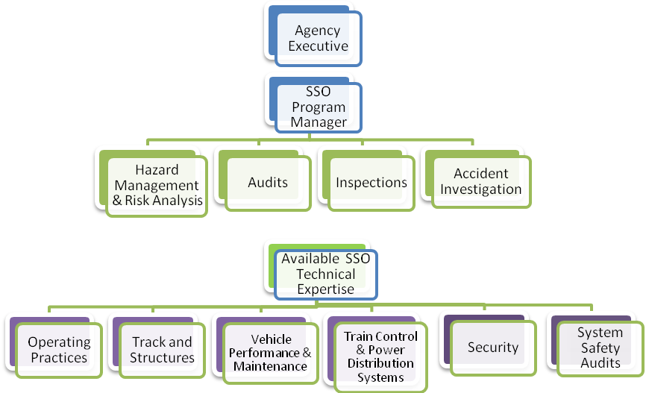
Figure 3. Functional organization structure for a SSO

Mr. Bassett then summarized WG2’s recommendations.
- FTA should be given authority to set minimum national standards (e.g., vehicle, track, signal, operations) for safety oversight of rail transit.
- FTA should ensure the enforcement authority of SSOs in their role as compliance agents.
- FTA should provide sufficient resources to support the adequate oversight and enforcement of federal transit safety regulations.
- FTA should support a due process mechanism (e.g., arbitration/mediation) for reviewing disputes between SSOs and RTAs on penalties and orders in the enforcement of federal transit safety regulations.
- FTA should conduct research and disseminate material on industry effective safety management system practices.
- FTA should encourage the establishment of measurable performance-based goals for passenger rail safety and provide tools, training and support that will assist SSOs and RTAs in performing performance-based safety management.
- FTA should reward RTAs for high safety performance through performance-based funding programs.
- FTA should continue to support both the RTAs in their continuous improvement of the state of good repair and the State of Good Repair Working Group to develop explicit guidelines.
- FTA should develop more explicit guidelines on the roles and responsibilities of SSOs and the minimum scope of their authority.
- FTA should establish consistent funding streams and guidelines for staffing and resource needs of small, medium and large SSOs.
- FTA should have the authority to establish minimum qualifications and certifications for SSO program managers and staff.
- FTA should expand the safety curriculum to include associated training that supports a robust culture of safety. FTA should support ongoing training in specific safety and security disciplines and provide funding so that all SSO staff can participate.
- FTA should continue to have an ongoing advisory committee composed of key stakeholders to evaluate the effectiveness and consistency of the FTA Safety Program.

Committee Comments on Essential Functions and Attributes

Accident Investigation
Regarding the accident investigation function, Mr. Cheng raised the issue of allowing SSOs to deputize RTAs with the responsibility for accident investigation. Mr. Basset explained that WG2 understands that it is not practical for all SSOs to conduct comprehensive accident investigations; however, WG2 believes that SSOs should have the capability to conduct an accident investigation if circumstances require. Mr. Goodworth noted that it was not the group’s intention to have SSOs take over the responsibilities for accident investigation.

Certification
Pamela McCombe asked if it was the intention of the group for SSOs to be involved in the review and certification of capital projects. Mr. Khawani explained that there are benefits to be gained from the SSO’s early involvement in the review of capital projects. SSOs can verify that safety standards are met, before expensive design changes are needed. Levern McElveen noted that FTA values the role SSOs play in the certification of New Starts projects. Richard Kristak commented that the SSO should be immersed as a team member in the development of capital projects, attending progress meetings on a regular basis and helping the RTA develop a capital program that addresses safety vulnerabilities.
Mr. Cheng warned that the certification process is very technical and small SSOs may lack the technical expertise and staff. Ms. Kleinbaum stated that the MTA has a huge capital program and it would be impossible for the SSOs to be involved in all of its projects. She suggested that the recommendation should be that FTA invite the SSOs to quarterly meetings. Ms. McCombe added that the SSOs shouldn’t duplicate FTA capital project oversight responsibilities for projects over $500 million. Mr. Khawani responded that he believes the SSOs need to be involved in all phases of capital project development, not just the quarterly meetings.

Risk Analysis and Hazard Management
Mr. Grizard asked if the SSOs should take on responsibilities of hazard management and risk analysis. Mr. Basset stated that the hazard management process is too large and integral a responsibility for the SSO to take on. Mr. Khawani stated that the SSOs should be familiar with RTA operations and operational risks. Leonard Hardy agreed that the SSO should be involved in the hazard management process but they shouldn’t assume the responsibility.
Tamara Lesh suggested that it could be a function of the SSOs to confirm that RTAs have SMS principles in place. Mr. Basset agreed.

Independence
Ms. Kovalan stated that she disagreed with the concept of independence as defined in the report. She does not believe that SSOs that are funding RTAs have a conflict of interest. By this logic, she pointed out, FTA would have a conflict of interest in regulating the safety of RTAs to which it provides grants. Serving as a funding agency, she asserted, provides an opportunity for SSOs and RTAs to engage in important discussions about safety priorities and resource needs.
Mr. Basset replied that WG2 was concerned that there were indeed conflicts of interest in models where the public agencies were responsible for both subsidizing and regulating an industry. He cited the current situation with the nuclear industry in Japan and the aviation industry in the United States in the past as examples of where conflicts of interest led to lax oversight on the part of the regulatory agency. He said that there should be a middle ground where internal safeguards, such as those recommended in the report, to allow funding decisions to be separated from oversight to a degree.
Ms. Gregory remarked that the real issue is not conflicts of interest, but rather the focus of SSO parent agencies (usually state departments of transportation (DOTs)) on highways rather than transit. It is a conflict of priorities not a conflict of interest that most impacts safety regulation.
Mr. Grizard suggested that one year is insufficient time to preclude former RTA employees from conducting oversight activities at the RTA in which they were previously employed. He suggested that conflict of interest policies define specific functions that former RTA employees could perform. Mr. Hardy agreed. Mr. Inclima noted that FRA has a similar policy. Ms. Gregory suggested that the conflict of interest policies described in the report be expanded to include contractors that work for SSOs as well as employees. Mr. Inclima agreed.
Mr. Basset objected. He noted that it is very difficult for SSOs to hire qualified employees and that it would be detrimental to unduly restrict the labor pool by setting a conflict of interest policy too broadly. Ms. Jeter expressed a similar concern. Ms. Gregory replied that if we believe that there are conflicts of interest we must say so. Gerald Ruggiero remarked that in Massachusetts a transit agency is notified if a former employee of that agency is going to perform oversight activities on their facilities.

Legislative Authority to Enforce Standards
Ms. McCombe suggested that some enforcement mechanisms, such as issuing subpoenas, could be at conflict with a collaborative relationship. It was not clear in the report, she said, when enforcement tools should be used. Mr. Clark responded that issuing subpoenas needed to be reserved as a method of last resort. Mr. Inclima commented that WG2 tried to identify the enforcement tools that should be at the SSOs disposal, but that these tools should only be used as a last resort.
Mr. Hardy commented that the proposed safety authority bill would allow FTA to withhold funding from a specific RTA. He believes this is a sufficient enforcement mechanism. Mr. Khawani said that the group discussed the capability of withholding funds from specific RTAs. The decision would have to be made by an independent arbitrator.
Mr. Dougherty remarked that it is important that there is due process and that the decision is made by an independent third party. Mr. Clark agreed that FTA shouldn’t be in the position of serving as an arbitrator. Mr. Hartberg remarked that he found it troubling that the report seemed apologetic about the use of fines. He was concerned that due process could lead to RTAs stonewalling.
Ms. Kleinbaum added that there should be a continuum of enforcement mechanisms. Ms. Gregory agreed. Ms. Gregory suggested that the recommendation be worded so that FTA is instructed to develop an enforcement schedule. She thought that one effective enforcement tool would be for FTA to tie funding for capacity building capital projects to a safety grade based on the RTA’s safety performance. Mr. Basset agreed. Ms. McCombe noted that state environmental agencies have adopted interesting approaches to enforcement and fines in particular, whereby a fine is reduced when compliance is achieved.
Mr. Dougherty stated that there are complications when a public agency is regulating another public agency fines. Without codified laws that define penalties, fines may be inappropriate. Mr. Bassett agreed that standards must be in place before there is stringent enforcement. Ms. Jeter said that there must be mechanisms for ensuring that RTAs comply with safety rules; however, withholding funding or issuing fines may reduce the RTA’s capacity to address safety issues. William Bates noted that fining individuals is a way to change individual behavior and can lead to cultural change.
Mr. Hardy stated that the points in this discussion are already well-represented in the text of the report, which says that you have to have enforcement, but it should be used as a last resort and there should be due process. Mr. Inclima said that WG2 never intended to get into the mechanisms for assessing fines. WG2 just wanted to be sure that there were both incentives and disincentives in place.

Review of Recommendations
- FTA should be given authority to set minimum national standards (e.g., vehicle, track, signal, operations) for safety oversight of rail transit.
Ms. Kleinbaum suggested that there should be a reference to existing standards like APTA’s. Mr. Clark suggested adding the word ‘states’, since states would be the ones enacting standards. Mr. Dougherty said it should be clear that there would be a codified set of rules before formal enforcement occurs. Mr. Grizard said it should be clear that our intention is not to target individual employees. These standards should not include civil penalties.
Ms. McCombe asked if the group contemplated design standards being included. Mr. Basset replied that design standards should not be excluded. Mr. Inclima noted that there are many inconsistencies across RTAs because there are no design standards. Ms. McCombe recommended that design standards be made explicit.
Mr. Inclima suggested clarifications to the language used regarding alternative standards.
- FTA should ensure the enforcement authority of SSOs in their role as compliance agents.
No comments.
- FTA should provide sufficient resources to support the adequate oversight and enforcement of federal transit safety regulations.
Ms. Gregory asked if WG2 came to a consensus regarding the use of contractors. Mr. Bryan clarified that the draft report states that contractors should not be given oversight responsibilities.
- FTA should support a due process mechanism (e.g., arbitration/mediation) for reviewing disputes between SSOs and RTAs on penalties and orders in the enforcement of federal transit safety regulations.
Ms. Kleinbaum suggested that this recommendation should be linked to the enforcement recommendation in the sequence of recommendations. Mr. Inclima suggested that the arbitrator or mediator should be a mutually agreed upon third party.
- FTA should conduct research and disseminate material on industry effective safety management system practices.
Ms. McCombe stated that this recommendation should apply to SSOs or it should be moved to WG1’s report. Mr. Bassett and Mr. Inclima agreed.
- FTA should encourage the establishment of measurable performance-based goals for passenger rail safety and provide tools, training and support that will assist SSOs and RTAs in performing performance-based safety management.
Ms. Gregory recommended that recommendations #5 and #6 should be more clearly tied to the body of the report. Mr. Basset suggested moving the recommendations to WG1’s report. Ms. Jeter noted that recommendation #6 could be linked to the upcoming TRACS task in terms of close call data collection.
- FTA should reward RTAs for high safety performance through performance-based funding programs.
See below.
- FTA should continue to support both the RTAs in their continuous improvement of the state of good repair and the State of Good Repair Working Group to develop explicit guidelines.
Mr. Bryan asked if this recommendation should be moved to WG1’s report as well. Mr. Grizard stated that the recommendation would need to be supported in the body of the text. Ms. Kovalan noted that collaboration between the SSO and SOGR must take place in the context of the State of Good Repair goal. Mr. Inclima said that this recommendation was included with the thinking that RTA’s should share information about the condition of the system with the SSO. Ms. Davidson stated that effective asset management system information should be provided to the SSOs.
Ms. Kleinbaum suggested that the WG2 strike language referring to specific technologies. Mr. Grizard suggested adding more detail regarding an asset management approach to this recommendation.
Mr. Basset noted that this recommendation is tied in some ways to recommendation #7. He asked, “are we trying to have our cake and eat it to?” We are saying that if the RTA performs well it should get more money, and if the RTA has more safety needs it should get more money. Mr. Inclima responded that, in an ideal world, if an agency was spending its money poorly, we wouldn’t reward them. Ms. Kleinbaum stated that FTA recognizes that the back log of deferred maintenance must be considered; the idea of incentives is separate. Ms. Gregory suggested that incentives for safety performance be linked to discretionary grants and capacity expansion projects. Mr. Goodworth recommended tying incentives to agencies that demonstrate dramatic improvements in safety or have a plan for a program that could lead to improvements in safety performance.
Mr. Bryan suggested that this could serve as an additional recommendation around incentives. Mr. Genova said that he was opposed to adding a recommendation. Ms. Kleinbaum agreed. Ms. Davidson suggested that the issue was clarifying the current recommendations. Mr. Basset noted that we agree that FTA should incentivize safety performance, the question is how. Perhaps, he suggested, we should leave this to FTA. Ms. Jeter suggested changing the word incentives to funding.
Ms. Kovalan suggested eliminating the second paragraph supporting this recommendation. Ms. Lesh agreed.
- FTA should develop more explicit guidelines on the roles and responsibilities of SSOs and the minimum scope of their authority.
No comment
- FTA should establish consistent funding streams and guidelines for staffing and resource needs of small, medium and large SSOs.
Ms. Gregory recommended combining this recommendation with recommendation #3.
- FTA should have the authority to establish minimum qualifications and certifications for SSO program managers and staff.
Ms. Gregory recommended adding a sentence regarding the development of an academic curriculum for higher education that focuses on the transit industry. Mr. Clark suggested adding language to clarify that SSO compensation should be equivalent to Federal employees as well as RTA employees.
- FTA should expand the safety curriculum to include associated training that supports a robust culture of safety. FTA should support ongoing training in specific safety and security disciplines and provide funding so that all SSO staff can participate.
Mr. Grizard noted that the American Public Transportation Association’s (APTA’s) position is that a transit academy that includes both technical and managerial aspects is needed. Mr. Khawani clarified that recommendations #11 and #12 apply to SSO staff. Mr. Grizard stated that safety knowledge is needed both at the RTA and the SSO. Mr. Inclima said that training for RTAs doesn’t fit with WG2’s task, but it is important. Ms. Kovalan said that recommendations #11 and #12 are about SSOs, the idea is that SSO employees should be certified and that FTA should provide training.
- FTA should continue to have an ongoing advisory committee composed of key stakeholders to evaluate the effectiveness and consistency of the FTA Safety Program.
No comment.

Committee Vote on WG-01 and WG-02 Proposed Letter Report Recommendations
Based on the discussion the recommendations were revised. Mr. Bryan suggested that the group vote on the revised recommendations (see below). Mr. Watt suggested that the vote should be preliminary and non-binding. Ms. Kleinbaum and Ms. Jeter agreed. The group made several minor revisions before voting. The preliminary non-binding vote was unanimously in favor of moving forward with the current recommendations. Ms. McCombe served as a proxy Mr. Hardy. Ms. Gregory served as a proxy for Mr. Krisak. Provision was made for a subsequent vote once the documents were finalized.

Revised Recommendations
The following is the full text of the recommendations submitted to a preliminary Committee vote at the end of the proceedings.

Working Group 1 Revised Recommendations
- Identify and disseminate guidance on leading indicators of safety.
FTA should identify meaningful safety performance measures that can help transit agencies assess their safety. The measures should be leading indicators that allow transit agencies to identify and address potential safety issues early on before they become critical. Safety culture measures can include the measurement of employee attitudes towards safety; organization hiring, training, and communication practices; and trends in root causes of near-misses, violations, or incidents (see examples of safety culture indicators in Appendix A). FTA should provide guidance on what indicators are most effective and how to implement those measures so that they are used to assess risks and adjust processes and practices.
- FTA should encourage the establishment of measureable performance based goals for passenger rail safety and provide tools, training and support that will assist SSOs and RTAs in performing performance-based safety management.
A performance-based approach needs to be established through the development and implementation of a Passenger Rail Safety Management System. SSO’s and FTA should establish continuous training, asset inventories and management, state of good repair, inspections, compliance, etc.) priorities. Consistent and reliable data on performance will be used to track success in meeting safety goals.
- Conduct a confidential assessment to establish a national baseline of transit agencies’ safety climate.
To be able to evaluate the effectiveness of its safety programs, FTA must establish a baseline understanding of the current safety climate at transit agencies. To do this, FTA should develop and implement a confidential assessment of transit agencies safety practices and culture and use the results to guide the development of its safety programs. The assessment should take into account both labor and management perspectives of the safety climate. Each transit agency should also include some of these elements of safety climate assessment in their internal audit program.
- Develop a safety culture maturity model.
Transit agencies clearly have distinct histories, attitudes and capabilities about safety practices and safety culture. A safety culture maturity model could help guide FTA in targeting and tailoring technical assistance and resources to diverse agencies by identifying characteristics of transit agency safety culture along a spectrum of maturity or formality. For example, safety practices could range from ad-hoc and informal to documented, practiced and ingrained. One advantage of a maturity model is that by defining incremental steps along a spectrum of capabilities, it can show a path towards improvement by which transit agencies set goals and measure progress.
- Create a guidance manual on safety practices and principles including those highlighted in this report.
A detailed guidance manual should serve as a reference and training guide to support transit agencies in their implementation of effective safety practices and principles. It should highlight effective practices, describe industry standards for safety management systems and inventory leading indicators of safety culture.
- Support external executive and labor leadership training and coaching on safety.
Given the critical role that management and union leadership plays in establishing and maintaining a safety culture in an agency, the FTA should support leadership training and coaching on safety. Transit agency leadership should understand the importance and value of safety to the organization and commit to the most effective leadership practices to ensure employee and customer safety.
- Recognize good safety performance and the establishment of innovative practices by transit agencies.
The FTA should recognize agencies with strong safety records and effective and innovative practices should be identified, documented, and disseminated. FTA can promote strong safety practices by identifying effective practices already in place among high performing safety organizations and promoting those activities among RTAs and SSOs.
- Implement a close-call/near-miss non-punitive reporting system.
By supporting the development of a close-call/near-miss non-punitive reporting system, the FTA can improve the collection and analysis of vital safety data and trends.
- Promote hazard identification and resolution for operations and maintenance.
Successful practices used in project design and construction should be used to provide detailed guidance and training on the use of hazard identification, management and resolution for operations and maintenance of the rail system. Additional effort is needed so that analysis of hazards is conducted and mitigated while the system is in revenue operation. Ensure accountability of conducting such analysis by requesting performance measures and copies of completed hazard analysis.
- Make FTA Funding criteria flexible enough to allow RTAs and SSOs implementing the recommendations of this report to acquire the resources necessary to make the recommendations in this report actionable.
The FTA should make funding requirements flexible enough so that federal funding can be used to support transit agencies in implementing the recommended principles and practices of this report.
- Evaluate implementation of these recommendations.
The FTA should evaluate whether transit agencies are implementing the recommended practices and principles and whether or not they have had an impact on transit safety. Effective practices should be codified in statutory requirements and official guidance.
- Consider appropriate adjustments to 49 CFR Part 659 to incorporate the safety management principles addressed in this paper.

Working Group 2 Revised Recommendations
- FTA should be given authority to set minimum national standards (e.g., vehicle, track, signal, operations) for safety oversight of rail transit.
The Secretary of Transportation should establish and enforce minimum federal safety standards through the FTA for passenger rail systems not already regulated by the Federal Railroad Administration (FRA). States should be allowed to adopt regulations where the FTA has not, and should be allowed to adopt more strict regulations where the FTA has adopted regulations, provided that the state has recognized and documented due process procedures for rule promulgation, and it is possible to comply with both federal and state regulations at the same time. FTA should also allow deviations from those standards if it can be demonstrated that the alternative to the standard provides at least an equivalent level of safety. If the regulatory authority is not passed by Congress, then we recommend industry operating standards and codes of practice be recommended as guidance to states and transit agencies.

- FTA should ensure the enforcement authority of SSOs in their role as compliance agents
SSOs need to be empowered by FTA and/or the state to perform enforcement of minimum national standards and operating practices to conduct inspections, accident investigations, audits, examinations, and testing of equipment, facilities, rolling stock and operations for existing and new services and systems. Enforcement tools available to the SSO should include the issuing of findings and reports, subpoenas, and discovery requests. Withholding of grant funds and fines may be applicable for the most severe infractions. FTA should develop a schedule of appropriate enforcement mechanisms for codified safety standards.
Enhanced enforcement tools could provide an avenue for voluntary compliance so that RTAs could have the opportunity to fix problems before any penalties are imposed or other actions are taken. A comprehensive Risk Based Analysis Program, for example, could be developed by FTA in concert with partners such as the RTAs, APTA and the state SSOs. The Risk Assessment Model would include modules for accident trend and accident prediction analyses, hazard management, staff assignment to critical areas.
- FTA should support a due process (i.e., arbitration/mediation) mechanism for reviewing disputes between SSOs and RTAs on penalties and orders in the enforcement of Federal transit safety regulations.
In the rare cases where an SSO must impose a penalty, RTAs should be entitled to substantive due process, including a forum for appeal to a mutually agreed upon third party or an existing appeals process with the power to review such measures. FTA should support the use of dispute resolution mechanisms such as arbitration or mediation in such cases.
- FTA should provide sufficient resources to support the adequate oversight and enforcement of Federal transit safety regulation and establish consistent funding streams and guidelines for the staffing and resource needs of small, medium and large SSOs.
SSOs cannot adequately perform oversight and enforcement of federal transit safety regulations without dedicated assistance to cover staffing costs, as well as the training, certification and costs associated with oversight and enforcement.
SSO staffing should be proportionate to the size, complexity and safety situation at the overseen properties, but should include program management staff (“generalists”) as well as dedicated subject matter experts (SMEs) in various fields. (See the Appendix for a suggested approach for determining SSO size)
- FTA should continue to support both the RTAs in their continuous improvement of the state of good repair and the State of Good Repair Working Group to develop explicit guidelines.
Maintenance of a state of good repair is a critical companion to State Safety Oversight. . An effective asset management system at the transit agency is critical to provide valuable strategic information to the SSO on safety risks and the state of good repair.
To fully protect the safety of rail passengers, it is essential that new technologies, such as positive train control (PTC) and advanced electrical equipment be made available and that RTAs conduct regular track rehabilitation and rail car upgrades. Likewise when safety critical findings and conditions are discovered, FTA should have a grant program available to accelerate remediation and corrective actions. Incentives should be provided to RTAs to make safety investments a priority by making the federal match larger for safety-critical projects.
- FTA should encourage greater collaboration, communication and partnering between SSOs and RTAs.
FTA should continue to support the SSO program through the two annual SSO/RTA meetings, workshops, peer-exchanges and the provision of travel funding. In addition, the FTA should explore other potential mechanisms for encouraging collaboration.
- FTA should develop more explicit guidelines on the roles and responsibilities of SSOs and the minimum scope of their authority.
FTA should define the core functions of SSOs and more clearly outline and delineate the scope of SSO and FTA’s authority.
- FTA should have the authority to establish minimum qualifications and certifications for SSO program managers and staff.
Qualified, certified technical specialists and inspectors are essential to the ideal SSO. The ideal SSO should attract and retain the best so therefore compensation levels for state staff should be competitive with private industry and the Federal government in order to recruit and retain expert and experienced staff. FTA should develop certification for inspection and enforcement staff in the areas of operating practices, track, signal and train control, motive power and equipment and hazard management Inspectors will then carry out national safety standards through an integrated system of on-site spot inspections and audits.
- FTA should expand the safety curriculum to include associated training that supports a robust culture of safety. The FTA should support ongoing training in specific safety and security disciplines and provide funding so that all SSO staff can participate.
Ongoing training should be offered by the FTA or through other approved agencies in the areas of the certified disciplines as well as program management, audit, accident investigation, early design construction safety review, new technologies and security assessment. Discipline specific training should include investigative techniques; interpretation of federal standards, report preparation; risk assessment and vulnerability analysis tools; auditing techniques; Drug and Alcohol program; evaluation of the structure and effectiveness of system safety program plans; and development and tracking of performance measurements. FTA should identify gaps in current training to then work with the industry, stakeholders and Federal training partners to address the gap in training. Training is an essential element in the establishment of a more robust culture of rail passenger safety. A comprehensive training program should include staff from FTA, SSO and RTA as a “transit academy” concept to ensure that critical skills are in place throughout the industry.
It needs to be acknowledged that safety and security oversight are closely related. Therefore SSO officers should receive training in Federal and state security matters so that they can be observant about security elements associated with intentional harm to public transportation systems. In addition, the SSO should have authority to mark documents as security sensitive information to ensure that security sensitive information is protected from public disclosure.
- FTA should continue to have an ongoing Advisory Committee comprised of key stakeholders to evaluate the effectiveness and consistency of the FTA Safety Program.
It is important for FTA to have an ongoing mechanism for external review and advice on the development of standards, guidelines, and best practices for the industry. For instance, since its first meeting in 1996, the Railroad Safety Advisory Committee (RSAC) of the Federal Railroad Administration (FRA) has accepted 32 tasks and has created Working Groups and Task Forces as necessary. The RSAC Passenger Safety Working Group has established four task forces to focus on the following areas: Crashworthiness/Glazing, Emergency Preparedness, Mechanical–General issues and Mechanical–Safety Appliances, and Track/Vehicle Interaction. It is therefore recommended that FTA continue the collaboration with TRACS in order to create a safer passenger rail system. At some time in the future, it is foreseeable that two advisory committee – RSAC and TRACS – could collaborate on subjects of mutual interest.

Briefings

Brief, FTA’s Proposed Certification and Training Curriculum for Rail Transit, Ruth Lyons, FTA
Ms. Ruth Lyons gave a presentation regarding FTA’s proposed Office of Safety and Security’s Strategic Plan for Training. FTA has developed a strategic plan to establish and formalize FTA’s Office of Safety and Security strategic vision for its safety, security and emergency preparedness programs. See attached.

Brief, Overview of FRA’s Close-Call Reporting System, Jordan Multer, Volpe
Mr. Jordan Multer gave a presentation about work the Volpe National Transportation System Center has performed in cooperation with the Federal Railroad Administration, the Bureau of Transportation Statistics, and NASA. The project developed and implemented a close-call reporting system for four railroad operators: Union Pacific Railroad, Canadian Pacific Railway, New Jersey Transit, and Amtrak. See attached.

Brief, Rx/OTC Study, Jerry Powers, FTA
Mr. Jerry Powers gave a presentation on the FTA’s drug and alcohol program and its approach to prescription and over-the-counter drug use. See attached.

Public Comment
Mr. Jared Small commented that he thought the discussion was very informative and he appreciated the opportunity to listen

FTA standards may reference existing standards and guidelines developed by industry groups.

