Transit Rail Advisory Committee for Safety
Implementing Safety Management System Principles
in Rail Transit Agencies
Final

Tasking 10-01: Implementing Safety Management System Principles in Transit Agencies

Executive Summary
Transit is one of the safest forms of transportation, but events in recent years have demonstrated that incidents can occur, often with tragic consequences. While loss of life is the most catastrophic and irreversible result of lapses in safety, the effects of safety incidents extend beyond the immediate and dramatic consequences of the worst accidents. The economic effects of such incidents can be far-reaching, including costly repairs, lost work days, and higher insurance premiums for the transit agency as well as costly loss of mobility and congestion that can affect an entire regional economy. Practitioners in high-risk industries such as aviation and the nuclear industry, who know the potential impacts of safety incidents all too well, have developed mature business practices that have led to dramatic reductions in accidents. The transit industry should do so as well.
Safety research has shown that major accidents are not simply the result of one individual’s behavior or actions. Major accidents typically have organizational antecedents with multiple causes involving people operating across many levels or functions in an organization. It follows that predicting and preventing major accidents requires addressing the root causes based in organizational practices, management systems, and culture.
This report examines the best principles and practices found in Safety Management Systems (SMS) and High Reliability Organizations (HRO) and suggests how those principles and practices, if incorporated into transit agencies, can enhance rail transit safety. Together, these principles and practices make up the core components of a safety management model for rail transit management and oversight. By adopting these principles and practices, rail transit organizations will be able to proactively identify and resolve safety hazards, cultivate internal practices that go beyond compliance with existing state oversight programs, and stimulate a safety culture.
The characteristics of effective safety management are well-known, and safety management principles and practices have been identified in models such as Safety Management Systems and High Reliability Organizations. These models have guided the development of regulations and the dissemination of best practices for a number of high-risk fields, including the nuclear industry, the medical profession, and the aviation and maritime industries. Of critical importance in both of these models is how prescribed principles and practices are internalized and expressed in a culture of safety.
A safety culture reflects the attitudes, beliefs, perceptions, and values that employees share regarding safety issues and that determine an agency’s commitment to and practice of safety principles. Organizations with a strong safety culture are characterized by communications among employees, their representatives, and management based on mutual trust, a shared perception of the importance and value of safety, and vigilance in identifying and resolving safety issues. Conversely, a poor safety culture enables conditions where non-compliance is commonplace and safety issues are left to linger.
A safety culture is one that collects the right kind of information, analyzes and disseminates that information, learns from its mistakes, and treats its employees fairly.
In short, a safety culture is all of the following:
- A reporting culture: Employees are encouraged to report safety issues in a confidential manner without fear of retribution.
- An informed culture: Leading indicators of safety performance are collected, analyzed, and disseminated.
- A learning culture: As a result of safety trends or incidents, processes and practices are changed and outstanding safety issues are resolved. Employees are trained to ensure competency in their disciplines.
- A just culture: Employees are held accountable for reckless or deliberate actions, but they are not unduly punished for unintentional errors.
Many of the principles and practices identified in these models are evident in high-performing transit agencies with a mature safety management culture. These organizations are the ones that are most likely to effectively implement Code of Federal Regulations (CFR), Title 49, Part 659. We recommend that these best practices be disseminated to all transit agencies supported by federal resources and be incorporated into the Federal Transit Administration’s (FTA) and State Safety Oversight guidance.

Introduction
FTA has regulatory authority to administer programs that place safety and security requirements on transit grantees and state agencies. Those requirements, known as the State Safety Oversight regulations, are described in 49 CFR Part 659. The requirements include the following:
- Designation of oversight agencies for establishing standards for rail safety and security practice.
- Preparation of a System Safety Program Plan and System Security Plan.
- Defined processes for hazard management, internal safety and security audits, accident notification and investigation, and corrective action plans.
These established programs have been effective in defining the basic framework and processes necessary for effective safety management. We are in consensus that 49 CFR Part 659 should remain the core of our safety management approach. The State Safety Oversight regulations provide a comprehensive framework for instituting a compliance-based safety system. To move a transit system from using a compliance-based approach to having safety as a core value, specific characteristics need to be understood and appropriate principles and practices put in place.
It is clear that reporting systems and planning documents alone cannot predict a safe transit system. Organizations with high safety performance are characterized by attributes that go beyond mere compliance and are reflected in the organization’s leadership, culture, and management systems.
These organizations hold safety as a core value and see managing safety as critical to overall business performance. As a result, they adopt a proactive and predictive approach to risk management that moves beyond traditional reactionary systems to address potential risk areas at their source. Many of the common characteristics of organizations with better than average safety records have been inscribed in literature related to the HRO and SMS models, as follows:
- The High Reliability Organization (HRO) model describes the principles used to proactively identify and respond to safety issues across a variety of high-risk industries. HRO principles describe an approach to safety decision-making that relies on the internalization of safety priorities and norms to guide decisions by individuals throughout an organization.
- The Safety Management Systems (SMS) are an integrated collection of policies, processes, and behaviors to ensure a formalized, proactive approach to safety risk management. SMS principles have matured over time across a number of industries to become formalized in policies, business rules, and risk-management processes. SMS principles, similar to a total-quality systems approach, recognize the importance of leadership and organizational culture in ensuring that safety policies, rules, and business processes are effectively implemented and continuously improved.
Common to both approaches is the importance of senior leadership commitment, front-line involvement, management accountability, and continual safety process improvements derived from data-driven risk assessments. Management processes that ensure consistent planning for and management of risks are just one aspect of a holistic approach to safety. We firmly believe that true system safety requires the following:
- Committed leadership at all levels of the organization.
- A safety culture that values employee knowledge and expertise.
- Safety management systems that foster a deeper analysis of potential safety issues through data-driven performance management.
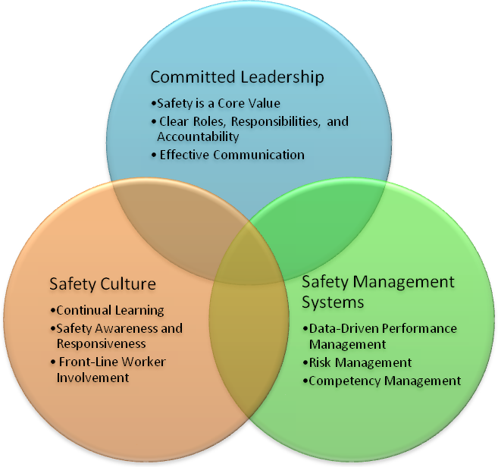
Figure 1. Components of high safety management performance in transit agencies
The following three sections outline how a transit agency can implement an SMS and HRO framework
in their organization. We then define a Safety Management Maturity Model that provides a strategic framework for how transit agencies can move from their current state toward the ideal safety culture. In the final section, we provide our recommendations.
We understand that no amount of federal resources, guidance, or regulation alone can elevate a transit agency to safety excellence. However, we believe that there are concrete, successful practices in our agencies and across the best transportation organizations that can and should be implemented. The effective practices described after each principle are provided as illustrative examples. If FTA adopts our recommended approach, a much more complete guidance framework will be needed.

Committed Leadership
Effective safety management requires committed and involved leadership that consistently prioritizes safety in its communications, policies, and allocation of resources. Senior executives and labor leadership should visibly demonstrate their commitment to safety by discussing and resolving safety issues in meetings and forums. In organizations that have established a safety culture, leaders model the desired culture and lead by example. Leaders should be actively engaged in questioning, assessing and resolving safety hazards and latent safety issues to continuously improve safety throughout the organization. Leaders must be willing to question the status quo and appreciate the vulnerability of their organization to safety risks.
Safety leadership is broader than the upper echelon of the organization, its board, senior and labor management. Rather, effective safety leadership is practiced through all levels of the organization as employees take their safety responsibilities seriously and are actively involved in developing solutions.

Safety is a Core Value
Effective leadership recognizes that safety issues are an integral strategic aspect of business management across the organization and sets priorities accordingly.
Safety is considered a core value, not simply a priority, and permeates the operations and attitudes
of the entire organization. Safety risks are recognized as a risk to business performance. The General Manager (GM), the executive team, and labor leadership demonstrate commitment through active involvement to ensure safety throughout the organization.
Effective Practices
- The strategic value of safety is explicitly incorporated in the agency’s mission, values, and vision. The strategic plan includes a safety goal and objectives that are integrated with other strategic goals.
- The organization encourages and empowers prompt resolution of safety issues through leadership by employees at all levels of the organization.
- The organization possesses a portfolio of safety issues that provide an assessment of safety risks. The portfolio receives ongoing executive review and is utilized to prioritize investment and mitigation strategies.
- Senior management and labor leadership is actively engaged in the oversight of safety-critical priorities and takes appropriate action to mitigate hazards.

Clear Roles, Responsibilities, and Accountability
An effective safety management system establishes clear safety roles and responsibilities throughout the organization.
These safety roles and responsibilities are clearly documented, understood, and practiced throughout
the organization. As a result, individuals not only understand their own responsibilities but also how their individual activities may affect the safety and performance of other employees and the organization as a whole. Each level of the organization is responsible and accountable for safety.
Effective Practices
- The GM or CEO is viewed as the chief safety officer. All employees are assigned safety roles and responsibilities. Safety requirements are built into every job description.
- The senior safety manager is a member of the executive team reporting to the GM and has equal footing with other executives. As part of the executive team, the senior safety manager ensures that safety is fully integrated and managed as an everyday part of the business objectives.
- Each supervisor is accountable for safety, and his/her safety performance measures and safety elements are included in performance appraisals and incentive systems. Leadership recognizes the importance that supervisors play in an organization’s safety performance by supporting and empowering supervisors to identify safety issues and encourage and enforce safe behavior.
- Clear responsibilities establish a hierarchy of operating rules and procedures to guide the performance of safety-critical tasks under normal, abnormal, and emergency conditions.
- All managers, supervisors, and front-line workers and their representatives are cognizant of the role that schedule and production pressures play in the “get the work done” culture of their agency and ensure that a proper balance is struck between competing priorities. Only a frank discussion of these competing aspects will establish the mindset that safety can never be compromised and that safety issues must be confronted and resolved.

Effective Communication
Effective safety leadership communicates clear safety values, goals, objectives, and priorities and reinforces a consistent approach to safety throughout the organization.
Clear and honest communication is a hallmark of safety culture. Information concerning safety issues must be conveyed clearly and consistently in plain language so that employees throughout the organization understand and act on the real risks associated with safety issues. Safety information should not be couched in euphemisms or vague language.
Effective Practices
- Regular arrangements exist for sharing safety information throughout the organization in order to promote effective reviews and continual safety improvement.
- Mandated training and meetings are held regarding important safety issues.
- Multifaceted outreach and communication about safety and risk management is utilized at all levels of the organization.
- The organization has documented procedures for ensuring that pertinent safety information is communicated to and from employees and other interested parties.
- Employees and their representatives are involved in the development and review of policies and procedures to manage risks, are consulted when there are changes that affect workplace safety, are represented on safety matters, and are informed as to who is their employee safety representative and specified management appointee.

Safety Management System Approach
A safety management system is defined as a system designed to manage the safety risks across an organization. Components of a safety management system include management strategies, policies, plans, structures, and systems; risk analysis and decision-making processes; documentation and reporting requirements; training and personnel policies; and audits and reviews. Together these components make up a cross-organizational system designed to facilitate the integration of safety
as a core value into all appropriate business processes and decisions. A safety management system presents a clear approach to the proactive control of safety risks through the continual improvement
of management processes.

Data-Driven Performance Management
Effective safety management systems use data-driven performance management practices and independent audits to drive continuous improvement of safety.
Defined performance measures serve as leading indicators of safety performance and risk and are used to identify, analyze, diagnose, and assess risk and to direct and incentivize employee performance. Performance measures and findings from independent audits, close call reporting, and behavior-based safety approaches are used to improve the responsiveness of the organization to safety risks by adjusting processes, policies, strategies, and investments. By allowing managers to predict and proactively address potential safety issues, undesired events are prevented before they can impact operational safety.
Effective Practices
- Leading indicators of safety performance, safety culture, and accident precursors are defined, measured, and monitored.
- All employees understand the value of collecting and reporting data to support risk analysis, address unsafe conditions, and prevent accidents.
- Reliable data is collected on operational performance, safety, maintenance, near misses, and training. Systems are in place to analyze trends, track and report data, and guide decisions. Variations from expected outcomes are reviewed to understand where the organization is failing and what corrective action is necessary to restore performance.
- Performance measures based on industry standards are cascaded through the organization so everyone is clear about fulfilling strategic safety goals. The performance measures are used to continually encourage all levels of the organization to reduce the risk to the agency.
- The organization uses performance measures to evaluate the effects of new programs and processes on safety.

Risk Management
At the core of any safety management system is the identification, assessment, and prioritization of risks and the application of resources and effort to minimize or mitigate those risks.
An organization’s ability to manage risk is associated with its awareness of the level of risk posed by its operations and its ability to plan and implement the details necessary to reduce the likelihood of an unpredictable outcome. The safety management system includes ongoing processes and policies to detect, measure, and diagnose the source of risk at a programmatic level. Robust, data-driven safety risk-management processes are embedded throughout the operational system. Risk is perceived independent of immediate consequences so that any unsafe act or condition, near miss, or accident
is seen as evidence of risk and a symptom of a possible failure of the management system.
Effective Practices
- A hazard analysis process is in place for identifying safety issues and concerns, including those associated with human factors and changes to operations or equipment. Data is analyzed to provide possible policy, process, or equipment modifications to eliminate or mitigate hazards.
- A reporting system is in place that allows employees to report important close calls/near misses and unsafe conditions to a neutral third party without retribution.
- Capabilities for swift learning, flexible role structures, and quick situational assessments are developed to mitigate risk impacts.
- A hierarchy of controls are identified and clearly understood.

Competency Management System
High-performing safety organizations effectively manage and develop the safety competencies of their employees.
The knowledge, skills, and experience needed to work effectively, efficiently, and safely are understood, valued, and developed by the organization. Sufficient resources are allocated to support recruitment, selection, training, and continued development activities that are focused on meeting the agency’s safety objectives. Appropriate safety training is provided to all employees.
Effective Practices
- Appropriate SMS training is provided to board members and the GM so they can understand the business risk of the organization.
- Safety competency criteria are defined and required of key maintenance and operation positions, and training certification is established.
- Leaders and staff are prepared to respond when system failures occur.
- Safety issues can often be recognized through a fresh perspective or a change to the daily routine. Effective safety organizations use job rotations, retraining, and intensive reviews to focus awareness on potential hazards.

Safety Culture
An effective safety management system is the basis for a safety philosophy and culture that permeates the entire organization. The safety culture of an organization is defined as “the product of individual and group values, attitudes, perceptions, competencies, and patterns of behavior that can determine the commitment to and the style and proficiency of an organization’s safety management system.” A safety culture is the manifestation of the internalization of the safety management system on the part of the employees that make up the organization. The safety management system should take account of and shape the safety culture of the organization. Effective safety management systems instill and reinforce a safety culture among employees, and that safety culture ensures the effective implementation of the policies, principles, and practices set forth by the management system.

Continual Learning
An effective safety organization develops shared values of trust, openness, and continual learning.
These values facilitate the proactive identification, analysis, and mitigation of risk by encouraging employees to provide essential safety-related information without fear of blame or retribution. The safety management system should define systematic processes for promoting core values that support a sound safety culture.
Effective Practices
- The organization fosters a culture in which employees feel safe to question assumptions and report problems or failures candidly.
- Individuals throughout the agency understand how their activities affect the safety of the organization. Staff is encouraged to make knowledge about the system transparent and
widely known.
- Individuals are encouraged to understand and communicate the potential weaknesses of their system along with ideas on how to manage or correct them.
- Redundancy, resilience, and reliability are built into the operations so there is not a single point of failure. Especially as experienced managers and workers retire, the agency ensures continuity of safety knowledge to the next generation.

Safety Awareness and Responsiveness
A safety culture is actively mindful about safety risks and quickly and effectively responds when risks are identified.
All staff are encouraged to be continually alert to the unexpected and sensitive to the fact that in uncertain situations any decision or action may be subject to false assumptions. When near-misses or residual risks are noticed, they are reported. Rather than viewing near-misses as proof that the system has effective safeguards, they are viewed as symptomatic of areas in need of more attention. Near misses are viewed as evidence of systems that should be improved to reduce potential harm to employees and customers. High reliability organizations aggressively seek to know what they don’t know and do not resort to simplistic explanations when analyzing hazards.
Effective Practices
- Create a climate where all employees are continually mindful of risks. They have a heightened concern about stability, routinization, and lack of challenge and variety, which can predispose an organization to sink into complacency, leading to carelessness.
- Employees envision undesired outcomes through job analyses and system reviews so that they can expand the precautions they will take.
- An anonymous, non-punitive reporting system is in place for near misses or close calls.

Front-Line Worker Involvement
In effective safety organizations, empowered employees are actively involved in identifying and analyzing risks and developing safer work processes.
Leaders and supervisors must be willing to listen and respond to the insights of staff with the best understanding of how processes work in practice and the degree and potential effect of safety risks. A safety culture enables an organization to reconfigure itself quickly in the face of continual operations when certain risks occur, often shifting from the conventional hierarchical mode to a flatter mode.
Effective Practices
- Organization leaders encourage collaboration between labor and management to improve organizational safety.
- Safety activities and decision-making activities are given to people who are best placed to carry them out.
- Employees are encouraged to proactively develop front-line safety practices and implement pilot programs to continuously improve their areas of work. The resulting data and improved practices are shared across the organization.
- A learning environment is created that encourages input from a variety of people on the organization’s ways of doing business. Staff is trained to manage these differences successfully.
- Training standards are developed jointly with labor leadership, or where workers are not represented, front-line workers.

Safety Management Maturity Model
We recognize that the principles and effective practices described in this report do not happen without sustained systemic change. High-performing transit agencies that exhibit these practices have built these elements into their organizations over many years, incrementally increasing their level of maturity, culture, policies, and safety practices.
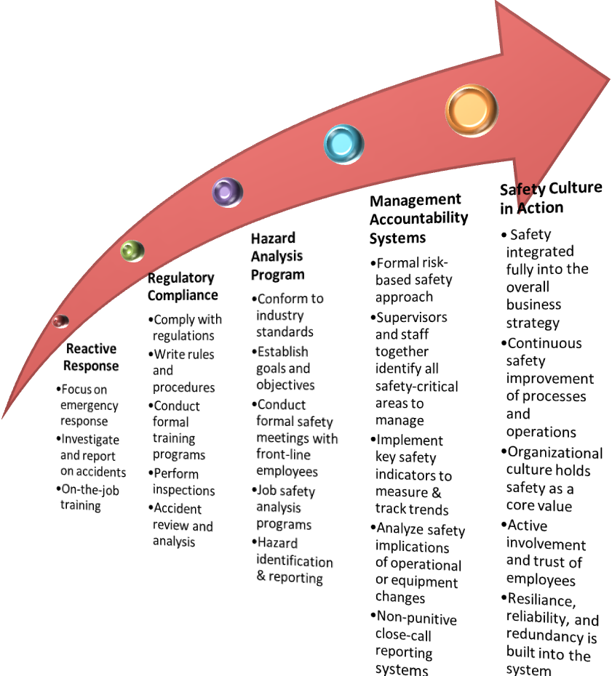
Figure 2. Safety management maturity model
The Safety Management Maturity Model provides a way to understand the continuum along which process maturity can be developed from one level to the next. As an agency progresses along the continuum, there is increasing safety commitment and leadership across the organization, increasing sophistication of safety processes integrated directly into operations and maintenance processes, and increasing trust and involvement of the front-line worker to solve critical safety issues. Skipping levels, although desirable, is not feasible. Therefore, in order for transit agencies to change their safety culture by implementing the principles and practices recommended, it is imperative that they understand where they are along the continuum and what next steps will be most successful in being implemented.
Level 1—Reactive
Organizations at this level have safety processes that are undocumented and in a state of dynamic change, tending to be driven in an ad hoc, uncontrolled, and reactive manner by users or events. This provides a chaotic, unstable, and unsafe environment.
Level 2—Regulatory Compliance
Organizations at this level have safety processes that are repeatable, possibly with consistent results. However, adherence to safety program discipline is due more to demands from outside the organization than being an inherent part of the culture.
Level 3—Hazard Analysis Program
Organizations at this level have defined and documented safety policies and processes that are subject to some degree of improvement over time. Standard processes for hazard analysis are in place and used to establish consistency of safety performance across the organization. Time and resources are increasingly set aside to review and correct safety issues as a priority to the organization’s performance.
Level 4—Management Accountability Systems
Organizations at this level manage all hazards using a risk-based approach. In particular, organizations can identify ways to adjust and adapt processes without measurable losses of operational performance or deviations from operational and maintenance requirements. Safety Process Capability is established from this level on. Safety performance and accountability is monitored at all levels of the organization.
Level 5—Sustainability Culture in Action
Organizations at this level focus on continually improving safety performance by involving the entire organization and integrating safety as a core value and strategic business driver.

Recommendations
FTA should play a leading role in encouraging the adoption of safety management principles and practices across the nation. The critical challenge for FTA will be how to develop support systems and resources that go beyond simply adding reporting requirements and that support the development of an effective safety culture at transit agencies of all sizes. This effort will require identifying, disseminating, and incentivizing effective safety practices. The following recommendations describe the methods that
FTA can use to adopt safety management systems and principles among transit agencies:
- Identify and disseminate guidance on leading indicators of safety.
FTA should identify meaningful safety performance measures that can help transit agencies assess their safety. The measures should be leading indicators that allow transit agencies to identify and address potential safety issues before they become critical. Safety culture measures can include the measurement of employee attitudes towards safety; organization hiring, training, and communication practices; and trends in root causes of near-misses, violations, or incidents (see examples of safety culture indicators in appendix A). FTA should provide guidance on what indicators are most effective and how to implement those measures so that they are used to assess risks and adjust processes and practices.
- Encourage the establishment of measureable, performance-based goals for passenger rail safety, and provide tools, training, and support that will assist state safety oversight agencies (SSOs) and rail transit agencies (RTAs) in performing performance-based safety management.
A performance-based approach needs to be established through the development and implementation of a Passenger Rail Safety Management System. Consistent and reliable data on performance will be used to track success in meeting safety goals.
- Conduct a confidential assessment to establish a national baseline of transit agencies’ safety climate.
To be able to evaluate the effectiveness of its safety programs, FTA must establish a baseline understanding of the current safety climate at transit agencies. To do this, FTA should develop and implement a confidential assessment of transit agencies’ safety practices and culture and use the results to guide the development of its safety programs. The assessment should take into account both labor and management perspectives of the safety climate. Each transit agency should also include some elements of safety climate assessment in their internal audit program.
- Develop a safety culture maturity model.
Transit agencies have distinct histories, attitudes, and capabilities about safety practices and safety culture. A safety culture maturity model could help guide FTA in targeting and tailoring technical assistance and resources to diverse agencies by identifying characteristics of transit agency safety culture along a spectrum of maturity or formality. For example, safety practices could range from
ad hoc and informal to documented, practiced, and ingrained. One advantage of a maturity model is that defining incremental steps along a spectrum of capabilities can show a path toward improvement by which transit agencies set goals and measure progress.
- Create a guidance manual on safety practices and principles, including those highlighted in this report.
A detailed guidance manual should serve as a reference to support transit agencies in the implementation of effective safety practices and principles. It should highlight effective practices, describe industry standards for safety management systems, and inventory leading indicators of safety culture.
- Support external executive and labor leadership training and coaching on safety.
Given the critical role that management and labor leadership play in establishing and maintaining an agency’s safety culture, the FTA should support leadership training and coaching on safety. Transit agency leadership should understand the importance and value of safety to the organization and commit to the most effective leadership practices to ensure employee and customer safety.
- Recognize and reward good safety performance and the establishment of innovative practices by transit agencies.
The FTA should recognize and reward agencies with strong safety records, and effective and innovative practices should be identified, documented, and disseminated. FTA can promote strong safety practices by identifying effective practices already in place among high-performing safety organizations and promoting those activities among RTAs and SSOs.
- Implement a non-punitive close-call/near-miss reporting system.
By supporting the development of a non-punitive close-call/near-miss reporting system, the FTA can improve the collection and analysis of vital safety data and trends.
- Promote hazard identification and resolution for operations and maintenance.
Successful practices used in project design and construction should be used to provide detailed guidance and training on the use of hazard identification, management, and resolution for operations and maintenance of the rail system. Additional effort is needed so that analysis of hazards is conducted and mitigated while the system is in revenue operation. Ensure accountability of conducting such analysis by requesting performance measures and copies of completed hazard analysis.
- Make FTA funding criteria flexible enough to allow RTAs and SSOs to acquire the resources necessary to implement the recommendations in this report and make them actionable.
The FTA should make funding requirements flexible enough so that federal funding can be used to support transit agencies in implementing the recommended principles and practices of this report.
- Evaluate implementation of these recommendations.
The FTA should evaluate whether transit agencies are implementing recommended practices and principles and whether they have had an impact on transit safety. Effective practices should be codified in statutory requirements and official guidance.
- Following a reasonable time period, based on lessons learned, FTA should consider appropriate adjustments to 49 CFR Part 659 to incorporate the safety management principles addressed in this paper.

Appendix A. Examples of Indicators of Effective Safety Management
in a Transit Agency
- Policies clearly describe the responsibilities for safety in all functions throughout the organization.
- Safety goals in the strategic plan are measured and assessed along with the other strategic goals.
- Competing pressures to safety are discussed openly.
- Safety performance measures (leading indicators) are part of everyone’s performance management plan and evaluation.
- Safety performance measures and priorities are clearly communicated and understood.
- Employee retention rates and absentee rates are evaluated for any issues with regard to safety.
- The CEO or GM discusses and assists in resolving safety issues with members of the executive team. Safety issues are discussed openly at executive meetings. There is an executive-level safety committee.
- The executive team implements corrective actions when safety issues are raised.
- The CEO or GM has his/her team participate at quarterly meetings with the SSO.
- Employees assess their supervisor’s concern about safety.
- Employees are regularly surveyed regarding their perspective on the organization’s safety climate.
- A joint union-management committee identifies and resolves safety issues.
- Supervisors’ safety attitudes are assessed and corrective actions taken.
- Front-line supervisors have performance measures associated with safety responsibilities.
- Supervisors conduct safety inspections and monitor the work that employees are doing.
- There is a process for the signing of safety briefing sheets.
- Front-line employees are involved in developing safety policies and procedures (hazard analysis).
- Front-line employees are empowered to restrict or stop operations based on unsafe conditions.
- Good faith challenge processes (safety dispute resolutions) are available to workers.
- There is interdepartmental involvement in developing safety policies and procedures (hazard analysis).
- Involved departments conduct hazard analysis when new systems or changes are introduced. They use engineering solutions as the first method of solving problems (hierarchy of control).
- A hazard tracking system is in place. Corrective actions are taken and the results of countermeasures are evaluated and published.
- The organization has a non-punitive near-miss policy and a reporting, analysis, and correction system that is regularly used and trusted.
- There is a safety hotline set up to report issues, conditions, and behavioral problems.
- Safety bulletins or newsletters are communicated across the organization. There are methods for taking in information and recommendations from workers.
- There is a board-level safety committee, and it discusses safety issues on a regular basis.
- An analysis of the board or executive team agenda shows that safety issues are given prominence.
- If there is an injury, managers or executives get involved.
- Leadership’s safety rhetoric matches reality.

Key References
Ahmed, S. (2011). “Elements of an Effective Safety Culture,” Presented at the TRB 90th Annual Meeting, Session 585,Washington, DC.
Cooper, D. (2001) Treating Safety as a Value, American Society of Safety Engineers
Cooper, D.(1998) Improving Safety Culture: A Practical Guide, John Wiley & sons, New York
Cummings, R. (2006). Expert Views on the Evidence Base for Effective Health and Safety Management (Phase 1), Health and Safety Laboratory, Derbyshire, UK.
Human Engineering for the Health and Safety Executive (2005). A review of safety culture and safety climate literature for the development of the safety culture inspection toolkit, Research Report 367, Human Engineering, Bristol, UK.
Institute of Nuclear Power Operations (2004). Principles for a Strong Nuclear Safety Culture, Atlanta, GA.
Office of Rail Regulation.(2011). Railway Management Maturity Model, London, UK.
ORC Worldwide (2009) “Leading Safety Indicators” (PowerPoint presentation)
Sumwalt, R. (2011). “Investigating and Preventing Organizational Accidents,” National Transportation Safety Board, Washington, DC.
Weick, K & Suttcliffe, K (2001). Managing the Unexpected: Assuring High Performance in the Age of Complexity. Josey-Bass.

Reason, J. (1997). Managing the Risks of Organizational Accidents, Ashgate Publishing, Burlington, VT.
See section 4.3. of “Guidelines on Occupational Safety and Health Management Systems,” International Labor Office, 2001, http://www.wbcsd.org/web/projects/cement/tf3/guidelin.pdf. Last accessed February 10, 2011. 4.3. Consultation and communication 4.3.1. The organization shall have documented procedures for ensuring that pertinent H&S information is communicated to and from employees and other interested parties. 4.3.2. Employees shall be: 4.3.2.1. involved in the development and review of policies and procedures to manage risks; 4.3.2.2. consulted where there are any changes that affect workplace health and safety; 4.3.2.3. represented on health and safety matters; and 4.3.2.4. informed as to who is their employee H&S representative(s) and specified management appointee 4.3.3. Employee involvement and consultation arrangements shall be documented and interested parties informed. 4.3.4. The employer shall ensure, as appropriate, the establishment and efficient functioning of a safety and health committee and the recognition of workers' safety and health representatives, in accordance with national laws and practice. 4.3.5. The employer shall ensure that workers and their safety and health representatives are consulted, informed and trained on all aspects of H&S, including emergency arrangements associated with their work. 4.3.6. The employer shall make arrangements for workers and their safety and health representatives to have the time and resources to participate actively in the processes of organizing, planning and implementation, evaluation and action for improvement of the H&S management system.
The approaches to controlling a safety issue in order of most effective to least effective are: elimination, substitution, engineering controls, isolation, administrative controls, and personnel protective equipment.
The Advisory Committee on the Safety of Nuclear Installations (ACSNI), 1993, p. 23.
Adapted from the APTA Safety Management Maturity Model

