OVERVIEW

BACKGROUND

The Federal Transit Administration (FTA) examines grantee performance and adherence to current FTA procurement requirements and policies using several management tools. FTA is required by 49 U.S.C. §5307 to perform reviews and evaluations of grant programs and to perform a full review and evaluation of the performance of grantees in carrying out grant programs with specific reference to their compliance with statutory and administrative requirements. Accordingly, FTA will perform procurement system reviews as part of its on-going oversight responsibility. The review process assesses the grantee's procurement management practices and program implementation of the FTA funded transit programs to ensure they are being administered in accordance with specific FTA procurement requirements.

WHO SHOULD ATTEND?

These workshops are for transit professionals responsible for procurement management or managing federally funded projects and professionals responsible for contracting or purchasing transit service or the activities that support the transit service. The workshops are designed to help attendees broaden their understanding of the Federal procurement rules and regulations that shape and define their programs.

WORKSHOP LEADERS

The Procurement System Review Workshop will be conducted by transit professionals, who are also reviewers for the FTA's Procurement System Review Program. The instructors will provide guidance in each of the 56 areas to be reviewed, answer questions about how to respond to specific review areas, and share industry best procurement practices. Staff from the FTA will attend the Workshop to answer questions about the Procurement System Review, assist you in any area related to your use of FTA funds, and refer you to printed guidelines or other resources should you require additional information.

WORKSHOP AGENDA

DAY 1 Tuesday May 18, 2010

8:00 am Participant Check-in / Breakfast

9:00 am Welcome and Introductions

9:15 am Presentation of FTA requirements in the areas of PSR Process, System Wide Procurement Elements, Written Standards of Conduct, Protest Procedures Contract Administration System, Prequalification, Efficient and Economic Purchases. Participant questions and group discussion.

12:00 pm Working Lunch – American Recovery and Reinvestment Act (ARRA) Implementation.

1:00 pm Presentation of OMB ARRA Accountability Objectives, ARRA Management Challenges as identified by the Office of Inspector General, DOT, Oversight and/or Technical Assistance of ARRA-funded projects. Participant questions and group discussion.

Presentation of FTA requirements in the areas of Independent Cost Estimates, Arbitrary Actions, Brand Name Restrictions, Price Quotations, A&E Geographic Preferences. Participant questions and group discussion.

4:30 pm Adjourn

DAY 2 Wednesday May 19, 2010

8:00 am Breakfast

9:00 am Presentation of Written Procurement Selection Procedures and Competitive Procurement. Participant questions and group discussion.

Presentation of FTA requirements in the areas of Buy America, Debarment and Suspension, Award to Responsible Contractors, Fair and Responsible Price Determination, Bid Opening, Cost/Price Analysis Written Record of Procurement History. Participant questions and group discussion.

12:00 pm Lunch on Your Own

1:00 pm Presentation of FTA requirements of FTA Circular 4220.1F, Best Practices Procurement Manual (BPPM), and Most Common Procurement Findings and Resolution of Findings, and PSR Follow - Up Reviews. Participant questions and group discussion.

3:00 pm Wrap-Up, Program Evaluations, and Feedback

4:00 pm Adjourn

HOTEL INFORMATION

The two-day Workshop will be held at the following location:

THE RADISSON PLAZA – WARWICK HOTEL
1701 Locust St
Philadelphia, PA 19103
Tel: 215-735-6000
Fax: 215-790-7766

http://www.radisson.com/philadelphiapa

ROOM RESERVATIONS INFORMATION

A sleeping room block of 10 Standard rooms (per night) at the rate of $146.00 per night (without tax) has been reserved for this workshop for the nights of May 17, 2010 and May 18, 2010. The cut-off date for accepting reservations into this room block is April 28, 2010. Reservation requests received after 5:00 p.m. local time at the hotel on the cut-off date will be subject to space availability and at prevailing room rate. The hotel accommodations are for confirmed workshop attendees only. The workshop is free of charge but participants are responsible for making their own sleeping room reservations and paying for these charges. Please do not reserve a room until you receive a “Confirmed for Registration” e-mail from Calyptus Consulting Group, Inc.

Participants can book, modify, or cancel guest room reservations by calling the Reservation Line at
1-215-735-6000 or 1-800-333-3333. To receive the special rate, participants should ask for the FTA PSR Workshop room block when making reservations. Please note a one night’s sleeping room and tax will apply if your cancellation is not made by 4 p.m. on the day prior to arrival date.

PARKING

The Radisson Plaza-Warwick Hotel does not own or operate valet or self parking service. Valet parking is provided by Penn Warwick, available at the front of the hotel on 17th Street at the rate of $30.00 per day to be added on guest room folio.

Self parking is available at two locations:

- Penn Warwick parking garage on Chancellor Street between 17th and 18th from $12.00 to $30.00 per day with in and out privileges. Charges can be billed directly to guestroom folio.
- Patriot parking garage on Chancellor Street between 16th and 17th from $13.50 to $19.00 per day. Prices are subject to change. Charges cannot be billed directly to guestroom folio.

TRANSPORTATION INFORMATION

The workshop site is conveniently located in the prestigious Rittenhouse Square district of downtown Philadelphia. It is accessible by taxi and the SEPTA Rail Lines.
Driving Directions from Airport to the Hotel

From Philadelphia International Airport (PHL)

Follow these directions to get to the Radisson Plaza – Warwick Hotel:
(Estimated Driving Time: 18 Minutes, Distance: 8.8 miles)

- Head east (0.7 mi)
- Take ramp right for SR-291 East/Penrose Ave toward Valley Forge (4.6 mi)
- Keep straight onto I-76 West/Schuylkill Express Way (2.4 mi)
- At exit 345, take ramp right for Chestnut St toward 30th St (0.4 mi)
- Turn right onto S 21st St (0.2 mi)
- Turn left onto Locust St (0.2 mi)
- Turn right onto W Rittenhouse Sq and immediately turn left onto Rittenhouse Sq (0.1 mi)
- Turn left onto S 18th St and immediately turn right onto Locust St (0.1 mi)
- Arrive at Locust St
- Hotel is on right

Other Types of Transportations

From Philadelphia International Airport (PHL) to the Hotel

- Taxi:

Cab fare is at a flat rate of $28.50 from the Airport to the Central Philadelphia Area. Taxi services are located at Zone 5 on the Commercial Transportation Roadway. Other fares are based on the meter rate of $2.70 per mile upon entry and $2.30 per mile or portion thereof, along with an additional $1.50 airport fee. Please advise the dispatcher upon your arrival to the Taxi are as all companies to not accept credit cards or vouchers as a form of payment.

- Shared Ride Van/Shuttle:

Shared Ride Van is located at Zone 7 on the Commercial Transportation Roadway. For more information, please make your inquiry at the Ground Transportation Information Desk at each baggage claim area. The cost for the Shuttle is $10 per one way ride per person.

Zone numbers and telephone numbers are also provided below:

Ground Transportation Services

SEPTA Bus | ZONE 1
Rental Car Shuttle | ZONE 2
Parking Courtesy Shuttle | ZONE 3
Hotel Shuttle | ZONE 4
Taxicabs | ZONE 5
Limousines | ZONE 6
Van Service | ZONE 7
Charter Bus/Couriers | ZONE 8

Ground Transportation Service Providers for Center City

AAA Airport One Direct | (215) 677-3544
American Limo | (484) 368-7041
Atlantic Sedan Service | (610) 659-8513
Lady Liberty | (215) 724-8888
Pennywise Sedan Service | (866) 255-7686
Tropiano | (800) 559-2040

- Public Transportation via SEPTA Rail:

Participants can access the SEPTA Regional Rail Line R1 via Terminals A-East, C, C, D, and E if coming from the airport or connection via other Regional Rail Lines from surrounding areas. Destination is the Suburban stop between 17th Street and JFK Boulevard. This stop is 7 blocks away from the hotel. The cost is $7.50 per one way ride.

Walking Directions from Suburban Station to the Hotel:

Follow these directions to get to the Radisson Plaza – Warwick Hotel:
(Estimated Walking Time: 8 Minutes, Distance: 0.4 miles)

- Head west on JFK Blvd toward N 17th St (223 ft)
- Turn left at N 17th St
- Arrive at 1701 Locus St

More information on SEPTA Regional Rail R1 can be found at http://www.septa.org/service/rail. The SEPTA map is provided on the next page for your reference.

SEPTA Rail:
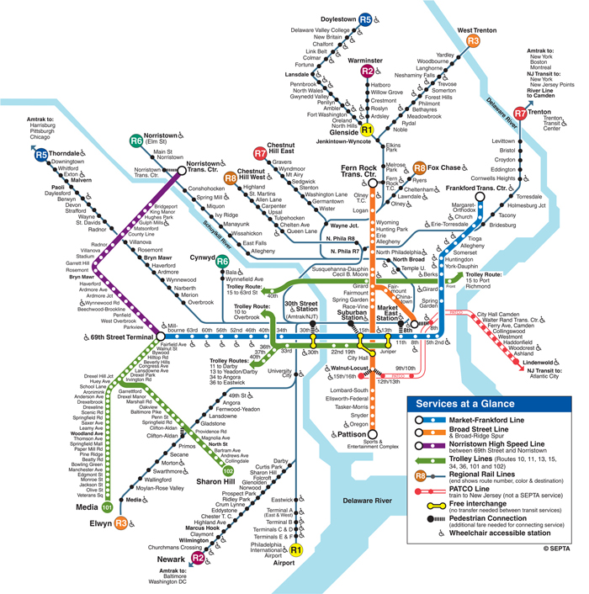
Get off here and walk to the hotel
If coming from Airport, take R1 here

REGISTRATION FORM

I will be attending the FY 2010 Procurement System Review Workshop. Please register me:

First Name:
Last Name:
Title:
Agency:
Street Address:
Street Address (cont'd):
City: State:
Zip:
Phone No.: Extension (if any):
Fax No.:
E–mail:
Special Needs (e.g., wheelchair access, hearing impaired):

Important Notes:

- This is an automated registration form. Please fill and review your entries carefully. After completing the form, please save the form and return it as an e–mail attachment to psrworkshop@calyptusgroup.com.

- You will receive two emails: (1) the first email is to acknowledge the receipt of the registration form; and (2) the second email is to confirm you are registered for the workshop. Please do not assume you are confirmed and registered until you receive the second email.

- Calyptus Consulting Group, Inc., a PSR Contractor, is organizing this event. If you have any difficulty returning the form by e–mail, feel free to print and submit by fax to Tiara Tran at (617) 577-0042. You can also call her at 617-577-0041 for more information.

- Submit one form for each participant per guidelines on the previous pages.

- Please submit your registration by May 11, 2010. Early registration is encouraged as the number of participants is limited.

