Transit Rail Advisory Committee for Safety (TRACS) Meeting

September 20 and 21, 2012

U.S. Naval Conference Center

1454 Parsons Avenue SE

Washington, D.C. 20374

# Table of Contents

Table of Contents 2

Attendance 3

Day One Proceedings 5

Introduction and Recap 5

Opening Remarks 7

Overview of MAP-21 Requirements 8

Framework for MAP-21 Implementation 14

TRACS Committee Membership 18

Group Discussion of Program Area Activities and Priorities 18

Day One Closing Thoughts 24

Day Two Proceedings 25

Day Two Opening Remarks 25

Concept for a National Public Transportation Safety Plan Outline 25

Comments on the Draft NPTSP Outline and Priorities for Future Taskings 26

Public Comment Period 30

TRACS Committee Membership 30

Conclusion 30

# Attendance

### TRACS Members in Attendance

**Samir Ahmed**, **Ph. D, PE**, Oklahoma State University School of Civil and Environmental Engineering

**William Bates**, AMTRAK and United Transportation Union

**Eric Cheng**, Utah Department of Transportation (UDOT)

**Diane Davidson (TRACS Chairperson)**, Oak Ridge National Laboratory (ORNL)

**James Dougherty**, Washington Metropolitan Area Transportation Authority (WMATA)

**Bernadette Fowlkes-Bridges**, Maryland Transit Administration (MTA)

**Grace Gallucci**, Northeast Ohio Areawide Coordinating Agency (NOACA)

**David Genova**, Denver Regional Transportation District (RTD)

**Georgetta Gregory**, Metropolitan Atlanta Rapid Transit Authority (MARTA)

**William Grizard**, American Public Transportation Association (APTA)

**Henry Hartberg**, Dallas Area Rapid Transit (DART)

**Susan Hausmann**, Texas Department of Transportation (TxDOT)

**Rick Inclima**, Brotherhood of Maintenance of Way Employees Division (BMWED) of the International Brotherhood of Teamsters

**Tamara Lesh**, Tri-County Metropolitan Transportation District (TriMET)

**Pamela McCombe**, Greater Cleveland Regional Transit Authority (GCRTA)

**Phyllis McDonald, Ed. D**., Johns Hopkins University

**Alvin Pearson**, Memphis Area Transit Authority (MATA)

**Nagal Shashidahara, Ph. D**, New Jersey Transit

**Edward Watt**, Transport Workers Union of America (TWU)

### 

### TRACS Working Group Members in Attendance

**Paul King**, California Public Utilities Commission

### U.S. DOT and FTA Representatives

**Ray LaHood**, Secretary, U.S. Department of Transportation

**Peter Rogoff**, Administrator, FTA

**Matthew Welbes**, Executive Director, FTA

**Vincent Valdes**, Interim Associate Administrator, Office of Safety and Oversight, FTA; Designated Federal Officer, TRACS

**Dorval Carter**, Chief Counsel, FTA

**Gerald Powers**, Drug and Alcohol Program Manager, FTA

**Bridget Zamperini**, Office of Safety and Security, FTA

**Ryan Frigo**, Office of Safety and Security, FTA

**Timothy Braxton**, Office of Safety and Security, FTA

**Paul Griffo**, FTA

**Holly Vandervort**, FTA

**Ruth Lyons**, Office of Safety and Security, FTA

**Deborah Freund**, Office of Safety and Oversight, FTA

**Iyon Rosario**, Office of Safety and Security, FTA

**Esther White**, Office of Safety and Oversight, FTA

**Richard Wong**, Attorney Advisor, FTA

**Ronald Keele**, Director Office of Safety and Security, FTA

**Maria Wright**, Office of Safety and Security, FTA

**Jarrett Stolzfus**, FTA

### Volpe Center Staff

**Robert Johns**, Associate Administrator and Director

**Eran Segev**, Safety Management Systems Technical Center

**Jeffrey Bryan, Psy. D.,** TRACS Facilitator

**Kevin McCoy**, Meeting Recorder

# 

# Day One Proceedings

## Introduction and Recap

### Safety Briefing

Jeffrey Bryan initiated the meeting by conducting a safety briefing. He informed the participants of the established procedures for building evacuation in the event of an emergency. Participants trained in CPR were identified.

### Welcome

Diane Davidson, the TRACS chairperson called the meeting to order. She welcomed the TRACS members, FTA representatives, Volpe Center staff and members of the public to the meeting.

### Recap of TRACS Activities

Ms. Davidson recapped the major activates of the TRACS since its formation. The TRACS had met as a full committee three times previously:

* September 9-10, 2010, in Washington, D.C.
* April 27-28, 2011, in Washington, D.C.
* February 23and 24, 2012, in Atlanta, Georgia

Ms. Davidson reviewed the four taskings the committee received from the FTA Administrator, and commented on the progress the TRACS had made in responding to these taskings:

#### Tasking 10-01: Safety Management Systems (SMS) Principles



Tasking 10-01, initially presented to the TRACS on September 9, 2010, asked the TRACS to develop consensus advice to FTA on the best safety planning model for the rail transit industry, to include, but not limited to, Safety Management System (SMS) principles and how those principles might be incorporated into transit safety plans to enhance rail transit safety, the challenges that might be faced in implementing the recommended model, and potential ways the challenges may be overcome.

The TRACS delivered a letter report to FTA on May 20, 2011 in response to this tasking. The report recommended that FTA play a leading role in encouraging the adoption of SMS principles and practices across the nation. Ms. Davidson reviewed the recommendations included in the letter report and noted that some of them are mandated or alluded to in the most recent surface transportation reauthorization legislation passed by Congress, the Moving Ahead for Progress in the 21st Century Act (MAP-21).

#### Tasking 10-02: State Safety Oversight (SSO) Agency Organization Models



Tasking 10-02, initially presented to the TRACS on September 9, 2010, asked the TRACS to develop consensus advice to FTA on the best state safety oversight (SSO) agency organization model, to identify the ideal state safety partner, to identify the challenges that may be faced in implementing the recommended model, and potential ways these challenges might be overcome.

The TRACS delivered a letter report to FTA on May 20, 2011 in response to this tasking. The report recommended that FTA be given authority to set minimum national standards for safety oversight of rail transit. Ms. Davidson indicated that this was the most important recommendation of the TRACS to date, and that Congress had granted FTA this authority in MAP-21. Ms. Davidson reviewed the other recommendations of the report and indicated that the TRACS would be happy to support the FTA in prioritizing the implementation of these recommendations.

#### Tasking 11-01: Close Call Reporting Pilot



Tasking 11-01, initially presented to the TRACS on April 28, 2011, asked the TRACS to provide consensus advice to FTA on proposed models and strategies for transit systems to implement a voluntary, non-punitive reporting system that comports with the committee’s recommendation that FTA pilot a close-call/near-miss non-punitive safety reporting system.

The TRACS delivered a letter report to FTA in July of 2012, which was under internal review at the time of the meeting.

#### Tasking 11-02: Prescription and Over-the-Counter (Rx/OTC) Medication Testing and Notification Procedures



Tasking 11-02, initially presented to the TRACS on April 28, 2011, asked the TRACS to assist the FTA Drug and Alcohol Program Manager with reviewing the recommendations of an FTA sponsored study on Prescription and Over-the-Counter (Rx/OTC) medication testing and notification procedures in the transit industry. The tasking also directed the TRACS to provide recommendations for improving the development of non-regulatory employer Rx/OTC policies, employee Rx/OTC notification training and employee reported information in accident/incident investigations.

A TRACS working group had been formed to respond to this tasking and was in the process of drafting a letter report to present to the full TRACS for approval.

## Opening Remarks

U.S. Secretary of Transportation, Ray LaHood arrived to address the TRACS. Ms. Davidson temporarily adjourned the meeting to allow TRACS members to meet the Secretary and participate in a group photo. The meeting resumed with the Secretary’s address to the TRACS, followed by remarks from FTA Administrator, Peter Rogoff.

### Ray LaHood – Secretary, U.S. Department of Transportation

Secretary LaHood thanked the TRACS members for their service to FTA and their dedication to improving safety in the transit industry. He remarked that following the Fort Totten crash on the Washington D.C. Metro system, he and Administrator Rogoff were frustrated that the law prohibited the FTA from taking action to improve the safety of transit systems nationwide. However, MAP-21 now provides FTA with the legal authority to regulate and oversee safety aspects of all transit systems. This is perhaps the most significant component of the MAP-21 legislation.

Secretary LaHood reminded the TRACS members of the government’s responsibility to the traveling public to ensure that transit systems are safe. He remarked that thousands of people use transit services every day and that these people are occupied with many daily concerns related to their personal and working lives, but they don’t think about safety. The reason is because it is the government’s responsibility to ensure that transit systems are safe. He remarked that the TRACS was ahead of the curve because it began its work even before FTA was granted safety oversight authority by Congress. This proved the commitment of the TRACS members to improving safety in the industry.

Secretary LaHood thanked the TRACS members again for their service and indicated that U.S. DOT and FTA were looking forward to the committee’s recommendations and continued partnership in helping ensure that everyone that boards a transit system in the U.S. is safe.

### Peter Rogoff – Administrator, Federal Transit Administration

Administrator Rogoff remarked that because of the passage of MAP-21, this TRACS meeting represented the beginning of a new era in transit safety and a new period for the TRACS. U.S. DOT had always foreseen an important role for TRACS in implementing the safety authority which had now been granted. This was demonstrated when Secretary LaHood announced that FTA would form the TRACS on the same day that FTA transmitted the proposed legislation to Congress that later formed the basis for the safety authority in MAP-21.

The Administrator indicated that FTA was very excited to be implementing the safety authority contained in the MAP-21 legislation, but that it would be a challenging task and that FTA would need the help of the TRACS. He remarked that because public transit safety had not previously been regulated at the Federal level, there was an opportunity to begin from a blank slate, and to design a system that both makes sense for modern transit systems and comports with contemporary safety thinking. He remarked that while the examples set by other modal agencies that had had safety oversight and regulation responsibilities for many years may be of value to the TRACS, the Administrator encouraged the TRACS to not restrict itself to existing models.

Administrator Rogoff introduced Vincent Valdes, the Interim Associate Administrator for the new FTA Office of Safety and Oversight. Mr. Valdes had recently assumed this position in the newly-established office within FTA. He had previously served in senior executive roles elsewhere in the agency. Most recently, Mr. Valdes had served as the Associate Administrator for Research, Demonstration and Innovation. Administrator Rogoff announced that as part of his new role, Mr. Valdes would assume the role of Designated Federal Officer for the TRACS.

## Overview of MAP-21 Requirements

Mr. Valdes addressed the TRACS, reviewing the safety provisions in MAP-21. A summary of his presentation follows.

### Presentation: Overview of MAP-21 Safety Requirements

MAP-21 provides FTA with the authority to establish and enforce a new safety framework for public transportation in the U.S. The law authorizes FTA to, among other things, issue regulations to carry out transit safety provisions for all public transit modes. The law covers all recipients, States and sub-recipients that receive funding under the Code of Federal Regulations, title 49, section 5311 (Section 5311), and SSO agencies.

MAP-21 provides FTA with the following expanded or continued safety oversight and enforcement authorities:

* Inspect and audit all public transportation systems
* Make reports and issue directives with respect to the safety of public transportation systems
* Issue subpoenas and take depositions
* Require the production of documents
* Prescribe record-keeping and reporting requirements
* Investigate public transportation accidents and incidents
* Inspect equipment, rolling stock, operations and relevant records
* Ensure that major capital projects include a safety component in their project management plans
* Set up a data collection strategy and approach that ensures FTA can collect, review and evaluate the data that the industry and FTA need to administer a strong safety program
* Continue conducting and administering a robust drug and alcohol testing program

It is FTA’s intent to work with the public transit community and the TRACS to develop a safety program that is appropriate for the diverse public transportation systems across the country, not a “one-size-fits-all” approach. The legislation provides the opportunity to start from a clean slate. FTA is not required to base new regulations on the existing safety requirements for SSO agencies, published as Part 659 of title 49 Code of Federal Regulations (49 CFR part 659), or the existing safety regulations of its sister modal agencies. Rather, FTA is excited for the opportunity to work with the TRACS to design a new safety framework that is right-sized for transit and sensitive to the unique needs of the diverse public transit agencies and systems in the U.S.

In addition to laying out the basic framework for FTA safety oversight and enforcement authority, MAP-21 also maps out some required major program elements. These include:

1. National Public Transportation Safety Plan (NPTSP)
2. Public Transportation Agency Safety Plans (Agency Safety Plans)
3. Public Transportation Safety Certification Training Program
4. SSO Program Requirements and Funding

#### National Public Transportation Safety Plan (NPTSP)

MAP-21 requires the U.S. DOT and FTA to develop a National Public Transportation Safety Plan (NPTSP). The NPTSP must, at a minimum:

* Establish safety performance criteria for all modes of public transportation
* Include a definition of the term “state of good repair”
* Establish minimum safety performance standards for public transportation vehicles used in revenue operations that are not regulated by other Federal agencies
* Incorporate National Transportation Safety Board (NTSB) recommendations to the extent possible
* Incorporate recommendations from the transit industry
* Define certification and training standards

#### Public Transportation Agency Safety Plans (Agency Safety Plans)

To complement the NPTSP, MAP-21 requires that all recipients of FTA grant funds develop agency-level safety plans. These plans must include, at a minimum:

* Strategies for identifying risks and minimizing exposure to hazards
* An adequately trained safety officer to report directly to the general manager or equivalent
* Performance targets based on the safety performance criteria and state of good repair standards established in the NPTSP
* A staff training program for operations personnel and other personnel directly responsible for safety

These plans will be due one year after FTA issues the final rule, and the performance measures and targets must be incorporated into metropolitan and statewide transportation plans and transportation improvement programs.

Rural transit agencies (sub-recipients of Section 5311 funds) are allowed to have their plans drafted by the State, and FTA must issue a rule designating which small urban systems (recipients of CFR 49, Section 5307 funds) may also have their safety plans drafted by the State.

Plans developed pursuant to the requirements of 49 CFR Part 659 remain in in effect as “interim plans,” until the new Agency Safety Plan requirements are put in place.

#### Public Transportation Safety Certification Training Program

MAP-21 explicitly requires a Public Transportation Safety Certification Training program, and this is arguably the most important requirement of the MAP-21 transit safety provisions. This provision is targeted to transit agency, state, and federal personnel who conduct safety audits and have direct responsibility for safety oversight.

The legislation requires FTA to develop a safety certification training program for all grantees, regardless of mode, and to establish an interim certification program in the short-term, while the program is being developed. MAP-21 also allows recipients of 49 CFR Section 5307 and 5311 funds to use up to 0.5 percent of these funds to cover up to 80 percent of the cost of training employees under this program.

#### SSO Program Requirements

MAP-21 establishes new requirements for each state with fixed guideway systems that are not currently regulated by the Federal Railroad Administration (FRA). At a minimum, these states must:

* Assume responsibility for oversight and enforcing Federal law of fixed guideway public transportation safety
* Establish an SSO agency that is legally and financially independent from the rail systems they oversee

FTA will assume responsibility for certification and oversight of the SSO agencies and will audit them for compliance at least triennially. This authority includes the ability for FTA to issue rules, oversee implementation of SSO programs, and to perform audits. In the event that FTA finds that an SSO agency is not meeting established requirements, the agency’s certification may be disapproved and FTA would issue a written explanation as to why the disapproval was issued. The State would be allowed to correct any issues or deficiencies. However, if FTA determines that corrective actions taken are not sufficient, the Secretary of Transportation will inform the Governor of the State and may take a number of actions, including:

* Withholding SSO program assistance funding
* Requiring the SSO agency to use up to 100 percent of Federal transit assistance funding for safety-related improvements until the SSO program is certified
* Withhold up to 5 percent of the amount required to be apportioned under 49 CFR Section 5307

Grants will be made available to the States to develop or carry out SSO programs. FTA will develop a formula for the distribution of SSO program support funds that takes into account vehicle revenue miles, route miles, and passenger miles associated with fixed guideway systems not currently regulated by other Federal agencies. The funds may be used for SSO operational and administrative expenses, including employee training. Federal funds may be used for up to 80 percent of eligible expenses, with the remaining funds coming from non-federal sources. These sources may include in-kind contributions, but cannot include funds received or earned by a public transportation agency.

#### Safety Management Systems Framework

FTA is grateful for the work that TRACS has done in the area of Safety Management Systems (SMS), and is interested in incorporating much of that thinking in the implementation of the MAP-21 safety requirements. The SMS approach is the underlying approach that FTA wants to take. The Volpe National Transportation Systems Center is assisting FTA in developing our approach and will provide more details in the next presentation.

#### FTA’s Next Steps for MAP-21 Implementation

Mr. Valdes presented FTA’s immediate and longer-term next steps for implementation of the MAP-21 safety requirements. These steps are summarized in the tables 1 and 2 below:

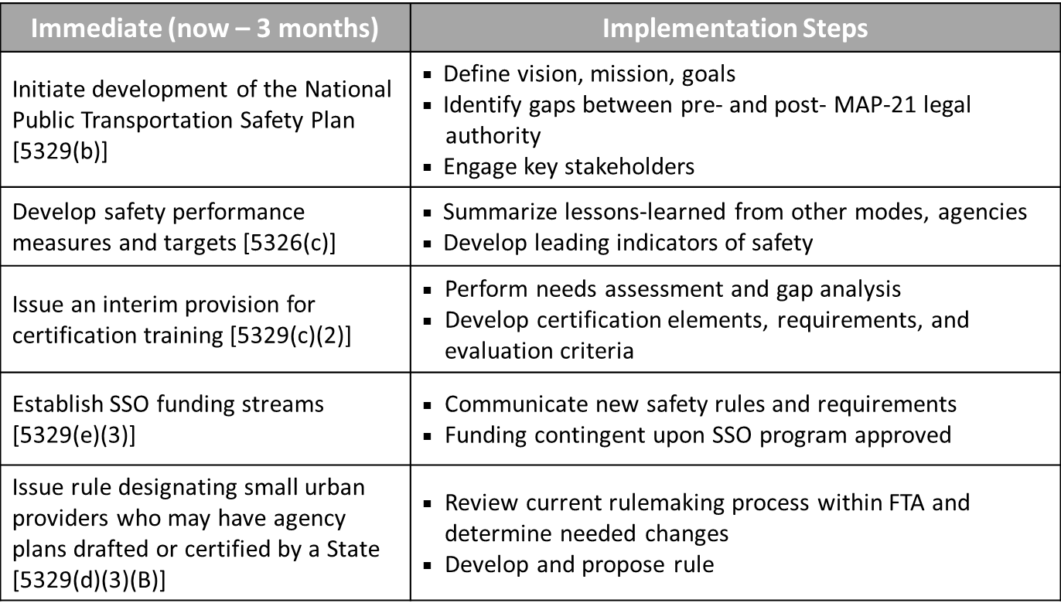

Figure : Immediate next steps for FTA's implementation of MAP-21 safety requirements

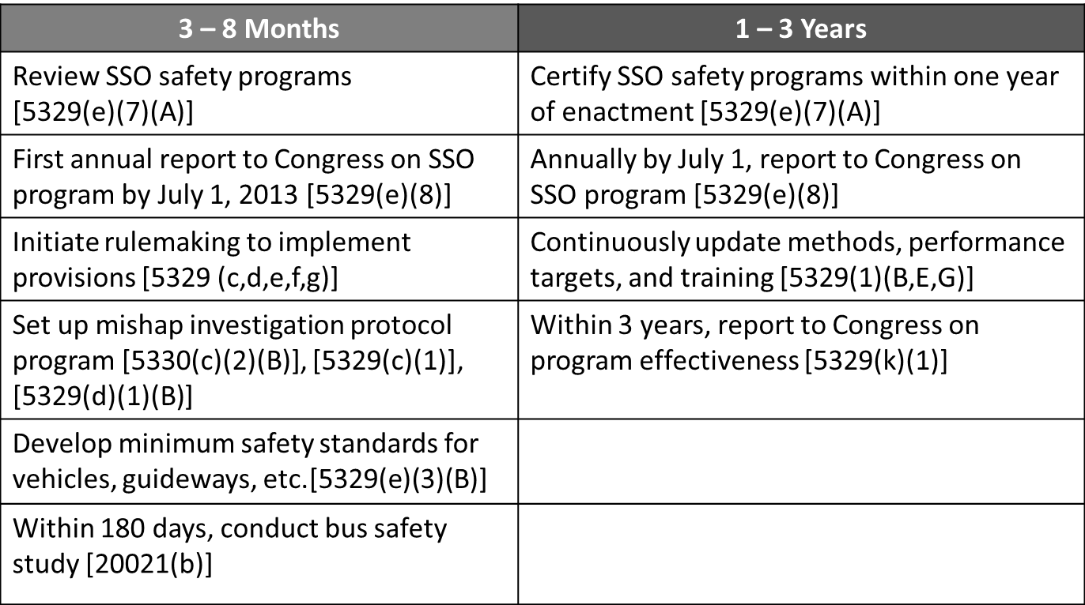

Figure : Longer-term next steps for FTA's implementation of MAP-21 safety requirements

### Questions and Discussion

Mr. Valdes, Administrator Rogoff, and other FTA representatives responded to questions from the TRACS members. FTA stressed that while would answer the TRACS members’ questions to the best of their ability, the agency’s thinking was still evolving, and that an important part of the TRACS meeting was for the TRACS to inform FTA’s thinking on these issues.

* Several TRACS members expressed concern that MAP-21 requires FTA to put systems and rules in place under tight time constraints. In particular, members expressed concern that FTA would be challenged to establish a safety training and certification program within three months.
  + Mr. Valdes agreed that the timing requirements may not be ideal, and that FTA would appreciate the assistance of the TRACS in this area.
  + Administrator Rogoff commented that not all the elements of MAP-21 were passed as envisioned by FTA. For instance, FTA requested that Congress allow for 100 percent of the SSO program to be paid for with federal funds. However, Congress chose to require a 20 percent non-federal match. To help States prepare, FTA has transmitted a letter to State Governors that are impacted, asking them to prepare and budget for this requirement. There are several questions related to the SSO certification requirement that the TRACS can help inform, including what SSOs will be expected to do with the funding provided. However, it is also important to remember that many SSOs have problems that funding cannot solve.

There are also aspects of the timing of the MAP-21 requirements that will be challenging to meet. However, while the TRACS should be mindful of the dates required in the legislation, the Administrator urged the TRACS to be primarily concerned with helping FTA implement the provisions in a logical way that will make sense for stakeholders in the transit industry and engender their buy-in and support.

* How will the existing standards for fixed guideway vehicles relate to the new public transit vehicle standards requirements in MAP-21?
  + Mr. Valdes indicated that in the case of fixed guideway vehicles, FTA intends to start with an analysis of current standards, but that FTA is interested in taking a systems approach to vehicle standards.
* One TRACS member commented that the use of the term “Safety Certification” has a different connotation in the transit industry and recommended using a different term.
  + Administrator Rogoff indicated that this language was included in the MAP-21 legislation, and therefore, FTA does not have the power to change it. However, the agency will be careful to be clear about what is meant by this term in the context of MAP-21 and future rulemakings.

* Can you expand on the rule for designating small urban providers who may be allowed to have safety plans drafted or certified by a State?
  + Dorval Carter, FTA Chief Counsel indicated that the MAP-21 statue is very broad in this area and that FTA will need to develop guidance on which particular transit providers will need to go through the safety planning process (as opposed to having the plan drafted by the State).

* How will the smaller, more rural states receive safety support from the FTA Regional Offices?
  + Administrator Rogoff indicated that FTA’s new safety mission would infuse and inform everything the agency does. For example, the Administrator will insist that regional safety managers report directly to the regional administrators. The reason for this is because in many cases the most important conversations happen between a transit system and the regional administrator.

* One TRACS member commented that many of the SSO agencies currently use contractors to perform safety audits, and that in these cases it becomes a for-profit, rather than non-profit enterprise. The member asked if this is one of the things FTA is concerned about for SSO certification.
  + FTA representatives indicated that standards for in-house vs. contracted roles and responsibilities could be included in the SSO certification standards.
* Several TRACS members congratulated FTA for successfully asking Congress to grant expanded safety oversight in MAP-21. They indicated that it would be important for the TRACS members to both contribute to the implementation effort and to communicate the importance of this effort to their executives and governing boards.
  + Several TRACS members also indicated that assistance will be needed from FTA to effectively communicate the new safety oversight and regulations to transit agency executives and governing boards.

## Framework for MAP-21 Implementation

Robert Johns, Director and Associate Administrator of the U.S DOT John A. Volpe National Transportation Systems Center (Volpe Center) addressed the TRACS. Mr. Johns commented that the Volpe Center had a long relationship supporting the work of FTA, but had not supported the agency in the area of safety management. However, with the expanded safety oversight role granted by MAP-21, the Volpe Center was excited to be working with FTA in this area, as it had with the Federal Aviation Administration (FAA), Federal Motor Carrier Safety Administration (FMCSA), and Federal Railroad Administration (FRA) for many years.

Mr. Johns echoed the FTA Administrator’s earlier comment that a logical framework for implementation would be the key to a successful launch of FTA’s new safety programs, and indicated that he hoped the framework he presented would help trigger a discussion on how best to do this.

### Presentation: Framework for MAP-21 Implementation

Mr. Johns presented a framework and work breakdown structure (WBS) for FTA’s implementation of the MAP-21 safety requirements, developed by the Volpe Center.

The framework for implementation of MAP-21 should be guided by a philosophy that: **development of a world-class transit safety program should be accomplished through a tailored Safety Management Systems (SMS) approach**. This philosophy was further developed with six guiding principles:

1. Respond to all of MAP-21 requirements in a timely manner
2. Design near-term deliverables to ensure long-term success
3. Develop a program that will continuously evaluate itself and improve over time
4. Collaborate with multiple stakeholders to support, inform and review planning products
5. Follow strategic vision, mission, and performance goals
6. Assist, certify and fund State Safety Oversight (SSO) programs

As the TRACS indicated in its SMS letter report, strong safety programs are not just a matter of good systems, they require committed leadership and a strong safety culture as well. With its Safety Management Maturity Model, the TRACS showed how these elements can build over time, from modest beginnings to a more robust model. He indicated that any implementation framework that Volpe and FTA develop will be based on these concepts and the other recommendations TRACS has provided to date.

#### SMS Framework Supporting Transit Safety

The Volpe Center and FTA developed an SMS framework for supporting transit safety. It is a formal, top-down, business-like approach to managing safety risk. The model featured:

* An emphasis on safety culture
* Proactive hazard analysis
* Use of performance measures and leading indicators
* Formal data collection
* Voluntary reporting
* Continuous learning and communications

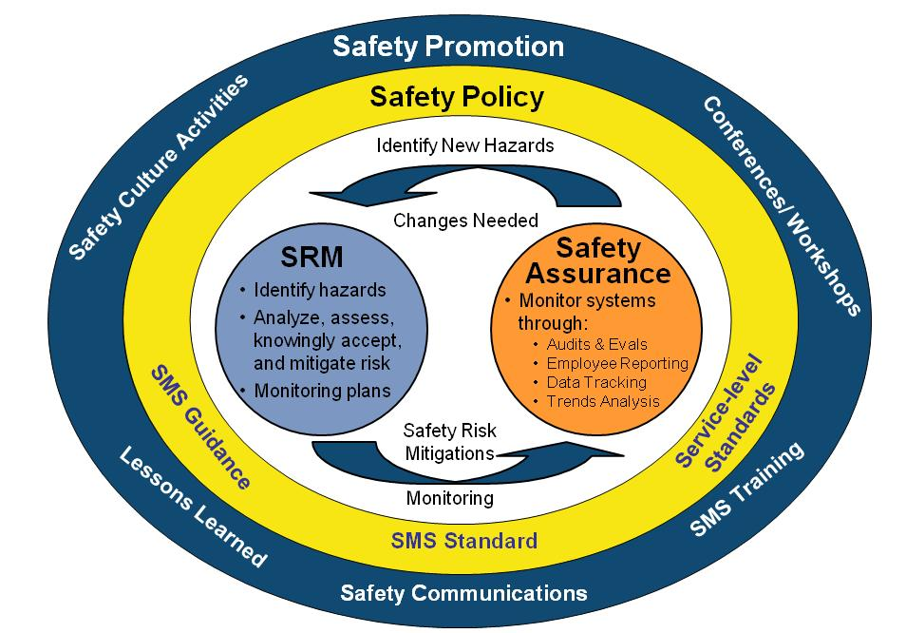

Figure : Safety Management Systems (SMS) Framework Supporting Transit Safety

#### Work Breakdown Structure

The Volpe Center and FTA identified the major activities that are needed to implement the MAP-21 safety provisions and organized them in a WBS. The WBS provided a way to understand the various program areas that would be needed to accomplish the complex task of MAP-21 implementation. While the WBS identified and categorized the major activities FTA would need to undertake, the activities had not been prioritized or integrated into a schedule. Input from the TRACS would help inform their prioritization.

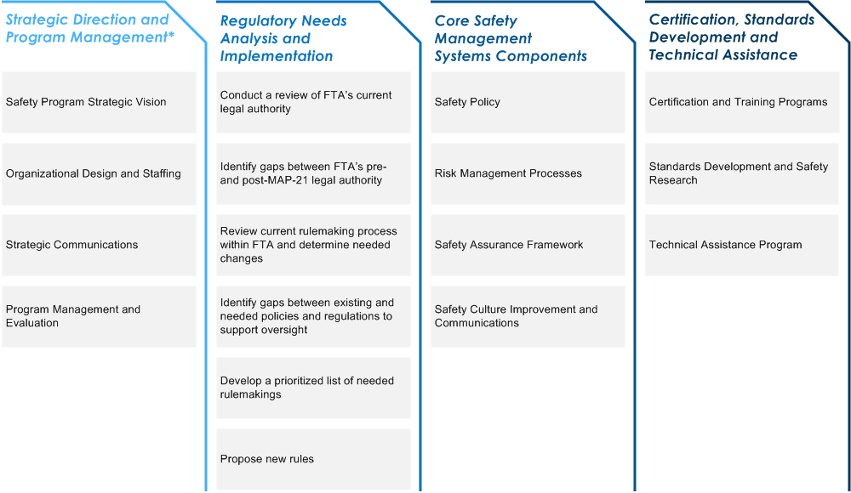

Figure : Work Breakdown Structure for Implementation of Transit Safety Provisions in MAP-21

Strategic Direction and Program Management

* It is very important that the implementation of the MAP-21 safety provisions be driven by a strategic vision and program mission. This will help us set meaningful goals.
* Organizational design and staffing is critical so we have the people it needs to do the work.
* Strategic Communication is necessary to ensure that all the different actors and stakeholders can work together and understand their respective roles in the process.
* Program management and evaluation is needed so we can tell if we are making progress towards the broad goals and objectives we define.

Regulatory Needs Analysis and Implementation

* We need to conduct a review of FTA’s current legal authority and identify any gaps between existing authority and the post-MAP-21 legal authority of the agency.
* The current rulemaking process should be reviewed and any changes needed to support MAP-21 implementation should be identified.
* A gaps analysis should be performed between existing and needed polices, and regulations to support FTA’s safety oversight responsibilities.
* We need to develop a prioritized list of needed rulemakings and then move forward to propose new rules.

Core Safety Management Systems Components

The first two program areas in the WBS set up the core work, which falls into this program area.

* One key component is to establish a Safety Policy. The major part of this will be the National Public Transportation Safety Plan, which is required by the MAP-21 legislation. This should also include performance measures.
* Another component is to set up a Risk Management Process. In the most mature models, voluminous data about incidents, fatalities and other safety indicators are collected and analyzed to determine risks, so corrective actions can be prioritized.
* We will need to develop a Safety Assurance Framework that puts the policies and procedures in place to facilitate robust safety practices throughout the industry. Close call reporting is an example of what could be included in this area.
* Safety Culture Improvement and Communications is another key component of this program area. We are recommending that there be a national assessment of safety culture, both at FTA and at the transit agencies. This will help determine what steps are needed to be taken to establish a robust safety culture throughout the industry

.

Certification, Standards Development and Technical Assistance

* MAP-21 requires certification and training programs. To put these programs in place we will need to develop certification criteria, design training, and tailor the training to specific audiences. This could also include training for transit agency executives and governing boards.
* Research may be needed to develop standards and to determine what long-term research needs could benefit the safety program over time.
* In order to create safety assurance for all the different types of transit, technical assistance will be needed at various different levels, tailored to the unique aspects of each system.

### Discussion

Mr. Johns indicated that the Volpe Center was working with Mr. Valdes to organize the activities in the WBS into a list of finer-grained activities which could be mapped to deadlines and used to create a critical path diagram. He indicated that they would like to discuss the proposed activities with the TRACS and hear its input on what the work priorities should be.

* The TRACS members indicated that it would be helpful to see the more detailed breakdown of activities, and that the recommendations of the TRACS should be mapped to these activities so the committee could see how FTA and Volpe propose to incorporate them into the implementation work plan.

* One TRACS member commented that the WBS is a good starting point, but that the follow-through and implementation of the plan needs to include input and buy-in from all stakeholders to actually lead to improvements in safety.
* TRACS members stressed the importance of providing training for transit agency executives and governing boards, and that such training should be mandatory. They indicated that training at this level would be essential to achieving buy-in from transit agency leadership.

## TRACS Committee Membership

MAP-21 includes a mandate for FTA to oversee and regulate safety aspects of all modes of public transportation. As the name of the committee implies, the TRACS was established to focus primarily on rail transit safety. Mr. Valdes indicated that FTA would appreciate the input of the TRACS on how the committee should evolve in light of the expanded mandate in MAP-21.

* The name of the TRACS may need to be changed. However, this is not a high priority.
* One member suggested establishing a standing subcommittee on bus transit.
* One member suggested including more representation from SSO agencies on the TRACS.
* Ms. Davidson indicated that the current composition of the TRACS includes significant experience in the areas of bus transit and paratransit. Approximately 50 percent of the TRACS membership included current or past experience in these areas. Therefore, the general composition of the TRACS may not need to be significantly altered to provide FTA with advice related to non-rail modes.
* When additional mode-specific expertise is required, the TRACS may be able to include outside experts through membership in one or more of the working groups.

## Group Discussion of Program Area Activities and Priorities

Mr. Bryan led the TRACS in discussions of the activities presented in the WBS. The major tasks for the TRACS during these discussions was to provide input on what FTA’s priorities should be, and then to determine what role the TRACS could play in helping accomplish the list of work that was presented in the WBS. Mr. Bryan indicated that additional working groups would likely need to be created to address specific tasks, and that these working groups could involve additional experts that are not TRACS members. Comments from all TRACS members and FTA representatives are summarized below.

### National Public Transportation Safety Plan

Mr. Valdes indicated that the NPTSP will be the primary interaction that FTA will have to give broad guidance to local agencies. The agency-level plans required by MAP-21 will be required to be consistent with the NPTSP.

Mr. Carter reviewed the major elements that the NPTSP will include (see page 9) and indicated that the goal of FTA is not to develop a one-size-fits-all system that all transit agencies will need to fit into. Rather, FTA intended to use the NPTSP to provide transit agencies with the information they need to know in order to develop a successful agency-level plan. This would require finding the proper balance between prescriptive requirements that tell an agency what it needs to do, and flexibility that allows an agency to decide what is needed for its unique circumstances.

The TRACS discussed the role it might be able to play in the development of the NPTSP. Several members indicated that TRACS could play an important role in helping develop the plan, or portions of the plan. Additional comments included:

* The basis for the agency safety plans could be the existing System Safety Program Plans (SSPP).
  + The SSPP could be a starting point, but these could be improved with the addition of standards and requirements. When possible, Federal standards should be developed to help guide agencies during the design process.
  + The SSPPs currently include 21 elements, but not all of the TRACS SMS letter report elements are included. One approach could be to start with the existing 21 elements and add the TRACS SMS letter report elements to improve the existing framework.
  + One member indicated that the SSPPs should not be the basis for the agency safety plans. As currently designed under 49 CFR part 659, they are just a piece of paper.
    - FTA reminded the committee that it need not be restrained by existing regulations. FTA encouraged the TRACS to take a reductive approach, starting from a blank slate, and then later to review existing requirements to make sure the good parts were properly included in the new approach.

* TRACS could establish a working group to concurrently develop the NPTSP and the agency safety plan elements that will be included in the NPTSP. If possible, this should be a more collaborative working relationship between the TRACS and FTA. In the past, TRACS has worked independently and provided recommendations to FTA through letter reports. If the TRACS will participate in the NPTSP development, there may be a need for more back-and-forth iteration.
  + FTA indicated that there would come a point in the process where the formal rulemaking will interest with the development of the NPTSP and agency-level plan requirements. At that time, FTA would need to establish rules to keep these processes separate.

* The NPTSP needs to accommodate the differences between systems and modes. The NPTSP should develop a framework that identifies the essential elements for all modes, and then provide information that is scalable and customizable to account for the numerous variances between systems.
* MAP-21 provides an opportunity to engage in a national dialogue with respect to safety. The SMS letter report could be the basis for this dialogue.

* Safety reporting standards should be unified. Currently the NTSB and FTA have different thresholds and reporting standards. It would be ideal to have one report that would satisfy the needs of FTA, NTSB and all others.
* FTA’s regional engineers should be engaged to help with the development of standards. This would take advantage of an existing FTA resource and also provide a meaningful link to the FTA Regional offices.
* The most effective way to improve safety is to provide financial incentives to agencies that do a good job. FTA and TRACS should determine if it is possible to provide financial rewards to transit properties that demonstrate that they have improved safety. However, this would require a careful redefinition of what constitutes a safe system. Perhaps the criteria could be the number of hazards identified and eliminated? This would provide a financial incentive for an agency to move up the safety maturity model.
* If we want a world-class safety plan then we need to spend some time to look at what others are doing around the world in this arena.
* Agency safety plans should go through the SSO agency before being transmitted to FTA.

### National Database of Safety Incidents / Risk Management Models

* The national incident database should be part of the overall risk management system.
* If possible, the national incident database should include close call reports as well as accidents or other reported incidents. Ideally, there would be a way to analyze all of these events together. This integration should happen at the local agency level and be either recommended or mandated at the national level.
* Public transportation safety includes all modes, and there are interactions between the modes. We need a systems approach to safety so we don’t end up looking at one mode in a vacuum. For instance, the main safety issues associated with bus safety are related to highways: traffic, intersection design, roadway design, etc… Many of these issues are beyond the purview of the public transportation agency, and require coordination with regional and state transportation agencies. For this reason, we should consider the role of the Metropolitan Planning Organization in a systems approach to public transportation safety. This is a level at which FTA and the Federal Highway Administration (FHWA) already works together, through the MPO certification process.
* There is an opportunity to develop a national risk management model for public transportation based on the national database of incidents. Although this is being done at the agency level, there may be an opportunity to take advantage of a national economy of scale to do something more state-of-the-art. Models may need to be developed for a range of different agency types and transit modes.

### SSO Certification

FTA clarified that while MAP-21 requires safety oversight for all public transportation modes, it does not require that the SSO agencies, originally set up for rail transit oversight, be the required to take on oversight for other modes. In some cases, the oversight responsibility for non-rail modes may be taken on by the State or by FTA directly.

FTA has not yet prescribed a methodology for determining what entity will take on non-rail oversight responsibilities. However, it is likely that the larger non-rail operators will be expected to report directly to FTA. The smaller and rural operators may be taken on by the States, the SSO agencies, or through some other mechanism.

The TRACS discussed the SSO-related aspects of the MAP-21 safety provisions:

* Page three of the TRACS SSO letter report describes the functions that a good working SSO needs to do in order to be effective. FTA should use this as a starting point and require that all SSO agencies perform these functions.

* The biggest challenge right now related to SSOs is that many of the SSO agencies use contractors to perform the audits. The contractors travel around the country auditing different systems, but they never learn the details and special circumstances of each system.
  + One TRACS member commented that in his agency’s case, the SSO agency does not use contractors for auditing and that because of this, the SSO employees have learned a lot about the RTA’s system. This should be considered the ideal modes (where the SSO employees perform the audits).

* + One TRACS member commented that there should be a limit on the number of years that a consultant can perform auditing for an SSO agency.
* The certification standards for SSOs should include a requirement of financial independence from the agencies being overseen.

* + There was some confusion among the TRACS members as to when the MAP-21 requirement for SSO financial independence will take effect. Mr. Carter clarified that SSO agencies will be required to be financially independent, but not until after FTA has established a formal rule.
  + The TRACS formally requested that FTA issue a “dear colleague” letter to the SSOs and RTAs in order to correct any misinterpretation of this requirement. FTA agreed.

### Employee Training

Ruth Lyons summarized the MAP-21 employee training requirements, and FTA’s initial approach to implementing them:

* MAP-21 requires training for the SSO agency, Federal, and transit agency employees that have safety oversight responsibilities. FTA has begun to identify the universe of everyone that is affected by this provision and define a list of roles. The next step is to develop working groups to identify the competencies of each role. The competencies are the key to the training program, because from the training standards will be based on the competencies.

* MAP-21 requires that interim training provisions be in place by December 31st, 2012. FTA is working hard to meet this deadline.

The TRACS commented on the employee training provisions in MAP-21:

* The groups of people that need training should be identified (roles), but FTA should also identify the level of training needed.
  + Once the competencies are identified, FTA is considering developing coursework for three levels: 1) awareness, 2) core competency, 3) technical expertise. FTA will also consider establishing an equivalency standard for employees that have been in the industry for years. Defining the equivalency standard will be part of the job of the competency working groups.

* There are currently four courses that are required for SSO employees to take. FTA should consider making them required for employees at the transit agency level as well. This may be a way to quickly meet the 90-day implementation timeframe for interim training provisions in MAP-21.
  + Some RTAs have already paid for employees to go through these training courses, despite the lack of a requirement. If the training requirements for transit agency employees do not include these courses, RTA employees that have completed them should be grandfathered in, as appropriate.

* + One TRACS member commented that these courses should not constitute the entire training requirement for transit agency employees.

* Grants should be made available to transit agencies to support the training of employees, similar to the funding that will be made available to States to support the training of SSO employees.

### General Comments

The TRACS discussed other aspects of MAP-21 safety provision implementation:

* In regards to preemption of safety requirements by State law or regulation, there is a discrepancy between what the TRACS recommended in the SSO letter report and what was included in the legislation. The TRACS recommended that the States be given the freedom to enact regulations that are stricter than the FTA regulations. However, instead of providing the States with this preemption authority, MAP-21 only provides it to the Secretary of Transportation. California and some other States may wish to enact stricter regulations.

* MAP-21 includes a requirement for FTA to set up a “mishap” investigation protocol. The committee agreed that the term “mishap” has no generally accepted definition in the public transportation industry.
  + FTA requested the assistance of the TRACS in interpreting the meaning of this term.

* FTA plans to conduct a confidential safety climate assessment at FTA, SSO agencies, and transit agencies to establish a baseline measure for safety culture. This came from a TRACS recommendation in the SMS letter report.
  + The assessment should be done by a neutral, third party.
  + One TRACS member commented that a survey is on the low end of the spectrum for what could be done to assess safety culture. It may be possible to develop a more innovative approach, such as the use of emotional intelligence test, tailored to safety issues.
  + One TRACS member commented that his RTA recently conducted an employee safety survey, and found the results very valuable. However, to incentivize employee participation, the RTA had to offer prizes and pay the employees for their time.
  + A Transportation Research Board (TRB) group is currently working on developing a model for implementing a safety culture at a public transportation agency. There may be an opportunity for TRACS to contribute to this effort.
    - Transit Cooperative Research Program (TCRP) study #835 will produce a safety culture survey. The study will evaluate all existing off-the-shelf products that would be applicable to the transit industry.
* MAP-21 requires that an “adequately trained safety officer” report directly to the transit agency chief executive officer (CEO). FTA should clarify what this means, ensuring that this officer must be empowered to make decisions related to safety within the organization. It cannot be someone without real safety responsibilities.

## Day One Closing Thoughts

Mr. Bryan concluded the first day of the TRACS meeting with a brief discussion of the potential roles for TRACS in supporting FTA’s implementation of the MAP-21 safety provisions.

The FTA indicated that the TRACS could play a meaningful role in the development of the NPTSP. Specifically, FTA would like help from the TRACS to determine what level of detail would provide the correct level of specificity, but also allow agencies the flexibility to tailor things to their unique circumstances. While some elements of the NPTSP will need to be developed by FTA, the TRACS could play a strong role in at least two of the four elements.

The TRACS members indicated that it was difficult to assess where the TRACS could play a meaningful role without a complete outline of the work that needs to be done. Some TRACS members requested that FTA provide an outline for the NPTSP and other work products that the TRACS could help with. A gap analysis of regulatory authorities and development of a list of performance measures for public transportation safety were mentioned as additional areas that the TRACS may be able to support FTA.

# Day Two Proceedings

## Day Two Opening Remarks

Matt Welbes, FTA Executive Director addressed the group. Mr. Welbes thanked the TRACS members for their service to FTA. He indicated that although MAP-21 was only 60 days old, FTA has been working internally to develop plans for how to stand up the new safety and oversight program required by MAP-21. He indicated that the contribution of the TRACS would be tremendously valuable to FTA in this effort. Implementing the new safety authority is FTA’s number one priority from MAP-21.

## Concept for a National Public Transportation Safety Plan Outline

In response to TRACS member comments during the Day One discussions, Jeffrey Bryan, presented a draft outline for the National Public Transportation Safety Plan based on the previous day’s discussion, and the structure of RTA safety plans currently required under 49 CFR Part 659. The outline was presented as a starting point, or “straw man” to facilitate discussion, not to constrain the work of the TRACS in any way.

#### Draft National Public Transportation Safety Plan Outline

1. **Safety Philosophy and Vision**
   1. SMS Principles
   2. Asset Management/Maintenance Principles
      1. State of Good Repair Definition
   3. National Risk Management Approach (e.g., CSA 2010 for Motor Carriers)
2. **Program Goals**
3. **Standards**
   1. Performance Criteria
   2. Performance Standards and Certification Requirements
      1. Leadership
      2. Safety Culture
      3. Vehicle
      4. Maintenance of Way
      5. Infrastructure
      6. Learning Organization
      7. Hazard Management
      8. Safety Assurance
      9. Enforcement
4. **Agency Safety Plan Elements**
5. **Training and Certification Plan**
6. **Program Evaluation**

## Comments on the Draft NPTSP Outline and Priorities for Future Taskings

Ms. Davidson suggested that the each committee member be given time to express comments on the draft outline for the NPTSP and state their priorities for future TRACS work. The TRACS agreed and proceeded as suggested, with each member providing brief comments and suggesting potential work areas. Comments from all members are compiled and summarized below:

#### NPTSP Outline Comments

General Comments

* The NPTSP should provide a model for the public transportation agencies and States, but should be at a high, strategic level. Each of the areas listed in the outline should be included, but it unclear to what level of detail they should be addressed in the national plan. The document should lay out the structure of elements that will eventually be included in the formal rulemaking, so that the two work together and complement each other.
* The NPTSP task as defined by MAP-21 is a bit odd because it should be a high-level strategic plan, but MAP-21 also requires that it include vehicle standards, so it is a blend of macro and micro.
* Some of the terms used in the outline are inconsistent with the common usage in the industry. We should be careful to use the commonly accepted terms to avoid creating confusion.
* It is unclear if the draft outline will be sufficient to address all modes of transportation, as required by MAP-21. Additional topics may need to be added for bus and paratransit, among others.
  + New York’s SSO includes both rail and bus oversight, so they may provide a good model.
* Trend Analysis should be a discrete topic.
* Will security be included in the NPTSP alongside safety?
* MAP-21 doesn’t talk about labor at all, but getting the front-line employees involved in this process is critical for it to succeed. We should be taking a two-pronged approach, from the top-down and from the bottom-up.
* The plan outline doesn’t include any mention of safety innovators. The plan should include case studies of innovative and successful safety practices in public transportation.
* FTA should look to tie funding to safety in whatever ways possible, either through incentives or enforcement.
* All of the recommendations from the SSO and SMS letter reports fit into the work breakdown that was presented on Day One. FTA should work hard to incorporate all of these recommendations into their work. In many cases, TRACS has already provided guidance on these issues.
* The plan should include a description of how public transportation safety is financed and an overview of the existing system.
* The plan should include a description of the organizational relationships between the FTA, National Transportation Safety Board, State Departments of Transportation (DOTs), Metropolitan Planning Organizations (MPOs), and public transit agencies.

Philosophy and Vision

* The NPTSP should link to overall transportation safety (all modes)
* TRACS could help by defining the overall outcomes that transit safety oversight should achieve and work backwards from there to develop goals and objectives.
* The vision needs to be very clear and concise

Enforcement

* Enforcement should be a stand-alone section underneath program evaluation.
* TRACS should not address enforcement until the standards and rules have been developed.

State of Good Repair

* Former Secretary of Transportation Peters provided a possible starting point for a definition of State of Good Repair in a July 25, 2008 letter to House and Senate committees with transportation oversight responsibilities:
  + “A condition in which the existing physical assets, both individually and as a system, (a) are functioning as designed within their useful lives and (b) are sustained through regular maintenance and replacement programs; state of good repair represents just one element of a comprehensive capital investment program that also addresses system capacity and performance.”
  + Mr. Valdes indicated that FTA is working on a definition for its State of Good Repair program, and that this definition will affect other areas beyond safety.

Standards

* The Standards categories could be combined into more general concepts (i.e., Leadership and Safety Culture).
* The group discussed the difficulty of determining performance measures for abstract concepts such as Leadership and Safety Culture. Although some members expressed concern that viable standards could not be developed, other members indicated that these areas are where the biggest safety improvements can be realized and that although it may be difficult, developing these standards could be a key contribution of the TRACS.
  + The British Office of Rail Regulation’s *Railway Safety Principles and Guidance* was mentioned as an example that may provide a viable approach.
  + One member commented that standards for Leadership and Safety Culture might fit better within the Philosophy and Vision portion of the document.
  + Some members suggested writing roles and responsibilities for leadership participation in safety meetings, inspections and audits as a standard that must be met.

* Several TRACS members indicated that engineering requirements should be integrated into all standards. In particular, members expressed concern that there is a temptation in the industry to design systems to a budget, rather than to a safety standard. Safety is an area often during value engineering.
  + Members mentioned that the American Public Transportation Association has developed good standards in this area that have already been adopted by some agencies. FTA should consider incorporating these into the Federal standards.
  + One member mentioned that FTA’s Project Management Oversight Contractors (PMOC) could be a resource for helping develop engineering standards. This could also be a way to engage the FTA Regions.
* Operations Performance standards should be included. This should include signal and traffic control systems and recovery systems and procedures.
* Track standards should be high on the list. Furthermore, the standards should consider the vehicle and the track and other related systems together, as one functional unit, not strictly independently.
* Human Factors issues (operators and operations control) should be added.
  + Drug and Alcohol standards and Medical Fitness for Duty should be included. This should include pre-employment qualification standards as well.
    - This is an important national problem. Although enforcement is part of the solution, education, prevention and treatment is where the most attention should be paid.
    - Learning from what FRA did in this area, FTA should consider a standard that focuses on conditions that could lead to sudden incapacitation. Otherwise, the list of disallowed medications and medical conditions will be so long that no one will be allowed to work.
* National standards across the industry are very important. In the current environment, where no Federal standards exist, transit agencies have a difficult time justifying safety-related actions. In some cases the public doesn’t see the need for action, in other cases agencies are pressured to go farther than is necessary.

* TRACS should focus on what the standards should be for the agency-level plans. This needs to be part of the NPTSP.

SSO Certification

* Should include a mechanism for ensuring that SSO personnel have a minimum level of expertise and experience. Ideally, FTA would work with universities to develop a curriculum so that individuals could choose a career in transit safety oversight and receive specialized instruction. This would provide agencies with a certification they could rely on when hiring.
* The NPTSP needs to include more specificity with regard to overall oversight responsibilities for the SSO. Many of the standards and SMS principles are important for the SSO as well as the transit agency (i.e., Safety Culture, Organizational Learning).

Training

* A national training course needs to be developed for leadership at transit agencies (i.e., CEOs and board members). Agencies will require outside help to communicate the new safety standards and requirements.
* Most university coursework focuses on highway safety. There is a definite need to develop transit safety coursework.
* MAP-21 requires training and certification for SSO employees, not for public transportation agency employees. We should caution FTA to not require certification of agency employees

#### Priorities for Future Taskings

Ideas for working groups were suggested by TRACS members during the comment period. These suggestions were voted on by the TRACS members via secret ballot. Each member was asked to indicate his or her top four priorities from among the areas listed below. The votes were tallied by Kevin McCoy, the meeting recorder. The four working group suggestions that received the highest number of votes are indicated in parentheses in the list that follows.

* National Public Transportation Safety Plan (#1)
* State Safety Oversight Agency Program and Certification Requirements (#2)
* Public Transportation Agency Safety Plan Requirements and Program Evaluation (#3)
* Training and Certification (#4)
* Standards
* Safety Culture and Close Call Reporting
* Performance Indicators/Management/Data Collection and Analysis

Ms. Davidson asked for feedback from Administrator Rogoff on the priorities developed by the TRACS. Mr. Rogoff indicated the FTA is comfortable with the TRACS priorities and suggested that FTA work through Mr. Valdes and Ms. Davidson to determine which TRACS members are interested in participating in which working groups, what the taskings will be for each group, and when a deliverable should be expected. The committee voiced no objections.

Ms. Davidson indicated that TRACS members interested in leading a working group should express their interest to her.

## Public Comment Period

Ms. Davidson made a call for comments from the public. None came forward to comment.

## TRACS Committee Membership

Mr. Rogoff indicated that while the tenure of some TRACS members may soon be up, FTA will extend the tenure of TRACS committee members that are participating in working groups as needed, until the working group task is complete.

FTA will also consider adding new members or adjusting the composition of the committee to make sure that non-rail public transportation modes are well represented on the committee. However, as was discussed during day one of the meeting, many of the current TRACS members have significant experience with bus transit and other modes of public transportation. FTA will also seek input on non-TRACS members that could participate in one of the four working groups identified by the TRACS, to provide specialized expertise. One member also suggested including representation from the vehicle manufacturing industry as future working group participants.

## Conclusion

Ms. Davidson thanked the TRACS members, and adjourned the meeting.