OVERVIEW

BACKGROUND

The Federal Transit Administration (FTA) examines grantee performance and adherence to current FTA procurement requirements and policies using several management tools. FTA is required by 49 U.S.C. §5307 to perform reviews and evaluations of grant programs and to perform a full review and evaluation of the performance of grantees in carrying out grant programs with specific reference to their compliance with statutory and administrative requirements. Accordingly, FTA will perform procurement system reviews as part of its on-going oversight responsibility. The review process assesses the grantee's procurement management practices and program implementation of the FTA funded transit programs to ensure they are being administered in accordance with specific FTA procurement requirements.

WHO SHOULD ATTEND?

These workshops are for transit professionals responsible for procurement management or managing federally funded projects and professionals responsible for contracting or purchasing transit service or the activities that support the transit service. The workshops are designed to help attendees broaden their understanding of the Federal procurement rules and regulations that shape and define their programs. Case studies and exercises will be included to offer examples of acceptable and unacceptable practices.

WORKSHOP LEADERS

The Procurement System Review Workshop will be conducted by transit professionals, who are also reviewers for the FTA's Procurement System Review Program. The instructors will provide guidance in each of the 56 areas to be reviewed, answer questions about how to respond to specific review areas, and share industry best procurement practices. Staff from the FTA will attend the Workshop to answer questions about the Procurement System Review, assist you in any area related to your use of FTA funds, and refer you to printed guidelines or other resources should you require additional information.

WORKSHOP AGENDA

DAY 1 Wednesday September 15, 2010

8:00 am Participant Check-in / Breakfast

9:00 am Welcome and Introductions

9:15 am Presentation of FTA requirements in the areas of PSR Process, System Wide Procurement Elements, Written Standards of Conduct, Protest Procedures, Contract Administration System, Prequalification, Efficient and Economic Purchases. Participant questions and group discussion.

12:00 pm Working Lunch – American Recovery and Reinvestment Act (ARRA) Implementation.

1:00 pm Presentation of OMB ARRA Accountability Objectives, ARRA Management Challenges as identified by the Office of Inspector General, DOT, Oversight and/or Technical Assistance of ARRA-funded projects. Participant questions and group discussion.

Presentation of FTA requirements in the areas of Independent Cost Estimates, Arbitrary Actions, Brand Name Restrictions, Price Quotations, A&E Geographic Preferences. Participant questions and group discussion.

4:30 pm Adjourn

DAY 2 Thursday September 16, 2010

8:00 am Breakfast

9:00 am Presentation of Written Procurement Selection Procedures and Competitive Procurement. Participant questions and group discussion.

Presentation of FTA requirements in the areas of Buy America, Debarment and Suspension, Award to Responsible Contractors, Fair and Responsible Price Determination, Bid Opening, Cost/Price Analysis, Written Record of Procurement History. Participant questions and group discussion.

12:00 pm Lunch on Your Own

1:00 pm Presentation of Most Common Procurement Findings and Resolution of Findings, and PSR Follow - Up Reviews. Participant questions and group discussion.

3:00 pm Wrap-Up, Program Evaluations, and Feedback

4:00 pm Adjourn

HOTEL INFORMATION

The two-day Workshop will be held at the following location:

CROWNE PLAZA Kansas City DOWNTOWN HOTEL
1301 Wyandotte St
Kansas City, MO 64105
Tel: 816-474-6664
Fax: 816-474-0424
http://www.ichotelsgroup.com/h/d/cp/1/en/hotel/mkcws

ROOM RESERVATIONS INFORMATION

A sleeping room block of 5 Standard rooms (per night) at the rate of $107.00 per night (without tax) has been reserved for this workshop for the nights of September 14, 2010 and September 15, 2010. The cut-off date for accepting reservations into this room block is September 3, 2010. Reservation requests received after 5:00 p.m. local time at the hotel on the cut-off date will be honored at the group rate as long as guest rooms are still available. The hotel accommodations are for confirmed workshop attendees only. The workshop is free of charge but participants are responsible for making their own sleeping room reservations. Please do not reserve a room until you receive a “Confirmed for Registration” e-mail from Calyptus Consulting Group, Inc.

Participants can book, modify, or cancel guest room reservations by calling the Reservation Line at
1-816-474-6664 or toll-free at 1-800-2CROWNE between 7/26/10 to 9/03/10. To receive the special rate, participants should ask for the FTA – Procurement System Review (PSR) Workshop room block when making reservations.

PARKING

Self-parking is available at $13.00 per car per day for the event or $13.00 per car per day for overnight guests.

TRANSPORTATION TO AND FROM HOTEL

General Driving Directions

Head South on I-29/US-71 S. Take Exit 2B and merge onto US-169 S toward Kansas City Downtown. Continue on Broadway Blvd, turn left at W12th Street. Turn right at Wyandotte Street.

Driving Directions from Airport to the Hotel

From Kansas City International Airport (MCI)

Follow these directions to get to the Crowne Plaza Downtown Kansas City Hotel:
(Estimated Driving Time: 25 Minutes, Distance: 19 miles)

- Head east on International/International Square toward East Dr/North Dr 335ft
- Turn right at East Dr 223ft
- Turn left at International Cir/South Dr, Continue to follow International Cir 0.2mi
- Slight right at L P Cookingham Dr 1.3mi
- Continue onto NW 120th St 0.5mi
- Merge onto I-29 S/US-71 S via the ramp to Kansas City 10.7mi
- Take the exit onto US-169 S 5.6mi
- Continue onto Broadway Blvd 0.5mi
- Turn left at W 12th St 0.2 mi
- Turn right at the 2nd cross street onto Wyandotte St 486ft
Destination will be on the left

Other Types of Transportations from Airport to the Hotel

Taxi to and from the Hotel

On average, cab ride is approximately 30 minutes and costs about $43.00 per one way ride.

Shuttles:

Blue Van Super Shuttles are available from and to the airport. Charge per one-way trip is approximately $17.00 and reservation is not required. Exit the terminal and follow signs to the Super Shuttle stop. For more information, please contact Super Shuttle at 816-243-5000 or http://www.supershuttle.com/.

Metro Bus:

The Metro Bus operates to and from the airport Monday through Friday, with one-way fare of $1.50. Exit to the airport to Terminal C, take Bus No. 129 – I-29 Express/10th & Main, and get off at 11th at Wyandotte Westbound. Walk to the hotel.

Max Bus:
Max buses are accessible at Union Station with destination of 11TH at Main Street. A map is provided on the following page for your reference.

TRANSPORTATION AROUND THE AREA

Complimentary Local Area Shuttle is offered for transportation around the downtown area.

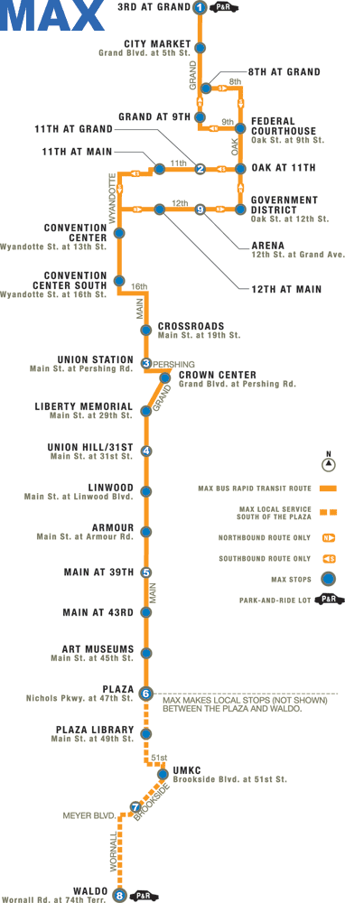

Get on at Union Station
Get off at 1tth at Main Street

REGISTRATION FORM

I will be attending the FY 2010 Procurement System Review Workshop. Please register me:

First Name:
Last Name:
Title:
Agency:
Street Address:
Street Address (cont'd):
City: State:
Zip:
Phone No.: Extension (if any):
Fax No.:
E–mail:
Special Needs (e.g., wheelchair access, hearing impaired):

Important Notes:

- This is an automated registration form. Please fill and review your entries carefully. After completing the form, please save the form and return it as an e–mail attachment to psrworkshop@calyptusgroup.com.

- You will receive two emails: (1) the first email is to acknowledge the receipt of the registration form; and (2) the second email is to confirm you are registered for the workshop. Please do not assume you are confirmed and registered until you receive the second email.

- Calyptus Consulting Group, Inc., a PSR Contractor, is organizing this event. If you have any difficulty returning the form by e–mail, feel free to print and submit by fax to Monika Gil at (617) 577-0042. You can also call her at 617-577-0041 for more information.

- Submit one form for each participant per guidelines on the previous pages.

- Please submit your registration by September 1, 2010. Early registration is encouraged as the number of participants is limited.

