Section Two

Development of Prototype Transit Frontal Collision Warning Systems

3 DEVELOPMENT OF A PROTOTYPE TRANSIT FCWS
In order to conduct field testing of different elements of the FCWS and for validation of the final requirement specifications, three prototype collision warning systems were developed. Because of the technical challenge for a transit FCWS to deal with the diversity of obstacles and the different traffic patterns in the urban environment, the emphasis of the prototype system development is placed on the investigation of a detection and warning algorithm. Based on a JDL data fusion model, a preliminary detection algorithm was developed that can track different obstacles within the field of sensor views and decouple the bus motion from the sensor measurements. A warning algorithm was also developed to incorporate a warning threshold synthesized from the drivers’ normal braking behavior.

This section will present the key tasks undertaken by PATH in the development of a prototype FCWS on SamTrans buses.
3.1 Hardware Configuration
The prototype transit FCWS was developed on a similar hardware platform as that of the DAS, which PATH had developed and installed on the SamTrans buses. For a full review of the development issues see Appendix V. Additional modifications to the DAS hardware arrangement included adjustment of sensor locations and the installation of the Driver-Vehicle-Interface (DVI).

To mitigate the influence of sensor errors upon algorithm performance evaluation, the prototype FCWS uses only lidars for object detection. The lidars’ measurement of object lateral position is much more accurate than that of the micro-wave radars. The micro-wave radars’ azimuth angle measurement is less satisfying. The bus speed and the steering angle information are used to predict the bus motion in the improved algorithm (the 2nd generation algorithm). All other sensors, the GPS, the accelerometer, the cameras, the throttle position sensor, and the brake pressure sensor, are not used in the algorithm and the data from these sensors is recorded. The data acquisition program runs in parallel with the prototype collision warning program on the same hardware platform. Raw data is recorded in the removable hard disks. The data is not only useful to verify the warnings, but also allows for collection of driver behavior changes in adaptation to the warning system.
3.2 The Transit FCWS Algorithm Architecture
The prototype FCWS algorithm was developed based on the data fusion and decision making model developed by the Joint Directors of Laboratories (JDL) data fusion sub-panel.
3.2.1 The JDL Data Fusion Process Model
The JDL data fusion model provides a top-level framework of data fusion systems, and defines terms commonly used in different areas. The top level of the JDL data fusion process model is shown in Fig. 1. A summary of the JDL data fusion process components is shown in. Table 15.
Fig. 1 JDL data fusion process model

Table 1 JDL process model components summary
SOURCE | The sources provide information at a variety of levels ranging from sensor data to a priori information from databases to human input.
PROCESS ASSIGNMENT | Source preprocessing enables the data fusion process to concentrate on the data most pertinent to the current situation as well as reducing the data fusion processing load. This is accomplished via data pre-screening and allocating data to appropriate processes.
OBJECT REFINEMENT  (Level 1) | Level 1 processing combines locational, parametric, and identity information to achieve representatives of individual objects. Four key functions are:  - Transform data to a consistent reference frame and units  - Estimate or predict object position, kinematics, or attributes  - Assign data to objects to permit statistical estimation  - Refine estimates of the objects identity or classification
SITUATION REFINEMENT  (Level 2) | Level 2 processing attempts to develop a contextual description of the relationship between objects and observed events. This processing determines the meaning of a collection of entities and incorporates environmental information, a priori knowledge, and observations.
THREAT REFINEMENT  (Level 3) | Level 3 processing projects the current situation into the future to draw inferences about the enemy threats, friendly and enemy vulnerabilities, and opportunities for operations. Threat refinement is especially difficult because it deals not only with computing possible engagement outcomes, but also assessing an enemy’s intent based on knowledge about enemy doctrine, level of training, political environment, and the current situation.
PROCESS REFINEMENT  (Level 4) | Level 4 processing is a meta-process, i.e., a process concerned with other processes. The three key level 4 functions are:  - Monitor the real-time and long-term data fusion performance  - Identify information required to improve the multi-level data fusion product, and  - Allocate and direct sensor and sources to achieve mission goals.
DATABASE MANAGEMENT  SYSTEM | Database management is the most extensive ancillary function required to support data fusion due to the variety and amount of managed data, as well as the need for data retrieval, storage, archiving, compression, relational queries, and data protection.
HUMAN-COMPUTER  INTERACTION | In addition to providing a mechanism for human input and communication of data fusion results to operators and users, the Human-Computer Interaction (HCI) includes methods of directing human attention as well as augmenting cognition, e.g., overcoming the human difficulty in processing negative information.
The JDL model is a generic model for common understanding and discussion. It has defined levels of processes to identify functions and techniques. The model has built a common base for researchers and system developers working in different areas. With the help of this model, we can adopt a lot of approaches and techniques developed for other applications, such as robotics, Computer Integrated Manufacturing Systems (CIMS), airport surveillance and air traffic control, etc., to develop a CWS.

The JDL model however, is not a universal architecture for real applications. It does not specify the level of data fusion. Data fusion level is an application-specific problem. To define the collision warning system architecture, analysis of the system function requirements is needed.
3.2.2 Function Requirements of Bus FCWS
All the functions defined in the JDL model, except level four are required in the bus FCWS. First of all, the source preprocessing must be performed to eliminate the unwanted signals and to detect the objects of interest. The sources here may include object sensors such as RADARs, LIDARs, SONARs, CAMs, GPSs, etc., and subject vehicle sensors such as speedometers, accelerometers, steering angle and braking pressure sensors, etc. Sensors are used to convert the measurable elements of the physical processes of the environment into electric parameters. The process to convert the physical process elements into electric parameters is observation. Some unwanted signals, such as pavement clutter, road-side trees and traffic signs, etc., and interference from the same kind of sensors mounted on other vehicles or from other sources, as well as noise from internal components of the sensor, must be suppressed, to pickup the real object signals. The preprocessing is the process to figure out, from one or more observations, whether an object exists or not, and to measure the status of the existing object.

The process to find out whether an object exists or not, is defined as detection. It is a probabilistic test of hypotheses. In the simplest situation, we have two hypotheses, H1 and H0, representing the object’s presence and absence respectively. The probability of being H1 while the object does exist, viz. probability of correct detection (Pd), is always less than 1. The probability of being H1 while the object does not exist, viz. probability of false alarm (Pfa), is always greater than zero.

The process to measure the object status, such as location and velocity, from the observations, is defined as estimation. The estimated parameters are random variables, because they are calculated from observations and the observations are random samples from a probabilistic set.

The results of detection and estimation are called measurements in this report. A measurement comes from single or multiple observations. Measurements, as functions of time, are stochastic processes in reality. Level 1 processing should then be performed to detect the processes and to estimate parameters of the processes. It is assumed in most cases that false alarms are less possible than real objects to form continuous processes. The detection of the process will eliminate the false alarms and determine when a process begins and when it ends. The estimation of the process will refine the measurements. The results of detection and estimation of processes are called tracks. The process to initiate, manipulate and end tracks is called tracking.

A track represents a stochastic process converted by a sensor from the physical process of an object. The parameters of a stochastic process are correspondent to the parameters (as functions of time) of an individual object. To develop a description of the current relationship among multiple objects and events in the context of their environment, level two processing is needed. Tracks from different sensors may represent the same object. These tracks must be fused into one track. This process is called track-to-track fusion, and the fused track is called the system track. After fusion, a system track usually is a refined unique representation of an object. The history of the tracks and the relationship among the tracks as an aggregation represents the scenario of the traffic. Once the scenario is described, level three processing is needed to assess the threats. Threat assessment is the process whereby the current situation is projected into the future to assess the severity of a potential traffic accident. Knowledge about vehicle kinematics, traffic, and the environment is needed for the assessment. Human behavior may also be used for this assessment. Once a potential threat is detected, a warning will be sent to DVI. Level four processing is not needed in an FCWS, because the developers of the system and the vehicle drivers will perform this function outside of the system.
3.2.3 Architecture of the Bus Collision-Warning Algorithm
Studies on collision warning/avoidance during the past few years have built a good foundation for the bus FCWS design. Individual sensors such as RADARs [3] and LIDARs [4] have been developed. Some sensors have been integrated with built-in Digital Signal Processors (DSP). The DSP’s can perform source preprocessing with some also able to perform level 1 processing. It is convenient to adopt these intelligent sensors in the bus FCWS. Threat assessment algorithms have been studied and various severity measures have been proposed, e.g. TTC [5,6], warning distance [7], warning boundaries [8, 9].

To develop a collision warning algorithm architecture from the JDL model, one of the key issues is to decide where in the data flow to fuse the data. We prefer the track-to-track fusion that matches the state-of-the-art technology of the sensors and helps us to concentrate our efforts on higher level processing. Fig. 54 is the block diagram of the bus collision warning algorithm architecture. For some sensors, lower level processes (source preprocessing and object refinement) may be implemented inside the sensors, though they are drawn apart from the sensors in the block diagram.
Fig. 2 Bus collision-warning algorithm architecture

3.3 The Preliminary Transit FWCS Algorithm
The algorithm framework was proposed on the basis of the JDL model. The functional requirements of the bus FCWS are partitioned into hierarchical levels in the algorithm framework, as illustrated in Fig. 55. This framework is almost the same as that in Fig. 54, except that in the preliminary FCWS algorithm, the gray background module, which is denoted by ‘linear long-term prediction’, replaces the scenario-parsing module. The linear prediction is based on the kinematical model and is scenario independent.
Fig. 3 Algorithm framework
The hierarchical framework determines the processing functions in the transit FCWS. It defines FCWS as a specific application of the multi-sensor data fusion JDL model described in the previous section. This makes it possible to utilize in the FCWS techniques already developed in a wide scope of data fusion research areas.

Object sensors, such as micro-wave radars and lidars, have built-in front-end signal processing functions. The algorithm to detect an object and that to measure the kinematic parameters of an object are not included in this report. Summarized in this report are the tracking algorithm and the threat assessment algorithm.
3.3.1 Tracking Algorithm
The block diagram of the tracking algorithm is illustrated in Fig. 56.

Fig. 4 Tracking algorithm diagram

In the diagram, the “track file” is a list of targets currently being tracked. Each target has a unique identification (ID), a status flag (tentative or firm), and a set of parameters estimated in the last step. The key module in the diagram is the “Kalman filter”. The system model for the Kalman filter is:

where, is the system state vector, whose elements are positions and velocities, is the measurement vector, A is the state transition matrix, C is the measurement matrix, and are zero-mean white system and measurement noises respectively.
The filtering algorithm is:

where, R and Q are covariance matrices of measurement and system noises, respectively, is the innovation vector, representing the new information in the latest measurement, is the innovation gain matrix, which is determined by the noise covariance matrices. The above Kalman filter assumes zero-mean noise input. This is usually not true for an automobile. Any kind of maneuvers, e.g. accelerating, decelerating or turning, may be non-zero-mean, and should be regarded as input. The “input estimation” module estimates maneuvers of the targets from the Kalman filtering error:

where is the Kalman filtering error, is the estimated input vector which is used to correct the Kalman filter output. This input estimator is a first order integrator.
The corrected output is saved in the track file under the ID of the corresponding target. If a target has not been updated for a certain number of cycles, it will be dropped out of the track file. In multiple target circumstances, there might be multiple measurements. It is unknown which measurement is generated by which target. This problem is solved in the “data association” module using the Nearest Neighbor (NN) data association criteria [10]. The measurements that are associated with tracks are sent to the Kalman filter. Those that are not associated with any targets are processed in the “track initiation” module to start new tracks.

Fig. 57 shows how the tracking algorithm manipulates multiple targets. The dots are measurements from a lidar in six second periods. The solid lines are tracks in the track file. At most sampling instances, there are multiple measurements. Accordingly, at most times during the six second period, there are multiple tracks. Each solid line links together a series of discrete dots, indicating good tracking. Sometimes, the measurement dots deviate from the tracks. The deviation is due to measurement errors, hard-to-track maneuvers and some unknown reasons.

Fig.58 plots out the trajectories of these multiple targets on a 2D plane. The two axes represent lateral and longitudinal positions respectively. The dots are measurements. The solid lines are tracks. It is clear in this plot that the measurements are well associated with the tracks.

The tracking algorithm has been coded in C language in Windows™ environment. After a thorough test, the codes have been ported to the QNX™ environment.
Fig. 5 Multiple target tracking result
Fig. 6 Multiple target trajectories

3.3.2 Threat Assessment Algorithm
There are two common measures to assess the threat of a target in ground traffic applications, Distance-To-Collision (DTC) and Time-To-Collision (TTC). In highway applications, the warning distance, or DTC is usually used. When the target is slowing down, the DTC is defined by the Stopping Distance Algorithm (SDA) [7]:

When the target is running at constant speed but the subject vehicle is closing up, the DTC is defined by the Closing Rate Algorithm (CRA) [7]:

where, , , , are speeds and deceleration rates of the subject vehicle and the object (the target) respectively, T is the total system delay time including processing delay, driver’s reaction time and the brake delay time. Burgett, et al. proposed more detailed scenario separations [9]. The SDA assumes that the target is slowing down to stop and the subject vehicle will slow down after the warning is given to the driver. The DTC is defined as the minimum distance between them that the subject vehicle needs to stop without colliding with the target. The CRA assumes that after the warning is given to the driver the subject vehicle will slow down to the same speed that the target is running at. The DTC is defined as the minimum distance the subject vehicle needs to slow down without colliding with the target.

DTC is a good measure of severity. When DTC is smaller than the actual distance, it is safe. When DTC is greater than the actual distance, a warning should be given. In this case, the larger the DTC is, the higher the degree of threat. However, the relationship between DTC and degree of threat depends on the speed. For the same DTC, the higher the speed is, the higher the encountered threat degree. To decouple the threat measure from speed, TTC is used. TTC is defined as the smaller positive root of the following equation:

where , , , are speeds and acceleration rates of the subject vehicle and the object (the target) respectively, T is the total system delay time, r is the actual distance. If TTC does not exist, there will not be a collision.

Define as relative speed and relative acceleration. TTC should satisfy the following equation:
This definition of TTC using the Range-Speed-Acceleration (RSA) model is straightforward and convenient to use, because sensors usually measure range and range-rate, which can be directly substituted into the equation as distance and relative speed. When the motion of both the subject vehicle and the target is restricted to translation only, this definition of TTC is a good measure of threat level. The shorter the TTC is, the higher the threat level is. However, when the subject vehicle turns, i.e. the motion includes rotation, use of the above definition will lead to an incorrect estimation of TTC. The reason is that in this case the sensor is mounted on a non-inertial system and kinematic laws do not exist.

To consider rotation, which happens frequently in urban streets, a more complex model is needed. Let and represent the measured position and velocity, the relative position and relative velocity in an inertial reference coordinate system can be derived as:

where R is the rotation matrix of the sensor coordinate system in the reference coordinate system. In two-dimensional case, R can be defined by the rotating angle :
.

And the rotating angle satisfies:
,

where is the angle speed.
TTC should satisfy the following equation:

where satisfies:

It is very difficult to find a universal analytic solution to this equation. Under the assumption that the driver’s control of the vehicle remains constant, i.e. the wheel slip angle and the tangential acceleration rate are constant, the equation can be simplified as:

where and , and

where k is a constant related to the wheel slip angle, is the constant tangential acceleration. This model is a non-linear model based on the Constant-slip-Angle and Constant-tangential-Acceleration (CACA) assumption. When , this CACA model is simplified to a linear RSA model.
3.3.3 Test of the Preliminary Algorithm
The CACA model was used in the preliminary algorithm to estimate TTC. The preliminary algorithm, including the tracking and threat assessment algorithms, was coded in C in the Windows™ environment. The collected data was then used to debug and test the program. After thorough testing, the algorithm was integrated into the data playback software which was developed earlier to review the data. On both sides of the frontal-looking video sub-window in the playback display, two bars of boxes are added to simulate the LED-bar Driver Vehicle Interface (DVI). As is depicted in Fig. 59, if time-to-collision is shorter than four seconds, the bars are lit up downward from the top. The number of boxes that are lit up is linearly related to the TTC value. The shorter the TTC value, more boxes are lit up. Color of the boxes also changes from yellow to orange to red, as TTC becomes shorter and shorter. The data playback tool integrated with the preliminary warning algorithm is called the warning playback tool.

The collected data was mostly reviewed with the warning playback tool. By playing back the collected data, both true warnings and false warnings were experienced. The true alarm rate (the probability that a target in front of the bus would have collided with the bus if the bus driver had not taken action) was relatively high, but the false positive rate (the probability that a target in front of the bus would not collide with the bus at all but a warning was given – nuisance alarm, or that a warning was given but no target at all was present – false alarm) was too high to be accepted. Almost all the false positives are nuisance alarms. The nuisance alarms mainly happen in the following situations:
- the bus is turning while the object is static or moving in the opposite direction
- the bus is running along a straight road but slightly yawing, while the object is static or moving in the opposite direction
- the bus is running at higher speed on highways or freeways which causes the sensors to vibrate, this vibration makes it appear to the sensors as though the object is moving at one time measurement and then static in the next.
The static objects encountered are mainly parked cars, trees, traffic signs, fences, and poles.

Fig. 7 Display of the preliminary algorithm in Windows™ environment

There are many causes of the nuisance alarms. The non-linear CACA model is based on the assumption that the bus driver would maintain the current turn angle and tangential acceleration rate. This is usually not true. The warning algorithm doesn’t have the information about the structure of the road or the type of the object. This makes it difficult to discriminate between true warnings and false warnings. The problem with a high false warning rate is that the drivers may loose trust in the system and ignore alarms. The following section will discuss the improvements made in the algorithm to deal with this problem.

3.4 Improvement of Transit FCWS Algorithm
The transit bus FCWS algorithm was improved in two main aspects. Firstly, the bus motion is decoupled from the radar measurements, so that the motion of the objects can be described with a simple kinematic model. This unique approach simplifies the algorithm and improves the precision of position prediction. Secondly, bus drivers’ normal braking behavior is used to set up the warning detection threshold. The threshold is friendlier to human operators.
3.4.1 Decoupling of Bus Motion from Radar Measurements
In a bus FCWS, radars and lidars are mounted on a bus. The bus is a moving platform. When the bus is moving, of course, all the sensors on the bus are moving together with the bus. When the bus is turning, all the sensors are also turning. A radar is a positioning sensor, observing the environment in its own coordinate system, the so-called reference system. What a radar observes is the relative position and motion of the objects in this reference system. When a radar is turning with the bus, its own coordinate system becomes a rotating reference system. In a rotating reference system, a phenomenon called the Coriolis effect is introduced. At this moment, in the radar’s measurements, a static object looks like it is moving, and an object that is moving along a straight line looks like its path is curving. This occurs because a nonlinear component is introduced into the measurements because of the Coriolis effect. This nonlinear component makes it harder to predict the future positions of the objects.

There are two approaches to deal with the nonlinear component. One is to model the Coriolis effect with a nonlinear kinematic model. The other is to transform the measurements into an inertial reference system, thus to remove the Coriolis effect from the measurements. It is not impossible to predict the future positions of the objects with a non-linear kinematic model. However the algorithm becomes too complex to do so. To simplify the algorithm, we can use simplified solutions proposed by the CACA model in the previous section. However the assumptions for the simplification are usually not practical. In order to decouple the bus motion from the sensor measurements, we developed a new approach. As the Coriolis effect is caused by the bus motion, once the bus motion is decoupled, the sensor measurements are equivalent to those transformed into the ground coordinate system, which is an inertial reference system. In this inertial system, both the bus and the objects can be modeled with a simple linear kinematic model. This makes the algorithm much simpler. After decoupling, the bus motion is described with a linear kinematic model. This provides the possibility of estimating the driver’s status from the bus motion parameters. The decoupling also gives us the individual motion of both the bus and the objects, which provides more information about the dynamic relationship between the bus and the objects, than observations can tell.

Fig. 60 is an exemplar plot of the raw trajectories of objects in the radar’s own coordinate system. Fig. 61 is from the same data but after decoupling. 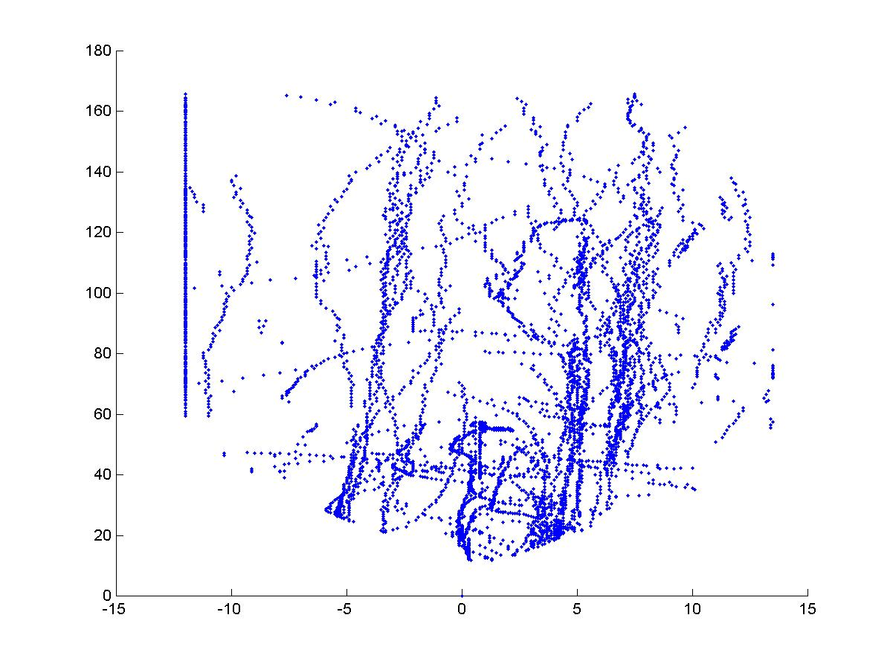
Fig. 8 Trajectories of objects in radar’s coordinate system
(Horizontal axis: lateral position in meters; Vertical axis: longitudinal position in meters)

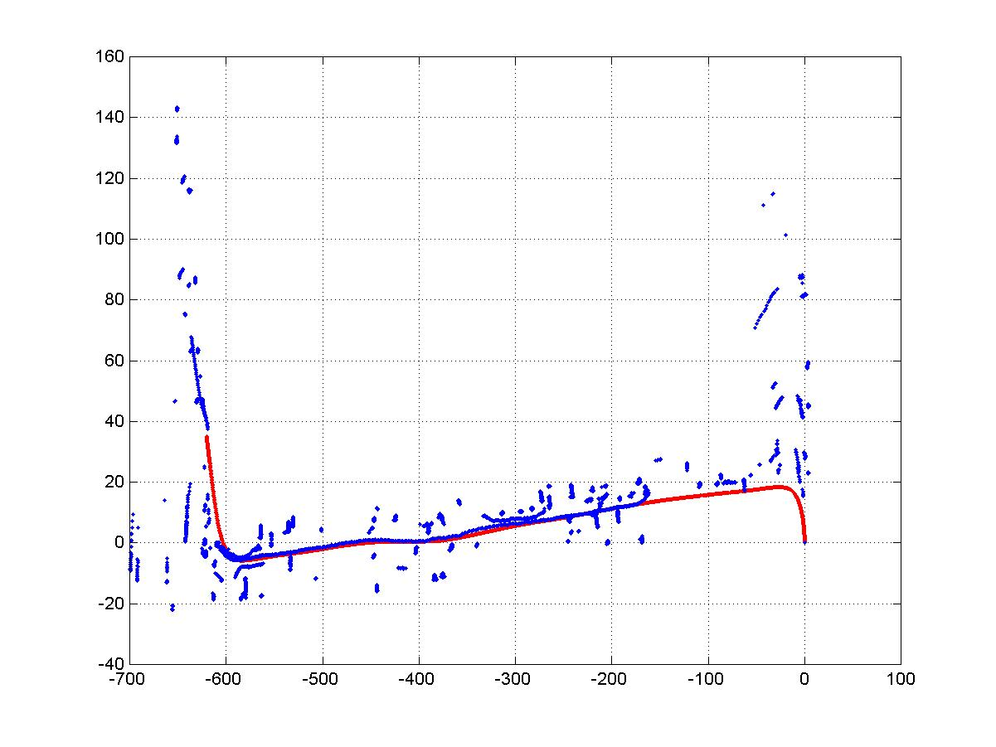
Fig. 9 Trajectories of objects (blue) and the bus (red) in the inertial system
(Horizontal axis: x-axis of the inertial reference system (m); Vertical axis: y-axis of the inertial reference system (m))

3.4.2 Human-Cooperative Threshold for Warning Detection
In a FCWS, the bus operator plays an important role. The operator not only controls the bus by accelerating, braking or turning, but also observes the environment, detects the potential threats and makes decisions. Before a FCWS is put on the bus, it is assumed that the operator had been independently, working well on the bus. The FCWS is supposed to give warnings only when the driver is inattentive, i.e., when the driver is distracted by something else, consequently unaware of the imminent threat ahead. The warnings are supposed to be given early enough, so that the operator has time to react and take control of the bus, either to fully avoid the threat or to lessen the impact of an unavoidable accident. The condition for activating a warning when the operator is inattentive must be emphasized herein. Research has shown that people tend to match their response rate to the reliability of the warnings. High levels of unreliable warnings tend to induce users to ignore all warnings. A warning that is given when the driver has already recognized the potential threat through his own observation provides very limited information. If too often the warnings are given when the driver is already aware of the potential threat, the reliability of the warning system will become too low for the driver to respond to it. In this case, drivers may consciously, and very rationally, decide not to comply with the warning, or even to disable the warning system. Bus operators are experienced drivers who are usually very attentive when driving. Although no quantitative result shows how often the bus drivers are inattentive, it is assumed that the rate of distraction is a low-probability event. This means, if warnings are activated disregarding the driver’s attentiveness level, most of them provide very limited information for the driver, because the driver is already aware of the potential threat. This greatly impairs the reliability of the FCWS. The approaches that simply use distance, closing rate, or TTC to detect a threat are subject to such a reliability problem. To solve this problem, the driver’s status (attentiveness) must be considered in the FCWS design.

We found from the collected data that the bus drivers’ normal braking onset timing drops into a certain safety region on the range-to-range-rate plot. Fig. 62 is the range-to-range-rate plot from the data we collected from August, 2000, to February, 2001. Each dot in this plot represents a braking case, in total 25,387 cases. The range and range-rate of each case are sampled at the onset of braking. A safety region can easily be identified in this plot. The safety region represents the normal timing that the drivers brake for to avoid accidents. We use the lower boundary of this safety region to define the threat detection threshold. This threshold is more human-cooperative, because it is from the data we have collected. It represents the safety limit of normal driver operations.

The improved algorithm was tested on SamTrans Bus 601 for one week, with six drivers involved. The threshold was slightly adjusted after the test. The test shows that false warnings are greatly suppressed.
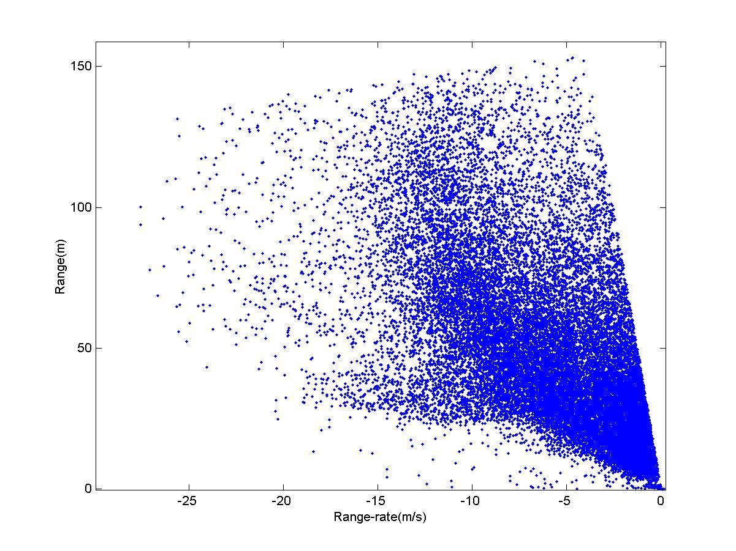
Fig. 10 Clustering of braking onset timing
3.4.3 Track File Structure

Track list
Fig. 11 Track file structure
The top-layer structure of track file is a linear list (see the following figure). Each entry of the list is a track, which contains an ID, a count of steps tracked, and a fixed-length FIFO of most-recent pointers to historical data. Track file is a static structure. Its size is defined by two constants: TOTAL_ID and TRACK_BUFFER_LENGTH. Each sensor has its own track file.

ID queue
Unused ID’s are saved in a queue (see the following figure). Whenever a new track is initiated, an ID is pulled out from the queue (pointed by ID_Tail) and assigned to this track. Whenever an old track is dropped out, an ID is released and pushed into the queue. The queue is a static structure. Its size is defined by the constant TOTAL_ID. Upon initialization, the queue is preset with integers from 1 to TOTAL_ID.

Fig. 12 ID queue structure

Object state buffer
Fig. 13 Object state buffer structure

Object state buffer is a 2D array (see the following figure). The first dimension is implemented as a circular queue; the second dimension is a fixed-length sub-array. The first column of object state buffer is for storing host-vehicle states. Size of object state buffer is defined by two constants: OBJECT_STATE_LENGTH and TotalObjects. Each entry of object state buffer is an OBJECT_STATES structure.

Object state data structure
where “stime” is the time when the observation is received from the sensor, “state” and “ID” are track properties, “m1” and “m2” are observations (e.g. range and lateral position), others are estimated states (smoothed states).

Additional information
Additional information may be saved in the track file as well. Currently the time stamp of processing and GPS locations are saved in the track file as additional information.
3.4.4 Data association
Data association for tracking is the process to figure out the correlation between observations and tracks, i.e. to associate observations with existing tracks.

Association metrics
An association metric is a measure of distances between observation-track pairs. An association metric must satisfy the following three criteria:
Distinguish ability: Given any two entities a and b, the distance between them must satisfy

$$\begin{aligned}d\left(a,b\right)≥0 \\ d\left(a,b\right)=0 ⇔ a=b\end{aligned}$$

Symmetry: Given any two entities a and b, the distance between them must satisfy
$d\left(a,b\right)=d\left(b,a\right)$;
- Triangle Inequality: Given any three entities a, b and c, the distances between them must satisfy
$d\left(a,b\right)+d\left(b,c\right)≥d\left(a,c\right)$;

We define the distance measure in 2D space (x,y) as:
$d\left(a,b\right)=\left|x_{a}−x_{b}\right|+\left|y_{a}−y_{b}\right|$, where $\left(x_{a},y_{a}\right)$ and $\left(x_{b},y_{b}\right)$ are coordinates of entities a and b in 2D space.

Gating and assignment
Gating is the process to remove those obviously impossible correlations between observation-track pairs. Multiple observations may fall in the gate of one track. One observation may fall in the gates of multiple tracks. Assignment is the process to determine the appropriate correlations.

Distance matrix
First of all, we calculate the distances between all observation-track pairs, which form a matrix.
Table 2 Distance matrix

where K is the total number of tracks, N is the total number of observations.

Gating
For each observation-track pair, if one of the following criteria is satisfied
$$\begin{aligned}1\text{.} \text{if} {\text{TK}}_{\text{Length}}<5 \text{and} d\left(\right)>5m; \\ 2\text{.} \text{if} 5≤{\text{TK}}_{\text{Length}}<\text{10} \text{and} d\left(\right)>4m; \\ 3\text{.} \text{if} {\text{TK}}_{\text{Length}}≥\text{10} \text{and} d\left(\right)>3m;\end{aligned}$$
the observation is immediately declared not belonging to this track.

Assignment
We assume that one observation can only be correlated to one track and vice versa.
The assignment logic is:
if $d\left(k,n\right)=\underset{i=1⋯K}{\text{min}}d\left(i,n\right)=\underset{j=1⋯N}{\text{min}}d\left(k,j\right)$, assign observation n to track k.
3.4.5 Host vehicle Data Filtering
Host vehicle state observations are longitudinal wheel speed and steering wheel angle. Host vehicle model is a nonholonomic bicycle model.

Nonholonomic constraint and kinematic model
Nonholonomic constraint means the wheels cannot move sideways. The nonholonomic bicycle model is illustrated in the following figure, where θ is front wheel turning angle, L is the wheel-base of host vehicle, v is longitudinal speed of front wheel, R is the turning radius. We have the following equations:
$$\begin{aligned}C=\frac{1}{R}=\frac{\text{sin}\left(θ\right)}{L} \\ ω=\text{vC}\end{aligned}$$

where C is the curvature, ω is the yaw-rate.
Fig. 14 Vehicle kinematic model

The host vehicle kinematical model with nonholonomic constraint is:
$$\begin{aligned}\left\{\overset{˙}{x}=v⋅\text{cos}\left(A\right) | \right.\left\{\overset{˙}{y}=v⋅\text{sin}\left(A\right) | \right.\left\{\overset{˙}{A}=ω=v⋅C | \right.\left\{\overset{˙}{v}=a_{l} | \right.\end{aligned}$$

where (x,y) is vehicle’s position in ground coordinate frame, A is vehicle’s headway in ground coordinate system, $a_{l}$ and $θ$ are driver inputs.
This model can be illustrated in the following input-output format.
Fig. 15 Vehicle state model

Filtering

Initialization
$$\begin{aligned}\left\{x\left(0\right)=0 | \right.\left\{y\left(0\right)=0 | \right.\left\{v\left(0\right)=v_{0} | \right.\left\{C\left(0\right)=\text{sin}{\left(θ_{0}\right)}/L | \right.\left\{A\left(0\right)=0 | \right.\left\{a_{l}\left(0\right)=0 | \right.\end{aligned}$$
where v₀ is the initial wheel speed, θ₀ is the initial front wheel angle.

Prediction
$$\begin{aligned}\left\{\hat{x}\left(k+1\right)=x\left(k\right)−v\left(k\right)⋅\text{dt}⋅\text{sin}\left(A\left(k\right)\right) | \right.\left\{\hat{y}\left(k+1\right)=y\left(k\right)+v\left(k\right)⋅\text{dt}⋅\text{cos}\left(A\left(k\right)\right) | \right.\left\{\hat{v}\left(k+1\right)=v\left(k\right)+a_{l}\left(k\right)⋅\text{dt} | \right.\left\{\hat{C}\left(k+1\right)=C\left(k\right)+a_{c}\left(k\right)⋅\text{dt} | \right.\left\{\hat{A}\left(k+1\right)=A\left(k\right)+C\left(k\right)⋅v\left(k\right)⋅\text{dt} | \right.\left\{{\hat{a}}_{l}\left(k+1\right)=a_{l}\left(k\right) | \right.\end{aligned}$$

Update
$$\begin{aligned}\left\{v\left(k+1\right)=α⋅\hat{v}\left(k+1\right)+β⋅\tilde{v}\left(k+1\right) | \right.\left\{C\left(k+1\right)=α⋅\hat{C}\left(k+1\right)+β⋅\text{sin}{\left(\tilde{θ}\left(k+1\right)\right)}/L | \right.\left\{a_{l}\left(k+1\right)=α⋅{\hat{a}}_{l}\left(k+1\right)+{β⋅\left[v\left(k+1\right)−v\left(k−T\right)\right]}/{\left[t\left(k+1\right)−t\left(k−T\right)\right]} | \right.\left\{a_{c}\left(k+1\right)=α⋅{\hat{a}}_{c}\left(k+1\right)+{β⋅\left[C\left(k+1\right)−C\left(k−T\right)\right]}/{\left[t\left(k+1\right)−t\left(k−T\right)\right]} | \right.\left\{A\left(k+1\right)=\hat{A}\left(k+1\right)+{\left[C\left(k+1\right)⋅v\left(k+1\right)−C\left(k\right)⋅v\left(k\right)\right]⋅\text{dt}}/2 | \right.\left\{x\left(k+1\right)=x\left(k\right)−\left[v{\left(k\right)}/2+v{\left(k+1\right)}/2\right]⋅\text{dt}⋅\text{sin}\left(A{\left(k\right)}/2+A{\left(k+1\right)}/2\right) | \right.\end{aligned}$$

If $k<T$,
$$\begin{aligned}\left\{a_{l}\left(k+1\right)={\hat{a}}_{l}\left(k+1\right) | \right.\end{aligned}$$
3.4.6 Motion Decoupling

Coriolis effect
If Newton’s laws of motion are used in a rotating system, the Coriolis effect appears. It introduces apparent components in the motion equations.
Let $X_{I}={\left[x_{I} y_{I}\right]}^{'}$ be the position of a point in an inertial system, $T={\left[x_{o} y_{o}\right]}^{'}$ the coordinate of the origin of a rotating system, R the rotation matrix from the rotating system to the inertial system, $X_{R}={\left[x_{R} y_{R}\right]}^{'}$ the observed position of the same point in the rotating system, we have
$X_{I}={\text{RX}}_{R}+T$ or $X_{R}=R^{−1}\left(X_{I}−T\right)$.

where
$R=\left[\begin{matrix}\text{cos}α & −\text{sin}α \\ \text{sin}α & \text{cos}α\end{matrix}\right]$ and $R^{−1}=\left[\begin{matrix}\text{cos}α & \text{sin}α \\ −\text{sin}α & \text{cos}α\end{matrix}\right]$.

See the following figure.

Fig. 16 Coordinate transformation

Then we have

$$\frac{d}{\text{dt}}X_{R}=\frac{d}{\text{dt}}R^{−1}\left(X_{I}−T\right)+R^{−1}\frac{d}{\text{dt}}\left(X_{I}−T\right)$$

where
$$\frac{d}{\text{dt}}R^{−1}=\left[\begin{matrix}−\text{sin}α & \text{cos}α \\ −\text{cos}α & −\text{sin}α\end{matrix}\right]⋅ω=R^{−1}\left[\begin{matrix}0 & 1 \\ −1 & 0\end{matrix}\right]⋅ω$$

$ω$ is the yaw rate of the host vehicle.

Let
$V_{C}=ω\left[\begin{matrix}0 & 1 \\ −1 & 0\end{matrix}\right]\left(X_{I}−T\right)$, $V_{I}=\frac{d}{\text{dt}}X_{I}$, $V_{T}=\frac{d}{\text{dt}}T$, and $V_{R}=\frac{d}{\text{dt}}X_{R}$,
then

$V_{R}=R^{−1}\left(V_{C}+V_{I}−V_{T}\right)$ or $V_{I}−V_{T}={\text{RV}}_{R}−V_{C}$.

When $ω=0$, $V_{C}=0$, the relative speed observed in the inertial frame is equal to the speed observed in the rotating frame rotated by the rotation matrix. When $ω≠0$, $V_{C}≠0$, after the speed observed in the rotating frame is rotated by the rotation matrix, it is not equal to the relative speed observed in the inertial frame. There is an extra component $V_{C}$ in the rotated non-inertial observation. This is the component caused by the Coriolis effect.

Decoupling algorithm
The problem could be solved by means of augmented state-space modeling which involves both the states of the target and the state of the host vehicle (sensor platform). However the augmented model is computationally complex. To simplify computation, we estimate rotation matrix and position of the host vehicle separately, then the results are used as known to estimate the states of the target. From the states of host vehicle, the rotation matrix and the position of host vehicle are unknown as:
$$R\left(k\right)=\left[\begin{matrix}\text{cos}A\left(k\right) & −\text{sin}A\left(k\right) \\ \text{sin}A\left(k\right) & \text{cos}A\left(k\right)\end{matrix}\right]$$
$T\left(k\right)=\left[\begin{matrix}x\left(k\right) \\ y\left(k\right)\end{matrix}\right]$, $V_{T}$ is the observation.
$X_{I}\left(k\right)=R\left(k\right)X_{R}\left(k\right)+T\left(k\right)$, $X_{R}\left(k\right)$ is the sensor observation.

We can now use $X_{I}$ as observation for target state estimation. In this decoupling algorithm, we have used the initial position and orientation of the host vehicle as the origin and orientation of the reference inertial frame.
3.4.7 Target data filtering

Kinematic model
Primarily we want to detect vehicle-like targets. Target data filtering is based on the same bicycle model as used for host vehicle data filtering.

Filtering

Initialization
$\begin{aligned}\left\{x\left(0\right)=x_{I}\left(0\right) | \right.\left\{y\left(0\right)=y_{I}\left(0\right) | \right.\left\{v\left(0\right)=0 | \right.\left\{C\left(0\right)=0 | \right.\left\{A\left(0\right)=0 | \right.\left\{a_{l}\left(0\right)=0 | \right.\end{aligned}$ where $\left[\begin{matrix}x_{I} \\ y_{I}\end{matrix}\right]=X_{I}={\text{RX}}_{R}+T$.

Prediction

Update
$$\begin{aligned}\left\{v_{x}={\left[x\left(k+1\right)−x\left(k−T\right)\right]}/{\left[t\left(k+1\right)−t\left(k−T\right)\right]} | \right.\left\{v_{y}={\left[y\left(k+1\right)−y\left(k−T\right)\right]}/{\left[t\left(k+1\right)−t\left(k−T\right)\right]} | \right.\left\{v\left(k+1\right)=\sqrt{v_{x}^{2}+v_{y}^{2}} | \right.\left\{A\left(k+1\right)=\text{arctan}\left({v_{y}}/{v_{x}}\right)−π/2 | \right.\left\{a_{l}\left(k+1\right)={\left[v\left(k+1\right)−v\left(k−T\right)\right]}/{\left[t\left(k+1\right)−t\left(k−T\right)\right]} | \right.\left\{C\left(k+1\right)={{{\left\lfloor A\left(k+1\right)−A\left(k−T\right)\right\rfloor }_{2π}}/{\left[t\left(k+1\right)−t\left(k−T\right)\right]}}/{\left[v{\left(k+1\right)}/2+v{\left(k−T\right)}/2\right]} | \right.\left\{a_{c}\left(k+1\right)={\left[C\left(k+1\right)−C\left(k−T\right)\right]}/{\left[t\left(k+1\right)−t\left(k−T\right)\right]} | \right.\left\{x\left(k+1\right)=x\left(k\right)−\left[v{\left(k\right)}/2+v{\left(k+1\right)}/2\right]⋅\text{dt}⋅\text{sin}\left(A{\left(k\right)}/2+A{\left(k+1\right)}/2\right) | \right.\end{aligned}$$
If $k<3T$, then
$a_{c}\left(k+1\right)={\hat{a}}_{c}\left(k+1\right)$;
if $k<2T$, then
$\begin{aligned}\left\{a_{c}\left(k+1\right)={\hat{a}}_{c}\left(k+1\right) | \right.\left\{C\left(k+1\right)=C\left(k+1\right) | \right.\end{aligned}$;

if $k<T$, then
$\begin{aligned}\left\{a_{c}\left(k+1\right)={\hat{a}}_{c}\left(k+1\right) | \right.\left\{C\left(k+1\right)=C\left(k+1\right) | \right.\left\{a_{l}\left(k+1\right)={\hat{a}}_{l}\left(k+1\right) | \right.\left\{v\left(k+1\right)=v\left(k+1\right) | \right.\end{aligned}$;

if target is stationary, then
$\begin{aligned}\left\{a_{c}\left(k+1\right)=0 | \right.\left\{C\left(k+1\right)=C\left(k\right) | \right.\left\{a_{l}\left(k+1\right)=0 | \right.\end{aligned}$.
3.4.8 Warning Detection
- Look into the table in Apendix VI; find the threshold corresponding to the speeds: T(vl,vb); and divide the distance D by the threshold:
d=D/T(vl,vb)
- The DVI is designed with seven segments. Warnings are accordingly divided into seven levels. Let mi (i=1,…,7) be the factors in the following lists:
for least sensitivity (%): 148,132,116,100,84,68,52
for medium sensitivity (%): 156,140,124,108,92,76,60
for most sensitivity (%): 164,148,132,116,100,84,68

and wi (i=1,…,7) be the corresponding warning levels, find the smallest mi that is greater than or equal to d, the corresponding warning level is wi. If d is greater than the m1, no warning is needed, the corresponding warning level is w0.
3.5 Summary
Based on the data fusion model, viz. the JDL model, a preliminary algorithm was developed and integrated into the data playback tool. By playing back the collected data with the warning playback tool, false positive patterns are experienced and analyzed. The algorithm was then improved by decoupling the bus motion from the sensor measurements and by setting the warning threshold according to the drivers’ normal braking behavior. As the warning threshold is changed, the leading time of the warning to the potential collision may become shorter than is needed to avoid the collision. This is the trade-off between the drivers’ acceptance and the benefit of the collision warning system, under the condition of the current system configuration and the techniques adopted. The shorter response time may be insufficient for avoiding an accident in some situations (not all situations), but it is possible for the loss of an accident to be greatly reduced because of the leading warning. Most importantly, the system becomes acceptable to the drivers. If the drivers don’t accept the system because of too many nuisance alarms, even though the leading time is long enough for the driver to avoid an accident, the accident will not be avoided because the driver will not believe the alarm.

The prototype FCWS was developed to evaluate the preliminary functional requirements and technical specifications. It has been realized that the probability of a true collision is so small that suppression of false alarms or nuisance alarms becomes the biggest issue in the FCWS. Object recognition and classification, GPS map utilization, driver status monitoring may all be helpful to remove nuisance alarms in the future. Random models may be better than deterministic models in terms of describing the evolution of vehicle states. These techniques will be considered in the second phase of the FCWS.
References
- Waltz E., Llinas J. Multisensor Data Fusion, Artech House, Inc. 1990.
- Hall D.L. Llinas J. An Introduction to multisensor data fusion, invited paper, Proc of the IEEE, Vol.85, No.1, Jan. 1997, pp6-23.
- Woll, J.D. Monopulse Doppler radar for vehicle applications. M+RF97 Microwave and Communications Technologies Conference Proceedings, Swanley, UK: Nexus Information Technology, 1997. p.234-8.
- Denso LIDAR documents, Denso Inc.
- Hayward J.C., Near misses as a measure of safety at urban intersections. Doctoral dissertation, Pennsylvania State University, 1971.
- van der Horst R. Time-to-collision as a cue for decision-making in braking, Elsevier Science publishers, 1991.
- Kenue, S.K. Selection of range and azimuth angle parameters for a forward looking collision warning radar sensor. Proceedings of the Intelligent Vehicles '95. Symposium, IEEE, 1995. p.494-9.
- Burgett A.L., Carter A., Miller R.J., Najm W.G., Smith D.I., A collision warning algorithm for rear-end collisions, paper number 98-s2-p-31, 1998.
- Seiler P., Song B., Hedrick K.J., Development of a collision warning system, SAE, 98PC-417, 1998.

4 DESIGN OF THE FCWS DRIVER VEHICLE INTERFACE (DVI)
The FCWS team has taken significant effort in the design of a prototype driver-vehicle interface for a FCWS. For a comprehensive review of the issues involved in implementing a DVI for a FCWS on a transit bus see Reinach & Everson [Error: Reference source not found & Error: Reference source not found]. Reinach & Everson provide a detailed analysis of the transit bus operational environment and provide an extensive set of transit bus collision avoidance system DVI interface requirements. In developing the DVI for FCWS, operators and trainers from the SamTrans transit agency were approached for their input on a DVI design as the operators consulted under the Reinach & Everson projects were from dense, east coast, urban cities (Boston & Manhattan). The additional perspective of SamTrans employees was considered useful given the additional environments (suburban, semi-rural) and the different regional driving behavior (Northern California).

This phase of the project culminated in a user center designed visual DVI implemented on a SamTrans bus for a FCWS. A decision was made to build a visual DVI because this was the most commonly accepted format by day operators and since most accidents occur during daylight hours (see section 1). Previous research also suggests that a visual warning display is potentially less annoying than an auditory warning [Error: Reference source not found] and time constraints meant that it was not feasible to perform testing on different modes with one instrumented bus. However, during the process of designing the visual DVI, information was also collected on different display modalities. It is expected that this information will be used at a later date when other DVI formats will be considered. The information collected on the other display modalities is included in Appendix VIII of this report. This document initially reviews the iterative design process for development of the visual DVI. It should be noted that as with any collision warning system it is critical that the FCWS be accepted by operators [Error: Reference source not found], and that it not interfere with the primary driving task [Error: Reference source not found].

The iterative design process involved the following stages: collection of preliminary DVI recommendations, preliminary DVI design and ongoing preliminary DVI design evaluations and refinements. The design and evaluation was realized in six steps/studies which are given in chronological order below:
- SamTrans Operator and Trainer meetings to get supplemental DVI design considerations
- Synthesis of operator input and Human Factors research into preliminary DVI design
- SamTrans Operator and Trainer meetings to get preliminary DVI design feedback
- Operator and advisory committee meetings to get preliminary DVI design feedback plus a ride along on a bus with a working prototype
- Operator training and test drives with the working prototype*
- Ongoing operator review*
Each of these steps/studies will be discussed further below.
Note: * indicates a small study was run.

4.1 SamTrans Operator and Trainer Preliminary Meetings
4.1.1 Method
Interaction with operators occurred in both formal and informal meetings in June 2001. The latter were typically when a human factors researcher was present at the bus yard waiting for a operator or bus to arrive. Trainers were also consulted for input. One member of the project's Advisory Board also provided input based on his expertise as a trainer. Typical interaction involved explanation of the project and FCWS functionality followed by a request for thoughts on appropriate warning methods. When possible, comments on existing CWS warning methods were also requested.
4.1.2 Summary of Operator and Trainer Input
Most of the comments were received prior to description of existing systems. Thus, many of the comments described below can be viewed as being without bias from existing systems. The comments have been sorted into logical groupings presented in the tables below. ”D” indicates operator comments, while “T” corresponds to those from trainers. There were cases where operators’ and trainers’ comments overlapped.

Table 3 Operator comments on the current physical operating environment
Requirement from Operators/Trainers | Comment
D | Cut-ins by other operators are frequent. This is often cited for cars entering highways, "Out of 20 cars, 19 will try to get in front of the bus."

Table 4 Operator requirements of a FCWS
Requirement from Operators/Trainers | Comment
T | Lateral scanning is essential. Devoting a third of the operator's attention in each direction (left, center, right) is recommended.
T | For large lead vehicles (trucks), operators should back off or change lanes.
T | Forward looking behavior should emulate a "yo-yo" in that operators should look up the road, then back in, then back up the road, etc. The distant look-ahead phase allows more lead time for reactions.
T | Position of the rear wheel is important for turning accidents as it is a pivot point. Operators are expected to locate the rear wheel in their mirrors prior to moving the steering wheel.
T | SamTrans utilizes the Smith System for training. The main topics are: the big picture, keep eyes moving, leave yourself an out, do not get a fixed stare, and aim high (with eyes) for steering. Consistent behavior is also emphasized.
T | Trainers emphasized a general theme that proper operator behavior will lead to no forward or sideswipe accidents at all - even those for which the operator was not at fault.
D | Operators uniformly expressed the opinion that the driving public misunderstands the capabilities of a bus. "A bus cannot stop on a dime."

Table 5 Operators comment of when a FCWS would be most helpful
Requirement from Operators/Trainers | Comment
T | Operators cannot be expected to depend on a CWS. It is only a tool for them to use.
DT | A more sensitive system was suggested for training periods. It was felt that this would accelerate operator experience.
D | Any system that can help prevent a chargeable accident (i.e., preventable, at fault) would be popular.
D | Operators dislike passenger falls, especially fraudulent ones. Agreement was voiced with the philosophies of earlier braking rather than harder braking and that warnings should not be readily perceived by passengers. One operator described an experience when the bus made a loud sound due to a mechanical failure. After pulling over to check the bus, some passengers got out and began kneeling and praying - they thought the bus had struck something and that they had been in danger.

Table 6 Operator suggestions for design of the warning
Requirement from Operators/Trainers | Comment
DT | Two modes of display, one for day and one for night was suggested. Night operators tended to prefer sound over light while daytime operators were more interested in visual displays. The operators decided that a system with both audible and visual displays where an operator could adjust the illumination and volume would be worth considering. One trainer agreed that nighttime glare from in cab displays should be avoided.
D | Operators would like the ability to dim or shut off dash lights that they perceive as of little value or possessing high glare, but were under the impression that this was not an option for safety related systems. There was concern that the DVI for CWS systems would not permit dimming or volume control due to the inherent safety nature of the system.
DT | Initial responses often involved either a visual display on the dash and/or an audible warning.
DT | Frequent activation of graded warnings or binary alerts at low risk levels (e.g., long TTC's) were discouraged.
D | Graded warnings or a combination of a binary alert followed by a binary critical warning were considered useful.
D | Highly salient alarms are good for:  1. When a vehicle in front drops speed suddenly with respect to the bus.  2. The forward object is moving slowly and the bus approaches at a much faster speed.

Table 7 Operator comments on visual warnings
Requirement from Operators/Trainers | Comment
T | "By the time an operator looks at the display, it is probably too late."
T | A trainer suggested using colors other than those used by current lights if mounted in the instrument cluster. Current lights are yellow, orange, and red.
D | Downward moving tapes on the operator side A-pillar and the center windshield pillar were suggested by the experimenter after operators indicated a desire to keep the forward scene unobstructed. This idea received concern from the night operators as they felt the additional illumination would be a problem. Daytime operators did not comment in either direction.
DT | Operators proposed two similar dash-mounted displays to identify threat locations (see diagram below). For the left-hand design, the arrows would illuminate corresponding to threat locations while the "S" would indicate stationary objects and would be replaced with an "M" for moving objects. The right-hand design would simply illuminate the quadrant for which a threat was present. When the high head-down location proposed in [Error: Reference source not found] was described, operators were not enthusiastic over concerns about obstruction of the forward visual scene. One trainer suggested a dash mounted row or column of three lights. A similar, A-pillar mounted column display was suggested by [Error: Reference source not found] for lateral warnings.  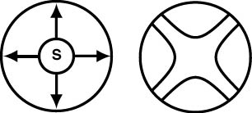  Operator Suggestions
4.1.3 Design Paradoxes
The operator and trainer input led to the identification of three major paradoxes:
1. Operators agree with the philosophy of earlier braking rather than harder braking yet they would like as few alerts and warnings as possible.
2. Nighttime operators prefer audible warnings due to concern over glare while daytime operators tended to focus on visual warning options.
3. The warning should be salient enough to elicit an operator response but should not be readily noticeable by passengers.
All three paradoxes are present in the passenger and CVO platforms but are amplified by the potential for passenger falls, especially fraudulent ones. Interestingly, operators were aware of these paradoxes and expressed willingness to give design suggestions for compromise solutions. The following designs are a synthesis of operator suggestions and human factors principles.
4.1.4 Multimodal Displays with Operator-controlled Intensity
Operators voluntarily expressed that the best design might be a combination of audible and visual displays. Nighttime operators have indicated that it is essential that any visual display introduced into the cab have a brightness knob. The additional glare from a high mounted display may introduce problems should this feature not be present. Some have also expressed a desire to be able to fully shut off the visual display and only use other display modalities (in this case, auditory).

As for the visual display, a volume knob is also considered essential by the operators. Daytime operators and trainers indicated that the ambient sound levels within a bus can vary due to passenger load. Furthermore, daytime operators seemed to be more interested in shutting off the auditory warning in favor of the visual display.

Some form of "only one modality can be off" logic may be needed so that operators cannot totally disable the CWS DVI. This is easiest to achieve by providing a primacy switch where an operator can choose which modality he/she would prefer to shut off. This approach may be a simple, yet effective method of resolving the daytime/nighttime paradox.
4.2 Preliminary Visual DVI
Human factors principles agree with the observation that any visual display should be mounted above the instrument cluster [Error: Reference source not found]. This is further emphasized by the assertion that experienced operators very rarely look down at their dashboard. HUDs have proven to not be suitable at this time and operators were averse to consuming any portion of the current field of view. The remaining high mount options are on the left A-pillar and the center pillar (Fig. 69). These locations are also useful in that a vertical oriented display will more naturally mimic the motion of an approaching target. The use of both pillars will allow a limited amount of spatial resolution to occur in that targets that are approaching head-on can be shown with matching column displays while cut-in targets can be shown with single columns corresponding to the direction of the threat.

Fig. 17 Preliminary DVI design

Use of the left A-pillar leads to the logical question of interference or confusion regarding lateral warning displays. Operators and trainers both indicated that lateral warning displays should be as close to the mirror assembly as possible. Furthermore, training programs emphasize the need to locate the rear tire in the mirror prior to steering motion. As such, warnings mounted in (e.g., [Error: Reference source not found]) or on the mirror assembly are more logical than those on the A-pillars. Locating the lateral displays at the mirrors may modify the behavior of operators who do not check their mirrors prior to moving, as the warning display may increase the perceived value of looking at the mirrors.

One important design characteristic is that the columns should utilize color changes for the whole bar. Research on assistive systems for snowplows suggests that operators used the change in CWS DVI color as an important cue for following behavior [Error: Reference source not found].

From the information above a preliminary visual DVI design was developed. The initial preliminary DVI design consisted of seven stacked LED segments (2 LED’s across per row). Each segment had the ability to light as yellow, orange, or red. The LED's used have a maximum luminance intensity of 90/60 millicandelas (mcd) and a viewing angle of 100 degrees. The use of large LED segments in this design was intentional since the columns will likely be in the operator's peripheral vision. The apparent motion of the column displays will be more salient given the large segment size. In order to limit passenger observation, a diffusion lens was placed over the LED segments.

Previous human factors research suggests that motion and size can be utilized to convey potential threat levels. In study two different illumination patterns were shown to operators and trainers. In the first illumination pattern segments of the LEDs illuminate in a downward progression as threat level increases. This pattern mimics the motion of an approaching target. This type of motion has been frequently used in passenger CWS DVIs [e.g., Error: Reference source not found] and has been effective in the aforementioned snowplow application [Error: Reference source not found]. The second illumination pattern was the use of looming (growing to ends from the center).

In order to determine to optimum way of conveying the threat level a simulation of different patterns of illumination was developed and tested in the next study.

For the next sections small studies were designed to evaluate either different design concepts or the DVI as a whole. Each small study is broken down into the goal of the study, the method used, feedback and what DVI refinements were undertaken as a result. It should be noted here that all refinements were carefully considered as mid-course changes in design strategies and though can be onerous, the goal was to ensure through operator input a high operator acceptance of the DVI.

For details of JDL model, please refer to ‘Multisensor Data Fusion’ by E. Waltz and J. Llinas (Artech House, 1990).

