Section One

Understanding Transit Frontal Collisions
1 Accident Data Analysis
Frontal collision accounts for a significant portion of all collisions. Data from both the Automotive Sampling System (NASS), General Estimate System (GES), and the NHTSA Fatal Accident Reporting Systems (FARS), showed that rear collisions are 20-25% of all police reported crashes per year [1,4,5]. Further studies [2,5] showed that frontal collisions occurred mostly during the daytime (~75%), on straight roads (~90%), and under dry weather conditions (60-79%). These studies revealed that 85% of rear-end collisions involved two vehicles with equal occurrence at intersection and non-intersection, 77%-84% are caused by driver inattention, and 7%-18% are of caused by following too closely, 67% without injuries. Asher [3] reported that about 60% frontal collisions could be avoided if the driver had an additional 0.5 sec of warning before the incident, this suggests that a collision warning system may offer great potential for reducing frontal collisions.

Both NHTSA and GES accident statistics also include accident data involving buses. The statistics in NHTSA Traffic Safety Facts 2000 [5] offers some insights into the types of crashes. Roughly, frontal collisions and rear collisions each account for one-fourth and side collisions half of all crashes. The following table outlines the distribution of crashes by the initial point of impact:

Table 1 Buses involved in all crashes by the initial point of impact
Initial Point of Impact | Number | Percentage
Front | 16,000 | 28.2
Left Side | 14,000 | 24.3
Right Side | 13,000 | 23.3
Rear | 13,000 | 22.9
Non-collision | * | 0.3
Other/Unknown | 1,000 | 1.0
Total | 56,000 | 100
*Less than 500 or 0.5 percent.
The GES data has concluded that the five most frequent crash types involving motor coaches are: lane change, rear end, intersection, hitting parked vehicles, and backing up scenarios. The total for the top five crash categories accounted for approximately 87% of crashes involving motor coaches within the United States. GES from 1992 data showed that 59% of crashes are caused by leading vehicle stopped; 37% are leading vehicle decelerating; 80% in clear weather and 70% under well-lit conditions; 73% on dry roads; 95% on straight roads.

Following a recommendation by the Transit IVI Steering Committee, a study was conducted by the Volpe Center to identify and prioritize transit industry requirements and problems involving IVI technologies [4]. This study revealed that the highest-accident-rate-and-severity-rating accident is intersection type of crashes where a bus is struck by another vehicle. The second major scenario is rear-end type of collisions where a bus is struck by another vehicle. These two types of crashes account for almost one third of the top five scenarios. The mid-level types of accidents, which carry a medium range of risk and severity, include the other half of the intersection type of accidents where the bus strikes another vehicle; rear-end type where the bus does the striking, and both backing up type of crashes. The study concluded that although the total number of accidents involving transit buses is relatively small, they result in significant social and economic consequences.

Although the national accident data provides statistics of transit accidents, detail accident analysis is still needed as in addition to urban transit buses, the national data includes additional sources of bus accidents, specifically school buses and intercity buses. It is not clear the percentage of each vehicle type and the impact of a particular type of vehicles on category of accidents. Additionally, our research suggests that the accidents involving transit buses often occur in very different environments such as urban areas with different speeds than that of automobiles. Furthermore, there is a critical need for gathering real life data that is transit specific so that accident type and associated cost can be investigated in detail to support the benefits of transit IVI systems and provide inputs for developing and implementing FCWS on transit buses. In order to fully understand the environment that transit buses are operated in, the causal factors of frontal collisions involving buses, the characteristics and consequences of these accidents and potential IVI approaches through which frontal collision warning systems can help to prevent or mitigate, the project team has conducted a series of accident data analysis.

In the first phase of the study of frontal collision warning systems, PATH has been working with the AC Transit, Central Contra Costa Transit Authority (CCCTA), Golden Gate Transit (GGT) and San Mateo County Transit District (SMT) in the San Francisco Bay Area to obtain transit accident data. The focus of this initial study is to determine the accident scenarios relevant to the design and implementation of frontal collision warning systems on transit buses. In the course of working with these agencies, it soon became clear that obtaining detailed collision cost data would not be a straightforward process. In many cases, costs such as damage repair, injury, legal, and compensation payout are not processed or tracked by a single agency department or division and the retrieval of this information often requires hand processing as the relevant information cannot be accessed by computer. In other cases, the handling of legal claims is out-sourced to private organizations (e.g., John Glenn Adjusters & Administrators (JGAA) in the Bay Area), so the data are not available directly from the transit agencies.

Following the initial accident analysis, PATH has worked with JGAA to conduct a detailed investigation of accident costs to support a cost-benefit analysis of transit IVI systems. The objectives of this effort are (1) to further determine accident scenarios in order to assist the improvement of the design and implementation of transit collision warning systems, and (2) to assess the overall costs of incidents or collisions.

In addition to the accident cost data for the SMT, Santa Clara Valley Transportation Authority (VTA), and GGT, JGAA has maintained cost data for the members of the California Transit Insurance Pool (CalTIP), which is an insurance authority currently serving 32 California transit operators (see Appendix I for a list of all the 32 members). Given the value of the broader database, it was decided to expand the project to include detailed accident analysis for CCCTA and Riverside Transit Authority (RTA) and generalized accident analysis for an additional 30 CalTIP agencies.

JGAA provided PATH with electronic copies of the accident data. PATH has developed software to automatically process the cost reports and put the information into data forms so that in-depth accident and cost benefit analysis can be carried out.
1.1 Analysis Detailed Accident Data from 35 California Transit Agencies
The detailed transit accident data analysis is based on the latest five fiscal years (May 1, 1997 to April 30, 2002) of cost data for 35 transit agencies including three in San Francisco Bay Area and the 32 CalTIP agencies. Those 35 transit agencies operate buses in different regions and operating environments in California, as it is shown in Figure 3 (not shown are the 3 San Francisco Bay Area agencies, VTA, SMT, and GGT).

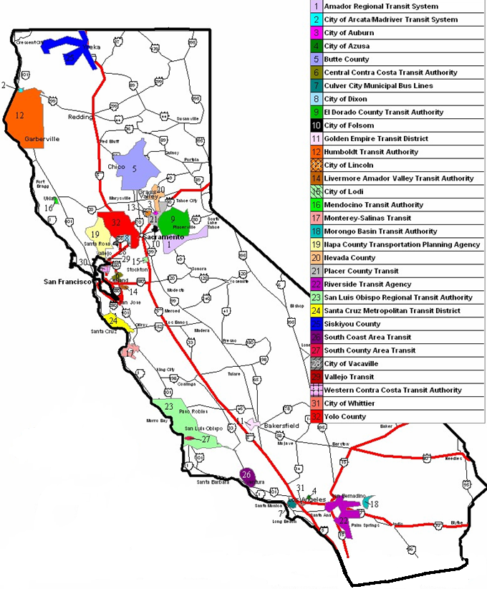
Fig. 1 Service coverage of 35 transit agencies

Each incident or accident is indicated as a claim in JGAA’s database. Each claim involves a transit bus and another party, which could be another vehicle, a pedestrian, a stationary object, and/or a passenger on the bus. JGAA tracks the accident costs in three categories: “Body Injury”, “Property Damage”, and “Legal and Other Fees.” The cost for a claim is the sum of these three types of costs. For each claim, JGAA includes a simple accident narrative describing what occurred. Different agencies have different cost report formats (see Appendix II for a sample JGAA cost report).

JGAA uses 103 loss codes to refer to various types of accidents (see Appendix III for the loss code descriptions.). The code system is designed from a legal perspective, and provides little information about the cause of the accident. It was found to be impossible to retrieve the initial point of impact from the loss code. Loss code 1, for example, indicates a bus going straight ahead colliding with a vehicle from its left at an intersection. This could be a frontal collision if the bus hit the other vehicle or it could be a side collision if the other vehicle ran into the bus. In order to understand the association between accident cost and the initial point of impact, PATH and JGAA have obtained the initial point of impact information for four transit agencies (two are CalTIP agencies) by reviewing the original driver reports and police reports. Four possibilities are considered for the initial point of impact: front (F), side (S), rear (R), and not-known (N). The statistics from these four agencies are then extended to other agencies.

The 103 loss codes are categorized into three groups:
1. Collision accident: A collision happened between a transit bus and another party.
2. Non-collision accident: Passenger injured on boarding, alighting, or on board (not caused by a collision).
3. Civil right and ADA violation.

Table 2 summarizes the accident and cost data for the 35 transit agencies. Agency III and IV are CalTIP members, and CalTIP(30) refers to the other 30 CalTIP agencies. For CalTIP agencies, one collision accident happened per 22,000 revenue miles, and one non-collision accident per 22,000 revenue miles.
Table 2 Accident cost data for 35-transit agencies (for 5 years)
Transit Agency | Collision |  | Non-collision |  | Violations
Transit Agency | Claim | Cost | Claim | Cost | Claim | Cost
Agency I | 353 | $2,904,763 | 182 | $1,188,326 | 11 | $13,500
Agency II | 1,146 | $6,319,107 | 669 | $1,857,460 | 13 | $35,953
Agency III | 358 | $997,982 | 474 | $858,162 | 8 | $2,039,006
Agency IV | 261 | $1,032,796 | 363 | $1,174,749 | 1 | $285
Agency V | 261 | $1,032,796 | 363 | $1,174,749 | 1 | $285
CalTIP(30) | 1,398 | $4,783,760 | 1,198 | $5,075,349 | 7 | $442,993
Total | 5,255 | $22,354,203 | 4,285 | $13,583,368 | 40 | $2,531,737

On average, each collision accident cost $4,254, and each passenger injury accident cost $3,170. Since cost from Civil Right and ADA violations is not directly related to accidents, it is not being included in this analysis.
1.1.1 Accident Costs of Agency I
Most bus routes of Agency I are operated on relatively congested roads. The accident costs for Agency I by accident type and the initial point of impact are summarized in Figures 4 and 5.

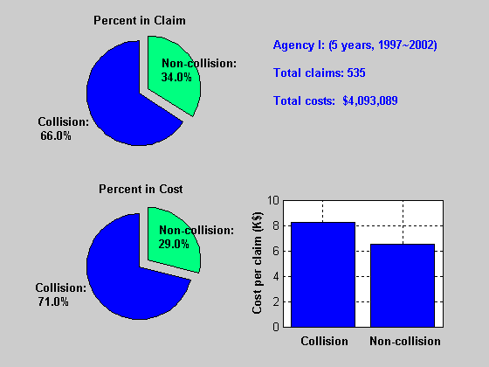
Fig. 2 Agency I: Accident costs by accident type
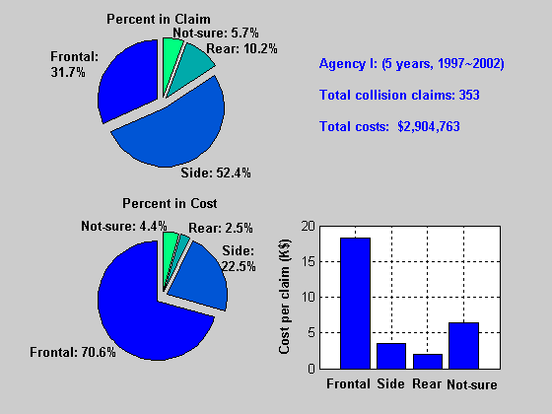
Fig. 3 Agency I: Collision accident costs by initial point of impact

1.1.2 Accident Costs of Agency II
The accident costs for Agency II are summarized in Figures 6 and 7.
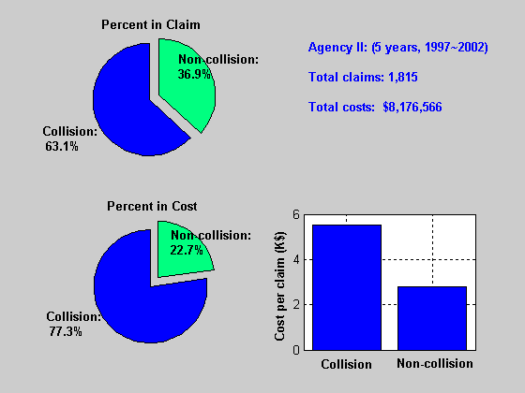

Fig. 4 Agency II: Accident costs by accident type
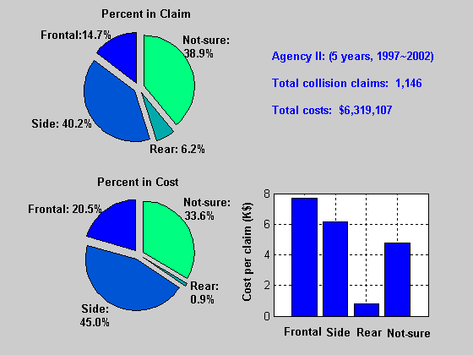
Fig. 5 Agency II: Collision accident costs by initial point of impact

1.1.3 Accident Costs of Agency III
The accident costs for Agency III are summarized in Figures 8 and 9.

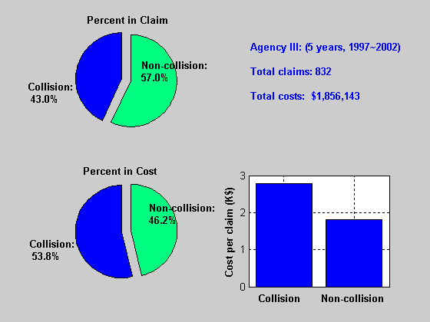
Fig. 6 Agency III: Accident costs by accident type

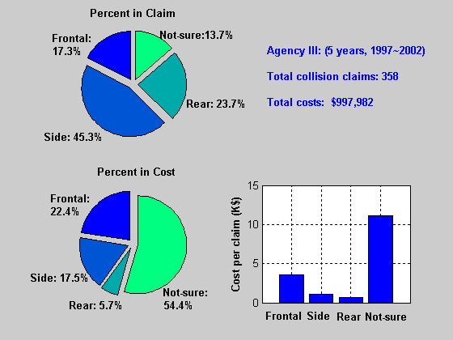
Fig. 7 Agency III: Collision accident costs by initial point of impact

1.1.4 Accident Costs of Agency IV
The accident costs for Agency IV are summarized in Figures 10 and 11.

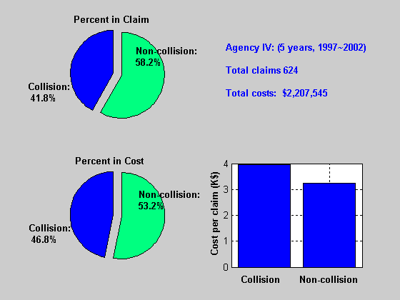
Fig. 8 Agency IV: Accident costs by accident type

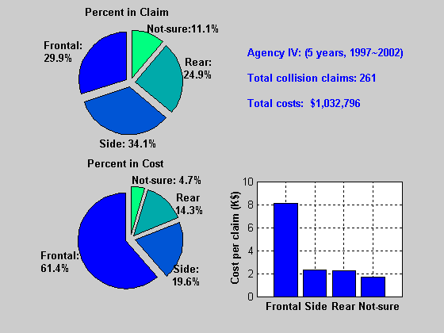
Fig. 9 Agency IV: Collision accident costs by initial point of impact

1.1.5 Distribution of Collision Claims and Costs by Loss Code
As can be seen, the cost distribution by initial point of impact varies from agency to agency. This may be due to the fact that every transit agency has its own driver training program as well as a different operating environment. These can lead to a unique collision pattern and claim distribution. Furthermore, each agency has several severe collision accidents, each costing more than $100,000, which can significantly affect the cost statistics.

Although most loss codes cannot be directly associated with an initial point of impact, it was found from the cost data that the claim distribution and cost distribution by loss code and the initial point of impact are very consistent within the four transit agencies for which detailed initial point of impact information was obtained from the original driver and police reports. The accident data of two CalTIP agencies (agencies III and IV) were selected to generate the claim and cost distributions by loss code and the initial point of impact. These distributions were then applied to the four agencies to verify their accuracy and consistency, and then extended to Agency V and other CalTIP agencies (CalTIP(30)).

There are a total of 47 loss codes that are related to collision accidents. In order to exclude the affect of severe collisions, only claims costing less than $10,000 are used to generate the claim distribution, $\text{claim_dist}[i][j]$, and cost distribution, $\text{cost_dist}[i][j]$, where i refers to the initial point of impact and j refers to the loss code. The original initial point of impact inputs are used for claims costing more than $10,000. For each transit agency, the generated distributions are applied to claims costing less than $10,000 as follows:
$$\begin{aligned}\text{claim_est}[i]=\sum_{j}{\text{claim}[j]⋅\text{claim_dist}[i][j]} \\ \text{cost_est}[i]=\sum_{j}{\text{cost}[j]⋅\text{cos}t\text{_dist}[i][j]}\end{aligned}$$
where $\text{claim_est}[i]$ and $\text{cost_est}[i]$ are estimated claim number and accident cost for point of impact i; and $\text{claim}[j]$ and $\text{cost}[j]$ are actual claim number and cost by loss code j, which are obtained from the accident data. Finally, the total claims and costs by loss code are given by
$$\begin{aligned}\text{claim_total}[i]=\text{claim_est}[i]+\text{claim_review}[i] \\ \text{cost_total}[i]=\text{cost_est}[i]+\text{cost_review}[i]\end{aligned}$$

where $\text{claim_review}[i]$ and $\text{cost_review}[i]$ are actual claim number and cost by the initial point of impact for claims costing more than $10,000.

Fig. 12 shows the comparison of actual claim and cost distributions by the initial point of impact (top row), and the distributions calculated by using the statistics from Agencies III and IV (bottom row). Again, only accidents with costs less than $10,000 are considered.

Using the same statistical distributions for accidents costing less than $10,000, and taking account of those collision accidents costing more than $10,000 for which PATH acquired the initial point of impact, Figure 13 compares actual cost and claim data (top row) to statistical estimations.

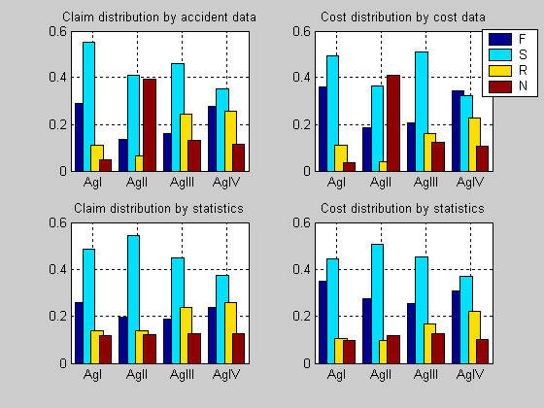
Fig. 10 Claim and cost distributions for collision accidents costing less than $10K
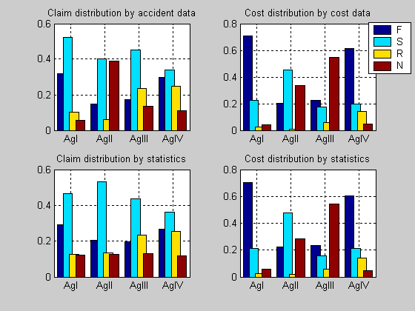
Fig. 11 Claim and cost distributions for all collision accidents

With the exception of Agency II, the derived distributions match the actual distributions quite well (error within 6%). Relatively larger variations can be found for Agency II. This is because 39.5% of its collision accidents have “not-known” initial point of impact due to the information limitation on original reports. This is much higher than other agencies.
1.1.6 Accident Costs of Agency V
The statistics from Agencies III and IV are applied to Agency V for collision claims costing less than $10,000. PATH has obtained the initial point of impact information for a total of 65 claims which cost more than $10,000. The results are summarized in Fig. 14 and 15.

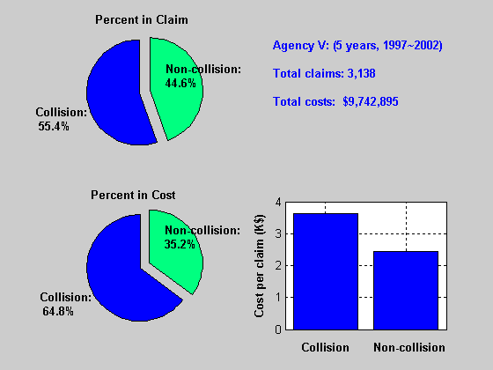
Fig. 12 Agency V: Accident costs by accident type

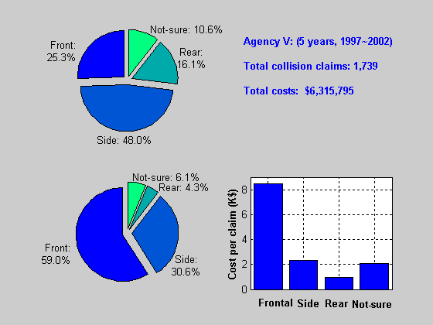
Fig. 13 Agency V: Accident costs by initial point of impact

1.1.7 Accident Costs of 30-CalTIP Agencies
Due to the prohibitive cost, in terms of both time and resources, to obtain the initial point of impact information for the 30-CalTIP members, it was decided to apply the statistics from Agencies IV and V to these agencies for collisions costing less than $10,000. PATH has obtained the initial point of impact information for all the collisions costing more than $10,000 (a total of 81 accidents). Figures 16 and 17 summarize the claim and cost data for the combined accident categories of the 30-CalTIP agencies.

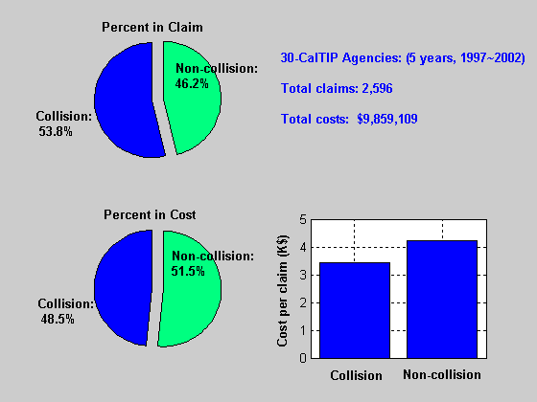
Fig. 14 30-CalTIP members: Accident costs by accident type
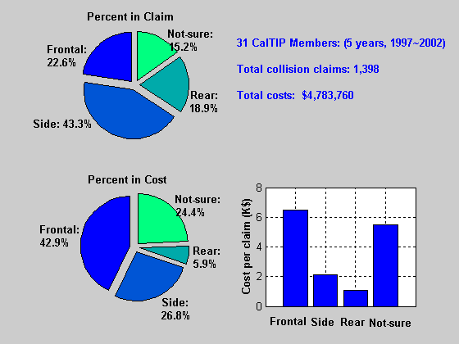
Fig. 15 30-CalTIP members: Collision accident costs by initial point of impact

1.2 In-depth Cost Analysis on Collision Accidents
Two crash severities are defined for collision accidents: serious casualty (collision accident costing more than $100,000), and general collision accident (collision accident costing less than $100,000). Because there are so few fatalities in transit accidents, they are included under serious casualty. Table 3 summarizes the accident cost by crash severity.
Table 3 Collision accident cost data for 35-transit agencies (5 years)
 | Claim |  | Cost
Serious casualty  (Accident costing more than $100K) | 31 | 0.6% | $11,563,53 | 51.7%
General accident  (Accident costing less than $100K) | 5,224 | 99.4% | $10,790,680 | 48.3%
Total for 35-transit agencies | 5,255 | 100.0% | $22,354,203 | 100.0%

Collision accidents account for 55.1% of claims and 62.2% of costs among all accidents, as shown in Table 4.
Table 4 Total accident cost data for 35-transit agencies (5 years)
 | Claim |  | Cost
Collision accidents | 5,255 | 55.1% | $22,354,203 | 62.2%
Non-collision accidents | 4,285 | 44.9% | $13,583,368 | 37.8%
Total for 35-transit agencies | 9,540 | 100.0% | $35,937,571 | 100.0%

1.2.1 Serious Casualty
A few serious casualties account for most costs from collision accidents. In five fiscal years, there are a total of 31 serious casualties for a total cost of $11,563,523. They account for 0.6% of claims and 51.7% of costs among all collision accidents. Table 5 lists all of the 31 serious casualties, which consist of 17 frontal, 7 side, and 7 not-known initial point of impact collisions.
Table 5 Serious casualties for 35-transit agencies (5 years)
Claim | Loss  Code | Initial Point of  Impact | Cost | Accident description
1 | 2 | S | $195,000 | Intersection, going straight bus hit a right turn vehicle
2 | 9 | F | $162,500 | Intersection, bus failure to yield right of way
3 | 14 | S | $203,300 | Sideswipe, bus changing lane
4 | 19 | F | $130,045 | Bus struck a standing vehicle
5 | 19 | S | $104,727 | Bus struck a standing vehicle
6 | 23 | F | $132,456 | Bus rear-ending another vehicle
7 | 23 | F | $121,335 | Bus rear-ending another vehicle
8 | 23 | F | $127,428 | Bus rear-ending another vehicle
9 | 23 | F | $236,616 | Bus rear-ending another vehicle
10 | 23 | F | $350,640 | Bus rear-ending another vehicle
11 | 23 | F | $158,908 | Bus rear-ending another vehicle
12 | 23 | F | $160.026 | Bus rear-ending another vehicle
13 | 23 | F | $100,207 | Bus rear-ending another vehicle
14 | 24 | F | $172,449 | Bus rear-ending another vehicle
15 | 27 | S | $267,223 | Bus pulling from loading zone
16 | 30 | N | $114,379 | Bicyclist veered in front of bus
17 | 30 | S | $506,313 | Bus vs. Bicyclist
18 | 37 | F | $302,307 | Collision, detail unknown
19 | 37 | N | $258,905 | Collision, detail unknown
20 | 39 | N | $163,542 | Bus striking a pedestrian
21 | 40 | S | $209,278 | Bus striking a pedestrian
22 | 41 | F | $1,642,054 | Bus striking a pedestrian
23 | 42 | N | $429,637 | Bus striking a pedestrian (fatal)
24 | 43 | S | $1,997,950 | Bus striking a pedestrian
25 | 43 | N | $906,025 | Bus striking a pedestrian
26 | 43 | F | $250,000 | Bus striking a pedestrian
27 | 43 | F | $975,000 | Bus striking a pedestrian (fatal)
28 | 43 | F | $298,015 | Bus striking a pedestrian
29 | 43 | N | $106,675 | Bus striking a pedestrian
30 | 43 | F | $326,093 | Bus striking a pedestrian
31 | 48 | N | $454,491 | Collision, detail unknown (fatal)
Total |  |  | $11,563,523

Two accident scenarios stand out from the others as sources of serious casualties: “bus hitting a pedestrian” (11 claims with 5 front, 2 side and 4 not-known POC), and “bus rear-ending another vehicle” (9 claims, all frontal). They account for 64.5% of claims and 76.7% of costs among all serious casualties.
1.2.2 General Collision Accident
As shown in Table 3, general accidents account for 99.4% of claims and 48.3% of costs among all collision accidents for the 35-transit agencies.
1.2.2.1 General collision accidents by initial point of impact
Figure 18 shows the claim and cost distributions by initial point of impact, and Figure 19 shows the average cost per claim for each agency. Actual accident and cost data are used for Agencies I, II, III and IV, and the generated distributions by loss code and initial point of impact are used for Agency V and CalTIP(30).

For each agency, side collisions account for the largest number of claims, while frontal collisions account for the greatest cost. Although different agencies have different claim and cost distributions for collision accidents, in general, frontal collisions account for 15~30% of claims and 30%~50% of costs while side collisions account for 35~50% of claims and 25~35% of costs. On average, each frontal collision costs more than twice as much as a side collision. The point of impact cost ranking, from most costly to least, is frontal, side, then rear collision.

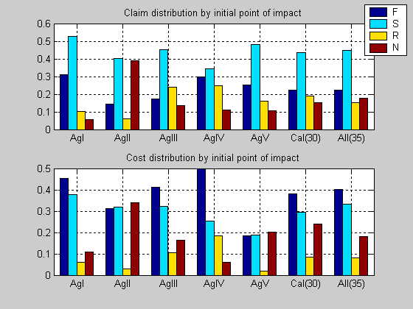
Fig. 16 35-transit agencies: General collision accident costs by initial point of impact

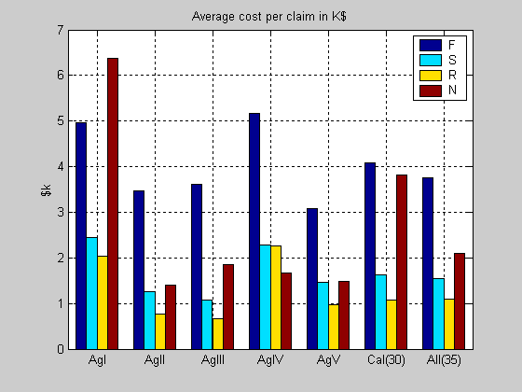
Fig. 17 35-transit agencies: Cost per claim by initial point of impact

1.2.2.2 General collisions by fiscal year
Since each transit agency has its own driver training program and operates in a different environment, it is difficult to find accident statistics that are consistent between agencies. The number of accidents and cost by fiscal year do provide interesting detail, however.

Each year, the 35-transit agencies had about 1,000 general collisions which cost $2 million. Approximately one quarter of these are frontal, and one half are side collisions. The claim costs from these two points of impact account for 40% and 35% of total costs, respectively. This is shown in Figure 20 and 21.

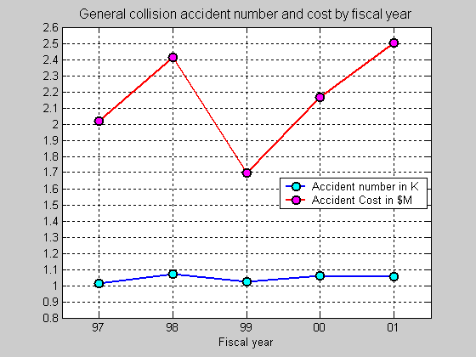
Fig. 18 35-transit agencies: General collisions by fiscal year

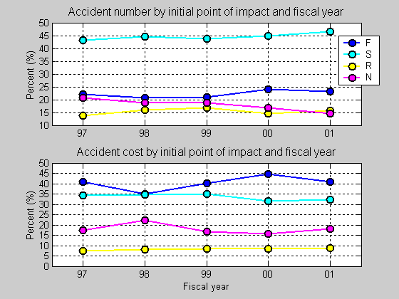
Fig. 19 35-transit agencies: General collisions by fiscal year and initial point of impact
1.2.2.3 General collision accidents by collision object
Collision objects are categorized into three groups: vehicle, pedestrian, and stationary object. Most collision accidents are vehicle collision accidents (91.2% of claims and 86.3% of costs). There are only a few pedestrian collision accidents (3.5% of claims), but they are the most costly. On average, each pedestrian collision cost $5,583 versus a per vehicle collision cost of $1,956. The results are shown in Figure 22. The ranking of collision objects, from most costly to least, is pedestrian, vehicle, and finally stationary object.

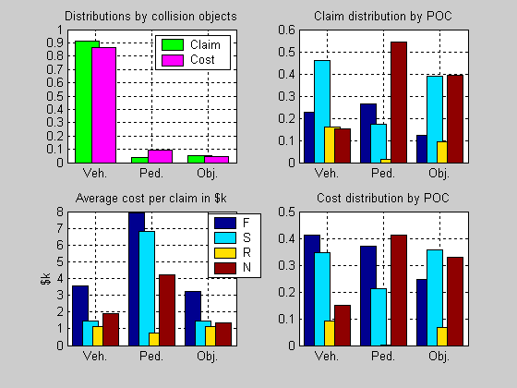
Fig. 20 35-transit agencies: General collision accident costs by collision object
1.2.2.4 Vehicle collision accidents by accident scenario
Ninety percent of collision accidents involve a bus colliding with another vehicle. The following eight accident scenarios have been considered:
Table 6 List of accident scenarios
Accident scenario | Stands for
S1 | Intersection accident
S2 | Bus rear-ending another vehicle (frontal collision)
S3 | Collision at bus rear, including bus backing up (rear collision)
S4 | Bus hit a standing vehicle
S5 | Sideswipe (side collision)
S6 | (Other vehicle) Cut-in accident
S7 | Loading zone accident
S8 | Collision between two buses
S9 | Other vehicle collision accident
Five accident scenarios: intersection collision (S1), bus rear-ending another vehicle (S2), bus hitting a standing vehicle (S4), sideswipe (S5), and collision between two buses (S8), account for 65.4% of claims and 74.4% of costs among all vehicle collision accidents. This is shown in Figure 23.
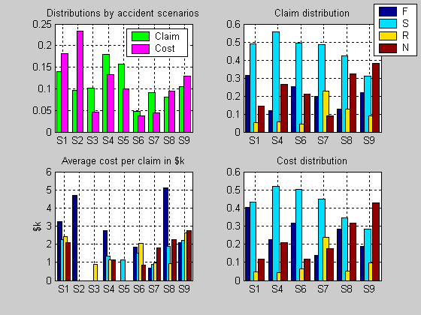
Fig. 21 35-transit agencies: General vehicle collision accident costs by accident scenario

Thirty-three percent of intersection accidents (S1) occurred while the bus was going straight (30% of costs), while 16% occurred while the bus was turning right (9% of costs) and 18% while the bus was turning left (28% of costs). The subset of accidents in which the bus was turning left and hit another vehicle (as opposed to being hit) made up 3.7% of claims and 16% of costs among all intersection accidents.

Thirty-seven percent of sideswipes (S5) occurred while the bus was passing another vehicle (41% of costs) and 45% occurred while another vehicle was passing a bus (37% of costs). Twelve percent of sideswipe accidents (18% of costs) occurred when a bus hit another vehicle while trying to turn a corner, confirming the fact that buses have a wide turning radius which often makes it difficult to avoid other vehicles.

Most standing vehicle accidents (S4) and cut-in accidents (S6) are side collisions. Twenty-two percent of loading zone accidents (S7) occurred while the bus was pulling out, accounting for 38% of costs, while 11% of claims and 13% of costs were the result of accidents while the bus was pulling into the loading zone. Two accident scenarios stand out from the others as sources of loading zone accidents: “bus pulling from zone and hitting a moving vehicle” (16% of claims and 30% of costs), and “bus pulling into zone and hitting a standing vehicle” (6% of claims and 10% of costs).
1.2.2.5 Top five vehicle collision scenarios by fiscal year
Considering accident frequency and cost, the top five collision scenarios involving a transit bus and another vehicle are, from the highest to lowest priority (severity), bus rear-ending another vehicle (S2), intersection collision (S1), collision between transit buses (S8), standing vehicle accident (S4), and sideswipe (S5).

Figure 24 shows the percentage of general vehicle collisions and general vehicle collision costs, by fiscal year, for all five accident scenarios. Figure 25 shows the same information broken out by scenario type.

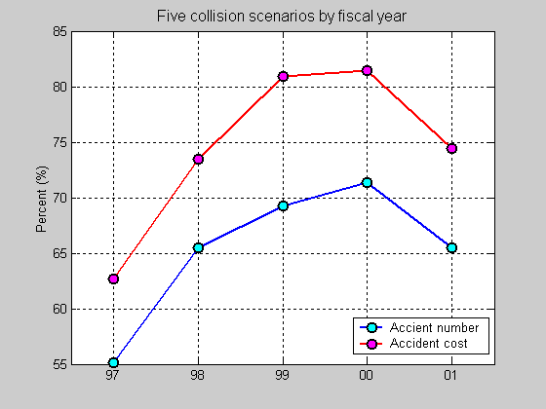
Fig. 22 35-transit agencies: Five collision scenarios by fiscal year

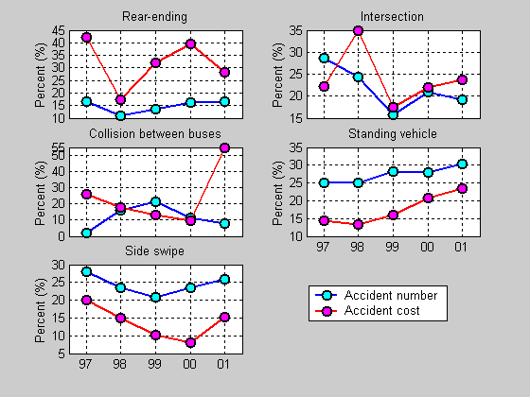
Fig. 23 35-transit agencies: Five collision scenarios

1.3 In-depth Cost Analysis of Passenger Injuries
For the 35 agencies, there are a total of 4,285 passenger injury accidents in 5 fiscal years with a total cost of $13,583,368, and they count for 44.7% in claim and 35.3% in cost among all accidents.

Two severities are defined for passenger injury accidents: severe for passenger injuries that cost more than $100,000; and general injury otherwise. Table 7 lists the 23 severe injuries in the five fiscal years.
Table 7 Severe passenger injuries for 35-transit agencies (5 years)
Claim | Loss Code | Cost | Accident Description
1 | 50 | $125,017 | Passenger fell on boarding
2 | 55 | $179,512 | Passenger fell on alighting
3 | 63 | $110,196 | Passenger fell due to abrupt stop
4 | 63 | $274,079 | Passenger fell due to abrupt stop
5 | 63 | $168,105 | Passenger fell due to abrupt stop
6 | 63 | $134,281 | Passenger fell due to abrupt stop
7 | 63 | $230,531 | Passenger fell due to abrupt stop
8 | 63 | $151,000 | Passenger fell due to abrupt stop
9 | 64 | $104,965 | Passenger fell on turning bus
10 | 65 | $200,000 | Passenger fell on going straight bus (walking)
11 | 67 | $107,910 | Passenger leaning out window, hit by sign
12 | 68 | $177,175 | Passenger fell, details unknown
13 | 68 | $169,493 | Passenger fell, details unknown
14 | 68 | $427,500 | Passenger fell, details unknown
15 | 74 | $500,000 | Passenger fell on running for bus
16 | 74 | $134,494 | Pedestrian fell on running for bus
17 | 78 | $163,593 | Details unknown
18 | 78 | $164,158 | Details unknown
19 | 78 | $150,000 | Details unknown
20 | 78 | $107,500 | Details unknown
21 | 88 | $245,560 | Bus vs. bicycle
22 | 66 | $175,000 | Wheelchair rolled backward on board
23 | 115 | $165,000 | Wheelchair rolled backward on board
Total |  | $4,365,069
Two out of the twenty-three severe injuries happened at loading zones; most severe injuries occurred when passenger were on board. The scenario of “Passenger fell due to abrupt stop” stands out from the others, accounting for about 25% of both number and cost among all severe injuries.

Excluding the 23 severe injuries, the 35-transit agencies had about 900 passenger injuries and spent about $1.8 million each year. This is shown in Figure 26.

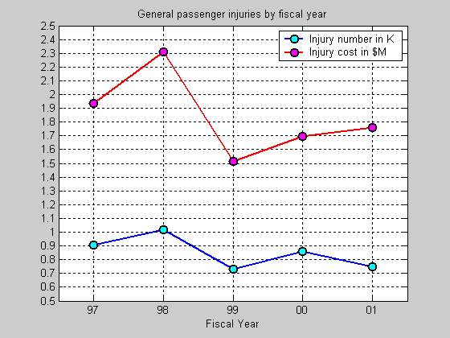
Fig. 24 35-transit agencies: General passenger injuries by fiscal year

The following eight maneuvers prior to an accident have been considered for general passenger injuries (excluding the 23 severe accidents)

Table 8 Maneuver types prior to an accident
Bus maneuver | Stand for
M1 | Passenger boarding
M2 | Passenger alighting
M3 | Bus starting
M4 | Bus stopping
M5 | Bus turning
M6 | Bus going straight
M7 | Bus moving (others)
M8 | Others
About thirty percent of general passenger injuries occurred at loading zones (boarding and alighting), which also accounted for 27.4% of costs. Twenty percent of passenger injuries occurred as a bus was stopping. This type of passenger injury has the highest severity, as it is shown in Figure 27.

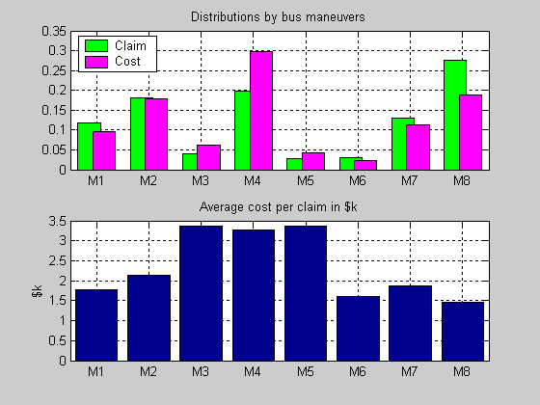
Fig. 25 35-transit agencies: Passenger injuries by bus maneuver

During the five fiscal years, there is a steady increase in the percentage of passenger injuries on stopping buses (M4) among all general injuries. This is shown in Figure 28.
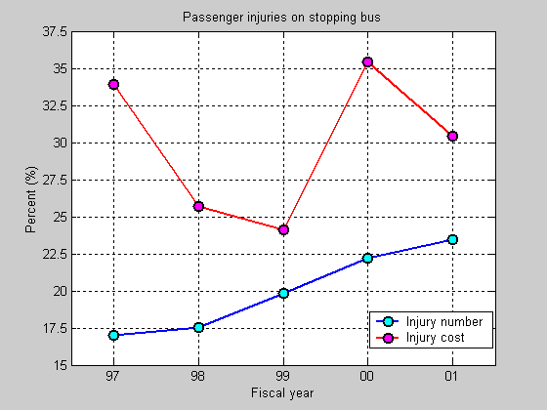
Fig. 26 | 35-transit agencies: Passenger injuries on stopping bus among all general injuries

1.4 System Impacts
As transportation transitions into the information age with the integration of advanced and information technologies, there is a need to examine the potential impacts of new technologies such as FCWS. The focus of this task is to look at the relationship between frontal (and other) collisions and the corresponding effect(s) at both micro and macro levels. At the macro-level, how can a FCWS make a bus a safer vehicle? And at a system level, how does widespread use of FCWS or other similar technology affect the system? What are the impacts as measured by the costs resulting from death and injury and the costs from increased congestion?

Each of the core participants as well as the associate partners involved with this project has different motivations for participation. As the owner and operator of the state highway system, Caltrans is interested primarily in how vehicle-based systems will affect mobility, transportation operations, and the environment (e.g., the regional and state transportation systems). SamTrans, meanwhile, as a transit property has a greater interest in how Advanced Vehicle Control and Safety Systems (AVCSS) might improve their operations by increasing bus safety and decreasing operating costs.

The original objective of system impact task was to conduct an analysis on the potential benefit of frontal collision avoidance devices (micro) and the impact of frontal collisions involving transit buses on regional traffic systems (macro). The impact estimates were to include (a) the loss of operation time of individual buses, (b) the loss of revenue, (c) the increase of operational costs due to collisions, and (d) the interruption of traffic flow and resulting congestion.

Because of the lack of data it was not possible to connect individual accidents to changes in congestion or specific accident related costs, therefore the scope of this task had to be modified to utilize specific accident data along with aggregate state or national data on the cost of accidents and congestion. The potential impacts were categorized into two areas: cost of accidents in terms or fatalities, injuries and property damage and the impact of congestion on society including pollution, energy, health, and personal costs.
Traffic congestion can be divided into two types: recurring and non-recurring. Recurring congestion is predictable and results when the demand for transportation facilities exceeds the supply (i.e., morning and evening commutes). Non-recurring congestion is traffic slowing down as a result of accidents, stalled cars, debris, or driver distracting events adjacent to the highway (such as fires, construction, etc.). It is non-recurring congestion that is of concern in this project. Estimates as to the percentage of congestion stemming from recurring versus non-recurring causes varies between 40% and 60% and 60% and 40% respectively.

The benefit estimates will be derived from the impact analysis outlined above as well as the potential reduction of property damage, personal injury, and liability claims. This analysis will provide a foundation for the eventual cost-benefit evaluation of collision warning devices later in this project.

The benefit estimates were derived using the above mentioned baseline data. At a later date, a similar analysis with data from collision warning devices on the local transit buses shall be performed correlating the data with the baseline data.

1.4.1 Data Source
Data came from several sources:
(a) Accident data
Accident data for this analysis was obtained from the California Highway Patrol/Caltrans' Traffic Accident Surveillance and Analysis System (TASAS) [8]. The data includes location, type of accident, type of vehicle(s) involved, time-of-day, weather conditions, pavement conditions, etc.
(b) Congestion or traffic volume data
Congestion or Traffic Volume Data was obtained from three sources:
1. Texas Transportation Institute's (TTI) 1999 Urban Mobility Study, [9]
2. Caltrans, the Traffic Volumes Computer Database, and the
3. Highway Congestion Monitoring Program [10] (HICOMP) Report.
(c) Costs associated with accidents and congestion
The costs associated with accidents and congestion came from a number of sources including:
TTI's Urban Mobility Study [9], The National Resources Defense Council/ Resource Futures International sponsored study “The Price of Mobility: Uncovering the Hidden Costs of Transportation,” The National Public Research Institute's report Highway Crash Costs in the U.S. by Drive Age, Victim Age, Blood Alcohol Level, and Restraint Use [11], and a number of other U.S. government-sponsored reports and documents.
1.4.2 Analysis Approaches
There were three primary activities as part of this task: (1) a review of current literature; (2) a search for pertinent accident, congestion, and cost data; and (3) an analysis of these data.

TASAS Data was downloaded from Caltrans’ mainframe computer system, and converted to worksheet and relational database format for subsequent analysis. Bus accident data versus time-of-day (by hour) was analyzed at three levels: statewide, for the San Francisco Bay Area, and for SR 82 in San Mateo County.

Cost estimates for fatalities, injuries, and property damage were obtained through the literature. The cost of bus accidents for California, the San Francisco Bay Area, and State Route 82 in San Mateo County was then calculated.

2 Field Data Analysis
The accident data provides a knowledge base for determining the type and frequencies of frontal collision accidents. As transit accident data relies on recall from the parties involved, the data may not accurately describe the cause and time sequence of events in enough detail to enable a detailed accident analysis. In order to better understand the bus operating environment and time sequence of events in potential accidents, the team determined that it was critical to collect field data so that bus accident scenarios can be constructed. Significant efforts were devoted to the development of a data acquisition system.

The objectives of the Data Acquisition System (DAS) are to: (1) help understand the environment that the Frontal Collision Warning Systems will operate in, (2) provide a basis for an analysis using a dynamic vehicle model to predict potential collision courses, (3) facilitate the development of the collision warning system, and (4) enable before-and-after data comparison to determine if there is any change in driving behavior with the introduction of the system. It is understood that the likelihood of the buses instrumented with the data acquisition system being involved in an accident is extremely small. However, the large amount of data collected on these buses will provide an accurate description of the relative movement of buses and the surrounding vehicles. In the absence of collisions, hazardous conditions that potentially can lead to accidents can be identified and driver reactions to these hazardous conditions can be analyzed. In-depth understanding of the bus operating environment and hazardous conditions through collection and analysis of field data is a critical portion in determining the specification of performance requirements for a transit bus FCWS.

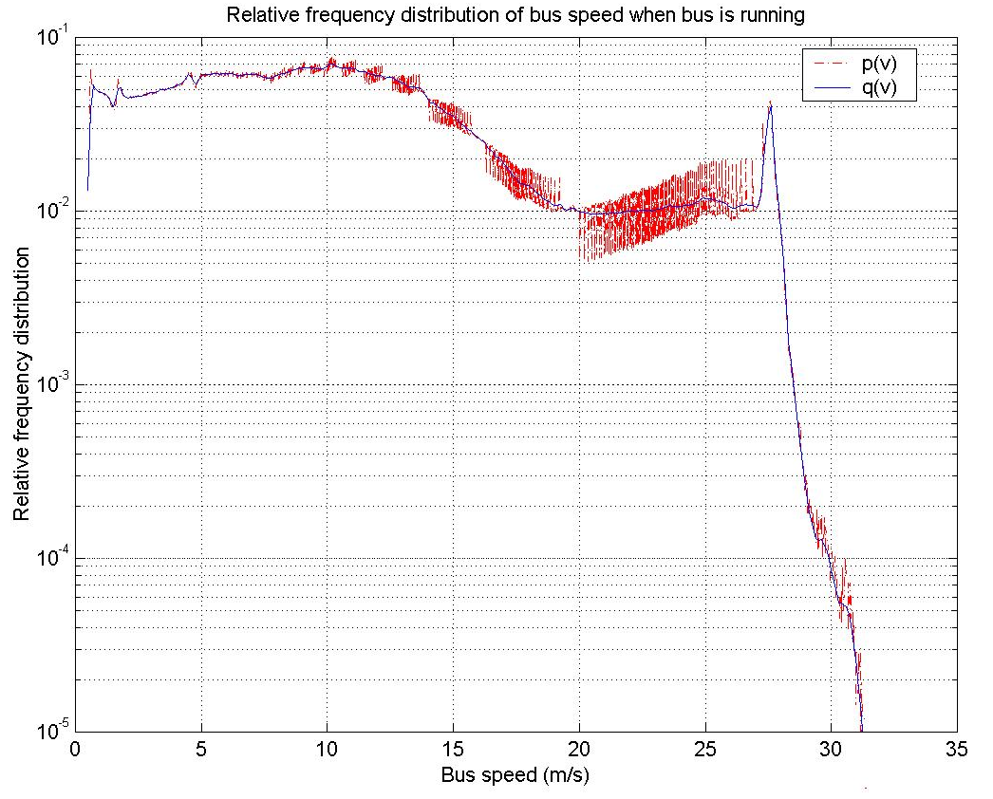
Fig. 27 Relative frequency distribution of bus speed when bus is moving

As we can see, the plot of is quite noisy. To smooth the plot and keep the peak at 27.5m/s, two different window sizes were used. One window with was applied on the intervals within m/s, and the other window with was applied to everything else. The smoothed relative frequency distribution is shown in Fig. 27 with a blue solid line.

As can be seen from Fig. 35, the bus mostly travels in four main speed ranges, 8~12m/s, .55~5m/s, 5~8m/s and 12~15m/s.

0.55~5m/s, 22%
5~8m/s, 18%
8~12m/s, 26%
12~15m/s, 15%
15~20m/s, 9%
20~26m/s, 6%
>26m/s, 3%
Fig. 28 Percentage of time for bus speed

2.1.3 Bus Acceleration
For bus acceleration, the value region () was divided into 133 intervals with step size . It was found from the field data that the maximum acceleration value is 0.523g, and the minimum acceleration value is –0.692g (deceleration).

The relative frequency distribution of bus acceleration is shown in Fig. 36 (in total 20,890,161 samples). Since the plot is pretty clean, no moving widow was applied to it. The highest peak locates at –0.01g. In the positive half, there is another peak at 0.028g. Although the maximum decelerating and accelerating found in the field data are quite large, there is a very limited likelihood that bus has acceleration values below () in slowing down or greater than () in speeding up. As shown in Fig. 36, the bus has a higher probability with acceleration valued from to for decelerating and valued from to for accelerating. Fig. 37 shows the percentage of time that the bus is operated with different acceleration levels. The percentage of time that the bus acceleration is greater than is 0.2%, this is not displayed in the pie chart.

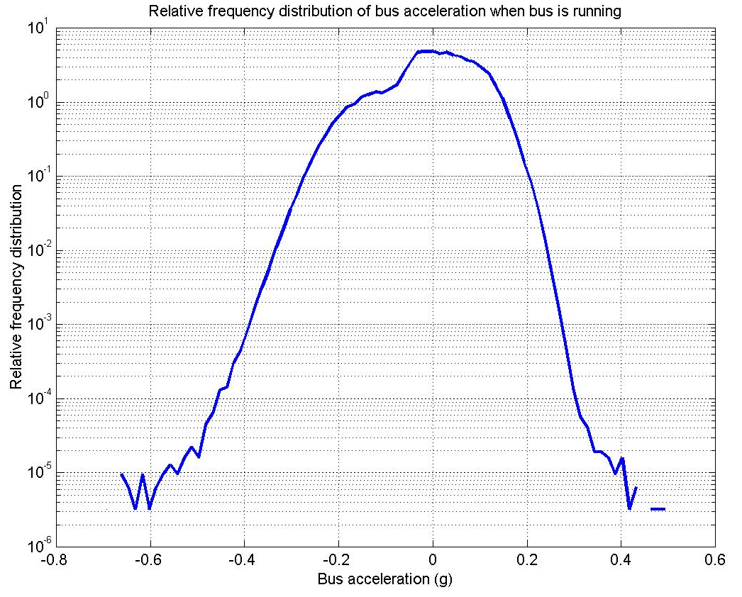
Fig. 29 Relative frequency distribution of bus acceleration when bus is moving

-0.4~0.1g, 14%
-0.1~0g, 28%
0~0.12g, 52%
0.12~0.2g, %6
Fig. 30 Percentage of time for bus acceleration

The total time spent speeding up is longer than spent slowing down (58%:42%). 67% of deceleration occurs within -0.1~0.0 g, while 90% of acceleration occurs within 0~0.12g.
2.1.4 Brake Pressure
For brake pressure, the value region psi was divided into 1,000 intervals with step size psi. When the bus is stopped, bus drivers sometimes step on the brake harder. This would affect the overall statistics of brake pressure. Hence, only the data from when the bus is moving was considered. There are a total of 20,890,161 samples. It was determined from the field data that 1.3 psi is an appropriate threshold to separate brake-on samples from no-brake data. Fig. 38 shows the percentage of time for brake-on vs. no-brake when the bus is moving.
No-brake, 77%
Brake-on, 23%
Fig. 31 Percentage of time for no-brake vs. brake
The maximum brake pressure in field data when the bus is moving is 81.7 psi, in this case the driver braked in an emergency to avoid hitting a child and a dog that had suddenly run across the street. Fig. 39 shows the relative frequency distribution of brake pressure (when brake is on) in red with dashed line. A moving window with was applied, the smoothed is displayed with a blue solid line.

The highest peak is at 9 psi. When the brake is on the most commonly occurring frequency of brake pressure is 6 to 12 psi. Fig. 40 shows the percentage of time for brake pressure in different levels. It should be noted that brake pressure is above 50 psi less that 0.2% of time.
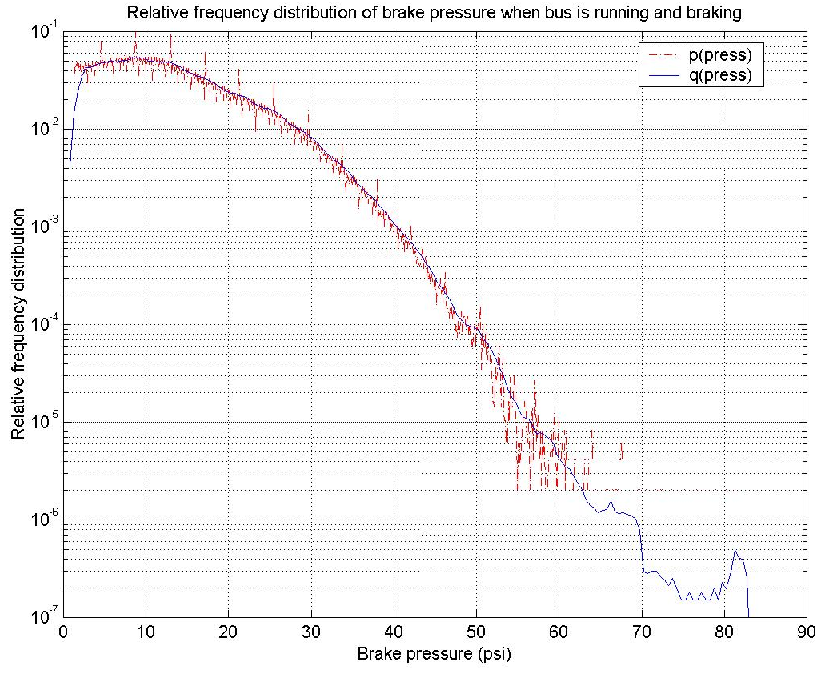
Fig. 32 Relative frequency distribution of brake pressure

1.3~6psi, 22%
6~12psi, 31%
12~20psi, 29%
20~30psi, 15%
30~50psi, 4%
Fig. 33 Percentage of time for brake with different pressure levels
2.1.5 Front Wheel Angle
For front wheel angle, the value region deg was divided into 800 intervals with step size deg. When the bus is stopped, bus drivers sometimes hold the steering wheel at certain non-zero angles. This would affect the overall statistics of wheel angle. Hence, only the data when the bus is moving (speed > 0.5m/s) was considered. In field data, the maximum front wheel angle is 45.5 deg to the right and 50.1 deg to the left.

The relative frequency distribution of front wheel angle, , is shown in Fig 41 with a red dashed line. Left is positive and right is negative. To smooth the plot and to maintain the peak at 0 degree, two moving windows were used. One window with was applied to the region of –6~ +6 deg, and the other window with was applied to everything else. The smoothed relative frequency distribution, , is shown with a solid green line. The highest peak locates at 0 degrees, this indicates that most of time the bus is moving straight forward.
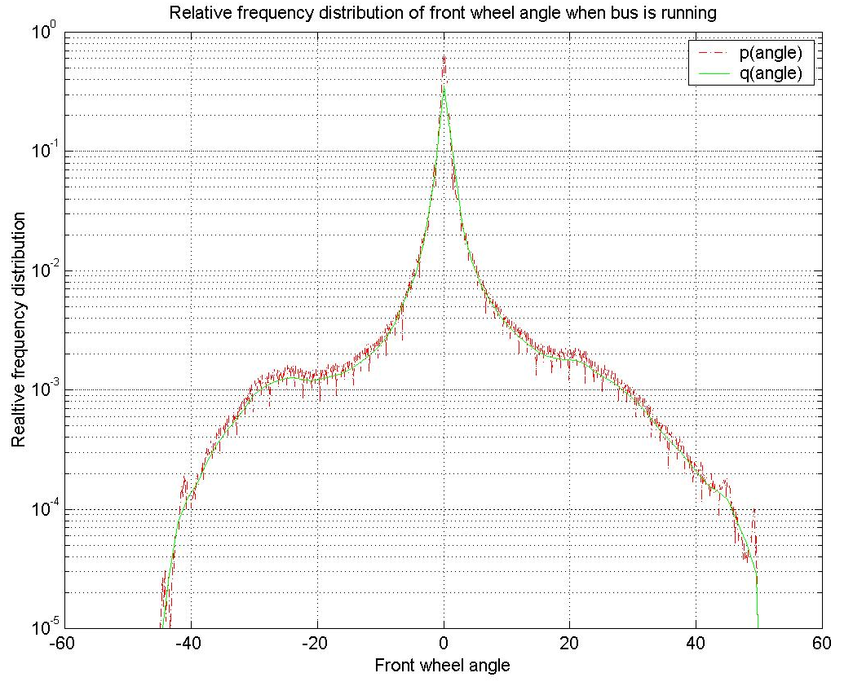
Fig. 34 Relative frequency distribution of front wheel angle (+left/-right)

2.1.6 Minimum Following Distance and Corresponding Closing Rate
Lidar can detect up to 8 targets simultaneously. Only those targets that are running in the same direction as the bus with 2-meter (about half a lane) or closer lateral distance to the bus center line were picked up. The minimum following distance is the minimum longitudinal distance from the bus frontal bumper to targets. The corresponding closing rate is the closing rate of the target at the minimum distance. Closing rate equals negative range rate. Positive closing rate means that the bus is approaching a forward target.

For minimum following distance, the value region m was divided into 2000 intervals with step size m. Again, only those samples from when the bus was moving were considered. There are in total 6,494,755 samples. The closest minimum following distance in the field data is 0.078m, which occurred in a case that bus was following a leading car in stop-and-go movement. The maximum value of minimum following distance found is 160.1m, which is the maximum range that the Lidars can detect.

The relative frequency distribution of minimum following distance, , is shown in Fig 42 with a red dashed line. A moving window with was applied to it to smooth the plot. The smoothed relative frequency distribution, , is displayed with a blue solid line. The highest peak locates at 22m.
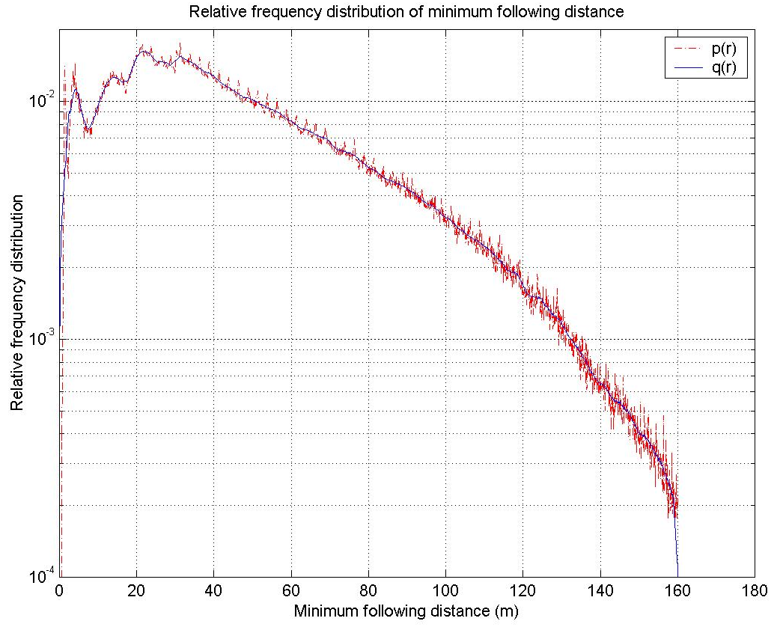
Fig. 35 Relative frequency distribution of minimum following distance

For the corresponding closing rate, the value region m/s was divided into 2,000 intervals with step size m/s. The maximum value of closing rate is 29.6m/s, when the bus was approaching a target. The minimum value of closing rate is –65m/s. This negative closing rate is doubtful because while it is possible it is very rare for a vehicle to move that fast. Furthermore, it is not clear in the video data if there is such a target. However, the Lidar did report such a target with a relative speed of 65m/s. Sensor noise, or other targets that are not in the camera’s field of view might cause this. We are still not sure what caused this problem, and need to do further investigation.

Fig. 36 Sensor arrangements of the Data Acquisition System

Based on the data acquisition needs, a sensor arrangement for the DAS is designed to include sensors to detect frontal and frontal corner obstacles and to monitor steering angle movement, brake and throttle motion, vehicle velocity and acceleration (Figure 32) provides the DAS configuration. Detail description of the development of data acquisition system can be found in Appendix V.

The hardware configuration of the DAS can also be used as the hardware platform of the FCWS. Minor changes in sensor layout and computer configurations may be required to do this. The data acquisition function and the collision warning function can both be implemented in software. They can run in parallel in a multi-task system. This means the DAS will be still running after the FCWS has been installed on the bus. This allows us to analyze driver adaptations by comparing the data collected before the FCWS is installed with the data after installation.

Fig. 37 Diagram of the data acquisition system

Using 3 buses instrumented with this data acquisition system, field data were collected since early 2001. The data was analyzed at three different levels: 1) manual review with the data playback tool which is a Windows™ program developed by PATH, 2) histogram analysis of specific parameters by simply counting the numbers of samples in the data, and 3) event-related histogram and clustering analysis by applying filtering algorithms to the data to detect events (e.g. braking onset) and estimate parameters. These approaches are discussed in detail in the following sections.
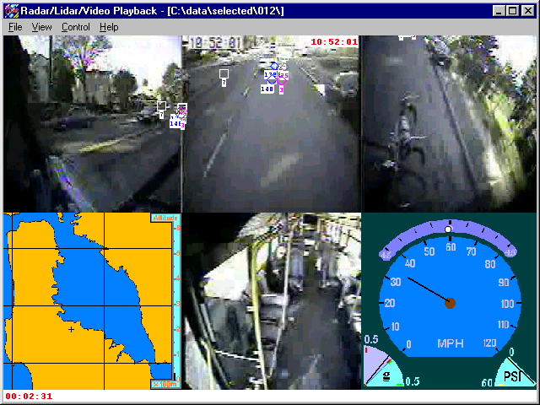
Video time
Left-side Looking
Front Looking
Right-side Looking
Title bar
Sensor time
Elapsed time
Acceleration
Wheel-angle
Speed
Interior Looking

GPS position

Brake Pressure

Passenger-side Radar

Driver-side Radar

Lidar

Fig. 38 Snapshot of the data playback tool window

To facilitate data analysis, PATH has developed a data playback tool, a program running in a Windows™ environment. The tool was developed in May 2000 and has been updated several times. The tool can decode and play back MPEG movies in Windows™. It displays bus states, such as speed, acceleration, brake pressure, front wheel angle and GPS location, simultaneously during video playback. It projects the radar and lidar targets into the video frames, using simple visual marks to indicate which objects in the frames have been detected by which radars or lidars. Fig. 33 is a snapshot of the data playback window. It can be seen that the display is divided into six sub-windows. Video from each camera is displayed in one sub-window. The GPS location and altitude are displayed in the lower left-hand sub-window. Other subject vehicle states, i.e. wheel angle, speed, acceleration and brake pressure, are displayed in the lower right-hand sub-window.

This tool provides the data reviewer a complete view of all the data collected at the same time. The tool provides the ability to understand sensor behavior, traffic scenarios, and the characteristics of targets. For example, the tool has been used to verify different sensor performance; see below for radar and liar information verified by the tool:
Micro-wave radar disadvantages
- Nearly stationary targets can not be detected;
- Target signal drops;
- Low azimuth accuracy.
Micro-wave radar advantages
- Working well in all weather;
- Accurate range;
Lidar disadvantages
- Saturation facing sun ;
- False alarms with rain, fog and grime on lens;
- Dependent range-rate estimate;
- More stationary roadside targets;
- Occasional target split.
Lidar advantages
- Able to detect stationary targets;
- Accurate two-dimensional position measurements;
- Large view angle;
- Fewer target drops.

The tool also provided a software platform to develop and test the warning algorithms.
2.1 Analysis of Data Samples
The field data used for this analysis was recorded on the first bus (SamTrans bus No.600) from August 1, 2000 thru April 16, 2001. There was 80 days of data. The bus was operated for average 7.5 hours a day. The experimental bus was on normal service in San Mateo County, California. The drivers who drove the bus were not specified or selected. The bus and the service routes were assigned to them by the dispatch center of SamTrans according to normal crew assignment schedules. The service routes were spread throughout San Mateo County, with connections to the Daly City and Colma BART stations, the San Francisco Airport, several Caltrain stations, and the downtown areas of local cities. Different weather conditions including rain, fog and wind, were encountered. The bus was usually put on service in the early morning before daybreak, until the late afternoon around sunset, with a few scheduled breaks. The 80-day data covers the representative drivers, routes, weather, time-of-day and level of traffic.
2.1.1 Approaches
For each parameter, the possible distributed value region was divided into equidistant intervals . The step size is. The data is scanned to accumulate the number of samples of that fall into each interval. This is like generating histogram bins. Since the Data Acquisition System (DAS) has a fixed sampling rate, the number of samples in each bin, , is proportional to the total time that stays on the value interval. The following normalized parameter ( is the total samples of):
is proportional to the total time that stays on the value interval . It has the property that:
is the relative frequency distribution. It is not necessarily an approximation of a Probability Density Function (pdf) of , because the adjacent samples may not be independent. However it still gives out the probability distribution characteristic of .
The initial step size, , is small to preserve the resolution of the relative frequency distribution. In the case that the step size is too small to accumulate sufficient samples in the bins, a moving window average method was used to combine the bins. Assuming the size of the moving window is , the smoothed relative frequency distribution is defined by:
.
It is also true that:
.
In practice, the moving window size is selected by trying different window sizes to smooth .
2.1.2 Bus Speed
For bus speed, the value region m/s (1m/s = 2.25 mph) was divided into 2000 intervals with step size of m/s. It was found from the data that the minimum speed sensor measurement, except 0, is 0.55m/s, hence a bus stop/running threshold is set at 0.5m/s. Speed above/below this threshold indicates when the bus is moving/stopped.

When the bus is running, the minimum speed measurement is 0.55m/s, and the maximum measurement is 31.3m/s. The maximum speed occurred in the case that a bus was running at highway speed. There are in total 20,890,161 samples. The estimated relative frequency distribution of bus speed, , is shown in Fig. 34 in red with dashed line.
1.4.3 Results
(a) Cost of accidents
The cost of accidents, taken from the literature, used a comprehensive cost method known as “Willingness to Pay” to calculate the monetary value of fatalities, injuries, and property damage. While there are other methods used to determine costs associated with accidents, these values were used because they have an acceptance level within Caltrans [12] and within the broader highway transportation community including FHWA and National Safety Council advisory groups.

The comprehensive cost method includes seven cost factor areas: medical, work loss (victim), public services, employer costs, travel delay, property damage, and quality of life. The first six of these categories are self evident (i.e., public services - costs incurred by police, EMT, fire, towing, etc; property damage - costs to repair or replace vehicle or objects struck by vehicles; etc.). The seventh category Quality of Life, however, puts a value to the quality of life by quantifying pain, suffering, and quality of life for a family. The value is computed from the amount people routinely spend in dollars or time to reduce their or a family member’s risk of death or injury. The amount people spend is calculated from what is commonly spent on items such as automobile air-bags, anti-lock brakes, and hazard pay for higher risk jobs.

Table 9 Accident costs 1997 dollars in California comprehensive cost method
Area | Fatality | Injury | PDO/vehicle
Rural | $3,123,603 | $45,802 | $2,058
Suburban | $3,123,603 | $39,745 | $2,058
Urban | $3,123,603 | $33,688 | $2,058
Average | $3,123,603 | $39,745 | $2,058

(b) Accidents involving buses
The number of accidents involving buses and the associated fatalities and injuries on California-owned highways was determined from the TASAS database [8]. Further investigation needs to be done in order to separate out school buses from other buses, although, informal observation indicates that the percentage of accidents involving school buses is relatively small. It also may be possible to determine what vehicle is the hitter and which was hit. This particular analysis would also go a long way toward determining the percentage of frontal collisions versus other types of collisions. The following table shows the breakdown of accidents involving buses on the state highway system.

Table 10 Accidents Involving Buses on California State Highways 1996–1998
California's Traffic Accident Surveillance and Analysis System (TASAS)[8]
Region | # of Accidents | Fatalities | Injuries
Statewide | 2914 | 24 | 1066
Caltrans District 4 (S.F. Bay Area) | 858 | 4 | 243
State Route 82 (In San Mateo Co.) | 66 | 1 | 15

(c) Cost of accidents involving buses
The cost of accidents involving buses was calculated from the previous two tables and is shown in the following table. The numbers indicate the potential benefit that would be gained by eliminating these accidents. Property damage is calculated assuming damage to two vehicles per accident.

Table 11 Cost Estimates of Accidents Involving Buses 1996–1998
(California State Highways Only)
Region | $ of Fatalities | $ of Injuries | $ of PDO | Total
Statewide | $75M | $36M | $12.M | $123M
CT District 4  (S.F. Bay Area) | $12M | $8.2M | $3.5M | $24M
State Route 82  (In San Mateo Co.) | $3.1M | $0.51M | $0.27M | $3.9M
(d) Accidents and congestion
There was a rough proportionality between the number of accidents involving buses and traffic volumes (i.e. morning and evening commutes) in that there more bus accidents occur in higher traffic volumes. While it is obvious that accidents impact traffic flow by reducing the capacity of the highway, it is not apparent whether congested traffic conditions cause more accidents because they are more hazardous (i.e., speed differentials created by alternating free-flowing and stop-and-go traffic flow) or if the increases are simply due to the fact that there are more vehicles on the road. Many different methods have been used over the years to estimate the cost of congestion.

Fig. 39 Number of accidents and traffic volume vs. hour

Fig. 40 Number of accidents and traffic volume vs. hour

Dealing with lack of data is perhaps the greatest difficulty when trying to perform this type of analysis. In addition to the fact that congestion data is generally aggregate and averaged over days or weeks or months, accident data, whether it be the physical data surrounding the accident or the subsequent medical and legal costs, are considered very sensitive and therefore difficult to obtain. Additionally, each agency has a different system for collecting and archiving safety data, varying from paper records to archaic computer databases to modern database systems. Also, congestion data was available only for California highways, whereas, most transit agencies operate their vehicles on local streets and roads. This data was generalized data that was averaged out over weekly or monthly periods so there was no way to correlate what effects specific accidents had on traffic flow.

Regardless of the perspective of the person looking at accident statistics, it is apparent that accidents, especially those leading to death or injury, are very expensive. Also, they get more expensive, at least in terms of dollars, as one transitions from the individual to the transit agency to the insurance company to state and federal governments and to society at large. Although the transit industry has the safest drivers when compared to commercial vehicle operators and the driving public, the costs of bus related accidents warrants the investigation and development of devices or systems to mitigate crashes, which is over one million dollars per year on only one state route in San Mateo County.

Because of the uncertainty in quantifying the costs related to accidents (i.e., congestion, air pollution, pain and suffering, public relations, etc.) it is important to consider measures other than dollars when deciding on whether to research, develop and eventually deploy collision warning and collision avoidance systems.

Baseline statistics proposed as benchmarks in measuring the effectiveness of projects in these areas should include, but not be limited to: frequency and severity of accidents, injuries and fatalities, vehicle role, corrective action, movement prior to critical
event, critical event, and damage costs. An effective benchmark would be a reduction in critical factors: overall incidents, injuries/fatalities, and costs.
1.5 Observation and Conclusions
This transit accident and cost analysis was conducted using actual accident data from 35 transit agencies in California for the most recent five fiscal years. These agencies operate buses in a wide range of regions and operating environments, including one of the most congested areas in the United States, the San Francisco Bay Area. We have confirmed that accident claim and cost distributions vary from agency to agency due primarily to the fact that every agency has its own driver training program and a different operating environment. We have also shown that the accident and cost distributions by loss code and the initial point of impact are very consistent between transit agencies.

The statistics obtained are consistent with the national bus accident statistics:
- 0.6% of collision accidents involved serious casualties of which 54.8% were frontal collisions and 22.6% were side collisions. NHTSA[5] reports 0.6% fatality, of which 68.4% were frontal and 16.8% were on the side for bus collision accidents (school, intercity and transit).
- 91.2% of collision accidents involved another motor vehicle, 5.3% involved an object, and 3.5% involved pedestrians. NHTSA[5] reported 83.5% of accidents with a vehicle and 16.2% with an object.
- Excluding not-known initial point of impact collisions, 27.1% of collision accidents are frontal collisions, 54.3% are side and 18.6% are rear collisions while NHTSA [5] reported 28.2% front, 47.6% side and 22.9% rear.

The cost benefit analysis confirmed the recommendation by transit IVI Committee on the need for IVI technologies:
- Excluding the costs for serious casualties and not-known point of impact collisions, 49% of collision costs are for frontal collisions, 41% are for side, and 10% are for rear collisions. These numbers may be significantly reduced by frontal/forward, side and rear warnings.
- Passenger injuries (not collision related) account for one third of all accident costs. Passengers injured due to the bus coming to an abrupt stop have the highest priority both in frequency and severity (19.8% of claims and 28.1% of costs). This type of accident may be avoided with smoother operation from FCWS.
- 56% of passenger injury costs are related to moving buses, while 21% are from boarding and alighting. Those numbers may be significantly reduced with Lane assist/precision docking.

This analysis also shows the specific needs for IVI technologies:
- Bus backing accidents are not a critical scenario for the 35 agencies.
- Forty-four percent of serious casualty costs are for pedestrian accidents, which also account for 15% of all accident costs. This shows the critical need for pedestrian detection and avoidance service.
- Considering accident frequency and cost, the top five collision scenarios involving a transit bus and another vehicle are, from the highest to lowest priority (severity): bus rear-ending another vehicle, intersection collision, collision between transit buses, standing vehicle accident, and sideswipe. These five accident scenarios account for 65.4% of claims and 74.4% of costs among all general vehicle collision accidents (excluding serious casualties).

Several observations can be concluded from the review of numerous accident reports in the course of this study:
- The speed of buses prior to the accident occurrence was generally modest as recorded in the incident reports, for example below 30 mph. This is due to the fact that the transit buses operate on suburban corridors, local streets, and among transit stations and typically they are not expected to run at high speeds for transportation purposes. For incidents near bus stops, traffic lights, or intersections, the speed can be considerably lower. Since the operating environment of transit buses covers a variety of local streets and corridors in urban and suburban environments, they generally see heavy traffic and frequently encounter street objects such as pedestrians, bicycles, and parked vehicles. It is essential to examine carefully the performance and capability of sensors under these circumstances. Thus, the first phase of data collection and the evaluation of sensing signals and noises will be extremely important.
- Among the reviewed accident reports, many incidents involved the bus making contact with a neighboring vehicle at the front corners at relatively low speeds. This may happen when the bus is pulling out from a stop or turning at an intersection, or an adjacent vehicle is moving aggressively ahead of the bus. The incident may be classified as a frontal or a side impact in reports. This implies that the implementation of corner sensors may be essential to alert the drivers of such obstacle presence. The corner sensors can also be useful for detecting cut-in vehicles.
- The operating speed of buses on local streets, near traffic lights, or bus stops is low and the distance to other vehicles or obstacles are short. Under these operating circumstances, it may be challenging to provide a warning signal that is timely yet not frequent enough to distract the driver.
- In the selection process of warning signal types and driver-machine interface, it should be taken into consideration that transit bus drivers are working under heavy work loads.

References

- T. Wilson, et al., “Forward-Looking Collision Warning System Performance Guidelines, “SAE No. 970456, 1997.
- T. Wilson et al., IVHS Countermeasures for Rear-End Collisions, Task1, Volume II: Statistical Analysis, DOT HS 808 502, 1994.
- H. Asher, B.A. Galler, “Collision Warning Using Neighborhood Vehicle Information, Proceedings of ITS America, 1996.
- Intelligent Vehicle Initiative Needs Assessment, FTA-TRI-11-99-33, DOT-VNTSC-FTA, November 1999.
- Traffic Safety Facts 2000, NHTSA, December 2001.
- Ching-Yao Chan, et al., “Studies of Accident Scenarios for Transit Bus Frontal Collisions”, Proceeding of ITS America, 2001.
- Traffic Safety Facts 2000, NHTSA, December 2001.
- California Highway Patrol/Caltrans' Traffic Accident Surveillance and Analysis System (TASAS)
- Schrank, David, Lomax, Tim, Texas Transportation Institute's 1999 Urban Mobility Study, November 1999, http://mobility.tamu.edu/
- Caltrans Traffic Operations Program, Office of Traffic Safety, Traffic Volumes Data
- Miller, Ted R., Spicer, Rebecca S., Lestina, Diane C. (1998) "Highway Crash Costs in the U.S. by Driver Age, Victim Age, Blood Alcohol Level, and Restraint Use", Accident Analysis and Prevention, Vol. 30(2):137-150. National Public Services Research Institute, Landover MD.
Peterson, Roy A., Estimated Crash Costs For California, 1999 California Department of Transportation, Traffic Operations Program, Office of Transportation Safety.

The relative frequency distribution of closing rate, , is shown in Fig 43 with a red dashed line. The highest peak locates at 0. There is another peak at 2.75m/s. It is also found that there is no data falling in the region of 1.45~2.45m/s. This is another issue that cannot be explained at this moment. Further investigation is needed.

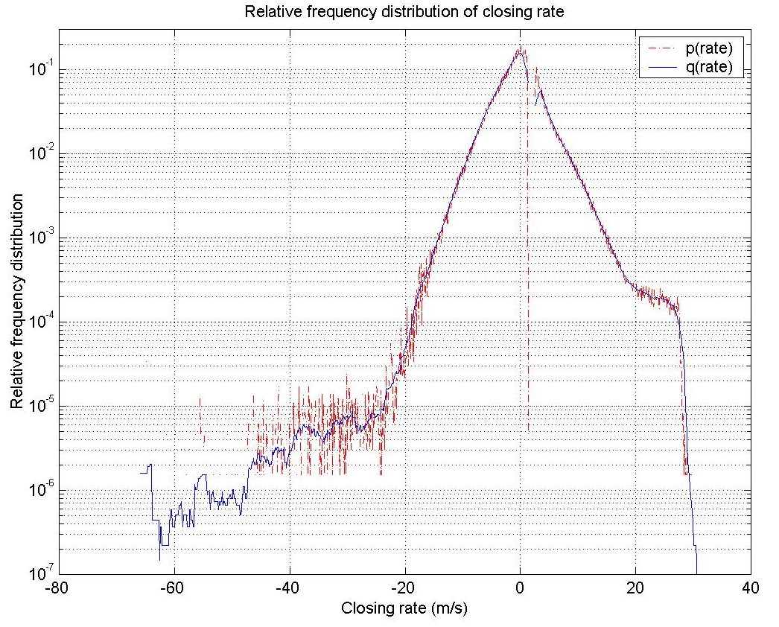
Fig. 41 Relative frequency distribution of closing rate

Two moving windows were used to smooth the plot. A window with was applied to the region of 1.45~2.45m/s, and another window with was applied to everything else. The smoothed relative frequency distribution is displayed with a blue solid line. Fig 44 shows the percentage of time for different closing rate levels. The percentage of time that closing rate is above 20m/s is 0.15%. The percentage of time that the closing rate is below –20m/s is 0.02%. Neither of these two closing rates are depicted in the pie chart.
-20~-5m/s, 11%
-5~0m/s, 47%
0~1.5m/s, 20%
1.5~5m/s, 13%
5~20m/s, 8%
Fig. 42 Percentage of time for closing rate
2.2 Braking Onset Analysis
The data that is used in the braking onset analysis was collected from September 2000 to February 2001, 77 days of data were used. The experimental bus was on normal service in San Mateo County, California. The drivers who drove the bus were not specified or selected. The bus and the service routes were assigned to them by the dispatch center of SamTrans according to normal crew assignment schedules. The service routes spread throughout San Mateo County, with connections to the Daly City and Colma BART stations, the San Francisco Airport, several Caltrain stations, and the downtown areas of local cities. Different weather conditions including rain, fog and wind, were encountered. The bus was usually put on service in the early morning before daybreak, until the late afternoon around sunset, with a few scheduled breaks. The 77-day data covers representative drivers, routes, weather, time-of-day and traffic.
2.2.1 Data Collection
The braking onset data is picked up from the 77-day data set. The lidar data, steering angle and bus speed are all processed with Kalman filtering to remove noise. The steering angle data is converted to the front-wheel angle. The target speed is transformed from relative speed to absolute speed. The time sequence of the braking pressure samples is compared with a threshold of 3 psi, producing a string of 0’s (under the threshold) and 1’s (over the threshold). Once four 1’s are found in five consecutive samples, and the preceding five consecutive samples are all 0’s, a braking onset is declared. The first of the five samples containing four 1’s is the braking onset. The lidar data at the braking onset is examined to find the closest target in front of the bus. If there is a target in front of the bus, and the bus speed is greater than 1m/s, and the Time-To-Collision (TTC) is smaller than 40s and greater than 0s, then the braking-onset data is picked up and saved in a data file for further processing. TTC is calculated as [1]
where R is the closest range, Vb is the bus speed, Vt is the target speed, and Vr is the Vt-to-Vb ratio. The front wheel angle is sampled five points later than the braking onset. In total 25,387 braking onset cases are extracted from the data.
2.2.2 Histogram Analysis of Braking Onset Parameters
The following pictures are histograms of bus speed, target speed, target range, initial brake pressure and TTC, all at braking onset.
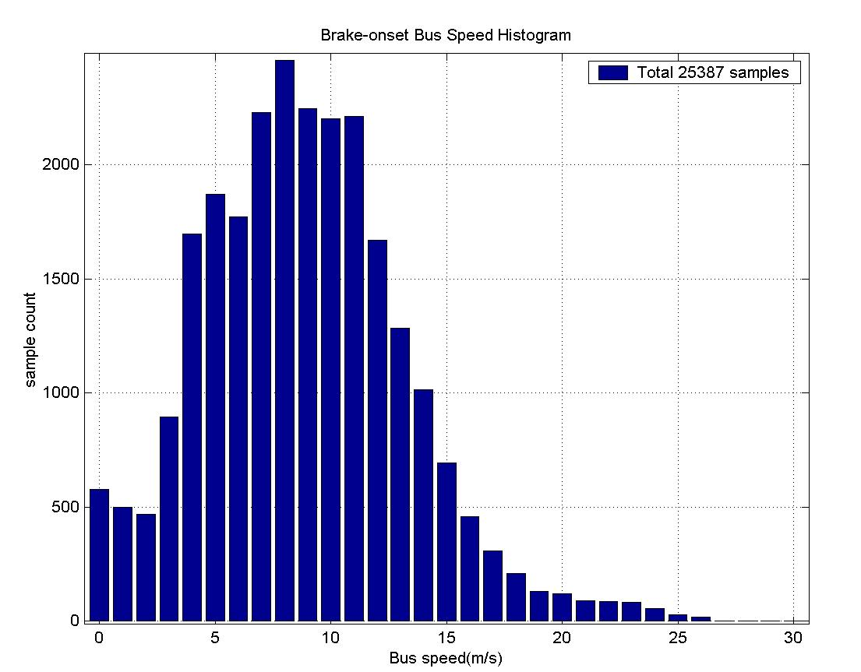
Fig. 43 Bus speed histogram

Most brakes are initiated at 4~12m/s (9~27mph), see Fig 45. Frequency of brakes at higher speed (over 16m/s or 36mph) is significantly smaller than those at lower speed. For stop-and-go situations when the bus speed is slower than 3m/s (6.5mph), the lower the speed, the higher the number of brake applications.

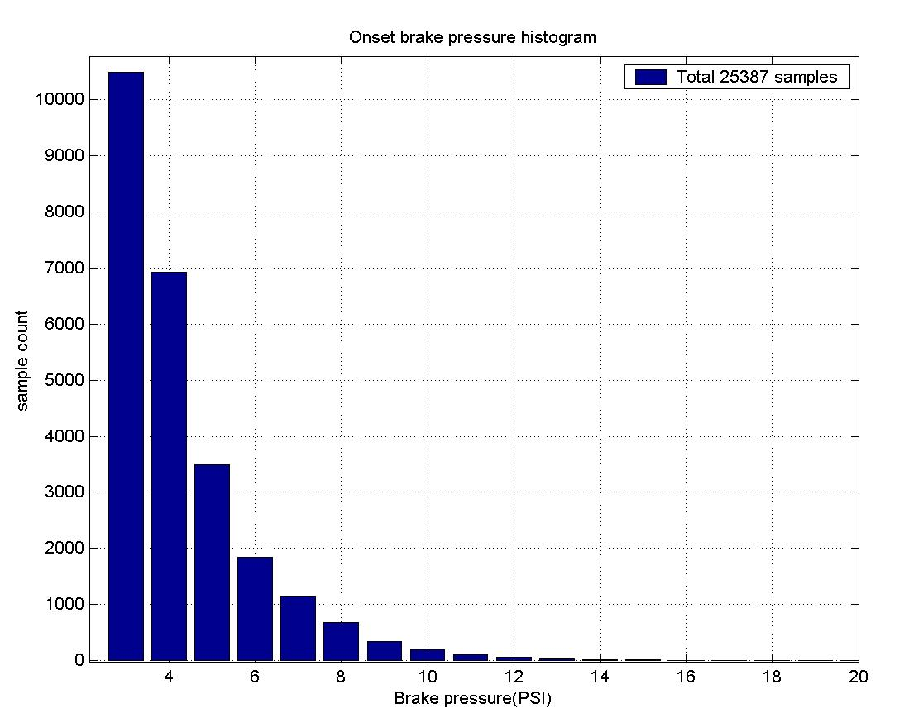
Fig. 44 Onset brake pressure histogram
In most cases, as seen in Fig. 46, the onset (initial) brake pressure is small (<10psi). This indicates that the bus drivers usually brake smoothly.
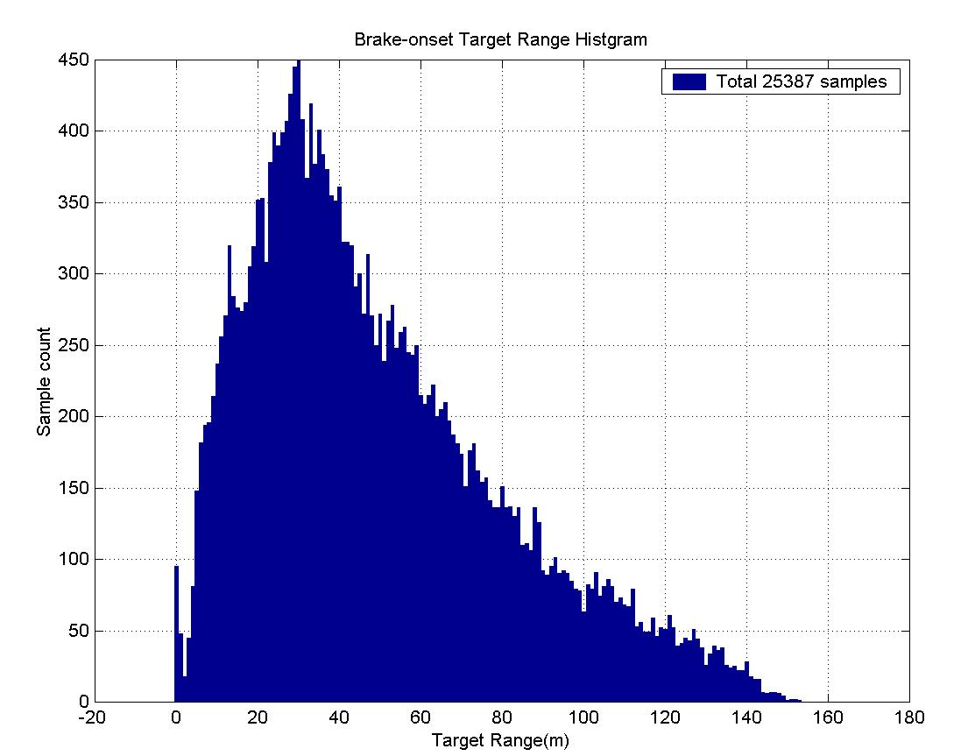
Fig. 45 Target range histogram

The maximum range of the closest target at braking onset is between 20 and 40 meters. There is a small peak at zero range as shown in Fig. 47. The data of those cases were checked. The target is either a very close object or a false target. In most cases the target is a false target (rain or fog).
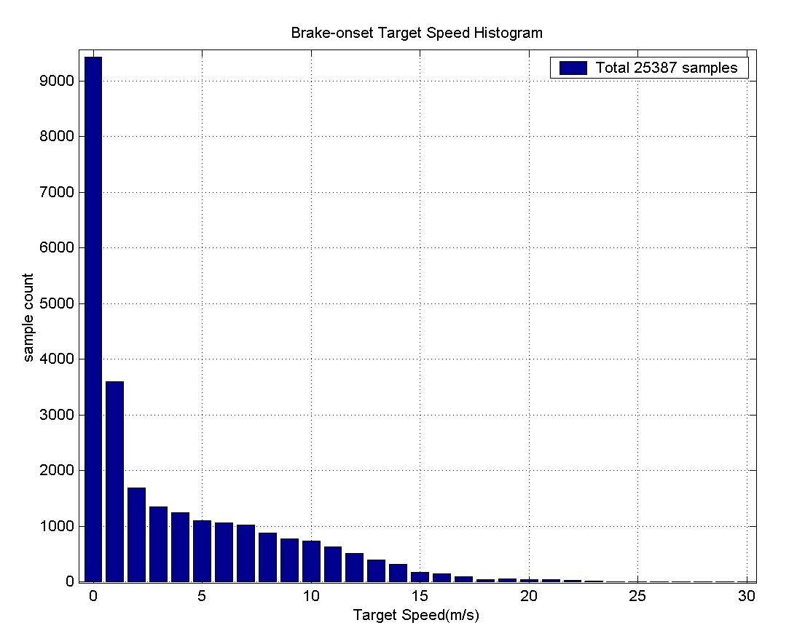
Fig. 46 Target speed histogram

In more than half of the cases, the closest targets in front of the bus at braking onset were stationary or slowly moving (<3m/s or <6.5mph), see Fig. 48. It should be noted that the target is not necessarily the direct cause of the brake. In other words, the driver might not be reacting to the target but something else at that moment. One example is where a lead vehicle speeds up after stopping at a stop sign, while the bus driver has to brake to stop at the same stop sign. It is not the lead vehicle but the stop sign that forces the bus driver to brake. Another example is where a car is parked at a corner of a curved road, while the bus driver has to slow down before turning at the corner. It is not the parked car but the curve that forces the bus driver to brake. In both examples, the cars are picked up as targets. But the bus driver is not responding to them.

This point is very important to understand in the TTC histogram of Fig. 49. The TTC does not imply the timing of drivers’ decision making in braking. It is merely a distribution of TTC at the moment the bus drivers initiate braking. It is informative in that false positives will not be avoided if we use TTC as a measure of severity. Whatever TTC threshold is set, there must be false positives, because in the cases where the TTC is smaller than the threshold, a warning is triggered before the drivers decide to brake, but the drivers would not consider this situation requiring a warning.

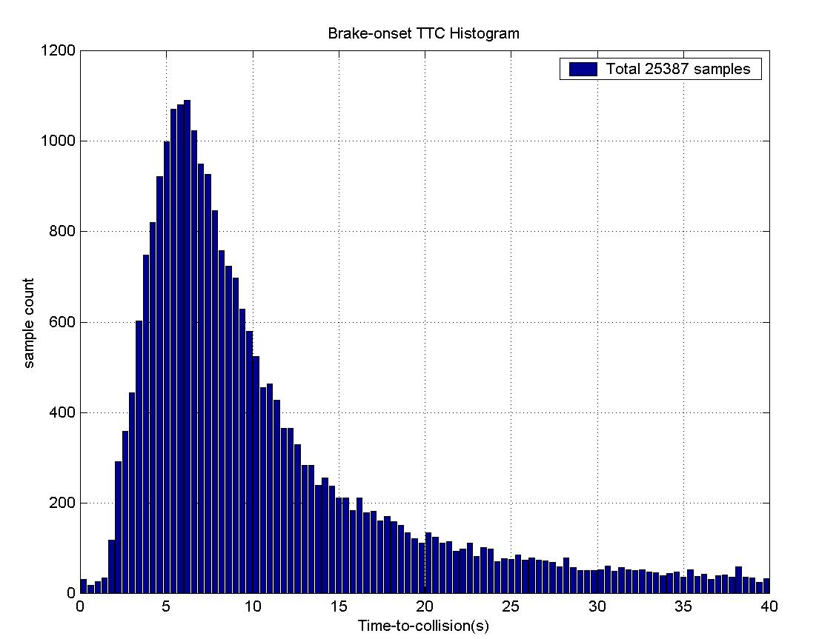
Fig. 47 Time to-collision histogram

2.2.3 Clustering of Target Following Scenarios
In the definition, TTC is proportional to the following range R. If the bus speed and the target speed are given, R is equivalent to TTC in characterizing the braking onset timing. For this reason, we focus on clustering of Vb and Vr hereafter.
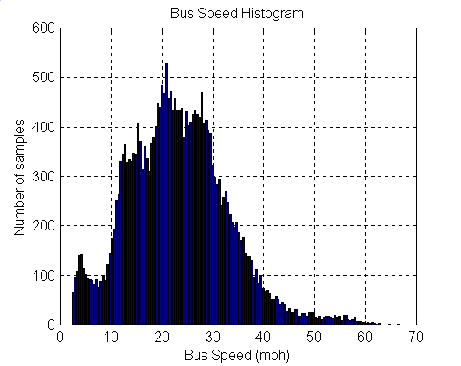
Fig. 48 Bus speed histogram

Fig. 50 is the refined histogram of Vb. There are several peaks. They are approximately at: 4.0-, 15.0-, 21.0-, 28.0-, 32.5- and 50.0-mph. This is not surprising, because the California speed limits are usually 5mph on congested areas with pedestrians, 15mph at blind intersections or in alleys, 25mph in business or residence areas, 30-, 35-, 40- or 45-mph for broader divided two-ways, and 55-65mph for freeways. The main body of the histogram is between 10- to 40-mph. This says that the bus mainly runs on low speed roads. The frequency that the bus runs below 7.5mph is high. The reason is probably that the bus needs to stop at the bus stations which are usually in congested areas, e.g. BART and Caltrain stations. The frequency becomes zero when bus speed approaches zero. This is because we didn’t pick up those data when bus speed is smaller than 1m/s.

We empirically divide the bus speed into five categories in the following table.
Table 12 Categories of bus speed
Category | B1 | B2 | B3 | B4 | B5
Vb(mph) | 0-7.5 | 7.5-17 | 17-31 | 31-45 | >45

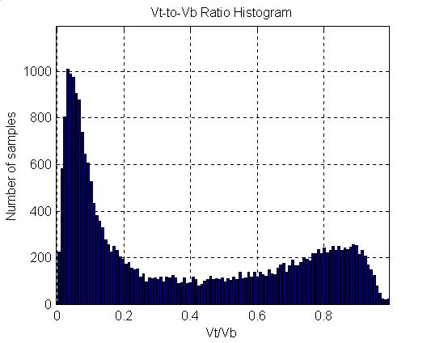
Fig. 49 Vt-to-Vb ratio histogram

Figure 51 is the histogram of the Vt-to-Vb ratio. There are two peaks. One is at approximately 0.04, the other is around 0.9. This indicates that most of the targets from which the bus is trying to keep away are either very slow or at the similar speed of the bus. The big peak at 0.04 shows that the bus usually faces a great amount of slow-speed or stationary targets.

We empirically divide the ratio into three categories in the following table.

Table 13 Categories of speed ratio
Category | T1 | T2 | T3
Vt/Vb | 0-0.25 | 0.25-0.7 | 0.7-1
Combining the bus speed categories with those of speed ratio, we get 15 clusters. This is shown in Fig. 52. Each braking onset case is represented by a dot in the 2-D plot. The dot density represents the concentration of the clusters. This is a reasonable clustering except the B5-T2 combination. There are too few dots in this region to form a cluster.

The numbers of the cases that fall into each cluster are listed in the following table.

Table 14 Total numbers of cases in each cluster
 | T1 | T2 | T3 | Subtotal
B1 | 573 | 525 | 138 | 1,236
B2 | 3112 | 1642 | 1033 | 5,787
B3 | 7151 | 3057 | 3230 | 13,438
B4 | 1761 | 798 | 1750 | 4,309
B5 | 290 | 45 | 282 | 617
Subtotal | 12,887 | 6,067 | 6,433 | 25,387

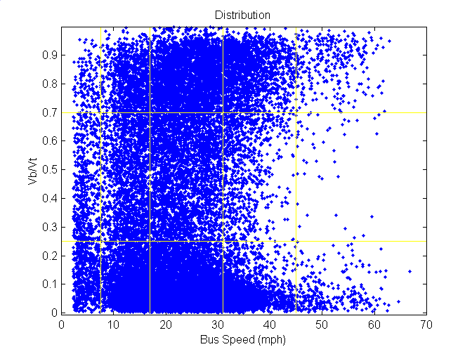
Fig. 50 Clusters of target following scenarios

The clustering in Fig. 52 provides a natural categorization of braking onset scenarios. Each cluster may follow different statistical characteristics. This provides a way to improve the collision warning performance.

2.3 Future Work
Further analysis of the field data requires complex algorithms to pick up specific scenarios or targets. Development of the scenario recognition algorithms will help to improve the performance of the collision warning system. PATH will focus its efforts on algorithm development in the future phase of the project. The data will be reviewed with the improved algorithms.

PATH has developed a prototype CWS on SamTrans buses. PATH is collecting data on these buses. Another task of data analysis would be to figure out drivers’ adaptations to the system, i.e. change of drivers’ behaviors after cooperating with the FCWS. Future work will also include comparing operators driving performance behavior prior to the introduction of the FCWS to after implementation.
References
- Hayward J.C., Near misses as a measure of safety at urban intersections. Doctoral dissertation, Pennsylvania State University, 1971.

