- An AMETEK Rayelco Position Transducer (range between 0 – 50ft), or String Pot (Figure 1), was used for measuring inter-vehicle distance. A String pot was installed on the rear end of the Lincoln, (then hooked to the Bus) including software. The data recorded from the string pot was converted to relative distance between the bus and the Lincoln. Speed and distance measurements on the Lincoln were calibrated before the test
- On the Lincoln a Gyro was used to monitor the lateral movement of the target;
- Data recording: For synchronization, the information passed over from the Lincoln were saved with the other data in the main computer of the subject vehicle.
- Carton boxes covered with RADAR/LIDAR reflecting materials to enhance signal reception were used as static objects.
- Wireless communication system: A FreeWave card was installed on both the Samtrans Bus and the Lincoln running under QNX-4 real-time operating system; The information passed from the Lincoln to the bus/ or from the bus to the Lincoln was:
  - time stamp
  - fifth wheel speed
  - vehicle acceleration
  - yaw rate from gyro scope
  - string pot voltage (can be converted as inter-vehicle distance)
  - Latitude (GPS)
  - Longitude (GPS)
  - UTC time (GPS)
  - Altitude (GPS)
- 4 voice radios were used for coordinating operation between drivers, people responsible target disposition, recording, ground position measurement
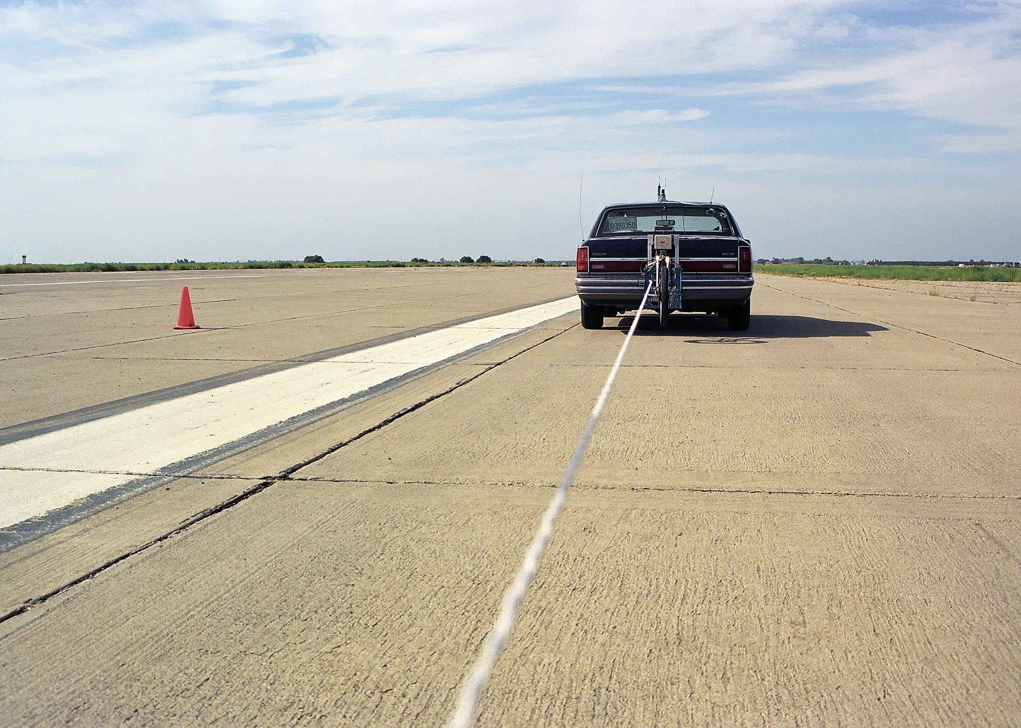

Figure 1 Using string port to detect true inter-vehicle distance on-the-fly

Known Driving Environment

The known driving environment can be designed to include static objects Figure 2 and Figure 3 ) and moving objects (Figure 4 ). For static objects there is no need to pass anything. It is only used to test the sensors measurement error and warning. These objects may be designed to include road side parked vehicles, mail boxes, traffic signs etc.. To present different objects, boxes with different size may be chosen. To make the objects RADAR/LIDAR sensitive, the boxes were wrapped with a reflecting cover.

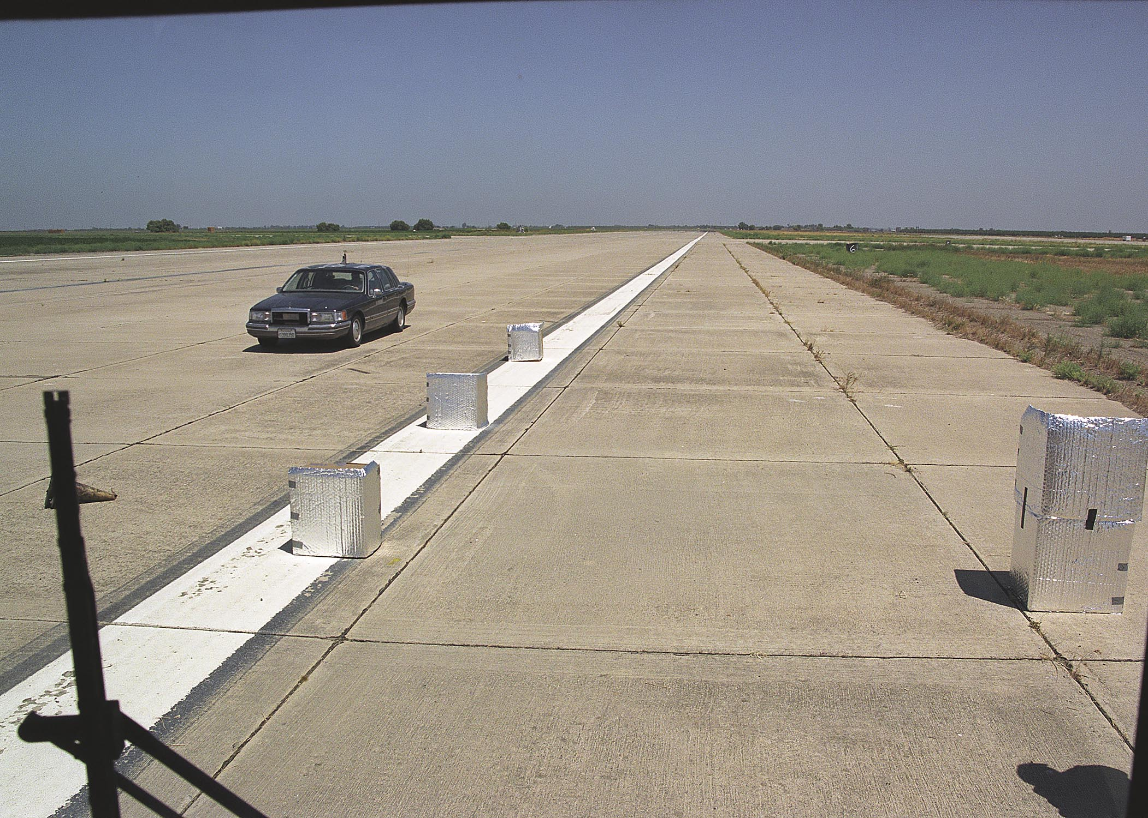

Figure 2 View of the Static Objects from the Bus

A Moving object may include vehicles driving in different directions, in adjacent lanes and front vehicle. The target vehicle and the subject vehicles are connected with a
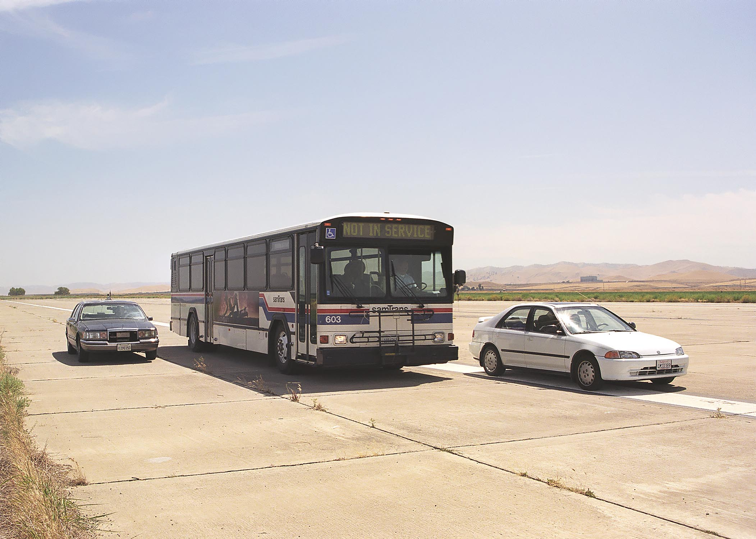
Figure 3 Detecting parked vehicles on both sides

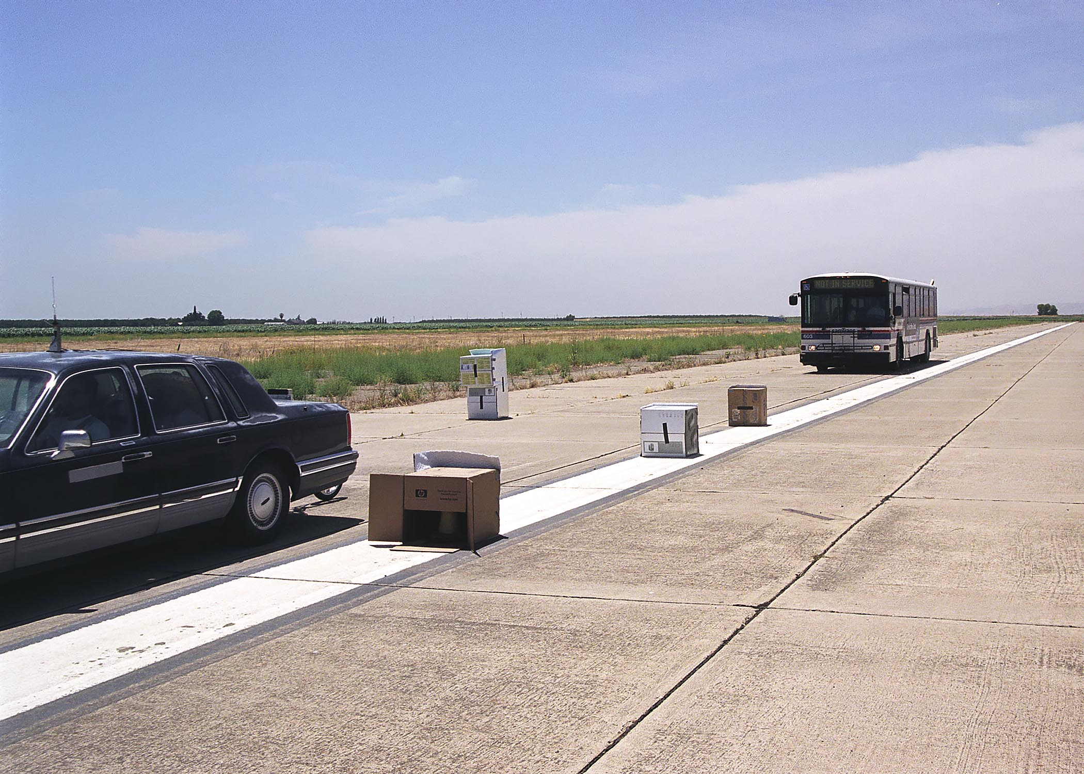

Figure 4 Moving (front vehicle) and static objects

measurement string which can measure inter-vehicle distance in real-time. Wireless communication can be used to synchronize the measurements on those two vehicles. This set up is to test real-time inter-vehicle distance measurement, estimation, prediction and filtering;

Host vehicles always start from a known position. Based on the ground position of the targets and the running distance of the bus at any time instant, we know the relative position between the bus and the targets, which is a critical point. All the measurements are with respect to a ground coordinate system as defined in Figure 5 .

Preliminary Test
A pre-test for the following items was conducted at SamTrans before the formal test:

- Re-calibrate the SamTrans bus and ensure that all the on-board sensors and computers working properly;
- Verify that the sensors and wireless communication systems were properly installed, calibrated and working on the Lincoln;
- To use laptop computer connected with the subject bus to use “run” instead of “auto-run” for manual data-saving interrupt for matching the saved data with the test maneuver;
- To make sure all the data saving are correct on the subject bus;

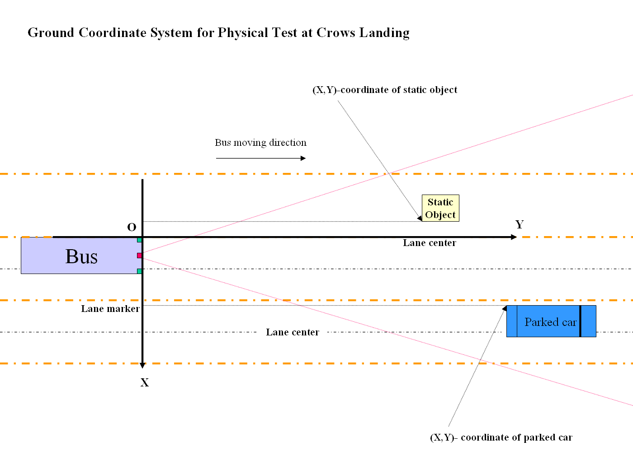
Figure 5 A Ground Coordinate System

Crows Landing Test

Relative speed and inter-vehicle distance error and time delay test without string but with wireless communication

This test can be used to figure out the relative speed error and measurement time delay with low relative movement. Without string, such movement can be made much larger and faster;

Maneuver 1: Vehicle following. (Figure 6) Use a leading vehicle in the front of the bus with FCWS to run at different constant speed: 5[mph], 10[mph], 27[mph], 40[mph], 55[mph] for some time. The bus driver was asked to determine a safe and comfortable inter-vehicle distance.

Leader vehicle approximate deceleration: 0.2[$m/{s^{2}}$], 0.8[$m/{s^{2}}$], 1.5[$m/{s^{2}}$]

Inter-vehicle distance: speed/relative-speed dependent on the vehicle speed and driver’s choice – feel comfortable;

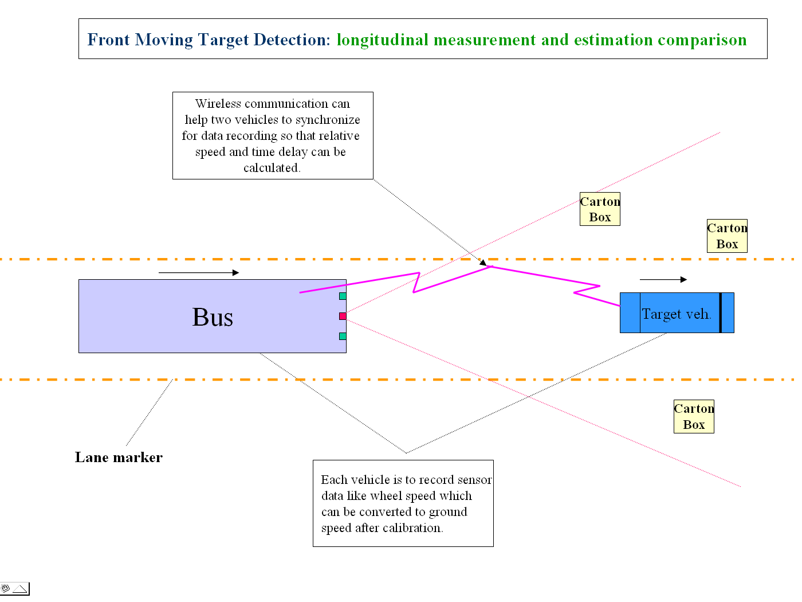
Figure 6 No string for vehicle following

Inter-vehicle distance error measurement (with string) and time delay test with variable speed and deceleration

Maneuver 2: Vehicle following (Figure 7): Use a leading vehicle in the front of the bus with FCWS to run at different constant speeds: 5[mph], 10[mph], 15[mph], 20[mph], 25[mph] for some time then the lead vehicle decelerates at approximately: 0.2[$m/{s^{2}}$], 0.5[$m/{s^{2}}$], 0.8[$m/{s^{2}}$]

Inter-vehicle distance: speed/relative-speed dependent. Because the total length of the string is 16 [m], an offset 6.38 [m] of the string is used to avoid break due to over-stretching.

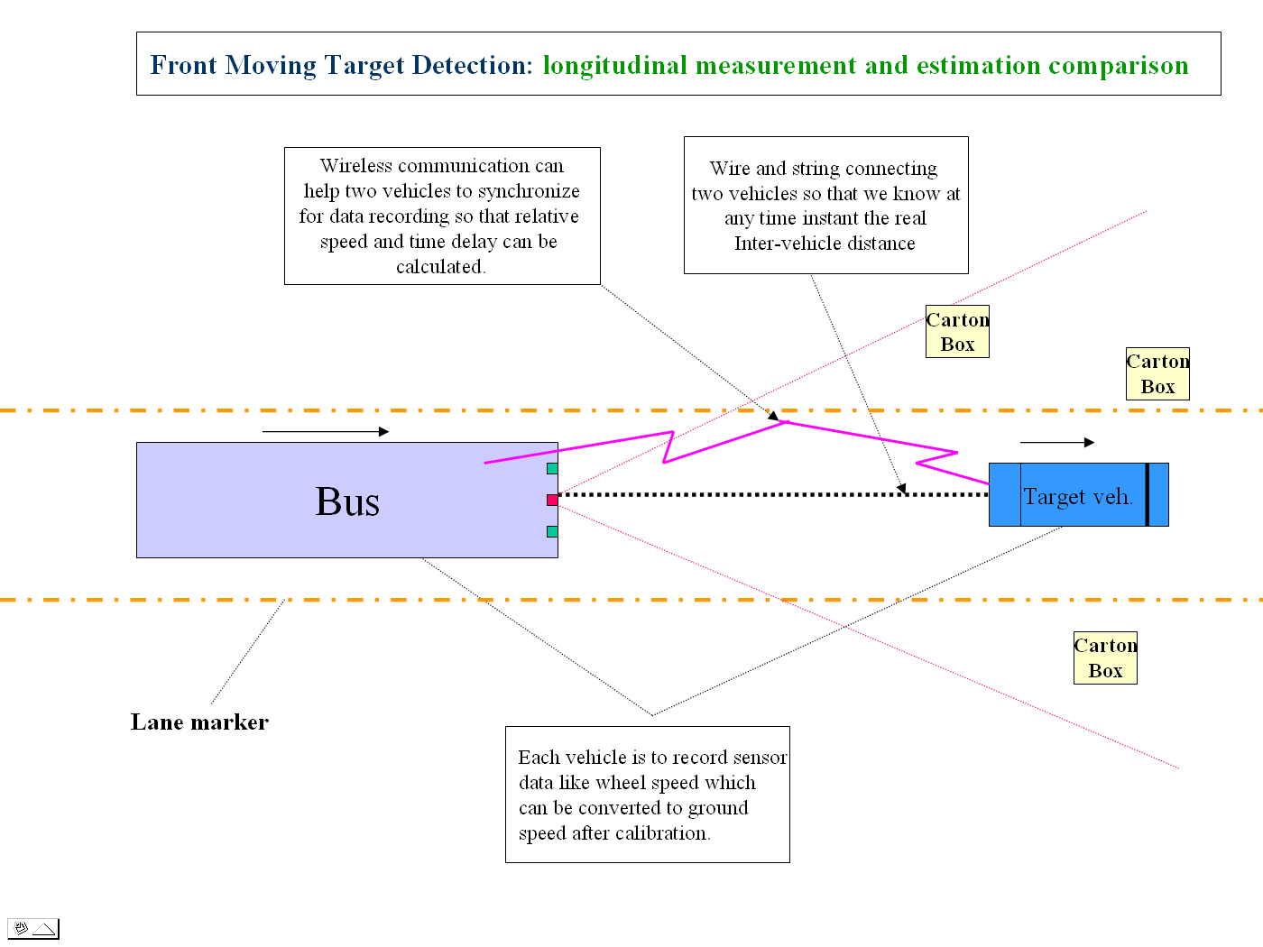
Figure 7 String Pot and wireless communication are used

Static object lateral distance measurement, prediction/estimation error test

Maneuver 3: Carton boxes covered with RADAR reflectors at certain heights are put in known places with respect to the center of the road (Figure 2). The Lincoln (Error: Reference source not found) is parked on the left or right side at certain distances with respect to the centre of the road: 1.4[m], 2.0[m], 3.0[m] measured to edge of the Lincoln; Drive the Bus straight ahead at different speeds: 5[mph], 15[mph], 27[mph], 35[mph]. The bus needs to run in the center of the lane or at the edge of the lane; The Lincoln driver opened the left door sometimes (Figure 9); Multiple cars and boxes used as objects to make sure there is no overlap. Heavy objects are put inside the boxes so they would stay in place.
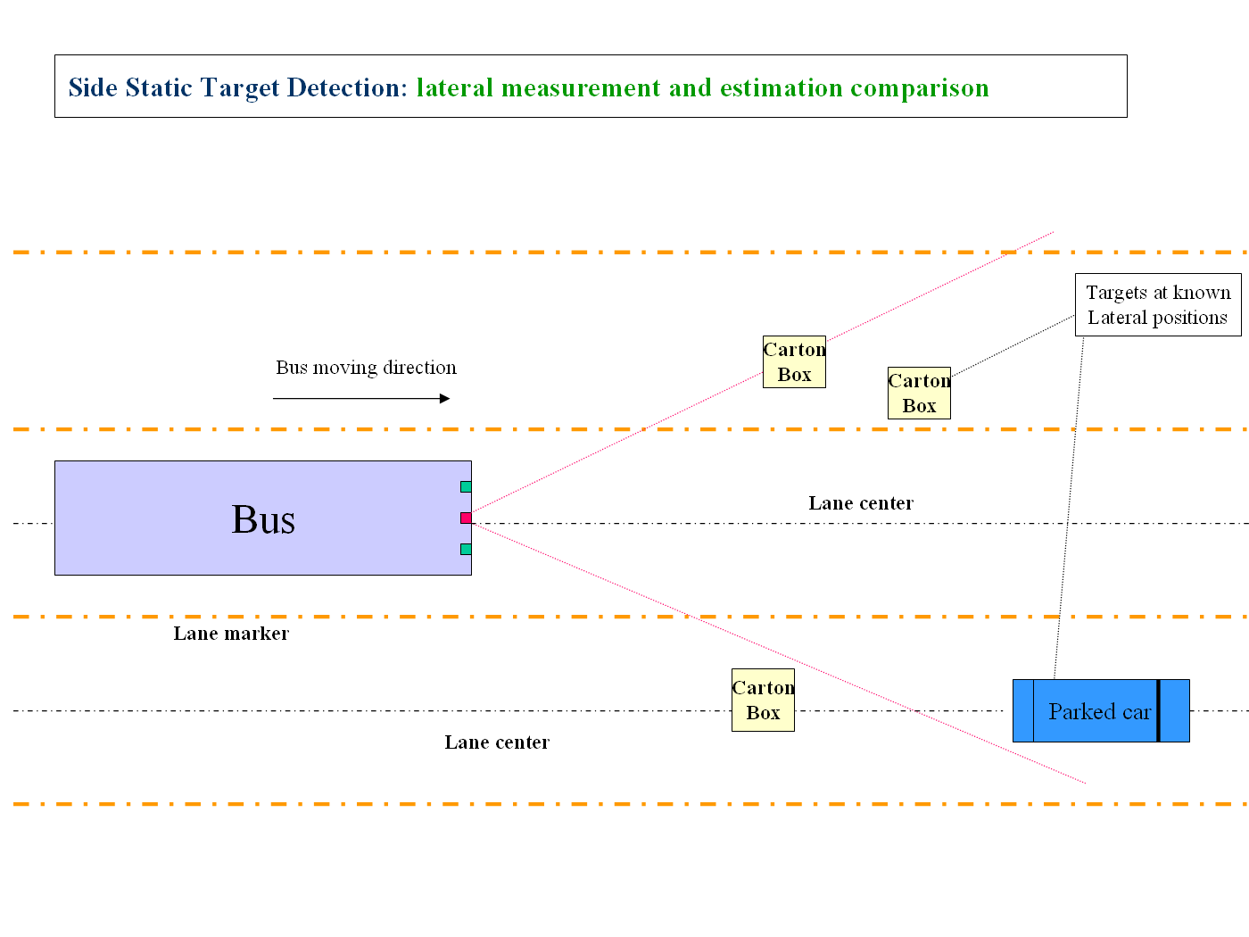
Figure 8 Parked car testing scenario

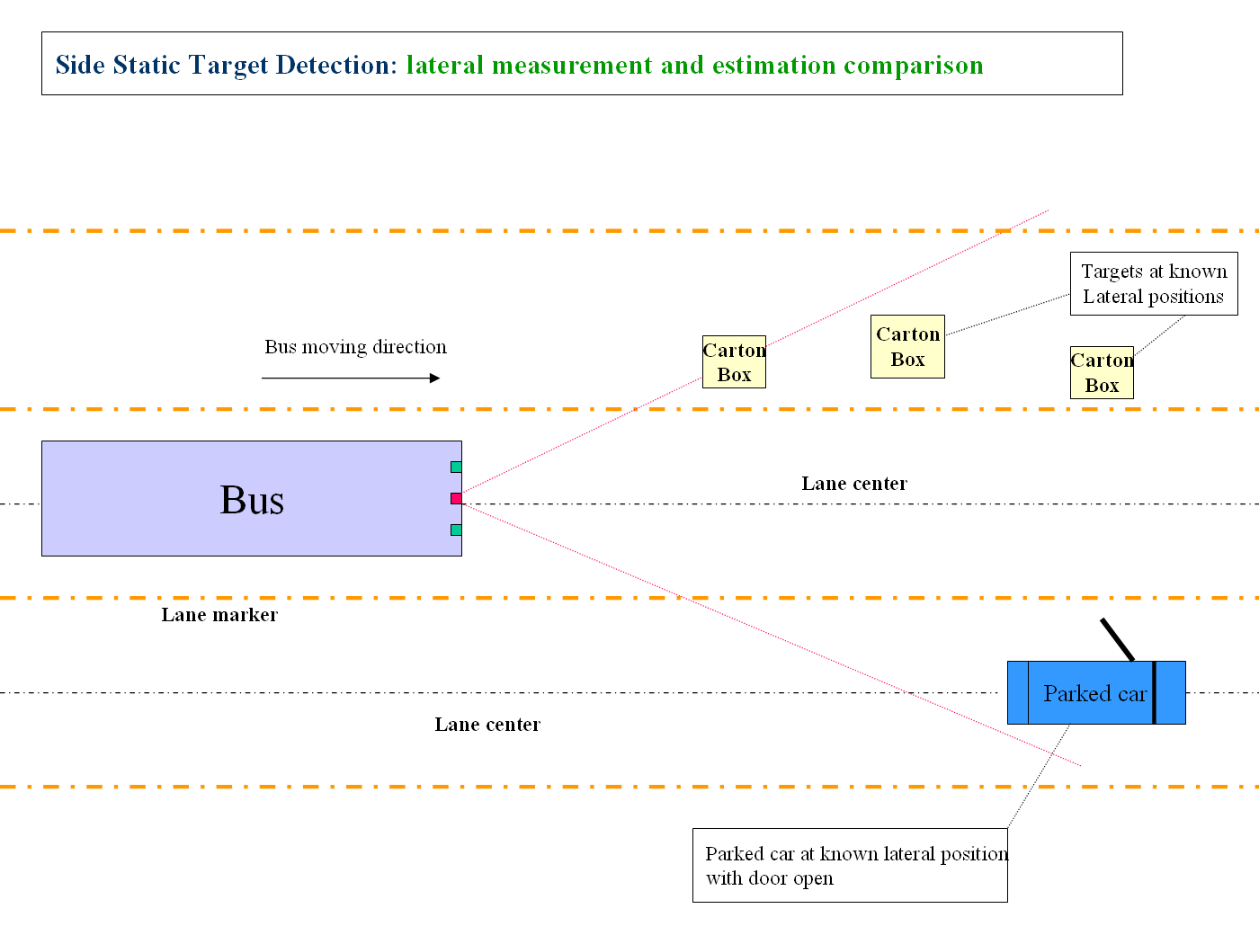
Figure 9 Park car door open test scenario

Maneuver 4: Two cars are running in left/right adjacent lanes but a known lateral distance in the same and opposite direction at different constant speeds: 10[mph], 30[mph]. The bus can run at slightly different speeds (non-constant) so that there is some relative movement when the vehicles run in the same direction (Figure 10)

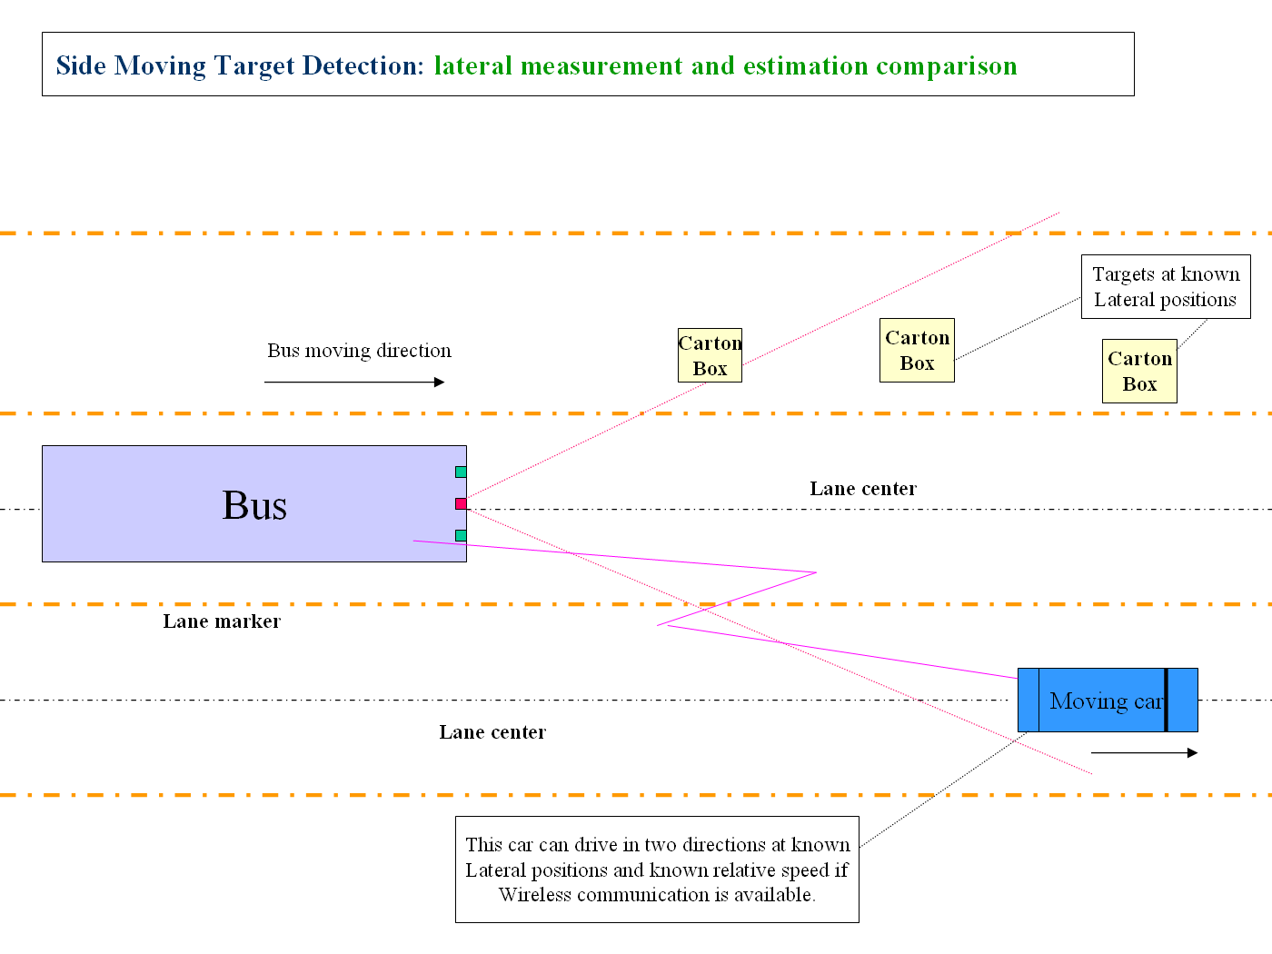
Figure 10 Side Moving Target Direction

Cut-in test
Maneuver 5: The Lincoln travels in the left/right adjacent lanes but at a known lateral distance in the same direction at different speeds: (10[mph], 20[mph], 35[mph]) for a while and then accelerates to take over the bus and cut-in (Figure 11). The speed variation of Lincoln is intentionally made. The bus driver is to decide an appropriate inter-vehicle distance.

Gyro rate and RADAR/LIDAR dynamic angle measurement test
Maneuver 6: Drive the bus straight at certain speed: 5, 15 [mph]; Once the bus arrives at a certain point, drive around and then return in the same lane in the previous direction and pass the objects again. In each run the objects will be viewed twice by the RADAR sensors.

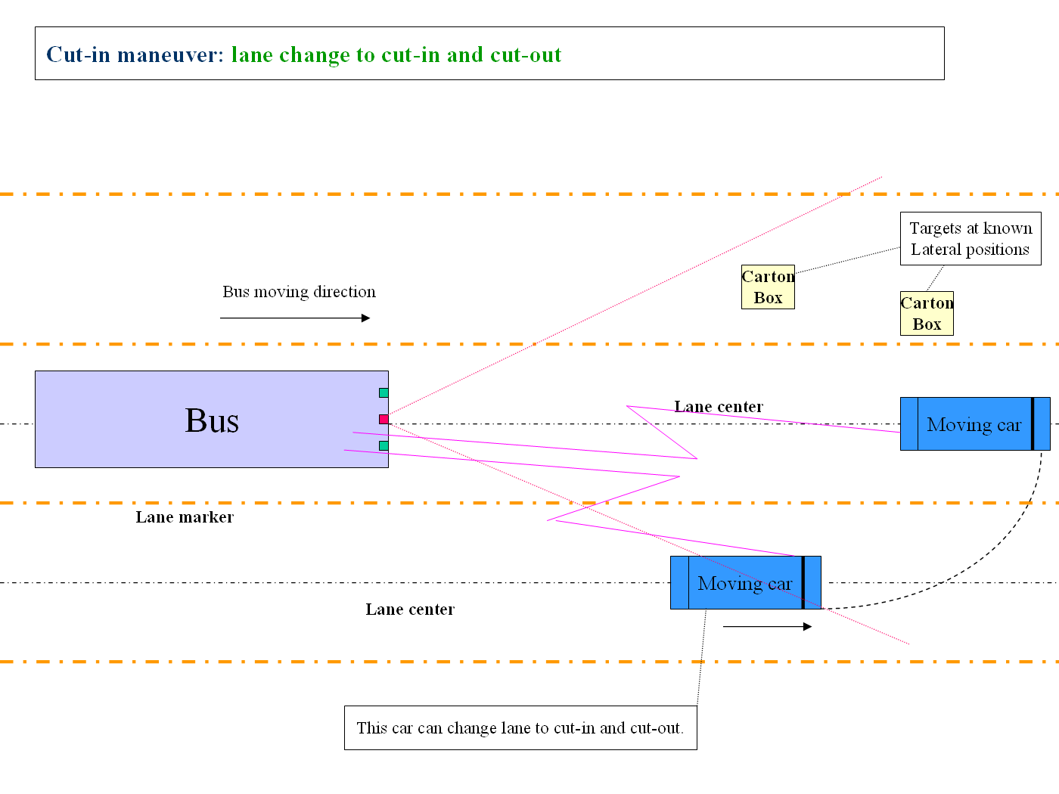
Figure 11 Cut-in and cut-out to test lateral movement detection

Low speed approaching/crashing to a static object
Maneuver 7: Carton box (covered with foam block) with RADAR reflectors at certain height are put in different places of the road and drive the Bus towards the object at different speed: 25[mph], 15[mph], 10[mph], 5[mph] to see the reaction of the warning system and driver’s response (Fig. 114);

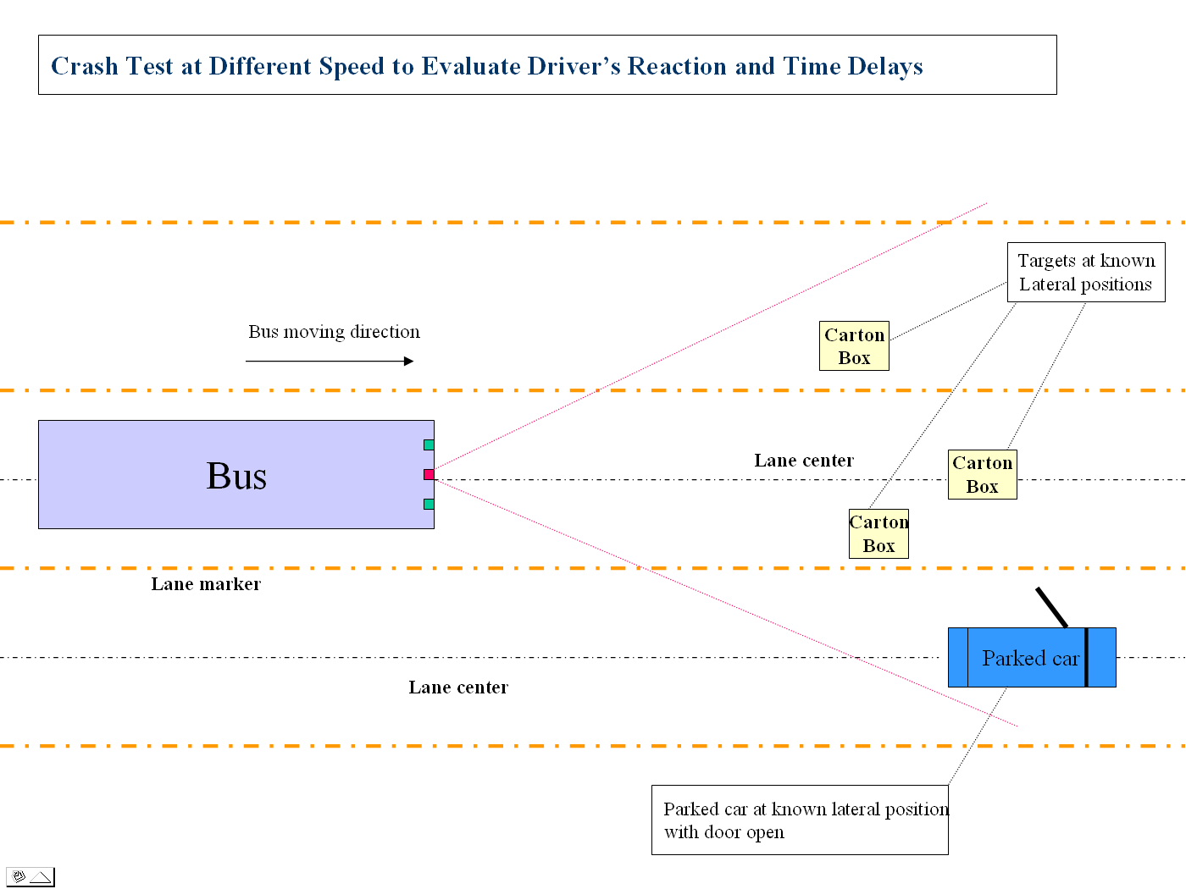
Figure 12 Crash Test; No string is used

Data Analysis
As mentioned previously, the test data can be used for two objectives: (a) To check LIDAR/RADAR measurement, estimation and target tracking; (b) To tune those parameters. The data collected through these experiments have shown that both of these objectives can be achieved. The following presents examples of measurement and estimation using LIDAR and RADAR compared with the independent measurement from the fifth wheel and the string pot measurements.

- The following plots correspond to Maneuver 2 (Figure 7) for target longitudinal measurement.

In Figure 13, Figure 14 & Figure 15, both target vehicle and SV speeds are around 10[mph]. String pot is used to test LIDAR/RADAR longitudinal measurement and estimation including distance and speed. The fifth wheel speed and string length are considered truth measurements after calibration. However, lateral position measurement is also plotted.

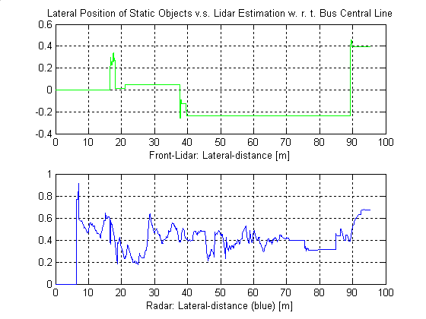
Figure 13 LIDAR/RADAR target lateral position measurement and estimation [m]

It can be seen from this figure that lateral measure of LIDAR is slightly more consistent compared to RADAR.
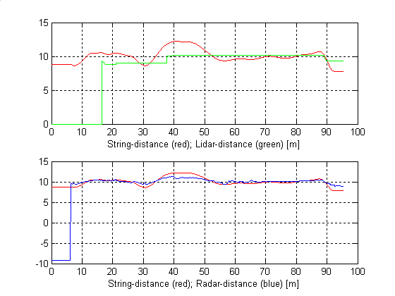
Figure 14 String (true) distance vs. LIDAR/RADAR distance estimation [m]
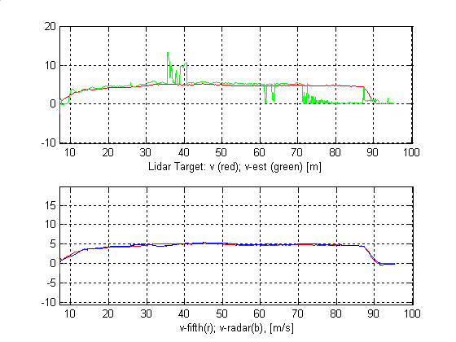
Figure 15 LIDAR/RADAR target speed estimation vs. fifth wheel [m/s]
The above two figure shows that RADAR distance and speed measurement in longitudinal direction could achieve better results.

Summary
Under this project, the SamTrans/FAAC™ simulator is being modified to incorporate CWS functions, which will allow us to create specific scenarios of interest to which large numbers of drivers can be exposed to, providing us with a much more extensive data set than we could obtain from in-service operation of two buses. The project team plans to conduct experiments using the simulator at the later stage of this project. From the simulator experiments, more extensive data sets will be obtained which will be used to analyze driver behavior change due to the introduction of ICWS and for further optimization of the warning algorithms and DVI.

Recommendations
The research and development of the ICWS has made significant progress toward deployment. However, due to the research nature, significant work is still needed in order to achieve a fully commercializable integrated collision warning system. The following outlines further development needed before commercialization can take place.

Develop ICWS Markets and Industrial Partnerships
Like any product, commercialization of ICWS requires both sizable market demand and willing suppliers. The crash data analysis under the early FCWS and SCWS studies have shown that transit collision warning system can enhance transit safety. A recent cost benefit analysis conducted by Volpe indicated that such safety systems can help the transit operators to reduce operation cost. For a specific transit operator, the extent of the cost saving will depend on level of deployment, which, transit operators say, is very much decided by the unit cost after the technologies meet their performance and technical requirements. The unit cost in turn will depend on the market size. The study conducted by the ICWS team indicated that ICWS can potentially benefit and be of interest of other commercial fleet operators such as UPS, which operate in similar environments. Under the current project, the ICWS team begins to reach out to transit and other fleet operators. The team recommends that this effort be continuously carried out until an initial market is established. In parallel to the market development, it is essential to work with industrial partners to commercialize the ICWS, starting from the phase of field operational tests.

Conduct Field Operational Tests
Under Phase One of FCWS and SCWS development, three revenue service buses were instrumented with frontal collision warning systems and a test vehicle was instrumented with a side collision warning system. These developments have led to the current ICWS efforts in instrumentation of two integrated collision warning systems onto a SamTrans bus and a PAT bus. Field testing is currently underway. Although the research team has carefully planned the field tests in order to collect data from multiple drivers on selected routes, the exposure to diverse driving behaviors, to different driving environments and to hazardous conditions is very limited. It is the consensus of the research team and interested transit agencies that a larger scale Field Operational Test (FOT) needs to be performed in order to collect adequate data for verifying the effectiveness of the ICWS and for fine tuning the design parameters or making improvements. The ICWS research team recommends that one or two fleets of 50-100 revenue transit vehicles be equipped with a prototype transit ICWS on a variety of routes and operating conditions for a duration that can justify industry-wide acceptance.

Human Factor Studies Using Samtrans Driving Simulator

The field tests conducted under the current project provided useful results for evaluation of the effectiveness of the CWS system from Human Factors perspective. Because of small number of buses involved in the field tests within this phase of the project, it is difficult to conduct analysis of driver behavior changes for specific hazard scenarios. We therefore propose to conduct human factors studies using the Samtrans driving simulator to conduct further study of the integrated (forward and side) collision warning system. The following studies have been identified as research priorities.

- To investigate if an integrated (forward + side) collision warning system (CWS) affects distracted and non-distracted Transit Bus Operators response in imminent collision warning situations.
- To investigate if operators’ visual scanning patterns change with the addition of the system. It would be useful to know if operators detect all warnings and whether the system causes the operator to become distracted. A similar issue was raised by Lee et al (2002) who, for a car collision warning study, determined that future research should investigate what happens if an operator is already braking when they receive a warning – do they continue to brake at for example the same rate?
- To further investigate what types of warnings bus operators view as nuisance warnings. Whilst some of the types of nuisance warnings have been identified in human factors ride-along, much variation has been seen both between and within operators’ responses to each encountered scenario. Use of the simulator would enable different operators to be exposed to the same scenario repeated times which would help to further clarify what aspects about a scenario feed into an operators’ consideration of whether the warning is a nuisance warning. This type of study could also be used to determine the effect of false and nuisance warnings on operators’ trust in the system.
- To determine optimal display techniques. This could include different visual display methods as well as audio warning sounds – to determine, whether operators react faster to visual or audio cues of hazards and to determine optimal warning sounds. Also of interest is where a visual display could be placed in a bus that does not have a center pillar. One solution, for this type of bus would be to place the display on the right pillar.
- To further determine optimal integration strategies for the integrated collision warning system. In the present system there is no prioritizing of warnings. It would be valuable to know what the human factors implications would be of the following scenarios: giving the forward system priority at all times, giving the side system priority at all time, giving the most critical hazard priority or having no priority (current system).

Finalize Performance Specifications
Learning from field operational tests and simulator studies, the performance specifications developed under the current ICWS research program should be updated and finalized in order to meet the transit and other fleet operators’ needs. The ICWS Performance Specifications should have separate sections for the following:
- Specifications related to frontal sensors and performance only
- Specifications related to side sensors and performance only
- Common specifications for frontal and side sensors and performance

This would allow transit agencies to purchase non integrated systems at a lower price if they have a lot of side collisions or frontal collisions only.

Hardware and Software integration of ICWS
The philosophy of building the first advanced prototype was to achieve functional integration and, at the same time, minimize the risk of system integration by having separate duplicate systems and data interfaces and to include comprehensive data collection capabilities. The duplicate systems would prevent one system from taking down the other system should a failure occur. It also minimized risk by making sure that each partner had available what they needed to deploy a system. The sensory data, additional engineering data and video streams collected are for thorough data analysis. In order to perform the FOT, a higher level of hardware and software integration needs to occur in order to achieve the level approaching a commercial prototype.

Eliminate Duplication of Hardware
The experience gained with each other’s system can now be taken to the next step of integrating the testing prototype by eliminating duplicate hardware and combining algorithms. Duplications that could be eliminated are:
- Creep Sensor Interface
- Gyros
- Separate electronic enclosures
- Dinex Interface
- Power supplies and power conditioning
- Power up and Power down logic
- GPS (May also be redundant with electronics for bus tracking and annunciation systems)
- Cell phone interface (could be eliminated completely)
- Reduce the number of processors (see next section)
- Eliminate most of the video cameras and one digitizer (see eliminate video section)
- Combine the data recording functions into one computer chassis (see next section)
- If transit bus has stability control system, then bus state information may be available without additional gyros or creep sensor
- Future drive by wire systems may include steering wheel encoders

Eliminating these duplications would increase the overall reliability of the system due to less electronics. It would decrease the overall cost of the system for the same reason.

Combine / Eliminate Processors
The current ICWS contains five CPU’s to handle the top level processing tasks. This does not include the processors that are embedded in any of the sensors. The CPU’s in the advanced ICWS prototype include:
- FCWS Engineering computer
- Left SCWS Engineering computer
- Right SCWS Engineering computer
- FCWS Video and Data recording computer
- SCWS Video and Data recording computer

A minimal commercial prototype could eliminate both of the Video and Data recording computers since they are not necessary to generate warnings to the transit operator and as a minimum combine the left and right SCWS Engineering computers. The current barrier to combining the FCWS and SCWS Engineering computers is that each system runs different warning algorithms and data processing thus increasing the CPU loading above what one processor could currently handle (see future research for more information).

Eliminate Video
The elimination of collecting video information not only minimizes the CPU and digitizing hardware on a commercial system, it would also eliminate seven of the nine cameras installed as part of the advanced ICWS prototype. The two remaining cameras are used for the curb detection at the front of the bus (laser line striper) and curb detection ahead of the bus (fusion of video with other sensors).

As part of the advanced ICWS prototype, the cameras and video / data recording were necessary to allow the continuing development of algorithms and analysis of system data.

One of the questions that would need to be answered is whether the additional data recording could be used as a feature of the system, e.g. to limit transit liability in collisions and helping to defend transit operators against fraudulent claims and recording vandalism. It could also be used for training purposes. This might be a feature for which some transit companies would pay the additional cost. It should certainly be part of an optional configuration, but may not be part of the base package.

Commercialize Laser Scanners
The most expensive components of the prototype ICWS system are the LIDARs (laser scanners). In the ICWS prototype the sensors alone account for over $ 15,000. That does not include the additional cost to mount them in retractable assemblies. To make the ICWS more economically feasible, LIDAR sensors should be designed for this specific application. Also, weaknesses of the current scanners significantly increase the system false alarm rate.

The main issues associated with this design are:
- Overlapping fields of view.
- Size
- Reliable detection
- Resolution
- Range
- Update rate
- Expense
- Synchronization of scanners
- Eye safety

Overlapping fields of view: The current system uses three LIDARs. There is a LIDAR mounted on the left side of the bus, the front of the bus and the right side of the bus. The side LIDARs have 180 degree FOV’s. The front LIDAR has a narrow FOV and is used to see far ahead in the lane. The LIDAR could be redesigned to mount on the left and right side of the front bumper with 270 degree FOV’s. This could eliminate one LIDAR and provide better coverage than the current system in front of the vehicle. Even if the front look ahead LIDAR could not be combined with the side LIDAR, it could be replaced with a much less expensive adaptive cruise control unit since the object tracking could be done with the other LIDARs. However, this roughly doubles the worst-case distance to cover the entire side of the bus. To get the same resolution we have now at the back of the bus, we would need twice the angular resolution. It seems plausible that coverage of the back half of the bus is not as important as in the front, but this would have to be looked at in more depth.

Size: The LIDARs used on the side of the transit bus are over six inches deep. Most transit buses are at the maximum width for roadway use already. Although exceptions are made for safety devices, such as mirrors, the addition of another foot of clearance needed makes the vehicle harder to operate in the urban environment and potentially more dangerous to pedestrians and other fixed objects and more prone to be damaged. For this project, these LIDARs were mounted in retractable / extendable assemblies. This adds cost, complexity, cpu loading and additional maintenance issues to the system. These were operated using the vehicle’s air system. These assemblies were computer controlled in order to implement a reflexive behavior for self preservation, present a lower profile in tight situations and retract if it looks like it was going to hit something in its path. Using a fixed mounted front bumper system not only reduces the cpu loading but also the interfaces necessary to extend and retract the LIDARs.

Reliable detection: Reliable object detection is crucial for proper system operation. There are two types of detection failures we have observed fairly frequently that significantly degrade system performance: missing returns and ground returns.
With the SICK sensors, missing returns which occurs both due to weak returns from low reflectivity objects and due to too-strong returns from nearby high-reflectivity objects. We don't understand exactly why the LIDAR fails to detect, and can only speculate on possible fixes. It would help for the sensor to have a larger dynamic range and use a different wavelength.

Ground returns occur when the scanner sees the ground, either because the ground is not flat (a hill) or the bus tilts to the side (going around a turn.) In the current system, ground returns are interpreted as potential collisions, and are one of the largest causes of false alarms. If the scanner had multiple beams spreading out vertically, or in some other way could measure multiple points vertically on the same object, this would greatly reduce false alarms from ground returns, because it would be easy to determine whether the object is more or less flat on the ground, or sticks up significantly. Multiple beams would also give us more chances to detect any given object, so would reduce missing returns as well.
Resolution: For the current side LIDARs one can set the angular resolution to 0.25º, 0.5º, or 1º. The smaller resolutions have the tradeoff of reduced update rate and interlacing. The 0.25º resolution has half the FOV. We are using the side LIDARs set to 1 degree azimuth resolution and 1cm range resolution. The position uncertainty is dominated by the azimuth resolution at ranges typically seen in the collision warning system. This means that in some sense the sensor is unbalanced for our purposes. The range resolution could be reduced without compromising performance, or alternatively the azimuth resolution could be increased to exploit the range resolution.

A characteristic of the SICK, and of many other possible similar designs, is that the range accuracy is roughly independent of range, whereas the position uncertainty due to azimuth resolution increases linearly with range. In any such scanner, there is one range at which the position error from range and azimuth is equal, where the scanner can be considered balanced. For the SICK with 1 degree resolution, this is approximately 2 meters (using a range accuracy of +/- 2cm to allow for noise.) To be balanced at 8 meters (a more typical range in the collision avoidance system), we would need to either increase the angular resolution to 0.25 degrees or reduce the range accuracy to +/- 8cm.

If the range accuracy was specified as percentage of the range, then the range error scales proportionately with the azimuth resolution uncertainty, so the measurement accuracy would be balanced at all ranges. The balanced RMS range accuracy as a percent of range is then about 25*sin(angular resolution), or 0.4% for one degree angular resolution.

The azimuth resolution can be increased to 0.5 degrees by using an interlaced mode where two consecutive scans are combined (reducing the update rate to 37 Hz.) We don't use the 0.5 degree interlace mode because it creates strong artifacts on moving objects, and also because the total amount of data is not actually increased (due to the drop in update rate.) With algorithmic improvements in the tracker, it should be able to tolerate the interlace artifacts, and then there would be some benefit to using interlace.

Range: The current side LIDARs are specified to be accurate to 50 meters and can see as far as 80 meters. As with range accuracy, maximum range should also be balanced with azimuth resolution. As range becomes large, the points become so far apart that any return becomes largely useless. We require at least three points on an object to create a track. Because of this, with 1 degree azimuth resolution, small objects such as pedestrians cannot be tracked above about 20 meters. For side collision warning, a reliable LIDAR range of 15 meters would be adequate. See however, the discussion of detection reliability.

Though we have seen detection fail at ranges of only a few meters, we do not suppose that the SICK is failing to meet it spec. The problem is that real-world objects may have reflectivity that differs significantly from the standard target used in the performance spec. A lower maximum range would not harm system performance as long as it did not further degrade detection reliability. The main conclusion here should be that the scanner range specification is not a valid indication of the actual detection range in the real world, and that although the SICK specification looks in excess of requirements, the observed scanner performance is one of the main limits on system performance.

Update rate: The current side LIDARs output 75 scans a second at 1 degree resolution. The scan update rate should be balanced against maximum speed and size of objects which we want to track. If an object moves too far between two scans, then it is difficult to create a track from consecutive measurements. With the current tracker configuration, we could tolerate an update rate as low as 25 scans per second and still track objects moving at 20 meters/sec. At 10 scans/sec, the max speed would be reduced to 8 meters/sec. A lower update rate could help with cost reduction.

Expense: The current price of these LIDARs makes an advanced ICWS prohibitively expensive for commercial applications. Designing a commercially deployable sensor would require a certain amount of non recurring expense; the recurring expense could be reduced significantly.

Synchronization of scanners: Currently the data from each scanner is analyzed separately all the way up to the level of warning generation. If the scanners are appropriately synchronized, the raw data can be fused to achieve a virtual 360 degree scanner. This then allows a single algorithm to compute front and side object detections and velocities, with no discontinuities at the limits between two scanners.

Eye Safety: Some trade offs will have to be performed to ensure that the laser scanner will be eye safe. This is less of a potential problem with the current configuration of SICK laser scanners due to the rotating mirror. However, it needs to be part of the design specifications.

Essentially we are looking for a system with:
- A lower profile so it won't stick too far out of the side of the bus (Coke can size with remote electronics may be one way to go)
- About 270 degrees FOV
- Weather resistant, since it would have to operate in the rain and snow
- Update rate of at least 10 scans/sec, 25 scans/sec preferred.
- Non-interlaced azimuth resolution of 1.0 degree or better.
- Reliable detection of real-world objects (not standard targets) to a range of about 15 meters.
- RMS range error of 0.4% of measured range or 4cm, whichever is greater (for balanced performance with 1 degree azimuth resolution.)
- Although not required, system false alarms could be significantly reduced if the scanner had two or more scan beams spreading perhaps 0.5 degrees above and below the horizontal scan plane.
- Be Eye-safe

All of these specifications have to be analyzed as to their effect on the warning algorithm performance and system cost. This is more of an engineering effort at this point and not research.

Integrate a Rear Collision Warning System
A Rear Collision Warning System could be integrated within the same framework as the FCWS and SCWS systems. For a minimal approach, the warning to drivers approaching the rear of the bus at an unsafe speed would not require transit operator involvement at all. A maximal approach would place two additional 270 degree LIDARs on the rear corners of the transit bus. The total of these two and the front two would provide redundancy and total surround sensing of the transit bus. This would make the algorithms more robust, especially for the side object tracking. It would also allow objects moving from the rear of the bus to the sides to be picked up more quickly and identified sooner. Some work would need to be done to see if the DVI would be modified to include rear objects. Although buses usually do not back up while in revenue service, it does sometime happen, so it makes sense to supply as a minimum a light to indicate an object is behind the bus.

Training
Buses equipped with the ICWS such as the advanced prototypes could be used not only for CWS functions, but could be used to provide training of transit operators. Through the use of feedback from the cameras and bus state information, instructors could provide feedback of how operators performed on training courses or on the road. As a training device, transit agencies may opt for more functionality and a higher price tag.

Areas for Future Research

Although the current phase CWS project has made significant progress for an ICWS that can effectively provide drivers with warnings and alerts under hazardous situations, some technical issues still remain and deserve additional research. The project team has identified the following research areas:

Transit bus data
A considerable amount of data will have been collected by the end of the ICWS project. In fact, the volume will be so great that many interesting secondary analyses will not be feasible to conduct due to time and resource limitations in the ICWS project. In this section we will identify a few potentially interesting analyses that could be explored at a later date. This is not an exhaustive list – it is only a small sampling of opportunities.

Inputs for operator training
Given the highly instrumented nature of the bus it is feasible to identify opportunities for new or modified operator training. For example, improved documentation of specified scenarios could be used to guide mirror use training. Another example would explore whether it is possible to induce safer pedestrian behavior as a result of door opening or bus stop approach actions.

Inputs for public education
During the course of safety analyses it may become obvious that certain behaviors by the driving public are extremely indicative of potential harm, such as cutting in front of a bus and braking. Isolating and breaking down such actions can identify and verify practices that may be in need of public education.

Inputs for roadway infrastructure
Using the data set we will be able to identify and verify roadway fixture geometries that produce difficult bus operations (e.g., road geometry garbage cans placed too close to curb, parking spots too close to corners, etc). These can be used to assist infrastructure specifications and parking enforcement activities (e.g., ticket and tow cars illegally parked near corners).

Verification of risky behavior predictors in the driving public
As a result of the sensor data we will be able to characterize how the driving public behaves irrespective of the bus. From this we may be able to identify and verify characteristics of vehicle motion that are indicative of potential dangerous behavior. For example, a vehicle that is tracked for 30 seconds may only exhibit dangerous behavior during the last 5 seconds (e.g., tailgating). It may be possible to correlate distinctive motions (e.g., rapid lane changes) or vehicle characteristics (e.g., dented body panels) with confirmed risky behavior. Certain unverified suspicions could be examined using real, anonymous data.

Unify the FCWS and SCWS Tracking and Warning Algorithms
Currently, the Advanced ICWS uses different object detection and tracking algorithms and different warning algorithms for the forward looking sensors and the side looking sensors. The development of a common object detection, tracking, and warning algorithm using the 360 degree virtual sensor would greatly reduce the complexity of the software, with all the benefits of reduced development time, increased robustness, and less maintenance. It will probably also give the driver a better intuition about the whole system, because the front and the side behave in a more consistent way.

Integrate ICWS with other electronic vehicle systems
The following systems offer an opportunity for standardization and cost savings:
- Annunciation Systems – This would provide dual usage of GPS based information.
- Bus Tracking Systems – This could add dispatch capability. The cell phone interface could call home if an incident occurs
- Provide inputs to bus electronics standards J1939 – As standards evolve, they should begin to accommodate the collision warning functions. Perhaps a separate safety bus should be defined.

Improvements to the object tracking algorithms (DATMO)
Improvements to the warning algorithm heuristics and object models for pedestrians, bicyclists and vehicles could be made. Areas for improvement would be the ability to recognize parked cars and longer distances from curb.

In the SCWS the warning algorithm can accommodate models for the bus and the objects. Currently we have an enhanced model for bus behavior, but only very simple models for pedestrian, cars, and fixed objects. There is no separate model for other objects like bicyclists, motorcycles, animals, and vegetation. Models for all objects can be developed or enhanced. The warning algorithm can also make use of environmental information like the position of the curb. Possible enhancements to the system are:
- Increase the look ahead of the curb position and identifying parked cars alongside the road. 4: Knowledge - Knowledge about road and route could be used to eliminate false alarms triggered by road-side objects or out-of-lane objects.
- Use more sophisticated algorithms to improve the response time of the turn rate and acceleration estimates. These currently are only marginally useful.
- Improve the segmentation procedure so that it works better in highly cluttered environments (where objects are closer than 0.7 meters.)
- Assign classifications such as car, pedestrian, bicycle, wall, and ground return to tracks based on the change in shape and motion over time. This would allow us to predict motion more accurately by using appropriate distinct dynamic models, and could also reduce false alarms by detecting tracks that change in ways atypical of good tracks.

Improvements to FCWS warning algorithm
Improvements to the FCWS warning algorithm would also be desirable in order to enhance the performance of the CWS system. The improvements are mainly in the following areas:
      - Transition of vehicle models: It was found that nonholonomic model is good for moving targets in terms of estimating yaw-rate and moving direction. However at lower speed, due to short displacement in processing time, it is hard to detect moving direction. In this case free moving model is better. The transition of vehicle models from higher speed to lower speed and vice versa needs improved.
      - Scenario parsing: This has been a topic since the beginning of the project. However it is not well resolved yet. It needs to consider the relationship among all objects and subject vehicle and infrastructure. Current algorithm only detects straight road in-lane objects, and cannot avoid false warnings due to lack of lane information and driver status.
      - Driver model: Driver’s field operational data were analyzed leading to the empirical threshold settings. However more complex driver model may help to tell whether driver is attentive. Collision warning is supposed to be issued only when driver is inattentive.
      - Knowledge - Knowledge about road and route could be used to eliminate false alarms triggered by road-side objects or out-of-lane objects.

Sensor Fusion
Each of the sensors that are currently available for obstacle detections collision warning system has its advantages and disadvantages. For example, LIDARs provide good range and azimuth measurements but do not function properly under the bad weather conditions. RADARs on the other hand, work with most of weather conditions but do not provide the level of accuracy that LIDARs provide. Field testing also indicates that additional information about road geometry and roadside furniture may help to reduce false detections. It is likely more than one type of sensors will be used in order to enhance the reliability of the system. When sensor options are considered, sensor fusion can help to maximize the benefits of these sensors. This is an research area that is currently being investigated under the ICWS program and it likely will require continuous investigation beyond this program.

Develop an under the bus sensor
The current SCWS algorithms employ an inferred under bus logic which looks for the disappearance of an object around the wheel wells of the transit bus. As described more fully in the text concerning the warning algorithms, a positive indication from a specific sensor would be a better indication of the presence of something in front of the wheels. The inferred method we are currently using is fooled by occlusions, multiple moving objects in the same vicinity and the inability to resolve people boarding the bus and someone slipping near the doorway under the bus, since both objects disappear within the same vicinity. The current algorithms detect too many false positives to be used as a strong measure of a problem. If a sensor could be developed that gave fewer false positives, then stronger operator interactions such as getting out of the bus to verify could be implemented. As it stands, we can only give an indication that there might be a problem.

- Acronym Definitions
ACRONYM | DEFINITION
APTA | American Public Transportation Association
ARQ | Acceleration Required
CALTRANS | California Department of Transportation
CMU | Carnegie Mellon University
CWS | Collision Warning System
DATMO | Detection And Tracking of Moving Objects
DTCMO | Detection, Tracking and Classification of Moving Objects
DVI | Driver Vehicle Interface
EODS | Enhanced Object Detection System
FCWS | Frontal Collision Warning System
FMI | Foster Miller, Inc
FTA | Federal Transit Administration
HF | Human Factors
IBEO | German Laser Scanner Company
ICD | Interface Control Document
ICWS | Integrated Collision Warning System
IRB | Institutional Review Board
IVN | In Vehicle Network
LED | Light Emitting Diode
PAT | Port Authority of Allegheny County
PATH | Partners for Advanced Transit and Highways
PENNDOT | Pennsylvania Department of Transportation
RAID | Redundant Array of Inexpensive Disks
RI | Robotics Institute
SAMTRANS | San Mateo County Transit District
SCWS | Side Collision Warning System
SICK | German manufacturer of laser scanners
SLAM | Simultaneous Localization and Mapping
SV | Subject Vehicle
TTC | Time to Collision
- Related Documents
Assessment of Technologies Supplementary Report April 2002, Christoph Mertz
ICWS Driver-Vehicle Interface April 2003 Design Specification, prepared by Aaron Steinfeld, Carnegie Mellon University and Joanne Lins, UC Berkeley

Integrated Collision Warning Systems Interface Control Document dated August 2004 prepared by the California PATH Program, University of California at Berkeley and the Robotics Institute, Carnegie Mellon University

Evaluation of Integrated Collision Warning System Proposal prepared by the Robotics Institute, Carnegie Mellon University and the California PATH Program, University of California at Berkeley. In collaboration with
California Department of Transportation (Caltrans)
Gillig Co.
Pennsylvania Department of Transportation
Port Authority Transit (PAT)
San Mateo Transit (Samtrans)

Transit Bus Collision Warning Systems Integration Program Proposal dated 5/23/01 prepared by:
California PATH Program, University of California at Berkeley
California Department of Transportation (Caltrans)
Clever Devices, Inc
Gillig Co.
Pennsylvania Department of Transportation (PennDOT)
Port Authority Transit (PAT)
Robotics Institute, Carnegie Mellon University
San Mateo Transit (Samtrans)

Evaluation Report: Driver Experience with the Enhanced Object Detection System for Transit Buses Final Report dated December 12, 2003, Battelle / TRI
Transit Bus Frontal Collision Warning System Final Report dated August 2003, Xiqin Wang, Joanne Lins, Ching-Yao Chan, Scott Johnston, Kun Zhou, Aaron Steinfeld, Matt Hanson, and Wei-Bin Zhang
Side Collision Warning System (SCWS) Performance Specifications dated May 2, 2002 prepared by the Robotics Institute, Carnegie Mellon University
Transit Bus Collision Warning Systems Performance Specifications Interface Requirements (Draft) dated October 25, 2002 by the California PATH Program, University of California at Berkeley and the Robotics Institute, Carnegie Mellon University

Development and Validation of Functional Definitions and Evaluation Procedures For Collision Warning/Avoidance Systems dated August 1999, Kiefer, R. J., LeBlanc D. J. , Palmer M. D., Deering R. K., and Shulman M. A., NHTSA Technical Report

Forward Collision Warning Requirement Projects: Refining the CAMP Crash Alert Timing Approach by “Examining” Last Second Braking and Lane Changing Maneuvers Under Various Kinematic Conditions dated , Jan. 2003, Kiefer, R. J., Cassar, M. T., Flannagan C. A., LeBlanc D. J. , Palmer M. D., Deering R. K., and Shulman M. A., NHTSA

- Published Papers
Publications funded by this program

Eye-Safe Laser Line Striper for Outside Use, C. Mertz, J. Kozar, J. R. Miller and C. Thorpe

Multiple Sensor Fusion for Detecting Location of Curbs, Walls, and Barriers, Romuald Aufreire, Christoph Mertz and Charles Thorpe

A 2D Collision Warning Framework based on a Monte Carlo Approach. Christoph Mertz

Simultaneous Localization, Mapping and Moving Object Tracking, C. Wang doctoral dissertation, tech. report CMU-RI-TR-04-23, Robotics Institute, Carnegie Mellon University, April, 2004

Development of the Side Component of the Transit Integrated Collision Warning System, Aaron Steinfeld, David Duggins, Jay Gowdy, John Kozar, Robert MacLachlan, Christoph Mertz, Arne Suppe, Charles Thorpe, Chieh-Chih Wang

Previous Publications

Dressed Human Modeling, Detection, and Parts Localization, Thesis for Liang Zhao (CMU-RI-TR-01-19) July 26, 2001

Driving in Traffic: Short-Range Sensing for Urban Collision Avoidance, Chuck Thorpe, Dave Duggins, Jay Gowdy, Rob MacLachlan, Christoph Mertz, Mel Siegel, Arne Suppe, Bob Wang, Teruko Yata

Facts and Data Related To Bus Collisions Interim Report April 11, 2002

A New Focus for Side Collision Warning Systems for Transit Buses, May 2000

Side Collision Warning Systems for Transit Buses, Christoph Mertz, Sue McNeil, and Charles Thorpe

Side Collision Warning Systems for Transit Buses: Functional Goals, CMU-RI-TR-01-11, David Duggins, Sue McNeil, Christoph Mertz, Chuck Thorpe, Teruko Yata dated 5/14/01

Simultaneous Localization and Mapping with Detection of Moving Objects, Chieh-Chih Wang and Chuck Thorpe

State of the Art of Technology Part I: General Overview, Christoph Mertz dated April 15, 2002

State of the Art of Technology Part II: Investigation of specific sensors, Christoph Mertz dated April 15, 2002

Static Environment Recognition Using Omni-camera from a Moving Vehicle, Teruko Yata, Chuck Thorpe, and Frank Dellaert

Stereo and Neural Network-Based Pedestrian Detection, Liang Zhao and Charles E. Thorpe, IEEE Transactions on Intelligent Transportation Systems, Volume 1, No 3 September 2000

“Studies of Accidents and Cost data for Transit Buses”, Kun Zhou, Wei-Bin Zhang, Gary Glenn, Xiqin Wang, and Ching-Yao Chan, ITS World Congress, Nagoya, Oct. 2004

“Development of Requirement Specifications for Transit Frontal Collision Warning System- Final Report”, Xiqin Wang, Joanne Chang, Ching-Yao Chan, Scott Johnston, Kun Zhou, Aaron Steinfeld, Matt Hanson, and Wei-Bin Zhang, PATH Technical Report, UCB-ITS-PRR-2004-14, May 2004

“Development of Requirement Specifications for Transit Frontal Collision Warning System”, Xiqin Wang, Joanne Lins, Ching-Yao Chan, Scott Johnston, Kun Zhou, Aaron Steinfeld, Matt Hanson, Wei-Bin Zhang, PATH Technical Report, UCB-ITS-PRR-2003-29, November, 2003

"A new maneuvering target tracking algorithm with input estimation", Kun Zhou, Xiqin Wang, Masoyashi Tomizuka, Ching-Yao Chang, and Wei-Bin Zhang, American Control Conference, Anchorage, Alaska, 2002

“Integrated Multi-Sensor System: A Tool for Investigating Approaches for Transit Frontal Collision Mitigation”, Xiqin Wang, Wei-Bin Zhang, Scott Johnston, Dan Empey, and Chinyao Chan, ITS World Congress, Sydney, Australia, 2001

Functional Analysis of Frontal Collision Warning System, M. El koursi, E.Lemaire, Ching-Yao Chan, Wei-Bin Zhang, ITS World Congress, Sydney, Australia, 2001

“Studies of Accident Scenarios for Transit Bus Frontal Collisions”, Ching-Yao Chan, Kun Zhou, Xi-Qin Wang and Wei-Bin Zhang, ITS America Annual Meeting, Orlando, Florida, 2001
“Scenario Parsing in Transit Bus Operations For Experimental Frontal Collision Warning Systems”, Ching-Yao Chan, Xi-Qin Wang, Wei-Bin Zhang, IEEE Intelligent Vehicle Conference, Tokyo, Japan, 2001

“Develop Performance Specifications for Frontal Collision Warning System for Transit buses”, Wei-Bin Zhang, et al. 7th Intelligent Transportation Systems World Congress Turin, Italy, November 6-11, 2000

“Preliminary Safety Analysis of Frontal Collision Aoidance”, El Miloudi El Koursi, Chinyao Chan, Wei-Bin Zhang, 3rd IEEE Inernational Conference on Intelligent Transportation Systems, Dearborn, MI, Oct. 1-3, 2000

- Conversion Tables
ENGLISH TO METRIC |  |  |  |  | METRIC TO ENGLISH
LENGTH (APPROXIMATE) |  |  |  |  | LENGTH (APPROXIMATE)
1 inch (in) | = | 2.5 centimeters (cm) |  | 1 millimeter (mm) |  | = |  |  | 0.04 inch (in)
1 foot (ft) | = | 30 centimeters (cm) |  | 1 centimeter (cm) |  | = |  |  | 0.4 inch (in)
1 yard (yd) | = | 0.9 meter (m) |  | 1 meter (m) |  | = |  |  | 3.3 feet (ft)
1 mile (mi) | = | 1.6 kilometers (km) |  | 1 meter (m) |  | = |  |  | 1.1 yards (yd)
 |  |  |  | 1 kilometer (km) |  | = |  |  | 0.6 mile (mi)
AREA (APPROXIMATE) |  |  |  |  | AREA (APPROXIMATE)
1 square inch (sq in, in²) | = | 6.5 square centimeters (cm²) |  | 1 square centimeter (cm²) |  | = |  |  | 0.16 square inch (sq in, in²)
1 square foot (sq ft, ft²) | = | 0.09 square meter (m²) |  | 1 square meter (m²) |  | = |  |  | 1.2 square yards (sq yd, yd²)
1 square yard (sq yd, yd²) | = | 0.8 square meter (m²) |  | 1 square kilometer (km²) |  | = |  |  | 0.4 square mile (sq mi, mi²)
1 square mile (sq mi, mi²) | = | 2.6 square kilometers (km²) |  | 10,000 square meters (m²) |  | = |  |  | 1 hectare (ha) = 2.5 acres
1 acre = 0.4 hectare (he) | = | 4,000 square meters (m²)
MASS - WEIGHT (APPROXIMATE) |  |  |  |  | MASS - WEIGHT (APPROXIMATE)
1 ounce (oz) | = | 28 grams (gm) |  | 1 gram (gm) |  | = |  | 0.036 ounce (oz)
1 pound (lb) | = | 0.45 kilogram (kg) |  | 1 kilogram (kg) |  | = |  | 2.2 pounds (lb)
1 short ton = 2,000 pounds (lb) | = | 0.9 tonne (t) |  | 1 tonne (t) |  | =  = |  | 1,000 kilograms (kg)  1.1 short tons
VOLUME (APPROXIMATE) |  |  |  |  | VOLUME (APPROXIMATE)
1 teaspoon (tsp) | = |  | 5 milliliters (ml) |  | 1 milliliter (ml) |  | = |  |  | 0.03 fluid ounce (fl oz)
1 tablespoon (tbsp) | = |  | 15 milliliters (ml) |  | 1 liter (l) |  | = |  |  | 2.1 pints (pt)
1 fluid ounce (fl oz) | = |  | 30 milliliters (ml) |  | 1 liter (l) |  | = |  |  | 1.06 quarts (qt)
1 cup (c) | = |  | 0.24 liter (l) |  | 1 liter (l) |  | = |  |  | 0.26 gallon (gal)
1 pint (pt) | = |  | 0.47 liter (l)
1 quart (qt) | = |  | 0.96 liter (l)
1 gallon (gal) | = |  | 3.8 liters (l)
1 cubic foot (cu ft, ft³) | = |  | 0.03 cubic meter (m³) |  | 1 cubic meter (m³) |  | = |  |  | 36 cubic feet (cu ft, ft³)
1 cubic yard (cu yd, yd³) | = |  | 0.76 cubic meter (m³) |  | 1 cubic meter (m³) |  | = |  |  | 1.3 cubic yards (cu yd, yd³)
TEMPERATURE (EXACT) |  |  |  |  | TEMPERATURE (EXACT)
[(x-32)(5/9)] °F | = |  | y °C |  | [(9/5) y + 32] °C |  | = |  | x °F
For more exact and or other conversion factors, see NIST Miscellaneous Publication 286, Units of Weights and Measures. Price $2.50 SD Catalog No. C13 10286 Updated 6/17/98

