DVI Development

Background: Transit Collision Warning Nuances
There are a number of transit operations characteristics that make this development effort particularly challenging. First and foremost, transit operators routinely drive close to other vehicles, obstacles, and pedestrians. The former two are specifically related to the size and handling of the vehicles in question and the locales in which they operate. The latter is due to events near bus stops where drivers are expected to pull close to the curb, thus coming into close proximity to waiting patrons and other pedestrians (and fixed objects like bus shelters). The challenge that this operating environment presents to a collision warning system is to determine under what circumstances a driver is intentionally operating the bus close to other objects and under what circumstances a driver is not aware of an object that poses a potential threat that the driver should be warned about.

Also worth highlighting is the environment the driver operates in and the perceptual demands that accompany transit tasks. Instrument panels are often mounted very low and out of sight for most drivers. Shifts are long, and the environment is noise rich, with many other audible warnings, passengers, and cell phones. Visual search is extensive; bus drivers are required to track many more visual targets in their field of view than their counterparts in passenger vehicles.

Finally, transit operators often encounter risky behavior on the part of nearby drivers and pedestrians. For example, it is not uncommon for vehicles to speed past a bus on the left and then cut in front, only to immediately turn right.

Guiding Concepts
Previous work towards a driver-vehicle interface (DVI) under this program identified three major paradoxes present in transit collision warning interfaces:

- Drivers agree with the philosophy of earlier action rather than harder action yet they would like as few alerts and warnings as possible.
- Nighttime drivers prefer audible warnings due to concern over glare while daytime drivers tend to focus on visual warning options.
- The warning should be salient enough to elicit a driver response but should not be readily noticeable by passengers.

It is important to keep the tradeoffs inherent in these paradoxes in mind when developing such systems. While often suggested by technologists new to the field, vibration displays in the seat or steering wheel have traditionally been strongly discouraged during driver interviews due to long shift durations. For example, one driver commented, “After 8 hours I don't have any idea what's going on down there.”. In addition many drivers report that when doing long shifts they constantly change their seating position, often times sitting at an angle which would make positioning of a vibration display for forward and side warnings problematic.

Other items of note are concerns that warnings may act as a “starting gun” for fraudulent falls by passengers (a very real problem) and that a high rate of false alarms will lead to severe dissatisfaction with the system. These concerns point towards a DVI that is discreet, not obnoxious, and isolated to the driver’s personal space.

Furthermore, it is necessary to provide a level of driver control so that individual differences and environmental factors can be accommodated. As such the FCWS DVI preliminary specification recommended that drivers have the ability to modify the brightness and volume of displays to suit their needs. However, there was also specification that drivers should not be able to use such adjustments to disable the system. Outside reviewers of the preliminary specification concurred:

“The idea of ‘only one modality can be off’ may not only be smart but also wise. This option allows some accommodation to the perceptual diversity of drivers; some may prefer auditory over visual warnings and vice versa.”

As such, this design feature was carried forward for the integrated DVI. Subsequent feedback from PAT employees reinforced this philosophy.

Warning Design
There was specific care to utilize multiple levels of warning for both the side and forward components. This practice has been suggested and successfully deployed in other intelligent vehicle research (e.g., , , , ). Previous iterations of the forward warning systems investigated the use of a three color level warning system (red, amber and yellow). However this was reduced to two level after drivers commented that it made the display “too busy” and that they did not find the amber color alerting enough.

DVI activation is consistent across the forward and side components. As the Under Wheel case is considerably more dangerous than Contact, it has been assigned the red option.
- Alert: Yellow LEDs.
- Imminent Warning: Red LEDs.
- Contact: The triangles for the appropriate side blink yellow.
- Under Wheel: The triangles for the appropriate side blink red.

The DVI hardware includes integrated speakers in the LED assemblies in order to reduce the installation requirements of the system. The use of sounds to augment the alerts is being examined in related simulator research. Currently, the plan is for sounds to be issued for all stimuli except Alert. However, sound is not present in the first version provided to the drivers due to the belief that sound should only be available if the warning algorithm is working well. Sound is currently planned for deployment later in the field test. For related reasons Contact and Under Wheel will be introduced later too. See the “Plans for DVI evaluation” section for additional detail.

No warning yields to warnings immediately. For each side, independently, the order of priority is as follows: Under Bus, Contact, Imminent, Alert, none. A 10% probability of contact (POC) hysteresis with a bias to higher POC is used for level decreases from Imminent or Alert to prevent border oscillations.

Interface Design and Placement
The DVI design implemented on the ICWS buses integrates the forward and side warning stimuli into a unified display ( Figure 1). The forward portion is an adaptation of a similar design utilized for low visibility snow removal operations [Steinfeld00] while the side warnings were developed specifically for this platform and application. This display involves two LED assemblies, one mounted on the left A-pillar and the other mounted on the center window pillar. A control box was installed next to the instrument cluster.

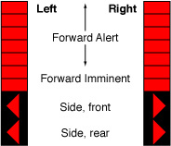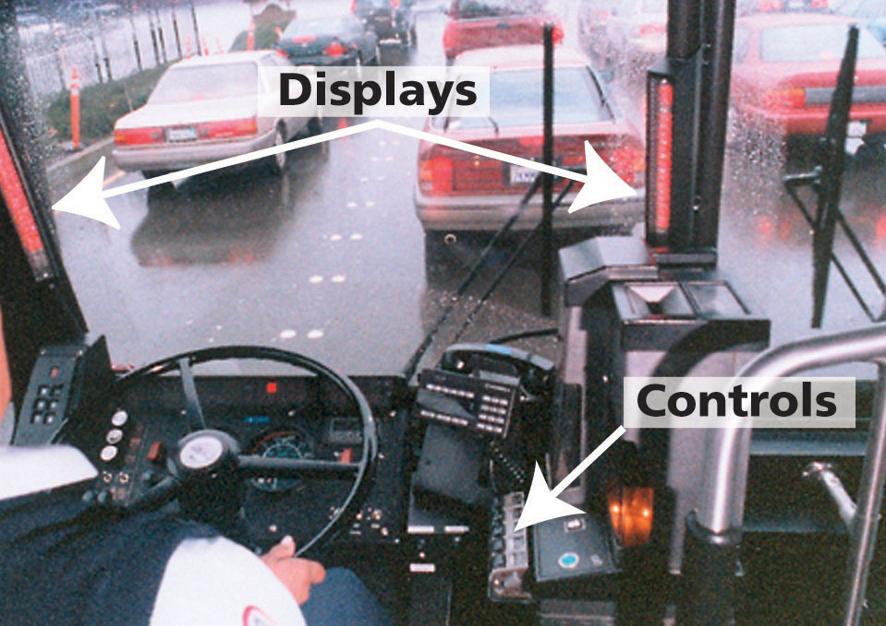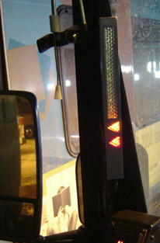
Figure 1 Integrated DVI. The forward LEDs grow downwards with threat level and “aim” at threat. The triangles point towards the relevant mirrors. Bars are mounted on the pillars of the driver’s forward window

When viewing the DVI the physical “location” of the driver with respect to the spatial representations of the LEDs is in the middle of the two DVI bars, between the lowermost forward LED and the “Side, front” LEDs. The bars are designed for the window pillars immediately in front of the driver, thus providing a peripheral display that does not obscure the driver’s external view of the road scene. The placement also supports rapid checking of the side mirrors – an action much more frequent in transit operations than in regular passenger vehicle operation. Digital DVI outputs are refreshed every 75ms.

Driver controls are mounted as a group in the instrument cluster (Figure 2). Volume, brightness, and warning sensitivity (high, medium, low) provide a level of driver control so that individual differences and environmental factors can be accommodated. However, the system is designed so that drivers are not able to use the volume and brightness adjustments to disable the system. Status lights for the three regions (left, front, right) are also provided for quick identification of system health. The controls include a Contact/Under Bus Override button for acknowledgement of these alarms.

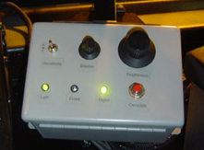

Figure 2 The DVI control box. The toggle sets the sensitivity, the knobs control volume and brightness, and the lights provide status information. Overrides are activated with the red button

Examples of DVI Behavior
Forward component
The bars illuminate sequentially from top to bottom to indicate an approaching threat. Depending on how imminent the threat is some combination of the first segment and the first four segments will sequentially illuminate amber. The greater the number of segments illuminated, the higher the threat. To indicate an imminent warning the segments will change color to red and as the threat becomes more time critical will grow to the full length of the display.

The two forward displays show the angle of the greatest threat to the bus. When the left display is lit the object is forward to the left of the bus. When the right display is lit the object is forward to the right of the display. When the object is directly in front of the bus both displays will be lit.

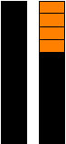
FCWS Alert Mode
Pictorially, forward alert on right side:

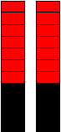
FCWS Imminent Mode
Pictorially, Forward imminent with no lateral bias:

Side component
The boundary line between side front and side rear is the plane that passes horizontally through the bus at the front wheel. The mapping of DVI side subcomponents to warnings is as follows:

Condition |  | 1 | 2 | 3 | 4 | 5 | 6
Left Front  (front wheel forward) | Alert | Y
Left Front  (front wheel forward) | Imminent | R |  |  |  | P
Right Front  (front wheel forward) | Alert |  | Y
Right Front  (front wheel forward) | Imminent |  | R |  |  |  | P
Left Rear  (front wheel back) | Alert |  |  | Y
Left Rear  (front wheel back) | Imminent |  |  | R |  | P
Right Rear  (front wheel back) | Alert |  |  |  | Y
Right Rear  (front wheel back) | Imminent |  |  |  | R |  | P
Contact | Left | BY | BY |  |  | A
Contact | Right |  |  | BY | BY |  | A
Under Wheel  (less than 5mph) | Left | BR | BR |  |  | A
Under Wheel  (less than 5mph) | Right |  |  | BR | BR |  | A
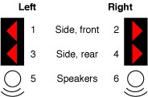 |  | Y = Yellow  R = Red  B = Blink at 2 Hz  P = Percussive sound (e.g., chime)  A = Aggressive sound (e.g., buzzer)
Table 1. Mapping of DVI side subcomponents to warnings

In the event that the side component detects an alert level threat it will trigger an Alert Side warning. The triangle shaped LED for the appropriate side and front/rear position illuminates.


SCWS Alert Mode
Pictorially, left side front alert:

In the event that the side component detects an imminent threat it will trigger an Imminent Side warning. The triangle LED for the appropriate side position illuminates red at highest brightness level. The Imminent warning sound plays.


SCWS Imminent Mode
Pictorially, right side rear imminent:

In the event that the side component detects a collision event it will trigger a Contact warning. Both triangles for the appropriate side illuminate yellow at highest brightness level and blink at 2 Hz and the Contact warning sound plays. The driver is then expected to check their mirrors and decide on an appropriate course of action. Should the driver determine that the warning is a false alarm, pressing the Contact/Under Bus Override button will turn off the alarm and suppress contact detection for 10 seconds. As previously mentioned, the button must be fully released before being activated again.

Under Bus warnings are the same as Contact warnings except the triangles are red and the Under Bus warning sound plays. Under Bus warnings only occur at speed less than 5 mph. The driver is then expected to check their mirrors and, if necessary, stop and exit the bus for closer inspection. Should the driver determine that the warning is a false alarm, pressing the Contact/Under Bus Override button will turn off the alarm and suppress contact detection for 10 seconds. As previously mentioned, the button must be fully released before being activated again.

Plans for DVI Evaluation
On-board collection of driver behavior data will provide insights to the utility of an assistance system and the potential for safety benefit. Such data is most effective when collected during field-testing in real world driving conditions as is currently underway.

DVI evaluation will include a longitudinal human factors analysis of driving behavior. The two states of data collection are (A) Baseline DVI off, but system on and recording and (B) Full System DVI and system on and recording. These states are being cycled for periods of about 3 months where (A) will only be the first few weeks of each cycle. The initial baseline (A₁) will be slightly longer in order to ensure considerable initial baseline data.

This experimental design will allow measurement of system benefit (A_{i} vs. B_{i}), behavior shift (A₁ vs. A₂), and system dependence (B₁ vs. A₂). These will be crossed with specific scenarios that are identified as interesting with respect to integrated CWS transit DVIs.

As previously mentioned, sound and the Contact and Under Wheel alarms are not in the initial version (A₁). These features will be deployed in the second or third cycle/version. Besides providing room to allow robust warning, this also permits limited comparison of visual+audio and visual only transit CWS and the impact of added alarms (e.g., A₁ vs. A₂, etc).

Surveys and interviews will also be employed to collect data on the DVI in order to collect driver, maintenance, and operations perceptions of the system. This technique is also useful for identifying system weaknesses and areas where training and documentation for the system may need to be modified. Additional insight on extrapolations to larger populations can also be achieved through such documentation.

Figure 3 Component diagram of LED assemblies

Data Analysis and Evaluation

FCWS Data Analysis
The main purpose of the following data analysis is to recreate the warning scenario in detail from a technical point of view. By watching the video clip and analyzing the variables, such as host-bus/target speed/heading/acceleration, we gain an understanding of the accuracy, smoothness and noise characteristic of the measurement, estimation and prediction of the host bus and targets (Bus track and target tracks). By this means, we determine areas in which improvements to components of the system should be made. For example, by looking at the raw speed data we found that the speed measurement resolution was degraded at low speeds. In our new PC104 version, the three-channel speed measurements will improve the measurement resolution at low speeds to address this issue. Generally, improvements in hardware and system software lead to more precise measurement. Improvements in algorithm may lead to better estimation, prediction of the tracks, scenario parsing and threat assessment.
Field Data Analysis
System
Performance Evaluation
Hardware/Software/Algorithm

Improvements
Figure 4 The goal of field data analysis

In this chapter, three typical categories of warning scenarios are analyzed using a three-step quantitive approach. They are:
- Moving/stopped target in front on a straight road;
- Stationary roadside target on curved road;
- Overhead obstacles on declined/flat road
Warnings that fall within the first category are considered correct warnings. The second category warnings are considered false positive or nuisance warnings A nuisance warning is a warning given in a case that a collision is correctly forecasted, but that the operator does not consider the situation to be a true potential threat to the bus. The third category is considered a false warning as the bus is in no danger of hitting these overhead obstacles.. Characteristics of three categories of warnings are analyzed and possible solutions for the later two categories are proposed.

FCWS Three-Step Quantitive Approach
A Three-Step Quantitive Approach for data/warning scenario analysis is developed to analyze the warning scenarios.
- Check if the weather is good when using LIDAR data to analyze the scenario, and then use a Fault Detection Tool to check the host bus sensor data and the LIDAR data, making sure they are not corrupted.
- Use Scenario Analysis Tools which recreate the warning scenario by demonstrating the bus/target location/speed/acceleration/heading/ARQ (required acceleration)/raw data in both a snapshot and a trajectory manner.
- Use a playback tool to review the video clip, showing the warning scenario in video format.

FCWS Warning scenarios categorization
Before any analysis is conducted, a comprehensive check of the data is necessary. If it is raining/snowing or foggy, the LIDAR will not function well and the RADAR will take its place. The host bus sensor data needs to be checked to ensure that all sensors were working properly. Generally, the FCWS warnings fall into three categories based on road geometry and target property (as shown in the following table). Scenario A, B and C are analyzed below with data from Sep. 22, 2003, which was a sunny day. Both host-bus sensors and LIDARs worked well.

Road  Target | Straight | Slightly Curved  /Curved | Bridges/Traffic Signs Overhead  Declined road/Flat road
Moving/Stopped | A | - | -
Stationary | - | B | C
Table 2. Warning scenario category

Scenario A
Scenario A is considered a TRUE WARNING. In the following example shown in Figure 5 of Scenario A, there are some road works ahead of the bus and the leading vehicle was decelerating while the host bus maintained a nearly constant speed. The warning started at 10:21:17. The following camera shots show the “road work ahead” sign and a snap shot of the warning scenario.

In addition to the simulation tool introduced in previous chapters a further simulation program was developed in MatlabTM to recreate warning scenarios. The simulation program is MatlabTM version of the real time program installed on the buses with some slight differences. Using high-level language programming, it is much easier to show the bus/target location/speed/acceleration/heading/ARQ (required acceleration)/raw data and recreate the warning scenario in a trajectory manner. This tool is also used to test new algorithms, add more scenario parsing functions and other sub-routings before integrating them to the off-line simulator using C language.

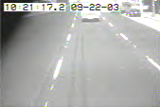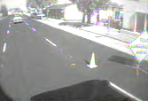
Frontal camera view Passenger side camera view

Figure 5 Warning scenario snap shop (note target ID 185: the leading vehicle)

Figure 6 shows ten samples of Target/Host location (top-left figure), Target/Host Speed (top-right figure), and Target/Host acceleration (middle-left figure) before and after the instant a warning was issued. Figure 6 also shows 20 samples of brake pressure before and after (middle-right figure), and required deceleration (bottom figure) before and after the exact instant when the warning was issued.

Figure 6 Technical variables

As we can see from the figures, the target vehicle was decelerating (the red line in the top-right figure keeps dropping) at a deceleration rate of about 2.5m/s/s. The bus, however, maintained an almost constant speed (dropping slightly) of about 13.5m/s with a deceleration ranging from 0 to 0.5m/s/s. At the tenth sample, the required deceleration exceeded the threshold of 1.8m/s/s, which means if the bus continues at the current driving status without more deceleration (for example, pressing the brakes more), 1.2 second later, a deceleration greater than 1.8m/s/s will be needed to avoid a collision. This is considered a dangerous situation. Therefore, the warning was issued starting from the tenth sample (at 10:21:17). (The sample interval is 75ms). From the brake pressure figure, we can see that the brake pressure increased dramatically after the tenth sample, because the driver did press the brakes harder after the warning was issued.
The warning continued at 10:21:18 and 10:21:19:
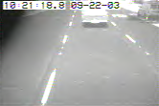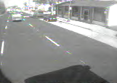
Frontal view Passenger Side view

The warning ended at 10:21:20.
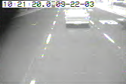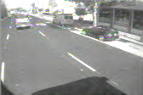
Frontal view Passenger Side view
Figure 7 Target vehicle Decelerating
Figure 8 shows ten samples of Target/Host location (top-left figure), Target/Host Speed (top-right figure), and Target/Host acceleration (middle-left figure) before and after the moment the warning ended. The figures also show 20 samples of brake pressure before and after (middle-right figure), and required deceleration (bottom figure) before and after the exact moment when the warning ended.

As we can see from Figure 8 , although both the host bus and the target vehicle are decelerating, the host bus speed is greater than the target vehicle (See the top right figure, both the blue line and the red line are dropping), the deceleration of the bus is changing from less than the target vehicle to greater than the target vehicle (see the crossing of the two lines in middle left figure). At the tenth sample, the deceleration of the bus is about 0.4m/s/s greater than the target vehicle (a minus sign should be added if referring to the acceleration), the required deceleration is 1.5m/s/s (below the 1.8m/s/s threshold), which means if the bus continues its current driving status, 1.2 seconds later, the situation will no longer be considered dangerous. Therefore at this exact moment, the warning ended. From the brake pressure figure, we can see that the brake pressure started going down after the tenth sample and decreased dramatically from the 15th sampling point, since the driver did release the brakes after the warning ended.

Figure 8 Technical variables

Scenario B
Scenario B is considered a NUISANCE WARNING. In this case, roadside objects, especially those hard reflective traffic signs and guardrails could be dangerous if the bus continued at its current heading, however in most cases like these the driver is aware of the street furniture, so a warning is not warranted. Minimizing the occurrence of these types of warnings has been one of the main issues in the development of the FCWS system. In the example, shown below in Figure 9, a warning was issued at 9:53:04. It was triggered by guardrails on the right side, not the vehicle on the other lane as shown in the following analysis.
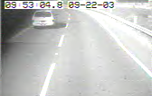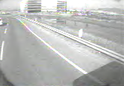
Frontal view Passenger Side view
The warning continued at 09:53:06:
Figure 9 Warning scenario snap shot. Note the warning trigger- target ID 145 in red, not target ID 156 in yellow which is the leading vehicle
The warning ended at 9:53:08.
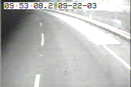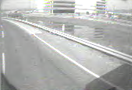
Frontal view Passenger Side view
Figure 10 Nuisance warning ends
Basically, when the road is curved or the bus driver makes a lane change (to the right-most lane), if there are stationary roadside objects ahead, especially those hard reflective traffic signs and/or guardrails, which are sensitive targets for the LIDARs, it will look as if the bus were heading towards those objects, also, since the system needs to predict 1.2 second ahead to compensate the sensor delay and give the driver enough time to react, a warning will be issued. It is called a nuisance alarm because if the driver were distracted, thus did not change the bus’s heading but remained going straight (in the curved road situation) to the right (in the lane changing situation), the crash would happen. However, most of the time, the diver is vigilant and will change the heading when confronted with curved roads and will go straight again after changing lanes. These warnings are explainable but some drivers may find them annoying.

The trajectory of the bus and the target are plotted in Figure 11. Blue squares represent the bus trajectory, green squares represent the car running on the left side, yellow squares represent road side guardrails, “yellow” represents the object that triggered the warning. Note that the up and down motion of the guardrail was caused by noise in the measurement. As is shown in the figure, the car on the left did not trigger the warning. (The “green” represents a “safe” track, which did not trigger the warning). This figure also shows why a comprehensive analysis tool is a must. Without the tool it is hard to determine the correct cause of the warning.
A Car
Guardrails
Left
Right
Bus:15m/s
Figure 11 Trajectories of the bus and the targets around

There are three areas where additional information could help us solve the above challenges.
- Road geometry.
For example, digital maps may tell us the curvature of the road ahead and help the system recognize if the obstacles are in lane or out of lane. If it is out of the lane, we could apply a smaller probability factor.
- Driver status.
This information is hard to get. If the driver is vigilant, these nuisance warnings could be annoying or distracting. However, if the driver is distracted, these nuisance warnings will be good warnings. Given the driver status, the system could utilize this information and decide if it should issue these warnings.
- Target property and crash data analysis result.
If street furniture such as guardrails could be identified by use of a GPS/digital map system, and crash data analysis showed that there is a very small possibility of a bus hitting a guardrail then the system could apply a small probability factor when seeing those guardrails in a curved road, which may dramatically reduce the nuisance-warning rate.

Road Geometry; Driver Status; Target Property and accident data analysis
Prediction:
1.2 second ahead
BU
S
Stationary Roadside objects
Figure 12 Problem: stationary objects along curved road

Scenario C
Scenario C is considered a FALSE WARNING. In the case shown below, the LIDAR detects objects right in front and it looks as if the bus were going straight towards the overhead obstacles. If it were not for the declined road, the LIDAR might not see the bridges since they are higher than the bus (above the ground). The required deceleration will rise sharply as the bus maintains constant speed while passing the bridge.
BUS
BUS
Bridges,
Traffic signs
Declined road
BUS
Figure 13 Problem: Overhead obstacles
As shown above, in this particular case, the declining road and the overhead bridges/traffic signs faked a threat to the host bus. The system incorrectly predicted a potential collision, as it did not have the information about the road geometry. Another similar case could occur with overhead traffic signs that are higher than the bus on a flat road. As the bus may pitch slightly due to different road surface condition, it is hard for the sensor to get the accurate height information of those “obstacles”. Detailed road geometry information may help us solve this problem. With the help of a detailed digital map, if the system knows that the target detected right in front is an overhead bridge and that the bus is on a declining road, or the system knows that the detected target is a traffic sign hung above, it will not issue the false warning.

FCWS Summary
The FCWS warning scenarios are categorized and analyzed using a three-step quantitative approach. The three scenarios include: moving/stopped target ahead on straight road; stationary target roadside on curved road; overhead obstacles on declining/flat road are analyzed. Improvement was made to the algorithm to include features that turn the nuisance warning to a friendly reminder. It is believed that, road geometry information (e.g., more precise GPS and digital map system), driver status information, target properties and crash data analysis, some of the nuisance induced by curved roads and overhead obstacle problems could be overcome.

SCWS Data Analysis
Custom analysis tools have been developed for examination of data generated by the SCWS component. These tools can be used in conjunction with the SCWS Data Replay tool for visual inspection of events and/or system behavior. There are two types of tools in use: driver behavior analysis and system debugging and development. Both will be described here.

Driver behavior analysis
Part of the evaluation of the collision warning system is to assess if and how the behavior of the driver changes. There are several ways of doing this, e.g. one can monitor the frequency and severity of dangerous situations. This can be done for complete runs or for particular maneuvers. We developed analysis tools with which we can pick out particular maneuvers and accumulate relevant statistics.

The analysis tools are flexible and can be customized to analyze many different maneuvers. From a high level, the data and video collected on the bus during operation is stored in a RAID on the CMU campus ( Figure 14). This data, which is read-only, is fed to the Analysis Tools – custom filters and collators that compose data from the RAID based on specified Event Definitions. Compiled Event Data consists of data snippets collated as a series of events. Each event has a bookmark for the beginning time stamp of the event. Experimenters can review the video (stored on the RAID) for each event by jumping to the bookmark in question. For the purposes of behavior analysis, the Analysis Tools extract and compute selected driver behavior data for subsequent processing in traditional statistical analysis software.
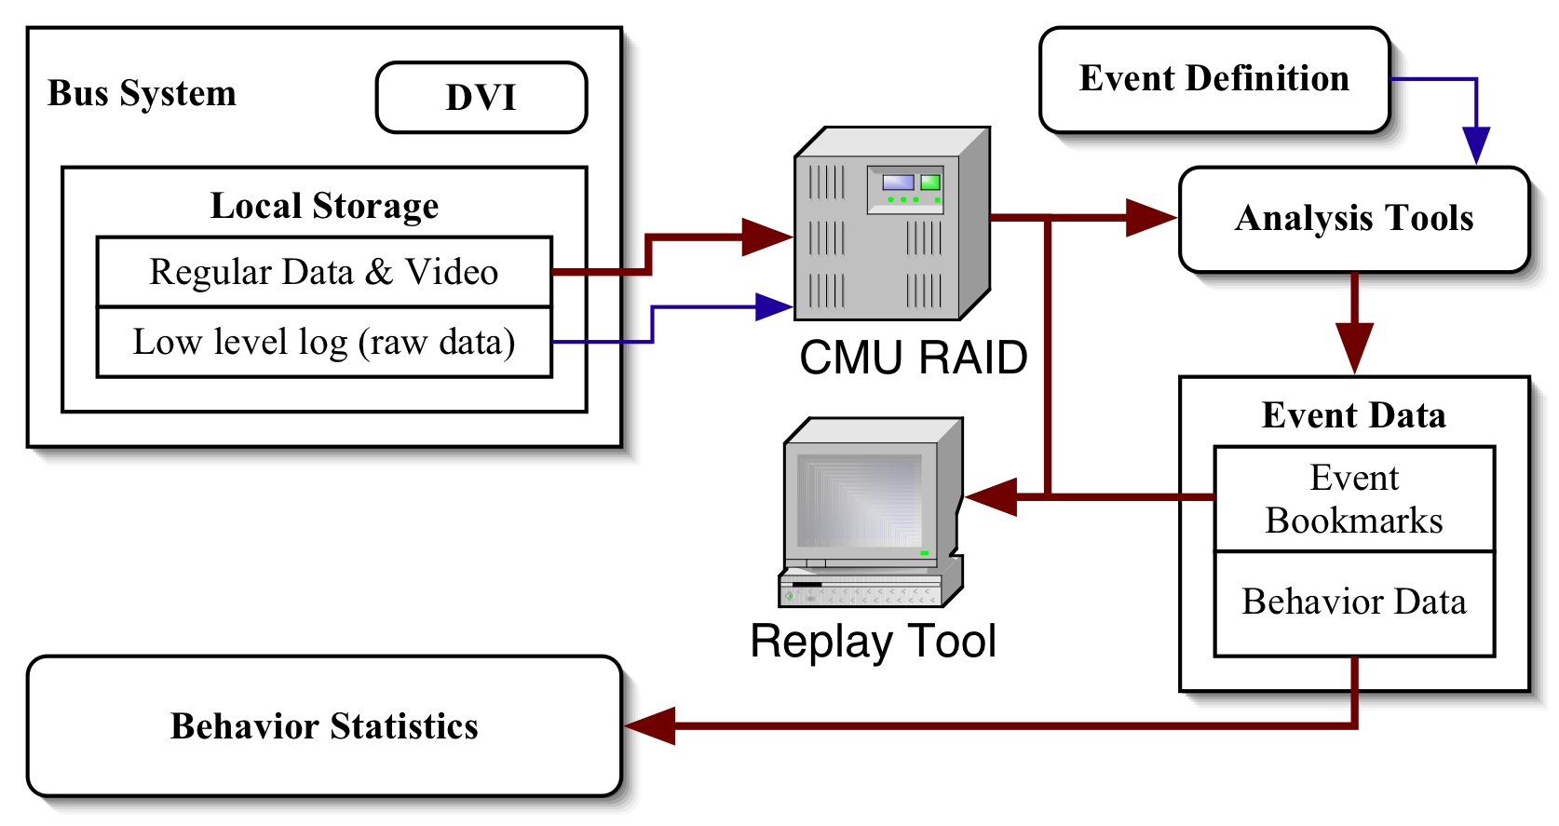
Figure 14 Data flow for driver behavior analysis

The most important part of this process is the specification of the event the experimenter wishes to examine. As an example, we will look at the evaluation measure “Time within each CWS DVI category” (see Table 3. Evaluation Metrics (MOE's)]) for the scenario where a bus pulls out of a bus stop and we want to monitor the level of danger. We specify the scenario in the following way:

- The priming condition “bus stopped and door is open” has to be fulfilled. This ensures that the bus has stopped at a bus stop. Events need to be specified mathematically. As such, we would specify that bus speed is below 2 mph and the door open flag is true.
- When the trigger condition “bus starts to move” is fulfilled (e.g., speed > 2mph), we start to record data: time, speed, turning radius, and probability of collision (see section Error: Reference source not found Error: Reference source not found). The probability of collision is the measure of danger.
- The stop condition is fulfilled when the bus has traveled a set distance and we stop to record data. For example, we may indicate that the bus has traveled more than 5 m.

The Analysis Tools then compile the recorded event data and additional (specified) optional computations may be run to see what danger levels are present for other system or custom sensitivity settings. Bookmarks are also stored so experimenters can quickly jump to the relevant events. The output data file can then be imported into any statistics program (tab separated values) and time within DVI category can be computed. Independent variables, like driver set sensitivity level and location, can be included in this file so that behavior analysis can be parsed accordingly. A primary independent variable, test or baseline data collection (DVI enabled/disabled) can be used for direct analysis of system effectiveness.

Should macro scale data be desired (e.g., average warning level for an entire month, regardless of scenario) then the event definition can be set to a wide level. For example, the priming condition could be system is powered up, the trigger condition be the departure of the bus from the bus yard, and the stop condition the arrival at the bus yard.

The analysis tools are also used to monitor the system for unusual statistics that can be due to system failures. Metrics of this type include wild fluctuations, infeasible warnings, lack of warnings, etc.

The behavior analysis example here is one of the many proposed metrics that will be examined in the evaluation phase of this program. The following matrix lists the additional evaluation criteria that will use these tools. An evaluation report will be written at the conclusion of this program reflecting these metrics
Task | Performance MOE | Before/After MOE | Measures of Interest
2 Closed Course | Time of alert  Time of warning  Time of notify  Latency  Rainfall performance  Environmental effects (salt spray, etc) |  | Daily precipitation  Daily High/Low temps
3 Detect Analysis | True positives  False negatives  True negatives  False positives |  | Fault tree distribution  Scenarios parsing (multiple events where at least one is bad)
4 Driving Behavior* |  | Behavior when within CWS DVI activation range  Time within each CWS DVI category [alert, warn]  Hard accelerations (braking & swerving)  Frequency of warnings over time  Normal following distances (front)  Probability of collision over time (side) | Driver sensitivity setting
5 Surveys Interviews | Nuisance alarms  Driver sensitivity ratings/reports  Driver and management perception of safety benefit  Satisfaction with system performance  Perception of system accuracy | Did system prevent an accident?  Self-reports of alterations in driving behavior | Relaying of passenger queries and comments
6 System Failures | MTBF  Software detected component failures (perform appropriate actions upon failure)  MTTR  Operability Time [correct, degraded, incorrect, not at all] vs. On time vs. Vehicle deployed time [Agency data] |  | Failure mode taxonomy  Component repair cost
Table 3. Evaluation Metrics (MOE's)
* Binned by DVI off (baseline) and DVI on time periods

System debugging and development
As previously mentioned, analysis tools for testing new algorithms are also used. These involve generation of new data that are used in place of collected data (Figure 15). Raw low-level data from the lasers or other sensors can be used to simulate new data, and subsequently, new warnings or object traces. These can be visualized in the SCWS Data Replay tool for performance assessment or compared directly to the real counterparts.
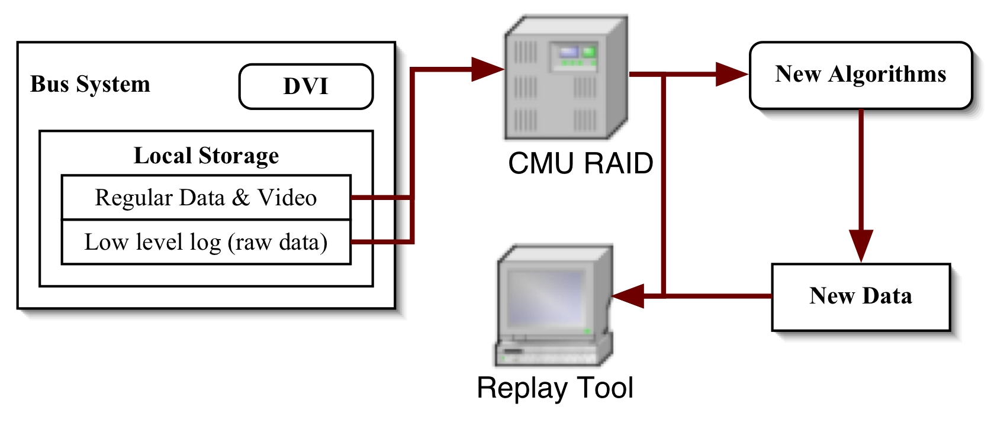
Figure 15 Fusion of new data from test algorithms with real data

This process is especially powerful in testing new DATMO and SCWS warning algorithms. The ability to view the results fused with original video and supporting data (e.g., speed, etc.) provides a good first pass for qualitative performance judgments before conducting labor-intensive comparison analyses. For example, a particular data segment may include a stereotypical false alarm that algorithm developers are attempting to prevent. Visualization of algorithm performance during this segment can be especially telling when trying to determine the root causes of the false alarm and progress towards handling them.

Calibration and Testing

SICK Laser Scanner

SICK resolution and accuracy
The basic properties of the laser scanner are:
Angular range: 180º
Angular resolution: 0.5º or 1.0º
Range: up to 80 m
Range resolution and accuracy: 1 cm
Update rate: 37.5 Hz or 75 Hz (depending on angular resolution)

The manufacturer claims that the resolution and accuracy of the SICK laser scanner is 1 cm. In the following sections we will test this claim.

Definition of terms
Following are important terms for our discussion:
Resolution: Minimum separation necessary to distinguish two objects or minimum displacement necessary to notice movement of an object.
Error, uncertainty, deviation, accuracy: Synonyms for differences between measured and actual property.
Standard deviation: Quadratic average of the differences:
$σ=\sqrt{\frac{\sum_{i=1}^{n}{(x_{i}−\bar{x})^{2}}}{n−1}}$ (1)
where n is the number of measurements x_{i} and $\bar{x}$is the mean of the measurements.

If the function e(x) describes the error distribution, the standard deviation is:
$σ=[\frac{1}{N}\int{e(x)^{2}\text{dx}}]^{\frac{1}{2}}$ (2)
with the normalization factor
$N=\int{e(x)\text{dx}}$ (3)

Error characterization
The basic nature of errors of a sensor can be inferred from its working principle. The laser scanner scans a range of angles and for each angle it determines the distance to the closest object by time-of-flight (TOF). Since the sensor scans the angles, it makes only sense to talk about its angular resolution (which can be chosen to be 0.5º or 1º) but not its accuracy. According to the manufacturer, its range resolution and error is 1 cm, independent of the absolute distance. When a distance d is measured, the actual distance is d ± 0.5 cm with all distances within this error range being equally likely. For later comparison, it is useful to calculate the standard deviation (see Equation (2)):
${Δd}_{s}=\sqrt{1/3}⋅0\text{.}5\text{cm}=0\text{.}\text{29}\text{cm}$ (4)
A discussion about the characteristics of a similar laser scanner can be found in the footnote below.

Experimental confirmation of resolution
In order to confirm the claims about measurement errors in the previous section, a straight fixed object was placed in front of the sensor and the distance to the object was measured several consecutive times. Figure 16 shows this data for the laser scanner and a linear fit through the data. The object extends for an angular range of about 50º. Upon close inspection of the points one can notice small steps, which are the result of the 1cm resolution mentioned in the previous section.

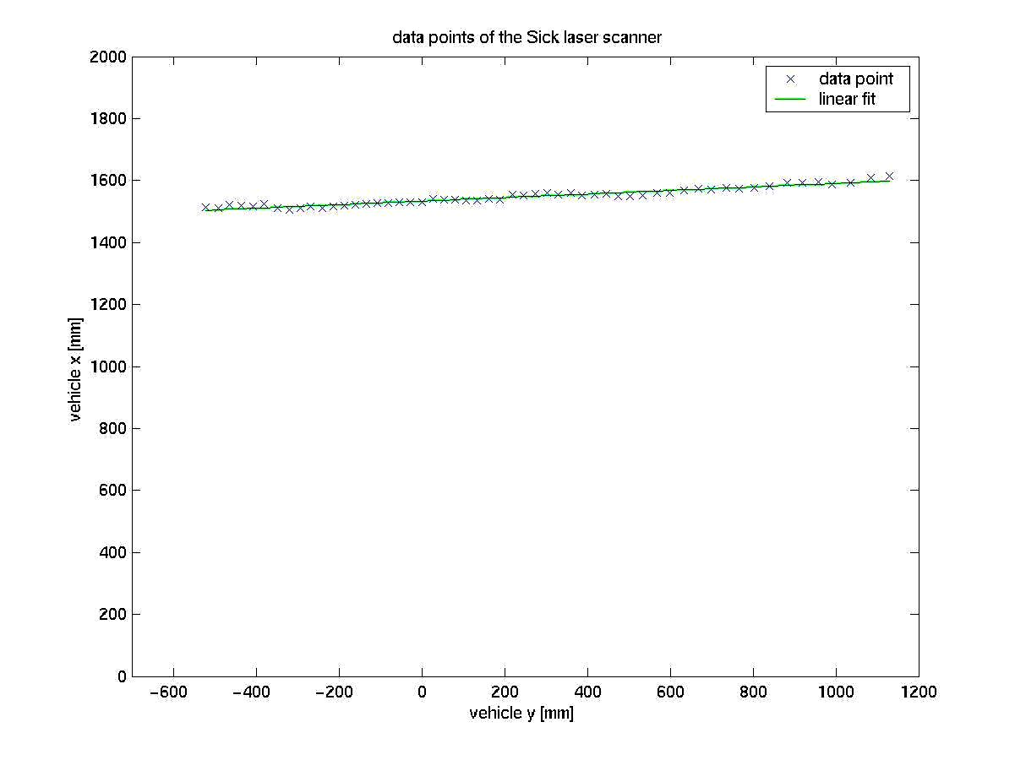
Figure 16 Distances to a straight object measured by the laser scanner. The green line is the linear fit to the data points.

The standard deviation of the points to the linear fit is 0.68 cm, larger than expected from Equation (4). But the object was not perfectly straight and it is likely that the difference can be attributed to this reason.

Next the measurements of the same location at different times were compared. The standard deviation of points measured at different times is shown in Figure 17 under the label “temporal”.

Also shown for each location is the (temporal) mean of the distance minus the average of its neighbors:
${Δd}_{n}=\overline{d_{n}−\frac{(d_{n+1}+d_{n−1})}{2}}$ (7)

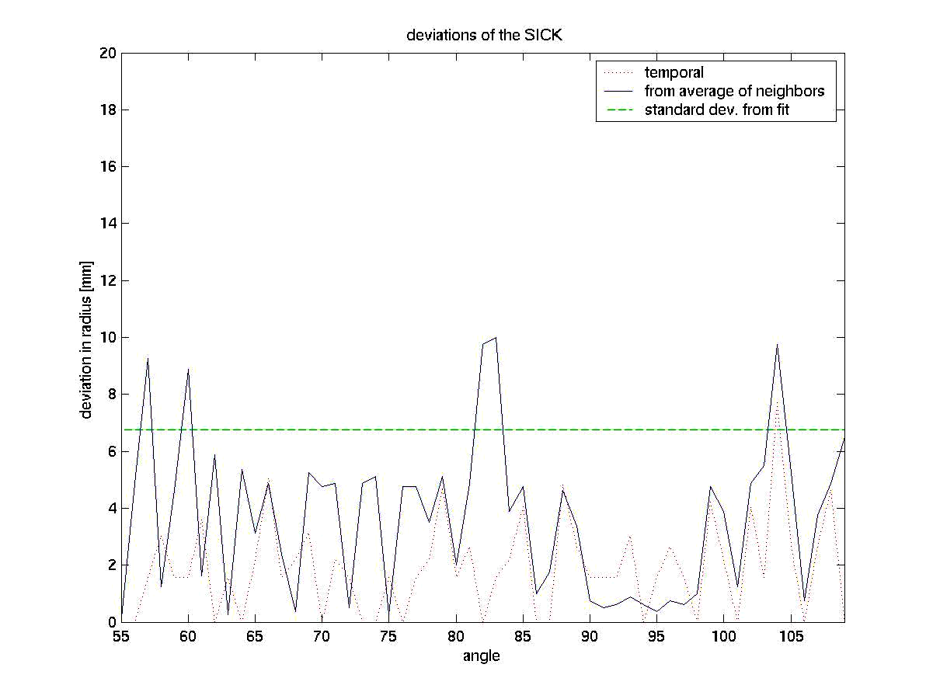
Both quantities are 1cm or less for all points, consistent with the resolution of 1cm.
Figure 17 Error comparisons for the laser scanner.

Experimental confirmation of accuracy
Next we want to test for accuracy for different distances. A target was placed at several distances between 1 m and 45 m. The distance was first measured with a measuring tape and then compared to the distance measured by the SICK laser scanner. The result can be seen in Figure 18 the standard deviation of the difference between the two measured distances is 1.5 cm. This deviation contains the uncertainties related to the target. The target was not entirely flat and it was only eyeballed to ensure that it is vertical. The standard deviation of 1.5 cm can therefore be considered consistent with an accuracy of the SICK of 0.3 cm (Equation 4) over the range of 45 m.
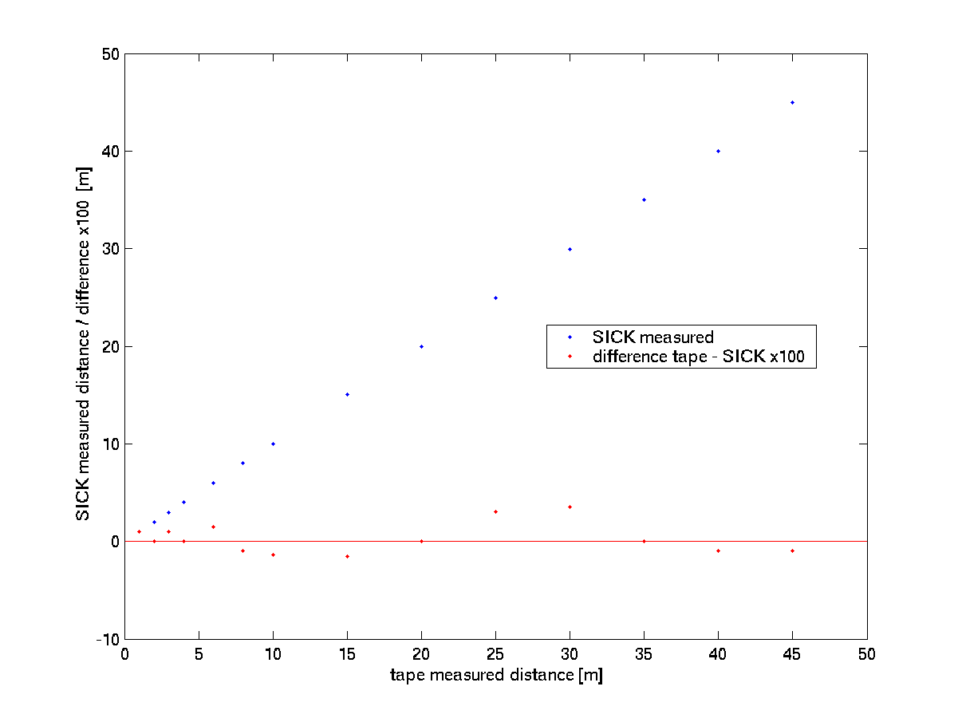
Figure 18 Distance to the target measured by the SICK versus measured by tape.

It needs to be mentioned, that the SICK is only accurate when the light pulse hits a flat surface. It has difficulties at edges of objects when the footprint of the laser pulse hits targets at different distances. In that case it can produce a ghost point in-between the two targets.

Summary
The claim of 1 cm accuracy and resolution has been confirmed for ranges of distances (45 m), angles (50º), and time.

Calibration of Scanner Position and Orientation
For the side collision warning system two SICK laser scanners were mounted on the bus, one for each side. The position of the sensor with respect to the bus coordinate frame was determined using a measuring tape. The laser scanner was mounted on the bus in such a way, that the orientation of its internal reference frames is either parallel or perpendicular to the axis of the bus reference frame. This way the rotation from one to the other coordinate system is easy to be determined. Small deviation from exact alignment of the yaw angle were determined in two different ways, the first was overlaying the scanner data on a calibrated image and the second was comparing the bus speed with the residual speed of fixed objects.

Calibration by overlay
In section Error: Reference source not found Error: Reference source not found we describe how several sensors are calibrated together and finally their data are overlaid on an image. See the first figure in that section. If the yaw of the laser scanner is not properly aligned it will show up as a misalignment in the overlay. The yaw can be corrected by simple trial and error until the overlay is satisfactory.

Calibration by residual speed of fixed objects
When a bus drives by a fixed object, DATMO will find that the relative speed of the object is equal but opposite of the bus speed. If the laser scanner is not exactly aligned, then the relative speed of the object is not exactly opposite (i.e. rotated by 180º), instead it is rotated by more or less than 180º. This effect was seen during the evaluation of Detecting and Tracking of Moving Objects (DATMO), (see section 1.12.2.2 Error characterization of the full DATMO). We studied the potential of this effect in detail to see, if it can be used for automatic calibration of the laser scanner. This study can be found in the next section Automatic external calibration of a laser scanner.

Automatic External Calibration of a Laser Scanner
It is important to know the position and orientation of the sensors mounted on a test vehicle in order to be able to have all the available data in a common reference frame. The process of determining the position and orientation is called external calibration. It is desirable to make that process as easy as possible, in the best case it should be done automatically by the system. In this report we discuss the possibility of automatically calibrating a laser scanner.

Calibration approach
Our approach is to compare the dynamic variables of the vehicle or vehicle state (velocity, turning rate, etc.) with those of the sensor. At first we will only consider the two-dimensional case, i.e. the vehicle travels on a plane surface and the field-of-view of the laser scanner is parallel to that plane.

Determining vehicle state
The vehicle state is determined by odometry (change in position) and by a gyroscope (change in orientation). Usually there is a bicycle model incorporated in the vehicle state, namely that the lateral velocity (vy_{v} in the definition below) is zero. In the derivation of the method this assumption is not being made, therefore the method is general and can also be used to calibrate two laser scanners to each other.

Determining external sensor state
We are using SLAM (Simultaneous Localization And Mapping) and DATMO algorithms [Wang and Thorpe] to determine the external sensor state. In SLAM successive laser scanner readings of the surroundings from a moving vehicle are compared and matched to each other. If the surrounding is fixed, the movement of the vehicle can be inferred from the change in the sensor reading and the matched data gives a map of the surrounding and how the sensor has moved from scan to scan. It is therefore possible to determine for each time step the position and orientation of the sensor relative to its initial position and orientation. If moving objects are present, they need to be filtered out and tracked with DATMO. Details about the algorithm can be found in the publication.

Reference system
The moving (!) reference system is defined as follows:
x_{v}
y_{v}
y_{s}
x_{s}
φ
Δy
Δx
Figure 19 Vehicle and sensor coordinate frames

The vehicle coordinate frame is (x_{v} , y_{v}). The sensor coordinate frame (x_{s} , y_{s}) has its origin at (Δx, Δy) and is rotated by the angle φ. The relationship between a point in the sensor frame and the same point in the vehicle frame is:
Equation 1 $x_{v}=x_{s}\text{cos}(ϕ)−y_{s}\text{sin}(ϕ)+Δx$

Equation 2 $y_{v}=x_{s}\text{sin}(ϕ)+y_{s}\text{cos}(ϕ)+Δy$
Figure 20 Moving vehicle and sensor coordinate frames
x_{v}
y_{v}
y_{s}
x_{s}
φ
v_{v}
ω
If the vehicle is traveling with the velocity v_{v} = (vx_{v} , vy_{v}) and rotating with the angular velocity ω, then the origin of the sensor is rotating with the same angular velocity ω, but traveling with the velocity v_{s} = (vx_{s} , vy_{s}) which is dependent on v_{v}, ω, Δx, and Δy:
Equation 3 ${\text{vx}}_{s}=({\text{vx}}_{v}−Δy⋅ω)\text{cos}(ϕ)+({\text{vy}}_{v}+Δx⋅ω)\text{sin}(ϕ)$
Equation 4 ${\text{vy}}_{s}=−({\text{vx}}_{v}−Δy⋅ω)\text{sin}(ϕ)+({\text{vy}}_{v}+Δx⋅ω)\text{cos}(ϕ)$
Having only two equations, the three unknowns Δx, Δy, and φ cannot be determined with one measurement. One needs to make measurements for different translational and rotational velocities.

Example implementation
We drove the Navlab 11 vehicle a distance of about 40 meters on a course of curves and straight lines and recorded for each the path and velocities ( Figure 21). As expected, the angular velocities of sensor and vehicle are very similar; their difference is due to measurement errors.
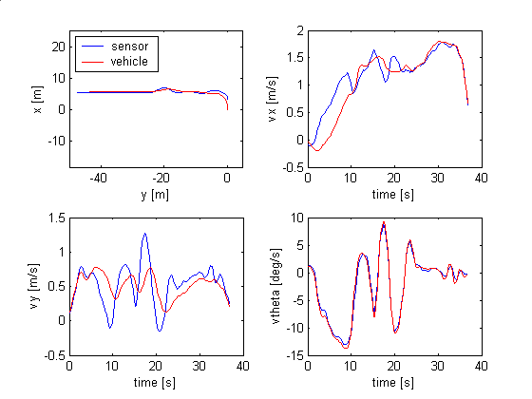
Figure 21 The path and the velocities recorded by the vehicle and the sensor in the fixed coordinate frame. The two paths are aligned according to the result of offset and orientation of the sensor.

Initial step
First we selected all the instances where the angular velocity is close to zero (ω< 2º/s). If we assume the angular velocity is exactly zero, Equation 3 and Equation 4 become:
Equation 5 ${\text{vx}}_{s}={\text{vx}}_{v}\text{cos}(ϕ)+{\text{vy}}_{v}\text{sin}(ϕ)$
Equation 6 ${\text{vy}}_{s}=−{\text{vx}}_{v}\text{sin}(ϕ)+{\text{vy}}_{v}\text{cos}(ϕ)$
Which is simply the rotation equations and φ is therefore the angle between v_{s} and v_{v}. We calculate this angle for each of the selected instances and then get our initial estimate φ₀ from their mean value. In Section 1.11.4 we discuss various methods besides the mean value which can be used to determine φ_{0.}

Iterations
If one has φ, the values of Δx and Δy can be determined from Equation 3 and Equation 4:
Equation 7 $Δx=\frac{1}{ω}({\text{vy}}_{s}\text{cos}(ϕ)+{\text{vx}}_{s}\text{sin}(ϕ)−{\text{vy}}_{v})$
Equation 8 $Δy=\frac{1}{ω}({\text{vy}}_{s}\text{sin}(ϕ)−{\text{vx}}_{s}\text{cos}(ϕ)+{\text{vx}}_{v})$
On the other hand, if Δx and Δy are known, φ is:
Equation 9 $ϕ=\text{arctan}({\text{vy}}_{v}+Δxω,{\text{vx}}_{v}−Δyω)−\text{arctan}({\text{vy}}_{s},{\text{vx}}_{s})$
The three calibration parameters can now be determined iteratively:
- Using all instances with small turning radii (< 10 m) and the previously determined value of φ determine Δx and Δy by forming the median of their distributions.
- Using all instances with large turning radii (> 60 m) and the previously determined value Δx and Δy determine φ by forming the median of their distributions.
- Repeat 1. and 2. until convergence is achieved.

In our example 3 iterations were sufficient.

Results
The distributions of Δx, Δy, and φ for the last iteration can be seen in Figure 22. The resulting values using the different methods:

sensor orientation | median: 0.50 deg | mean: 0.37 deg | std: 2.60 deg | error: 0.36 deg
gaussian fit |  | center: 0.49 deg | sigma: 1.02 deg | error: 0.14 deg
sensor del x | median: 3.439 m | mean: 3.424 m | std: 0.844 m | error: 0.113 m
gaussian fit |  | center: 3.393 m | sigma: 0.158 m | error: 0.021 m
sensor del y | median: -0.129 m | mean: -0.153 m | std: 0.296 m | error: 0.040 m
gaussian fit |  | center: -0.026 m | sigma: 0.304 m | error: 0.041 m
Table 4. Values for sensor orientation, Δx, and Δy

Summary:
Δx = (3.39 +- 0.02) m Δy = -(0.03 +- 0.04) m φ = (0.49 +- 0.14)º
Remember that the errors are purely statistical and do not include systematic errors.

The following positions were measured with measuring tape, for the angle a target was placed directly in front of the vehicle and measured with the laser scanner itself:
Δx = (3.35+-0.01) m Δy = (0.0+-0.01) m φ = (0.75+-0.5)º
The errors are estimates.

Special case: bicycle model
If one places the center of the coordinate at the middle of the rear axle of the vehicle, then there is never a lateral movement (vy_{v}=0). This fact simplifies the equations.
If the vehicle travels straight, then vx_{v} can be calculated from v_{s}:
Equation 10 ${\text{vx}}_{v}=\sqrt{{\text{vx}}_{s}^{2}+{\text{vy}}_{s}^{2}}$
And φ can be calculated according to Section 1.11.2.1. “Driving straight” means that v_{s}>> Δxω and v_{s}>> Δyω. Strictly speaking it is never possible to know if these conditions are fulfilled since Δx and Δy are not known and one can not measure if ω is exactly zero. Nevertheless, one can always make some reasonable assumption, i.e. Δx and Δy are smaller than the size of the vehicle.

Once φ is known, Δx can be calculated from a simplified version of Equation 7:
Equation 11 $Δx=\frac{1}{ω}({\text{vy}}_{s}\text{cos}(ϕ)+{\text{vx}}_{s}\text{sin}(ϕ))$
It is therefore possible to determine φ and Δx without any vehicle state information.

Extracting the best value from a distribution
There are various methods to determine the best value and error of that value from a set of measurements. We will discuss here the mean, the median, standard deviation, and fitting a curve to the distribution of measurements.
.
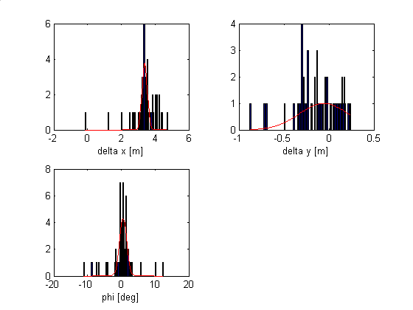
Figure 22 Distributions of Δx, Δy, and φ. Gaussian curves are fitted to each and are shown in red.

Mean value
The mean or average value gives a correct answer if the distribution of measurements is symmetric. Problems arise if there are outliers, i.e. few measurements which are far from the center of the distribution. These outliers can distort the mean. Another situation that the mean value does not handle well is if the distribution is split, i.e. if we have more than one peak. This situation arises in our method when the angle φ we want to measure turns out to be around 180º and we look at the distribution between –180º< φ<180º. Since +180º and –180º are equivalent, we will get a peak around each of the two.

Median value
The median value often does not give an answer as accurate as the mean value, but it is much less sensitive to outliers and the split peak problem

Standard deviation
The standard deviation gives a measure of the width of a distribution or the error of a measurement. It is important to note, that it gives the error for the individual measurements and not the error on the mean or median. The error on the mean or median is smaller than the error on the individual measurements.

Fitting a curve
If the underlying shape of the distribution is known, one can fit the appropriate curve to the distribution of measurements and thereby extract the best estimate of the value, width etc. There are two main problems, one is that the underlying shape is often not known and the other is that one can end up in a local minimum when doing the fit and thereby getting a false result.
We found that fitting a Gaussian curve to our distributions gives us good results. Fits to the distributions of Δx, Δy, and φ are shown in Figure 22.

Error of the estimated value
We have estimated the desired value by forming the mean, median, or fitting the distribution and we have the width or standard deviation of the distribution. In the ideal case when the error on each individual measurement is purely statistical and Gaussian, as opposed to e.g. a systematic offset, the mean and the fitting would give the same result and the error on each individual measurement is the standard deviation (same as the σ in a Gaussian fit). Then, the mean is a combination of N individual measurements with error σ, and the error on the mean is:
Equation 12 $σ_{\text{mean}}=\frac{σ}{\sqrt{N}}$

Accuracy of Velocities Measured by DATMO
The raw data supplied by a laser scanner are distances from the sensor to objects. By observing the changes of distances over time, it is possible to determine the velocity of objects. The basic steps to measure velocities are:
- Segment the raw data into objects
- Track the objects over time
- The velocity is the displacement of the object divided by the appropriate time

In the following sections we will discuss several different methods on how this can be done. The methods differ mainly on the third point, namely how the displacement is being measured. These four will be mentioned:
- Center of mass tracking: The displacement is the difference in the location of the center of mass.
- Closest point tracking: The displacement is the difference in the location of the closest point to the vehicle.
- Point-to-point matching: The displacement is the best match between the points from one scan to the other.
- Line-to-line matching: The displacement is the best match between the line(s) fitted to the points from one scan to the other.

General test procedure
To measure the accuracy of a velocity measurement one needs know the velocity of the object by an independent, preferably more accurate, method. In our case, one would have the sensor observe an object while at the same time we record the movement of the object. This has some technical difficulties, especially the synchronization of the sensor and the data taking of the object. Also, it will be quite time consuming if one wants to do this with several different object.

We chose a different method. The sensor was mounted on a vehicle and we observed stationary objects while at the same time we recorded the movement of the vehicle. Since the sensor was moving, the objects had an apparent velocity. This velocity was measured by the sensor and compared with the apparent velocity of the object calculated from the movement of the vehicle. In other words, a moving sensor observing stationary objects is functionally equivalent of a stationary sensor observing a moving object.

Velocity accuracy from location accuracy and update rate
The laser scanner has a distance accuracy of +-0.3 cm (standard deviation) and an update rate of 75 Hz (1º resolution). If the change in location between two scans divided by the time between two scans is used as the velocity, then the accuracy in velocity is +-20 cm/s. If instead one uses scans separated by 1 second, then the accuracy is +-0.3 cm/s, but now the update rate is 1 Hz.

This error does not include the tracking error. Objects are extended and the scans often measure different parts of the object while tracking it. In the worst cases this introduces errors in the location of the object equal to the size of the object and accordingly an error in the velocity equal to the size of the object divided by the appropriate time (e.g. the time it takes to drive past an object).

In the ideal case one tracks one fixed point of an object (e.g. its center or one feature) and facilitates an appropriate filter. A typical filter would include a motion model of the host vehicle and the observed object.

Center-of-mass tracking of compact objects
In the following discussion we investigate the accuracy of velocity determination by using a center-of-mass tracker and compact objects. The sensor was mounted on Navlab 11. We choose a tree as the object to track ( Figure 23).
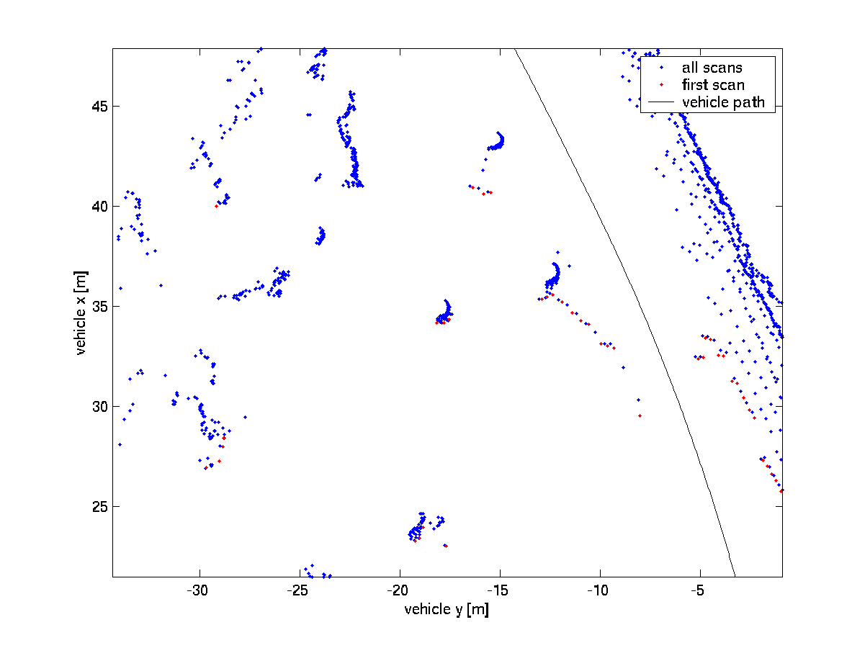
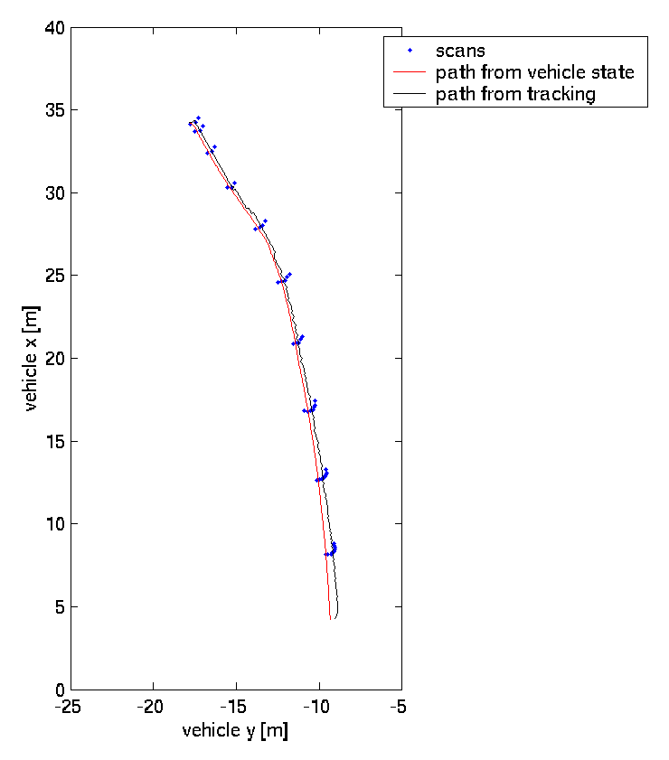
Figure 23 The left side shows the scans projected into a global reference frame. The chosen tree is in the center. The right graph shows the scans in the (moving) vehicle frame. The "path" of the tree determined by the vehicle state and by tracking are shown.

There are four basic steps to the center-of-mass tracking algorithm:
- Location X₀ of the tree is given (user supplied for the first iteration).
- All points p_{i}=(x_{i},y_{i}) of the next scan within +- 3m of X₀ are collected.
- The new location X₀=(x,y) of the tree is the center of mass of these points, i.e. the average of x_{i} and y_{i}.
- 4. back to 1.

Figure 23 shows in the right graph the scans and the “path” of the tree determined by the vehicle state and by the tracking. The velocity at time t was determined as:

v = (X₀(t) – X₀(t-1s)) / 1s

I.e. the average velocity of the last 1s with an update rate of 35 Hz.
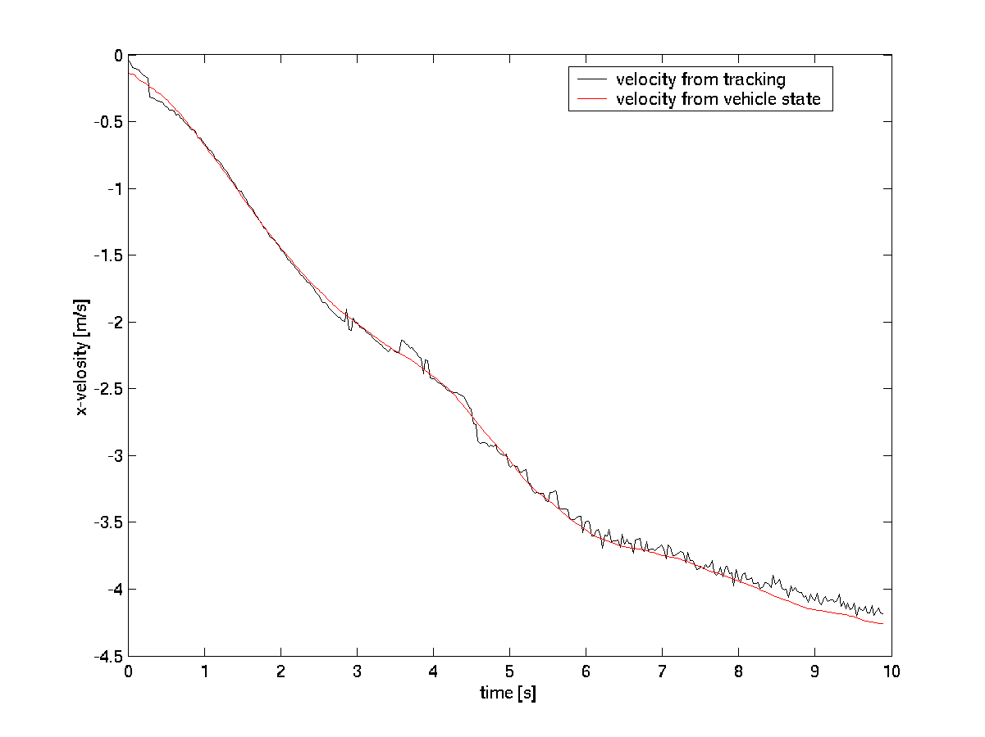
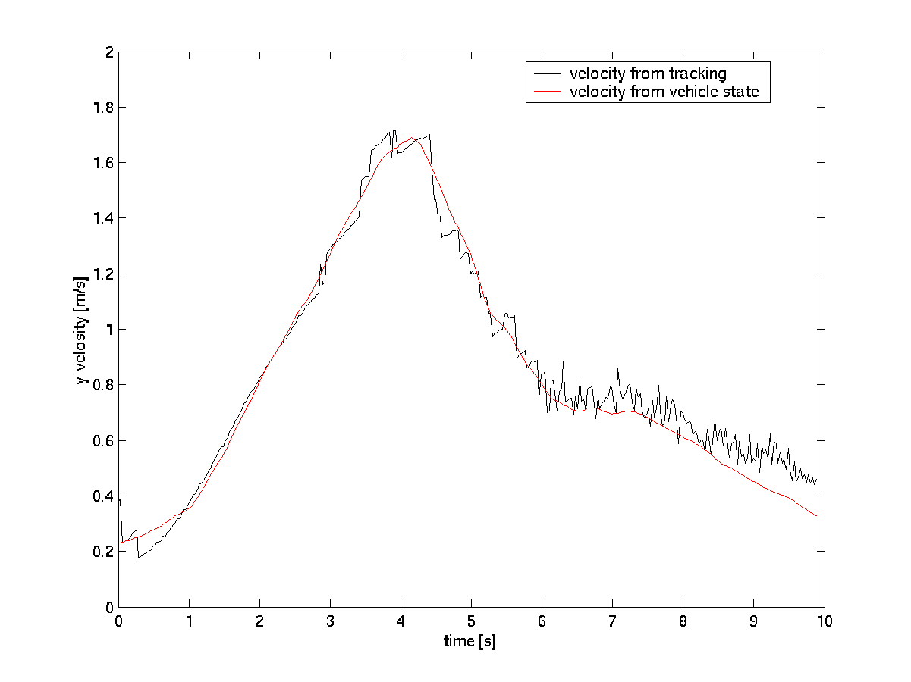
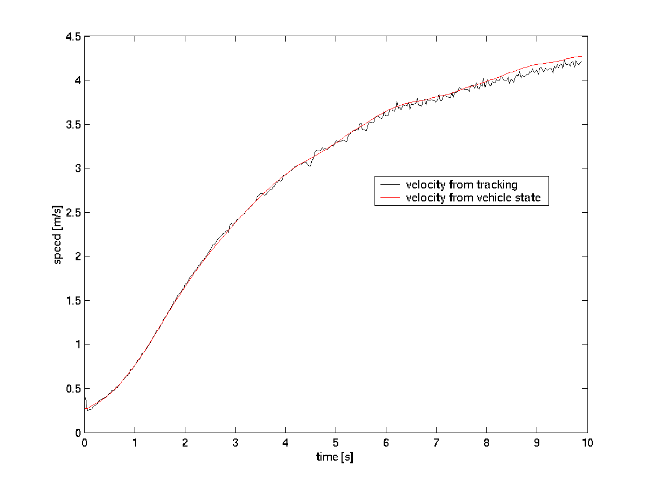
Figure 24 Velocity in x and y direction and the speed determined by tracking and by vehicle state.

Figure 24 compares the velocities and the speed determined by tracking and vehicle state. The speed is the quadratic sum of the two velocities. The standard deviations of the difference between the tracking and vehicle state estimates are 0.051 m/s, 0.062 m/s, and 0.038 m/s for x-velocity, y-velocity, and speed respectively. The error for the speed is considerably less than the ones for the velocities, indicating that the x – and y-velocities are correlated.

These measurements were repeated for a situation where the vehicle makes a sharp turn and another situation where the vehicle speed was almost 13 m/s. For the sharp turn situation the errors were 0.082 m/s, 0.075 m/s, and 0.109 m/s and for the higher speed situation 0.071 m/s, 0.167 m/s, and 0.065 m/s. These errors are larger than the previous ones and some of it can be attributed to a timing issue we had with the yaw measurement of the vehicle and a misalignment of the laser scanner.

Nevertheless, following numbers describe a conservative estimate of the error in the velocity of a relatively compact object:
Error in x velocity: 0.08 m/s
Error in y velocity: 0.17 m/s
Error in speed: 0.11 m/s

Tracking and matching algorithms for extended objects
The data presented in this section was taken with the side collision warning system mounted on the transit bus of the Port Authority of Allegheny County.
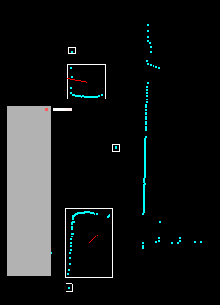
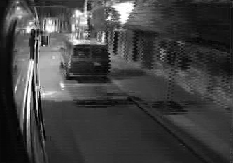
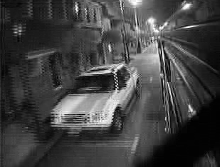
Each single scan from the laser scanner is segmented into objects. An object is the sum of points that are less than a threshold value apart from each other. An example can be seen in Figure 25:
Figure 25 On the left side is a single laser scan segmented into different objects. The images on the right are from two video cameras and show the corresponding objects. Notice that the segmentation is not perfect, there are single points which are designated as separate objects even though they originate form the same car as a large object. The red line inside the large objects indicate their velocities.

Objects are tracked between scans and, in the example shown in Figure 25, the velocity of the objects is determined by point-to-point matching. (i.e. for each point in the current scan, one finds the closest point in the previous scan while not exceeding a certain threshold). For this closest point one finds again the closest point in the scan before, etc. Finally, for each point in the current scan one has a chain of points reaching in the past and one can determine a velocity for each point. The velocity of the object is then the average of the point velocities.

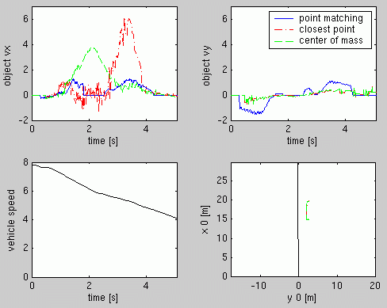
Figure 26 shows the calculated velocity of the stationary car that is depicted in Figure 25. Because the car is stationary, the velocity should be zero for all times. Any deviation from zero is a direct measure of the error.
Figure 26 Velocity measurement of a stationary car passed by a bus. The top two graphs show the measured velocities parallel (vx) and perpendicular (vy) to the bus for three different methods. The lower left graph is the speed of the bus and the lower right graph is the path of the bus together with the locations of the closest points and center of masses.

The velocity determined by the point-to-point matching method is compared with two other methods: tracking the point of the object closest to the bus and tracking the center-of-mass of the point cloud. The quality of the point-to-point matching method is approximately the same for velocities parallel (x-direction) or perpendicular (y-direction) to the bus. The closest-point or center-of-mass methods are both much worse for the x-velocity, but much better for the y-velocities. The standard deviations are shown in following table:

 | Point matching | Closest point | Center-of-mass
σ(vx) [m/s] | 0.43 | 1.70 | 1.17
σ(vy) [m/s] | 0.69 | 0.22 | 0.23
Table 5. Standard deviations of three matching methods for a stationary car

We wanted to investigate, if these numbers change under different circumstances. In the above example, the car is parked parallel to the bus, is not occluded, and the bus is driving straight. In the next example, the bus is turning left, the car is occluded for some times and the car is oriented at different angles relative to the bus.

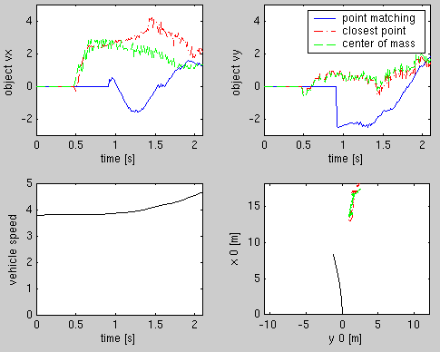
Figure 27 The same as Figure 26 but now for a situation where the bus is turning left.

The respective standard deviations are listed in following table:
 | Point matching | Closest point | Center-of-mass
σ(vx) [m/s] | 0.95 | 1.32 | 0.98
σ(vy) [m/s] | 1.04 | 0.51 | 0.58
Table 6. Standard deviations of three different matching methods for bus turning left
Most of the values are worse (and sometimes more than twice as bad) than in the previous example. Only the determination of vx with the closest-point or center-of-mass method is better.

Conclusion
The source of the error for the closest-point and the center-of-mass methods are obvious, namely, the laser scanner sees different parts of the object and therefore the object seems to be moving. The results from the point-to-point matching, especially why it is so much worse for vy than the other two methods, are more complicated. The point-to-point method would work, either if the points would be randomly distributed on the surface of the object or if they would always be at the same location on the surface of the object. But in our case the points move systematically on the surface of the object and so we have this movement in addition to the movement of the object. An example can be seen in Figure 28.
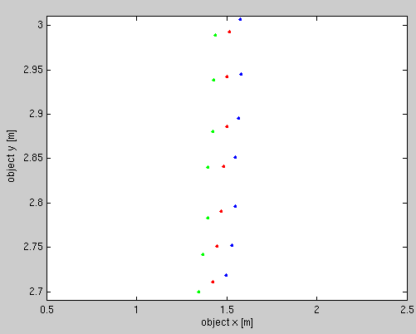

Figure 28 Three consecutive scans, blue, red, and green. The movement to the left is caused by the moving object itself. The small movement down is caused by the points moving on the surface of the object.

Neither of these three methods is good enough for our purposes, we therefore developed another method, the line-to-line matching method. This new method is described in detail in the section on the DATMO algorithm. In the next section, we discuss the accuracy of the resulting measurements.

Quantitative results of line-to-line matching
As before, we looked at the residual velocity of fixed objects to determine the accuracy of the velocity measurements.

We chose two situations. The first one is the same as the one we analyzed in the previous section, in which the bus drives straight while passing a parked car. The second one we chose because it gave larger measurement errors than other situations we observed. This should show us what we could expect in a worse than typical situation. We suspect that this second situation gives worse results because the shape of the vehicle is more rounded and therefore lines do not fit as well as they would to a rectangular shaped vehicle.

Figure 29 shows the first situation. The following table lists the errors of the line matching algorithm compared to the point-to-point matching, closest point, and the center of mass tracking methods (everything in m/s):

 | line match | point match | closest point | center of mass
σ(vx): | 0.29 | 0.43 | 1.77 | 1.18
σ(vy): | 0.09 | 0.69 | 0.22 | 0.24
max(vx): | 0.81 | 1.29 | 6.08 | 3.78
max(vy): | 0.39 | 1.53 | 0.73 | 0.73
Table 7. Line matching algorithm errors vs other methods

The velocity estimation is significantly better with the line matching algorithm than with any other method, no matter which criteria is used (standard deviation or maximum deviation in x or y direction). The error in the y-direction is expected to be less, because the object is less extended in the y-direction. The standard deviation of the velocity from the line matching algorithm is less than 0.3 m/s and the maximum (absolute) deviation is less than 1 m/s.
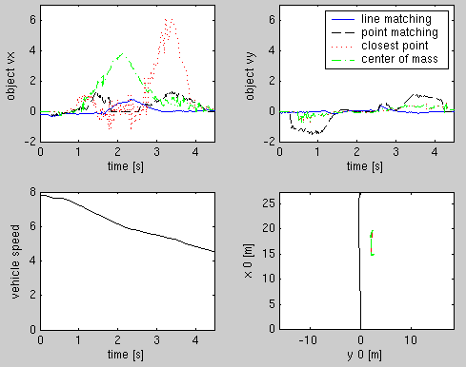
Figure 29 Velocity measurement of a stationary car passed by a bus. The top two graphs show the measured velocities parallel (vx) and perpendicular (vy) to the bus for four different methods. The lower left graph is the speed of the bus and the lower right graph is the path of the bus together with the locations of the closest points and center of masses

Figure 29 shows the comparison between line-to-line matching, closest point, and center of mass tracking methods for the second situation:

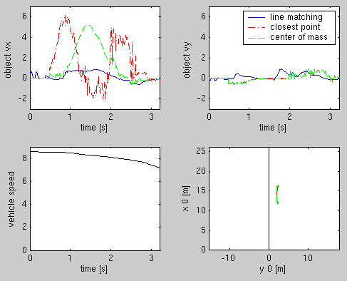
Figure 30 Same as Figure 29 but for a situation which gives worse error.

This table summarizes the errors in Figure 30 for the different methods:

 | line match | closest point | center of mass
σ(vx) | 0.44 | 2.18 | 1.77
σ(vy) | 0.26 | 0.35 | 0.34
max(vx): | 0.85 | 6.18 | 5.25
max(vy): | 0.93 | 0.95 | 0.93
Table 8. Errors from the three different methods

The errors from the closest point and center of mass tracking methods are comparable with the previous situation, but the errors from the line matching in the y direction is twice as bad.

We analyzed a few more situations and always found similar results as reported above. In one of those situations the maximum speed of the bus was a little bit over 10 m/s and the accuracy was +-0.15 m/s.

Discussions about line-to-line matching
The line-to-line matching algorithm is clearly better than any of the three other methods. Its accuracy decreases if the observed object is not well described by straight lines. Even with this decreased accuracy, it is still better than the other methods. Another situation which is difficult to analyze is when the observed object is oriented in such a way, that the scanner can only see one line, i.e. when the surface of the object is perpendicular to the beam of the scanner. But in that situation any algorithm will have problem because of the lack of features (i.e. a corner).

Error characterization of the full DATMO
In order to get a better characterization of the error function of the full DATMO we looked at a 40 second long data set. During this time the bus was driving at about 10 m/s past a whole series of fixed objects: parked cars, mail boxes, and lamp posts. DATMO detected 312 different objects. The DATMO Algorithm section describes how the velocities of all the different objects are determined. The distribution of the measured velocities shows the error function.
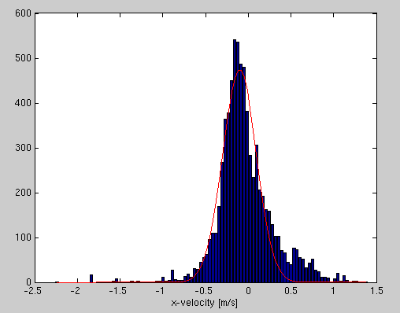
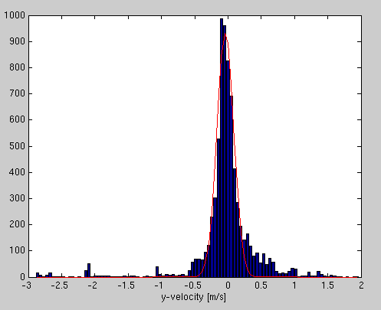

Figure 31 Distribution of the error in velocity. The left shows it for the velocity in x direction and the right for the y-direction. The red lines are Gaussian fits to the distributions.

Figure 31 shows the distributions for the x and y directions. Gaussian curves were fit to the distributions (shown in red) and gave following parameters:

x-velocity center: -0.10 m/s σ: 0.20 m/s
y-velocity center: -0.04 m/s σ: 0.13 m/s

The centers of both distributions are not exactly at zero. The offset for the x-direction can be explained by a 1% inaccuracy of the speed of the bus. The offset for the y-direction could be due to a small misalignment of 0.2º of the laser scanner. Both of these errors are very small and well within the known accuracy of the bus speed and the sensor alignment.

The distributions are fairly well described by the Gaussian curve, except for their tails which are much stronger. These outliers can come from inconsistent scanner data, e.g. if the scanner sees different parts of an object or does not get any return from certain parts of a vehicle. We later discovered that the bus itself was not level and therefore the sensor plane was not parallel to the ground. This would explain why we didn’t always get consistent returns, i.e. the scanner probed the objects at different heights depending on the distance of the objects.

Another source of errors is ground returns. Sometimes the laser scanner sees the ground at a very shallow angle. Since the angle is so shallow, any movement of the scanner results in a strong change in what the sensor sees, and therefore DATMO sees a fast moving and/or fast accelerating object.

Conclusion
In one of the sample situations and for the extended data set, the relative velocity of the car was more than 10 m/s. The car was moving towards and away from the scanner, and it was moving almost parallel to the scanner beams and perpendicular to them. All this is equivalent of saying:

Relative velocity: vx = -10 ... +10 m/s
vy = -10 ... +10 m/s
Depending on the situation, the accuracy is between +/- 0.15 and +/- 0.45. The accuracy is mainly dependent on how well straight lines can be fitted to the object. In general, the accuracy is described by a Gaussian distribution with σ = 0.2 m/s plus occasional outliers of a few m/s.
The algorithm runs about 5 times faster than real time on a standard PC.

Steinfeld, A. FCWS Driver-Vehicle Interface Driver and Trainer Input and PRELIMINARY Design. California PATH, U. C. Berkeley. Unpublished, 2001.
Steinfeld, A. FCWS Driver-Vehicle Interface Driver and Trainer Input and PRELIMINARY Design. California PATH, U. C. Berkeley. Unpublished, 2001.
Steinfeld, A. FCWS Driver-Vehicle Interface Driver and Trainer Input and PRELIMINARY Design. California PATH, U. C. Berkeley. Unpublished, 2001.
Mitretek. FCWS Driver-Vehicle Interface Driver and Trainer Input and PRELIMINARY Design Comments and Observations. Unpublished 2001.
Graham and Hirst. “The effect of a collision avoidance system on drivers' braking responses.” Proceedings of the 4th Annual Meeting of IVHS America. Washington, DC: 1994: 743-749.
Wilson, Butler, McGehee, and Dingus, “IVHS countermeasures for rear-end collisions, driver warning system performance guidelines.” Proceedings of the 1996 Annual Meeting of ITS America. 1996: 949-957.
Dingus, Jahns, Horowitz, and Knipling. “Human factors design issues for crash avoidance systems,” Barfield and Dingus eds. Human Factors in Intelligent Transportation Systems. New Jersey: Lawrence Erlbaum Associates, 1998: 55-93.
Steinfeld and Tan, “Development of a driver assist interface for snowplows using iterative design.” Transportation Human Factors, vol. 2, no. 3. 2000: 247-264.
Wang, Chang, Chan, Johnston, Zhou, Steinfeld, Hanson and Zhang. Development of Requirement Specifications for Transit Frontal Collision Warning System. Unpublished August 2003.
Jensfelt and Christensen. “Pose Tracking Using Laser Scanning and Minimalistic Environmental Models.” IEEE transactions on robotics and automation Vol. 17, No.2. April 2001.
Wang and Thorpe. "Simultaneous Localization and Mapping with Detection and Tracking of Moving Objects." IEEE International Conference on Robotics and Automation. May 2002.
op. cit.

