Sub-routine “AssignData2Track()” and “FreeHistoricalData()” can add a data cell into or remove a data cell from the historical data list.

Object state FIFO buffer
The object state buffer is a FIFO structure. Each entry is an OBJECT_STATES structure. The head pointer of the FIFO is the “LatestData_Head”. There is no tail pointer. Total number of targets detected in the latest snapshot is saved in LatestData_Total.

Upon initialization, each entry of the FIFO is released. LatestData_Head is set to -1. LatestData_Total is set 0.
When new observations come in, they are going to be pushed into the FIFO. The old entries that are going to be replaced are released first.
When an old entry is going to be released, its previous entry’s pointer to the next entry (the one that is going to be released) is set to NULL. When a new entry is assigned to a track, the pointer in the track is updated to point to the latest entry, and the former no.1 entry becomes the 2nd entry.

Sub-routine “NewSensorMeasurement()” can put new sensor measurements into object state buffer.

Host-vehicle state structure
Host-vehicle data are saved in a separate data structure. It is defined in “HOST_STATE”:
Constant HOST_BUFFER_LENGTH is currently 10. The data structure is organized as a FIFO very similar to the object state buffer. The variable “Ready” is used to indicate that the buffer is filled with data.

Variable allocation
It is important to note that data are saved in OBJECT_STATE structure. Variable allocations of host vehicle and objects are different.

Memory | Variable | Comment
dobsv[0] | $$\tilde{V}$$ | speed measurement
dobsv[1] | $$\tilde{ω}$$ | yaw-rate measurement
par[0] | x | x position in ground frame of reference
par[1] | y | y position in ground frame of reference
par[2] | v | forward speed
par[3] | ω | yaw-rate
par[4] | A | Heading
par[5] | al | forward acceleration
par[6] | Aω | angle acceleration
par[7] | CosT | cosine of rotation angle
par[8] | SinT | sine of rotation angle
Table 1. FCWS Host vehicle state variable allocation

Memory | Variable | Comment
dobsv[0] | $$\tilde{x}$$ | decoupled x position in ground frame of reference
dobsv[1] | $$\tilde{y}$$ | decoupled y position in ground frame of reference
dobsv[2] | L | Lateral position measurement
dobsv[3] | R | Longitudinal position measurement
par[0] | x | x position in ground frame of reference
par[1] | Y | y position in ground frame of reference
par[2] | vx | x component of velocity
par[3] | vy | y component of velocity
par[4] | V | forward speed
par[5] | A | heading
par[6] | Al | forward acceleration
par[7] | ω | yaw-rate
par[8] | CosT | cosine of heading angle
par[9] | SinT | sine of heading angle
Table 2. FCWS Object state variable allocation

FCWS Tracking algorithm
Data association for tracking is the process to determine the correlation between observation-track pairs, i.e. to assign observations to existing tracks, update them and extend the tracks. To reduce computations, data association is usually done in two steps: gating and assignment. Gating is a coarse association process, which removes unlikely correlations. Assignment is a fine association process, which determines the correlations.

Association metrics
An association metric is a measure of distances between observation-track or observation-observation pairs. An association metric must satisfy the following three criteria:
Distinguishability: Given any two entities a and b, the distance between them must satisfy
$$\begin{aligned}d\left(a,b\right)≥0 \\ d\left(a,b\right)=0 ⇔ a=b\end{aligned}$$
Symmetry: Given any two entities a and b, the distance between them must satisfy
$d\left(a,b\right)=d\left(b,a\right)$;
Triangle Inequality: Given any three entities a, b and c, the distances between them must satisfy
$d\left(a,b\right)+d\left(b,c\right)≥d\left(a,c\right)$;

The normal distance measure in 2D space (x,y) is:
$$d\left(a,b\right)=\left|a−b\right|=\sqrt{{\left(x_{a}−x_{b}\right)}^{2}+{\left(y_{a}−y_{b}\right)}^{2}}$$
The corresponding gate is a circle:
$\sqrt{{\left(x_{a}−x_{b}\right)}^{2}+{\left(y_{a}−y_{b}\right)}^{2}}=R$, R is the radius of the gate.
Another distance measure in 2D space is:
$$d\left(a,b\right)=\text{max}\left\{\left|x_{a}−x_{b}\right|,\left|y_{a}−y_{b}\right|\right\}$$
where $\left(x_{a},y_{a}\right)$ and $\left(x_{b},y_{b}\right)$ are coordinates of entities a and b in 2D space. The properties of absolute value operation immediately satisfy criteria 1 and 2. To prove that $d\left(a,b\right)$ is a valid distance measure, we only need to verify the triangle inequality. Because
$$\begin{aligned}\text{max}\left\{\left|x_{a}−x_{b}\right|,\left|y_{a}−y_{b}\right|\right\}≥\left|x_{a}−x_{b}\right| \\ \text{max}\left\{\left|x_{b}−x_{c}\right|,\left|y_{b}−y_{c}\right|\right\}≥\left|x_{b}−x_{c}\right|\end{aligned}$$
hence,
$\text{max}\left\{\left|x_{a}−x_{b}\right|,\left|y_{a}−y_{b}\right|\right\}+\text{max}\left\{\left|x_{b}−x_{c}\right|,\left|y_{b}−y_{c}\right|\right\}≥\left|x_{a}−x_{b}\right|+\left|x_{b}−x_{c}\right|≥\left|x_{a}−x_{c}\right|$;
and similarly
$$\text{max}\left\{\left|x_{a}−x_{b}\right|,\left|y_{a}−y_{b}\right|\right\}+\text{max}\left\{\left|x_{b}−x_{c}\right|,\left|y_{b}−y_{c}\right|\right\}≥\left|y_{a}−y_{b}\right|+\left|y_{b}−y_{c}\right|≥\left|y_{a}−y_{c}\right|$$
we then have
$\text{max}\left\{\left|x_{a}−x_{b}\right|,\left|y_{a}−y_{b}\right|\right\}+\text{max}\left\{\left|x_{b}−x_{c}\right|,\left|y_{b}−y_{c}\right|\right\}≥\text{max}\left\{\left|x_{a}−x_{c}\right|,\left|y_{a}−y_{c}\right|\right\}$,
that is
$d\left(a,b\right)+d\left(b,c\right)≥d\left(a,c\right)$.
The corresponding gate is a square:
$\text{max}\left\{\left|x_{a}−x_{b}\right|,\left|y_{a}−y_{b}\right|\right\}=L/2$, L is the side length of the square.
An even simpler distance measure in 2D space is:
$$d\left(a,b\right)=\left|x_{a}−x_{b}\right|+\left|y_{a}−y_{b}\right|$$
The corresponding gate is a square rotated by $π/4$:
$\left|x_{a}−x_{b}\right|+\left|y_{a}−y_{b}\right|=L/2$.
The latter two measures are computationally simpler and appropriate for gating. The former is more precise and appropriate for assignment.

Data association

Gating
Gating is the process prior to assignment to remove unlikely correlations between observation-track pairs.

First of all, we calculate the distances between observation-track pairs using simpler distance measures, which form a matrix.
where K is the total number of tracks, N is the total number of observations, $d\left(n,k\right)$ is the distance between observation n and track k.

For an observation-track pair $\left(n,k\right)$, use $n∝k$to denote the relationship that observation n is inside the gate of track k; use $n\bar{}k$to denote the relationship that observation n is outside the gate of track k.

Gating is a binary hypothesis-testing process. The two hypotheses are:
$$\left\{\begin{matrix}H_{0} & n\bar{}k \\ H_{1} & n∝k\end{matrix}\right.$$
The gating criteria are:
$d\left(n,\hat{k}\right)\begin{matrix}H_{0} \\ \\ \\ H_{1}\end{matrix}σ_{R}+σ_{v}⋅T$,
where T is the time from last update of the track to the moment of observation, $\hat{k}$ denotes the prediction of the track to the moment of observation, $σ_{R}$ is the range error threshold, $σ_{v}$ is the speed error threshold. Temporary settings of the thresholds are: $σ_{R}=3m$, $σ_{v}$ for firm, premature, tentative and initial tracks are $5m/s$, $8m/s$, $\text{15}m/s$ and $\text{30}m/s$ respectively. The relationship among these thresholds can be seen below.

Assignment
One observation may fall in the gates of multiple tracks. Multiple observations may fall in the same gate of a track. Assignment is the process to resolve the ambiguities. Co-existent tracks may be at different tracking levels. The tracking levels, from lower to higher, are initial, tentative, premature and firm. These levels also represent the growing-up stages of tracks.

To simplify the assignment process, we make the following assumptions:
- Higher-level priority: if an observation can be assigned to multiple tracks at different stages, higher level tracks should be given higher priority.
- Higher-level-track uniqueness: if an observation is assigned to a higher-than-initial-level track, neither should it be assigned again to any lower-level tracks, nor should it be assigned to another same-level track;
- Initial track non-uniqueness: if an observation is not assigned to any higher-level track, it may be assigned to multiple initial tracks;
- Observation non-uniqueness: multiple observations may be assigned to the same track.
- False alarm ignore: if an observation cannot be assigned to any existing tracks, it should be set as the start point of an initial track, in other words, it should not be treated as a false alarm anyway.

The assignment criterion is nearest neighbor:

For observation n and track $k∈K$, where K is the set of tracks of the same level all with n falling in their gates, if
$∀$ $k_{K}∈K$, $\left|n−{\hat{k}}_{K}\right|≥\left|n−\hat{k}\right|$
then we assign n to k, and track k is called the nearest neighbor of observation n. Use $n⇒k$ to denote the assignment of observation n to track k. The assignment criterion can be expressed as:
if $\left|n−\hat{k}\right|=\underset{n∝k_{K}}{\text{min}}\left\{ \left|n−{\hat{k}}_{K}\right| \right\}$, then $n⇒k$.
The association process begins with firm tracks and proceeds to lower levels step by step.

Observation to firm track association
For a firm track, the prediction algorithm is described in section 1.1.5.2.5.

For an observation-firm track pair $\left(n,k\right)$, if the following conditions are satisfied:
$n∝k$(gating),
$\left|n−\hat{k}\right|=\underset{n∝k_{f}}{\text{min}}\left\{ \left|n−k_{f}\right| \right\}$,$k_{f}$are firm tracks.
then $n⇒k$, and n is removed from observation list.

Observation to premature track association
For a premature track, the prediction equation is:
$\hat{k}=k_{3}+\frac{k_{3}−k_{1}}{t_{3}−t_{1}}\left(t−t_{3}\right)$.
For an observation-premature track pair $\left(n,k\right)$, if the following conditions are satisfied:
$n∝k$(gating),
$∀k_{f}, n\bar{}k_{f}$,$k_{f}$are firm tracks,
$\left|n−\hat{k}\right|=\underset{n∝k_{p}}{\text{min}}\left\{ \left|n−k_{p}\right| \right\}$,$k_{p}$are premature tracks.
then $n⇒k$, and n is removed from observation list.

Observation to tentative track association
For a tentative track, the prediction equation is:
$\hat{k}=k_{2}+\frac{k_{2}−k_{1}}{t_{2}−t_{1}}\left(t−t_{2}\right)$.
For an observation-tentative track pair $\left(n,k\right)$, if the following conditions are satisfied:
$n∝k$(gating),
$∀k_{f}, n\bar{}k_{f}$,$∀k_{e}, n\bar{}k_{e}$,$k_{f}$and$k_{e}$are firm and premature tracks respectively,
$\left|n−\hat{k}\right|=\underset{n∝k_{t}}{\text{min}}\left\{ \left|n−k_{t}\right| \right\}$,$k_{t}$are tentative tracks.
then $n⇒k$, and n is removed from observation list.

Observation to initial track association
For an initial track, there is no way to predict.

For an observation-initial track pair $\left(n,k\right)$, if the following conditions are satisfied:
$n∝k$(gating),
$∀k_{f}, n\bar{}k_{f}$,$∀k_{p}, n\bar{}k_{p}$,$∀k_{t}, n\bar{}k_{t}$, $k_{f}$, $k_{p}$ and $k_{t}$ are firm, premature and tentative tracks respectively,
then $n⇒k$. If n is assigned to at least one initial track, it is removed from observation list.

Unresolved observations
If an observation cannot be assigned to any existing tracks, it starts an initial track.

Track update

Firm track update
After association, a firm track may result in one of the four outcomes:
- It is kept firm and updated with only one new observation for only one new observation is assigned in (without ambiguity);
- It is kept firm and updated with the average of multiple new observations as more than one new observations are assigned in (with ambiguity);
- It is kept firm but not updated due to lack of a new observation (maintained);
- It is dropped out as being maintained for a certain period (e.g. 3sec) due to lack of new observations (out of date).

Premature track update
After association, a premature track may result in one of the three outcomes:
- It is upgraded to firm (successful initiation) and updated with only one new observation for only one new observation is assigned in (without ambiguity);
- It is upgraded to firm and updated with the average of multiple new observations as more than one observation are assigned in (with ambiguity);
- It is downgraded to tentative by removing the oldest point due to lack of a new observation so that it can be put in the tentative category to be tested in association again.

Tentative track update
After association, a tentative track may result in one of the three outcomes:
- It is upgraded to premature and updated with only one new observation for only one new observation is assigned in (without ambiguity);
- It is upgraded to premature and updated with the average of multiple new observations as more than one observations are assigned in (with ambiguity);
- It is downgraded to new by removing the oldest point due to lack of a new observation so that it can be put in the new-track category to be tested in association again.

Initial track update
After association, an initial track may result in one of the three outcomes:
- It is upgraded to tentative and updated with only one new observation for only one new observation is assigned in (without ambiguity);
- It is split into multiple tentative tracks and updated with each of multiple new observations as more than one observations are assigned in (with ambiguity);
- It is treated as a false alarm and removed from the track list due to lack of a new observation.

It should be noted that one observation may be assigned to multiple initial tracks.

Initial track initiation
If an observation cannot be assigned to any existing tracks, it initiates an initial track. A new ID is allocated to the initial track.

FCWS Host vehicle state estimation
Host vehicle state observations are longitudinal wheel speed and yaw-rate. Host vehicle model is a nonholonomic bicycle model.

Nonholonomic constraint and kinematic model
Nonholonomic constraint means the wheels cannot move sideways. We choose the center point of the rear axle as the reference point of the vehicle body. The nonholonomic bicycle model is illustrated in the following figure, where θ is front wheel turning angle, L is the wheel-base, v is longitudinal speed, R is the turning radius, C is the curvature.
Figure 1 Non-holonomic bicycle model

We have the following equations immediately from the geometry in the sense of nonholonomic constraint:
$C=\frac{1}{R}=\frac{\text{tan}\left(θ\right)}{L}$.
And yaw-rate ω would be:
$ω=\text{vC}$.
The host vehicle kinematic model with nonholonomic constraint is:
$$\begin{aligned}\left\{\overset{˙}{x}=v⋅\text{cos}\left(A\right) | \right.\left\{\overset{˙}{y}=v⋅\text{sin}\left(A\right) | \right.\left\{\overset{˙}{A}=ω=v⋅C | \right.\left\{\overset{˙}{C}=a_{c} | \right.\end{aligned}$$
where (x,y) is position of vehicle’s reference point in ground coordinate frame, A is vehicle’s heading angle in ground coordinate system, $a_{l}$ and $a_{c}$ are driver inputs for adjusting longitudinal speed and yaw rate.

This model can be illustrated below:
The observation model is:
$$\begin{aligned}\left\{\tilde{v}=v+n_{v} | \right.\end{aligned}$$
where $n_{v}$ and $n_{θ}$ are noise components.

The polarity of $θ$ is defined as such that it is positive for left-turn and negative for right-turn. According to this definition, roads curving left have positive curvature, while roads curving right have negative curvature. We use $\tilde{v}$ and $\tilde{C}$ to denote speed and curvature converted from observations hereafter

Model initialization
To initialize the model, K (K>1) steps of observations need to be collected. K is adjustable to compensate the object sensor delays so that the host vehicle data can be synchronized with object sensor data.
$$\begin{aligned}\left\{x\left(0\right)=0 | \right.\left\{y\left(0\right)=0 | \right.\left\{v\left(0\right)={\tilde{v}}_{0} | \right.\left\{C\left(0\right)={\tilde{C}}_{0} | \right.\left\{A\left(0\right)=π/2 | \right.\left\{a_{l}\left(0\right)={\left({\tilde{v}}_{K−1}−{\tilde{v}}_{0}\right)}/{\left(t_{K−1}−t_{0}\right)} | \right.\end{aligned}$$
where ${\tilde{v}}_{0}$ is the initial wheel speed measurement, ${\tilde{C}}_{i}=\text{tan}{\left({\tilde{θ}}_{i}\right)}/L$ is the curvature from observation, ${\tilde{θ}}_{i}$ is the front wheel angle measurement.

Prediction of observations
$$\begin{aligned}\left\{\hat{v}\left(k+K\right)=v\left(k\right)+a_{l}\left(k\right)⋅\left(t_{k+K}−t_{k}\right) | \right.\end{aligned}$$

Parameter estimation
$$\begin{aligned}\left\{v\left(k+1\right)=v\left(k\right)+a_{l}\left(k\right)⋅\left(t_{k+1}−t_{k}\right) | \right.\left\{C\left(k+1\right)=C\left(k\right)+a_{c}\left(k\right)⋅\left(t_{k+1}−t_{k}\right) | \right.\left\{A\left(k+1\right)=A\left(k\right)+{\left[C\left(k+1\right)⋅v\left(k+1\right)+C\left(k\right)⋅v\left(k\right)\right]⋅\left(t_{k+1}−t_{k}\right)}/2 | \right.\left\{x\left(k+1\right)=x\left(k\right)+{\left[v\left(k\right)⋅\text{cos}\left(A\left(k\right)\right)+v\left(k+1\right)⋅\text{cos}\left(A\left(k+1\right)\right)\right]⋅\left(t_{k+1}−t_{k}\right)}/2 | \right.\end{aligned}$$

Model update
$$\begin{aligned}\left\{a_{l}\left(k+1\right)=α⋅a_{l}\left(k\right)+{β⋅\left[{\tilde{v}}_{k+K}−v\left(k\right)\right]}/{\left(t_{k+K}−t_{k}\right)} | \right.\end{aligned}$$

FCWS Motion decoupling

Coriolis effect
If Newton’s laws of motion are used in a rotating system, a Coriolis effect appears. It introduces apparent components in the motion equations.

Let, $X_{I}={\left[x_{I} y_{I}\right]}^{'}$ be the position of a point in an inertial system, $T={\left[x_{o} y_{o}\right]}^{'}$ the coordinate of the origin of a rotating system, R the rotation matrix from the rotating system to the inertial system, $X_{R}={\left[x_{R} y_{R}\right]}^{'}$ the observed position of the same point in the rotating system, we have
$X_{I}={\text{RX}}_{R}+T$ or $X_{R}=R^{−1}\left(X_{I}−T\right)$.
where
$R=\left[\begin{matrix}\text{cos}α & −\text{sin}α \\ \text{sin}α & \text{cos}α\end{matrix}\right]$ and $R^{−1}=\left[\begin{matrix}\text{cos}α & \text{sin}α \\ −\text{sin}α & \text{cos}α\end{matrix}\right]$, see below:
Then we have
$$\frac{d}{\text{dt}}X_{R}=\frac{d}{\text{dt}}R^{−1}\left(X_{I}−T\right)+R^{−1}\frac{d}{\text{dt}}\left(X_{I}−T\right)$$
where
$$\frac{d}{\text{dt}}R^{−1}=\left[\begin{matrix}−\text{sin}α & \text{cos}α \\ −\text{cos}α & −\text{sin}α\end{matrix}\right]⋅ω=R^{−1}\left[\begin{matrix}0 & 1 \\ −1 & 0\end{matrix}\right]⋅ω$$
$ω$ is the yaw rate of the host vehicle.
Let
$V_{C}=ω\left[\begin{matrix}0 & 1 \\ −1 & 0\end{matrix}\right]\left(X_{I}−T\right)$, $V_{I}=\frac{d}{\text{dt}}X_{I}$, $V_{T}=\frac{d}{\text{dt}}T$, and $V_{R}=\frac{d}{\text{dt}}X_{R}$,
then
$V_{R}=R^{−1}\left(V_{C}+V_{I}−V_{T}\right)$ or $V_{I}−V_{T}={\text{RV}}_{R}−V_{C}$.
When $ω=0$, $V_{C}=0$, the relative speed observed in the inertial frame is equal to the speed observed in the rotating frame rotated by the rotation matrix. When $ω≠0$, $V_{C}≠0$, after the speed observed in the rotating frame is rotated by the rotation matrix, it is not equal to the relative speed observed in the inertial frame. There is an extra component $V_{C}$ in the rotated non-inertial observation. This is the component caused by Coriolis effect.

Decoupling algorithm
The problem could be solved by means of augmented state-space modeling which involves both the states of the target and the state of the host vehicle (sensor platform). However the augmented model is computationally complex. To simplify computation, we estimate the rotation matrix and position of the host vehicle separately, then the results are used as known to estimate the states of the target. Estimation of host vehicle states is described in section1.1.3. From the states of host vehicle, the rotation matrix and the position of host vehicle are known as:
$$R\left(k\right)=\left[\begin{matrix}\text{cos}A\left(k\right) & −\text{sin}A\left(k\right) \\ \text{sin}A\left(k\right) & \text{cos}A\left(k\right)\end{matrix}\right]$$
$T\left(k\right)=\left[\begin{matrix}x\left(k\right) \\ y\left(k\right)\end{matrix}\right]$, $V_{T}$ is the observation.
$X_{I}\left(k\right)=R\left(k\right)X_{R}\left(k\right)+T\left(k\right)$, $X_{R}\left(k\right)$ is the sensor observation.
We can now use $X_{I}$ as observation for target state estimation. In this decoupling algorithm, we have used the initial position and orientation of the host vehicle as the origin and orientation of the reference inertial frame.

FCWS Target state estimation

Kinematic model
The kinematic model for a free-moving object in 2D space is:
$$\begin{aligned}\left\{\overset{˙}{x}=v_{x} | \right.\left\{\overset{˙}{y}=v_{y} | \right.\left\{{\overset{˙}{v}}_{x}=a_{x} | \right.\end{aligned}$$
The kinematic model for a vehicle-like target with nonholonomic constraint (see section 1.1.3.1) is:
$$\begin{aligned}\left\{\overset{˙}{x}=v⋅\text{cos}\left(A\right) | \right.\left\{\overset{˙}{y}=v⋅\text{sin}\left(A\right) | \right.\left\{\overset{˙}{A}=ω | \right.\end{aligned}$$
The relationships between the two models are:
$$\begin{aligned}\left\{v_{x}=v⋅\text{cos}\left(A\right) | \right.\left\{v_{y}=v⋅\text{sin}\left(A\right) | \right.\left\{a_{l}=a_{x}\text{cos}\left(A\right)+a_{y}\text{sin}\left(A\right) | \right.\end{aligned}$$
In these models, (x,y) is object’s position, A is heading angle and $\left(v_{x},v_{y}\right)$ is velocity, all in ground coordinate system; $v$ is longitudinal speed, $a_{l}$ is longitudinal acceleration and $ω$ is yaw rate.

This model can be illustrated as the following:
The observation model is:
$$\begin{aligned}\left\{\tilde{x}=x+n_{x} | \right.\end{aligned}$$
where $n_{x}$ and $n_{y}$are noise.

Implementation in the programs may slightly vary from the equations described below, however the models behind those programs are the same.

Initialization
Target kinematic model is initialized during the initialization of the track.

Initial track
$$\begin{aligned}\left\{x\left(0\right)={\tilde{x}}_{0} | \right.\end{aligned}$$
where $\left[\begin{matrix}\tilde{x} \\ \tilde{y}\end{matrix}\right]=X_{I}={\text{RX}}_{R}+T$. ($R$ and $T$ are defined in section 1.1.4.2.)

Tentative track
$$\begin{aligned}\left\{x\left(0\right)={\tilde{x}}_{0} | \right.\left\{y\left(0\right)={\tilde{y}}_{0} | \right.\left\{v_{x}\left(0\right)={\left({\tilde{x}}_{1}−{\tilde{x}}_{0}\right)}/{\left(t_{1}−t_{0}\right)} | \right.\end{aligned}$$

Premature track
$$\begin{aligned}\left\{x\left(0\right)={\tilde{x}}_{0} | \right.\left\{y\left(0\right)={\tilde{y}}_{0} | \right.\left\{v_{x}\left(0\right)={\left({\tilde{x}}_{2}−{\tilde{x}}_{0}\right)}/{\left(t_{2}−t_{0}\right)} | \right.\end{aligned}$$

Firm track first steps
$$\begin{aligned}\left\{x\left(0\right)={\tilde{x}}_{0} | \right.\left\{y\left(0\right)={\tilde{y}}_{0} | \right.\left\{v_{x}\left(0\right)={\left({\tilde{x}}_{3}−{\tilde{x}}_{0}\right)}/{\left(t_{3}−t_{0}\right)} | \right.\end{aligned}$$

Prediction
$$\begin{aligned}\left\{\hat{x}\left(k+1\right)=x\left(k\right)−v\left(k\right)⋅\text{dt}⋅\text{sin}\left(A\left(k\right)\right) | \right.\left\{\hat{y}\left(k+1\right)=y\left(k\right)+v\left(k\right)⋅\text{dt}⋅\text{cos}\left(A\left(k\right)\right) | \right.\left\{\hat{v}\left(k+1\right)=v\left(k\right)+a_{l}\left(k\right)⋅\text{dt} | \right.\left\{\hat{C}\left(k+1\right)=C\left(k\right)+a_{c}\left(k\right)⋅\text{dt} | \right.\left\{\hat{A}\left(k+1\right)=A\left(k\right)+C\left(k\right)⋅v\left(k\right)⋅\text{dt} | \right.\left\{{\hat{a}}_{l}\left(k+1\right)=a_{l}\left(k\right) | \right.\end{aligned}$$

Update
$$\begin{aligned}\left\{v_{x}={\left[x\left(k+1\right)−x\left(k−T\right)\right]}/{\left[t\left(k+1\right)−t\left(k−T\right)\right]} | \right.\left\{v_{y}={\left[y\left(k+1\right)−y\left(k−T\right)\right]}/{\left[t\left(k+1\right)−t\left(k−T\right)\right]} | \right.\left\{v\left(k+1\right)=\sqrt{v_{x}^{2}+v_{y}^{2}} | \right.\left\{A\left(k+1\right)=\text{arctan}\left({v_{y}}/{v_{x}}\right)−π/2 | \right.\left\{a_{l}\left(k+1\right)={\left[v\left(k+1\right)−v\left(k−T\right)\right]}/{\left[t\left(k+1\right)−t\left(k−T\right)\right]} | \right.\left\{C\left(k+1\right)={{{\left\lfloor A\left(k+1\right)−A\left(k−T\right)\right\rfloor }_{2π}}/{\left[t\left(k+1\right)−t\left(k−T\right)\right]}}/{\left[v{\left(k+1\right)}/2+v{\left(k−T\right)}/2\right]} | \right.\left\{a_{c}\left(k+1\right)={\left[C\left(k+1\right)−C\left(k−T\right)\right]}/{\left[t\left(k+1\right)−t\left(k−T\right)\right]} | \right.\left\{x\left(k+1\right)=x\left(k\right)−\left[v{\left(k\right)}/2+v{\left(k+1\right)}/2\right]⋅\text{dt}⋅\text{sin}\left(A{\left(k\right)}/2+A{\left(k+1\right)}/2\right) | \right.\end{aligned}$$
If $k<3T$, then
$a_{c}\left(k+1\right)={\hat{a}}_{c}\left(k+1\right)$;
if $k<2T$, then
$\begin{aligned}\left\{a_{c}\left(k+1\right)={\hat{a}}_{c}\left(k+1\right) | \right.\left\{C\left(k+1\right)=C\left(k+1\right) | \right.\end{aligned}$;
if $k<T$, then
$\begin{aligned}\left\{a_{c}\left(k+1\right)={\hat{a}}_{c}\left(k+1\right) | \right.\left\{C\left(k+1\right)=C\left(k+1\right) | \right.\left\{a_{l}\left(k+1\right)={\hat{a}}_{l}\left(k+1\right) | \right.\left\{v\left(k+1\right)=v\left(k+1\right) | \right.\end{aligned}$;
if target is stationary, then
$\begin{aligned}\left\{a_{c}\left(k+1\right)=0 | \right.\left\{C\left(k+1\right)=C\left(k\right) | \right.\left\{a_{l}\left(k+1\right)=0 | \right.\end{aligned}$.

FCWS Threat assessment

Threat measure
The threat measure in the final version of algorithm is “required deceleration”. Let $a_{L}$,$v_{L}$,$a_{F}$,$v_{F}$ be deceleration (positive means decelerating) and speed of leading object and following vehicle respectively, the required deceleration can be calculated as follows.
When $v_{F}\left(\frac{v_{L}}{a_{L}}\right)≤2\left(R+\frac{v_{L}^{2}}{2a_{L}}\right)$, to avoid colliding with the leading object, it is required:
$a_{F}≥\frac{{v_{F}^{2}}/2}{R+{v_{L}^{2}}/2a_{L}}$;
When $v_{F}\left(\frac{v_{L}}{a_{L}}\right)>2\left(R+\frac{v_{L}^{2}}{2a_{L}}\right)$, to avoid colliding with the leading object, it is required:
$a_{F}≥a_{L}+\frac{{\left(v_{F}−v_{L}\right)}^{2}}{2R}$.

Warning detection

Thresholds
The following table shows warning levels decided by thresholds and sensitivity levels. Warning level 7 is the highest level. Warning level 0 means no warning. Sensitivity is the input from the sensitivity switch that the driver can adjust.
Thresholds (m/s²) | 4.0 | 3.8 | 3.6 | 3.4 | 3.2 | 3.0 | 2.8 | 2.6 | 2.4 | 2.2 | 2.0 | 1.8 | <1.8
Sensitivity-6 | 7 | 7 | 7 | 7 | 7 | 7 | 6 | 5 | 4 | 3 | 2 | 1 | 0
Sensitivity-5 | 7 | 7 | 7 | 7 | 7 | 6 | 5 | 4 | 3 | 2 | 1 | 0 | 0
Sensitivity-4 | 7 | 7 | 7 | 7 | 6 | 5 | 4 | 3 | 2 | 1 | 0 | 0 | 0
Sensitivity-3 | 7 | 7 | 7 | 6 | 5 | 4 | 3 | 2 | 1 | 0 | 0 | 0 | 0
Sensitivity-2 | 7 | 7 | 6 | 5 | 4 | 3 | 2 | 1 | 0 | 0 | 0 | 0 | 0
Sensitivity-1 | 7 | 6 | 5 | 4 | 3 | 2 | 1 | 0 | 0 | 0 | 0 | 0 | 0
Table 3. FCWS Sensitivity, threshold and Warning level

Moving objects
If the following conditions are satisfied:
- object is in lane: |dx|<1.4m
- object is in the same direction as bus
- object is moving
- object is relatively approaching: vr<0
- bus is not turning violently: |host yaw-rate|<0.1rad/sec
- object is decelerating: acceleration<0
In-same-lane moving object is detected. Required deceleration is calculated and compared with thresholds.

Stationary/stopped objects
If the following conditions are satisfied:
- object is stopped or stationary
- object is in lane: |dx|<1.4m
- object is within 3.5s TTC
- bus is not turning violently
In-same-lane stationary object is detected. Required deceleration is calculated and weighed with probability factor:
- For stationary object, factor is 0.3
- For stopped object, factor is 0.35.

Warning signal generation
Once a warning is detected, the signal sent to driver will be extended. The warning pulse patterns are defined in “WarningSignalPattern[][]”:
When a warning dwells longer than one snapshot, multiple warning pulses overlap. In this case, the highest pulse level (not original warning level) at current moment is displayed. For example, in four successive detection cycles, warning levels are: 7,4,6,4, then warnings displayed are:
Time | 0 | 1 | 2 | 3 | 4 | 5 | 6 | 7 | 8 | 9 | 10 | 11 | 12 | 13 | 14
1st pulse, level 7 | 7 | 7 | 7 | 6 | 6 | 5 | 5 | 4 | 4 | 3 | 2 | 1
2nd pulse, level 4 |  | 4 | 4 | 4 | 4 | 4 | 3 | 3 | 2 | 2 | 1 | 1 | 1
3rd pulse, level 6 |  |  | 6 | 6 | 6 | 5 | 5 | 4 | 4 | 3 | 3 | 2 | 2 | 1
4th pulse, level 4 |  |  |  | 4 | 4 | 4 | 4 | 4 | 3 | 3 | 2 | 2 | 1 | 1 | 1
Warnings displayed | 7 | 7 | 7 | 6 | 6 | 5 | 5 | 4 | 4 | 3 | 3 | 2 | 2 | 1 | 1
Table 4. FCWS Warning display

FCWS Further improvement

Side recognition
In the third generation warning algorithm, if the warning is triggered from obstacles detected by the Frontal LIDAR, both passenger side and driver side DVI bars will be lit up, as is depicted in Figure 50. Please note target 145, it is the guardrail that is the warning trigger, not the vehicle on the left.
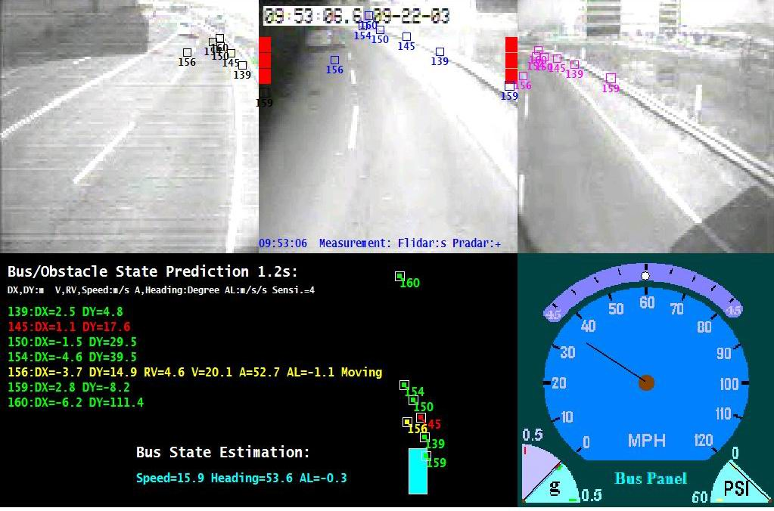
Figure 2 FCWS Warning scenario snap shot (without side recognition)

This warning was often considered a nuisance warning by drivers as they did not think that the hazard was in the path of the bus. To give another example, in a lane changing scenario, a parked car on the passenger side picked up by the frontal LIDAR may lead to a warning lit up of both the passenger side and the driver side DVI. These instances affect the credibility of the system from a driver point of view.

To address the problem, we set up a limit XM, if the lateral position of the obstacle (Dx) is greater than XM, only the passenger side DVI bar is lit up and the warning level is reduced to one if the obstacle is stationary. As shown in Figures 50 and 51, the driver might feel comfortable to the scenario below and easily figured that the guardrail is the warning trigger instead of the car on the left.
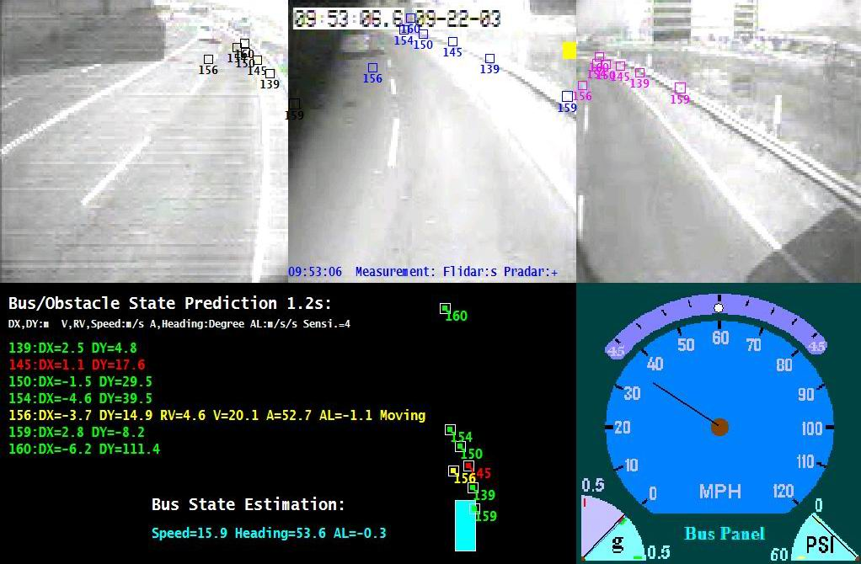
Figure 3 FCWS Warning scenario snap shot (with side recognition)

The strategy here is to turn the nuisance warnings to a friendly reminder as shown in Figure 52. Without any hardware cost, it only involves algorithm change and improves the perception of the system from the drivers point of view.
Stationary
Roadside
Targets/
Stopped
Targets
DVI
F-Lidar
Turn the distraction to a friendly reminder
(Algorithm change: no hardware cost)
The system better conforms to driver expectations
Stationary
Roadside
Targets:
Cars
Signs
……

DVI
F-Lidar
Dx
If Dx>XM
Set level=1
Right DVI only

Figure 4 FCWS Strategy of side recognition

Scenario parsing and target recognition

Following distance constraint
One dangerous scenario, which was not accounted for in previous versions of the algorithm, is a tailgate scenario. In this scenario if the bus gets too close to the subject vehicle, for example, two vehicles maintain constant speed at 40 miles per hour, the calculated required deceleration would be almost zero which indicates no hazard and the TTC would not fall within the dangerous zone either. However since the behavior of the driver of the subject vehicle is not completely predictable, there is a chance that the leading vehicle could suddenly decelerate and the bus driver could not have enough time to avoid a collision even if the correct warning is given. Therefore, a following distance constraint was added. As long as the following distance falls within the dangerous zone which is calculated based on the bus speed, the sensitivity level and relative speed of the subject vehicle, a warning will be issued to inform the driver of the potential danger of following too close.
If Dy<Y(V, dV, Sensi), issue a warning.
V; |Dx|<X
BUS
S.V.
|dV|<5m/s
Figure 5 Following distance constraint

The figure below depicts the scenario before and after. The upper part shows the scenario and the “before” situation. The relative velocity is only -0.4m/s and the calculated required deceleration does not fall within the dangerous zone. The DVI does not light up. However, as we can see, the predicted distance between these two vehicles in 1.2 seconds is dangerously close. After we added the following distance constraint, as shown in the lower part of the figure which is the “after” situation, the system is now going to trigger a warning as shown in red.

Figure 6 Following distance constraint (before and after)

Creeping warnings and target recognition
Another dangerous scenario which was suggested by the drivers and human factor researchers is the creeping warning. When the driver slowly follows a vehicle and then stops the bus, there is a chance that the driver gets distracted and his foot slips away from the brake pad therefore causing the bus to move slowly towards a leading vehicle without the driver’s awareness. Hence it is considered important to issue a warning under this circumstance. In order to do this, besides the range limit constraint been enforced when the bus speed is slow, the target recognition subroutine is added to tell if the target is a moving vehicle/object or not. As the tracking algorithm records the historical data of every track, a bit is set to tell the target information based on the pattern of its movement, the probability factor is increase to 0.9 when the target is recognized as a stopped vehicle.
DVI
F-Lidar
S.V
(stopped)

DVI
F-Lidar
Dx
S.V
(stopped)

BUS: V<15miles/hour
BUS
If |Dx|<X and TTC<T_limit
Increase
the probability factor to 0.9

Figure 7 The creeping warning

Using RADAR data
The warning algorithm is designed for LIDAR applications but could be used for RADAR data processing as well. To cope with different weather conditions, for example, snow, rain or fog, which LIDARs may have difficulty dealing with, two microwave RADARs are installed on the bus. When the windshield wiper is turned on we assume that the weather is getting bad, the system will automatically switch to RADAR sensors. An interface subroutine is developed for RADAR data conversion. The program will take RADAR data input and convert it to LIDAR data format. That is, converting from the target distance, azimuth angle measurement of RADARs to the lateral and longitudinal position measurement of the target, and then feed the data to the warning algorithm. Although the azimuth angle resolution of the RADAR is not as good as the LIDAR, the system is now capable of working under harsh weather conditions.

FCWS Suggestions
To suggest more improvements of the algorithms, these points should be emphasized:
- Transition of vehicle models - It was found that nonholonomic model is good for moving targets in terms of estimating yaw-rate and moving direction. However at lower speed, due to short displacement in processing time, it is hard to detect moving direction. In this case free moving model is better. The transition of vehicle models from higher speed to lower speed and vice versa needs to be improved.
- Scenario parsing - This has been a topic since the beginning of the project. However it is not well resolved yet. It needs to consider the relationship among all objects and subject vehicle and infrastructure. Current algorithm only detects straight road in-lane objects, and cannot avoid false warnings due to lack of lane information and driver status.
- Driver model - Driver’s field operational data were analyzed leading to the empirical threshold settings. However more complex driver model may help to tell whether driver is attentive. Collision warning is supposed to be issued only when driver is inattentive.
- Road geometry - Knowledge about road geometry and route could be used to eliminate false alarms triggered by road-side objects or out-of-lane objects, which could be obtained via on-vehicle detection or an AVL / map database and GPS.

FCWS Summary
The FCWS has been tested for the over two years time period and has been demonstrated in various occasions including 2003 National IVI event in Washington DC and General Managers’ meeting in Santa Monica. The system is able to significantly suppresses false positives (unwanted warnings) but keeps high sensitivity to frontal collision scenarios. The biggest challenge for transit collision warning systems is that buses usually serve in urban/suburban environment where too many objects (guard rails, traffic signs, parked cars, etc.) may trigger false alarms. Additionally, bus drivers are very well trained experienced drivers who are less likely to run into accidents thus are very cautious with collision warnings. It is therefore a difficult problem to detect real imminent crashes and give drivers timely warnings while suppressing excessive false alarms. The FCWS algorithm developed under this program has addressed this problem to a great extent. It is also worth noting that the target tracking and state estimation algorithms can be used for general applications. In the Intersection Collision Warning Program, the algorithm has been used for LTAP/OD (Left Turn Across Path/Opposite Direction) collision warning scenarios, without major changes.

SCWS Warning algorithm
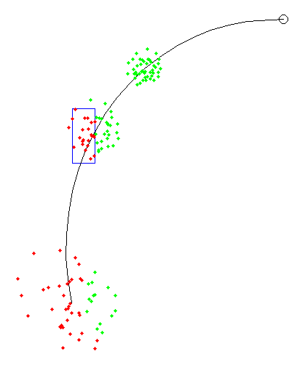
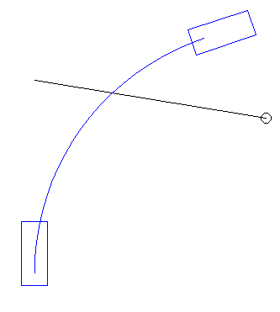
The sensors and modules described in the previous sections provide the dynamic quantities of the bus and the observed objects and additional information about the environment. These measurements are combined with preloaded information to analyze the threat level of the situation. In the warning algorithm the system calculates the probability that a collision will occur within the next five seconds. If the probability of collision exceeds a certain threshold, an appropriate warning is displayed to the driver. In the warning algorithm for the SCWS we have two warning levels, “alert” and “imminent warning”. An “alert” is displayed to the driver when the situation is somewhat dangerous, an “imminent warning” is given if the situation is dangerous enough to inform the driver in an intrusive way. A detailed description of the algorithm can be found in . A short example is illustrated here.
World coordinates
Fixed bus frame
bus
object
bus
object
2s
3s
5s

Figure 8 The trajectories of a bus and an object shown in the world coordinate frame (left) and the fixed bus frame (right). In the right figure possible positions of the object are shown for the times 2, 3, and 5 seconds in the future. Green indicates that no collision has happened; red indicates that a collision has happened.
In Figure 8 a bus turns right while an object crosses its path from right to left (World). The sensors measure the speed and turn rate of the bus and the location and velocity of the object. The algorithm calculates possible paths of the object with respect to the bus (Fixed bus). In this calculation the paths are distributed according to the uncertainties of the measured dynamic quantities as well as according to models of driver and object behavior. Next, the system determines for times up to 5 seconds into the future which fraction of these paths lead to a collision. In Figure 8 this is shown for the times 2, 3, and 5 seconds. This fraction is the probability of collision and is plotted versus time (Figure 9). This graph is divided into three areas, each a different level of threat severity. The area with the severest level that the probability of collision curve reaches determines the warning issued to the driver.

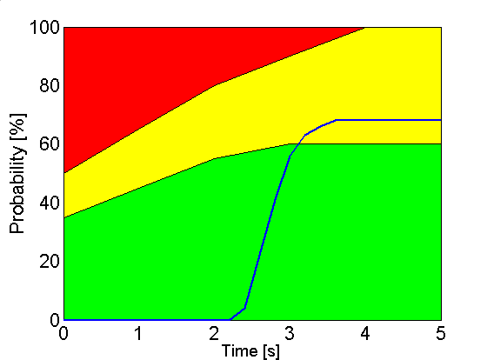
Imminent
Warning
Alert
Aware
(tracking)
Figure 9 Probability of collision plotted versus time. The three regions correspond to the warning levels aware, alert, and imminent

The algorithm can also deal with environmental information. For example, if the object is a pedestrian and is on the sidewalk, there is an enhanced likelihood that the pedestrian will stay on the sidewalk. This is addressed by giving the paths leaving the sidewalk a lower weight.

Under-bus warning
Another important alarm is the under-bus warning. It is issued when a person falls and has the potential of sliding under the bus. We detect these situations by observing pedestrians who disappear while being close to the bus. The challenge in this algorithm is to distinguish people who disappear through falling and people who only seem to disappear, but in fact either merged with another object or are occluded by other objects. We have not yet completely finalized this algorithm.

Notification that a collision occurred
Sometimes the bus can collide with an object, especially a person, and the driver does not notice it. It is therefore important to notify the driver if a collision has occurred. A notification will be triggered if the probability of collision is 100% for times up to 1 second.

Frequency of alarms
We analyzed 5 hours of data to see how many alarms we will get. The following table lists the number of alarms according to side (left or right), severity (alert or imminent warning), and sensitivity level of the warning algorithm:

sensitivity | low | medium | high
left alert | 62 | 75 | 91
left imminent warning | 15 | 21 | 27
right alert | 17 | 24 | 40
right imminent warning | 2 | 2 | 4
Table 5. SCWS Alarm Frequency

These alarms contain true and false positive alarms. The subsection titled False Alarms in section Testing and Data Analyses deals in more detail with false alarms. Taking the numbers for the medium sensitivity, then we will get an alert once every three minutes and an imminent warning once every 13 minutes.

Another interesting measure is how long the alarms will last. Following table lists the average duration of the alarms when the high sensitivity was set:

 | cycles | time [s]
Left alert | 30.6 | 0.41
Left imminent warning | 24.4 | 0.32
right alert | 26.8 | 0.36
right imminent warning | 7.8 | 0.1
Table 6. SCWS Alarm Duration

About 80 % of the alerts last less than 0.5 seconds and most are 0.1 and 0.2 seconds long (see figure below).
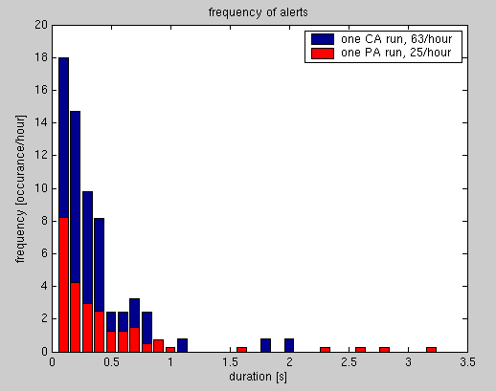
Figure 10 - Duration and frequency of SCWS warnings

At first glance, this seems like warnings occur way too often and certainly more side warnings occur than frontal one. It should be pointed out that the frontal and side CWS systems serve different purposes. The frontal alerts are used as an aid for distracted driver, while the side alerts provide the transit operator with additional information. As shown above, most of the warnings are very short and transit operators have not complained about too many warnings. This was also seen by a researcher riding on the bus who also did not feel that there are too many warnings.

False Alarms
A few things need to be said about false alarms. False alarms can be caused by system failure, i.e. the system did not perform as expected. It is also possible that the system performs as it should, but the driver considers the alarm a nuisance. In this section we will mostly discuss the first kind; we will describe system failures we observed. The second kind is mostly part of testing the system with drivers, but some of these nuisance alarms are due to the inability of the system to recognize certain situations.

Since there are only a few positive alarms, it is relatively easy to test for false positives. To find the rate of false negative alarms on the other hand is very tedious.

In the following sections we will discuss the false alarms mostly qualitatively. Some of the sources of false alarms have since been eliminated, but we have just begun to collect new data.

Sources of false positive alarms

Incorrect velocity estimates
In section Error: Reference source not found Error: Reference source not found we found that the error in the velocity of objects can be described by a Gaussian distribution plus some outliers. The Gaussian error will cause some velocities to be a little bit off, but that can increase the probability of collision by enough to trigger a higher warning level. These false alarms are not necessarily a nuisance to the driver since the situations are in fact somewhat dangerous, just not as dangerous as the system calculates it to be. We have found that when the driver can understand the basis for why the warning was triggered, he will not perceive the warning as false, even if it is not as dangerous as the system displays. Quite a different matter is the case of the outliers. Here warnings might be issued for objects which pose no danger at all.

Since most of the false positive alarms in this category are caused by small errors in the velocity and only a very few are caused by the outliers, the transit operator is not overwhelmed by nuisance warnings that they don’t understand.

Error in location
The distance accuracy of the laser scanner is very good (see previous section on the SICK laser scanner) and is very unlikely to have a false alarm due to an error in location. However, when the system determines if an object is on or off the curb, a small error in the position can have a large effect, if the position is very close to the curb. Also in this case, we need a second position measurement, namely the position of the curb. The position measurement of the curb is more prone to errors than position measurements of objects.

Vegetation
Vegetation poses a challenge in many ways. Returns from a bush can be very inconsistent and therefore DATMO might attribute false location and/or velocities to such objects.

It also sometime happens that a small amount of vegetation (e.g. some grass) is very close to the bus and triggers an imminent warning. The bus driver usually will not consider some grass as any threat at all and therefore will consider this warning as a nuisance or malfunction of the system.

Ground return
Usually the objects seen by the laser scanner are above the ground, like people, cars, mailboxes, walls, etc. But sometimes the scanner can see the ground itself, either because the ground is sloped or because the scanner is tilted. If the ground is seen in the path of the bus, a warning might be issued. These false positive alarms from ground returns have in the past been the biggest source of false positives. We discovered that the bus itself was titled by a few degrees towards the left side which resulted in many ground returns on the left. The problem has recently been fixed and we hope that this source of false alarms has been greatly reduced.

Sensor failure
During the operation of the side collision warning system we had several sensor failures. Cameras got misaligned, the camera of the laser line striper stopped working because water leaked into it, and the laser scanner didn’t fully extend. Each of these failures can cause false positive alarms.

One of the cameras and the laser line striper are used to determine the curb position. If they do not work properly, the curb position can not be determined and nuisance alarms can not be reduced.

When the laser scanner does not fully extend, it sees the frame of the bus. This return will be interpreted as an object very close to the bus and a warning will be issued. Furthermore, the scanner is misaligned and objects appear at incorrect positions which can lead to false alarms.

Statistics of false positive alarms
We looked at all the alarms with the high sensitive setting mentioned in section 1.2.3 Frequency of alarms and tabulated them according to following categories: True positives, velocity might be somewhat off, velocity is an outlier, vegetation, and ground return. The category “velocity might be somewhat off” is a judgment call because we do not have an independent measurement of the velocity. We watch the video or the raw laser scanner data to judge if the velocity given by DATMO is reasonable. It is also not always obvious, if there would have been the same alarm or not if DATMO would have given the correct velocity.

 | true positive |  | velocity off |  | velocity outlier |  | vegetation |  | ground return
left alert | 40 | 44% | 15 | 16% | 5 | 5% | 0 | 0% | 31 | 34%
left imminent warning | 1 | 4% | 7 | 26% | 3 | 11% | 0 | 0% | 16 | 59%
right alert | 25 | 63% | 3 | 8% | 7 | 18% | 4 | 10% | 1 | 3%
right imminent warning | 1 | 25% | 2 | 50% | 1 | 25% | 0 | 0% | 0 | 0%
total | 67 | 41% | 27 | 17% | 16 | 10% | 4 | 2% | 48 | 30%

This data set was taken before we leveled the bus and it therefore has a great number of false positives caused by ground returns (30% of total). We also analyzed a later run, after the bus was leveled, and we did not see any more problems with the ground return. However, we experienced a failure of the laser scanner in that later run. The sensor did not always extend fully. The data was therefore corrupted and resulted in 120 (!) imminent warnings on the right side within a 5 hour period.

In summary one can say that the majority of the positive alarms are understandable by the transit operator. Many of the false positives are not very seriously false (velocity off), and the driver might not even consider them nuisances. When a large amount of false positives are seen by the operator, the problem can be traced back to sensor failures (e.g. laser scanner not level or not fully extended). The number of serious false positives which will be present even if all the sensors work correctly is small and due primarily to velocity outliers which represent about 10% of warning generated.

Sources of false negative alarms
Many of the reasons for false positive alarms can also cause false negatives. Specifically these are errors in velocity and location. The ratios (false positives)/(correct negatives) and (false negative)/(correct positives) due to these errors should be comparable. But since there are much less correct positives than correct negatives, one should expect much less false negatives than false positives due to these errors.

Sensor failure
If the laser scanner or the vehicle state module stops to function, then the system will not be able to issue any warnings. If the laser line striper fails the system will not have the ability to reduce nuisance alarms by considering the relation of objects to the curb.

Reduction of nuisance alarms through curb detection
The system tries to reduce the number of nuisance alarms by taking into account the relation of the object to the curb when the probability of collision is calculated. Details of the method can be found in the paper “A 2D Collision Warning Framework based on a Monte Carlo Approach”. We found that there are 30% less alerts when using curb information. For a few scenarios the warning severity increased, where vegetation reached over the curb and therefore its position was considered off the curb. The system worked as expected, but the driver might consider an imminent warning for an overhanging bush as a nuisance alarm.

System Faults and Recovery

SCWS System faults and recovery
The SCWS system has several layers of fault detection and recovery.

- First, any process which dies is restarted within 5 seconds.

- There are processes which are labeled "vital." If a vital process dies then the whole SCWS system will be gracefully shut down and restarted. Vital processes include data logging processes, as if we lose a data logging process then the data continuity could be compromised.

- The central system manager checks to see if both the left and right processors are still up. If it loses contact with either process it shuts down the SCWS system, waits until contact is reestablished, and then restarts the SCWS system.

- All processes in the system have a "heartbeat" which is propagated via the shared memory system. These heartbeats contain the time of the last run and some simple debugging messages. The central system manager monitors these heartbeats, and if it does not see a heartbeat change for a process in 30 seconds, it shuts down and restarts the SCWS system, as a "hung" process can have serious repercussions on the proper operation of the system.

- The heartbeat information can be displayed in a graphical user interface for debugging as shown in Figure 11, but the same information is also periodically saved to disk for later debugging Just as each line of the GUI indicates the status of a running process to give a system overview at a glance, the log file contains all the necessary information to judge the system's health remotely.

- The system sends e-mail via a cell modem to the researchers when it starts and finishes and researchers can remotely check the heartbeat log to make sure the system is functioning properly.

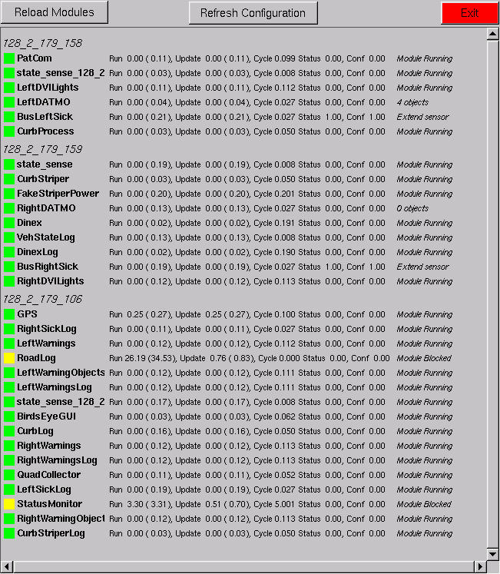
Figure 11 SCWS Status Debugging GUI

FCWS System faults and recovery
A fault is an unexpected change in a system which tends to degrade overall system performance. Early detection of faults in the FCWS can be communicated to the driver in which case the driver may solely rely upon their own judgment when driving and report the malfunction to an engineer as soon as possible.

A fault can be categorized into different classes from different perspectives, for example faults can be categorized into either static faults or dynamic faults, or software faults or hardware faults. For the FCWS from a system input/output perspective, faults are categorized into four main groupings: power faults, sensor data faults, DVI faults and hard disk faults.

Many approaches have been proposed for fault detection, isolation and system recovery. For example, two speed sensors might be installed to measure the vehicle speed, so that if one of them is detected malfunctioning, the data of that sensor will not be used. However, the extra cost incurred must be considered for the hardware redundancy. The approaches proposed here are mainly traditional approaches, which require no or little additional hardware cost, and are model-based approaches, which make use of mathematical models of the system.

When a fault occurs, some actions need be taken based on the severity of the fault. For example, if a power fault is detected and confirmed, a warning message (DVI fast flashing) might be displayed for a couple of seconds, the fault will be recorded in a disk file, and after the warning is given the system will be automatically shut down or switched to a debugging mode until the problem is solved.

FCWS Faults categorization
Figure 12 FCWS Fault categorization

To categorize faults of the FCWS, the first thing we need to know is how the system works. Basically, the FCWS reads the sensor data from the database and processes the data to issue warnings (displayed on the DVI), at the same time, sensor data and other information (including fault records) are recorded on the hard disk. A fault may occur in a sensor itself, in the signal driver or filter, or in the software processing. Regardless of where it happens, or what type of fault it is (mechanical or electrical), there will be a fault of the sensor data in the database. Hence from the system input/output prospective, for the FCWS, there are four main fault categories: power faults, sensor data faults, DVI faults and engineering computer faults.

FCWS Fault detection

Power faults
An open circuit or a short circuit may occur in power transmission lines. The use of Kalman filter for power system state estimation was introduced in 1986. For the FCWS, it is possible to utilize Kalman filter to detect power faults. Additional A/D channels are needed to monitor the power supply. Thus the state space models for the voltages and currents, the noise statistics could be investigated. Further investigation and research are still needed for power fault detection.

Key sensors (for vehicle states and target detection/tracking)
Speed sensors, steering angle sensor/gyro/accelerometers are used for the estimation of vehicle states. LIDARs provide information on target detection/tracking. The measurements of these sensors are essential for vehicle/targets state estimation and prediction. Faults of these key sensors could be circuitry fault, mechanical fault or software fault, which result in corrupted sensor data. The fault could be detected and isolated using the following approaches.

Traditional fault detection approaches

Installation of multiple sensors (hardware redundancy)
Additional sensors may be installed to compare the measurements of the speed, the steering angle, etc. There are a lot of algorithms based on hardware redundancy, however, the extra cost must be considered.

Limit checking
All measurements could be checked based on a pre-set limit. If the measurement exceeds the limit a fault is indicated. For example, the LIDAR has its own detection range and azimuth coverage. If the LIDAR data exceeds the limit, the malfunction will be recorded. This approach is recommended.

Fault dictionary approach
Each type of fault has its own characteristic. A fault dictionary contains all known “characteristics”. We will know if a fault presents by comparing the system behavior with repertoires of faults in the dictionary. For this approach the more we know about the outcome of a fault, the more efficient our fault detection will be. For example, when the string-pot is broken, the steering angle data becomes a constant value even when the bus turns. This pattern could be saved in the dictionary and the fault could be easily detected. This approach is recommended.

Model based approaches-Basic principle of Kalman residual test
In the FCWS, this method is recommended as it requires no additional hardware, and is easy to implement and capable of detecting and isolating (indicating which sensor data has problems) most sensor data faults. Utilizing the Kalman filtering method, there are two options: Kalman residual test or ($χ^{2}$) Chi-square test. After investigations and simulations, the first method is found to be both an effective and efficient way to detect some of the key sensor faults.

If the Kalman filter is correctly modeled, the innovations, which are the differences between what comes out of the sensor and what is expected, would be zero mean white noise and its autocorrelation function would be zeros except at zero delay.

Assuming system model:
$$\begin{aligned}\left\{X_{k}=φ_{k/k−1}X_{k−1}+W_{k−1} | \right.\end{aligned}$$
where $X_{k}$ is an n dimensional system state vector, $φ_{k/k−1}$ is an n*n system matrix, $W_{k}$ and $V_{k}$ are independent Gaussian white noise vectors with n dimension and m dimension respectively, $Z_{k}$ is an m dimensional measurement vector. $H_{k}$ is an m*n system measurement matrix.
$r_{k}=Z_{k}−H_{k}{\hat{X}}_{k/k−1}$ where ${\hat{X}}_{k/k−1}=φ_{k/k−1}{\hat{X}}_{k−1}$.
$r_{k}$ is m dimensional zero mean white Gaussian noise with $E(r_{k})=0$, $E(r_{k}r_{k}^{T})=A_{k}=H_{k}P_{k/k−1}H_{k}^{T}+R_{k}$ when there are no sensor failures.

When there are sensor failures, it will not be zero mean white noise.
$H_{0}:$ No fault detected:$E(r_{k})=0$ $E(r_{k}r_{k}^{T})=A_{k}$
$H_{1}:$ Sensor failure:$E(r_{k})=μ$ $E[(r_{k}−μ)(r_{k}−μ)^{T}]=A_{k}$
$r_{k}$ is a Gaussian vector. Therefore, to detect sensor failures it is convenient to use the log-likelihood $r_{k}^{T}A_{k}^{−1}r_{k}$ which is a Chi-square statistic (with m degrees of freedom). The threshold should be determined according to our needs.

An upper threshold and lower threshold for the absolute value of the residual and the trace of the covariance matrix of the Kalman residual are used for fault detection. This is based on the fact that the estimation is not perfect resulting that the Kalman residual can not be too small all the time, but it can not exceed a certain limit either otherwise we would have used other gain factors in the Kalman filter.

Abs (Residual)
Trace of the
Covariance matrix
Lower-Threshold
Upper-Threshold
0

The following three figures show the raw speed data, Kalman filter residual, trace of the covariance matrix of the residual and its lower threshold when the speed data is corrupted starting from the 100th sampling (This is a simulation of a fault. Speed: m/s). Once the trace of the covariance matrix of the Kalman residual is below the lower threshold, the event will be recorded on the hard disk.
Errors start here
Figure 13 Speed raw data

Time
Figure 14 Kalman filter residual
Lower Threshold
Time
Figure 15 Trace of the covariance matrix

The following three figures show the raw speed data, Kalman filter residual, trace of the covariance matrix of the residual and the upper threshold when the speed data was interfered by an additional -10db white Gaussian noise starting from the 100th sampling. Once the trace of the covariance matrix of the Kalman residual is higher than the upper threshold, the event will be recorded on the hard disk.
-10db white Gaussian noise
Errors start here
Figure 16 Speed raw data

Figure 17 Kalman filter residual

Upper Threshold
Figure 18 Trace of the covariance matrix

DVI faults
Essentially, the DVI is part of the system circuitry. Circuitry faults include stuck faults, bridge faults, short circuits, open circuits, etc.

One simple way of DVI fault detection is to let it flash at certain frequency for a few seconds when the engine is ignited. The driver could easily find any broken LED. In addition if the DVI is broken when the bus is in operation, the driver should identify what is not working and sometime later report it to an engineer.

Despite the off-line fault detection mentioned above, there is an on-line approach as well. At present, DVI could be regarded as “write only memory cells”, which can only be written but can not be read or checked by the engineering computer. If additional A/D channels are available, it will be possible to monitor the DVI in real time and therefore the system will be capable of isolating the broken LED/circuitry. For example, if an open circuit of a LED occurs, when we write a “Low” to the digital output, and then read the input , a +5V voltage instead of a +1V voltage will be read and the open circuit fault will be detected at once.
Figure 19 Detect DVI fault

Engineering computer / Removable hard disk faults
The fault of the engineering computer can be detected by its self-testing program. An additional program for the removable hard disk could be added. During the system initialization, a specific type of data could be written to the removable hard disk, and then the data will be read and verified to see if the disk is properly locked so that the recording can proceed as expected.

Detection scheme
To avoid false alarms, except for power faults, the fault detection should keep monitoring the system for a while (half to 1 minute) before giving an error code which confirms the fault. But all abnormal events will be recorded.
Errors
Detected
Keep
Monitoring
Errors
Recorded
Confirmed
Give an
Error code
Working
Figure 20 Detection scheme

FCWS Faults reporting and system recovery

Power faults
A power fault could be devastating, a fast flashing of the DVI will give an urgent warning telling the driver a severe fault has just occurred and the system will be shut down soon after. The fault should be recorded in a file for later off-line investigation. We might use a power relay or modify the current power relay to build a soft-switch that could automatically turn the system off after the urgent warning is given. Any faults regarding the power will need further investigation by an engineer.

Sensor data faults
If a key sensor data fault is detected and confirmed, the DVI will be disabled and an error code will be displayed on the DVI bar, indicating which sensor data may have problems. For example, if there is something wrong with the speed sensor data, the DVI will not display warnings issued by the collision warning algorithm, instead, it will turn on the lowest segment of the DVI bar to inform the driver of the malfunction (Assuming the DVI is working properly). All faults should be recorded in a file for later off-line investigation. Fault detection could locate which sensor data is corrupted, and record the fault property. By analyzing fault record at the receiving end, a good guess could be made about whether it is the mechanical fault or the circuitry fault, but repairing it will still need further investigation by an engineer.

DVI faults
If any part of the DVI is out of order, the driver himself could be aware of it quite soon. The rest of the LED’s (which still work) may flash slowly for a few minutes to warn the driver that the DVI is out of order. The fault should be recorded in the file for further investigation. Although fault detection could locate the broken LED, it is not necessarily the LED that is broken, for example, the digital output line might be broken. Therefore repairing it will need further investigation by an engineer.

Engineering computer / Removable hard disk faults
The engineering computer has its own self testing program. An additional self testing program will be added to check if the hard disk works properly. If there is a fault, a warning message will be given (an error code will be displayed on the DVI) and the driver may report the problem to an engineer. If it is not locked, then lock it. If the disk is broken, then replace a new one. If the disks are full, the new pc104 system will automatically stop recording new data and record the disk full message.

FCWS Summary
The summary of the system fault and recovery are shown below. Four categories of system fault: power fault, key sensor fault, DVI fault, engineering computer fault are described and its detection algorithm and detection strategy are proposed and system fault reporting and system recovery methods are summarized.
Figure 21 FCWS Fault detection architecture

FCWS Simulation Playback Tools
To aid in the analysis of the data collected from the buses and to test out alternative warning algorithms and sensitivity levels three tools have been developed. The tools were developed in an iterative fashion with the first tool being developed in May 2000. The three tools are:

- The Data playback tool (developed in 2000)
- The Simulator tool (this tool can work in conjunction with an updated data playback tool) (developed in 2003)
- The Data marking tool (this tool is based on the data playback tool with additional functionality (developed in 2003)

Both the simulator tool and the data marking tools allow the user to post-process data off-line. The tools are used to help us analyze the warning scenarios by recreating detailed state information from any video clips that are of interest. (For example, to figure out if a warning was triggered appropriately). The purpose of the tools can be described as:
- to run simulations of potential changes/improvements of the algorithm
- to analyze/set system parameters, such as sensitivity levels

The three tools are described in greater detail below.

The FCWS Data playback tool
The basic data playback tool is a Windows™ based application and is designed so that a user can watch a clip of video (from 4 different views) while simultaneously displaying bus state information such as speed, acceleration, brake pressure, front wheel angle and GPS location. As this tool has been superseded by the Simulator tool and the data marking tool its function and improvements are discussed in the next two sections.

The FCWS Simulator Tool
The simulator tool is programmed in C and based on the FCWS warning algorithm program that is running on the FCWS and ICWS buses. The main difference is that instead of processing data from the database in real time, the simulator processes the data off-line using the interface subroutine, which converts the sensor files to a virtual database. Therefore, the simulator will have all the processing details and intermediate variables that are not recorded in real time processing.
FCWS Engineering Computer
(Collision warning algorithm)
Sensor data
Sensor data
(Saved in hard disk)

Warning
Messages

DVI
(Interface program)

Any PC
(Simulator program)

Algorithm changes/ Parameter changes

Warning Messages

Saved in files
Variables

Figure 22 The simulation tool

An updated version of the playback tool utilizing the simulation tool is developed to help us comprehensively study a warning scenario. The display is divided into 5 sub-windows. Video from each of the three cameras is displayed in one sub-window. It projects the RADAR and LIDAR targets into the video frames, using simple visual marks to indicate which objects in the frames have been detected by which RADAR or LIDAR. The tool can decode and play back MPEG movies in Windows™. Two virtual DVI bars are added in the front-looking sub-window. Whenever there is a warning, it will be displayed accordingly as shown.
Host-bus measurements including bus speed, bus front wheel angle, bus accelerations and brake pressure, are displayed in the lower right sub-window simultaneously during video playback.

The right part of the lower left sub-window shows a birds eye view of the bus and targets around it. The larger blue box represents the bus, squares in green represent stationary/stopped obstacles in front of the bus, squares in yellow represent moving targets, squares in red represent warning trigger, which could be stationary, stopped or moving objects. The left part shows the prediction of target tracks (up-left) and the bus state estimation, which is in blue. They are all played simultaneously during video playback.

For example in Figure 23: at 10:21:18 there is a warning triggered by a subject vehicle (ID 185). Its raw data LIDAR measurement is mapped onto the front view window (small red circle), the text in red in the lower left window starting with the target ID-185 show the prediction of its relative position, speed of the target (relative to the bus). A birds-eye view of the scenario is shown in the big white circle with the same target ID 185.
Figure 23 The updated playback tool

This tool provides the data reviewer a complete view of all the data collected at the same time. With the help of the simulator mentioned above, it also provides processing details, which include the bus/target state estimation and prediction. Furthermore, the tool provides the ability to understand sensor behavior, traffic scenarios, and the characteristics of targets.

The FCWS Video Data Marking Tool
This tool can decode and play back MPEG movies in Windows™. The display is divided into 7 sub-windows as shown in Figure 24 Video from each of the four cameras is displayed in one sub-window. DVI bars have been superimposed onto the forward view to display any warnings as they occur. Also projected onto the camera views are visual marks to indicate objects detected by the RADAR and/or LIDAR. Host-bus measurements including bus speed, bus front wheel angle, bus accelerations and brake pressure, are displayed in the upper right sub-window simultaneously during video playback.
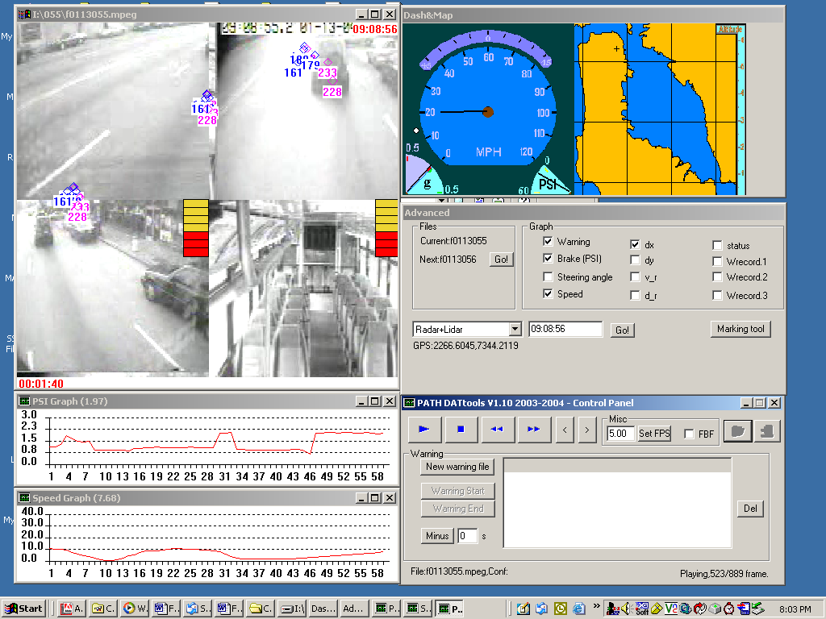
Figure 24 FCWS Video Data Marking Tool
DVI bar

Wheel angle
Graphs
Control panel
Graph selection
Marking tool selector
Video time

The sub-window titled advanced allows the user to jump to the next saved file and to graph various bus states. 12 different items of data can be graphed. The first four graphs; warning, brake, steering angle and speed can be plotted directly from the engineering data. The remaining eight graphs require that the data is first post-processed. The three selectable graphs titled Wrecord1, Wrecord2 and Wrecord3 allow the user to plot data that has been post-processed off-line to determine what effect proposed changes in the algorithm or sensitivity levels would have. The graphs appear beneath the video sub-window and plot data for 1-minute intervals simultaneously as the video plays. The graphs are useful as they allow the user to watch for trends in the drivers’ behavior.

The sub-window titled Control Panel allows the user the following functionality:
- an option to set the frame rate (on a per second basis)
- an option to view the video frame by frame (i.e., each time the user hits play the video will advance one frame)
- a play/pause button
- a stop button
- fast-forward and rewind
- a tool to mark the beginning and end of all the warnings viewed by a user. Once a number of warnings have had their start and end times marked the user can open the “mark” file and select play to watch all of the marked sections.

The final sub-window is the mark tool sub-window as seen in Figure 25 , which is accessed by selecting the Marking Tool button on the Advanced sub-window. This tool allows the user to “mark” the data so that by selecting from any of the 5 rows of 6 buttons (30 buttons in total) when the video is stopped a new file is created that has the file name, the time, and which buttons were selected. The names of the buttons are changeable, the current pre-set set are:

Bus speed (in mph)
- 0−10
- 11−30
- 31−40
- 41+

Steer behavior
- yes prior to receiving a warning
- yes prior to and post receiving a warning
- yes post receiving a warning
- no steer around the time of a warning

Brake behavior
- yes prior to receiving a warning
- yes prior to and post receiving a warning
- yes post receiving a warning
- no brake around the time of a warning

Warning reason
- pulling into a bus stop
- a decelerating or stopped lead vehicle
- another vehicle cutting in from the left
- another vehicle cutting in from the right
- the road curving, trees and/or guardrails
- poles and/or signs

Driver comment (obtained by human factors researcher riding on the bus)
- The driver liked (thought the warning was appropriate)
- The driver did not know what the warning was for
- The driver made no comment
- The driver expected the warning
- The driver thought that the warning was late or wanted a warning

Using the above selections it is possible to synchronize driver feedback with video and engineering data to gain a more comprehensive understanding of patterns of drivers opinions of individual warnings. It is also possible to determine scenarios where drivers like and dislike warnings as well as take a look at scenarios where the driver wanted/expected a warning and was not given one.

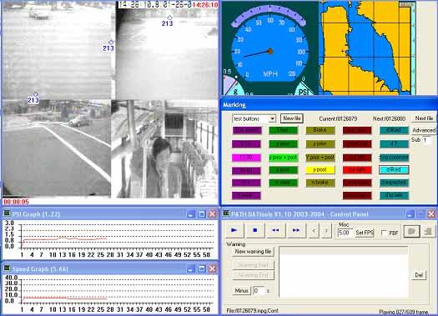
Marking tool selection buttons
Figure 25 Mark tool sub-window
The simulator and the data-marking tool allow the user to study various variable of interest in an integrated way, providing the data reviewer with such a complete set of data collected at the same time

FCWS Analysis Procedure
A standard procedure is proposed for comprehensive analysis of four warning scenarios (True, Miss, False, and Nuisance warning). It includes basic technical analysis, warning timing/consistency analysis and driver feedback analysis. The basic technical analysis is to recreate the warning scenario in detail. By watching the video clip and analyzing the variables mentioned below, we try to evaluate the accuracy, smoothness and noise characteristic of the measurement, estimation and prediction of the host bus and targets (Bus track and target tracks) and try to improve the system in every aspect. The ultimate goal of the warning timing/consistency analysis is to achieve good warning timing and a high level of system consistency. For example, we would examine if a true warning is issued too early or too late from both the technical point of view and the driver’s point of view. If there is inconsistency, it could result from either threat assessment or the delay factors listed in the table, which would then be a factor for further testing and investigating. Furthermore, the driver’s feedback is very important for us to adjust, evaluate and improve our system.

True/Miss/False/Nuisance/ Warning Scenario Analysis
Basic technical variables |  |  | Timing/Consistency and Feedbacks
Measurement | Estimation | Prediction | From data | From drivers
Road Geometry | N/A | N/A | Brake Pressure | Comments for this particular warning
Weather(wiper) | N/A | N/A | Bus Heading | Comments for this particular warning
Bus headway speed and yaw rate |  |  | Throttle Position | Comments for this particular warning
Target lateral and longitudinal position and speed  (relative to the bus) |  |  | Sensor Delay  Processing Delay  Driver Reaction time | Suggestions for similar warnings of this kind:  Warning timing  Warning level and  Duration, etc.
N/A | Bus/Target location, heading, headway acceleration, angle acceleration, height |  | Compensation/  Prediction time
N/A | N/A | ARQ, TTC,  Inv. TTC, etc | Sensitivity level  Warning duration  Starting/End time  Warning level
Table 7. Standard analysis procedure and main variables

SCWS Data replay tools
The data collected by the SCWS is stored in multiple different files. Each file represents a single stream of information. These include:
- Vehicle State
- Raw range data from line scanners and curb sensors
- Tracked and classified object information
- Tracked and predicted curb information
- Warning levels sent to the DVI
- Auxiliary bus information, such as doors open/closed and signal status
- DVI information, such as which lights have been lit and which buttons have been pressed
- MPEG movies derived from the cameras pointed forward and backwards on each side of the vehicle.

Each data stream has the same underlying format created by the same underlying tools: A set of arbitrary data records where each record is not just tagged with the time of collection, but is indexed by it. The distinction between tagging and indexing by time is important: If each record was simply tagged with time we would have to search through an entire file in order to find a particular record at a particular time. Instead, we maintain a time based index for each data file that is loaded into memory at startup. When we want data from a particular time, we look up in the time index where in the data file the necessary record is, and retrieve that record from the file. The cost, of course, is in the up-front time and memory needed to load in the file index, but we find that modern systems can read in the index of a file with thousands of entries collected over hours in seconds without taxing the system's memory requirements.

The data replay system takes full advantage of the common, time-based data access and replay tools. At any given time there is a synthetic "replay time" estimate, i.e., the current time of the data we should be showing to the user. For each data stream that is being displayed, we simply use the index to look up and obtain the appropriate data for the current replay time. Not all data will be available at every instance in time, so when necessary we use common tools for shifting the data display by the appropriate vehicle motion. For example, if the most appropriate piece of object tracking information is 100 milliseconds before the current replay time, we can adjust the display of the object track display to account for the motion of the vehicle by shifting the display of all the tracked objects by the distance and direction that the vehicle has traveled in the last 100 milliseconds.

Thus, the temporal and spatial synchronization of the many disparate data streams is achieved in a straightforward manner by the replay system. In addition, the approach to data replay lets us provide the users with movie player-like controls, whereby they can vary the flow of time, pausing, fast forwarding, slowing down, and even moving arbitrarily around in the data using a scroll bar. To the end user, it all looks like one unified data source that can be accessed like a single movie. For displaying data, we have taken as our inspiration web browsers, which provide a framework of common tools and constraints for displaying fairly arbitrary information with plug-ins.

In our data replay system we provide two main output modalities: The 2D OpenGL-based overhead view of the data and the data overlaid on the video we store from the forward and rear looking cameras.

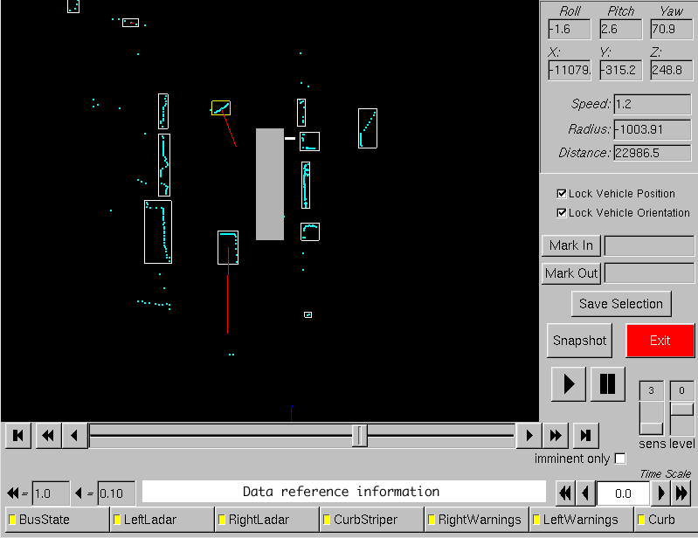
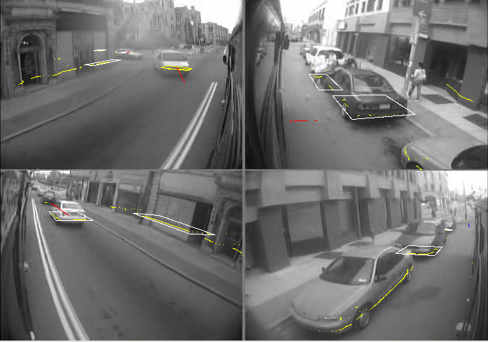
Figure 26 Example 1 of Overhead View and Overlaid data on video
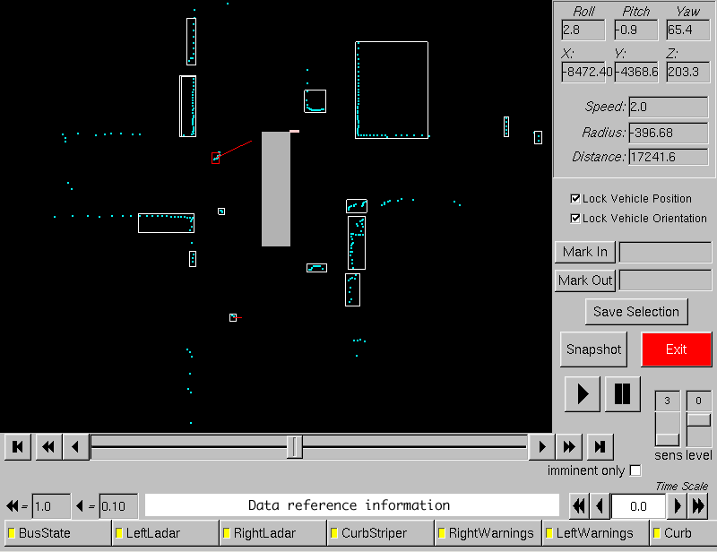
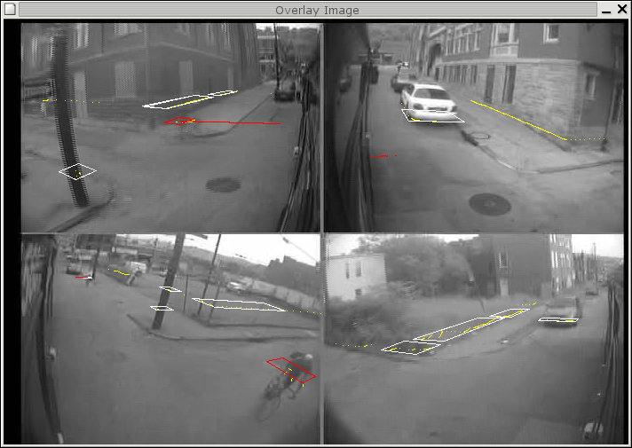
Figure 27 Example 2 with bicycle

We provide a common framework to develop fairly arbitrary plug-ins for displaying data in these two output modalities. Each plug-in can implement methods for displaying overhead data or overlay data. The user configures the system to choose and configure a palette of these plug-ins for displaying the various data streams, and can select in real time whether to hide or show any individual data stream display. This allows us to have an almost arbitrarily expandable display system, where we can introduce new data modalities and manners of displaying data in an almost arbitrary manner. Thus we can have the display system easily evolve in the future while still being able to display today's data.

The data replay system can be used to explore our raw, collected data, but it can also be used in concert with analysis tools. For example, the user can select beginning and ending points in time and create a new data set just containing data in this time slice. This is not simply one file, but represents the appropriate sub-set of every data stream in the display palette. The smaller data sets can be easier to share and analyze for development purposes. In addition, our off-line analysis tools can go through a data set and generate a list of "bookmarks" which can be loaded into the replay tool. The user can then instantly navigate to these bookmarks to examine the parts of the data set that the analysis tools have marked as interesting.

[?] Mertz, C. “A 2D collision warning framework based on a Monte Carlo approach,” Proceedings of ITS America's 14th Annual Meeting and Exposition. April 2004.
Mertz, C. A 2D Collision Warning Framework based on a Monte Carlo Approach.

