REPORT DOCUMENTATION PAGE |  |  |  | Form Approved  OMB No. 0704-0188
Public reporting burden for this collection of information is estimated to average 1 hour per response, including the time for reviewing instructions, searching existing data sources, gathering and maintaining the data needed, and completing and reviewing the collection of information. Send comments regarding this burden estimate or any other aspect of this collection of information, including suggestions for reducing this burden, to Washington Headquarters Services, Directorate for Information Operations and Reports, 1215 Jefferson Davis Highway, Suite 1204, Arlington, VA 22202-4302, and to the Office of Management and Budget, Paperwork Reduction Project (0704-0188), Washington, DC 20503.
1. AGENCY USE ONLY (Leave blank) |  | 2. REPORT DATE  December 2004 |  | 3. REPORT TYPE AND DATES COVERED  Final Research Report  April 2002 – March 2004
4. TITLE AND SUBTITLE  Integrated Collision Warning System Final Technical Report |  |  |  |  | 5. FUNDING NUMBERS  Federal ID # 250969449000
6. AUTHOR(S)
University of California PATH, Carnegie Mellon University Robotics Institute
7. PERFORMING ORGANIZATION NAME(S) AND ADDRESS(ES)  University of California PATH Carnegie Mellon University Robotics Institute  5000 Forbes Ave  Pittsburgh, PA 15213 |  |  |  |  | 8. PERFORMING ORGANIZATION REPORT NUMBER
9. SPONSORING/MONITORING AGENCY NAME(S) AND ADDRESS(ES)  U.S. Department of Transportation, Federal Transit Administration  400 Seventh Street, S. W.  Washington, D. C. 20590 |  |  |  |  | 10. SPONSORING/MONITORING  AGENCY REPORT NUMBER  FTA-PA-26-7006-04.1
11. SUPPLEMENTARY NOTES

12a. DISTRIBUTION/AVAILABILITY STATEMENT -- Available from the National Technical Information Service/NTIS, Springfield, Virginia, 22161. Phone 703.605.6000, Fax 703.605.6900, Email [orders@ntis.fedworld.gov] |  |  |  |  | 12b. DISTRIBUTION CODE
13. ABSTRACT (Maximum 200 words)

Based on the foundation of the frontal and side collision warning systems, the Frontal Collision Warning System (FCWS) and Side Collision Warning System (SCWS) teams joined efforts to improve the collision warning algorithms. The objective of the ICWS Program is to study how frontal and side collision warning system might interface with each other, and to develop prototype ICWS systems on two buses, one at Samtrans and the other at PAT. The prototype ICWS buses have been in revenue operation in the Bay
Area and Pittsburgh to collect field operational data and driver responses. The results of the ICWS design, build, and integration efforts as well as an analysis of early data collections to evolve the warning algorithms are documented in this final technical report. Evaluation and performance analysis are currently being finalized and will be issued in a separate report.

14. SUBJECT TERMS  ICWS, Collision Warning, Transit bus safety |  |  |  |  |  | 15. NUMBER OF PAGES
 |  |  |  |  |  | 16. PRICE CODE
17. SECURITY CLASSIFICATION  OF REPORT  Unclassified | 18. SECURITY CLASSIFICATION  OF THIS PAGE  Unclassified |  | 19. SECURITY CLASSIFICATION  OF ABSTRACT  Unclassified |  |  | 20. LIMITATION OF ABSTRACT
NSN 7540-01-280-5500 Standard Form 298 (Rev. 2-89)
Prescribed by ANSI Std. 239-18298-102
Integrated Collision Warning System
Final Technical Report (Final Draft)

December 2004

Prepared by:

Carnegie Mellon University  Robotics Institute  5000 Forbes Ave  Pittsburgh, PA 15213 | University of California at Berkeley  PATH Program  1357 South 46th Street  Richmond, CA 94804

Prepared for:

U.S. Department of Transportation
Federal Transit Administration
Washington, DC 20590

Report Number:
FTA-PA-26-7006-04.1
Disclaimer Notice

NOTICE

This document is disseminated under the sponsorship of the U.S. Department of Transportation in the interest of information exchange. The United States Government assumes no liability for its contents or use thereof.

The United States Government does not endorse products of manufacturers. Trade or manufacturers’ names appear herein solely because they are considered essential to the objective of this report.

List of Figures i
List of Tables i
Acknowledgements i
Executive Summary ii
1 Introduction 9
1.1. Background 9
1.2. Scope 10
1.2.1 Transit bus and object sensing 11
1.2.2 ICWS Algorithms - Signal and data processing 12
1.2.3 Driver-vehicle interface (DVI) 13
1.3. Organization of Content 14
2 Integrated Collision Warning System 15
2.1. System Description 15
2.2. Integrated ICWS 17
2.3. Sensing Needs 19
3 System Overview 20
3.1. FCWS System Overview 20
3.1.1 The goals of the FCWS 20
3.1.2 FCWS functions 20
3.1.3 FCWS system hardware 22
3.1.4 FCWS system algorithms 22
3.2. SCWS System Overview 27
3.2.1 SCWS data acquisition and communication 28
4 Hardware Development 30
4.1. FCWS Obstacle Detection Sensors 30
4.1.1 FCWS obstacle sensors 30
4.1.2 FCWS Host-bus sensors 33
4.1.3 FCWS Battery / Ignition monitoring and shutdown circuitry 34
4.2. SCWS Side Sensors 35
4.2.1 SCWS Laser Scanner 35
4.2.2 Laser scanner retraction system 36
4.3. SCWS Curb Detector 37
4.3.1 Sensor fusion of curb detector, bus state and video 41
4.4. PC-104 Platforms 47
4.4.1 SCWS PC-104 platforms 47
4.4.2 FCWS PC-104 platforms 48
4.5. Digital Video Recorder PC-104 Platforms 50
4.5.1 SCWS Digital Video Recorder PC-104 platform 50
4.5.2 FCWS Digital Video Recorder PC-104 platforms 51
4.5.3 SCWS timing synchronization 52
4.5.4 FCWS timing synchronization 53
4.5.5 FCWS / SCWS data synchronization 54
4.5.6 FCWS / SCWS data protocol 54
5 System Software 58
5.1. SCWS Software Architecture Development 58
5.1.1 Inter-process communications 58
5.1.2 Vehicle state propagation 60
5.1.3 Data flow 62
5.1.4 Integration with the FCWS 66
5.2. FCWS Software Introduction 66
5.2.1 FCWS Software structure 68
5.2.2 FCWS Initialization 69
5.2.3 FCWS Loop body 72
5.2.4 FCWS Synchronization 76
5.2.5 FCWS Program exit 76
6 Algorithm Development 77
6.1. Object Tracking Using Scanning Laser Rangefinders 77
6.1.1 Input / Output example 77
6.1.2 Sensor characteristics 78
6.1.3 The tracking problem 80
6.1.4 Tracker structure and algorithms 86
6.1.5 Evaluation 107
6.1.6 Summary 109
6.2. FCWS Warning Algorithm 109
6.2.1 FCWS Algorithm structure 111
6.2.2 FCWS Data structure 112
6.2.3 FCWS Tracking algorithm 118
6.2.4 FCWS Host vehicle state estimation 126
6.2.5 FCWS Motion decoupling 129
6.2.6 FCWS Target state estimation 131
6.2.7 FCWS Threat assessment 135
6.2.8 Warning signal generation 136
6.2.9 FCWS Further improvement 137
6.2.10 FCWS Suggestions 143
6.2.11 FCWS Summary 143
6.3. SCWS Warning algorithm 145
6.3.1 Under-bus warning 146
6.3.2 Notification that a collision occurred 146
6.3.3 Frequency of alarms 147
6.4. False Alarms 148
6.4.1 Sources of false positive alarms 149
6.4.2 Statistics of false positive alarms 151
6.4.3 Sources of false negative alarms 152
6.4.4 Reduction of nuisance alarms through curb detection 152
6.5. System Faults and Recovery 152
6.5.1 SCWS System faults and recovery 152
6.5.2 FCWS System faults and recovery 154
6.5.3 FCWS Faults categorization 155
6.5.4 FCWS Fault detection 156
6.5.5 FCWS Faults reporting and system recovery 164
6.5.6 FCWS Summary 165
6.6. FCWS Simulation Playback Tools 167
6.6.1 The FCWS Data playback tool 167
6.6.2 The FCWS Simulator Tool 168
6.6.3 The FCWS Video Data Marking Tool 170
6.6.4 FCWS Analysis Procedure 174
6.7. 175
6.8. SCWS Data replay tools 175
7 DVI Development 181
7.1. Background: Transit Collision Warning Nuances 181
7.2. Guiding Concepts 181
7.3. Warning Design 183
7.4. Interface Design and Placement 184
7.5. Examples of DVI Behavior 186
7.6. Plans for DVI Evaluation 190
8 Data Analysis and Evaluation 192
8.1. FCWS Data Analysis 192
8.1.1 FCWS Three-Step Quantitive Approach 193
8.1.2 FCWS Warning scenarios categorization 193
8.1.3 FCWS Summary 203
8.2. SCWS Data Analysis 203
8.2.1 Driver behavior analysis 203
8.2.2 System debugging and development 208
9 Calibration and Testing 209
9.1. SICK Laser Scanner 209
9.1.1 SICK resolution and accuracy 209
9.1.2 Definition of terms 209
9.1.3 Error characterization 210
9.1.4 Experimental confirmation of resolution 210
9.1.5 Experimental confirmation of accuracy 212
9.1.6 Summary 213
9.2. Calibration of Scanner Position and Orientation 213
9.2.1 Calibration by overlay 214
9.2.2 Calibration by residual speed of fixed objects 214
9.3. Automatic External Calibration of a Laser Scanner 214
9.3.1 Calibration approach 215
9.3.2 Example implementation 217
9.3.3 Special case: bicycle model 219
9.3.4 Extracting the best value from a distribution 220
9.4. Accuracy of Velocities Measured by DATMO 222
9.4.1 General test procedure 222
9.4.2 Quantitative results of line-to-line matching 229
9.5. Quantitative Evaluation and Testing of FCWS 236
9.5.1 Test Objectives 237
9.5.2 Considerations for Designing the Tests 238
9.5.3 Hardware and Software Setup 238
9.5.4 Known Driving Environment 240
9.5.5 Preliminary Test 243
9.5.6 Crows Landing Test 244
9.5.7 Data Analysis 251
9.5.8 Future work 254
10 Transit CWS Simulator 255
10.1. The SamTrans simulator 255
10.2. PATH CWS/FAAC Simulator Integration 258
10.3. Summary 261
11 Recommendations 262
11.1. Develop ICWS Markets and Industrial Partnerships 262
11.2. Conduct Field Operational Tests 262
11.3. Human Factor Studies Using Samtrans Driving Simulator 263
11.4. Finalize Performance Specifications 264
11.5. Hardware and Software integration of ICWS 265
11.5.1 Eliminate Duplication of Hardware 265
11.5.2 Combine / Eliminate Processors 266
11.5.3 Eliminate Video 266
11.5.4 Commercialize Laser Scanners 267
11.5.5 Integrate a Rear Collision Warning System 272
11.5.6 Training 272
11.6. Areas for Future Research 273
11.6.1 Transit bus data 273
11.6.2 Unify the FCWS and SCWS Tracking and Warning Algorithms 274
11.6.3 Integrate ICWS with other electronic vehicle systems 274
11.6.4 Improvements to the object tracking algorithms (DATMO) 275
11.6.5 Improvements to FCWS warning algorithm 275
11.6.6 Sensor Fusion 276
11.6.7 Develop an under the bus sensor 276
Appendix A: Acronym Definitions 278
Appendix B: Related Documents 280
Appendix C: Published Papers 282
Appendix D: Conversion Tables 285

List of Figures

Figure 1 - Basic ICWS Algorithms 9
Figure 2 Configuration of Integrated Collision Warning System 14
Figure 3 System Architecture 14
Figure 4 Three stages towards a commercial product 16
Figure 5 Integrated system spatial coverage illustration 17
Figure 6 Functions of frontal collision warning system 19
Figure 7 FCWS system architecture 19
Figure 8 JDL data fusion process model 21
Figure 9 The architecture of the transit FCWS warning algorithm 25
Figure 10 Layout of sensors, cameras and HMI 28
Figure 11. Interface between the engineering computer and host-bus sensors 32
Figure 12. SICK Laser Scanner and Retraction Assembly 33
Figure 13 Schematic of a laser line striper. 35
Figure 14 A LLS mounted on a vehicle looking to the side at various objects. 36
Figure 15 LLS mounted in the front bumper of the bus. 37
Figure 16 Profile of the road and curb observed by the laser line striper. 38
Figure 17 Curb alongside the bus 39
Figure 18 Example of three points chosen for the calibration. 42
Figure 19. FCWS System Architecture 47
Figure 20. FCWS Computer enclosure on the bus (top view) 48
Figure 21. FCWS Video recorder-camera interface 49
Figure 22 FCWS Warning signal definition 51
Figure 23 FCWS Data acquisition program 65
Figure 24 FCWS Software flow chart 66
Figure 25 FCWS RADAR file format 71
Figure 26 FCWSr file format 72
Figure 27 FCWS Host-bus sensor file format 73
Figure 28 Check time to open a new set of files 74
Figure 29: Tracker input (one frame) 75
Figure 30: Tracker output example 76
Figure 31: Scanner angular resolution 77
Figure 32: Shape change 81
Figure 33: Occlusion 82
Figure 34: Vegetation 83
Figure 35: Weak returns 84
Figure 36: Corner fitting 88
Figure 37: Features 90
Figure 38: Incidence angle and point spacing 91
Figure 39: Tracker dynamics 105
Figure 40: Track history matching 106
Figure 41 FCWS Algorithm structure 110
Figure 42 FCWS Track file structure 111
Figure 43 Linked list of tracks and historical data 113
Figure 44 Non-holonomic bicycle model 125
Figure 45 FCWS Warning scenario snap shot (without side recognition) 136
Figure 46 FCWS Warning scenario snap shot (with side recognition) 137
Figure 47 FCWS Strategy of side recognition 138
Figure 48 Following distance constraint 138
Figure 49 Following distance constraint (before and after) 139
Figure 50 The creeping warning 140
Figure 51 The trajectories of bus and object shown in world coordinate frame . 143
Figure 52 Probability of collision plotted versus time 144
Figure 53 - Duration and frequency of SCWS warnings 146
Figure 54 SCWS Status Debugging GUI 152
Figure 55 FCWS Fault categorization 154
Figure 56 Speed raw data 157
Figure 57 Kalman filter residual 157
Figure 58 Trace of the covariance matrix 158
Figure 59 Speed raw data 159
Figure 60 Kalman filter residual 159
Figure 61 Trace of the covariance matrix 160
Figure 62 Detect DVI fault 161
Figure 63 Detection scheme 161
Figure 64 FCWS Fault detection architecture 164
Figure 65 The simulation tool 166
Figure 66 The updated playback tool 168
Figure 67 FCWS Video Data Marking Tool 169
Figure 68 Mark tool sub-window 172
Figure 69 Example 1 of Overhead View and Overlaid data on video 176
Figure 70 Example 2 with bicycle 177
Figure 71 Integrated DVI 183
Figure 72 The DVI control box 184
Figure 73 Component diagram of LED assemblies 189
Figure 74 The goal of field data analysis 190
Figure 75 Warning scenario snap shot 193
Figure 76 Technical variables 194
Figure 77 Target vehicle Decelerating 195
Figure 78 Technical variables 196
Figure 79 Warning scenario snap shot. 197
Figure 80 Nuisance warning ends 198
Figure 81 Trajectories of the bus and the targets around 199
Figure 82 Problem: stationary objects along curved road 200
Figure 83 Problem: Overhead obstacles 200
Figure 84 Data flow for driver behavior analysis 202
Figure 85 Fusion of new data from test algorithms with real data 206
Figure 86 Distances to a straight object measured by the laser scanner 209
Figure 87 Error comparisons for the laser scanner. 210
Figure 88 Distance to the target measured by the SICK versus measured by tape. 211
Figure 89 Vehicle and sensor coordinate frames 214
Figure 90 Moving vehicle and sensor coordinate frames 214
Figure 91 Path and the velocities recorded by the vehicle and the sensor in the fixed coordinate frame. 215
Figure 92 Distributions of Δx, Δy, and φ. 218
Figure 93 The left side shows the scans projected into a global reference frame. 222
Figure 94 Velocity in x and y direction and the speed determined by tracking and by vehicle state. 223
Figure 95 On the left side is a single laser scan segmented into different objects. 224
Figure 96 Velocity measurement of a stationary car passed by a bus. 225
Figure 97 Same as Figure 96 but now for a situation where the bus is turning left. 226
Figure 98 Three consecutive scans, blue, red, and green. 227
Figure 99 Velocity measurement of a stationary car passed by a bus 229
Figure 100 Same as Figure 99 but for a situation which gives worse error. 230
Figure 101 Distribution of the error in velocity. 231
Figure 102 Fifth wheel to measure true ground speed and string pot 237
Figure 103 Using string port to detect true inter-vehicle distance on-the-fly 238
Figure 104 View of the Static Objects from the Bus 239
Figure 105 Detecting parked vehicles on both sides 240
Figure 106 Moving (front vehicle) and static objects 240
Figure 107 A Ground Coordinate System 242
Figure 108 No string for vehicle following 243
Figure 109 String Pot and wireless communication are used 244
Figure 110 Parked car testing scenario 245
Figure 111 Park car door open test scenario 246
Figure 112 Side Moving Target Direction 247
Figure 113 Cut-in and cut-out to test lateral movement detection 248
Figure 114 Crash Test; No string is used 249
Figure 115 LIDAR/RADAR target lateral position measurement and estimation [m] 250
Figure 116 String (true) distance vs. LIDAR/RADAR distance estimation [m] 251
Figure 117 LIDAR/RADAR target speed estimation vs. fifth wheel [m/s] 251
Figure 118 Simulator set-up from the back 254
Figure 119 Trainer/Experimenter workstation 255
Figure 120 Driver Seat with forward view 255
Figure 121 Simulated view of the interior of the bus 256
Figure 122 PATH simulator software architecture 257
Figure 123 DVI light bar. 258

List of Tables

Table 1. JDL data fusion process model 22
Table 2. Location and orientation of obstacle detection sensors 29
Table 3. Locations of cameras 30
Table 4. LIDAR specifications 30
Table 5. RADAR specification 31
Table 6. Range and Resolution of Laser Line Striper 36
Table 7. Configuration of Left and Right SCWS Computers 45
Table 8. Configuration of SCWS Digital Video Recorder 48
Table 9. Video board specifications 50
Table 10. Parameter Values 53
Table 11. Data sent from the FCWS to the SCWS 54
Table 12. Data sent from the SCWS to the FCWS 55
Table 13. FCWS File pointers – sensors 67
Table 14. FCWS System signals 67
Table 15. FCWS Database variables – sensors 68
Table 16. FCWS Sensor data pointers 69
Table 17. FCWS File name format 70
Table 18. Features and improvements of three generations of FCWS algorithms 108
Table 19. FCWS Host vehicle state variable allocation 115
Table 20. FCWS Object state variable allocation 116
Table 21. FCWS Sensitivity, threshold and Warning level 133
Table 22. FCWS Warning display 135
Table 23. SCWS Alarm Frequency 145
Table 24. SCWS Alarm Duration 145
Table 25. Standard analysis procedure and main variables 173
Table 26. Mapping of DVI side subcomponents to warnings 186
Table 27. Warning scenario category 192
Table 28. Evaluation Metrics (MOE's) 205
Table 29. Values for sensor orientation, Δx, and Δy 217
Table 30. Standard deviations of three matching methods for a stationary car 226
Table 31. Standard deviations of three different matching methods 226
Table 32. Line matching algorithm errors vs other methods 228
Table 33. Errors from the three different methods 230
Table 34 Objects and obstructions of Interest 233

Acknowledgements
This report presents the results of a research effort undertaken by the Carnegie Mellon University Robotics Institute and the University of California PATH Program under funding provided by the Federal Transit Administration under Federal ID # 250969449000. The direction of Brian Cronin is gratefully acknowledged.

Special thanks are also due to the state transportation agencies for providing additional funding and contractual assistance. Specifically, the California Department of Transportation (Caltrans) and the Pennsylvania Department of Transportation (PennDOT) were instrumental in the progress of this work.

Also this work would not have been possible without the cooperation of the local transit agencies. Specifically, the Port Authority of Allegheny County (PAT) and the San Mateo County Transit District (Samtrans)

We would also like to acknowledge the work of Clever Devices. We have learned a lot and hopefully applied the lessons learned from their work of designing and installing their obstacle detection systems on transit buses.

The feedback of Eric Traube of Mitretek has also been very beneficial to the effort of this research and evaluation program.

Executive Summary
This final technical report documents technical developments conducted under the Integrated Collision Warning System Program (ICWS). It is a continuation of the development programs for the individual frontal and side collision warning systems for transit buses. The goal of the ICWS program is to integrate the advanced frontal and side collision warning systems into a unified collision warning system. A single Driver Vehicle Interface (DVI) is being developed that can effectively display warnings from both frontal and side collision warning systems and signal the driver in a manner that is effective in helping the driver avoid crashes.

Vehicle collisions have been a significant concern for transit operators. They not only result in property damage, service interruptions and personal injuries, but also affect transit efficiency, revenue and public perception. In addition to collision damage, passenger falls resulting from emergency maneuvers also contribute to an increased potential for passenger injuries and liability. A transit collision ripples through the agency and consumes additional resources to settle claims and results in significant loss of good will. Transit operators and industry stakeholders actively seek solutions to avoid collisions and have recommended that studies be conducted under the US DOT’s Intelligent Vehicle Initiative (IVI) to develop transit collision warning technologies. The primary goal of the Transit IVI program is to develop technical and performance specifications for collision warning systems which can identify hazards that may potentially lead to collisions in complex urban environments and warn drivers accordingly. Based on the recommendations, Federal Transit Administration initiated the Transit IVI Program in 2000. As part of the Transit IVI Program, substantial efforts were carried out to develop frontal and side collision warning systems that can deal with the urban driving environment.

The research efforts on Frontal Collision Warning Systems (FCWS) were carried out by the San Mateo County Transit District (SamTrans), University of California PATH Program (PATH), California Department of Transportation (Caltrans), and Gillig Corporation. Most of the San Francisco Bay Area transit agencies are participating in the project in an advisory role and have provided significant inputs to the project. The team conducted in-depth study of accident data for 35 transit agencies. The team obtained a better understanding of the causes of transit frontal collisions and the conditions in which crashes may potentially occur through field testing and data collection using instrumented buses. Human factors researchers also closely interacted with SamTrans drivers to understand their needs and expectations. Based on the accident data analysis and field data collection, the FCWS team developed sensing schemes, obstacle detection and collision warning algorithms and a DVI design. Prototype collision warning systems were instrumented onto three Samtrans buses that include radar and lidar sensors, obstacle detection and collision warning algorithms, and a DVI. These prototype FCWS systems address imminent crashes and warning needs for smoother maneuvering. As the final product, preliminary requirement specifications were developed and experimentally verified through field testing using the three buses equipped with the prototype warning system.

The research efforts on Side Collision Warning Systems (SCWS) were carried out by the Port Authority of Allegheny County (PAT), Carnegie Mellon University Robotics Institute (CMU-RI), the Pennsylvania Department of Transportation, and Clever Devices. Similar to the research on FCWS, the side collision warning team has collected field data to study the hazards on both side of the bus while the bus is in motion and has developed approaches for tracking the movement of vehicles and pedestrians using scanning laser rangefinders mounted on the sides of the bus. While vehicle collision avoidance is an important goal of SCWS, much of the emphasis of this study is placed upon pedestrian detection by assessing the movement of pedestrians relative to the sidewalk. A prototype side collision warning system was first installed on a test vehicle platform and later on a PAT bus for field experiments. Based on the test results, preliminary requirement specifications for an SCWS were developed.
Based on the foundation of the frontal and side collision warning systems, the FCWS and SCWS teams joined efforts to improve the collision warning algorithms. The objective of the ICWS Program was to study how frontal and side collision warning system might interface with each other, and to develop prototype ICWS systems on two buses, one at Samtrans and the other at PAT. The prototype ICWS buses have been in revenue operation in the Bay Area and Pittsburgh to collect field operational data and drivers’ responses. Evaluation and performance analysis are still being conducted.
This report mainly describes the following:
- ICWS introduction and overview.
As a driver assistance system, the primary goal of the ICWS is to predict imminent potential crashes, or collisions with objects so that it can warn the transit operator when necessary. To achieve this goal, first of all, the system needs to be capable of gathering information from both the subject vehicle and the surrounding environment (Transit bus and object sensing and detection), it then needs to track the objects (around both front and side), predicts their trajectories and assesses the threat based on all knowledge available, finally, it needs to be able to issue warnings to the operator via the Driver Vehicle Interface. These functions are implemented by the system hardware, software and algorithms.
- ICWS hardware, software and algorithm.
The ICWS hardware includes power adaptors, host-bus sensors, object sensors, engineering computers, cameras, video recorders and DVI. Host bus sensors measure bus speed, accelerations, yaw rate, brake pressure, throttle position, windshield wiper status, back up light, turn signals, GPS location, etc. Object sensors include frontal Lidars, two additional Radar sensors used as alternative sensors in harsh weather, one curb detector and two side laser scanners. Three PC104 engineering computers are used for ICWS data acquisition, archiving and warning algorithm generation. Recorders were developed to save the video streams from cameras that are installed to provide different views around the bus. These recorders are part of the research system and are not necessary for the final system. The FCWS is connected with the SCWS using serial ports. The system hardware provides the platform for system software and application algorithms.
The ICWS computers are running QNX (FCWS) and Linux (SCWS). Although the specific implementations are different, a “single-writer multiple-reader” model is used as the basic protocol for inter-process communications in the system software. The FCWS exchanges data with the SCWS via a custom-built protocol. Built on the system hardware and software are the ICWS application algorithms.
The ICWS algorithms include system modeling, object tracking and threat assessment, system fault detection and recovery.
The biggest challenge for the FCWS is that buses usually serve in urban/suburban environment where too many objects may trigger false alarms. Hence it is a difficult problem to detect real imminent crashes and give drivers timely warnings while suppressing excessive false alarms. The third generation algorithm PATH developed for forward collision warning has five unique features (1) Modeling moving targets with non-holonomic constraints. (2) Taking into account the driver’s role in the system. (3) Eliminating Coriolis effect. (4) Suppressing finite size object effect. (5) Using required deceleration as threat measure. All these features address reducing the nuisance alarms to a great extent as shown in the data analysis and field testing.
The SCWS uses the linear feature tracker combined with history-based track validation and is able to generate reasonably accurate velocity estimates for cars and pedestrians in a cluttered urban environment, while giving a low rate of spurious motion indications that can cause false alarms. The estimation of acceleration and turn rate appears to improve prediction of future positions.
The ICWS has four categories of fault from the system point of view: power fault, sensor fault, DVI fault, and engineering computer fault. The practical fault detection algorithms and detection strategies are proposed and system fault reporting and system recovery methods are introduced.
- DVI development.
The DVI for the ICWS was an extension of the UC Berkeley PATH experience over the previous two years on transit bus operation. The design of the DVI took into consideration the characteristics of the bus design and special needs for transit drivers. Many discussions with and feedback by Foster Miller, Inc and members of the transit community (SamTrans, PATH and a dozen of transit agencies in the Bay Area) were also used for the current design. The current design of the DVI will be evaluated in simulation by PATH and SamTrans as part of this program and evaluated by transit operators. These results will be incorporated into the final performance specifications for an ICWS.
- ICWS field testing, data analysis and system evaluation.
The prototype system has undergone detailed testing and analysis. Simulation tools and playback tools for ICWS were developed to analyze the raw data, as well as test and evaluate the system. The simulation tools regenerate all intermediate variables and trace back each detail of the processing performed. Playback tools are used to show the video files together with all engineering data so that we can have a comprehensive understanding of the scenarios.
Series of tests were conducted at both RFS and Crows Landing to test the FCWS. A leading vehicle and a bus were the main focuses of the testing. A fifth wheel, an accelerometer and a string pot were installed on the leading vehicle and synchronized with the FCWS. A string connected to the bus was used to measure the distance between the leading vehicle and the bus. The leading vehicle ran at low/medium speed with the bus following it at a reasonably safe distance. The estimations (from the FCWS algorithm) of the essential variables: relative positions, target speed and acceleration were compared with the raw measurement from the Lidar, the string (when applicable), the fifth wheel or the accelerometer on the leading vehicle. The result is a good match as shown later in this document.

The FCWS warning scenarios were categorized and analyzed using a three-step quantitative approach. The three scenarios include: moving/stopped target ahead on straight road; stationary target roadside on curved road; overhead obstacles on declining/flat road are analyzed. Improvements were made to the algorithm to include features that turn the nuisance warning to a friendly reminder. With the road geometry information (e.g., more precise GPS and digital map system), driver status information, target properties and crash data analysis, some of the nuisances induced by curved roads and overhead obstacle problems could be overcome.

Bench tests were also conducted for the SCWS system to verify the resolution, the accuracy of the object sensors and the accuracy of velocities measured by DATMO. Closed Course testing was conducted to verify the warning algorithms by constructing situations in which cardboard objects came in contact with the bus to verify the true positives and look at the relative timing of the incident prediction and DVI activation.

The majority of the positive alarms SCWS issues are understandable by the transit operator. Many of the false positives are not very seriously false (velocity off slightly), and the driver might not even consider them nuisances. When a large amount of false positives are seen by the operator, the problem can be traced back to sensor failures (e.g. laser scanner not level due to the bus tilting or road variation and picking up ground returns). The number of serious false positives which will be present even if all the sensors work correctly is small and due primarily to velocity outliers.
- Transit CWS Simulator.
The SamTrans FAAC™ simulator is being modified to incorporate CWS functions, which will allow us to create specific scenarios of interest, including scenarios too dangerous to test on real buses, to which large numbers of drivers can be exposed, providing us with a much more extensive data set than we could obtain from in-service operation of two buses. From the simulator experiments, more extensive data sets will be obtained, which will be used to analyze driver behavior changes due to the introduction of ICWS and for further optimization of the warning algorithms and DVI.
- ICWS commercialization and further research recommendations.
As more advanced sensors and more powerful computers are available, together with further integration of the FCWS and the SCWS, the ICWS will have fewer sensors needed to maintain the same or even higher sensing capability and process all functions using only one computer, resulting in smaller volume and less cost. More research is being conducted to improve the ICWS tracking algorithm and threat assessment algorithm. Research on use of GPS/Digital map and sensor data fusion will also be introduced to help ICWS performance improve.

Introduction

Background
The Federal Transit Administration has been funding work over the last five years to shorten the commercialization and deployment cycle of collision warning systems for the transit industry. FTA developed initial cooperative agreements with San Mateo Transit Authority (Samtrans), California Department of Transportation (Caltrans), University of California at Berkeley PATH Program (PATH) and Gillig Cooperation to develop Frontal Collision Warning Systems (FCWS), and with Port Authority of Allegheny County (PAT), Pennsylvania Department of Transportation (PennDOT), Carnegie Mellon University Robotics Institute (CMU RI) to develop Side Collision Warning System (SCWS) and with Ann Arbor Transit Authority and Veridian Engineering Division to develop Rear Collision Warning Systems (RCW). The focus of these efforts was to fund technology development to the point where a commercial system could be developed. In addition, existing Side Object Detection systems using ultrasonic automotive sensors were put into operational field tests to learn how to introduce technology onto a transit platform in a way that made it acceptable to operators, maintenance personnel and management. Initial results of this work were an advance in the technology usable for collision warning systems, specifications for advanced collision warning systems, and the evaluation of 100 commercially available side object detection systems in revenue operation.

The next step in this program was to determine what it would take to field an integrated advanced frontal and side collision warning system and conduct a more limited field test on ten commercial systems. The objectives for this work were as follows:

- Develop a Functional ICWS
- Create System Acceptable to Operators
- Prove Technical Feasibility Through Field Test of Prototype System
- Demonstrate a Potential for Reduction in the Severity and Frequency of Collisions

In 2002, FTA entered into cooperative agreements with a consortium that included San Mateo Transit Authority (Samtrans), Port Authority of Allegheny County (PAT), California Department of Transportation (Caltrans), Pennsylvania Department of Transportation (PennDOT), University of California PATH Program and the Carnegie Mellon University Robotics Institute. Prototype hardware designs and algorithm research were focused early in the project to field an advanced Integrated CWS. This report documents the results of this research prior to the evaluation of the prototype advanced ICWS. The final evaluation report for this Integrated CWS will be produced in June 2005

Scope
As detailed in the Preliminary ICWS Performance Specifications, the primary goal of an integrated collision warning system is to predict imminent potential crashes, or collisions with objects and warn the transit operator. To achieve this goal the collision warning system has the sensing capability to gather information from both the subject vehicle and the surrounding environment (Transit bus and object sensing) and display it to the operator via the Driver Vehicle Interface. The ICWS fulfills eight functions as illustrated in Figure 1, including object sensing, transit bus sensing, the basic signal and data processing functions shown within the dotted lines and the Driver Vehicle Interface (DVI). At the beginning of this program, these functions were examined to see what research needed to be done to accelerate the deployment of commercial systems.
Transit Bus
Sensing
Object
Sensing
Object Detection and Tracking
Bus Trajectory
Prediction
Object Trajectory Prediction
Threat Assessment
Warning Algorithms
Driver Vehicle Interface
ICWS Performance Specifications

Figure 1 - Basic ICWS Algorithms

Transit bus and object sensing
Subject vehicle status sensing refers to the acquisition of information on operator actions and the current kinematic states of the bus. Examples of subject vehicle status sensors are: speedometers, accelerometers, brake pressure sensors, steering angle sensors, and GPS receivers. Commercial sensors exist in this area and only need to be specified and incorporated into a commercial system. The goal of this program was to determine what sensor information is necessary and should be defined in the ICWS Specifications.

Object sensing refers to the acquisition of information from the environment (for example, road curvature), the presence of other objects (for example, vehicles and pedestrians) and the current kinematic states of the objects. Examples of sensors for object status sensing are microwave RADARs, laser LIDARs, imaging sensors and ultrasonic sensors. The sensors used in this early prototype ICWS were the more expensive and higher performance ones in order to determine where the performance level should be set for a commercial system. The development of a cheaper sensor for a commercially viable system is discussed more fully in the Recommendations Section.

ICWS Algorithms - Signal and data processing
The main research component of this program involved developing the algorithms necessary to process the incoming data and generate warnings to a transit operator. Research was accomplished in each of the five algorithm areas defined below.

The function of object detection and tracking is to tell if there is an object within the monitoring coverage of the collision warning system. The state of the art in object tracking was not sufficient to develop ICWS systems that could accurately and in a timely fashion present objects to be tracked. The conversion of sensor data to object data represented a large challenge to developing these systems and significant effort was devoted to this cause.

The function of object trajectory estimation is to determine the present and future kinematic states of an object. The states included such information as spatial position, velocity and acceleration of an object. The algorithms for predicting the trajectory are straightforward and did not need to be researched, but the importance of each of the states for the warning algorithms were examined and the results incorporated in the current set of ICWS Specifications.

The function of bus trajectory estimation is to determine the present and future kinematical states of the transit bus. The states included such information as spatial position, velocity and acceleration of the bus. Once again, the algorithms for predicting the trajectory are straightforward and did not need to be researched, but the importance of each of the states for the warning algorithms was examined and the results incorporated in the current set of ICWS Specifications.

The function of threat assessment is to determine the likelihood of collision between the transit bus and an object by assessing such factors as the probability of a collision, time to collision and the likely severity of a collision. These factors form the basic data used in the warning algorithms. As such, they were a primary part of the research and used as metrics in the evaluation phase of this program.

The warning algorithms determine the safety level of the transit bus and its environment based on the threat assessment. One important aspect of the warning algorithms is to use heuristics based on threat assessment, object location and timing to minimize the number of nuisance alarms. A framework for these heuristics was developed which allows future heuristics to further tune the system based on data obtained during revenue service during the evaluation part of this program.

Driver-vehicle interface (DVI)
The DVI is a critical component of the ICWS, which displays the outputs of the ICWS to the operator for appropriate corrective action. These signals are presented via displays whose modalities include visual and the capability for auditory. An effective DVI must be able to bring the driver’s attention to the hazardous situation while he/she performs a variety of driving and non-driving tasks and does not pose additional workload or distraction. The DVI for the ICWS was an extension of the UC Berkeley PATH experience over the previous two years on transit bus operation. The design of the DVI took into consideration the characteristics of the bus design and special needs for transit drivers. Many discussions with and feedback by Foster Miller, Inc and members of the transit community (SamTrans, PATH and a dozen of transit agencies in the Bay Area) were also used for the current design. The current design of the DVI will be evaluated in simulation by PATH and SamTrans as part of this program and evaluated by transit operators. These results will be incorporated into the final performance specifications for an ICWS. A more thorough discussion of the DVI in Section 7 of this report titled DVI Development.

Organization of Content
This report documents the research undertaken as part of this program by two universities, with each one describing their respective parts of the system. As such each major section is structured to discuss fully either the side component of that section or the frontal component. Care has been taken to title the subsections sufficiently to show this distinction so as not to confuse the reader. This document is divided as follows:

1 Introduction (Background, Scope, and Organization of Content)
2 Integrated Collision Warning System (System Description and Integrated ICWS)
3 System Overview
4 Hardware Development
5 System Software
6 Algorithm Development
7 DVI Development
8 Data Analysis and Evaluation
9 Calibration and Testing
10 Transit CWS Simulator
11 Recommendations
Appendix A: Acronym Definitions
Appendix B: Related Documents
Appendix C: Published Papers
Appendix D: Conversion Tables

Integrated Collision Warning System

System Description
The integrated collision warning system is functionally divided into FCWS and SCWS processors dealing with frontal and side collision detection and warning signal generation. This modularity makes it easier to specify and integrate a rear collision warning system in the future for 360 degree situational awareness. The warning information is presented to the transit operators through an integrated Driver Vehicle Interface. Additionally, data collected through each processor is shared with the other processor and stored for easier data analysis. The elements of the ICWS include:
- Vehicle state estimation and bus signals interface – this includes the common infrastructure that each collision warning system needs such as vehicle position, speed, heading, door open/close, turn signals, etc.
- Frontal collision processor –Includes sensors for detecting frontal obstacles and vehicle status information for determining risk levels and for generating warning outputs to integrated DVI. Appropriate sensory information is exchanged with the side collision processors.
- Left and Right Side collision Processors - Includes sensors for detecting side obstacles and vehicle status information for determining risk levels and for generating warning outputs to the integrated DVI. Appropriate sensory information is exchanged with the frontal collision detection processor.
- Integrated DVI – to display the warning to the operator
- Data storage – Stores video and digital data for later analysis and evaluation. The data collected by both frontal and side collision detection systems are stored with time synchronized data formats for post processing analysis.

A top level overview showing the general configuration of the ICWS and a more detailed hardware / architectural layout are shown in the next two figures.
Figure 2 Configuration of Integrated Collision Warning System
Right Side Collision Processor
Sensors
Vehicle state estimation and bus signals interface
Integrated
DVI
Frontal Collision Processor
Data
Storage
Sensors
Power
Data
Storage
Left Side Collision Processor
Sensors

Figure 3 System Architecture

Integrated ICWS
What do we mean by an “integrated” ICWS? This question would naturally occur as you look at the functional configuration figure above, since it appears that each of these systems is operating independently. The overarching design philosophy for this early prototype combining the FCWS and SCWS was that the frontal and side collision warning systems should be closely integrated through information integration. In implementing the hardware, we wanted to ensure that each system can operate even if the others go down. With separate computing systems this dictates a level of independence that does not need to be reflected in the end commercial product. This integrated prototype is integrated at the information level primarily through the RS232 interface and the time synchronization of data streams to allow integrated post processing data analysis.

A visual integration occurs though the common Driver Vehicle Interface and the Driver Interface control box. This display to the operator integrates the warnings by displaying them on a single set of DVI’s. Lastly, a common coordinate system has been defined to allow the meaningful passage of data between the FCWS and SCWS systems.

Advanced ICWS
Engineering Prototype
Initial Commercial Prototype
Final
Commercial Product
Figure 4 Three stages towards a commercial product

As shown in the above figure, this early prototype of an ICWS allows us to test the concepts and develop an integrated set of performance specifications for a commercial prototype of an ICWS. Offline data analysis will show additional levels of integration potential by revealing the benefit of real time information transfer between systems. Human factors testing will determine if a transit operator can assimilate the current DVI information. This familiarity and experience with the combined systems will show additional areas for further integrated specifications.

Once these integrated specifications are released, there are still two stages left to developing the final commercial ICWS. The first is the initial commercial prototype and the second is the commercial product itself. The commercial prototype will involve the integration of hardware subsystems, elimination of redundant components and interfaces, common software modules and overlapping sensors. This additional step before the development of a final commercial product is necessary in order to provide for the integration of the forward and side collision algorithms using a common algorithm base. This is discussed more fully in the Recommendations Section of this report.

Sensing Needs
The farthest detectable range in the same lane is 100m (330ft). The closest detectable range in the same lane is no greater than 3m (10ft). The maximum detectable side-looking angle from the front bus corners is 30 degrees. The detectable lateral position for the forward sensors is over 6m (20ft). The side looking sensors will closely track objects that are within 3m of the bus however, objects will be detected as far as 50 meters away.

Figure 5 Integrated system spatial coverage illustration

System Overview

FCWS System Overview

The goals of the FCWS
The goals of the transit Frontal Collision Warning System (FCWS) under the context of this project include:
- Address imminent crashes.
- Provide warnings for smoother maneuvering.
- Provide warnings when a bus is too close to a forward vehicle.

FCWS functions
The operation environment for ICWS is significantly different from the environment that automobile CWS deals with in the following two ways. First, most of the transit frontal crashes occurred in urban areas while previous studies on collision warning and collision avoidance have mostly focused on highway applications, freight trucks, and light-duty passenger cars. The urban environment presents considerable challenges with respect to the diversity of obstacles to be detected and different traffic patterns. The transit FCWS must be able to deal with the complex urban environment besides the one that current commercial CWS address. Second, transit bus drivers are professional and experienced drivers who may have different needs for a FCWS. Transit drivers have also expressed concern regarding the presentation of warnings that can be seen by passengers. Bus passengers might find warnings for advance cues of potential threats to be annoying and potentially alarming. There is still a great need for human factors research in FCWS within the transit environment.

Despite the differences between the collision warning applications, the FCWS for transit buses requires the same functional elements that are required by other CWS. The principal functional element of a CWS is sensing and detection of presence of hazardous objects. Furthermore, this function must be able to match the complex urban environment. The second functional element is warning generation. It processes the sensor information to “detect” the targets that may potentially be dangerous to the bus, then determines the threat level and generates warnings at a reasonable good timing if necessary. The third functional element is the Driver Vehicle Interface (DVI) which issues the warning message to the driver. The figure below depicts the functional description of the collision warning system:
Figure 6 Functions of frontal collision warning system

The figure below shows the architecture of the FCWS system PATH developed:
Figure 7 FCWS system architecture

FCWS system hardware
The FCWS system hardware consists of power and adapters, two PC104 computers (one is an engineering computer and the other is a video recorder), sensors (including five obstacle sensors, and host-bus sensors) and cameras (frontal looking camera, driver-side looking camera, passenger-side looking camera and interior looking camera), and human machine interface (including a driver control box and two DVI bars).

The engineering data, which mainly includes the obstacle sensor data and the host bus sensor data, is recorded and processed by an engineering computer which is a PC104 computer running QNX operating system. The obstacle sensors selected by PATH to capture the environment around the bus include commercially available mono-pulse millimeter-wave RADARs and scanning infrared lasers. Both the RADAR and scanning laser measure distance and azimuth angle of multiple targets. The RADAR units are mounted on the front bumper, one on each end, pointing forward. The Denso LIDAR unit is mounted near the center of the bumper, pointing forward. Host bus sensors measure the bus status, including bus speed, accelerations, yaw rate, brake pressure, throttle position, windshield wiper status, back up light, turn signals. Other sensors include a GPS system and a driver control box, which controls the brightness of the DVI bars and the system sensitivity level.

Video streams from four cameras are combined together with a titler by a quad combiner and recorded by another PC104 video-recording computer running QNX 6. It is synchronized with the engineering computer in real time through RS232 serial ports.

The FCWS and the SCWS communicate with each other through RS232 serial ports. The two systems exchange information that the other party may need.

FCWS system algorithms
The prototype FCWS algorithm was developed based on the data fusion and decision making model developed by the Joint Directors of Laboratories (JDL) data fusion sub-panel.

The JDL data fusion process model
The JDL data fusion model provides a top-level framework of data fusion systems, and defines terms commonly used in different areas. The top level of the JDL data fusion process model is shown in the figure below:
Figure 8 JDL data fusion process model

The JDL model is a generic model for common understanding and discussion. It has defined levels of processes to identify functions and techniques. The model has built a common base for researchers and system developers working in different areas. With the help of this model, we can adopt a lot of approaches and techniques developed for other applications, such as robotics, Computer Integrated Manufacturing Systems (CIMS), airport surveillance and air traffic control, to develop a CWS.

SOURCE | The sources provide information at a variety of levels ranging from sensor data to a priori information from databases to human input.
PROCESS ASSIGNMENT | Source preprocessing enables the data fusion process to concentrate on the data most pertinent to the current situation as well as reducing the data fusion processing load. This is accomplished via data pre-screening and allocating data to appropriate processes.
OBJECT REFINEMENT  (Level 1) | Level 1 processing combines locational, parametric, and identity information to achieve representatives of individual objects. Four key functions are:  - Transform data to a consistent reference frame and units  - Estimate or predict object position, kinematics, or attributes  - Assign data to objects to permit statistical estimation  - Refine estimates of the objects identity or classification
SITUATION REFINEMENT  (Level 2) | Level 2 processing attempts to develop a contextual description of the relationship between objects and observed events. This processing determines the meaning of a collection of entities and incorporates environmental information, a priori knowledge, and observations.
THREAT REFINEMENT  (Level 3) | Level 3 processing projects the current situation into the future to draw inferences about the enemy threats, friendly and enemy vulnerabilities, and opportunities for operations. Threat refinement is especially difficult because it deals not only with computing possible engagement outcomes, but also assessing an enemy’s intent based on knowledge about enemy doctrine, level of training, political environment, and the current situation.
PROCESS REFINEMENT  (Level 4) | Level 4 processing is a meta-process, i.e., a process concerned with other processes. The three key level 4 functions are:  - Monitor the real-time and long-term data fusion performance  - Identify information required to improve the multi-level data fusion product, and  - Allocate and direct sensor and sources to achieve mission goals.
DATABASE MANAGEMENT  SYSTEM | Database management is the most extensive ancillary function required to support data fusion due to the variety and amount of managed data, as well as the need for data retrieval, storage, archiving, compression, relational queries, and data protection.
HUMAN-COMPUTER  INTERACTION | In addition to providing a mechanism for human input and communication of data fusion results to operators and users, the Human-Computer Interaction (HCI) includes methods of directing human attention as well as augmenting cognition, e.g., overcoming the human difficulty in processing negative information.
Table 1. JDL data fusion process model

The JDL model however, is not a universal architecture for practical applications. It does not specify the level of data fusion. Data fusion level is an application-specific problem. To define the collision warning system architecture, analysis of the system function requirements is needed.

Requirements of the transit FCWS
All the functions defined in the JDL model except level four are requirements of transit FCWS. First of all, the source preprocessing must be performed to eliminate the unwanted signals and to detect the objects of interest. The sources here may include object sensors such as RADARs, LIDARs, CAMs, GPSs, and subject vehicle sensors such as speedometers, accelerometers, yaw rate and braking pressure sensors. Sensors are used to convert the measurable elements of the physical processes of the environment into electric parameters. The process to convert the physical process elements into electric parameters is observation. Some unwanted signals, such as pavement clutter, road-side trees and traffic signs, etc., and interference from the same kind of sensors mounted on other vehicles or from other sources, as well as noise from internal components of the sensor, must be suppressed in order to pickup the real object signals. The preprocessing is the process to figure out, from one or more observations, whether an object exists or not, and to measure the status of the existing object.

The process of finding out whether an object exists or not is defined as detection. It is a probabilistic test of hypotheses. In the simplest situation, we have two hypotheses, H1 and H0, representing the object’s presence and absence respectively. The probability of being H1 while the object does exist, viz. probability of correct detection (P_{d}), is always less than 1. The probability of being H1 while the object does not exist, viz. probability of false alarm (P_{fa}), is always greater than zero.

The process to measure the object status, such as location and velocity, from the observations, is defined as estimation. The estimated parameters are random variables, because they are calculated from observations and the observations are random samples from a probabilistic set.

The results of detection and estimation are called measurements in this report. A measurement comes from single or multiple observations. Measurements, as functions of time, are stochastic processes in reality. Level 1 processing should then be performed to detect the processes and to estimate parameters of the processes. It is assumed in most cases that false alarms are less possible than real objects to form continuous processes. The detection of the process will eliminate the false alarms and determine when a process begins and when it ends. The estimation of the process will refine the measurements. The results of detection and estimation of processes are called tracks. The process to initiate, manipulate and end tracks is called tracking.

A track represents a stochastic process converted by a sensor from the physical process of an object. The parameters of a stochastic process are correspondent to the parameters (as functions of time) of an individual object. To develop a description of the current relationship among multiple objects and events in the context of their environment, level two processing is needed. Tracks from different sensors may represent the same object. These tracks must be fused into one track. This process is called track-to-track fusion, and the fused track is called the system track. After fusion, a system track becomes a refined unique representation of an object. The history of the tracks and the relationship among the tracks as an aggregation represent the traffic scenario. Once the scenario is described, level three processing is needed to assess the threats. Threat assessment is the process whereby the current situation is projected into the future to assess the severity of a potential traffic accident. Knowledge about vehicle kinematics, traffic, and the environment is needed for the assessment. Human behavior may also be used for this assessment. Once a potential threat is detected and exceeds the threshold, a warning will be sent to DVI. Level four processing is not needed in an FCWS, because the developers of the system and the vehicle drivers will perform this function outside of the system.

Architecture of the transit FCWS warning algorithm
Studies on collision warning/avoidance during the past few years have built a good foundation for the bus FCWS design. Sensors such as RADARs and LIDARs for automobiles have been developed. Some sensors have been integrated with built-in Digital Signal Processors (DSP) which can perform source preprocessing with some also able to perform level one processing. It is convenient to adopt these intelligent sensors in the bus FCWS. Threat assessment algorithms have been studied and various severity measures have been proposed, e.g. TTC, warning distance, warning boundaries.

To develop a collision warning algorithm architecture from the JDL model, one of the key issues is to decide where to fuse the data in the data flow. We prefer the track-to-track fusion that matches the state-of-the-art technology of the sensors and helps us focus on higher level processing. The figure below is the block diagram of the transit FCWS warning algorithm architecture. Details of the warning algorithm are described in the algorithm chapter.
Figure 9 The architecture of the transit FCWS warning algorithm

SCWS System Overview
The computer systems on the bus have four major tasks:
- Data collection
- Data processing
- Data storage
- User interface
All items in the above list are critical to a functioning side collision warning system except for the data storage task, which is a necessary research tool. The major data processing task is the detection and tracking of objects from the range data from the SICK Laser ranger. Early in our design process, it was recognized that this task would consume the largest share of our processor power. However, the tracking problem of objects on either side of the bus easily lends itself to a bilateral partitioning, leading us to an architecture of two semi-independent computers.

While the bulk of the processing is object tracking, most of the data collected by the system comes from a set of external cameras that allow the algorithm designer to better interpret the rather abstract range finder scans. This video data is not part of the core SCWS. Since it would be impractical to move so much data over the in-vehicle network, we added a third computer that serves as a central data repository and digital video recorder.

One further observation is that the right side of the bus is more important that the left since it faces the curb and is most often near pedestrians. For this reason, all the crucial vehicle state sensors are connected directly to the right processor and shared with other computers via an Ethernet network. The right computer is also the master clock in the system, allowing the different computers to properly interpret the shared data. Finally, the right computer is the central code repository. Source code, executables, and configurations all reside on the right computer’s hard disk, but are transparently shared via NFS (Network File System).

SCWS data acquisition and communication
There are 5 major data sources in the system.
- Vehicle State
- LIDAR Data
- Video Data
- Ancillary Data
- FCWS/SCWS Interface
Two CPUs collect and process left and right side LIDAR data, respectively Vehicle state is a critical component of the SCWS, and is therefore attached to the right processor, the more important of the two, and then shared with other computers in the system. Vehicle state includes odometry and IMU data, both of which are instruments that connect to a serial port.

While both the SCWS and FCWS require a pose estimate, they each compute their own estimate and do not share this information. This increases the independence of the system at the expense of redundant hardware. However, this is more than justified by eliminating the additional downtime that would come with complete interdependence. The two systems do share a physical connection to a PATH installed odometer.

Video data sources include a curb detector and a forward looking camera that serves as a curb predictor. Since the curb detector is more reliable than the predictor, this instrument is attached to the right processor, with the predictor camera on the left. Only samples of the raw video data from either instrument are saved.

Where possible, we have tapped into existing vehicle systems to supplement our understanding of what the driver and vehicle are doing. The J1708 data bus broadcasts engine related information, such as vehicle speed and accelerator pedal position. The DINEX data bus broadcasts the status of turn signals, warning lights, head lamps, and tells us which doors are open and whether a passenger has requested a stop.

The DINEX system is not present on all buses, in which case we rely on instrumentation installed by PATH. Since this data is not critical, the FCWS collects this data and shares it via a serial link. This serial link is the only form of communication between the two systems. It is also used to hand off objects tracked with one system that are moving into the field of view of the other.

Hardware Development

FCWS Obstacle Detection Sensors

FCWS obstacle sensors
The figure below shows the layout of obstacle sensors and video cameras (Front view). The positions of each sensor/camera are measured in a FCWS reference frame. The frame is originated on the ground under the center point of the frontal bumper with positive directions of x-, y- and z- axes pointing to driver-side, upward, and forward respectively.
Figure 10 Layout of sensors, cameras and HMI
For convenience, the following abbreviations are used:
F- | Frontal-looking or frontal
D- | Driver-side-looking or driver-side
P- | Passenger-side-looking or passenger-side
I- | Interior-looking
LIDAR | Laser scanning RADAR
RADAR | Micro-wave RADAR
CAM | Camera
For example, F-CAM represents “frontal-looking camera”, and D-RADAR stands for “driver-side micro-wave RADAR”.
The numbers that are given in the following table are the obstacle-sensor positions of FCWS on the Samtrans bus.
Sensor/Parameter |  | Host bus/Value
Description | Parameter | Bus 601
F-LIDAR | X (lateral, mm) | 768
F-LIDAR | Y(vertical to ground, mm) | 445
F-LIDAR | Z(longitudinal to frontal face of the bumper, mm) | -25
F-LIDAR | Angle (°) | 0
D-LIDAR | X (lateral, mm) | 1150
D-LIDAR | Y(vertical to ground, mm) | 435
D-LIDAR | Z(longitudinal to frontal face of the bumper, mm) | -38
D-LIDAR | Angle (° to the left) | 20
P-LIDAR | X (lateral, mm) | -1180
P-LIDAR | Y(vertical to ground, mm) | 445
P-LIDAR | Z(longitudinal to frontal face of the bumper, mm) | -76
P-LIDAR | Angle (° to the right) | 20
D-RADAR | X (lateral, mm) | 965
D-RADAR | Y(vertical to ground, mm) | 445
D-RADAR | Z(longitudinal to frontal face of the bumper, mm) | -51
D-RADAR | Angle (°) | 0
P-RADAR | X (lateral, mm) | -965
P-RADAR | Y(vertical to ground, mm) | 440
P-RADAR | Z(longitudinal to frontal face of the bumper, mm) | -51
P-RADAR | Angle (°) | 0
Table 2. Location and orientation of obstacle detection sensors

Cameras
Camera  (Bus 603) | X(m) | Y(m) | Z(m)
P-CAM | -0.60 | 2.59 | 0.27
D-CAM | 0.95 | 2.69 | -0.26
F-CAM | 0.93 | 2.70 | -0.13
Table 3. Locations of cameras

LIDARs (DENSO Corporation)
The table below shows LIDAR specifications.
Detection range | 0-120m
Detection angle | 40deg (lateral, ±20deg)
Detection angle | 4.4deg(elevation)
Update rate | 100ms
Laser wave length | 850nm
Laser beam size | 0.2deg(lateral) 0.9deg(elevation)
Number of detection points | 265(lateral),6 (elevation)  total: 1590points/cycle
Table 4. LIDAR specifications

The power supply of LIDARs is controlled by a speed-controlled relay. Whenever the bus speed measured is below 3m/s and the creeping detector detects the bus is not moving, a LIDAR control signal is set inactive to turn off the power to the LIDARs. When the bus speed measured is greater than 3m/s or the creeping detector detects the bus is moving, the LIDAR control signal is active and the LIDAR power is resumed. (This relay may be removed if the sensor manufacturer improves the design to make the sensor eye-safe.)

RADARs (EVT-300)
The table below shows RADAR specifications.
Detection range | 0.3-110m
Detection angle | 12deg (lateral,±6deg)
Update rate | 65ms
Table 5. RADAR specification

FCWS Host-bus sensors
Vehicle speed is measured by listening to the vehicle’s SAE J1939/1708 data bus and also by tapping off of an analog speed signal directly from the transmission. This speed signal from the transmission is filtered and conditioned by an electronic circuit.
Vehicle yaw rate is measured using a fiber optic rate gyro. This unit is mounted in a waterproof enclosure under the floor near the rear axle. This transducer has an RS232 interface.
Brake pressure is measured using a pressure transducer mounted on a spare port of the air brake system under the floor of the driving area. A proximity sensor, which is used to determine if the bus is moving at speeds lower than 2-3 miles per hour, is mounted near a universal joint on the drive shaft. Turn signal activation and backing light status is recorded by tapping off the existing turn signal circuit and backing lights. Windshield wiper activation is determined with a proximity sensor mounted on the windshield wiper mechanism. The host-bus state signals, including brake pressure, turn signals and back up light status , windshield wiper signal, creeping detector status and sensitivity level are filtered before going to A/D converters.

Figure 11. Interface between the engineering computer and host-bus sensors
The GPS antenna is mounted on the rear of roof near the exhaust for the HVAC, the GPS computer is mounted in a waterproof enclosure near the HVAC evaporator unit in the rear of the bus. The GPS and CDPD modem antenna are mounted on the rear of roof near the exhaust for the HVAC, the GPS and CDPD modem computers are mounted in a waterproof enclosure near the HVAC evaporator unit in the rear of the bus.

FCWS Battery / Ignition monitoring and shutdown circuitry
Two relays control the master power supplies: one is the master relay; the other is a time-delay relay. After ignition is on/off, the master relay turns on/off the switch. The switch will trigger the time-delay relay counter. Once the counter reaches a preset value, the time-delay relay will turn on/off the 12V and 24V bus Bars. The purpose of the time-delay is to avoid noise-triggered false on/off of power supplies, and give some additional time to the computers to save files before exit the program after the ignition is off. The master relay on/off signal is sent to the engineering computers to indicate the ignition operation.

SCWS Side Sensors

SCWS Laser Scanner
A laser ranging scanner manufactured by SICK, Inc is mounted on each side of the bus, behind the front wheel wells, below floor level. These laser scanners are use for object detection. This is a commercially available LIDAR that has been used extensively in the field of robotics and engineering for many years. A detailed error analysis of this sensor is included in the testing section of this document. The specifications for this LIDAR far exceed what is necessary for this application. It’s usage for the research prototype system allowed the collection of high quality range data which can be used to show what is possible with collision warning systems. Any commercial collision warning system will not need to use as high performance LIDAR as we used. With the data collected it is easy to down sample and add noise to see how future algorithms perform.

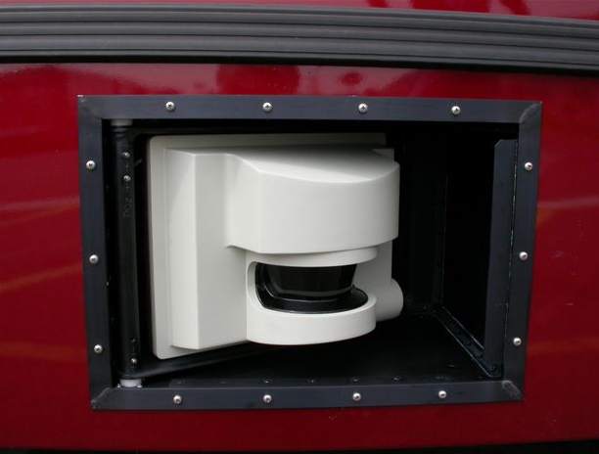
Figure 12. SICK Laser Scanner and Retraction Assembly

Laser scanner retraction system
Each laser is mounted in a box approximately 18” H x 12” W x 12” D which mount in an opening in the sheet metal side panel of the bus. In operation, each laser extends approximately 4” beyond the side panel of the bus, but they are retracted below flush with the side panel when not in use. A small air cylinder on top of each enclosure box actuates the retract / extend motion of the laser, which swings on an arm pivoted near the front of the box. If the laser comes in contact with obstacles in the environment, the compliance of the air cylinder allows the laser to be pushed back into the enclosure to minimize damage to the laser and environment.

The actuation system comprises:
(2) Bimba air cylinders, 1-1/2” bore x 3” stroke;
(2) Automatic 4-way, spring-return, 24VDC, 8W solenoid valves;
(1) Watts filter-regulator;
(1) 2-way shutoff (ball) valve;
125PSI air supply with storage tank (On bus);
Plastic air tubing, ¼” OD and push-lock fittings.

With system air and/or electrical power off, the laser will be held retracted into the box by a return spring. To operate the actuation system, the ball valve (located at the bus air tank) will be opened allowing compressed air to pass through the filter-regulator (which will be adjusted to achieve appropriate force from the air cylinders) to the two solenoid valves located near the cylinders. Spring return on the solenoid valves will normally hold the cylinders retracted, even with zero air pressure. When the valves are activated based on a command signal from the control computer, air will flow through the valves to the cylinders, causing them to extend and push the laser support arms against a mechanical stops to precisely position the lasers for operation. When the valves are deactivated, air plus the return spring will cause the arms to swing back into the box against a back stop, such that the lasers will be within the bus envelope. Speed controls on the cylinders will be adjusted to give appropriate extend and retract speeds. Cylinder volume is 5.3 cubic inches (each); for the worst case of 125PSIG (max. available pressure; normal operating pressure is 50 PSIG), each cylinder stroke will consume about 50SCI (standard cubic inches) of air, or about .029SCF (standard cubic feet). Under normal operation, we expect operation of the cylinders to occur not more than a few times per hour, so total air consumption should be small. The bus air tanks each hold about 1 cubic foot or air, so the volume consumed by actuation of two cylinders going full-stroke should be less than 1% of the tank volume. Leakage (through cylinder seals, etc.) is negligible.

SCWS Curb Detector
For the SCWS we need to determine the location of the sidewalk in order to better assess the situation. Pedestrians on the sidewalk are considered safer than if they are not on the sidewalk. We used a laser line striper (LLS) to detect the position of the curb at the front of the bus. The technical details of the LLS are presented in a paper. Here we give an overview over its working principle and illustrate, how it was mounted on the bus.
Figure 13 Schematic of a laser line striper.
camera
laser
object
α
β
s
d = s cotan(α)

The LLS projects a pattern of light into the scene that is imaged by a camera (see Figure 13) and the appearance of the pattern is used to compute distance to objects in the environment. The LLS is attractive because of its relative small size and robustness. In addition, computation of range is very low cost compared to other optical methods such as stereovision that requires high computation.

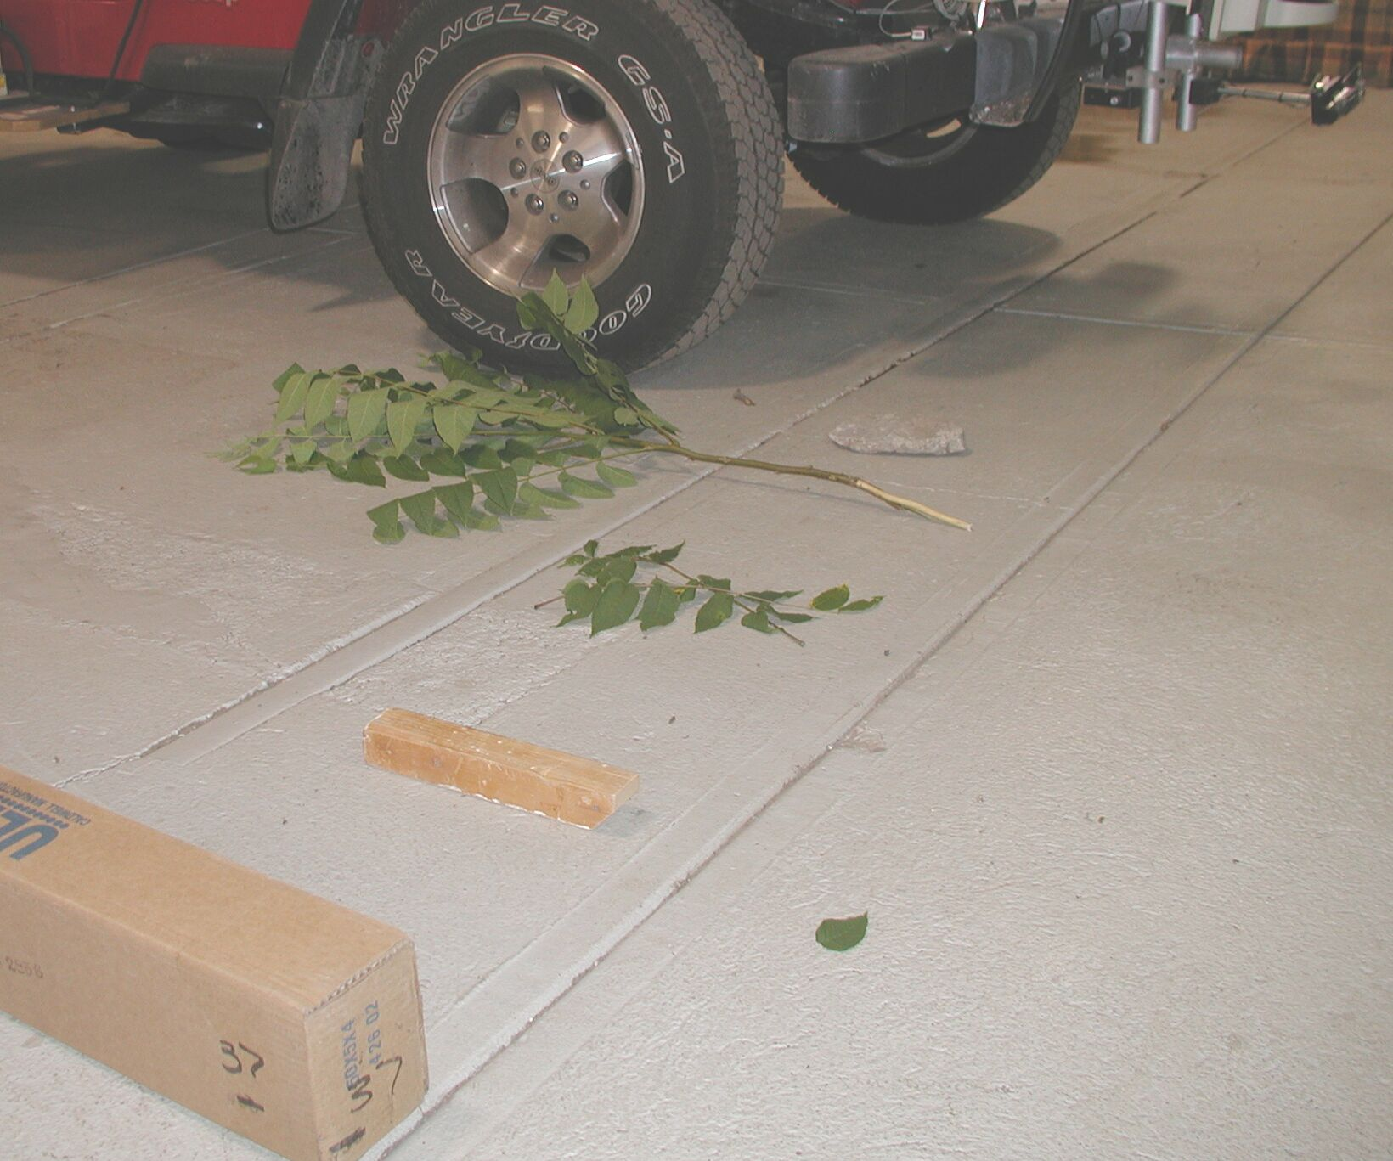
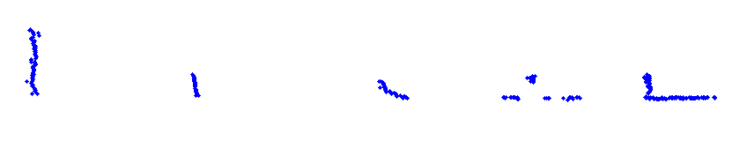
Figure 14 A LLS mounted on a vehicle looking to the side at various objects. The return from the sensor is shown in the lower part of the figure.
LLS

We have built and employed such a sensor where the light pattern is a plane of NIR light and the appearance on the object is a line (see Figure 14). The novelty of our sensor is that it can work outside in bright sunlight even though the power output of the laser is limited by eye safety. The background from ambient sunlight is suppressed by synchronizing a pulsed laser with a fast shutter, employing a narrowband filter, and some image analysis. The figure shows our LLS mounted on a vehicle and looking at various objects on the side of the vehicle. In the lower part of the figure, one can see the output of the sensor.

The range and resolution are dependent on the sensor configuration. In the following table they are shown for three different field-of-views:

field of view [deg] | 30 | 55 | 105
angular resolution [deg] | 0.05 | 0.09 | 0.16
max. range (ideal) [cm] | 700 | 520 | 300
max. range (typical) [cm] | 300 | 200 | 130
range resolution [cm] | 1.4 | 2.6 | 5.0
Table 6. Range and Resolution of Laser Line Striper

The maximum range is for ideal conditions (high reflectivity objects, etc.). For typical conditions, it is about half that distance. The range resolution is for a 2 m distance, resolution varies with the square of the distance.

The LLS was mounted inside the front bumper of the bus with a field-of-view perpendicular to the side of the bus (see Figure 15).
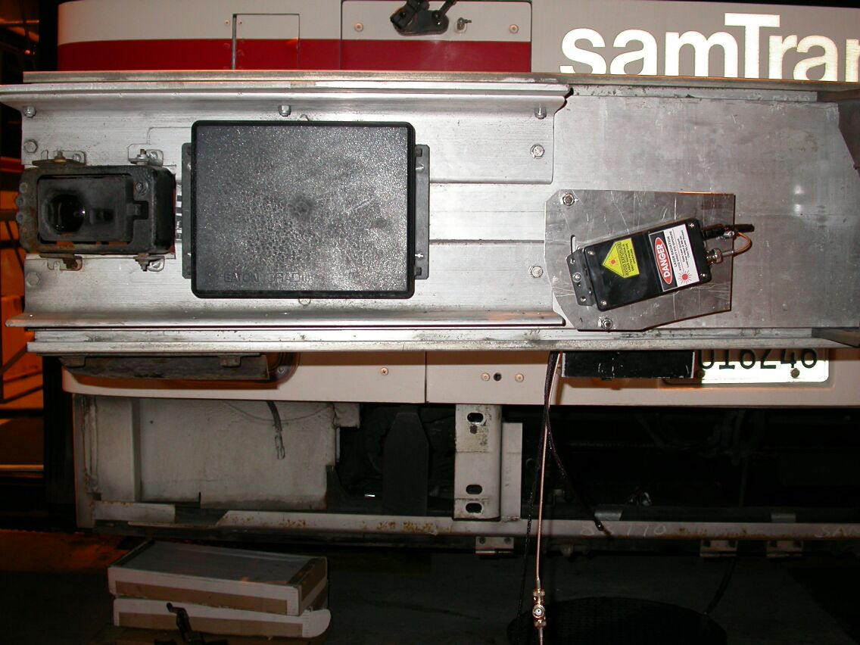
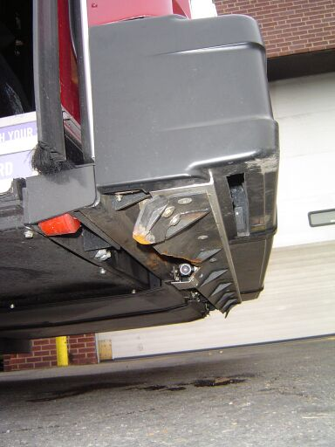
Figure 15 LLS mounted in the front bumper of the bus. On the left side is a frontal view of the SamTrans bus with the rubber skin of the front bumper removed. The laser can be clearly seen, the camera is occluded by the holding bracket. On the right is a side view of the PAT bus. The red semitransparent area indicates the location of the laser plane.
camera
laser

The LLS returned the cross section profile of the environment besides the bus. If there is a curb besides the bus, the profile looked like the one shown in Figure 16.

seen above the road.

Finally, the location of the curb was extracted from the profile by a histogram method (see paper for details).
During the operation of the bus with the LLS we had following experiences with environmental conditions:
Temperature: The temperature range for operation in Pittsburgh was between 0º F and 120º F. The upper range is 20º F above the ambient temperature. This temperature was added because the laser is located within the black enclosure of the front bumper and above the black pavement. We needed to add a heater to the laser in order to reduce this range of temperatures.
Water: The LLS can be exposed to water through rain or the bus wash. We had to do some extra waterproofing to the camera.
Mechanical: The camera and laser needed to be tightly screwed to the frame of the bumper to keep its alignment. No mechanical damage occurred during the time of operation.
Dirt: Only a minimal amount of dirt accumulated on the lens of the camera or the exit window of the LLS, it did not affect its operation.

Sensor fusion of curb detector, bus state and video
In the previous section we described how we detect the curb next to the front bumper with a laser line striper. In this section we discuss how we determine the location of the curb alongside the bus and in front of the bus. Details of this method can be found in a technical paper. The section below is a summary.

Tracking the curb alongside the bus
The movement of the bus is recorded and therefore it is possible to transform past curb measurements into the current reference frame. The collection of these past curb measurements in the current reference frame gives us the curb alongside the bus. An example can be seen in Figure 17, where the curb alongside the bus is indicated as a blue line.

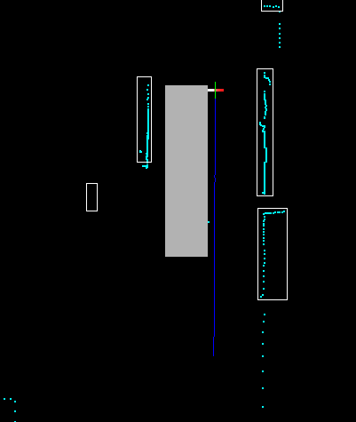

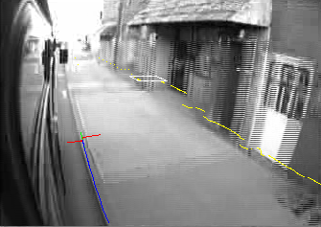

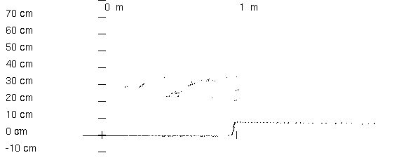
Figure 16 Profile of the road and curb observed by the laser line striper. Some erroneous readings can be Figure 17 Curb alongside the bus. On left is a birds-eye-view and on the right is a view from the right camera. The raw data from the LLS is indicated with red color, the curb position extracted from that raw data is in green and the tracked curb is in blue.

The curb in front of the bus
To detect the curb in front of the bus we use a vision process which is initialized by the knowledge of the curb position we already have. The right image in Figure 17 shows the view of the right, forward looking camera. We already know where the curb is and in which direction it proceeds. This is used for the initial start and direction of a search for an edge in the image. This search is continued till we reach a preset limit in the image, reach the edge of the bus, or reach an object. The position of the object is known from the laser scanner data. An orange line in Figure 17 indicates the curb ahead of the bus in our example.

Calibration of sensors
The above mentioned method of determining the position of the curb in front of the vehicle requires careful calibration of four sensors: Bus state, curb detector (LLS), camera, and laser scanner.

The bus is the reference frame and therefore the location and orientation of the other three sensors need to be determined with respect to the bus. The locations of the sensors are all measured using measuring tape. The laser scanner and the LLS are mounted on the bus in such a way that the orientation of their internal reference frames is either parallel or perpendicular to the axis of the bus reference frame. This way the rotation from one to the other coordinate system is easy to be determined.

Only the orientation of the camera is not trivial. First we want to define the rotation matrix. We use roll angle φ, pitch angle θ, and yaw angle ψ.

Equation 1 $R(ϕ)=\left(\begin{matrix}\text{cos}(ϕ) & −\text{sin}(ϕ) & 0 \\ \text{sin}(ϕ) & \text{cos}(ϕ) & 0 \\ 0 & 0 & 1\end{matrix}\right)$

Equation 2 $P(θ)=\left(\begin{matrix}1 & 0 & 0 \\ 0 & \text{cos}(θ) & −\text{sin}(θ) \\ 0 & \text{sin}(θ) & \text{cos}(θ)\end{matrix}\right)$

Equation 3 $Y(ψ)=\left(\begin{matrix}\text{cos}(ψ) & 0 & −\text{sin}(ψ) \\ 0 & 1 & 0 \\ \text{sin}(ψ) & 0 & \text{cos}(ψ)\end{matrix}\right)$

Equation 4 $C=\left(\begin{matrix}0 & 0 & 1 \\ 1 & 0 & 0 \\ 0 & 1 & 0\end{matrix}\right)$

The matrix which rotates the camera coordinates to the vehicle coordinates is:

Equation 5 $A=C⋅R⋅P⋅Y$

The matrix C takes care of the different conventions for the orientation of the axis. For the vehicle the x-axis is forward, the y-axis points to the right, and the z-axis points down. For the camera the z-axis is in the forward direction, the x-axis points to the right, and the y-axis points down.
The goal is now to find the three angles which describe the orientation of the camera. For this one can make use of the image provided by the camera. The distance between two pixels in the image correspond to about 1/10 of a degree in the real world and therefore one can measure angles quite accurately with the help of the image. Each point in the image has one horizontal and one vertical angle. Since we need to determine three angles (roll, pitch, and yaw), we need at least two points in the image and their corresponding points in the real world. To simplify the problem we choose three points with following properties:
- The first point has the same y-position (in bus coordinates) as the camera.
- The second and third points are vertical to each other in the bus coordinate frame.
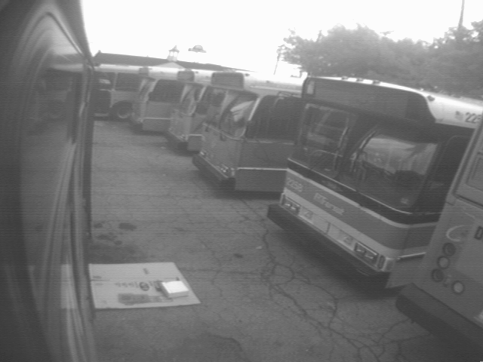
a
b
c
Figure 18 Example of three points chosen for the calibration. Point a is on the ground at the front wheel at the same y-position as the camera. Points b and c are edges at the lower and upper part of the open front door.

If the three angles are small, the solution is to a good approximation:

Roll = difference in angle between the vertical and the line b-c.
Yaw = horizontal angle of a.
Pitch = vertical angle of a after correction of fact that a is not at the same height as the camera.

We found out that this approximation is not always good enough and we worked out the exact solution.

The three points are expressed in homogenized coordinates:
Equation 6 $a=\left(\begin{matrix}a_{1} \\ a_{2} \\ 1\end{matrix}\right)$, $b=\left(\begin{matrix}b_{1} \\ b_{2} \\ 1\end{matrix}\right)$, $c=\left(\begin{matrix}c_{1} \\ c_{2} \\ 1\end{matrix}\right)$

All vectors in the following section are homogenized, i.e. they are always divided by their own third component so that the third component becomes 1.
The approximate yaw angle is:
Equation 7 $ψ_{a}={\text{tan}}^{−1}(a_{1})$
To get the approximate pitch angle, we need to do following calculation:
Equation 8 $a_{y}=Y(ψ_{a})⋅a$
Equation 9 $θ_{a}={\text{tan}}^{−1}(a_{y2})+{\text{tan}}^{−1}({Δz}/{Δx})$
where Δz and Δx are the distances in the z and x directions (bus coordinates) between the camera and point a.

Now we can construct following three points by rotating the points a, b, and c:
Equation 10 $a_{\text{yp}}=P(θ_{a})⋅Y(ψ_{a})⋅a$
Equation 11 $b_{\text{yp}}=P(θ_{a})⋅Y(ψ_{a})⋅b$
Equation 12 $c_{\text{yp}}=P(θ_{a})⋅Y(ψ_{a})⋅c$

Now we need to find a rotation which will make the line b_{yp}-c_{yp} vertical while leaving a_{yp} unchanged, i.e. rotate around a_{yp} Therefore we need to solve following equation for the rotation angle φ_{a}:
Equation 13 $(S(ϕ_{a})⋅b_{\text{yp}})_{1}−(S(ϕ_{a})⋅c_{\text{yp}})_{1}=0$
where the index 1 means the first component of the vector (which of course has been homogenized). The rotation S is defined as
Equation 14 $S(ϕ_{a})=P^{−1}(α)⋅R(ϕ_{a})⋅P(α)$
Equation 15 $α={\text{tan}}^{−1}(a_{\text{yp}2})$
Equation 13 is the condition that the two points become vertical, Equation 14 is the rotation around the point a_{yp}.
Putting all the numbers into the equations and doing the multiplications is tedious but straightforward until one reaches an equation of the form:
Equation 16 $\text{cos}(ϕ_{a})⋅x−\text{sin}(ϕ_{a})⋅y=z_{1}$
The solution to this equation is:
Equation 17 $ϕ_{a}=±{\text{cos}}^{−1}\left(\frac{x⋅z_{1}+y⋅z_{2}}{\sqrt{(x^{2}+y^{2})(z_{1^{2}}+z_{2^{2}})}}\right)$
With
Equation 18 $z_{2}=−\sqrt{x^{2}+y^{2}−z_{1^{2}}}$
The angle φ_{a} is negative if
Equation 19 $\text{cos}(ϕ_{a})⋅x−\text{sin}(ϕ_{a})⋅y−z_{1}>0$
Now one can construct the full rotation matrix:
Equation 20 $A=C⋅P^{−1}(α)⋅R(ϕ_{a})⋅P(α)⋅P(θ_{a})⋅Y(ψ_{a})$
Notice that this equation does not contain the usual roll angle φ, pitch angle θ, and yaw angle ψ. If desired, one can determine them in the following way:
Equation 21 $ϕ={\text{tan}}_{2^{−1}}(a_{\text{32}},a_{\text{33}})$
$$\begin{aligned}θ=−{\text{sin}}^{−1}(a_{\text{31}}) \\ ψ={\text{tan}}_{2^{−1}}(a_{\text{21}},a_{\text{11}})\end{aligned}$$
where a_{ij} are the components of the matrix A and tan₂⁻¹(x,y) is the inverse tangent which takes appropriate care of the sign with respect to the four quadrants.

The solution has been implemented in a MatlabTM program. This MatlabTM program includes an interface which lets you choose the points by clicking on the image. It does the calibration on full images as shown in Figure 18 or on quad-images. The calibration is also used to do image overlays as one can see in Figure 17 on the right.

PC-104 Platforms

SCWS PC-104 platforms
All computers contain processor boards from various manufacturers, all based on the Intel Pentium III with speeds ranging from 700 MHz to 1.26 GHz. This part selection was motivated by the need for the most powerful processor available at the time in a rugged PC/104 form factor that is capable of withstanding extreme temperatures.

All computers run Red Hat Linux 7.2 with a 2.4.18 kernel and
patched to reduce kernel latencies. This ensures that a heavily loaded computer is more responsive and allows us to use Linux for this data driven very soft real-time task. The benefit of this, as opposed to a real time system, is in ease of use.

The left and right computers are almost identical, physically. Minor hardware and software changes are all that is required to interchange the two.
PC/104 Stack | Left | Right
CPU  2 Serial Ports  100 Mbps Ethernet  40 GB Notebook Hard Disk | J1708 Interface | IMU
Frame Grabber | Forward Looking Curb Detector | Striper/Curb Detector
High Speed Serial Ports (4) | Left SICK Data, FCWS Interface, DINEX | Right SICK Data, Odometry
Sound Card | (N/A) | Driver Vehicle Interface
Digital I/O | Left SICK Power and Retraction, Left DVI | Right SICK Power and Retraction, Striper Power, Right DVI
Power Supply
Table 7. Configuration of Left and Right SCWS Computers
Measurement of CPU loading on each of the three computers indicates that our 600MHz left computer is 65% loaded, our 1.2GHz right computer is 45% loaded, and our 700MHz data logging computer (Digital Video Recorder) is 60% loaded.

FCWS PC-104 platforms
The FCWS system hardware is composed of sensors, an engineering data recording- processing computer and a video-recording computer, as illustrated in the figure below. The engineering data that sensors send out is recorded and processed by a PC104 computer system. Besides regular ports for a PC104 computer, it has a digital I/O card, an Analog/Digital I/O card, a CAN card which reads J data bus, a Serial Port card and a counter/timer card.
A sensor arrangement for FCWS is designed to include sensors to detect frontal and frontal corner obstacles and to monitor steering angle movement, brake pressure, throttle position, vehicle velocity and acceleration. Video data from the cameras is recorded using another PC104 computer.
Figure 19. FCWS System Architecture

The figure below shows the layout of the computer enclosure. The computer enclosure contains an engineering computer, a video recorder, electronics circuits including battery ignition monitoring and shutdown circuitry, power adapters, bus power bars and cable connectors.
Figure 20. FCWS Computer enclosure on the bus (top view)

Digital Video Recorder PC-104 Platforms

SCWS Digital Video Recorder PC-104 platform
The digital video recorder / data repository computer also serves as an Internet gateway via a cellular telephone modem. This provides remote system monitoring; something we have found quite useful when managing such a complex system in the field.
PC/104 Stack
PCMCIA Interface | PCMCIA Cellular Modem Adapter
MPEG-1 Hardware Encoder | External Video Cameras
CPU  2 Serial Ports  100 Mbps Ethernet  Removable Disk Drive | GPS for Location Tagged Data
Power Supply
Table 8. Configuration of SCWS Digital Video Recorder

Initially, the removable hard drive was a 250 GB desktop model, the largest drive available. It was hoped that although the environmental vibration and shock would well exceed the manufacturer’s specifications, the drive would still function most of the time. This has proven to not be the case. For this reason, the two 80 GB notebook drives provide enough data storage for about 2 weeks of use, as opposed to the 3+ weeks with the larger drive.

FCWS Digital Video Recorder PC-104 platforms
The cameras capture the front road scene, the left and right front corner road scene, and the passenger compartment of the bus. The video streams from the four cameras are combined into one video stream by a quad image combiner to extend the hard drive storage capacity. The video-in port of video recording computer is connected to the video-out port of the quad combiner by a75$Ω$ video cable.
Figure 21. FCWS Video recorder-camera interface

The video recording system is a standalone PC/104 system with a video board. It reads commands from the engineering computer and records the MPEG video clips to a removable hard drive. The video is recorded at 1Mbps, which is about 450MBytes per hour. The specifications of the board are as follows:
General specifications
Capture rate | 30 frames/sec (NTSC, RS-170, CCIR)  25 frames/sec (PAL)
A/D resolution | 8-bits for luminance  8-bits for chrominance
Output resolution | 768 x 576 (PAL)  640 x 480 (NTSC, RS-170)
Video inputs | 4 multiplexed input channels total: 2 S-video or 4 composite.
Video output | PAL or NTSC from a BNC connector
Output data | MPEG2 streaming data at rates of 100 kbits to 10 Mbits/second
Bus structure | PC/104
Board size | 3.80” x 3.55”
Input power | 5 volts at 280 mA
Number of cards per system | 2
Supporting operating systems | Windows, Linux, QNX6
Table 9. Video board specifications

The video board supports variable bit rates (number of bits of the stored video data per second).

SCWS timing synchronization
Internal to the SCWS, NTP (Network Time Protocol) is used to synchronize the clocks on our three computers over the Ethernet network. The right computer is considered the master clock, independent even of the more accurate GPS clock, which is however slow to converge and unreliable as the bus moves. Upon system boot, the left computer and the data storage computer resynchronize their clocks to the master clock to correct for temperature induced clock drift, which is especially noticeable when the computers have been exposed to extreme temperatures. Thereafter, the NTP daemon on the slave computer uses the network to statistically sample the master clock so that it can determine the error on the local clock. It corrects this error by effectively speeding up or slowing down the local clock to close the difference. The clock is always monotonically increasing, and without steps in time.

FCWS timing synchronization
The following serial ports on the engineering computer are used for synchronization between the FCWS engineering computer and the video recorder:
Port 1: Sensor-Video Computer Communications (115200 Baud)
Port 8: (RS-232) Video timestamper (9600 baud)
The video files and the sensor file need to be synchronized to describe the same scenario. The video recorder reads commands from the engineering computer and records the MPEG video clips to a removable hard drive. The commands from the engineering computer are “begin recording (with a time stamp),” and “stop recording”. Every time the video recorder gets a “begin record” command it closes the old video file, opens up a new file (named by the time stamp) and starts recording.
Figure 22 FCWS Warning signal definition

FCWS / SCWS data synchronization
Data between the FCWS and the SCWS is a serial port on the SCWS left computer and the FCWS at 115 Kbaud. Data that is exchanged by the computers is sent with no time tag, but is saved by the receiver with the receiver’s time tag

FCWS / SCWS data protocol
Each message consists of a Header, ID, Length, Data, Checksum values. The Header is a four character sequence (HEADER0 … HEADER3). The ID is a message identification byte. Messages from the FCWS computer to the SCWS computer will have odd ID numbers. Messages from the SCWS computer to the FCWS computer will have even ID numbers. This is a two byte value. The length is the total number of data bytes. The length does not include itself, the header, ID, or checksum. This is a 2-byte sequence. Data is an array denoting the length of bytes. The checksum is the last byte per message. The checksum is a two's complement of the sum of all the prior bytes in the message, including the header, ID, length, and data. The two's complement is used so that if all of the bytes of the message (including checksum) are summed by the receiver, the result is zero for a valid message. Specific values and parameters are shown below:

HEADER0 | 0x99
HEADER1 | 0x44
HEADER2 | 0x22
HEADER3 | 0x66
PATH_TO_CMU_ID | 1
CMU_TO_PATH_ID | 2
Bytes for status flags
FRONT_DOOR_OPEN | 0x01
REAR_DOOR_OPEN | 0x02
RIGHT_TURN_SIGNAL_ON | 0x04
LEFT_TURN_SIGNAL_ON | 0x08
HAZARD_LIGHTS_ON | 0x10
POWER_DOWN | 0x20
OVERRIDE_ON | 0x40
IN_REVERSE | 0x80
UNKNOWN_POSITION_CM | -10000
UNKNOWN_POSITION_M | (UNKNOWN_POSITION_CM/10.0)
Bit numbers for warning message from SCWS to FCWS
RIGHT_FRONT_LOW_ALERT | 0
RIGHT_FRONT_LOW_WARN | 1
RIGHT_FRONT_MEDIUM_ALERT | 2
RIGHT_FRONT_MEDIUM_WARN | 3
RIGHT_FRONT_HIGH_ALERT | 4
RIGHT_FRONT_HIGH_WARN | 5
RIGHT_REAR_LOW_ALERT | 6
RIGHT_REAR_LOW_WARN | 7
RIGHT_REAR_MEDIUM_ALERT | 8
RIGHT_REAR_MEDIUM_WARN | 9
RIGHT_REAR_HIGH_ALERT | 10
RIGHT_REAR_HIGH_WARN | 11
LEFT_FRONT_LOW_ALERT | 12
LEFT_FRONT_LOW_WARN | 13
LEFT_FRONT_MEDIUM_ALERT | 14
LEFT_FRONT_MEDIUM_WARN | 15
LEFT_FRONT_HIGH_ALERT | 16
LEFT_FRONT_HIGH_WARN | 17
LEFT_REAR_LOW_ALERT | 18
LEFT_REAR_LOW_WARN | 19
LEFT_REAR_MEDIUM_ALERT | 20
LEFT_REAR_MEDIUM_WARN | 21
LEFT_REAR_HIGH_ALERT | 22
LEFT_REAR_HIGH_WARN | 23
RIGHT_NOTIFY | 24
LEFT_NOTIFY | 25
RIGHT_UNDER_WHEEL | 26
LEFT_UNDER_WHEEL | 27
LOW_SETTING | 28
MEDIUM_SETTING | 29
HIGH_SETTING | 30
Table 10. Parameter Values

Data sent from the FCWS to the SCWS

timestamp_secs | Number of seconds since 1/1/1970
timestamp_usecs | Additional microseconds
Warning_msgs | Warning field
Forward object of interest, z=-10000, x=-10000 means no object
front_obj_x | Longitudinal position of object (= x in SCWS)
front_obj_y | Lateral position of object (= -y in SCWS)
front_obj_heading | Orientation of object velocity vector (= -heading in SCWS)
front_obj_speed | Left object speed along heading direction
sound_index | Index of sound in sound directory, -1 for none
sound_bearing | Left to right bearing of sound, percentage
curb_loc_2x | Longitudinal curb position (= z in FCWS)
Status | (Note: REAR_DOOR_OPEN, HAZARD_LIGHTS_ON, and OVERRIDE_ON are not produced by the FCWS)
Table 11. Data sent from the FCWS to the SCWS

Data sent from the SCWS to the FCWS

timestamp_secs | Number of seconds since 1/1/1970
timestamp_usecs | Additional microseconds
warning_msgs | Warning field
brake_pressure | Brake pressure - currently always 0
Latitude | GPS latitude
Longitude | GPS longitude
Altitude | GPS altitude
Speed | Speed from vehicle state estimation in km/hour
Left object of interest, x=-10000, y=-10000 means no object
left_obj_x | Longitudinal position of object (= z in FCWS)
left_obj_y | Lateral position of object (= -x in FCWS)
left_obj_heading | Orientation of object velocity vector (= -heading in FCWS)
left_obj_speed | Left object speed along heading direction
Right object of interest, x=-10000, y=-10000 means no object
right_obj_x | Longitudinal position of object (= z in FCWS)
right_obj_y | Lateral position of object (= -x in FCWS)
right_obj_heading | Orientation of object velocity vector (= -heading in FCWS)
right_obj_speed | Right object speed along heading direction
Tracked and predicted curb locations, ordered in increasing x (longitudinal)
curb_loc_1x | Longitudinal curb position (= z in FCWS)
curb_loc_1y | Lateral curb position (= -x in FCWS)
curb_loc_2x | Longitudinal curb position (= z in FCWS)
curb_loc_2y | Lateral curb position (= -x in FCWS)
curb_loc_3x | Longitudinal curb position (= z in FCWS)
curb_loc_3y | Lateral curb position (= -x in FCWS)
curb_loc_4x | Longitudinal curb position (= z in FCWS)
curb_loc_4y | Lateral curb position (= -x in FCWS)
curb_loc_5x | Longitudinal curb position (= z in FCWS)
curb_loc_5y | Lateral curb position (= -x in FCWS)
curr_curb_loc_x | Current Longitudinal curb position (= z in FCWS)
curr_curb_loc_y | Current Lateral curb position (= -x in FCWS)
sound_index | Index of sound in sound directory, -1 for none
sound_bearing | Left to right bearing of sound, percentage
Status | (Note: IN_REVERSE is not produced by the SCWS)
Table 12. Data sent from the SCWS to the FCWS

System Software

SCWS Software Architecture Development
The SCWS uses software architectural and communications tools that were originally developed to support the ongoing robotics research of the Navlab project. The architectural tools allow algorithm developers to view the rest of the system through a set of abstract, reconfigurable interfaces. In the initial development and ongoing debugging of an algorithm or in the post development analysis of data, the interfaces can be configured to read data from time tagged files using a common set of data access tools. As the algorithm matures, the interfaces can be reconfigured to use a common set of inter-process communications tools which integrate the individual algorithm into the larger system running in the field.

Inter-process communications
The vast majority of inter-process communications in the SCWS can be considered as analogous to signals in electronics. These are repeated estimations of a consistently changing value, such as the most recent line scanner data or most recent set of tracked objects in the environment. It doesn't truly matter if the recipient misses a signal value: all that matters is the most recent value. What does matter is the minimization of latencies in transporting the signal value from producers to consumers. An appropriate paradigm for propagation of signal type information is global shared memory: A producer sets the memory and a consumer simply reads the most recent value. The Neutral Messaging Library (NML) from the Real-Time Control System (RCS) library produced by NIST demonstrates this control-centric method for integrating robotic systems. We have chosen a simpler implementation than NML for global shared memory which uses a "single-writer, multiple-reader" model. When processes are communicating on the same machine we use actual System V shared memory, whereas when processes are communicating between machines we transparently propagate changing memory values from writer to readers via the UDP socket protocol managed by shared memory managers running on each machine.

One of the reasons we chose to implement a simple shared memory communications scheme rather than adopting NML was that while signals make up the bulk of the communications, signals are not the only paradigm for inter-process communications in a robotic system. Symbols, i.e., atomic pieces of information, changes in state, or requests for information, are very difficult to communicate via a signal-based communications paradigm. For example, unlike signals, if a symbol value is dropped or missed, then information is lost, state changes don't get noticed, and requests are ignored. The guarantee that a symbol has been transported from writer to reader is worth significant additional latency and complexity in the implementation. Symbolic information is typically communicated in robotic systems via TCP/IP message based packages
ranging in complexity from the raw use of socket libraries all the way up to complex, object based systems such as the Common Object Request Broker Architecture (CORBA). In order to limit the complexity and size of our software while still providing some abstraction and flexibility, we have chosen a simple TCP/IP based messaging package developed for the Navlab project: The Inter-Process Toolkit (IPT).

A key abstraction built in the SCWS using the messaging toolkit is the concept of a central black board. Individual algorithms mainly query the black board for their configuration parameters, but they can also post information in the black board and watch for changes in values on the black board. Thus, the black board becomes a channel for propagating information through the system that has to be generally available, but for which a certain degree of latency is acceptable. For example, when a driver sets the sensitivity switch to different levels, this causes a change to be posted to the warning levels stored in the central blackboard. These changes are then propagated to the warning algorithm automatically and transparently. In addition, since much of the system's high level information is being funneled through the blackboard, we have chosen to make the black board manager the system process manager. It initiates, parameterizes, and monitors the system processes. Interestingly, this paradigm of a central black board was one of the earliest used in robotics , but it has been often rejected because if the black board is the only means for propagating information through the system, it becomes an intolerable bottleneck for the kind of low-latency, high-bandwidth signal-type information that forms the backbone of information flow for a real robotic system.

Thus we see the core of our communications philosophy: Instead of having one tool or one approach, which must be bent and stretched to handle all possible uses, we select a suite of simple tools, each one narrowly focused on a particular style of communications necessary for the efficient and successful operation of the system.

Vehicle state propagation
A fundamental question for most mobile robots is, "where am I?" For almost every module in the SCWS this question needs to be answered before going on to "what am I seeing?" Thus, a fundamental part of the SCWS architecture is the ubiquitous availability of vehicle state, i.e., the estimate of where the vehicle is, where it is pointing, and where it is going.

In past Navlab systems, the question of "where am I?" was assumed to mean "where am I right now?". Thus, perception algorithms would ask "where am I right now?", get the answer from the pose estimation system, and then apply that to the latest sensor information. This works fine when a robot is moving slowly, at a few meters per second, but when a robot is moving fast, at 10, 20, or even 30m/s, small discrepancies in time between the latest sensor pose estimation and the latest sensor information can lead to significant errors in placing that sensor information in the world, and thus to significant errors in operation.

The goal of the current Navlab pose estimation system used in the SCWS is to allow perception algorithms on any machine in the system ask "where was I at time T?", where T is the time stamp of some relevant sensor event.

The pose propagation architecture we use is shown below. On one machine there is a pose estimation system connected to all the various sensors which is repeatedly answering the question "where am I?" Each pose estimate is put into a ring buffer in shared memory that any process on that machine can access. The user pose estimation routines take a time tag, and attempt to interpolate (or extrapolate a small amount) in this pose history buffer to come up with the best estimate of the vehicle pose at the requested time. When a new pose estimate is created, in addition to being entered in the local pose history table, it is sent via the shared memory managers to every machine in the system. On each of these client machines there is a process waiting for incoming pose estimates and using them to build a pose history buffer which can be used by other processes running on that machine to precisely match up pose estimations with sensor time tags.

Of course, a potential weakness of this system is that the clocks on all the machines must be precisely synchronized. Although we experimented with using hardware solutions using the IRIG-B protocol to allow us to have time estimates synchronized to within microseconds across machines, we found that the freely available package NTP could synchronize our clocks to within a millisecond across the machines, even in the face of the harsh, changing environmental conditions encountered by a system running over long periods of time on a transit bus. Millisecond synchrony is more than sufficient for successful integration of vehicle pose and sensor information even at high vehicle speeds.
Master Processor
Vehicle State
Estimator
Vehicle State
Client
Client processor
Vehicle State
Propagator
Vehicle State History Table
Current Vehicle State
Vehicle State
Client
IMU
Odometry
GPS
DINEX
Vehicle State History Table
Current Vehicle State

Data flow
Apart from the ubiquitous connections to the blackboard and vehicle state propagation system, the data flow for the vast majority of communications within the SCWS is fairly simple. The system has a left side processor which contains most of the processes for producing warnings on the left side of the bus, a right side processor for producing warnings on the right side of the bus, and a central processor responsible for managing the system, saving data from the left and ride side processors, and saving a video record of the bus operation.

Left side data flow
On the left side of the bus, warnings are generated based only on the laser range data.
- The data from the SICK laser range finder is read in by a reflexive "guarding" module. This module monitors the returns from the laser range finder and the velocity of the bus to do a quick determination if the sensor will hit anything. If the algorithm sees an imminent collision, it sends the signal which retracts the sensor and flags the range data as "bad". The algorithm continues to monitor the environment as best as it can from its retracted position, and when it determines there is enough room to extend safely, it does so. This algorithm should be considered analogous to a "flinching" reaction in a human which keeps the sensor (and those the sensor may hit) safe. No matter what happens, the guarding module publishes the laser data to the rest of the system via shared memory. The guarding module also examines the quality of the data coming from the laser. If it detects too many permanent blockages, usually due to mud or dried road salt, it will retract the sensor until the sensor is cleaned.

- The detection and tracking of moving objects (DATMO) algorithm reads in laser data and vehicle state data via shared memory and produces a list of moving and stationary objects around the vehicle.

- The warning algorithm takes the list of moving and stationary objects around the vehicle and combines the vehicle state (specifically the bus velocity and turning speed) to predict collisions. It produces an annotated list of objects with warning classifications and overall warning level.

- The left Driver Vehicle Interface (DVI) control module watches the overall warning level and controls the appropriate lights on the left side to warn the driver about objects around the vehicle. The left DVI control module also monitors the sensitivity and override switches on the DICB and changes values in the blackboard in response.
Sensor
Guarding
SICK LMS 291
DATMO
Warning
Generation
DVI
Control
Ranges, bearings
Ranges, bearings
Objects
Warning Levels
Classified Objects
Shared Memory
Sensor Retractor

Right side data flow
On the right side of the bus, the system uses a curb detection and prediction system to augment the laser range data in generating warnings.
- The curb striper algorithm digitizes a laser strip painted on the curb and uses its knowledge of the intrinsic and extrinsic camera parameters to produce a set of detected 3D points to shared memory

- The curb processing algorithm combines the output of the curb striper with the vehicle state data to produce an estimate of where the curb was over the last few seconds. It then digitizes an image from the right rear forward looking camera and uses the curb estimate to initiate a visual search for the curb ahead of the bus. The resulting curb information is published via shared memory.

- The warning algorithm is configured to read the curb information and uses it to modify its warning level production.

- As with the left DVI control module, the right DVI control module monitors the right warning levels and sets the lights appropriately. The right DVI control module does not monitor the switches. That is done by the left DVI control module alone.

In addition, the right side processor has the vehicle state estimation module that is connected to the various sensors and data source and produces the actual vehicle state for the rest of the system.
Sensor
Guarding
SICK LMS 291
DATMO
Warning
Generation
DVI
Control
Ranges, bearings
Ranges, bearings
Objects
Warning
Levels
Classified Objects
Shared Memory
Curb
Striper
Curb
Processor
Curb
Positions
3D Points
Curb Camera

Forward Looking Camera

Images
Images

Central processor data flow
The central processor is responsible for many of the data collection and system management aspects of the system.
- It runs the central blackboard and process management modules.

- The four external side bus cameras feed into a quad-combiner which then feeds into an MPEG encoder card which the central processor reads. The MPEG stream is time tagged and saved to disk

- It runs modules attached to all the other various shared memory outputs on the system, such as vehicle state estimation, laser range data, classified objects, etc., and saves them to disk.

Integration with the FCWS
The connection to the Forward Collision Warning System (FCWS) is through a serial link. There is a gateway module running on the left processor which gathers together, packages, and writes the following information over that serial link:
- Warning levels
- Nearest object position and speed for each side
- Curb position, if any
- GPS position
- Vehicle speed
- Auxiliary bus state information, such as door open/closed status or lights status.

The gateway module also monitors the output from the FCWS and saves the following information:
- Front warning levels
- Nearest front object position and speed.
- The FCWS's estimation of the auxiliary bus state information.

The bus state information is duplicated because the actual hardware sensors may not be connected to the same system on different platforms. For example, on the Pittsburgh bus the SCWS system has direct access to the bus state information sensors and has a separate module to read and publish these values, but on the San Mateo bus, the bus state information is read from the FCWS and propagated to the rest of the system by the gateway module.

FCWS Software Introduction
This chapter focuses on the data acquisition program of the FCWS on integrated Samtrans bus 601. This includes most of the interfaces that serve as the bridge between the low-layer hardware/software drivers and the upper-layer application programs such as warning algorithms. The communication of FCWS and ICWS is specified in the ICD document.
Figure 23 FCWS Data acquisition program

The purpose of the data acquisition program is to save data from sensors and synchronize the engineering computer with a video recorder. Basically, the data acquisition program is comprised of an initialization process and a loop body; the program has a short period of time to save all files and then to abort when the power is turned off. The loop body is composed of the following actions:
- Copy the sensor data from the database to the local memory.
- Save sensor data from the local memory to a set of disk files.
- Check power-off flag (if power-off flag is set, run power-off subroutine)
- Check time consumed for file collection.
- (If exceeds 15 minutes, open a new set of files)
- Generate synchronization signals.
- Wait for the 75ms flag.
The LIDAR data is saved every 75 ms, which is the lowest update rate. About every 15 minutes old files will be closed and a new set of files will be opened. A timestamp is also included with each entry.

FCWS Software structure
Figure 24 FCWS Software flow chart

FCWS Initialization

Define variables

File pointers (Global variables)
File pointer | Sensor
*f_RADARA | P-RADAR
*f_RADARB | D-RADAR
*f_LIDARO | F-LIDAR
*f_LIDARM | P-LIDAR
*f_LIDARN | D-LIDAR
Table 13. FCWS File pointers – sensors

System signals
Signal | Description
SIGINT | Interruption
SIGQUIT | Quit
SIGTERM | Terminate
ERROR | System error
Table 14. FCWS System signals

After initialization (signals added), whenever the program receives these signals, it will close files, log out of the database and exit. For example, Ctrl+C from the keyboard will generate a SIGTERM signal and this program will receive the signal then close files, log out of the database and exit.

Database variables
The following database variables are used for database read operation; each variable (a structure) contains some variables and an unsigned char. This char will be the pointer of the sensor data in the local memory after the execution of clt_read () function (database read operation).
Variable | Sensor
Db_data_radarA | P-Radar
Db_data_radarB | D-Radar
Db_data_LidarOA | F-Lidar(section A)
Db_data_LidarOB | F-Lidar(section B)
Db_data_lidarMA | P-Lidar(section A)
Db_data_lidarMB | P-Lidar(section B)
Db_data_lidarNA | D-Lidar(section A)
Db_data_lidarNB | D-Lidar(section B)
Db_data_long_input | Host-bus sensors
Db_data_gps_gga | GPS
Db_data_gps_vtg | GPS
Db_data_jeec2 | J-bus
Db_data_dduA | DDU-display of P-Radar
Db_data_dduB | DDU-display of D-Radar
Table 15. FCWS Database variables – sensors

Sensor data pointers
The pointers listed below point to the sensor data in the local memory. For instance, pRADAR gets its value from the database variable: db_data_radarA or db_data_radarB that contains the pointer pointing to the RADAR data. The data structures of RADAR, LIDAR, host-bus sensors are shown in FCWS hardware documentation. These pointers are then used to save sensor data from local memory to a hard disk.

Pointers | Sensor
*pradar | RADAR
*pddu_display | DDU-display
*plidarA | Lidar(section A)
*plidarB | Lidar(section B)
*plong_input | Host-bus sensors
*pgps_gga | GPS (position)
*pgps_vtg | GPS(speed)
*plong_jeec | For J-bus
Table 16. FCWS Sensor data pointers

Time variables

Start_time, Curr_time
These two variables are used to check the time consumed for file collection, if Curr_time-Start_time>15 minutes, the old files will be closed and a new set opened.

Hour, minute, second, millisec
These four variables are used to generate the time of day an entry is recorded.

Process user switches
A user should specify the time for file collection. In this program, 15 minutes are allotted for file collection. Command format: wrfiles3 –m 15

Open a serial port for the titler
This port is used to send current time (hour, minutes, second) to the titler for adding a timestamp.

Log in to the database
In order to read data from the database, we need to get a node ID and then log in to the database.

Get the current time
The current time is used to calculate time consumed for file collection.

Open files
File name | Sensor
AMMDDSSS.dat | P-Radar
BMMDDSSS.dat | D-Radar
OMMDDSSS.dat | F-Lidar
MMMDDSSS.dat | P-Lidar
NMMDDSSS.dat | D-Lidar
EMMDDSSS.dat | Host-bus sensors and others
Table 17. FCWS File name format

In the above names, MM is replaced by a 2-digit month code, DD is replaced by a 2-digit day code, and SSS is replaced by a 3-digit serial code. Serial codes for a given day start at 000 and proceed to 999. Detailed information of the file format is in the program comments.

FCWS Loop body

Database operations
The program copies the specified sensor data from the database to local memory consecutively before performing any disk operations. (Please note, we do not read data of a specified sensor, save it to a disk file, and then read data of another sensor.) As a result, the timestamp of all disk files can be consistent. The reason is that memory operation are much faster than disk operations, given the same quantity of data transmissions.

Disk file operations
Disk file functions save: the data of RADAR sensor and DDU display, two sections of LIDAR sensor data (section A and section B combined) and saves data of host-bus sensors, GPS, and J-bus data. All these save functions perform memory read and disk write operations and add the same timestamp to their files.

RADAR file format (P-RADAR, D-RADAR)
Figure 25 FCWS RADAR file format

LIDAR file format (F-LIDAR: First generation)
Figure 26 FCWS lidar file format

Host-bus sensor file format
Figure 27 FCWS Host-bus sensor file format

Check power off flag
If the power off flag is set, there is less than 1 minute to close files and clear video alarm signals. If power resumes within 1 minute, a new set of files will be opened, a new timestamp will be sent to the video recorder and all synchronization signals will be cleared before the program check time consumed for file collection.

Check time to open a new set of files
If the current time - the start time >15 minutes, the old files will be closed and a new set of files will be opened. Whenever a new set is opened the current timestamp will be sent to the video recorder through the serial port already opened.
Figure 28 Check time to open a new set of files

FCWS Synchronization
The video files recorded and the sensor file recorded need to be synchronized to describe the same scenario. The engineering computer will send the master time to the video recorder after ignition to synchronize the two systems in real time. The video recorder will adjust its clock accordingly. The engineering computer will send instructions to the video recorder to open or close a file for video recording when it opens or closes a new set of engineering files. The video recorder also records the start time and end time of each video file for synchronization verification.

FCWS Program exit
The program will abort when the power is turned off for four minutes. The program will exit when there are:
(1) Signals (added in initialization) received
(2) Invalid user switch or bad number of minutes for file collection.
(3) Failure to initialize the timer (75ms).
(4) Error in opening serial port for video timestamp.
(5) Database initialization error, database reading error, database update error.

Algorithm Development

Object Tracking Using Scanning Laser Rangefinders
CMU has developed software for the tracking of vehicles and pedestrians using scanning laser rangefinders mounted on a moving vehicle. Although the system combines various algorithms and empirical decision rules to achieve acceptable performance, the basic mechanism is tracking of line features, so we call this approach linear feature tracking.

There are three major parts to this presentation:
- Introduction of the sensor characteristics, comparison with other tracking problems, and discussion of some specific problematic situations.
- Presentation of the structure and algorithms used by the tracker.
- Discussion of the performance and limitations of the current system.

Input / Output example
To get some idea of what the tracker does, consider the tracker input and output. Figure 29 is a portion of an input frame from the laser rangefinder:
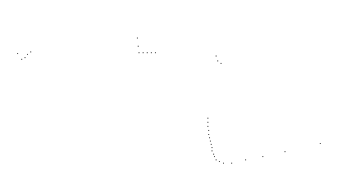
Figure 29: Tracker input (one frame)

Figure 30 is a visualization of the tracker output. The numbers are track identifiers, with additional information displayed for moving tracks. Track 38 (brown) is a car moving at 5.7 meters/sec and turning at 21 degrees/sec. The light blue arc drawn from track 38 is the projected path over the next two seconds. The other tracks are non-moving clutter objects such as trash cans and light poles. The actual scanner data points are single pixel dots. The straight lines have been fitted to these points. An X is displayed at the end of the line if we are confident that the line end represents a corner.
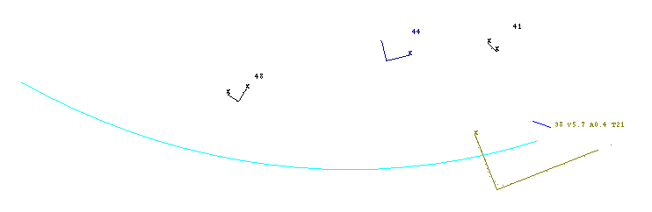
Figure 30: Tracker output example

Sensor characteristics
A laser rangefinder (or LIDAR) is an active optical position measurement sensor. Using the popular time-of-flight measurement principle, a laser pulse is sent out by the sensor, reflects off of an object in the environment, then the elapsed time before arrival of the return pulse is converted into distance. In a scanning laser rangefinder, mechanical motion of a scanning mirror directs sequential measurement pulses in different directions, permitting the building of an approximation of a 2D model of the environment (3D with two scan axes.) We will use the term scanner as a shorter form of scanning laser rangefinder.

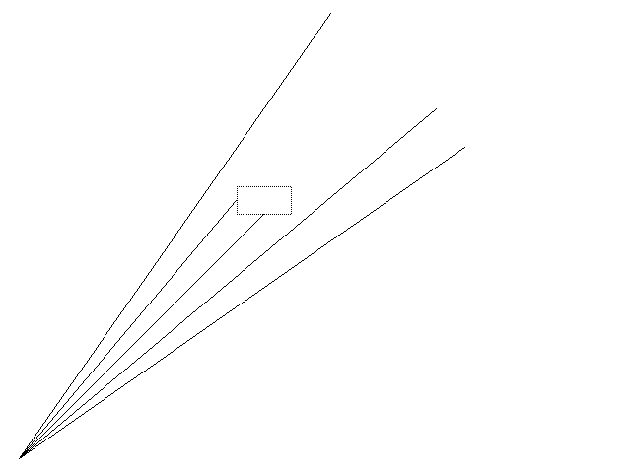
Figure 31: Scanner angular resolution

The scanning mirror moves continuously, but measurements are made at discrete angle increments (see Figure 31.) Though this is not actually how the scanner operates, the effects of angular quantization are easier to understand if you visualize the scanner as sending out a fixed pattern of light beams which sweep across the environment as the scanner moves (sort of like cat whiskers.)

When viewed in the natural polar coordinates, the rotational (azimuth) and radial (range) measurement errors are due to completely different processes, and have different range dependence:
- The azimuth error is primarily due to the angular quantization, though this is related to the underlying physical consideration of laser spot size. For a given beam incidence angle on the target, the Cartesian position uncertainty is proportional to the range.
- The range measurement error comes from the per-pulse range measurement process, and in a time-of-flight system is largely due to the timer resolution. This results in a range accuracy that is independent of distance.

Linear feature tracking was developed for a collision warning system for transit buses. This system uses the SICK LMS 200, which is a scanning laser rangefinder with a single scan axis. The scanner is oriented to scan in a horizontal plane, and all processing is done using 2D geometry in this scan plane. Performance specifications are 1cm range resolution, 50 meter range, 1 degree basic azimuth resolution and 75 scans/second update rate. The output of the scanner is simply a vector of 181 range values. If the measurement process fails due to no detectable return, this is flagged by a distinct large range value.

Note that with these range and angle resolutions, the position uncertainty is dominated by azimuth quantization throughout the entire useful operating range. At a practical extreme range of 20 meters, a one degree arc is 34cm, whereas the range resolution is still 1cm.

The tracking problem
Given this sensor, we would like to identify moving objects, determine the position and velocity, and also estimate higher order dynamics such as the acceleration and turn rate. The tracker must also be computationally efficient enough so that it can process 75 scans a second in an embedded system with other competing processes.

A track is an object identity annotated with estimates of dynamics derived by observing the time-change. The function of the tracker is to generate these tracks from a time-series of measurements. The purpose of maintaining the object identity is twofold:
- We need to establish object correspondences from one measurement to the next so that we can estimate dynamics.
- The object identity is in itself useful as it allows us to detect when objects appear and disappear.

In general, tracking can be described as a three-step process which is repeated each time a new measurement is made:
- Predict the new position of each existing track based on the last estimate of position and motion.
- Associate measurement data with existing tracks. If there is no good match, consider making a new track.
- Estimate new position and motion based on the difference between the predicted position and the measured one.

Comparison of tracking with laser scanner vs. other sensors
The problem of tracking moving objects using a scanning laser rangefinder is in some ways intermediate in characteristics between long range RADAR tracking (e.g. of aircraft) and computer vision tracking.

What advantages for object tracking does a laser scanner have over computer vision? Two difficult problems in vision based tracking are:
- Position: determination of the position of objects using vision can only be done using unreliable techniques such as stereo vision or assuming a particular object size. Position determination is trivial using ranging sensors like RADAR and laser scanners, as long as there is adequate angular resolution,
- Segmentation: when two objects appear superimposed by our perspective, how do we tell where one ends and the next begins? Range measurement makes segmentation much easier because foreground objects are clearly separated from the background.

An important problem that laser scanners have in common with computer vision is point correspondence: given two measurements of the same object, which specific measurements correspond to the same point on the object.

In long range RADAR, the point correspondence problem typically doesn't exist -- the object size is at or below the angular resolution, so the object resembles a single point. In contrast, when a laser scanner is used in an urban driving situation, we need to be able to track objects whose size is 10 to 100 times our angular resolution. Not only do the tracked vehicles not resemble points, after taking into consideration the effect of azimuth resolution, they often effectively extend all the way to the horizon in one direction.

When the size of objects can't be neglected, this creates ambiguity in determining the position of the object (what point to use). Since a tracker estimates dynamics such as the velocity by observing the change in position over time, this position uncertainty can create serious errors in the track dynamics.

As in computer vision, the extended nature of objects does also have some benefits. Because we have multiple points on each object, we can make use of this additional information to classify objects (bush, car, etc.)

Shape change
It is a crucial aspect of the tracking problem considered here that the laser rangefinder is itself in motion. If the scanner is not moving, the problem of detecting moving objects is trivial: just look for any change in the sensor reading. Once the scanner is moving, we expect fixed objects to appear to move in the coordinates of the scanner, and can correct for this with a coordinate transformation.

It is assumed that the motion of the scanner is directly measured, in our case by a combination of odometry and an inertial turn rate sensor. Since tracking is done over relatively short ranges and short periods of time, the required accuracy of the estimate of scanner motion is not great, and relatively inexpensive sensors can be used.

The more intractable difficulty related to scanning from a moving vehicle is that, even after object positions are corrected by a coordinate transform, the appearance still changes when we move due to the changing scanner perspective. The scanner only sees the part of the object surface currently facing the scanner. As the scanner moves around a fixed object, we see different contours of the object surface.

The shape change doesn't cause any serious difficulty for determining that scan data corresponds to the same object from one scan to the next because the change is small. What is difficult is determining that these small changes are due to changes in perspective, and not actual motion of the tracked object.

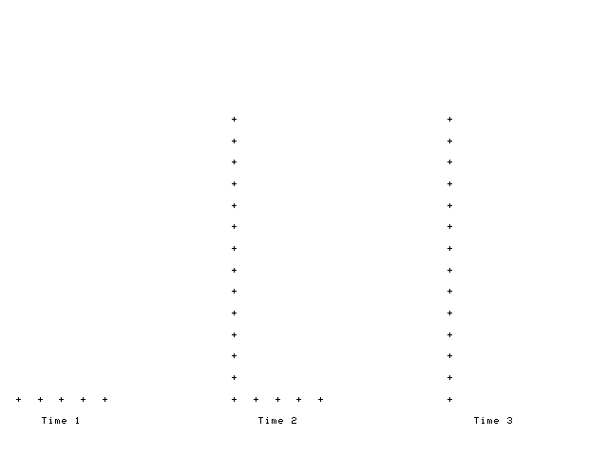
Figure 32: Shape change

To get a sense of the shape change problem, consider a naive algorithm which considers the object position to be the mean position of the object's measured points (see Figure 32.) Suppose that we are driving past a parked car. At time 1, we see only the end of the car. At time 2, we see both the side and end. By time 3, we only see the side. During this process, the center of mass of the point distribution shifts to the left, giving the parked car a velocity moving into our path, causing a false collision prediction. The point distribution also moves in our direction of motion creating false velocity in that direction.

Occlusion
Another problem happens when a small object moves in front of a larger background object (see Figure 33.) In this case, what is in effect the shadow of the foreground object creates a false moving boundary on the background object (as well as splitting the background object in two.) Due to the changing perspective, moving shadows also appear when both objects are fixed but the scanner is moving.
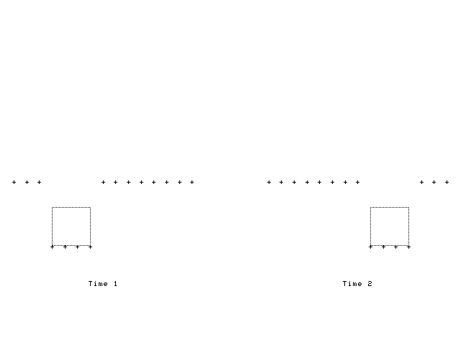
Figure 33: Occlusion

2D scan of a 3D world
Two major problems come from using a single axis scanner:
- When the scanner pitches or rolls, we see a different contour of each object, and if the surface is not nearly vertical, we may see a large amount of motion.
- When the ground is not flat, the scanner beam may hit the ground, resulting in seeing the ground itself as an obstacle. Due to pitch and roll, these ground-strike returns may also appear to be rapidly moving.

Use of a scanner with several beams that scan in parallel can greatly help with this problem because we can detect when the beam is striking an object that is significantly sloped, and either disregard it or attempt to compensate in some way.

Vegetation
With some objects, the outline seen by the scanner appears to fluctuate in a random way as the scanner moves. Vegetation has this problem. Figure 34 shows the superimposed points from 20 scans combined with markers for the points from one single scan. Clearly there is a great deal of noisy fluctuation of the range measurements. Also, the underlying outline which we can see in the superimposed scans is complex enough to defy simple geometric models.
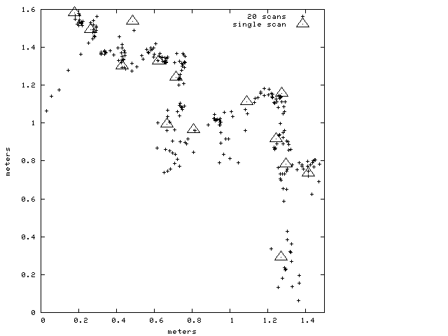
Figure 34: Vegetation

Weak returns
Some objects have very poor reflectivity at the infrared frequency where the SICK scanner operates. Figure 35 shows an example of a car that is almost invisible to the scanner. During the 10 seconds that we drive by, we are able to build up a reasonably complete idea of the car (small dots), apparently largely from specular glints. However, on any given scan, very little of the car is visible. In this particular single scan, we are mainly seeing inside the wheel wells (oblong areas area inside outline box.) Evidently the dirt inside the wheel well is a better reflector than the paint.

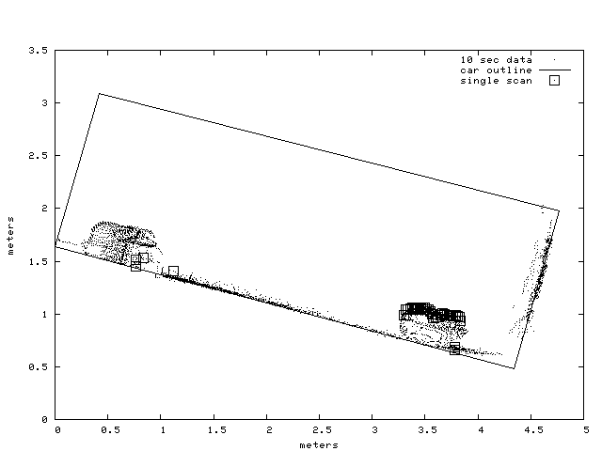
Figure 35: Weak returns

Clutter
Another cause of unclear object outlines is clutter: when objects are close together. In this case, it isn't clear whether to segment the data as one or two objects. If the segmentation flips between one and two objects, this causes apparent shape change. Clutter can also cause spurious disappearance of tracks, for example when a pedestrian moves close to a wall, and appears to merge with the wall.

Tracker structure and algorithms
These are the major parts of the tracker:
- Segmentation: group scanner points according to which object they are part of.
- Feature extraction: fit line and corner features.
- Prior noise model: assign feature error covariances using a measurement error model.
- Data association: find the existing track corresponding to each new segment, creating a new track if there is none.
- Dynamic model and Kalman filter: determine velocity, acceleration and turn rate from the raw position measurements.
- Track evaluation: assess the validity of the dynamic estimate and see if the track appears to be moving. Check how well the estimate “predicts” the measured past positions when time is reversed.

There are 60 numeric parameters used by the tracker. For concreteness and conciseness, we will refer to the specific numeric values that have been empirically tuned for our particular scanner and application, rather than to parameter names. Generally the parameter values are not all that sensitive, but for best performance with a different scanner or application, different values would be used.

Also, since the source code is available and well commented, we will avoid in-depth discussion of implementation details better read from the source. In particular, although efficiency is one of the important characteristics of the tracker, we won't do much in-depth discussion of performance-related issues.

One performance consideration is worth discussing because it affects the structure of the algorithm, especially in the segmentation and feature extraction steps. We have exploited two major geometric constraints that come from the use of a single scanner:
- Given an assumption that all corners are 90 degrees, at any time it is possible to see at most two sides and three corners of an object. Data structures are designed for this fixed number of linear features, rather than an arbitrary number. This also simplifies the feature correspondence problem in data association.
- In various places we exploit the assumption that the inherent azimuth ordering in the scanner output is also an ordering of consecutive points on the object surface.

Both of these assumptions break down if there is more than one scanner. We have demonstrated one way to use multiple scanners: convert all the scan points into a point cloud in Cartesian coordinates, and then convert each point back to polar coordinates of a single “virtual scanner.” Although not a great solution, it does show that the limitation to a single scanner can be relaxed.

Segmentation
Segmentation takes the list of 181 range and azimuth points returned by the scanner and partitions it into sublists of contiguous points. Two neighboring points are contiguous if the separation is less than 0.8 meters. After segmentation, the points are converted into a non-moving Cartesian coordinate system by transforming out the effects of the known motion of the scanner.

During segmentation we also classify each point as occluded or normal. A point is occluded if an adjacent point in the scan is in a different segment and in front of this point, or if it is the first or last point in the scan. This flag has two uses:
- When an occluded point appears at the boundary of an object, we consider this to be a false boundary (the feature is vague.)
- We only count non-occluded points when determining if there enough points to create a new track or if the point density is high enough for a segment to be compact.

In segmentation, missing range returns are treated as points at maximum distance, and are not assigned to any segment. If there is a large enough dropout in the middle of an object, this splits the object into two segments.

Linear feature extraction
For each segment, we do a least-squares fit to a line and to a right-angle corner. Since the stability of feature locations is crucial for accurate velocity measurement, there are two refinements to the basic least-squares fit:
- Points are weighted proportional to their separation along the line. Since some parts of the object may be much closer than others, the point density along the object contour can vary a great deal. This weighting reduces problems with rounded corners that have high point density causing the line fit to rotate away from more distant points that actually contain more information about the overall rectangular shape approximation.
- The 20% of points with worst unweighted fit are discarded, and then we refit. Although this reduces sensitivity to outliers from any source, the scanner has little intrinsic noise, so the effect is mainly on real object features that violate the rectangular model, notably rounded corners and wheel wells.

Because conceptually both the point spacing (distance along the line) and fit error (distance normal to the line) depend on the line (which is what we are trying to find in the first place) we use an iterative approximation. Each line fit requires three least-squares fits:
- An equal-weight least-squares fit of all the points in the segment, used to determine the point spacing for weighting.
- A trial weighted fit, used to determine the outlier points.
- The final weighted fit.

The position of each line end-point is determined by taking the ending point in the input points and finding the closest point lying on the fitted line.

Corner fitting
Corner fitting is done after fitting as a line. This is a somewhat degenerate case of a polyline simplification algorithm. We split the point list in two at the knuckle point: the point farthest from the line fit. The geometrically longer side is then fit as a line. Since we constrain the corner to a right angle, the long side fit determines the direction of the short side. All we need to do is determine the location of the short side, which is done by taking the mean position along the long side of the short-side points. The location of the corner itself is the intersection of the two sides.

When doing the corner fit, we test for the corner being well-defined (approximately right angle) by doing an unconstrained linear fit on the short side, and testing the angle between the two sides. The angle must be at least 50 degrees away from parallel to be considered a good fit.

The corner must also be convex, meaning that the point of the corner aims toward the scanner (hence away from the interior of the opaque object.) We impose this restriction because in practice concave corners only appear on large fixed objects like walls, not on moving objects.

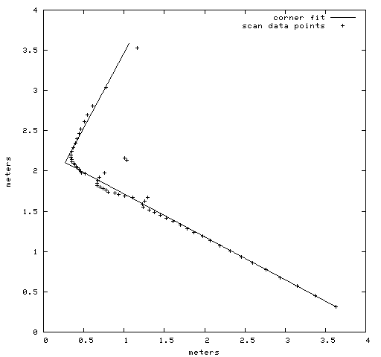
Figure 36: Corner fitting

Figure 36 is an example of corner fitting in the presence of corner rounding, outliers and variable point spacing. The fit matches the overall outline accurately fairly accurately.

Shape classification
After fitting and line and corner, each segment is given a shape classification:
corner | Corner fit mean-squared error less than line fit and less than 10 cm.
line | Line fit mean-squared error less than 10cm.
complex | Fall-back shape class for objects with poor linear fit.

There are two Boolean shape attributes which are semi-independent from the shape-class:
compact | Diagonal of bounding box < 0.7 meters and point density > 5 points/meter. The compact criterion is chosen so that pedestrians will be compact (as will lamp-posts, fire hydrants, etc.) Because compact objects are small, we can estimate their velocity reasonably accurately without having a good linear fit.
disoriented | Rotation angle not well defined. True if the line or long side of corner has less than 6 points, the RMS fit is worse than 4 cm, or the line and corner fit disagree by more than 7 degrees and the chosen classification’s RMS error is less than 4 times better than the alternative. Segments that are complex or < 0.7 meters diagonal are always disoriented.  The disoriented attribute is used to determine whether to use the change in orientation for turn rate estimation. Also, if a segment is disoriented and not compact, then it has a poor linear fit, and we are more skeptical of the motion estimate.

Due to the restrictions of single-scanner perspective and 90 degree convex corners, there is a small fixed set of possible features that a segment can have:
min, max | The two diagonal corners of the bounding box (in world coordinates.) Defined for all shape classes.
first, last | End points in a line segment, ends of the two sides in a corner segment.
corner | Corner point in a corner segment.
center | Rough estimate of object center derived from other features. Defined for all shape classes.

Figure 37 illustrates a segment with all features present.

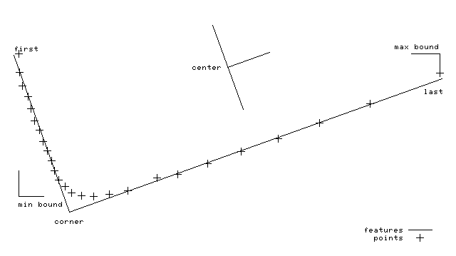
Figure 37: Features

Feature noise model
We observed earlier that due to the distinct angular and range resolution of the scanner, the shape of the position uncertainty in Cartesian coordinates is strongly asymmetrical.

The Kalman filter used in the tracker uses a statistical model of error in the measurement. If the actual measurement and modeling errors are white and zero-mean, then the Kalman filter is optimal. In practice, our errors differ greatly from this ideal, so there is no theoretical optimality. However inaccurate, in order to use the Kalman filter, we must attempt to capture the measurement error characteristics as a two-dimensional position covariance.

There are two parts of the noise model: the prior noise and the adaptive noise. The prior noise is determined from the segment points for one single scan, and is based mainly on the geometric properties of the scanner. The adaptive noise is estimated as part of the filter update, and will be discussed later.

The prior noise for linear features is computed from separate longitudinal and lateral variances that are then rotated into the world coordinates. The lateral variance is 1 cm or the mean-square line fit error, whichever is greater.
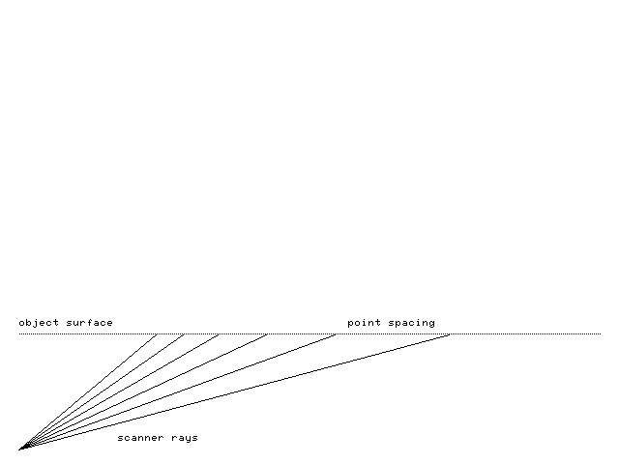
Figure 38: Incidence angle and point spacing

Geometrically, the longitudinal measurement uncertainty goes to infinity as the scanner ray approaches parallel to the line (see Figure 38.) Due to the segmentation algorithm, the observable inter-point spacing is limited to the segment threshold (0.8 meters.) The prior longitudinal variance is (0.3 * spacing) 2, where spacing is the maximum inter-point spacing of the last 7 points at the end of the line. Using the actual inter-point spacing incorporates the geometric angular resolution effect, and also additionally discriminates against objects with missing returns (due to poor reflectivity.)

If a segment is disoriented, we are unsure of the orientation, so also unsure of the orientation of the measurement error uncertainty. In this case we bound the ratio of the longitudinal and lateral variance to 5 by increasing the lateral variance.

Vague line ends
A line-end feature can be marked as vague, which means that its longitudinal position is so poorly determined that the endpoint position should be regarded as arbitrary by the tracker. A vague line end is still usefully localized laterally, and one end of a line can be vague when the other end isn't.

Due to shape change and occlusion, it turns out to be crucial to identify situations where the position of line ends is unreliable. This need results in a rather complex decision rule. A line end is vague if:
- The scanner point defining the endpoint position was occluded,
- The prior longitudinal error estimate is exceeds 15 cm, or
- The next adjacent point not assigned to this segment is at least 1.2 meters behind the line. Any intervening no-return points are skipped.

Rule 3 has these functions:
- It is a more precise occluded test in the case of a line with known orientation.
- It also marks ends as vague when the adjacent point in the next segment falls near the same line, hence may well be part of the same object that happened to be segmented separately due to missing returns.

Data association
Data association is the process of determining which current measurements correspond to existing tracks. In the context of the long-range tracking literature, our approach is basically nearest-neighbor. We pick one single segment in the measurement data which most closely resembles the prediction and use that for the new estimate. However, since each segment has many 2D points, the concept of “distance” is rather complex.

Our first approach to data association used the combined log-likelihood of the feature positions as a distance measure, then chose the most likely segment. However, we found this approach performed poorly, in that it both created bad tracks by associating separate objects and also caused good tracks to break up if the object shape changed too much. To the human eyeball the errors seemed rather silly.

Overlap based association
We now use an approach based primarily on spatial overlap between the track and the measurement data. The concept of overlap-based association is simple: given rectangles representing the outlines of the track and the measurement, the two are associated if the outlines overlap.

The actual overlap algorithm is somewhat different, and handles non-rectangular objects much better. For two objects to overlap, we require that at least one actual measurement point fall inside the track outline, and symmetrically, that when the track's last measured points are updated for predicted motion, that at least one of these predicted points falls inside the segment's outline. Since the points are on the edge of the object, we expand the object outline by 0.8 meters when checking the point overlap. If there is no linear fit (complex shape class), then we use the bounding box in fixed coordinates as the object outline.

This algorithm works well even when a moving track passes though a concave part of a large fixed object (wall, etc.) In this case, none of the wall's points fall inside the track outline, even though the bounding box for the wall may entirely enclose the track.

Track splitting and merging
In addition to its robustness, another advantage of overlap-based association is that it leads to a straightforward way of detecting when tracks split or merge. In these cases, overlap does not establish a one-to-one correspondence between tracks and segments. If a track splits, then there will be two segments overlapping the track. If two tracks merge, then there will be two tracks overlapping one segment.

Actual splitting or merging can happen when pedestrians get into or out of vehicles. In practice, segmentation errors are the most common cause of splitting and merging. In the presence of clutter, an object may appear to split from or merge with another nearby object. Missing returns can also create holes in the middle of objects, causing them to split in two.

Whatever the cause, it is important to detect when tracks merge because it is a common reason for track disappearance. See section Track Creation and Deletion where we discuss the “died without offspring” test.

When two tracks join, the ID of the merged track is that of the older track.

Maximum closeness:
In addition to split/merge situations, our fairly permissive overlap test can also generate complex overlap relationships when tracks are simply close together. Since in general the overlap test may create a many-to-many association between tracks and segments, we need a procedure for deciding which particular association to make.

This discrimination is done based on maximum closeness, where closeness of a track and segment is defined as the sum of the reciprocal of the individual feature distances. This differs from the RMS distance in two important ways:
- The result is dominated by the best agreeing features, not the worst, so it is not confused by the gross shape change which happens when tracks split or merge, and
- The result is not normalized by the number of features in correspondence. The more features, the higher the closeness. In a split/merge situation, we want to discard the track or segment with less information.

Tracks are associated from oldest to newest, which gives older tracks preference. A track may associate with a segment that is not mutually closest (there may be another newer track that is closer.)

Feature correspondence
Once we have decided which track and segment correspond, we are faced with the problem of feature correspondence: which features in the track and segment represent the same point? Due to our extremely restricted feature model, this is much simpler than it might be.

The only case where features may not correspond directly is when associating lines and corners. This happens when we move around an object, sometimes being able to see two sides, sometimes only one. Correct handling of this case is important because often visibility of one side of an object will be marginal due to shallow gaze angle, and the segmentation will keep flipping between line and corner.

Often the corner will correspond to one of the endpoints of the line, but sometimes the line ends match better onto the ends of the sides of the corner. We associate the line with whichever side of the corner is a better directional match, as long as this has less mismatch than the direct ends-to-ends match.

Track creation and death
If we fail to associate a measurement segment with any existing track, then we consider creating a new track. A new track is created if the segment has at least 3 non-occluded points and is not a line with both ends vague.

If we fail to associate an existing track with any measurement segment, then we may delete the track. Tracks are deleted if they have not been associated for 10 cycles or the total number of previous associations, whichever is less.

When a track dies, we report this event, whether the track merged with another object, and also whether the track “died without offspring”. This is determined by examining the split-from chain of all currently live tracks, seeing if the dead track was a parent. This test is done to support detection of objects that may still be present but have passed out of the scanner field of view (pedestrians that have fallen down.) If some track that split off is still alive, then the split was probably spurious (due to a segmentation problem), so there is no real disappearance.

Track state and dynamic model
The basic dynamic model is constant acceleration and constant turn rate. There are nine state variables: XY incremental motion, XY velocity, XY acceleration, position theta, heading theta and angular velocity. The first six states estimate translational motion and the last three estimate heading and turn rate. All of the translational states are expressed in the fixed world coordinate system. The track incremental motion is initially zero, and is an estimate of the net XY motion since track creation.

Using a constrained vehicle dynamic model such as the bicycle model, the velocity and acceleration are single-dimensional when expressed in the track's moving coordinates. We implement a similar effect by rotating the velocity and acceleration by the predicted incremental rotation on each update cycle. However, we maintain a 2D velocity and acceleration, so our model allows for velocity and acceleration normal to the vehicle heading (in addition to the apparent acceleration due to turning.) While this can happen in a skidding vehicle, this is not really relevant in our application. The interpretation of the 2D acceleration is somewhat non-obvious, as it is the residual acceleration after the effect of turning has been removed.

There are actually separate linear Kalman filters for linear estimation (6 state) and rotational estimation (3 state.) In the future we plan to investigate a combined 7 state nonlinear filter which would simultaneously estimate the linear and rotational motion without unnecessary degrees of freedom.

The dynamic model for compact objects (such as pedestrians) is modified by forcing acceleration to zero. Pedestrians don't spend much time in a constant acceleration regime, so predicting parabolic trajectories doesn't make sense. We do however predict pedestrian “turn rate” as in the bicycle model. Though pedestrians don't really turn on constant curvature paths, they don't normally turn abruptly either, so this seems to have some value.

Rotational estimation
Additional complexity for rotational estimation comes from the fact that we can sometimes (see Shape Classification) directly measure vehicle heading (orientation theta), and thus fairly directly measure the turn rate. For other tracks, the only way to discern the turn rate is to observe the change in the direction of velocity (heading theta) over time.

Due to the kinematics of the bicycle model, the instantaneous velocity of a turning vehicle is not normal to the front or back surface of the vehicle. Fortunately, we are really mainly interested in estimating the angular velocity, not the heading, and the time rate of change of the velocity vector is the same as for the orientation of any part of the vehicle outline.

However, we run into problems when we are forced to switch between these two orientation estimates (when the disoriented flag changes.) This can create spurious jumps in position that would be interpreted as angular velocity. By maintaining separate estimates for these two different headings we avoid this confusion.

Tracking features
Because we have up to three features for each for each track, we have a data fusion problem. How do we combine the motion estimates from the separate features into one track motion estimate? Fortunately, the Kalman filter provides a natural framework for data fusion. Each feature can be considered an independent measurement of the position.
Because each feature has its own error model, the Kalman filter weights the contribution of each feature appropriately.

One complication is that the features do not have the same position because they are different points on the object. To allow motion assessment of individual features, we need to know the previous position of each feature. This is done by a modified Kalman filter structure. Each feature has an independent position, but shares its motion with the track. The position innovation is determined by subtracting the old feature position and the new measurement. The Kalman gain is the computed using the feature's position noise and the track state covariance. The position part of the track state change is applied to both the feature position and the track incremental motion.

Vague line ends are tracked specially. Although vague line ends are given a large longitudinal position covariance, this does not cause a sufficiently profound suppression of spurious longitudinal motion. There is large rapid motion of vague line ends in common situations such as a side of an object becoming visible when we round the corner. To completely suppress this motion, we zero the longitudinal component of velocity and acceleration state change for vague line ends. We allow the incremental motion to be affected so that huge jumps in longitudinal position can still cause the association to fail (due to excess state change Mahalanobis distance.)

Which features contribute to the motion estimate depends on the shape classification. Of course, features not present can't contribute. Less obviously, the motion of the bounding box corners only contributes to the motion estimate when the shape class is complex. We track the position of the bounds regardless, so that we have a valid feature position and noise estimate available if the shape switches to complex.

Track center
We maintain a crude estimate of the track center. This is done via the center pseudo-feature. During shape classification, we compute the center as the midpoint of the object. For center finding on linear objects, we extend vague sides to be at least 2 meters long. This can be regarded as a prior object model that everything is a 2 meter square.

Because this is a very low quality estimate, and is in any case contains no additional motion information not present in the other features, the motion of the center feature is measured using a separate Kalman filter. This gives some smoothing of the center position, while avoiding any interaction with the actual motion estimate.

Noise adaptation
We make use of measurement noise adaptation to estimate the position covariance for each feature. The primary benefit of measurement noise adaptation is in its effect on the data-fusion aspect of the Kalman filter: noisy features contribute less to the motion estimate. This is valuable because some features are much noisier than others.

The noise is estimated from the statistics of the measurement residue, which is the disagreement between the predicted feature position and the measured one. (With our dynamic model, the residue is the same as the feature position innovation.)

The covariance of the residue is an estimate of the position measurement covariance.
In theory, for computing an adaptive measurement noise, we should reduce the noise residue by the estimate covariance to represent the contribution to the measurement residue from the estimate uncertainty. However, this risks creating small or even negative measurement noise when the estimate covariance is too high. Since we are knowingly inflating process and measurement noise to deal with time-varying behavior and modeling error, subtracting out the state covariance would to cause problems.

If the mean of the residue is not nearly zero, this indicates a non-zero-mean error. In some applications it would be appropriate to subtract out this mean from the measurement; in our case there is no independent measurement of the feature position, so a significant mean error means that we are not tracking properly. If the residue mean exceeds 10 cm, we reset the feature position from the current measurement and clear the residue mean to zero.

The need for this resetting comes from a sort of instability that the noise-adaptive tracker exhibits in the presence of time-varying non-zero-mean disturbances. In short, if a feature position drifts around, and no compensating track velocity is inferred (perhaps due to data fusion correctly rejecting spurious motion), then the measurement covariance for that feature becomes inflated, and this further degrades the tracking performance for that feature. Our response in this situation is to allow the feature to be basically ignored by fusion, but to keep the feature position approximately correct by resetting the position when the residue mean becomes too large.

Residue update has two phases: during track startup, we compute recursive mean and covariance with equal sample weighting. After 0.3 seconds, we switch to a first order response (exponential decay) with 0.3 second time constant. Initially, the sample is small, so the estimate is unreliable. For the first 15 cycles, we use only the prior noise estimate. After 15 cycles, we use the sum of the residue covariance and (prior_ noise * 0.57). The prior noise then serves as a lower bound on the adaptive noise. This lower bound is particularly valuable in cases where the prior noise is high (like vague line ends.)

Improving the Kalman filter for non-Gaussian errors
The Kalman filter is optimal when the measurement error and process disturbance are Gaussian. One of the characteristics of the Gaussian is its light tails: it is very unlikely that a result will be very far from the mean. Unfortunately, when feature tracking breaks down, it can produce outlier measurements which are effectively impossible in the Gaussian model.

Since a Kalman filter doesn't suppress these glitches it is common to extend the Kalman filter by limiting the magnitude of outlier measurements or discarding them. We make use of this approach in several places:
- If the change in track state due to a measurement is too incredible, then we discard the measurement. This is done when the Mahalanobis distance of the state change with respect to the estimate covariance exceeds 6. Before discarding the measurement, we see if we can get a reasonable association by resetting a subset of the features. We reset any features that contribute a state change with Mahalanobis > 4 by setting their position to the measurement, zeroing their contribution to the innovation.
- The time rate of change (d/dt) of velocity, acceleration and angular velocity are limited to physically plausible values: 9.8 meters/sec², 5 meters/sec³, 60 degrees/sec². Note that these limits are applied to the incremental state change, not just to the output estimate. For example, the acceleration limit is applied not only to the acceleration estimate, but (more importantly) also to the change in velocity estimate on any given update cycle. This prevents impossible jumps in position from causing big velocity jumps.
- The measurement of heading from feature orientation (orientation theta) is prone to jump when there is a track merge/split or the shape classification changes. If the innovation exceeds 7 degrees in this situation, then we reset the position to the new measurement.

Track startup
When a track is newly created, the dynamics are unknown, so we assume that the velocity and acceleration are zero. If a track splits off of an existing track, we initialize the velocity and acceleration to the one for the existing track, but still leave the estimate covariance at the default (large) value.

Commonly tracks will come into range already rapidly moving, so this prior velocity can be significantly in error. It takes some time for the measurement to settle to the correct value, and dv/dt limiting prolongs this. During dv/dt limiting we hold acceleration fixed, as otherwise the acceleration slews wildly because the Kalman filter feedback loop is open. We also modify the Kalman filter update so that the velocity covariance is effectively fixed during dv/dt limiting, preventing spurious covariance convergence.

The physical dv/dt limit does not apply during track startup because this velocity change is not a physical acceleration. As a heuristic, we increase the dv/dt limit when the velocity covariance is high. We allow the velocity to change by 12 sigmas per second if this is higher than the physical limit.

Information increment test
When attempting data association of a segment and track, we find the information increment, which is a measure of how much the track was influenced by this measurement. If the information increment is low, then the track is not responding to the measurement because the measurement is considered too noisy relative to how certain we think we are of the current state. In this case, the tracker is not actually tracking anything, just speculating based on past data.

A common problem situation is that a track may change to a line with both ends vague. In this case, the track is localized in one direction only, and the longitudinal velocity is unmeasured, which can lead to unacceptable spurious velocities. Low information increment can also happen if we reset all of the features in a track or when a track is very noisy (via noise adaptation.)

To keep the track from coasting indefinitely, we fail the association when the information increment is below 0.04 (response time constant of 25 cycles.) Tracks that are not associated for 10 cycles are deleted. If there is a one-to-one overlap relationship, then we pretend not to associate for purposes of the deletion test, but actually do associate. This helps to keep good tracks tracking properly in situations where the association is clear but the information is momentarily bad.

Though we call this "information" increment, the computation is really based on the covariance. This mimics the computation of the Kalman gain, which is what actually determines the response speed of the filter. If w₊ is an eigenvalue of the covariance after the measurement, and w₋ is the eigenvalue before update, then the info increment is the mean of w₋ /w₊ - 1 for the two eigenvalues. The eigenvalues are sorted so that we compare eigenvalues of similar magnitude.

The assumption is that the eigenvectors are little changed by any one measurement cycle, so the change in the sorted eigenvalues represents the change in uncertainty on each axis in the rotated (uncorrelated) coordinates. This insures that the track is well localized in two dimensions.

Track evaluation
The tracker outputs two flags for each track to aid in the interpretation of the result:
Valid | true when the motion estimate is believed to be accurate
moving | true if there is compelling evidence that the track is moving

Spurious velocities on fixed objects can easily cause false collision warnings. Since true imminent collisions are very rare, and fixed objects are very common, we must drive down the reporting of false velocities on fixed objects to a very low level in order to get an acceptable rate of false alarms.

To achieve this we have developed an additional evaluation procedure that operates independently of the Kalman filter. We collect the last 35 segments (raw measurements) associated with each track, then check how well the track path matches up with the measurements if we project it backward in time.

If our dynamic model adequately describes the motion and the estimated parameters are close, then the paths should agree well. If the match is poor, then there is either unmodeled disturbance (rapid change in acceleration or turn rate), or there is a tracking failure due to problems in feature extraction, etc.

We accumulate two different streams of information about the difference between the back-predicted location and measured location of corresponding features:
- The mean-square Mahalanobis distance according to prior position error. This is used to evaluate moving and valid.
- The Euclidean distance normalized by the elapsed time from the measurement to now. The mean is a velocity correction and the covariance is an estimate of the velocity covariance. The velocity correction is added to the output velocity. If the covariance is bigger than Kalman filter covariance, then it is output instead.

We also find the sum of the position information for all features in the history that contributed to the distance estimate. This is used to determine whether the history has adequate quality to localize the track in two dimensions. The smaller eigenvalue of the information matrix must be greater than 35 meters⁻¹.

This information eigenvalue is also used to normalize the Mahalanobis distance back into a nominal length, which is then compared to a threshold for the moving/valid test. For a track to be marked valid, the distance must be less than 5 cm, and after that must stay below 15cm to remain valid. Though the units are meters, the physical interpretation is obscure. The empirically chosen values seem reasonable if regarded as an RMS fit error in meters. The advantage of this distance measure over a simple RMS distance is that it takes into consideration the asymmetric prior error distributions generated by the position measurement model.

We also compare the past measurements to the null hypothesis that we are not moving at all. This is done using the same comparison procedure, but with no projected motion. We then compare the matching error of the two hypotheses. For the track to be moving and valid, the matching error of the moving hypothesis must be 4 times less than that of the fixed hypothesis. This rejects situations where there is equal evidence for moving and non-moving because one feature moves and another doesn't.

In order to minimize the effect of noisy variation, the results of the history analysis are filtered using an order 21 median filter before being tested against the above limits.

Because the history-based validation is fairly computationally expensive (about 250 microseconds per track on 1.2 GHz PC), we have used several optimizations:
- Only do history test on apparently moving tracks. A track is apparently moving if it has a feature that has been tracked for at least 15 cycles, the speed is greater than 0.75 meters/sec, Mahalanobis distance of the velocity from zero exceeds 6. There is hysteresis in this test so that tracks tend to stay moving once they are initially moving. Also, if a track is a line with two vague ends that was not previously moving, then only the lateral component of the velocity is considered.
- Only use the oldest 1/3 of the history data, as this contains most of the information about velocity error.
- Limit the number of tracks validated on any tracker cycle to 4. There are seldom this many moving tracks, so this limit is rarely exceeded. The purpose is to bound the runtime of a single tracker iteration.

Evaluation
Linear feature tracking has been tested primarily as part of the larger collision avoidance system, with the main tuning criterion being minimizing the number of false alarms due to spurious motion. However, there are a number of ways that we can characterize the performance of the tracker. First, we can visually examine the output to get sense of the noise and response time of the output. Figure 39 shows the output for a car that comes into view turning a corner, then drives straight.
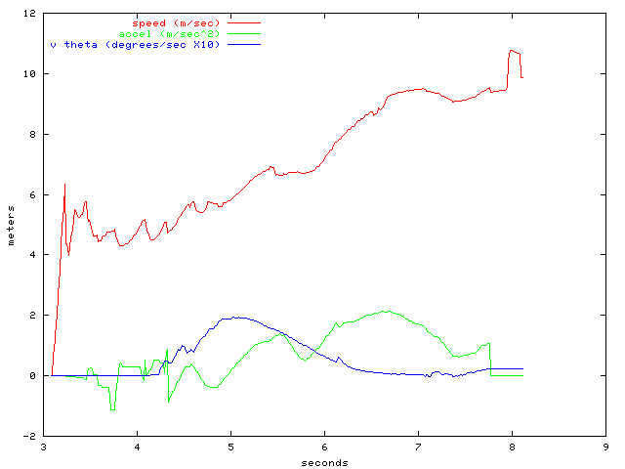
Figure 39: Tracker dynamics

The track is flagged as moving and valid at 4.3 seconds. After that time, the noise fluctuations in the velocity seem to be less than 0.5 meters/sec peak-to-peak. The acceleration and turn rate (v_theta) are fairly smooth, but clearly have a lot of delay. The vehicle is probably near peak turn rate at the time that the track is detected as moving, but the peak in output turn rate happens almost a second later.

The acceleration estimate is also responding to the low frequency change in velocity, but slowly. At around 5.7 seconds it appears that the acceleration is near zero. The output estimate is dropping fairly rapidly, but doesn't make it to zero during the apparent low acceleration period.
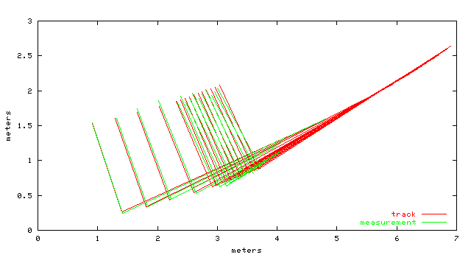
Figure 40: Track history matching

The history-based track evaluation provides another way to investigate tracker performance. By using the current motion estimate to predict the past position, then comparing with the actual measurements, we can get a sense of how well the tracker can predict motion over short periods of time (0.3 seconds.)

Though the idea of comparing the prediction to actual measurements is a good way to verify the tracker performance, this particular data is not very good evidence because of the short time scale (where the effect of acceleration and turn rate error is slight) and because the velocity correction is calculated from this very data so that it minimizes the error. It would be much more convincing to show that we can predict the future.

We can see that there is very good agreement of position, showing the velocity estimate is fairly accurate. Also, we can see that the turning approximately matches up as well. Slight acceleration error is visible in the middle of the sequence (the first order velocity correction forces both ends to line up.)

Summary
We have found that the linear feature tracker combined with history-based track validation is able to generate reasonably accurate velocity estimates for cars and pedestrians in a cluttered urban environment, while giving a low rate of spurious motion indications that can cause false alarms. These false alarms are discussed in detail in the Sections 6.3 titled SCWS Warning Algorithm and 6.4 False Alarms. The estimation of acceleration and turn rate appears to improve prediction of future positions, but the prediction would be significantly better if the response time could be improved.

We also have enough experience in working on this particular problem to be able to state with some confidence that any significantly simpler approach will not be able to achieve comparably low levels of false motion estimates. When the scanner is in motion, the apparent shape of objects changes, and fairly sophisticated measures are required to determine that this is not actual motion.

The computational efficiency is significantly better than some of our previous attempts at solving this problem. No large data structures such as maps are used. The average time to process one scan on a 1.2 GHz PC is 4 milliseconds. The code size is about 7000 lines of C++, and is written at a fairly high level of abstraction, so considerable further performance gains could likely be achieved if necessary.

FCWS Warning Algorithm
From 2001 to August 2003, three generations of warning algorithms were developed, with each later version being an improvement on the previous version. The current version is the third generation algorithm, which has undergone further improvements based on data analysis and driver feedback since September 2003. The features and improvements of the third generation of algorithm are summarized in the following table and the five points below. The improvements to the third generation algorithm and its modification in order to process radar data are introduced later in the chapter.
 | Object model | Bus model | Driver | Coriolis effect | Finite-size-object effect | Threat measure
1st algorithm (2001) | Free-moving | No consideration | No consideration | No consideration | No consideration | TTC  (Time-to-Collision)
2nd algorithm (2002) | Non-holonomic | Non-holonomic | Empirical TTC threshold | Decoupling bus motion from sensor data | No consideration | Speed-dependent TTC
3rd algorithm (2003) | Free-moving (stopped or creeping targets) + non-holonomic (moving targets) | Non-holonomic | Empirical required deceleration threshold | Decoupling bus motion from sensor data | Delayed-filter which can well estimate acceleration from range data | Required deceleration
Table 18. Features and improvements of three generations of FCWS algorithms

The main features of the third generation algorithm are described in the following five points:
- Model: Moving targets are modeled with non-holonomic constraints, so that heading and yaw-rate can be more precisely estimated. For stopped and creeping targets a free-moving model is used because moving direction can not be detected from short-time displacement. A free-moving model is a 2D kinematic model based on Newton’s laws of motion. A non-holonomic constraint means that lateral slide is prohibited.
- Driver’s role: It is taken into account that the bus driver is working in parallel with FCWS, and responsible for fusing warning information with his/her own perception and decision making. Empirical data were analyzed to derive thresholds from the driver’s behavioral data so that the FCWS can better match the driver’s normal operation.
- Coriolis effect: The algorithm decouples the bus’s motion from sensor observations so that the Coriolis effect can be eliminated. The Coriolis effect introduces an imaginary component of motion due to the rotating of the sensor’s coordinate frame of reference.
- Finite-size-object effect: The finite-size effect introduces ranging error due to the size of vehicle bodies. The “delayed filter” can better estimate target velocity and acceleration by delaying the update of the model to improve the displacement-to-error (signal-to-noise) ratio that is usually impaired by finite-size effect.
- Threat measure: Required deceleration is used as threat measure. Required deceleration is the minimum deceleration that should be applied to the bus to avoid an imminent collision with a preceding object. TTC (Time-to-Collision), speed-dependent TTC (which is a look-up-table of empirical TTC derived from real data indexed by object speed and bus speed) were also tried as threat measures, but required deceleration is more natural in terms of matching with the driver’s operation. It is the delayed filter which makes it possible to utilize the required deceleration as the threat measure.

FCWS Algorithm structure
The structure of the warning algorithm is shown below. The main data structure-track file, the tracking and warning detection algorithm are described in detail at the end of this section.
Figure 41 FCWS Algorithm structure

FCWS Data structure

Track file structure
A track file is a list of tracks being processed. Each track is a correlation and refinement of the time sequence of observations of an object (a target). An ID indexes each track using the name (usually an integer) for an object under tracking. An object under tracking is described by the object state in the track file. Object state is a combination of kinematic states and track properties of an object.
Figure 42 FCWS Track file structure

The designed track file consists of two major memory buffers: track head buffer and data buffer. Both are declared as linear arrays but are organized in linked-lists. Every track head cell belongs to one of the following five levels:
LEVEL_DISUSE: currently not in use;
LEVEL_INITIAL: initial tracks;
LEVEL_TENTATIVE: tentative tracks;
LEVEL_PREMTURE: premature tracks;
LEVEL_FIRM: firm tracks.
Each level of track heads is organized as a double-linked list. Each track head is then linked to a double-linked list of historical data of the track. The whole data buffer is organized as a circular queue (or equivalently a First-In-First-Out (FIFO)). If the head of the queue reaches the tail, the oldest cells are released from double-links of tracks to provide memory for new data. New data collected in the latest snapshot are saved in a double-linked list. The structure of track file is illustrated in the above picture.

Track head data structure
One key element of a track file is the data structure for storing track information. This is defined in the TRACK_HEAD structure;
where ID is the index of a track, Pred is the predicted state.

Object state data structure
Another key element of a track file is the data structure for storing data of an object in one snapshot. This is defined in the OBJECT_STATES structure:
where t[] are time members (e.g. time of availability of data and estimated time for filtering output considering the delays); pntr[] are pointer members for data structure manipulation (e.g. building up linked lists); iobsv[] and dobsv[] are observation members for raw data storage; par[] are estimated motion states members for refined parameters storage; the identifiers in brackets are constants.

This structure is easily extendable. The usage of members is defined in the program and is subject to change. Currently the constants are:

Linked lists of tracks
Tracks are categorized into four levels: initial, tentative, premature and firm (see section Error: Reference source not found and Error: Reference source not found for details of these levels). Each level of tracks is organized in a double-linked list. The sub-routine “ChangeTrackLevel()” can move a track from one level to another. Upon initialization, all track heads are put in “disuse” category. Sub-routine “FreeTrack()” can move a track from any level to disuse.

Linked lists of track histories
The historical data of tracks are built in double-linked lists. Each node is an OBJECT_STATES structure. The following figure shows a typical linked list.
Figure 43 Linked list of tracks and historical data

where ID of the track is saved in DATA set of each node.

Mertz, Kozar, Miller, Thorpe. “Eye-safe Laser Line Striper for Outside Use.” IV 2002, Proceedings of the IEEE Intelligent Vehicle Symposium (IV2002). June 2002. http://www.ri.cmu.edu/pubs/pub_3890.html
Aufrère, Mertz, and Thorpe. “Multiple Sensor Fusion for Detecting Location of Curbs, Walls, and Barriers,” Proceedings of the IEEE Intelligent Vehicles Symposium (IV2003). June 2003.
op. cit.
Thorpe, Charles E. Vision and Navigation: The Carnegie Mellon Navlab. Kluwer Academic Publishers, 1990.
Gowdy, Jay. Emergent Architectures: A Case Study for Outdoor Mobile Robots. Thesis for PhD at the Robotics Institute, Carnegie Mellon, CMU-RI-TR-00-27. November 2000.
Gazi, Moore, Passino, Shackleford, Proctor and Albus. The RCS Handbook: Tools for Real-Time Control Systems Software Development. New York: John Wiley & Sons, 2001.
The Object Management Group. The Common Object Request Broker: Architecture and Specification. Massachusetts: 1996.
Gowdy, Jay. {IPT}: An Object Oriented Toolkit for Interprocess Communication. Technical Report for the Robotics Institute, Carnegie Mellon University, CMU-RI-TR-96-07. March 1996.
Hayes-Roth, B. A blackboard architecture for control. Artificial Intelligence, Volume 26. 1985: 251-321.
Mills, David L. Internet time synchronization: The Network Time Protocol. Published as: The Network Working Group Request for Comments: 1129. October 1989: 1-29.

