PROGRAM APPLICATION INSTRUCTION/OPPORTUNITY SYNOPSIS

DEPARTMENT OF TRANSPORTATION

Federal Transit Administration

Section 5309 Discretionary Bus and Bus Facilities Program and Section 5312 National Research Program Funds

ACTION: Notice of Funding Availability (NOFA) of FTA Section 5309 Bus and Bus Facilities Program and Section 5312 National Research Program Funds: Solicitation of Project Proposals for Veterans Transportation and Community Living Initiative II Grants

____________________________________________________
FTA will announce final allocations on the FTA website and to subscribers of Veterans Transportation and Community Living Initiative grant program update emails at http://www.fta.dot.gov/veterans. Applications must be submitted electronically through the GRANTS.GOV “APPLY” function.

DATES:
Complete proposals for the Clean Fuels Grant program must be submitted by 11:59 pm EDT on April 19, 2012. All proposals must be submitted electronically through the GRANTS.GOV APPLY function. Any agency intending to apply should initiate the process of registering on the GRANTS.GOV site immediately to ensure completion of registration before the submission deadline. Instructions for applying are found in this document.
Award Information:
FTA will provide approximately $25 million in unallocated discretionary FY 2012 Bus and Bus Facilities Program funds, supplemented by approximately $5 million in unallocated FY 2011 National Research Program funds, subject to funding availability, for this grant opportunity.
VTCLI II projects may consist of separate awards from the two funding sources.

FTA will award a maximum of $2 million of FY 2012 Section 5309 funds for any single project. FTA will fund up to 80% of the project cost, requiring a minimum 20% local match for capital costs. FTA will award a maximum of $50,000 or 50% of the Section 5309 request, whichever is less, in FY 2011 Section 5312 funds for research and demonstration costs directly related to the implementation of the capital project. FTA will fund 100% of the research costs.

Eligible Applicants:
Eligible applicants and eventual grant recipients for VTCLI II awards must be Direct Recipients under FTA’s Section 5307 Urbanized Area Formula program, local governments, States, or Indian Tribes. States may submit consolidated proposals for multiple projects.
Eligible Projects:
Projects eligible for funding under VTCLI II must focus on the implementation of One-Call/One-Click Centers and related transportation coordination. Eligible expenses under the Section 5309 portion of VTCLI II are capital expenses related to the establishment of a One-Call/One-Click Center and technologies to ensure transportation service connectivity. These costs include, but are not limited to: hardware purchases (computers, servers); in-vehicle technology (automatic vehicle location systems, communication devices, mobile data terminals); software (scheduling & dispatching, communications, billing, consumer mobile applications); facility-related capital (purchase, lease, alteration); design and engineering, including consultant costs; and project administration (up to 10% of total capital project costs). Capital items not listed may be eligible if clearly associated with the implementation of a One-Call/One-Click Center.

Eligible expenses for the Section 5312 portion of VTCLI II include, but are not limited to, coordinated planning, marketing, and public engagement efforts not eligible as capital but directly related to demonstrating the implementation of the proposed VTCLII capital project.
Instructions:
Project proposals must consist of two files: (1) the SF 424 Mandatory form (downloaded from GRANTS.GOV) and (2) the Supplemental Form. Proposer must use the correct supplemental form and attach it to their submission in GRANTS.GOV to successfully complete the application process. A proposal submission may contain additional supporting documentation as attachments. Mail and fax submissions will not be accepted.
Applicants should receive three e-mail messages from GRANTS.GOV: (1) confirmation of successful transmission to GRANTS.GOV, (2) confirmation of successful validation by GRANTS.GOV and (3) confirmation of successful validation by FTA. If confirmations of successful validation are not received and a notice of failed validation or incomplete materials is received, the applicant must address the reason for the failed validation, as described in the notice, and resubmit before the submission deadline. If making a resubmission for any reason, include all original attachments regardless of which attachments were updated and check the box on the supplemental form indicating this is a resubmission.
Applicants are instructed to initiate the process of registering on Grants.gov immediately to ensure completion of registration prior to the deadline for submission. Please note that the registration process can take a minimum of three to five business days, or as long as four weeks if all steps are not completed in a timely manner.
Submitting an Application in Grants.gov
In the following screenshots, the asterisk and arrow are your visual indicators of where to click based on the instructions above the screenshot.
On the Grants.gov home page, click the Find Grant Opportunities link on the left hand navigation menu
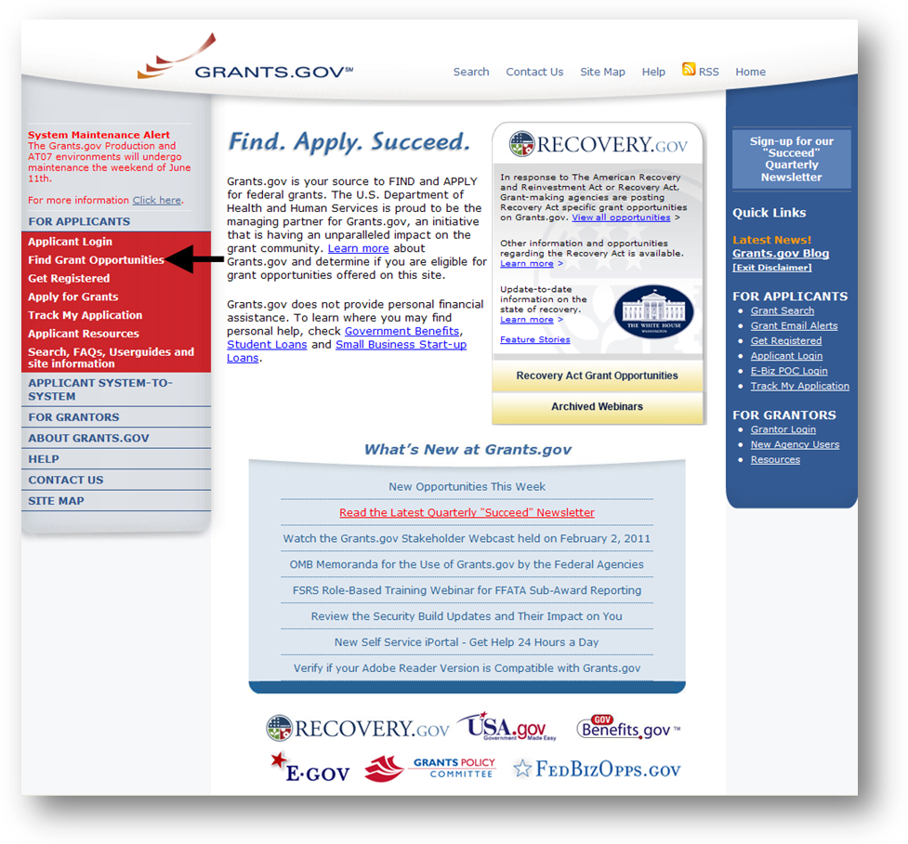
The Find Grants Opportunity screen is displayed. You can search for grant opportunities by clicking on the Basic Search link (arrow) or the Browse by Agency link (asterisk).
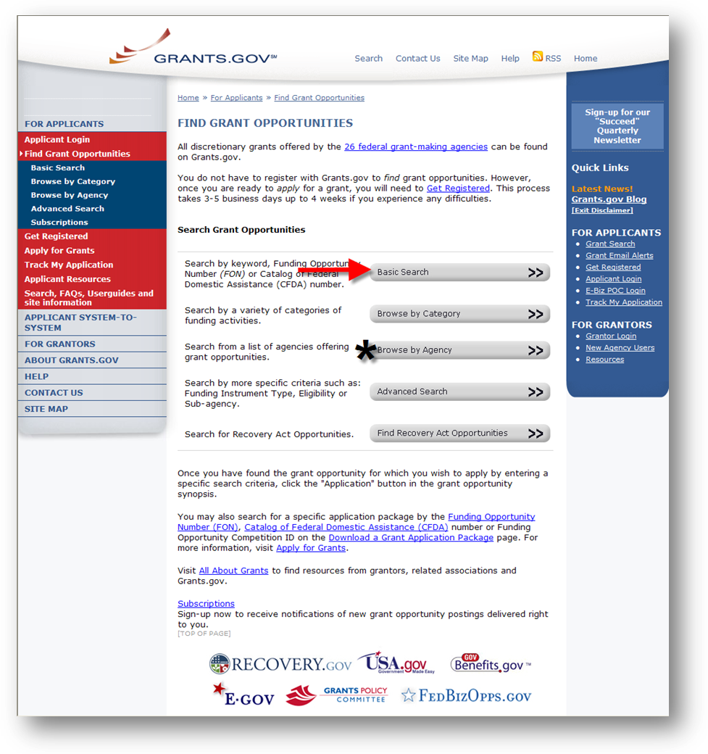
If doing a Basic Search enter a keyword(s), a Funding Opportunity number or a CFDA number then click Search. In this situation, we recommend using “FTA-2012” as the Search term
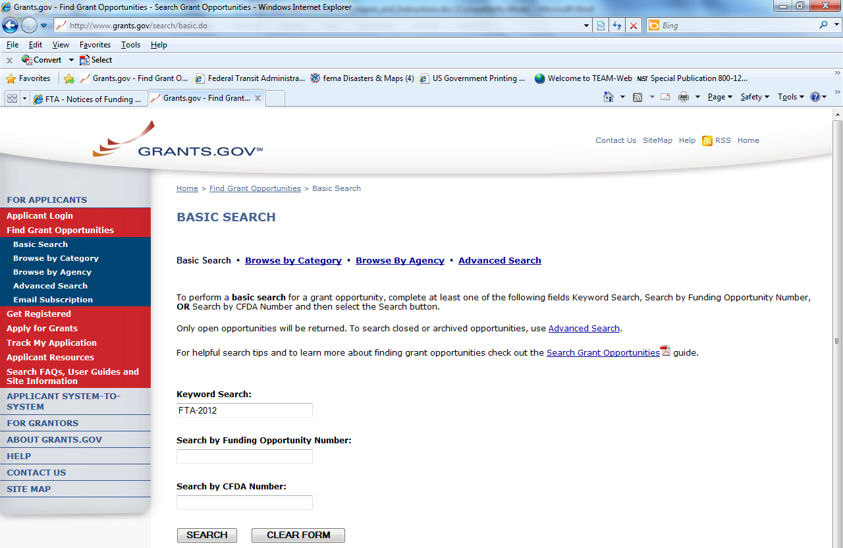
The Search Results page is displayed. All the available opportunities are displayed. Note: You may see more funding opportunities as they become available. Using other search terms may result in opportunity announcements that do not belong to FTA.
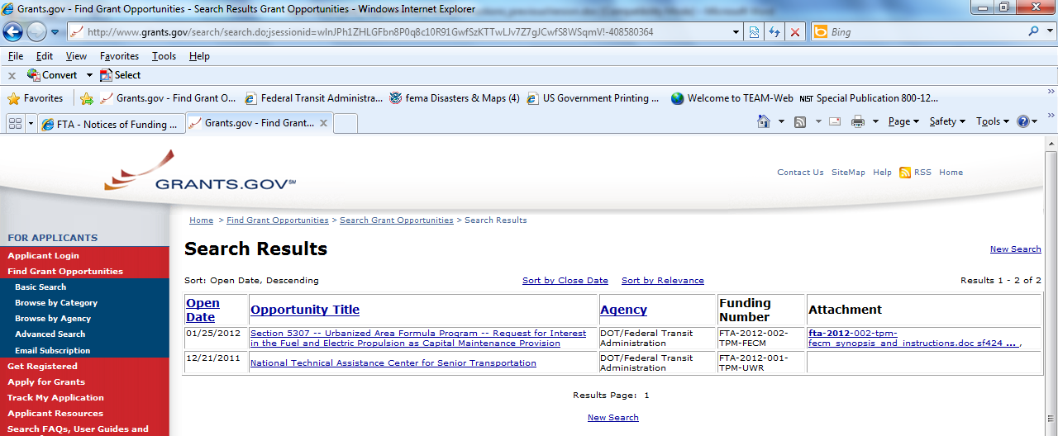
To view an opportunity synopsis, click on the name link from the Opportunity Title column shown above.

The “Synopsis” page displays details about the opportunity. To apply for this opportunity applicants are encouraged to first download and complete the Supplemental Form ("Applicant and Proposal Profile") form. To download the application package, click the Application link at the top right corner of the Synopsis page to download the Grants.gov mandatory form.
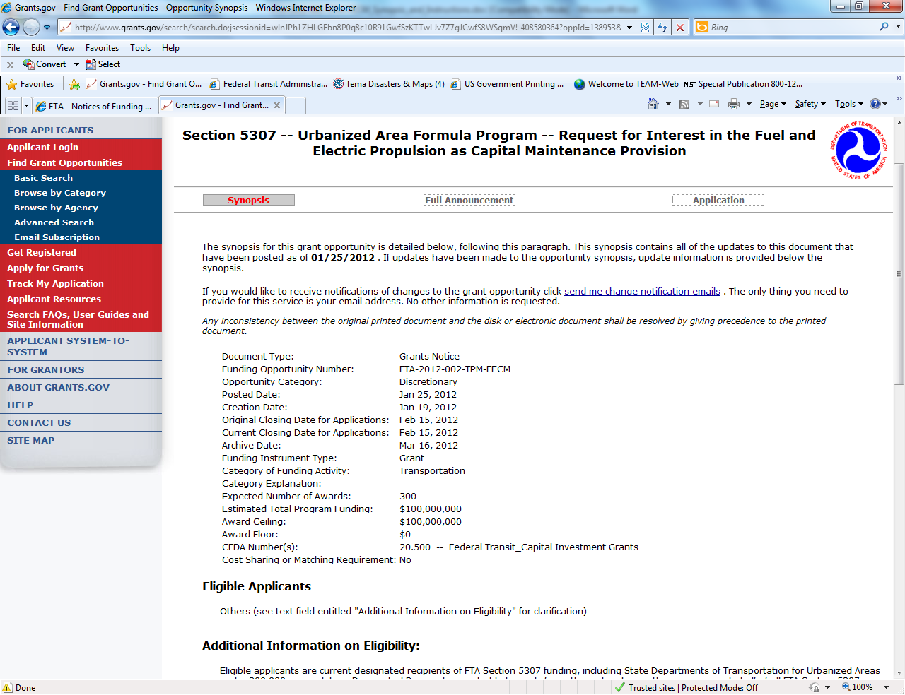

The Selected Grant Applications for Download screen is opened in a new window browser. In the table at the end of the page (shown below), click the download link located in the Instructions and Application column.
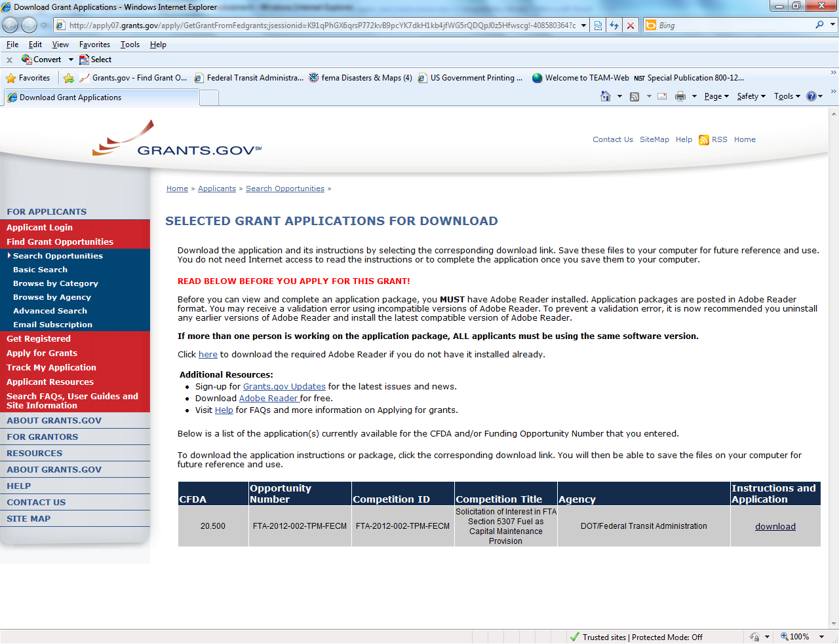
The Download Opportunity Instructions and Application screen is displayed. To download the SF424 application click link number 2. Download Application Package.
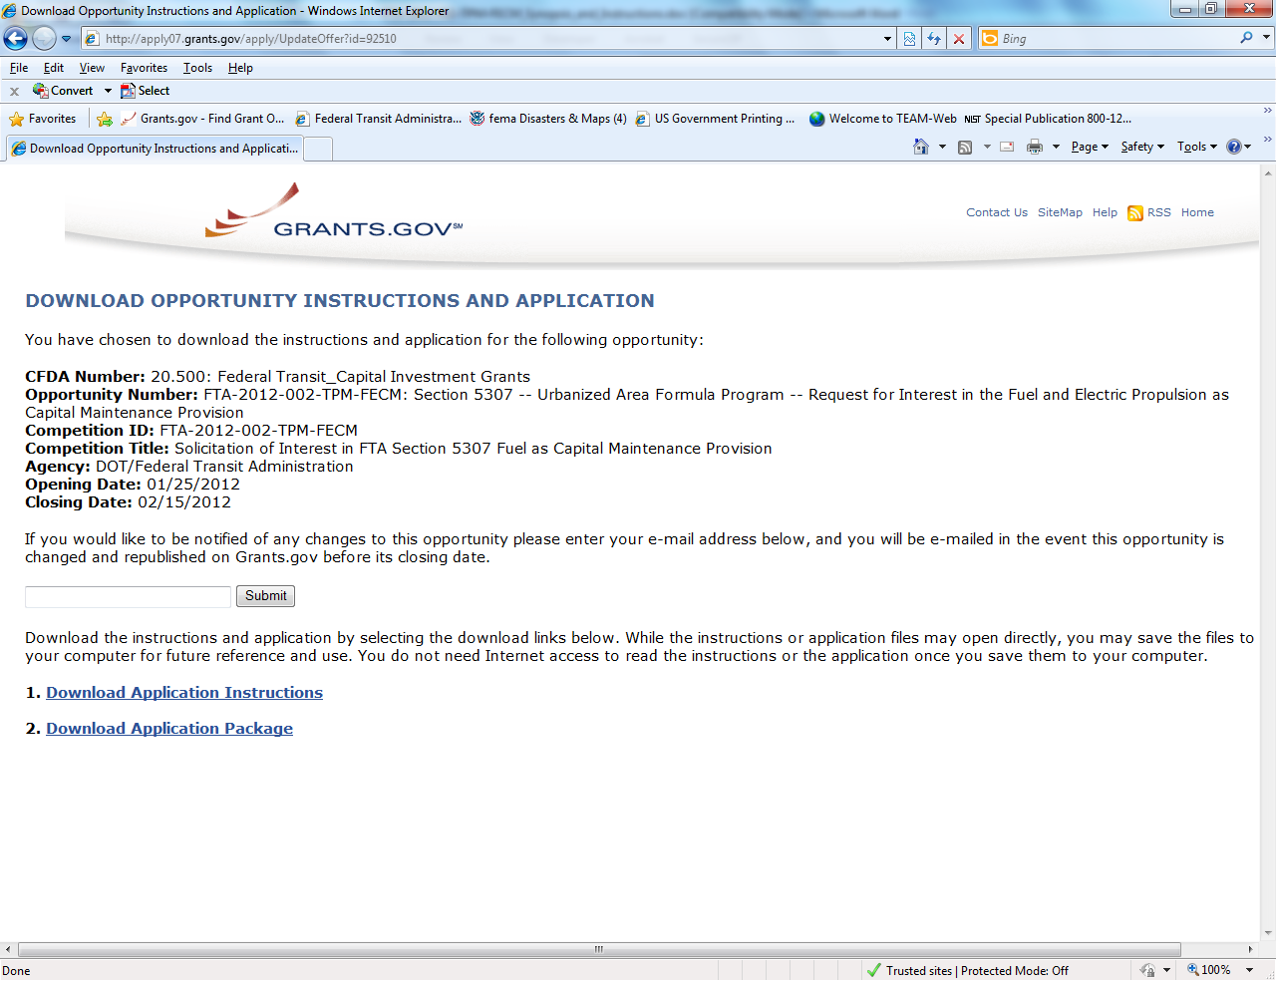

The Grants.gov Application package downloads an SF-424 which opens as a PDF file.
In the two blue boxes below the Application Filing Name, you must move the SF424 Mandatory Form and the Attachments from the Mandatory Documents to the Mandatory Documents for Submission. Simply highlight each of the forms, then click the Move Form to Complete button (see the arrows).
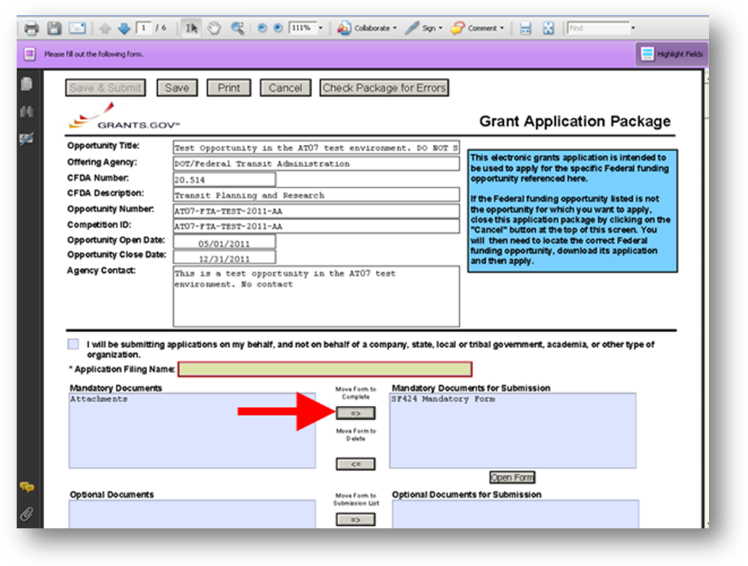

The Attachments Form you just moved over to the Mandatory Documents for Submission box is located at the end of the SF424. You MUST attach the corresponding Supplemental Form (a.k.a. applicant profile) or your proposal will not be accepted by FTA. For example, if you are applying for a Grant Opportunity for Clean Fuels Program, you must attach the Clean Fuels Program Supplemental form in the Attachments Form section of the SF424. If you do not attach the correct Supplemental form, FTA will mark your submission as invalid and your proposal will not be reviewed by FTA.
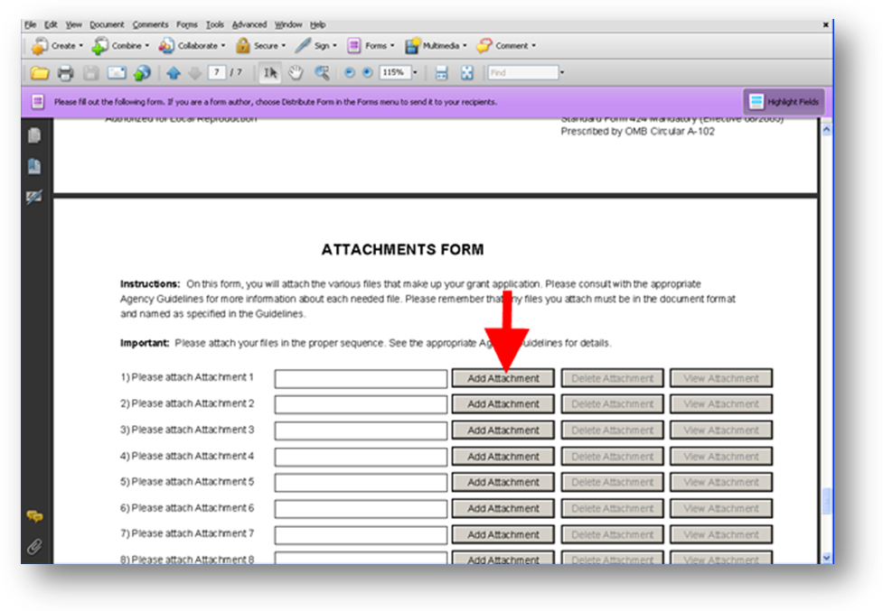
In most instances applicants will be submitting two forms: the SF424 Mandatory form required by Grants.gov and attaching the FTA Supplemental Form (“Applicant and Proposal Profile”) that will be attached to the SF424 Mandatory form as shown above.
If the supplemental form is not attached or a wrong form is attached your application may be rejected.
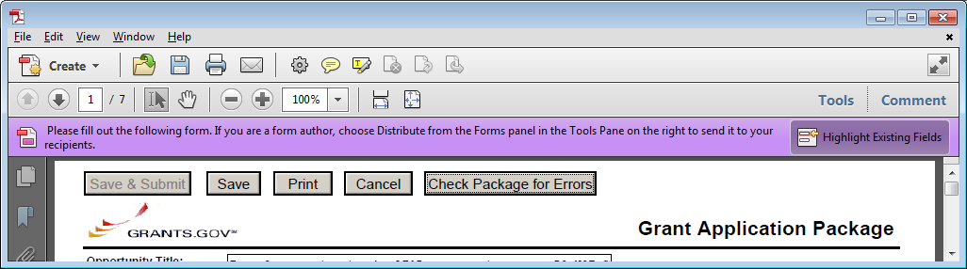
Please save all completed documents to a local drive before attempting to upload or submit the application in Grants.gov. If the “Save & Submit” button is not available, first save the completed SF 424 Mandatory form. Once saved, then you may attach the Applicant and Proposal Profile form.
Click the “Check Package for Errors” button to check for required fields that are still blank. The FTA Applicant and Proposal Profile has a similar validation button at the top.
Important tips about Supplemental Forms
- Only attach one supplemental form to the SF424. Submitting more than one supplemental form to an SF424 will only accept the first supplemental form in FTA’s evaluation system (Discretionary Grants System).
- Do not print and attach a scanned version of the supplemental form or your submission will come back as invalid. The Discretionary Grants System (DGS) tool is unable to read the data unless it is saved as a PDF file.
- When attaching files to the SF424 form, file names are allowed a maximum of 50 characters in Grants.gov. Special characters are not allowed.
- All fields on a supplemental form must be filled out, unless instructed otherwise. Leaving fields blank will mark your submission as invalid.
- Use the Validate Form button located at the top right hand corner of the supplemental form to make sure no required fields were left blank.
Download the Applicable Supplemental Form
- Please ensure you download and use appropriate Supplemental Form for the opportunity you are applying for. Forms can be downloaded from Grants.gov and from the FTA website. The following table provides links to supplemental forms and program information on the FTA Public Website:
Program | Notice of Funding Availability | Link to Supplemental Form | Link to Program Webpage
Veterans Transportation and Community Living Initiative (VTCLI) | http://fta.dot.gov/grants/13077_14333.html | http://www.fta.dot.gov/documents/SF424_Supplemental_Form_-_VTCLI.pdf | http://www.fta.dot.gov/veterans
Bus & Bus Facilities (SGR) | http://fta.dot.gov/grants/13077_14330.html | http://www.fta.dot.gov/documents/SF424_Supplemental_Form_-_Bus_and_Bus_Facilities.pdf | State of Good Repair: http://www.fta.dot.gov/about/13248.html  Bus & Bus Facilities: http://www.fta.dot.gov/grants/13094_3557.html
Clean Fuels (5308) | http://fta.dot.gov/grants/13077_14329.html | http://fta.dot.gov/documents/SF424_Supplemental_Form_-_Clean_Fuels.pdf | http://www.fta.dot.gov/cleanfuels
Bus -Livability | http://fta.dot.gov/grants/13077_14331.html | http://fta.dot.gov/documents/SF424_Supplemental_Form_-_Bus_Livability.pdf | http://www.fta.dot.gov/grants/13094_3557.html

