# Charter Registration Tool Quick Reference Guide

## Charter Bus Service Information

Charter Bus Service information can be obtained on the FTA Public Website (<http://www.fta.dot.gov/laws/leg_reg_179.html>).

## Registration Website

The Charter Registration Website can be access via the following link <http://www.fta.dot.gov/CharterRegistration>

## Resubmission

Accepted Private Charter Registrations and Qualified Human Service Organization registrations expire two (2) years after they have been accepted by FTA.

Brief instructions for each are provided on the following pages.

**Resubmit a Private Charter Registration** (Required every 2 years)

Registered companies must resubmit registration every two (2) years. Two weeks before a registration expires the Primary Contact will receive an Initial Notice email asking them to re-register. The Primary Contact will then receive a Final Notice email one week before a registration is about to expire. Click on the link provided at the end of the email to re-register the company.



Review the information on the Edit screen and if applicable, update the fields that are out of date. Click **Save** to submit and save the changes to the registration.

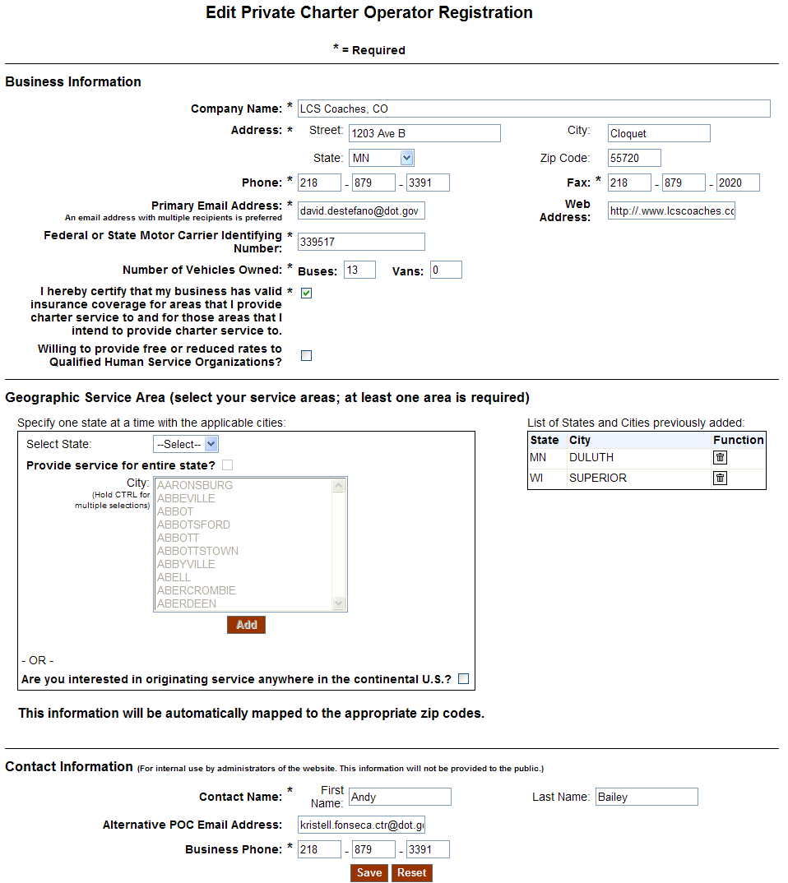

After the user re-registers it will be in Pending status until FTA accepts it. **Note:** All registrations must be accepted by FTA before they can be viewed.



If a company has not re-registered in the two week period before it expires they will have the option to re-register through the [Charter Registration Public](http://www.fta.dot.gov/CharterRegistration) tool.

Click the Private Charter Operator Registration **Submit New**

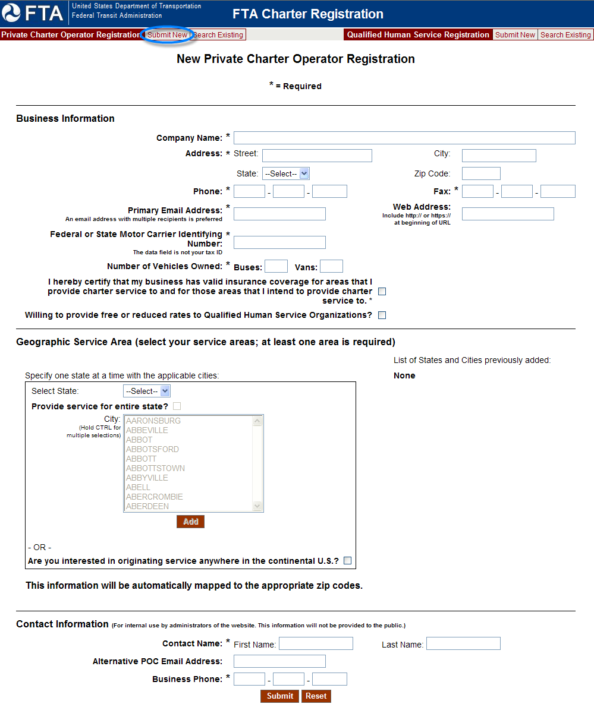

* Enter **Business Information**. Required fields are noted with an asterisk (*). These fields require information for the registration to be saved.
* Enter **Geographic Service Area** information. At least one service area is required.
  + Select a **State** that the private charter operator provides service for
    - Click **Provide service for entire state** if the private charter operator provides service for the entire state and click **Add**

OR

* + - Select **City** that the private charter operator provides service for and click **Add**. To select more than one city for a state, click on a city and hold **CTRL** then click on other cities in that state.

OR

* + Click **Are you interested in originating service anywhere in the continental U.S.?** If the private charter operator provides service for that area.
* If applicable, click **View the complete listing of cities** to view the list of cities for a state that the Private Charter Operator registered with. See the View Geographic Service Area list of cities section for more information.
* Enter **Contact Information** as needed. Required fields are noted with an asterisk (*). These fields require information for the registration to be saved.
* Click **Submit** to save the changes to the registration.
  + If the tool finds similar records a new screen is displayed with possible matches. If one of the records matches the information you entered click the **Update Existing Record** () button. If none of the similar records matches click the **New Record** () button to submit your new record.

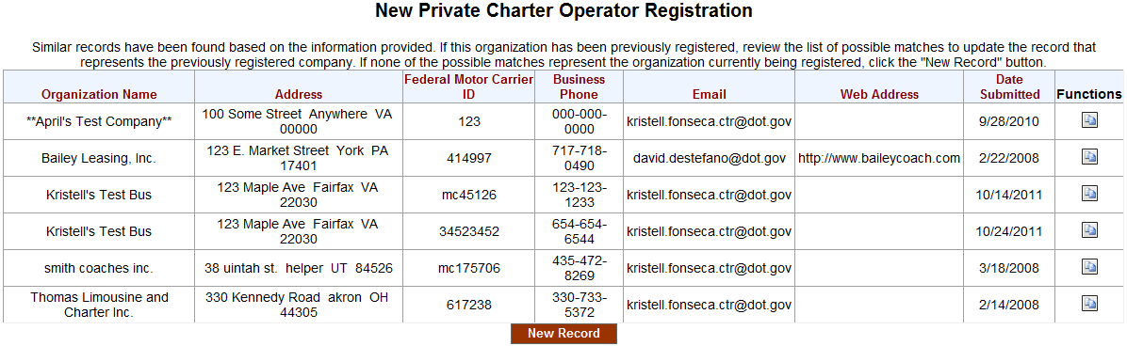

**View Geographic Service Area list of Cities**

If the list of cities registered for a state is too long to be displayed, a link is displayed in the **Geographic Service Area** table on the **New Private Charter Registration** screen.

* Click **View the complete listing of cities** link to open a new window with the list of cities.

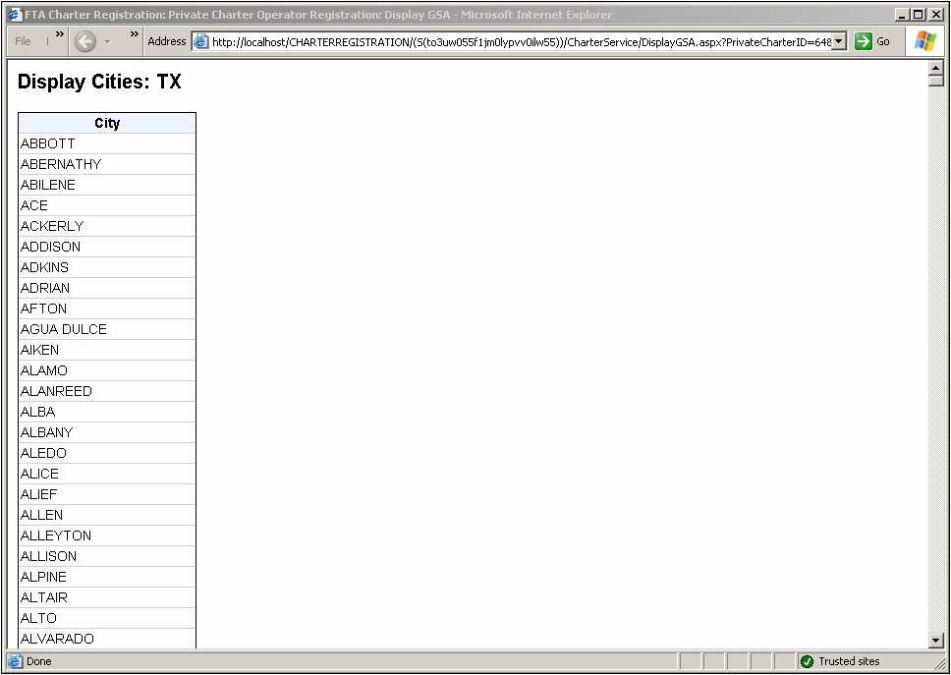

**Resubmit a Qualified Human Service Organization Registration** (Required every 2 years)

Registered companies must resubmit registration every two (2) years. Two weeks before a registration expires, the Primary Contact will receive an Initial Notice email asking them to re-register. The Primary Contact will then receive a Final Notice email one week before a registration is about to expire. Click on the link provided at the end of the email to re-register the company.



Review the information on the Edit screen and if applicable, update the fields that are out of date. Click **Save** to submit and save the changes to the registration.

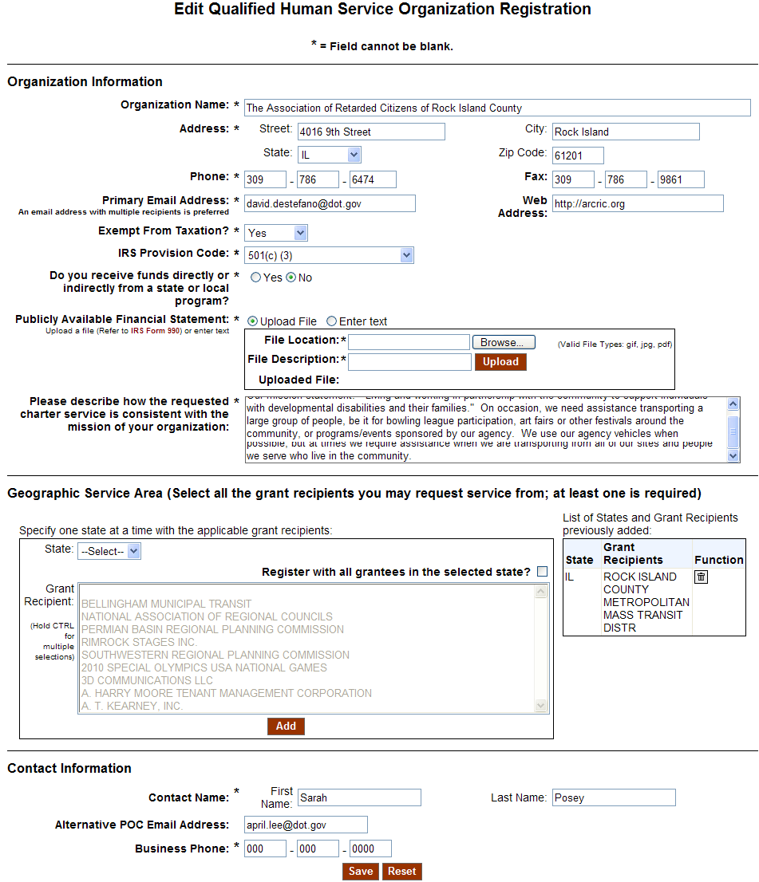

After the user re-registers it will be in Pending status until FTA accepts it. **Note:** All registrations must be accepted by FTA before they can be viewed.



If a company has not reregistered in the two week period before it expires they will have the option to re-register through the [Charter Registration Public](http://www.fta.dot.gov/CharterRegistration) tool.

Click the Qualified Human Service Registration **Submit New**

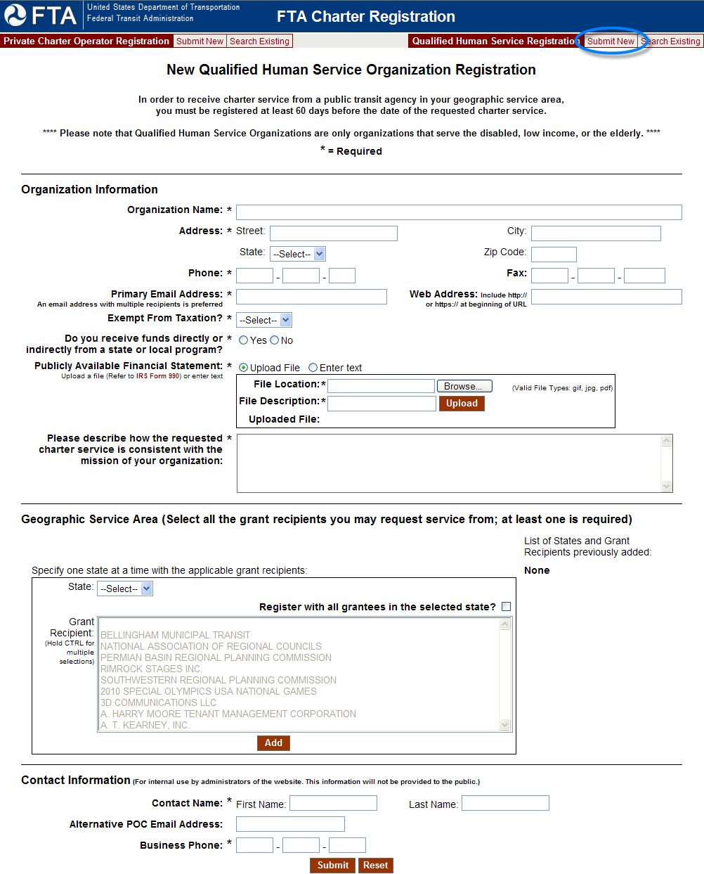

* Enter **Organization Information**. Required fields are noted with an asterisk (*). These fields require information for the registration to be saved.
* Enter **Geographic Service Area** information as needed. Select all the grant recipients you may request service from. At least one grant recipient is required.
  + Select a **State** that applies to the grant recipient(s) you may request service from.
    - Click **Register with all grantees in the selected state** if you want to request service for all the grantees for an entire state and click **Add**

OR

* + - Select **Grant Recipient** that you may request service from and click **Add**. To select more than one grant recipient for a state, click on a grant recipient and hold **CTRL** then click on other grant recipients in that state.
* If applicable, click **View the complete listing of Grantees** to view the list of Grantees for a state that the Qualified Human Service Organization registered with
* Enter **Contact Information**. Required fields are noted with an asterisk (*). These fields require information for the registration to be saved. For more information see the View Geographic Service Area list of Grantee Recipients section.
* Click **Submit** to save the changes to the registration.
  + If the tool finds similar records a new screen is displayed with possible matches. If one of the records matches the information you entered click the **Update Existing Record** () button. If none of the similar records matches click the **New Record** () button to submit your new record.

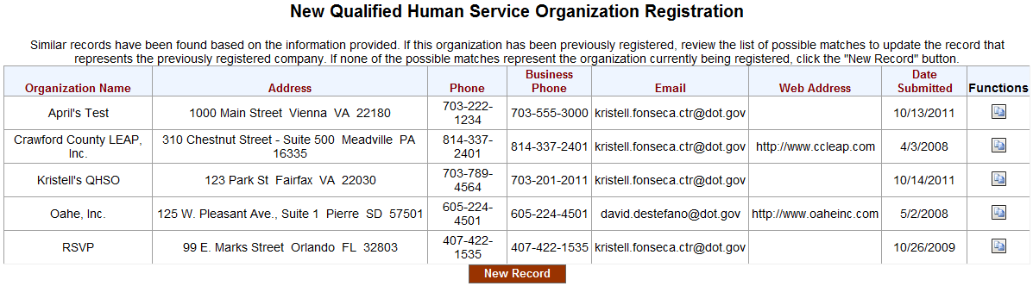

**View Geographic Service Area list of Grantee Recipients**

If the list of cities registered for a state is too long to be displayed, a link is displayed in the **Geographic Service Area** table on the **New Qualified Human Service Organization Registration** screen.

Click **View the complete listing of Grantees** link to open a new window with the list of cities.

