# Charter Registration Tool Quick Reference Guide

## Charter Bus Service Information

Charter Bus Service information can be obtained on the FTA Public Website (<http://www.fta.dot.gov/laws/leg_reg_179.html>).

## Registration Website

The Charter Registration Website can be accessed via the following link <http://www.fta.dot.gov/CharterRegistration>

Registration Tool users are allowed to:

* Search for registrations (Private, QHSO)
* Generate a list of business email addresses for registered private charter operators
* View accepted registrations (Private, QHSO)
* Submit new registrations (Private, QHSO)
* Receive email notifications

## Legal Disclaimer

Legal Disclaimer screen provides the user with information about the FTA Charter Registration Website. You must click **I accept these terms** to accept the terms of the Legal Disclaimer and access the FTA Charter Registration Website. Click **I do not accept these terms** to leave the application and be taken to the Charter Bus Service webpage on the FTA Public Website (http://www.fta.dot.gov/).

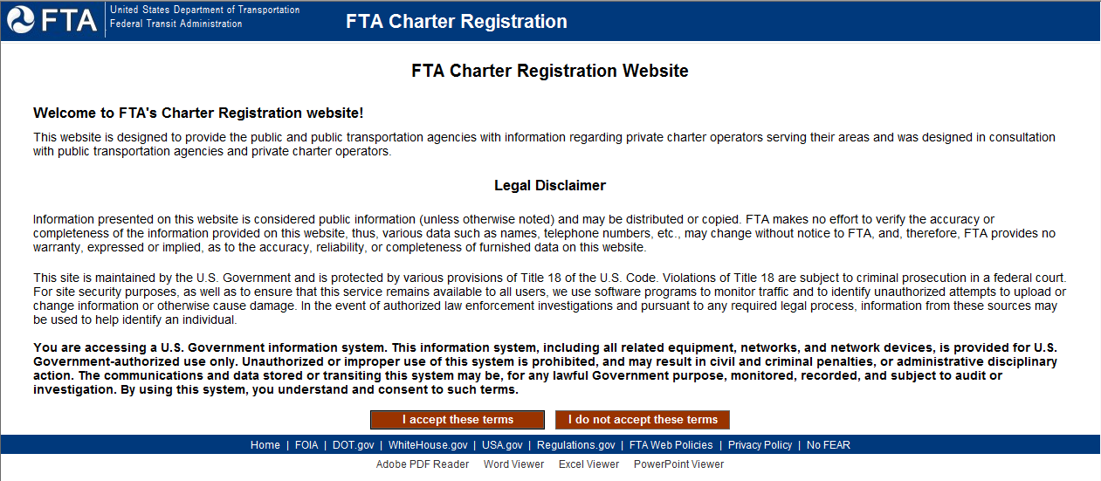

## Splash Screen

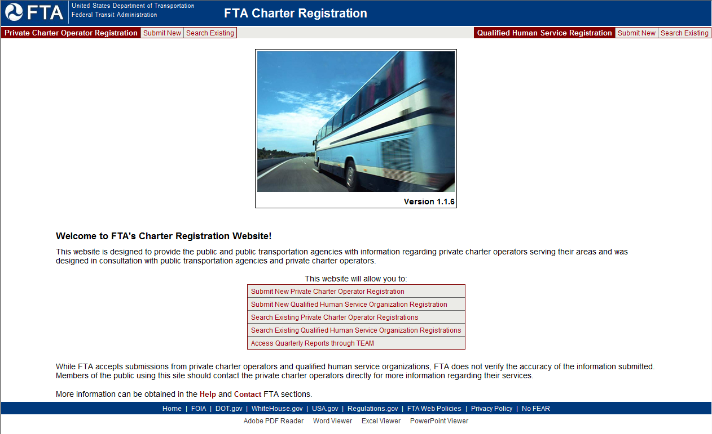

Main Menu (at the top of the screen) options include:

* Private Charter Operator Registration **Submit New**
* Private Charter Operator Registration **Search Existing**
* Qualified Human Service Registration **Submit New**
* Qualified Human Service Registration **Search Existing**

Functions available on the **Splash Screen**:

**Private Charter Operator Registration** options:

* **Submit New** Private Charter Operator RegistrationClick this option for the **New** **Private Charter Operator Registration** screen.
* **Search Existing** Private Charter Operator RegistrationsClick this option for the **Private Charter Operator Registration Search** screen. You can search the registrations using criteria to narrow down your search results.

**Qualified Human Service Registration** options:

* **Submit New** Qualified Human Service Organization RegistrationClick this option for the **New Qualified Human Service Organization Registration** screen.
* **Search Existing** Qualified Human Service Organization RegistrationsClick this option for the **Qualified Human Service Organization Registration Search** screen. You can search the registrations using criteria to narrow down your search results. No fields are required when performing a search. Searching without specifying any criteria will return all registrations.
* **Access Quarterly Reports through TEAM**Click this option to view reports through **TEAM** (Transportation Electronic Award and Management) system.

## Help

Click Help on the Splash screen to view the Help information available.

**Technical Services**

If you experience a problem while accessing or using Charter Registration, or have a technical question, you can contact **DOT IT Services** for information or assistance by phone: call **5-HELP** (202-385-4357) or 1-866-466-5221 to reach **DOT IT Services.**

## Contact FTA

Click Contact FTA on the Splash screen to view contact information.

## Private Charter Operator Registrations

**Search for a Registration**

Click Private Charter Operator **Search Existing** to view the **Private Charter Operator Registration Search** screen:

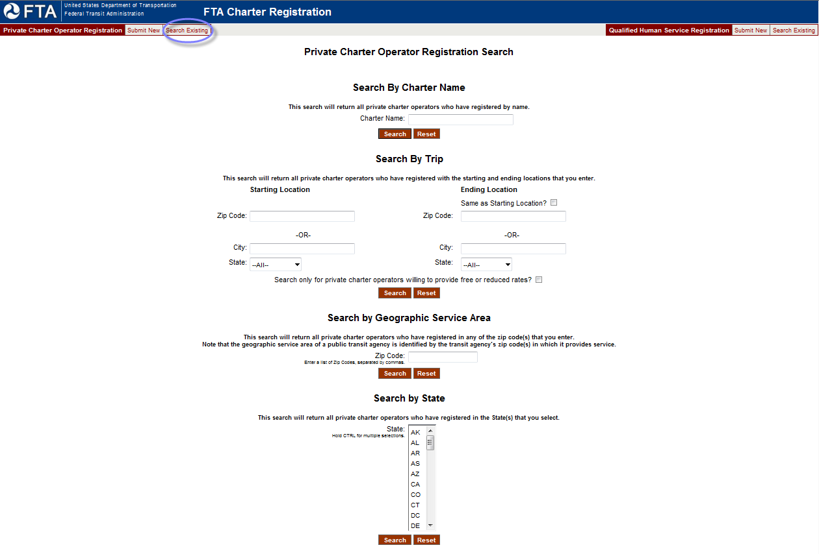

You can search the registrations using criteria to narrow down your search results. The Search screen allows you to search in four different methods:

* **Search By Charter Name**
* **Search By Trip**
* **Search By Geographic Service Area**
* **Search By State**

To **Search By Charter Name** enter the name of the charter service and click the Search button.



To **Search By Trip** enter startling location information and ending location information and click the Search button.

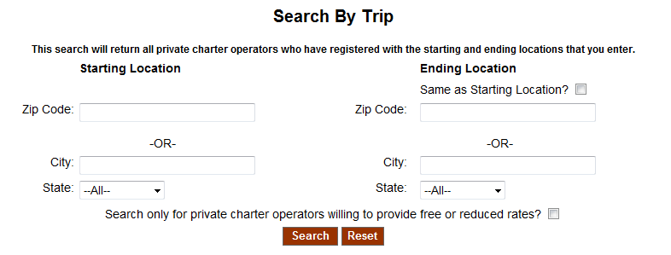.

To **Search By Geographic Service Area** location you can enter one or more zip code followed by a comma. A valid 5 digit zip code must be entered in order to search by geographic location.

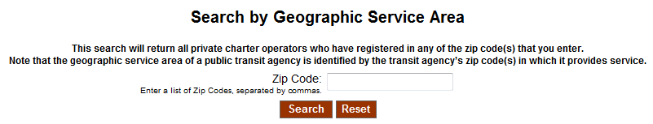

To **Search By State** if searching for more than one state, hold down the CTRL key and select as many states from the State dropdown field and click the Search button.

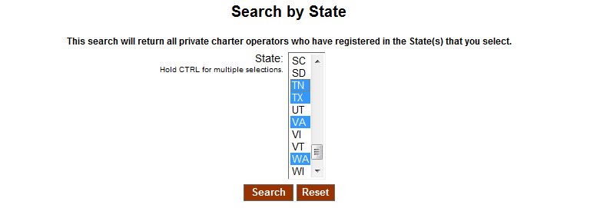

Search results will be displayed on the **Private Charter Operator Registration Search Results** screen.

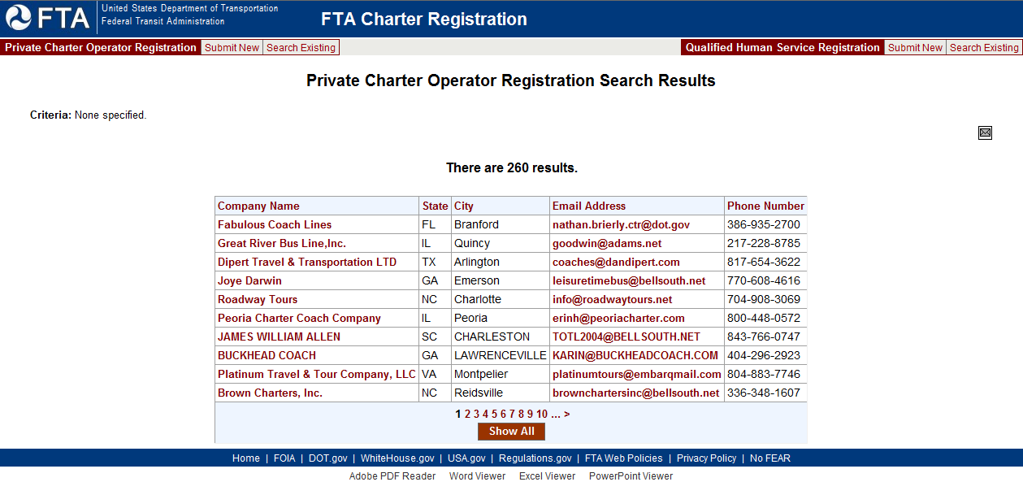

* The search results are listed in pages.
* Click **Show All** (if applicable)to view all the registrations available in the Charter Registration Tool on one page.
* Click a page number to view the search results by page.
* Click on a **Company Name** to view information for that particular company.

**Note**: All registrations must be ***Accepted*** by FTA prior to being available for viewing in the Charter Registration Tool. ***New (Pending)*** status registrations are not available for viewing in the Charter Registration Tool.

**Generate a List of Business Email Addresses**

To export a list of email addresses from the Search Results screen you can click the Email Addresses icon ( ).

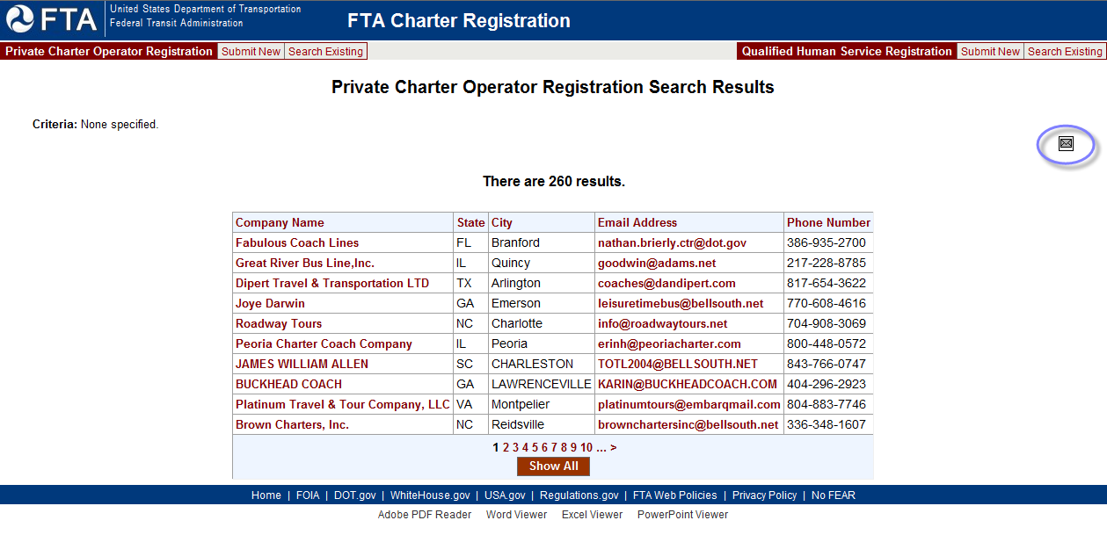

You will either see a pop-up Microsoft Outlook email window with the email address pre-populated in the **To** field

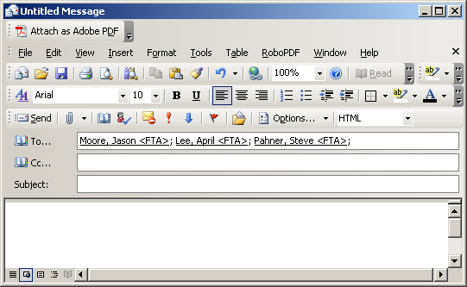

OR

You will see a pop-up message indicating the email addresses were copied to your Clipboard.

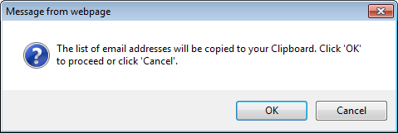

Click **OK** to copy the list to your Clipboard or click **Cancel**. **Cancel** will prevent the email list from being copied to your Clipboard. Clicking **OK** will copy the email list to your Clipboard.

If you click **OK**, the copy verification message will be displayed.

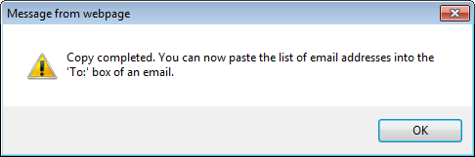

Click **OK** to close the copy verification message.

**Note**: The **Generate List of Email Addresses** icon () is only available for Private Charter Registration Search Results.

**View an Existing Registration**

Click the **Company Name** for the registration you wish to view.

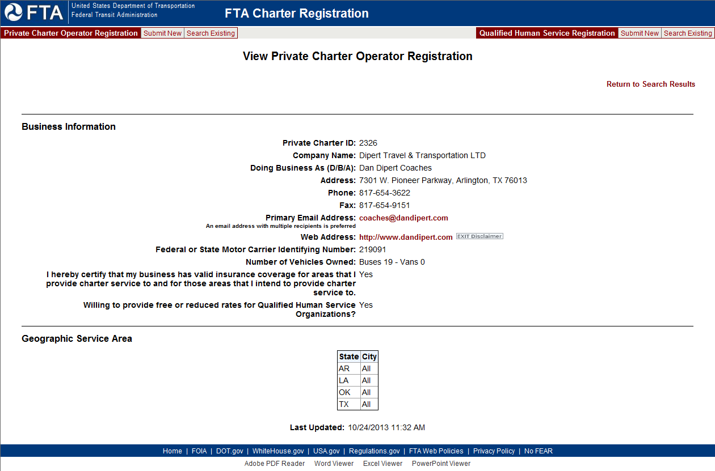

Available actions on the **View Private Charter Operator Registration** include the following:

* Click **Return to Search Results** to return to the **Private Charter Operator Registration Search Results** screen.
* Click the **Primary Email Address** to send an email.
* Click **Web Address** to open the organization's web address in a new window.
* If applicable, click **View the complete listing of cities** to view the list of cities for a state that the Private Charter Operator registered with. For more information see the Geographic Service Area section.

**Submit a New Private Charter Operator Registration**

Registered companies must resubmit their registration every two years. The primary contact will receive email notifications informing them of the registration expiration date. The new registration must be accepted by FTA before it can be viewed. Please see the Quick Reference Guide for Resubmitting Expired Registrations for more detailed information.

Click the Private Charter Operator Registration **Submit New** tab.

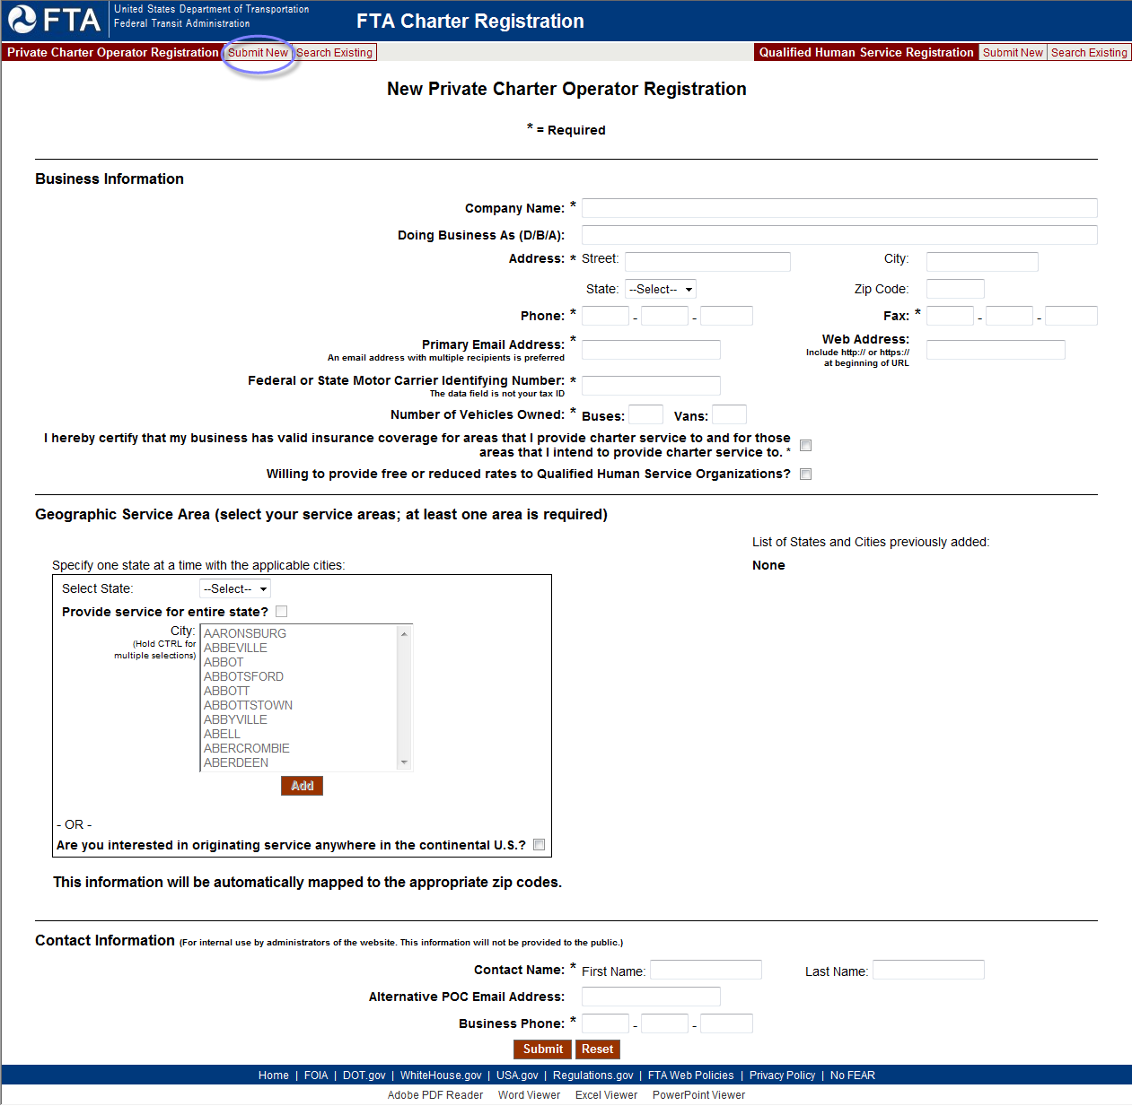

* Enter **Business Information**. Required fields are noted with an asterisk (*). These fields require information in order for the registration to be submitted.
* Enter **Geographic Service Area** information. At least one service area is required.
  + Select a **State** that the private charter operator provides service for
    - Click **Provide service for entire state?** if the private charter operator provides service for the entire state and click **Add.**

OR

* + - Select **City** that the private charter operator provides service for and click **Add**. To select more than one city for a state, click on a city and hold **CTRL** then click on other cities in that state.

OR

* + Click **Are you interested in originating service anywhere in the continental U.S.?** if the private charter operator provides service for that area.
* If applicable, click **View the complete listing of cities** to view the list of cities for a state that the Private Charter Operator registered with. For more information see the Geographic Service Area section.
* Enter **Contact Information** as needed. Required fields are noted with an asterisk (*). These fields are required before the registration can be submitted.
* Click **Submit** to save the changes to the registration.

## Qualified Human Service Registrations

**Searching for a Registration**

Click Qualified Human Service Registration **Search Existing** toview the Qualified Human Service Organization Registration **Search** screen:

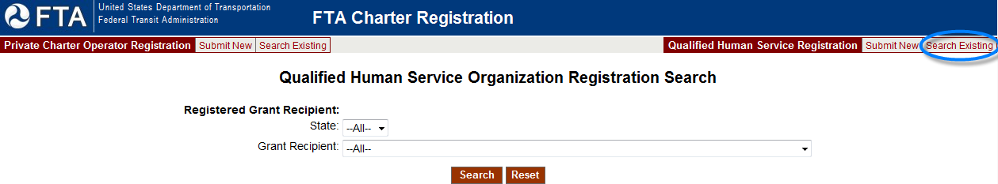

You can search the registrations using criteria to narrow down your search results. No fields are required when performing a search. Searching without specifying any criteria will return all registrations.

Click **Search** to view the **Qualified Human Service Organization Registration Search Results** screen.

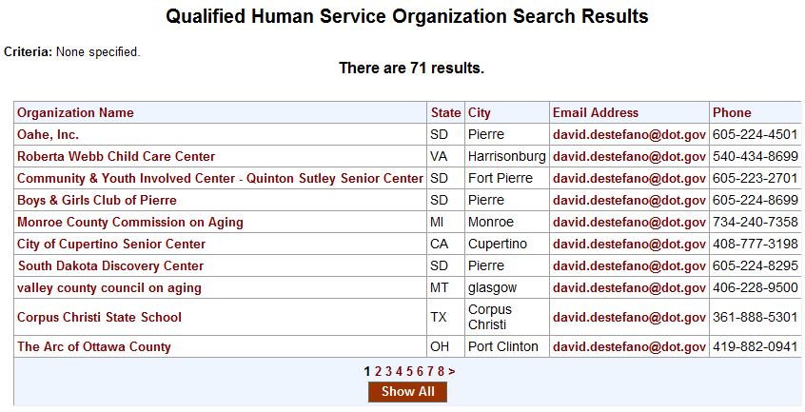

* The search results are listed in pages.
* Click **Show All** to view all the registrations available in the Charter Registration Tool on one page.
* Click a page number to view the search results by page.
* Click on a **Organization Name** to view information for that particular organization.

**View a Registration**

Click the **Organization Name** for the registration you wish to view.

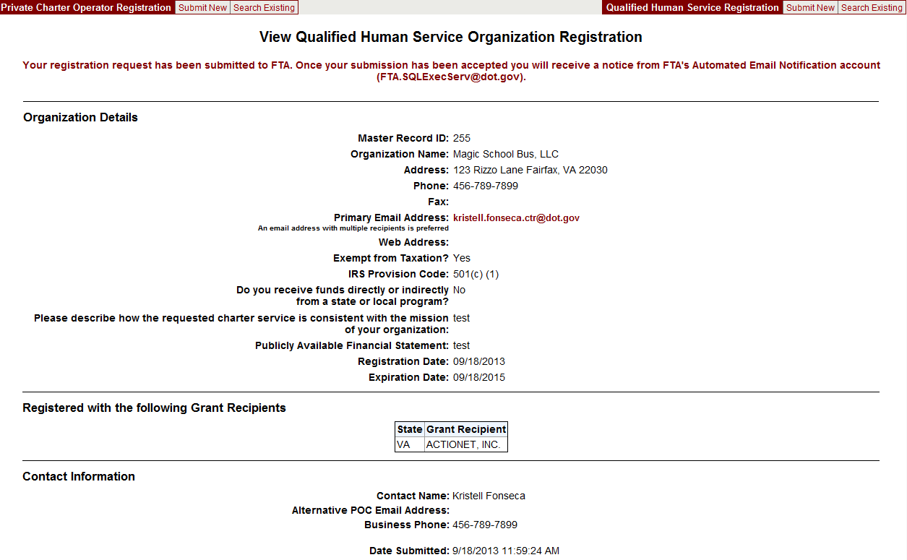

Available functions on the **View Qualified Human Service Organization Registration** screenvary depending on:

* Information supplied by the submitter. Certain fields are not required when creating a new registration (e.g. Registrations may not have a **Web Address** listed in their **Business Information**).
* Click **Return to Search Results** to return to the **Qualified Human Service Organization Registration Search Results** screen.
* If applicable**,** click **View the complete listing of Grantees** to view the list of Grantees for a state that theQualified Human Service Organization registered with. For more information see the Geographic Service Area section.
* Click **Organization Details: Primary Email Address** to send an email to the primary contact for the organization.
* Click **Organization Details: Web Address** to open the organization's web address in a new window.

**Note: Users can view the registration date and expiration date for a record in the Organization Details section.**

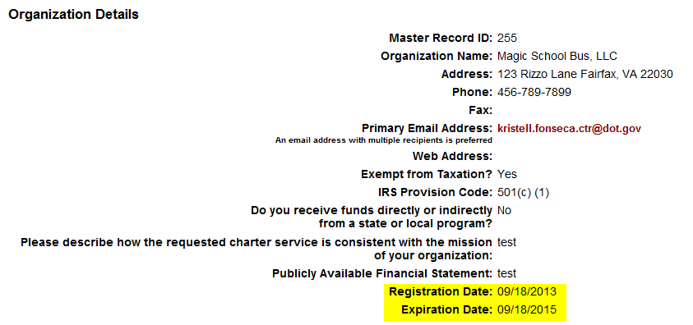

**Submit a New QHSO Registration**

Click the Qualified Human Service Registration **Submit New.**

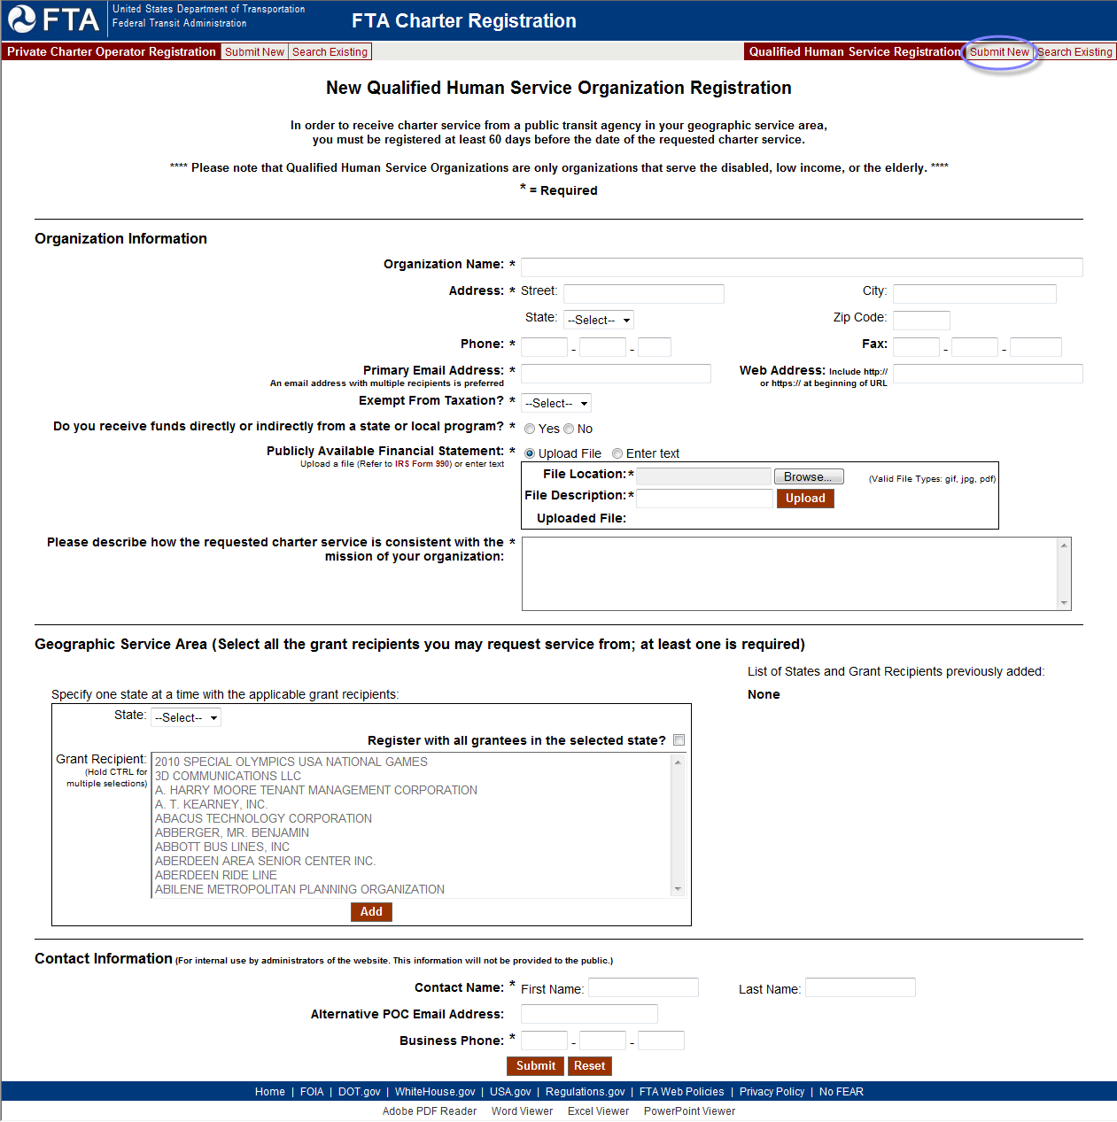

* Enter **Organization Information**. Required fields are noted with an asterisk (*). These fields are required before the registration can be submitted
* Enter **Geographic Service Area** information as needed. Select all the grant recipients you may request service from. At least one grant recipient is required.
  + Select a **State** that applies to the grant recipient(s) you may request service from.
    - Click **Register with all grantees in the selected state?** if you want to request service for all the grantees for an entire state and click **Add.**

OR

* + - Select **Grant Recipient** that you may request service from and click **Add**. To select more than one grant recipient for a state, click on a grant recipient and hold **CTRL** then select other grant recipients in that state.
* If applicable, click **View the complete listing of Grantees** to view the list of Grantees for a state that the Qualified Human Service Organization registered with. For more information see the Geographic Service Area section.
* Enter **Contact Information**. Required fields are noted with an asterisk (*). These fields are required before the registration can be submitted.
* Click **Submit** to save thechanges to the registration.

**View Geographic Service Area list for Cities or Grantee Recipients**

**Geographic Service Area List for Cities**

If the list of cities registered for a state is too long to be displayed, a link is displayed in the **Geographic Service Area** table on the **New** or **View** screens for a **Private Charter Registration.**

Click **View the complete listing of cities** link to open a new window with the list of cities.

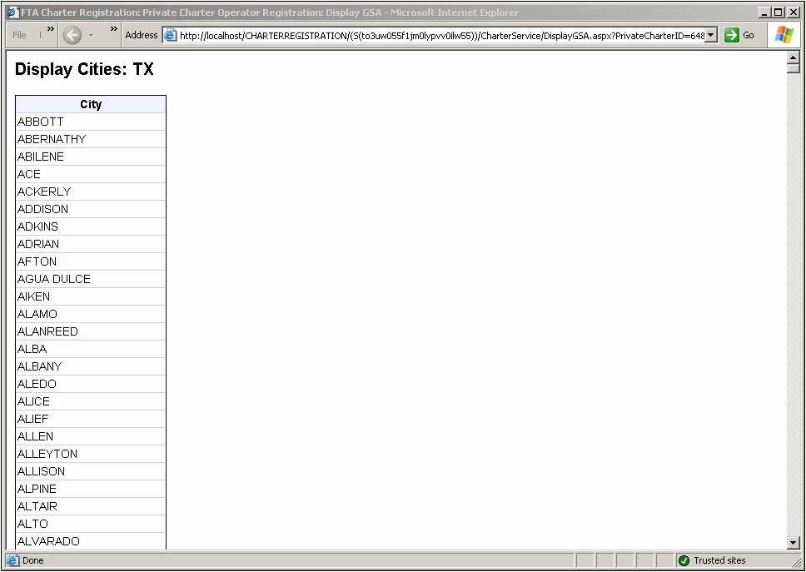

**Geographic Service Area List for Grantee Recipients**

If the list of grantees registered for a state is too long to be displayed, a link is displayed in the **Geographic Service Area** table on the **New** or **View** screen for a **Qualified Human Service Organization Registration**.



Click **View the complete listing of Grantees** link to open a new window with the list of organizations.

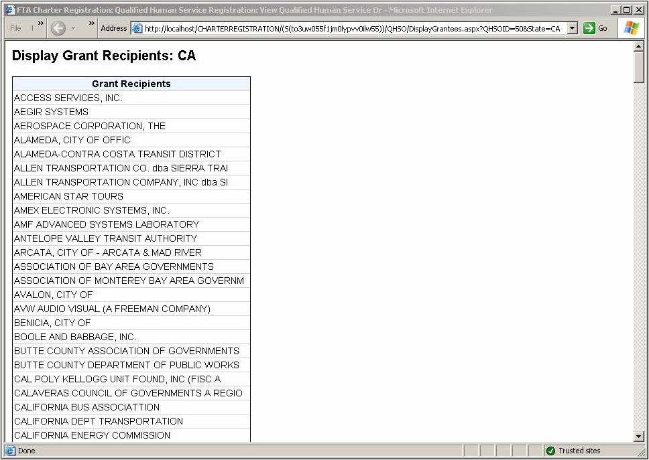

## Email Notifications

The Charter Registration Tool sends automated email notifications alerting a user to activities concerning a submission. You should not reply to these emails since this is an automated email account that is not monitored. You will receive an automated email notification when

* Confirmation of registration being submitted
* Your registration is accepted by FTA
* Registration rejected by FTA
* Registration removed by FTA
* Access link generated upon request to Charter Ombudsman
* Two weeks prior to your registration expiration date (Expiration Date is two years after the registration was accepted by FTA)
* One week prior to your registration expiration date

To ensure prompt delivery of these emails, verify that your junk email and email rules are not set to block these notifications.