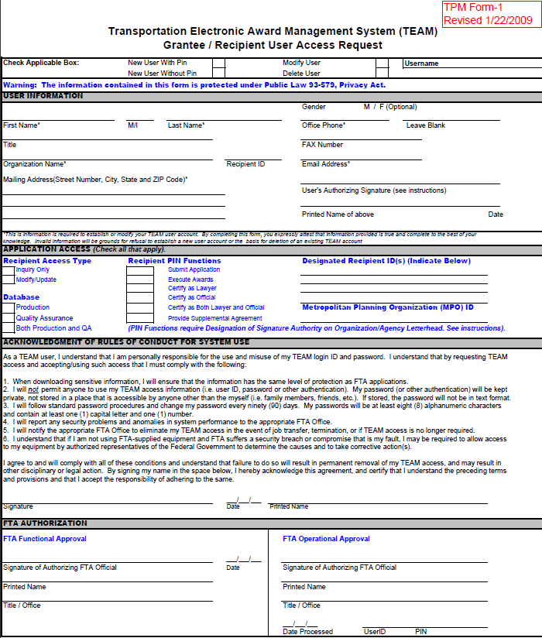

Will the user be able to modify data or view only? Database will typically be both.

The new user signs here.

If the user requires any of these PIN functions a Designation of Signature Authority letter must also be provided. (See website for example)

This is to be signed by official of grantee agency not the new user.

These areas are for FTA action only.

What is the action being done for this user?