

National Transit Database
User Management and
Monthly Reporting

2014 User Manual

Table of Contents

Table of Contents 2
Table of Figures 4
New Reporting System (“NTD 2.0”) 7
Background 7
Local System User Manager (LSUM) 7
LSUM NTD Startup Tasks 7
LSUM Receives Email Instructions 8
LSUM Starts Password Process 9
Request Password Reset 10
LSUM Receives Password Instructions 11
LSUM Logs In to Create Users 14
News Page is the Home Page 15
Records Page 16
My NTD Reporter Profile(s) 17
Reporter Profile 18
Related Actions for Reporter Profile 19
View & Manage Users (P-30) 20
CEO and NTD Contact Required 25
LSUM Sign Out 26
NTD Contact Startup Tasks 27
What is a Kickoff? 27
NTD Contact Logs in to NTD 2.0 28
Kickoff Starts on News Page 29
How to Start Report Kickoff 30
Accept Kickoff Task 31
Manage Reporter Users 32
Manage Modes 33
Add Mode Screen 34
Edit Mode Screen 35
Proceed to Reporter Type Confirmation 36
Previous Reporter Type Confirmation 37
NTD 2.0 Reporter Type Questionnaire 38
Reporter Type Questionnaire 39
Complete Kickoff 40
Ridership Activity Form (MR-20) 41
MR-20 Data Items 42
Access MR-20 Report Package 43
Report Package Summary Screen 44
Report Packages Screen 45
Individual MR Forms by Mode/TOS 46
MR-20 Data Entry Form 47
Print Document 48
Link Created after Print Request 49
Issue Checks 50
Addressing Issue Checks 51
View Validation Issues 52
Address Single Issue 53
National Transit Database Offices 54
Additional Training 54

Table of Figures

Figure 1 - LSUM Flow Chart 5
Figure 2 - Example of Process Flow on editing an Individual MR-20 form 6
Figure 3 – NTD Roles 23

Figure 1 - LSUM Flow Chart

Figure 2 - Example of Process Flow on editing an Individual MR-20 form

New Reporting System (“NTD 2.0”)

Background
Monthly ridership was first operational module. Reporting started October for reporting September data. Annual reporting will start December 15 for FY 2014 reporting. There are no changes in data requirements. Data definitions are the same in NTD 2.0 as in the previous on-line reporting system for monthly data.

Local System User Manager (LSUM)
- LSUM at each reporting agency approves (certifies) new users of FTA Systems
- NTD 2.0
- TRAMS (updated TEAM)
- FTA requires each agency to identify a LSUM to FTA for “authentication”
- TEAM users upload designation letter in TEAM
- Non-TEAM users send letter to FTA NTD project manager in Washington DC

LSUM NTD Startup Tasks
- Create LSUM password
- Approve and enter local users into NTD 2.0

LSUM Receives Email Instructions

- Open e-mail that you received from Administrator
- Click the link on the e-mail to be directed to the NTD website.
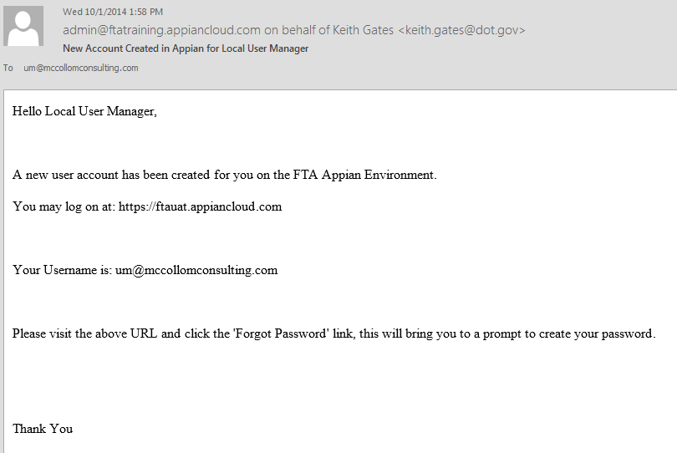
walter.mondale@mankato.org
walter.mondale@mankato.org

Log on using LSUM email address as username

LSUM Starts Password Process

Follow the steps below to start up the password process.
- Read the Government Disclaimer, then click on the I agree button to accept terms of use
- Begin log-in process using the government e-mail address you hold as your username
- Click on the Forgot Password link to begin process to set a new password
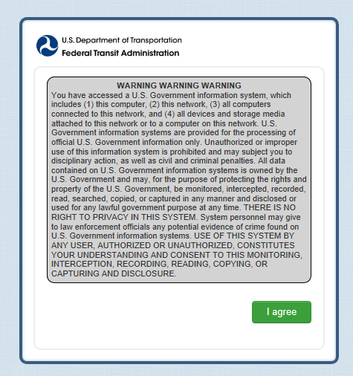
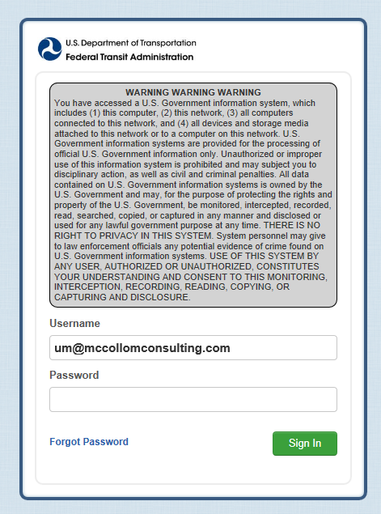
Click on I agree to accept government warning
walter.mondale@mankato.org

Enter Username (all lower case letters)

Click on Forget Password to start process to set password

Request Password Reset

- Once again enter in the e-mail address that is your username
- Click on Request Password Reset button to continue

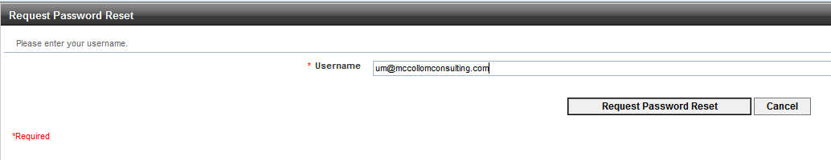
walter.mondale@mankato.org
Click on Request Password
Reset
Enter user name (email address)

LSUM Receives Password Instructions

- Wait for an automated admin e-mail to arrive, then open to read its content
- Click on the hyperlink that will take you to the set password form

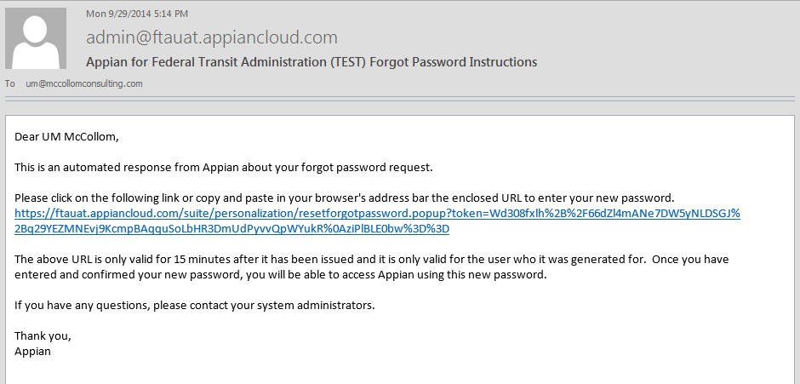
Mon 12/15/2014 8:00 AM

walter.mondale@Mankato.org

Dear Walter Mondale
Click to go to set password

Set Password

- Enter in your Username/E-mail
- Enter in your desired Password (Make sure that your password meets the Federal requirement for length & complexity)
- Confirm your desired Password by re-entering the unique sequence of characters

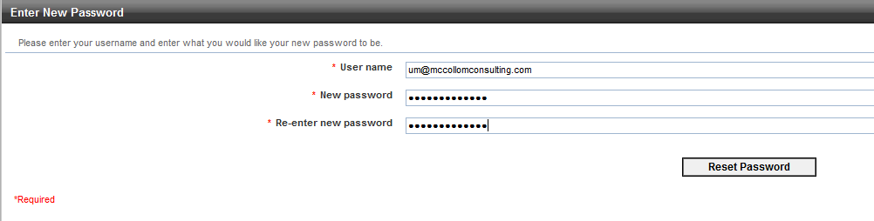
Enter user name (email address)
walter.mondale@mankato.org
Enter and re-enter password
Click on Reset Password

Password Features (All Users)

The Password security requirements are the same as the current system.
  - Federal requirements for length and complexity
    - Password length
      - must be 12 characters and not more than 20 characters
    - Complexity
      - 3 out of 4 – Lower case, Upper case, Numbers, Special Characters
    - Password History
      - Password must be different from 10 previous passwords and must be different from any password used in the last 6 months
    - Password expiration period is 60 days

LSUM Logs In to Create Users

- Click on I agree button to accept the Government’s terms of use
- Enter in Username/E-mail
- Enter in your newly-created Password
- Click on Sign In button to Log In to the System

Enter Username and Password
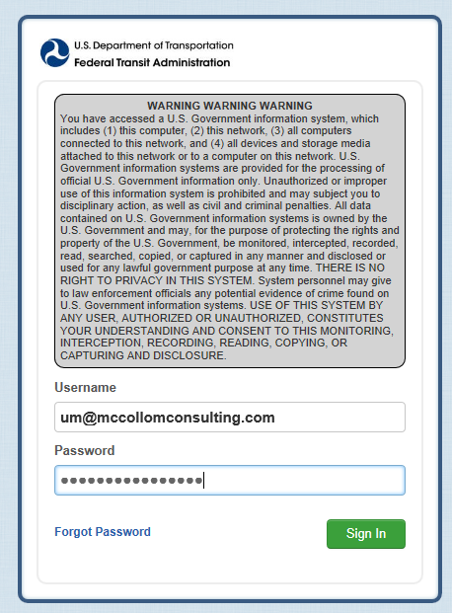
Click on I agree to accept government warning
Click on Sign In
walter.mondale@mankato.org

News Page is the Home Page

The News menu item is the defaulted page when you first log-in to NTD. Click on Records to enter users.

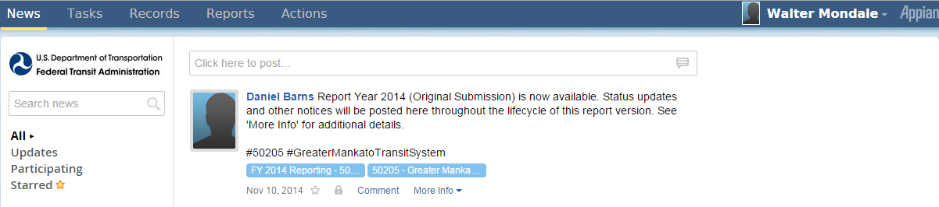

Click on Records to enter users

Records Page

The Records menu item is where you can select Reporter Profiles to enter users.

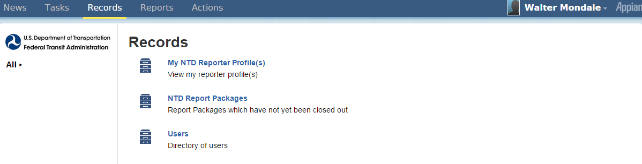

Click on My NTD Reporter Profile(s)

My NTD Reporter Profile(s)

After selecting Records menu item, click on the reporting agency name in order to view the reporter profile.

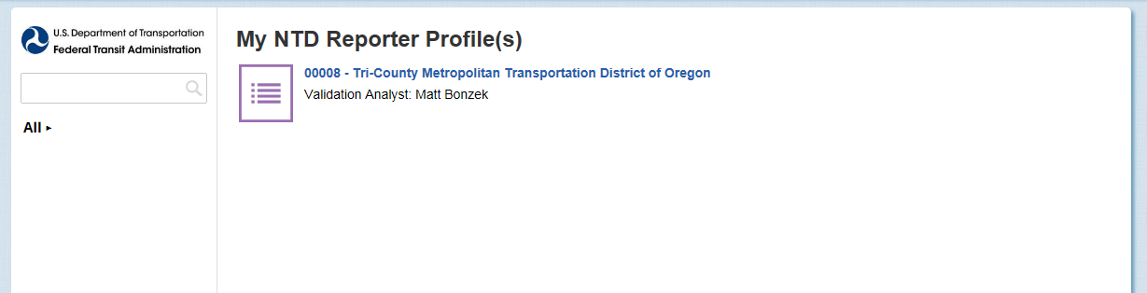
Click on reporting agency name

Reporter Profile

On the Reporter Profile Summary page click on Related Actions to manage Reporter Users.

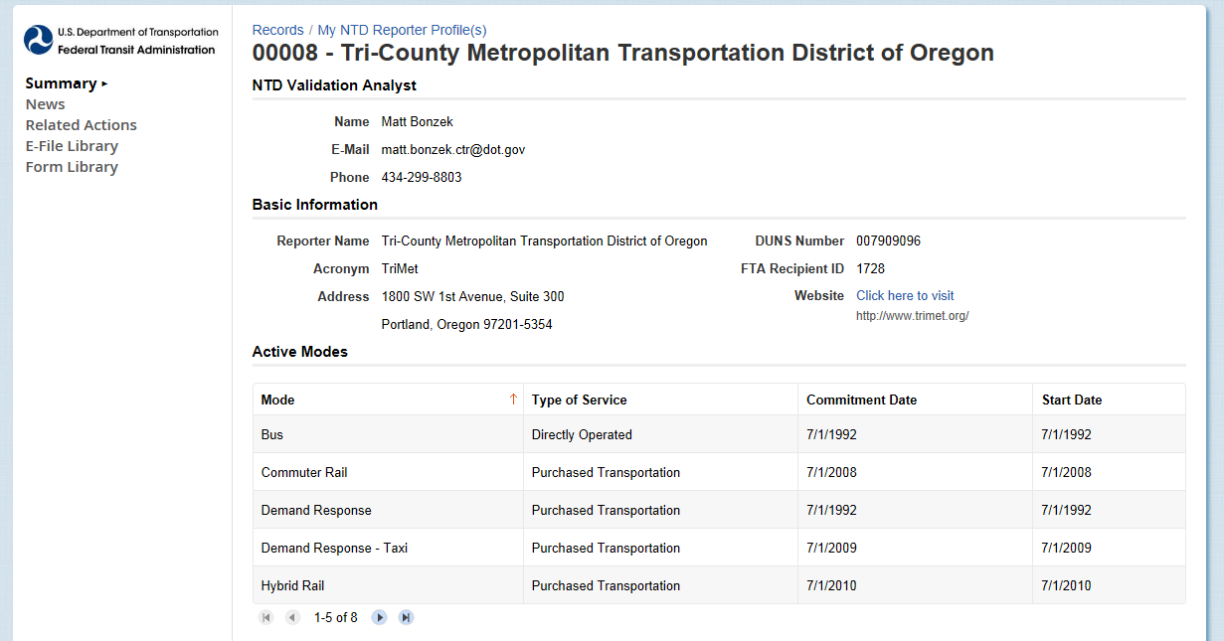
Click on Related Actions

Related Actions for Reporter Profile

Under Related Actions, click on View & Manage Reporter Users (P-20) to manager users.

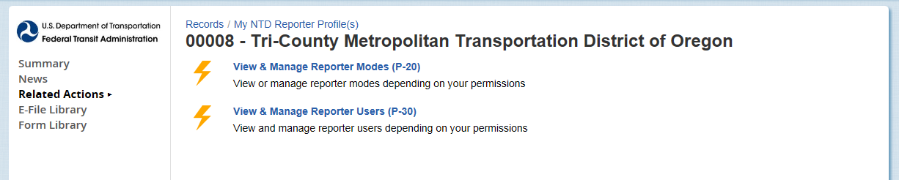
Click on View & Manage Reporter Users (P-30)

View & Manage Users (P-30)

In the P-30 form you can Add, Edit, or Deactivate users, or View Details on a user. To add a user, click on Add User button.
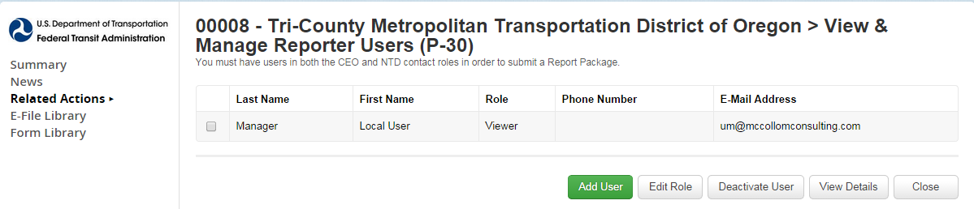
Click on Add User

Add New System User

After you click on Add user button, fill out the information on the form and click Next when complete.
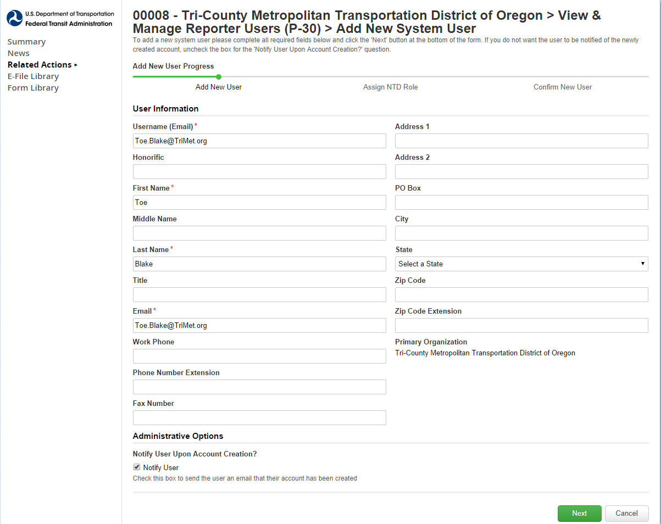
Add user information (name, email, address)
Click Next when completed
Click Next when completed

Select Reporter Role

Select the user’s role from a drop-down menu and click Next when complete.

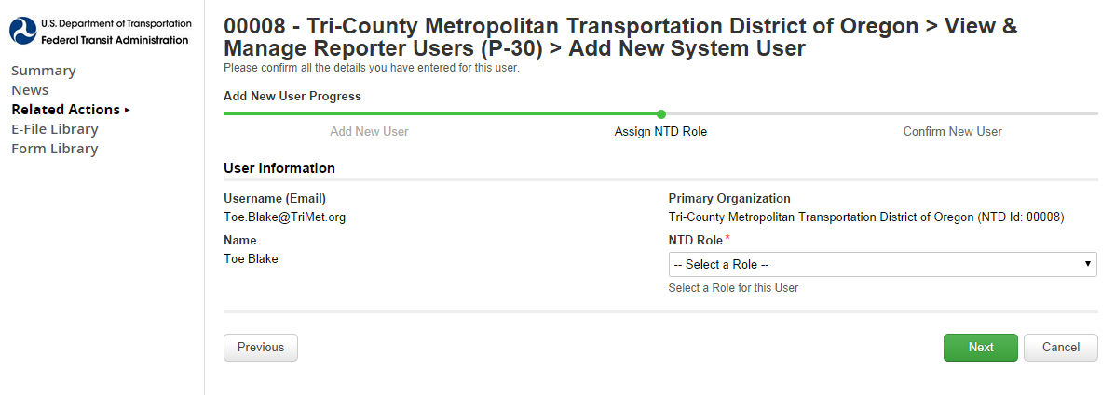
Select Role
Click Next when completed

Figure 3 – NTD Roles

Role | Functions
CEO | Data entry, submit report, submit the CEO certification, all reporting areas
NTD Contact Person | Data entry, submit report, all reporting areas
Editor | Data entry, view forms
Viewer | View forms

Review and Submit User

- After submission, instructions are emailed to user to set up password
  - Identical process used for LSUM password

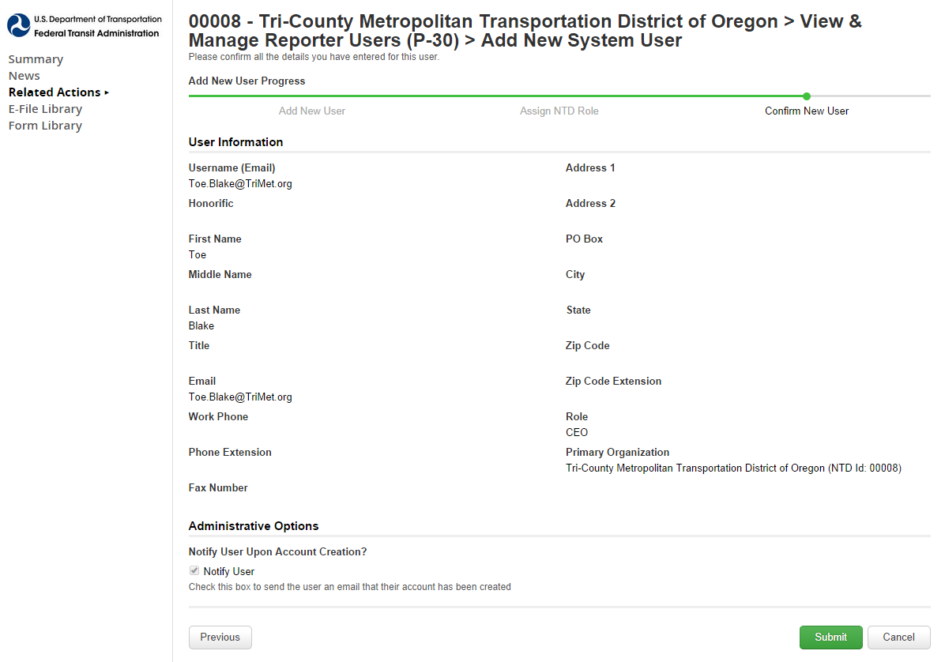
Click Submit

CEO and NTD Contact Required

- LSUM should create CEO and NTD users
- Required for report “kick-off

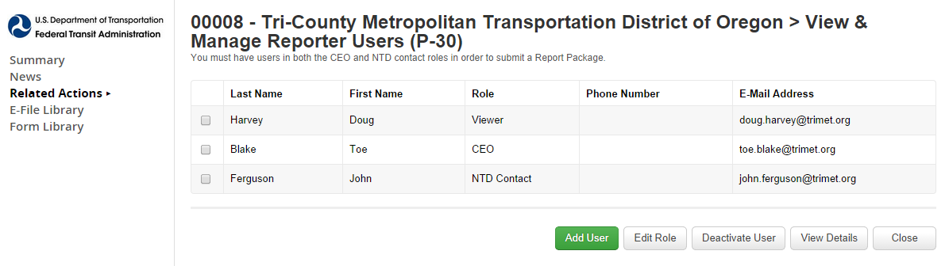

LSUM Sign Out

After the CEO and NTD contact have been created the LSUM can log-off if they are finish with managing accounts.

Click on username and click Sign Out

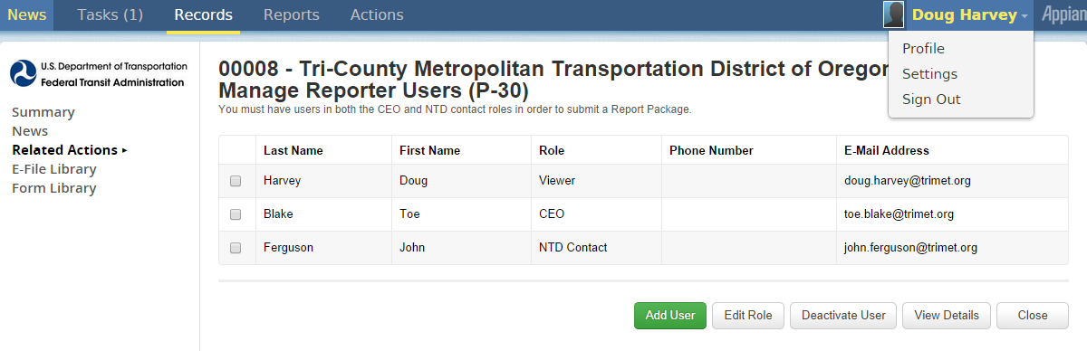

NTD Contact Startup Tasks

The NTD contact can start up the following task:
- Perform “report kickoff”
- Enter annual data into NTD forms

What is a Kickoff?

Kickoff is the confirmation of current “profile” information at beginning of fiscal year
- Kickoff Actions
  - Confirm reporter contact information is accurate.
  - Confirm mode information is accurate.
  - Confirm declared reporter type for previous FY is still accurate (e.g., small systems waiver)
  - Declare reporter type for new fiscal year

NTD Contact Logs in to NTD 2.0

Enter your Username and Password to log-in to the NTD system.

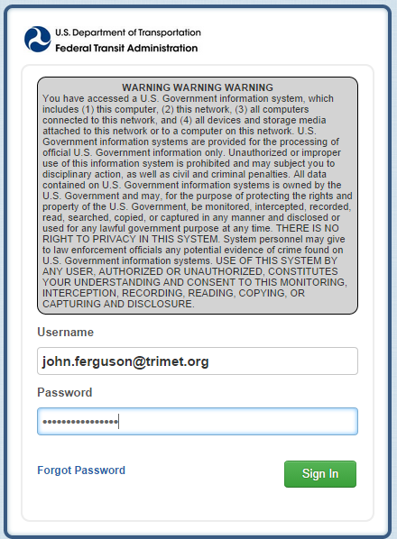
Click on Sign In

Kickoff Starts on News Page

The News menu item is the defaulted page when you first log-in. The Task menu item displays how many task(s) are in your cue. Click on Task to start the Kickoff of the fiscal year reporting.

Click on Tasks to start FY 2015 and FY 2014 Annual Reporting
News

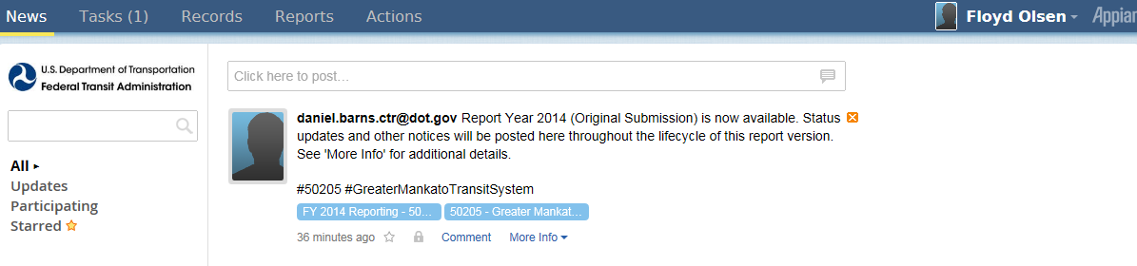

How to Start Report Kickoff

On the Task menu item, there will be a task hyperlink to Kick off the Fiscal year.

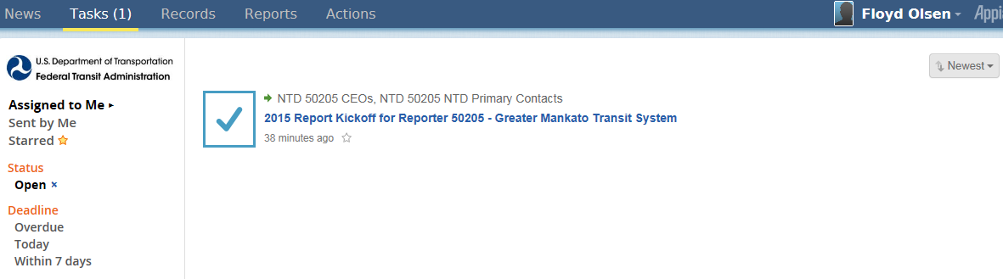
Click on 2015 Report Kickoff task

Accept Kickoff Task

Read the Introduction to the Report Kickoff, and Accept the task, then you can click on Proceed button to begin the Kickoff.

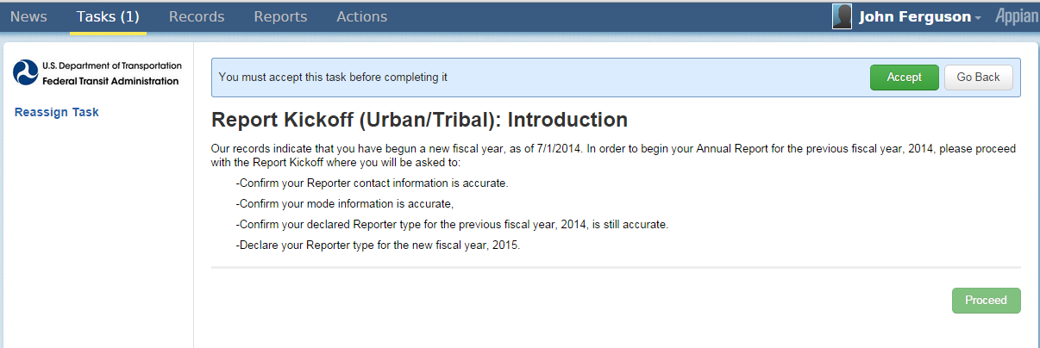
1. Click Accept
2. Click Proceed

Manage Reporter Users

In the Report Kickoff you can Manage Reporter Users. Only user managers can add new users.

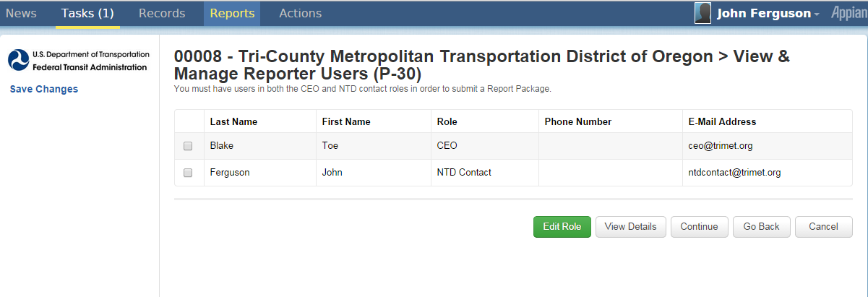
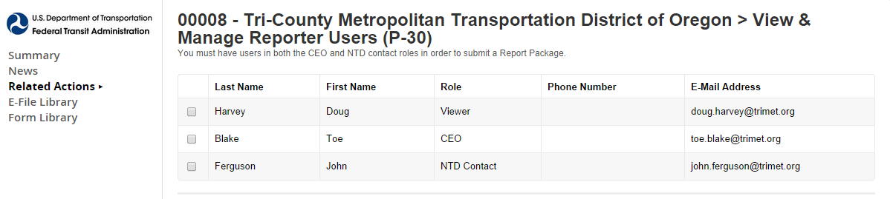
Click Continue to go to next confirmation

Manage Modes

You can manage modes in the Report Kickoff (add, edit, or end mode/TOS as needed).

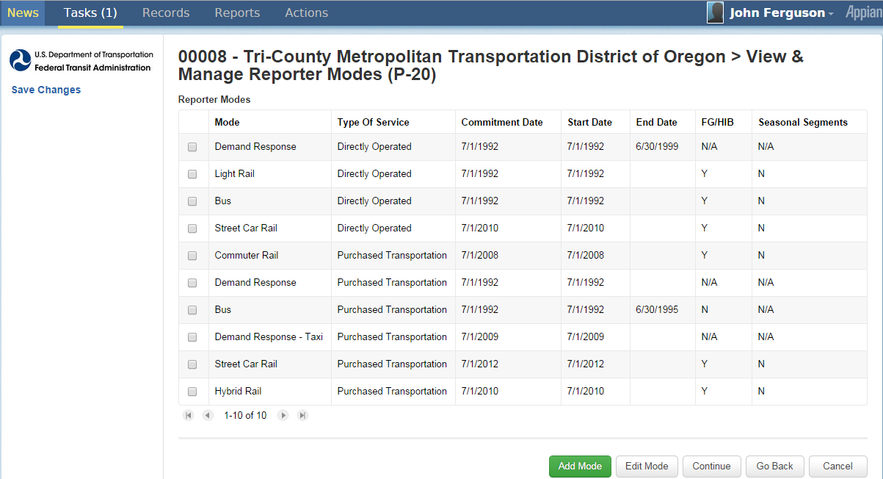

Click to edit/delete selected mode/TOS
Click to add mode

Add Mode Screen

When adding a mode in the Report Kickoff, the following items will display:
- Mode drop down menu
- TOS selection = directly operated or P.T.
- Commitment date = date capital funds first expended
- Start date = first day of revenue service

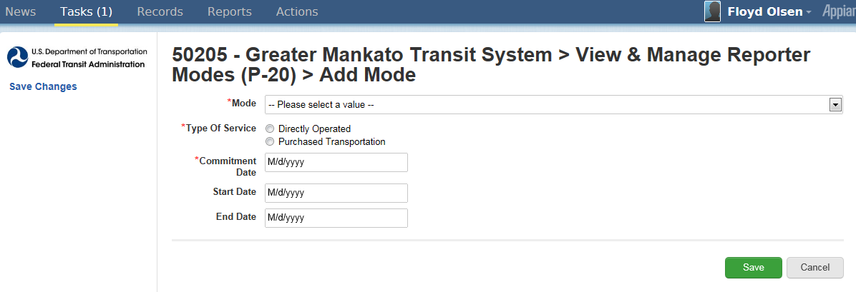
Click to save
Drop down menu

Edit Mode Screen

When editing a mode in the Report Kickoff, the following items will display:
- End date = Last day of revenue service
- Modes are ended, not deleted

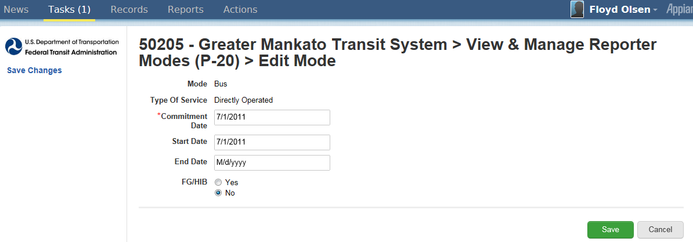
Click submit to save changes

Proceed to Reporter Type Confirmation

Once you have completed managing modes, you can click on Continue to go to the Reporter Type Confirmation section.

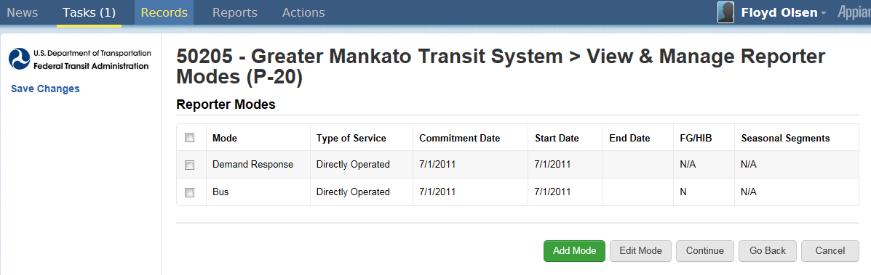
Click continue to go to next confirmation

Previous Reporter Type Confirmation

The answers you select on the Reporter Type Confirmation will determine the required forms.
- Click yes to go through questionnaire
  - Questions appear
  - Strongly suggested for first-time NTD 2.0 users even if they are confident about their type
  - Click Continue once you have completed the questionnaire

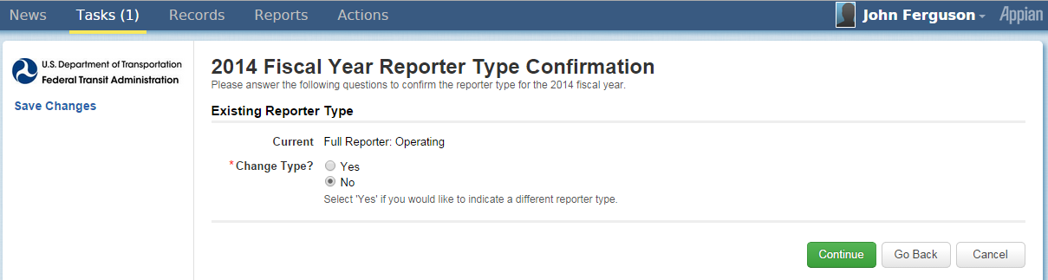
Click yes for questionnaire
Click continue to complete kickoff

NTD 2.0 Reporter Type Questionnaire

The Resulting Reporter Type is based on the answers given on the questionnaire. Click Continue when all questions are complete.

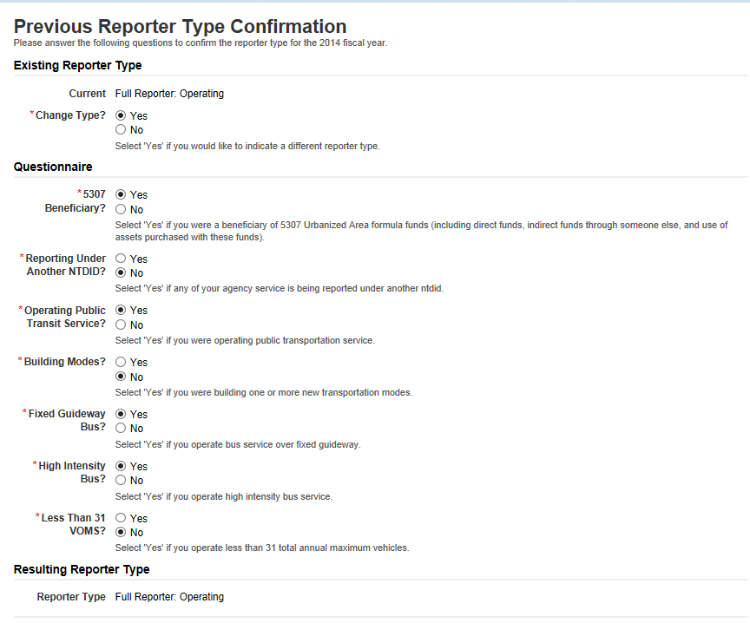
Resulting Reporter Type based on answers to questions

Reporter Type Questionnaire

The lists below are examples of the questions asked in the Reporter Type Questionnaire.
- 5307 beneficiary?
- Reporting under another NTD ID?
- Operating public transit service?
- Building new modes?
- Fixed guideway or high intensity bus or both?
- Operating less than 31 VOMS?

Complete Kickoff

Click Submit to complete the Kickoff. A confirmation will display after it’s submitted. Click OK on the confirmation.

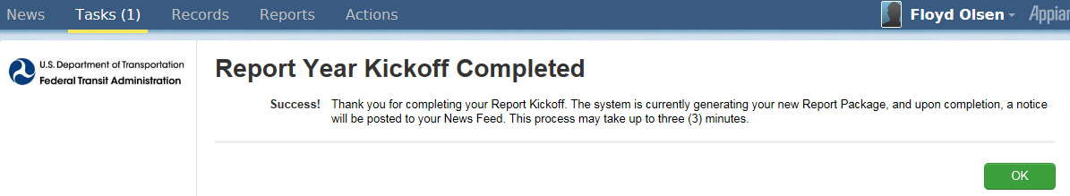
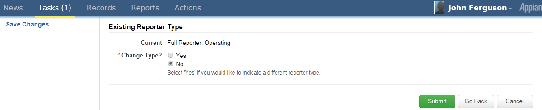
Click Submit to complete kickoff
Click OK

Ridership Activity Form (MR-20)

The Ridership Activity Form (MR-20) is collected by mode and TOS. It provides FTA with monthly trends in passenger usage and service levels. Submit data by the end of the month for the previous month
- For example, September data is submitted by the last day of October


MR-20 Data Items

There are two Ridership Activity forms (MR-20). Each is tailored for:
  - Rail
  - Non-rail

The Ridership Activity form (MR-20) is used to report monthly data by mode and TOS for the revenue vehicles used to provide transit service. The data includes:
- Unlinked passenger trips(UPT)
- Actual vehicle revenue miles (VRM) and vehicle revenue hours (VRH)
    - Car miles/hours for rail modes
- Vehicles operated in maximum service (VOMS)


**Total data reported must be consistent with annual total in S-10

Access MR-20 Report Package

Follow the steps below to access the MR-20 Report Package
- Go to the News tab.
- Look under [Analyst email] Report Year 2015 (Original Submission) is now available.
Note. The screen will show Report Year 2014 for systems still their RY 2014
- Click left box to go to Summary Screen

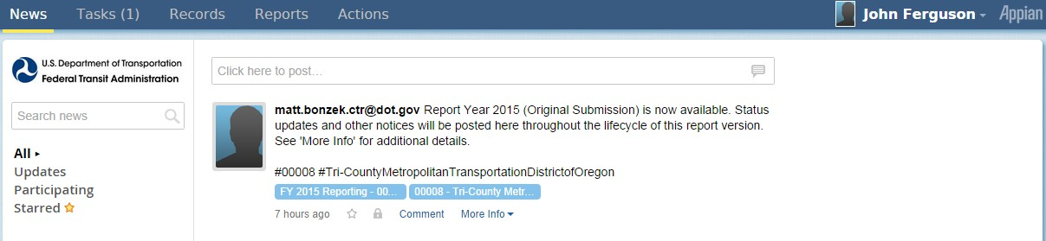
Click to access report packages

Report Package Summary Screen

When you first open to the Report package screen, the screen is defaulted to a Summary page, which displays summary information on transit agency’s package. Click Related Actions to go to report packages screen.

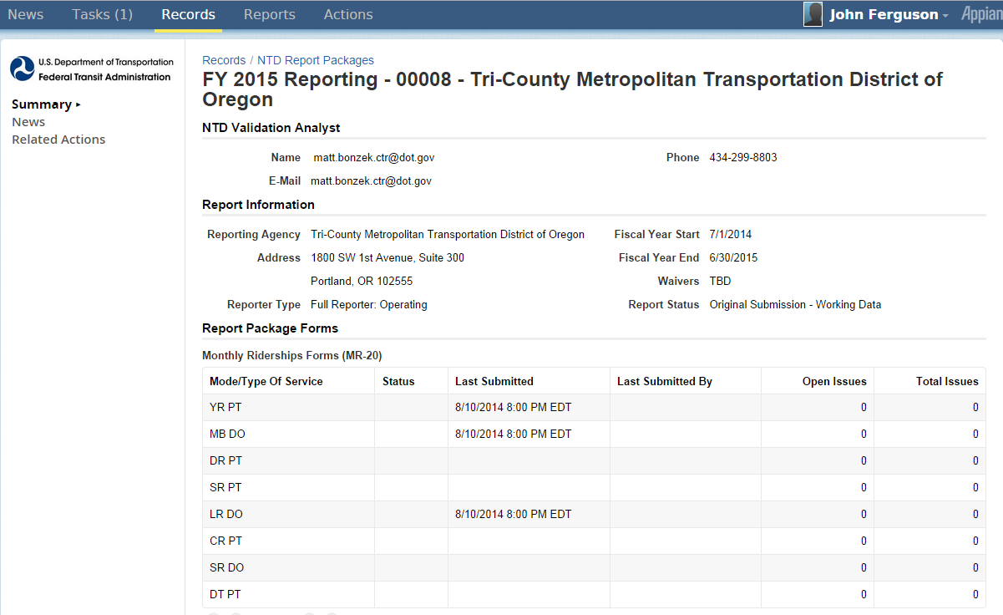

Click to access report packages

Report Packages Screen

After you click on Related Actions, the screen will display a list of report package items. Click Monthly Ridership Forms to access the MR-20 forms.

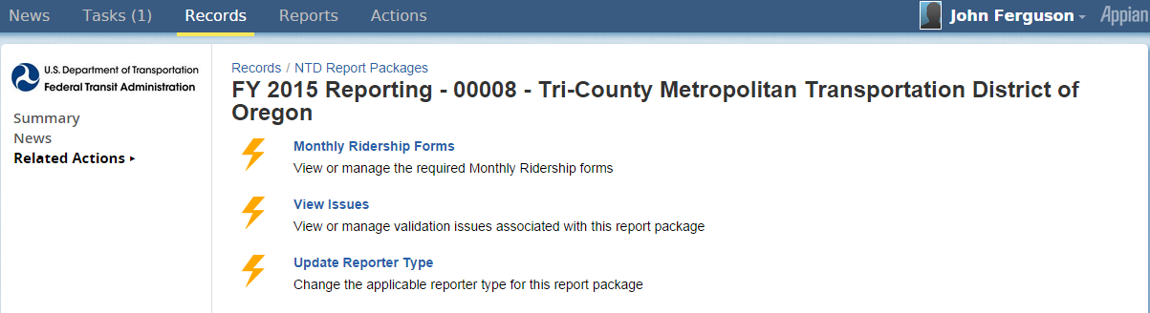
Click to access individual mode/TOS forms

Individual MR Forms by Mode/TOS

After you click on Monthly Ridership Forms from the report package screen, you can then select individual MR form by Mode/TOS.
- Check box for specific mode/TOS
- Click View Form

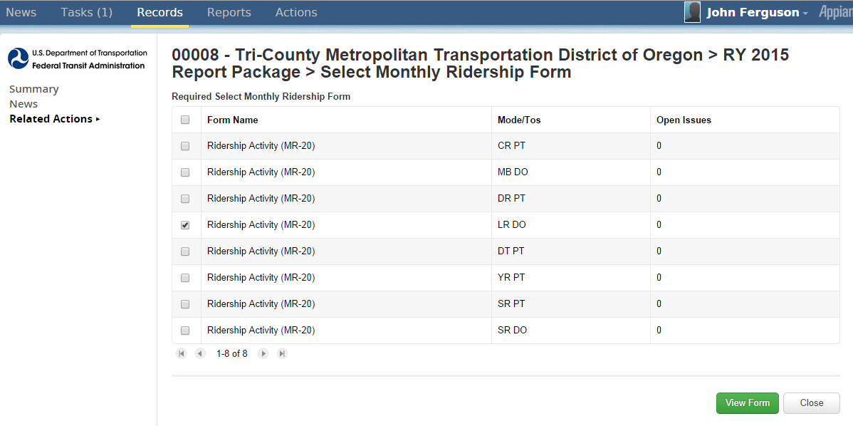

1. Click for mode/TOS forms
2. Click View Form

MR-20 Data Entry Form

Once you select an individual MR form and View Form, then you can enter monthly MR data.
- There are two data entry options that will save the report.
  - The Submit button is used when you have completed all data specific to the reporters Fiscal Year and are ready to submit to FTA. Once you submit, the reporter will not be able to make further changes.
  - With the Save button, the reporter is still able to make further changes prior to submission/
- Submission date’s and submitter’s name will automatically be generated by the system.

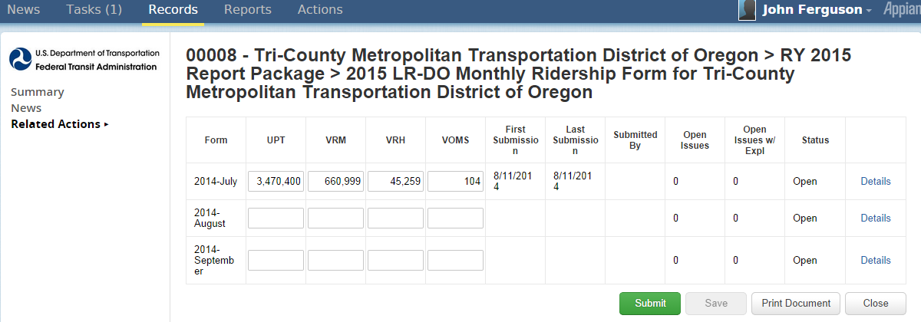

Print Document

A printer friendly version of the MR-20 form is available by selecting Print Document on the individual MR-20 form. You can either view the file in your browser or print the file. The Print Document creates an HMTL file (copy of form) for downloading and saving to your computer, or for printing.

Click to create HMTL copy

Link Created after Print Request

When the Print Document button is selected, a link is created at the top of the form with the following information, “View Printable Version of Form – [as of MM/DD/YYYY HH:SS]”
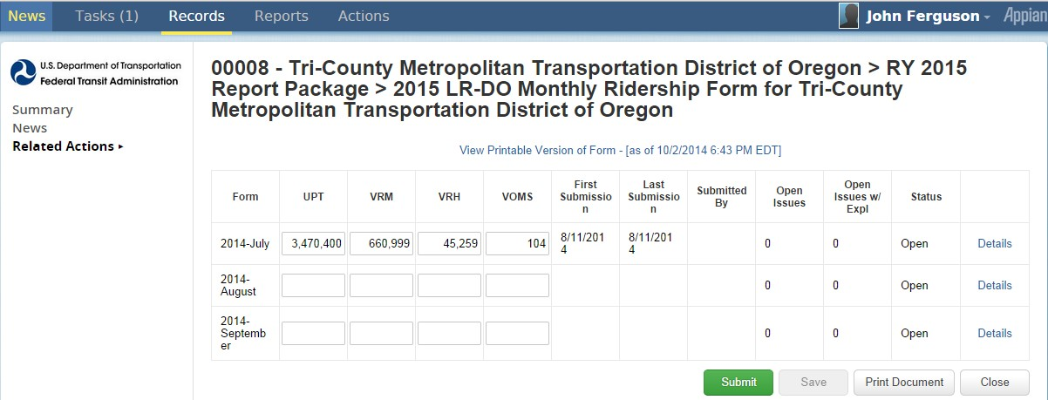

Click to download
HMTL copy

Issue Checks

When you Save a form, the system will automatically check the form for any issues. If any issues are found, a count of issues will display on column, “Open Issues”. If any of the open issues are given an explanation, they will also be counted under column, “Open Issues w/Expl”.
- Click Save to check the form for any issues.

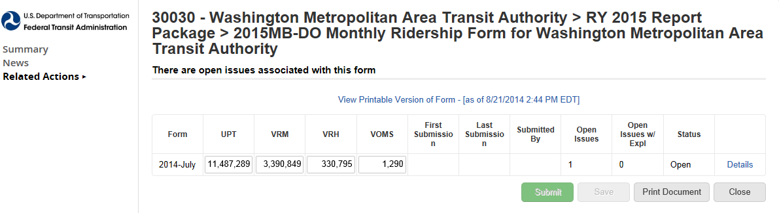
Click to save

Addressing Issue Checks

To address an Open Issue, follow the steps below:
- Click on Details. A table will then display with Percentage Changes.
- Click on View Issues.

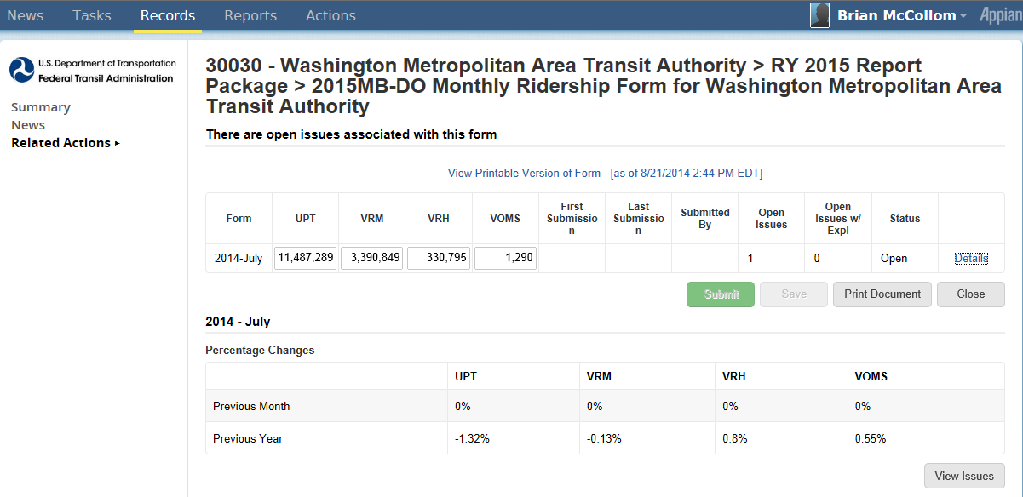
1. Click on Details
2. Click on View Issues

View Validation Issues

After selecting the View Issues button, the screen will then display a Validation Issue List. To view and address an individual issue from the list, follow the steps below:
- Select Issue
- Click on View to address issue

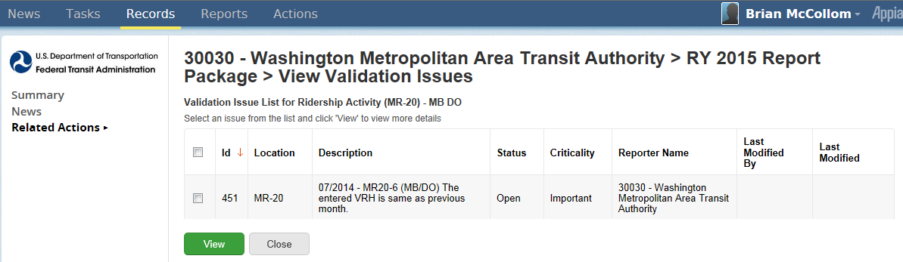
1. Select issue
2. Click on View

Address Single Issue

After you select an issue and View, then the Issue Review Details will become editable. Follow the steps below to complete the Issue Review Details.
- Provide explanation on the Comment box
- Click on Save button

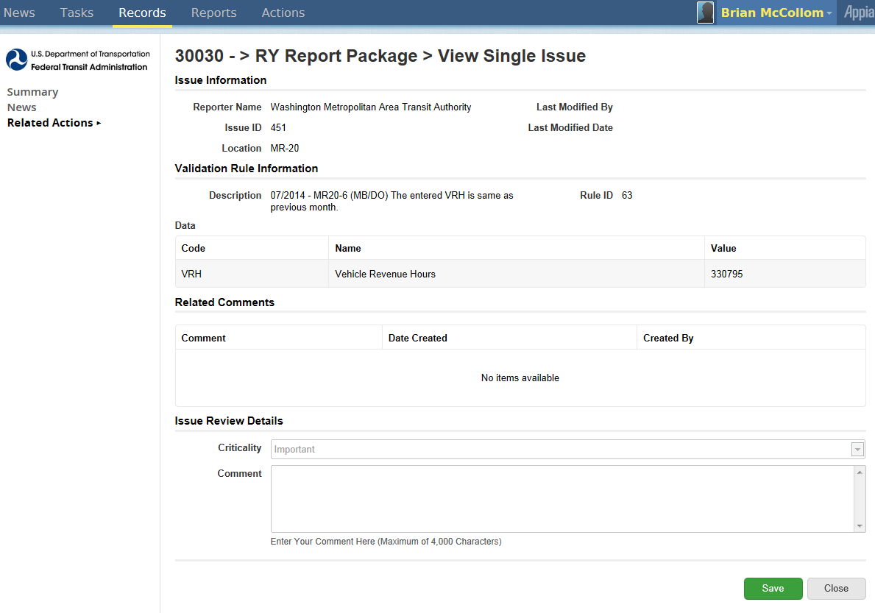
1. Provide explanation
2. Click on save

National Transit Database Offices

- NTD Operations Center
  - Charlottesville, Virginia
  - Monday to Friday: 0800 –1900 Eastern
NTD Help Desk
  - (888) 252-0936
  - NTDHelp@dot.gov

- NTD Program Office
  - Washington, DC
  - Keith Gates, Program Manager
  - (202) 366-1794
  - keith.gates@dot.gov

Additional Training

- NTD Website training page:
http://www.ntdprogram.gov/ntdprogram/seminars.htm
- National Transit Institute, NTD courses:
http://www.ntionline.com/courses/courseinfo.php?id=7
- NTD Website presentations page:
http://www.ntdprogram.gov/ntdprogram/announcements.htm

