FTA Census Map Access Guide

Table of Contents

How to Access Feature Layers 2

How to Change the Basemap Layer 3

Getting a Closer Look of the Data 4

How to Change Map Symbology 6

Data Sources 9

Census TIGER Files 9

National Transit Map 9

ESRI Products 9

National Transit Database 9

2020 Census Urban Areas – Change Case Examples 10

Now Small UZA: 10

Now Large UZA: 10

Now Rural: 11

Combinations of Change Case Types: 11

# How to Access Feature Layers

The map viewer will open on the “Legend” panel. To view the data included in the map, navigate to the “Layers” panel, as shown below.

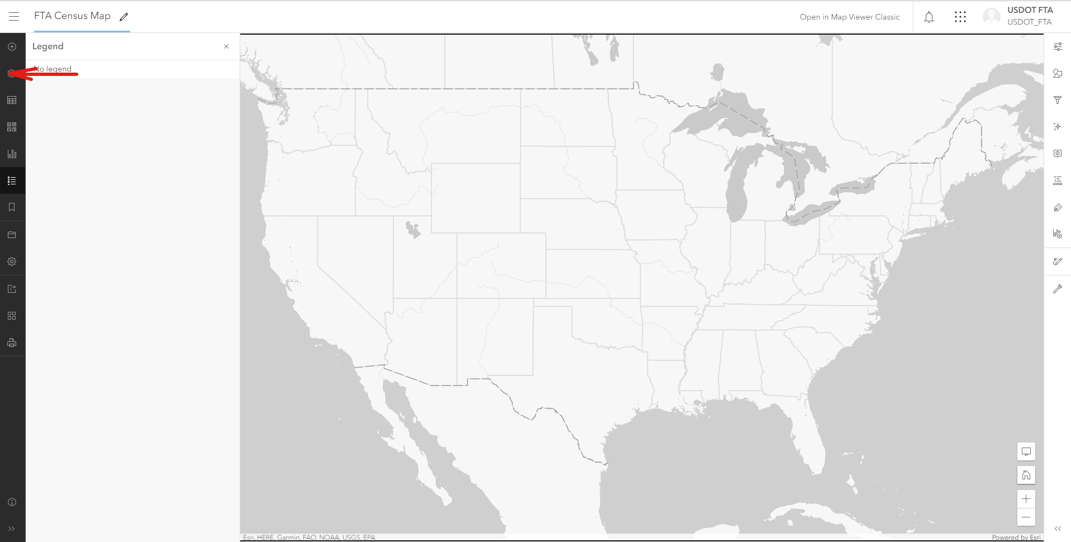

Once selected, the Layers panel will appear:

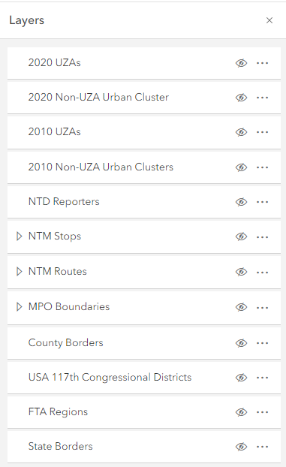

Each row represents a different layer that can be active on the map. The gray eye icon towards the right of the row indicates if the layer is currently active on the map. By clicking the eyeball, you can make the layer visible.

# How to Change the Basemap Layer

Some use of the map may require more information on the background for navigation purposes. To show more information at the base level of the map and include things such as street names, topography, and more, you must change the basemap. To do so, you need to navigate to the basemap panel, as shown below.

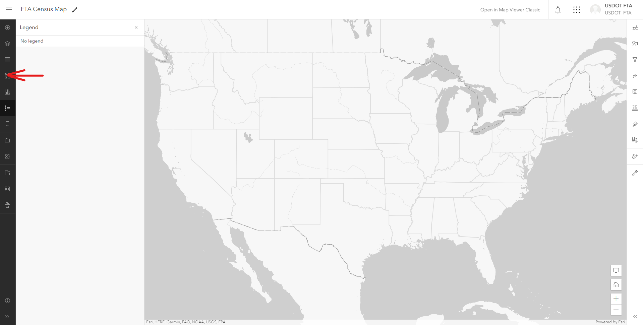

From here you can select any of the choices available. This selection will last while you are viewing the map but will not be saved once you exit the map and will not be saved for other users.

# Getting a Closer Look of the Data

To investigate an entity on the map further, click the shape, point, or line directly on the map interface.

The object selected will be highlighted in blue, and will create a popup box with information, as demonstrated below:

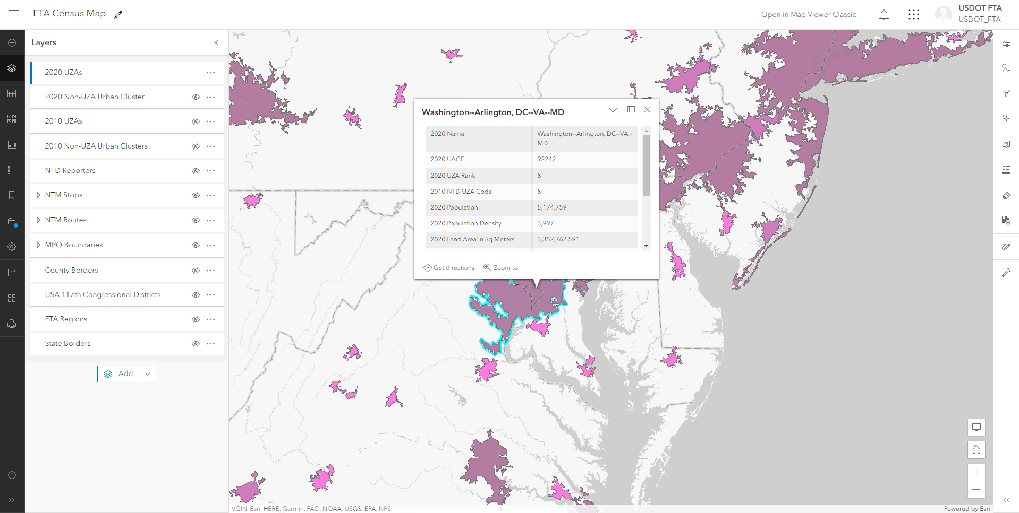

You can view more information about the layers you currently have active by returning to the legend pane and clicking on the icon shown below:

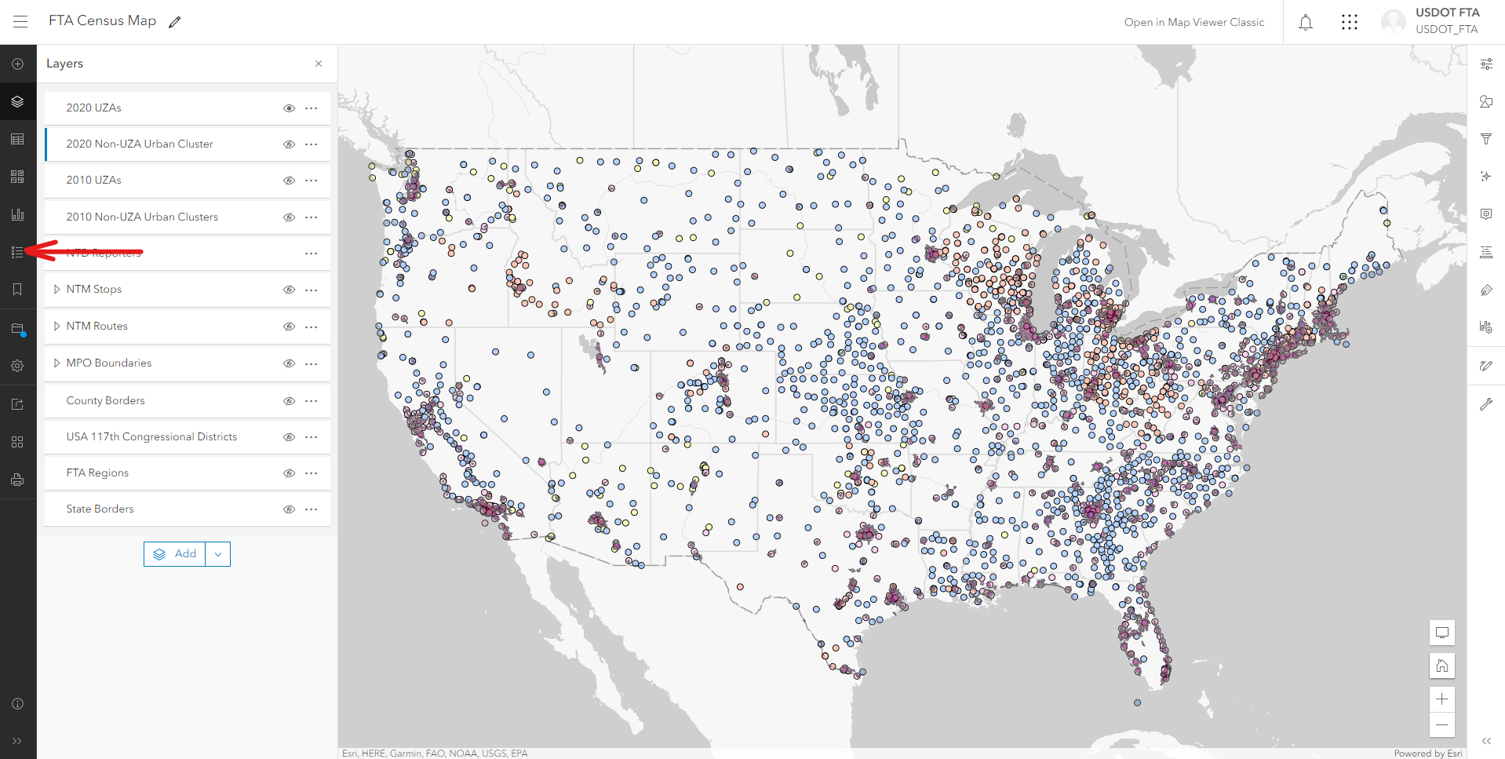

Pictured below, the legend now shows information about the active layers. The 2020 UZAs and the NTD Reporters layers are currently active. In the Legend pane, it provides the color code for the shapes and points that are active on the map. This may be helpful to reference as you add multiple layers.

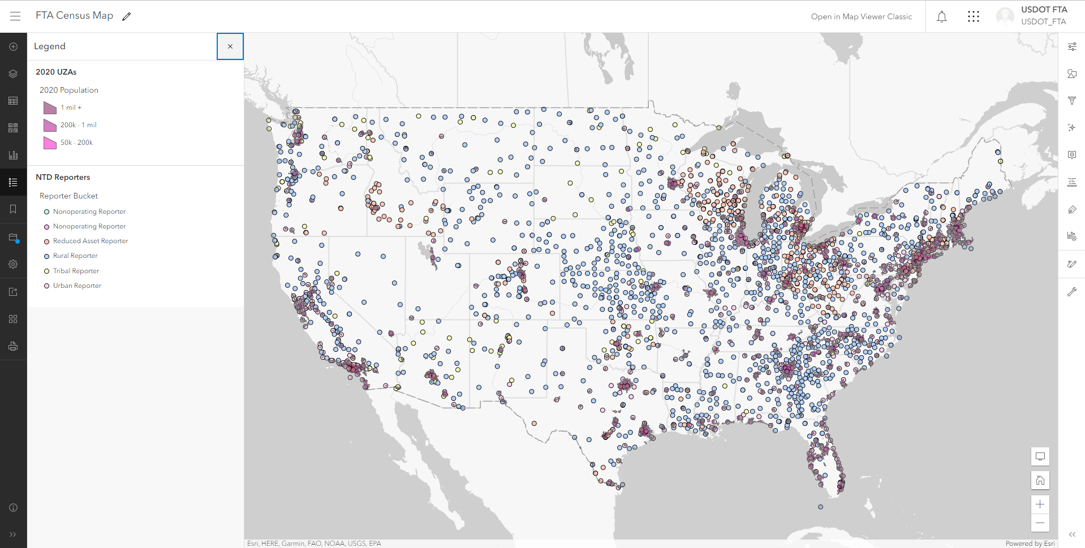

# How to Change Map Symbology

It may be beneficial to change the layer symbology to make it easier to compare and analyze the map data. To do so, go to the “Layer” panel (on the left), then select the feature layer you would like to adjust. Then go to the “Properties” tab as shown below. This will open a new panel on the right side of the screen to adjust the feature layer symbology.

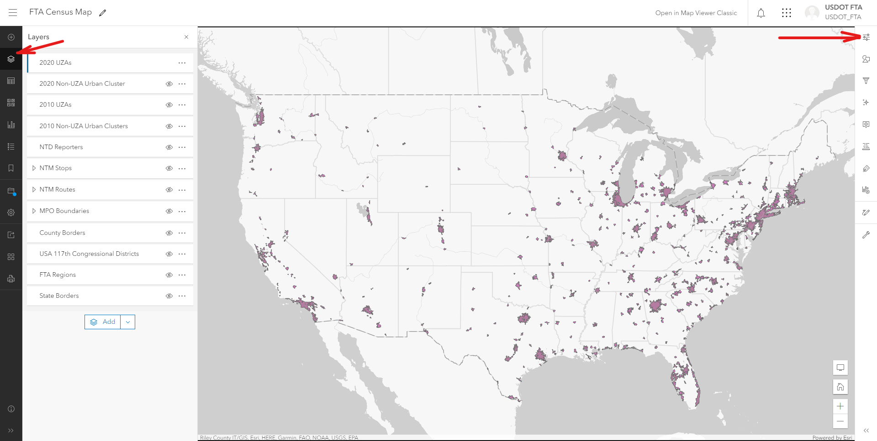

To change the transparency of the feature layer, use the slider shown below on the right.

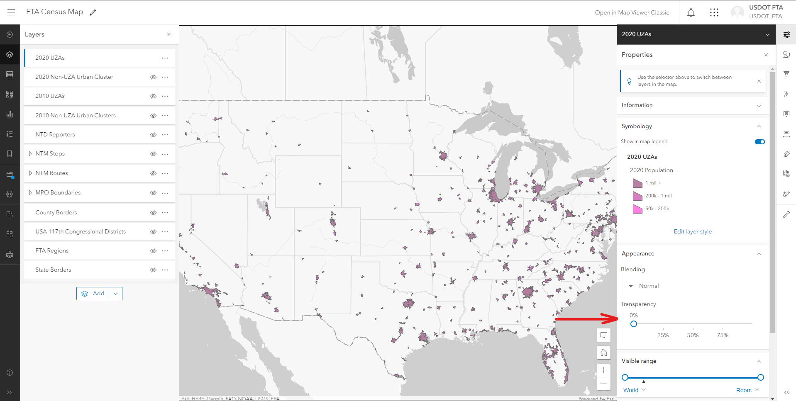

To change the color of the feature layer, first click “Edit layer style.”

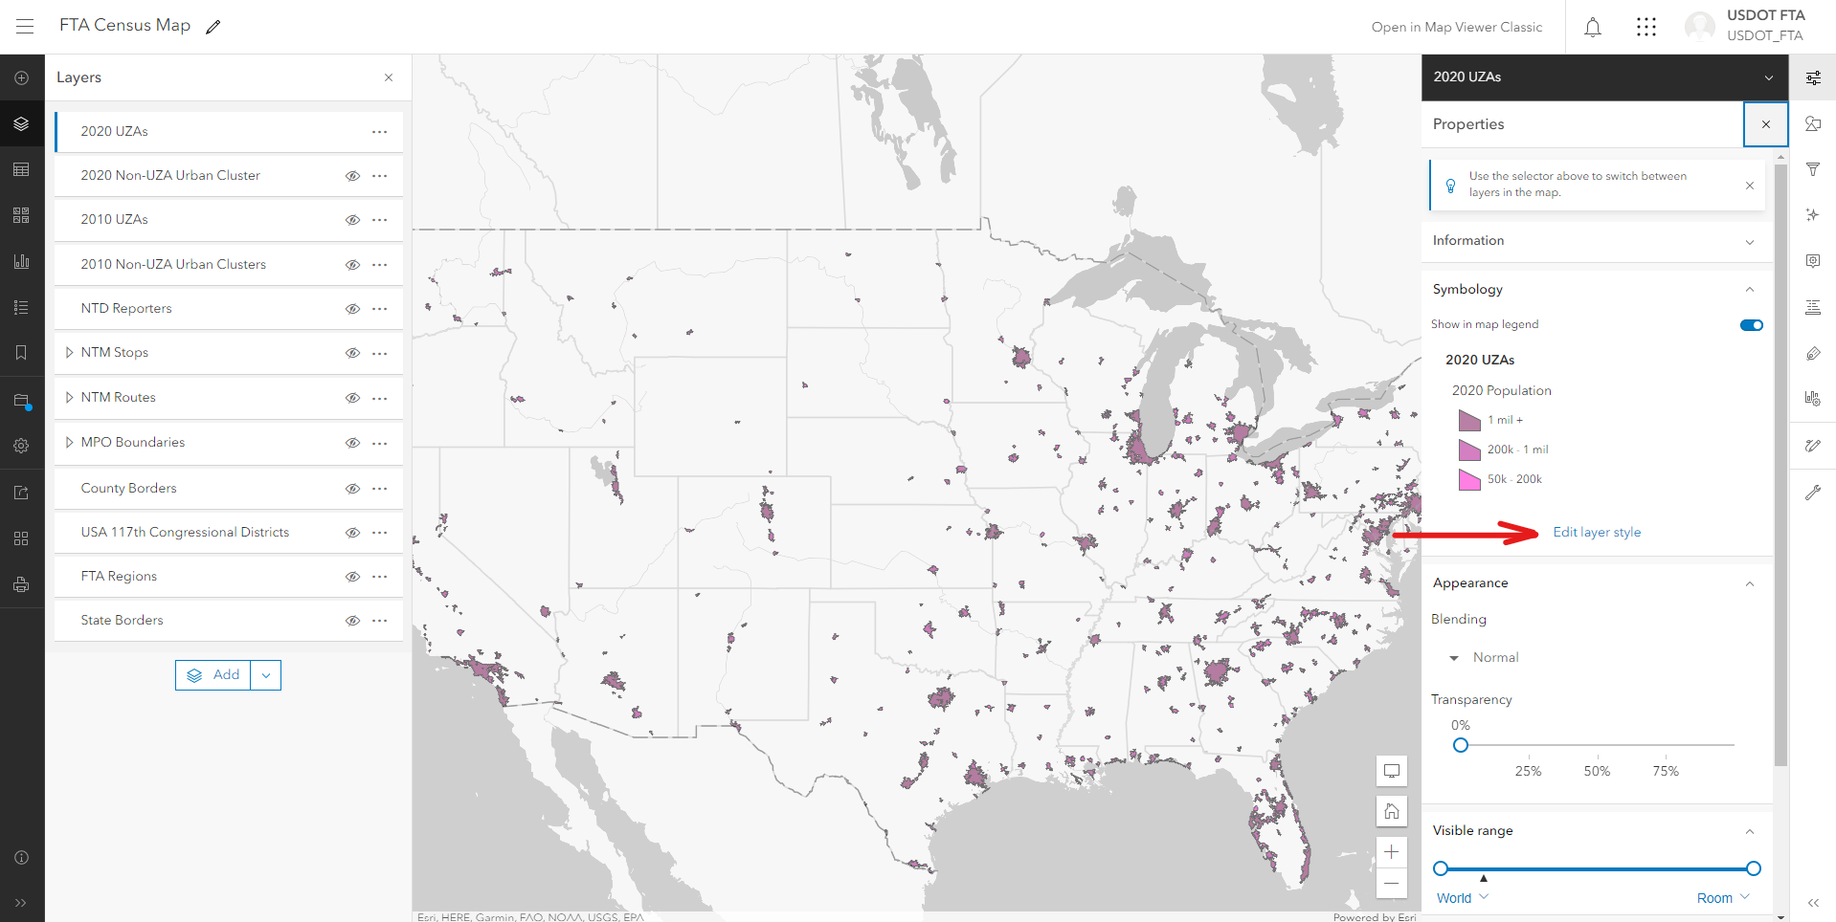

Then, select “Style options."

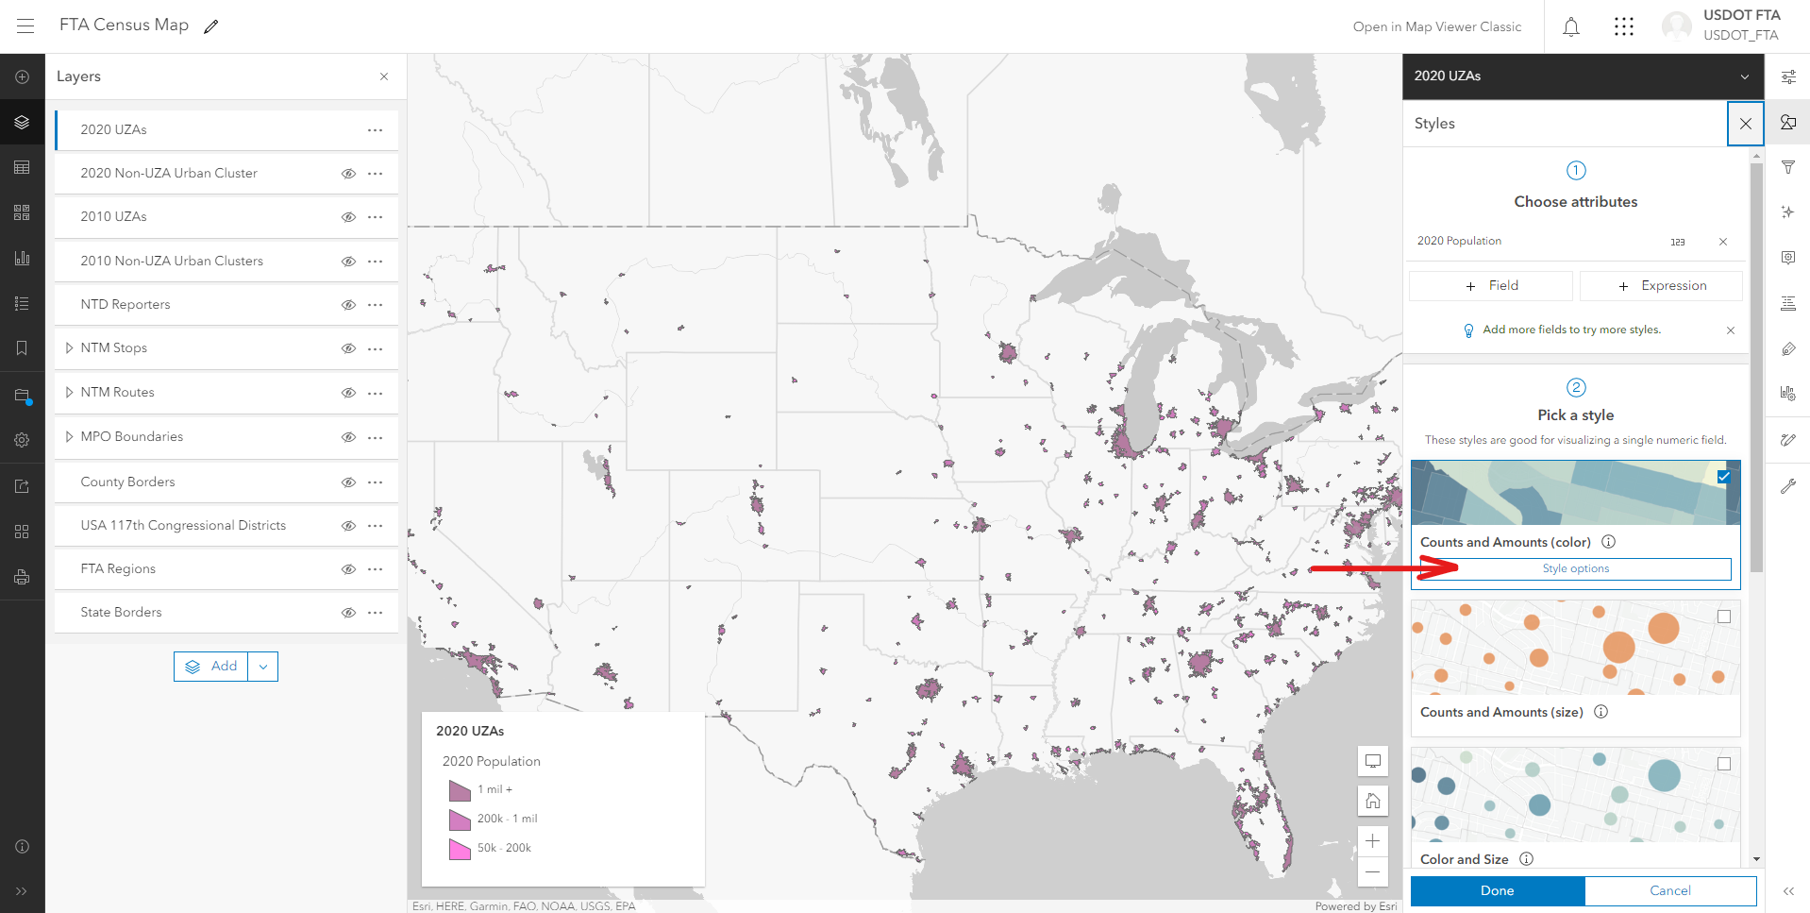

Then select “Symbol style.” This will bring up several color options to choose from.

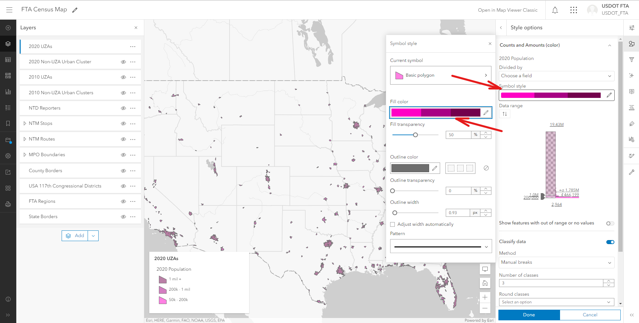

# Data Sources

The census map hosts several different feature layers, created from different data sources.

## Census TIGER Files

The 2020 UZA, 2020 Non-UZA Urban Clusters, 2010 UZA, and 2010 Non-UZA Urban Clusters feature layers are all created using the census released TIGER files to create the geometries used. The TIGER files can be found [here](https://www2.census.gov/geo/tiger/TIGER_RD18/LAYER/UAC20/). The data in the tables is created using the demographic data created by the FTA crosswalk table, as seen [here](https://www.transit.dot.gov/ntd/2020-census-changes-uzapopulation).

## National Transit Map

The National Transit Map (NTM) Routes and Stops are created by using the NTM data source hosted by the Bureau of Transportation Statistics (BTS). The NTM is used for both the shapes and the attribute tables for both feature layers mentioned. The NTM layers utilize voluntarily reported GTFS data from fixed-route services. The nature of this feature layer means it does not show the full amount of fixed route service provided by transit agencies across the nation and does not show any demand response related services. NTM data is also included in the NTD Reporters attribute table.

## ESRI Products

The MPO Boundaries and US Congressional District layers are created using feature layers published by ESRI. This data source is used to create both the shape and the attribute table.

## National Transit Database

The National Transit Database (NTD) is utilized to create the NTD Reporter feature layer. The NTD is used to create both the points and the attribute table for the NTD Reporter feature layer.

# 2020 Census Urban Areas – Change Case Examples

Following are specific FTA-relevant examples for common change case types manifesting from the U.S. Census Bureau’s re-delineation of urban areas that correspond to the 2020 Census.

## Now Small UZA:

1. New Small UZA Created from Previously Rural Territory

**Minot, North Dakota**, is a new small UZA with a population of between 50,000 and 199,999 created from a previously rural area.

1. New Small UZA Created from Separate Pre-Existing Large UZA

**Amherst Town--Northampton--Easthampton Town, Massachusetts**, is a new Small UZA with a population of between 50,000 and 199,999 created from an area that was previously located in a large UZA with a population of 200,000 or more (i.e., Springfield, MA UZA).

1. Pre-Existing Small UZA Expanded to Encompass Previously Rural Territory

**Longview, Washington**, is a pre-existing Small UZA with a population of between 50,000 and 199,999 that expanded to include a populated area that was previously rural (i.e., Castle Rock, WA).

1. Pre-Existing Large UZA Depopulated to a Small UZA

**Norwich-New London, Connecticut**, is now a Small UZA with a population of between 50,000 and 199,999 that depopulated from a Large UZA with a population of 200,000 or more.

## Now Large UZA:

1. New Large UZA Created from Separate Pre-Existing Large UZA

**San Rafael-Novato, California**, is a new Large UZA with a population of 200,000 or more that was created out of the separate San Francisco-Oakland Large UZA.

1. Pre-existing Large UZA Expanded to Encompass Previously Rural Territory

**Lubbock, Texas**, is a pre-existing Large UZA with a population of 200,000 or more that expanded to include a populated area that was previously rural (i.e., Shallowater, TX).

1. Pre-Existing Small UZA Grew to Be a Large UZA

**Gainesville, Florida**, is now a Large UZA with a population of 200,000 or more that was previously a Small UZA with a population of between 50,000 and 199,999.

1. Pre-existing Small UZA Absorbed by Pre-Existing Large UZA

**Twin Rivers, New Jersey**, was a pre-existing Small UZA with a population of between 50,000 and 199,999 that was absorbed by the Trenton, NJ Large UZA with a population of 200,000 or more.

1. Pre-Existing Large UZA Expanded to Encompass Territory from Separate Large UZA

**Hartford, Connecticut**, was and continues to be a Large UZA with a population of 200,000 or more that expanded to encompass territory previously located in the Springfield, MA Large UZA.

## Now Rural:

1. Pre-Existing Small UZA Depopulated to a Rural Area

**Bloomsburg-Berwick, Pennsylvania**, was a pre-existing Small UZA with a population of between 50,000 and 199,999 that has depopulated to a population under 50,000 and has become a rural area.

1. Pre-Existing Small or Large UZA Retained but Contracted in Extent

**Springfield, Missouri**, is a pre-existing Large UZA with a population of 200,000 or more that has been retained as a Large UZA but contracted in extent to yield rural area from previously urbanized territory (i.e., Republic, MO).

**Walla Walla, Washington-Oregon**, is a pre-existing Small UZA with a population of between 50,000 and 199,999 that has been retained as a Small UZA but contracted in extent to yield rural area from previously urbanized territory (i.e., Milton-Freewater, OR).

## Combinations of Change Case Types:

Many UZAs experienced changes that involve a combination of the change case types explained above. For example, Portsmouth, NH-ME is a pre-existing Small UZA that expanded to include a populated area that was previously rural (i.e., Kennebunk, ME), but it also contracted in extent to yield rural area from previously urbanized territory (i.e., Exeter, NH). As another more complex example, McKinney-Frisco, TX was a pre-existing Small UZA that grew to encompass a significant amount of area previously located in the Dallas-Fort Worth-Arlington UZA and became a Large UZA, but it also expanded to encompass a populated area that was previously rural (i.e., Paloma Creek South-Paloma Creek, TX) and in a separate location contracted in extent to yield rural areas from previously urbanized territory (i.e., Melissa and Princeton, TX).